High Voltage Geiger Muller Power Supply
Hardware revision 4.1

Designed by Allan R. Lind, March 2013
Test/support by Kalin Kozhuharov

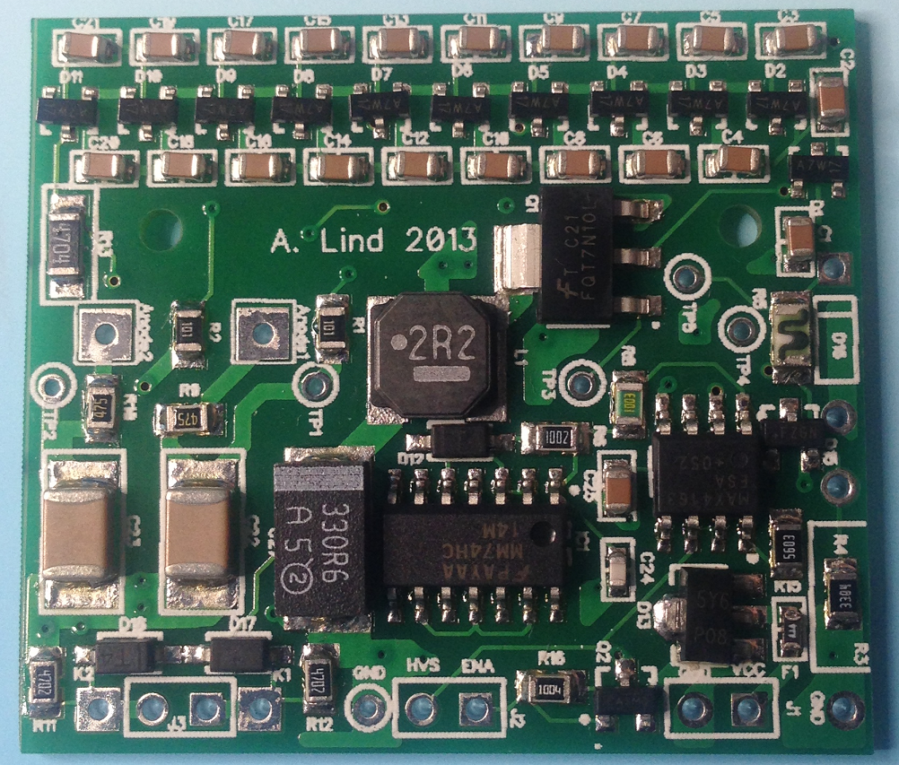
Fig 1: A working prototype

Overview
A small and lightweight high voltage power supply, wired for positive high voltage, designed specifically for battery operated radiation detectors employing Geiger-Mueller tubes.

The board is designed to run for long periods off a single-cell 3.7V Lithium Ion or Lithium Polymer battery.

There are 2 independent HV outputs, each of which can be configured for +391V, +548V, or +860V suiting most commonly available GM tubes.

There are 2 independent pulse outputs derived from the Geiger-Mueller tube’s Cathodes.
These outputs are diode protected from voltage pulses extending beyond the battery rail voltage. A detected event creates a positive pulse.

The power supply is fuse protected from overvoltage and reverse polarity.

There is an enable input (inverted, so take to ground to enable the supply). If not using it, place a solder bridge as indicated to have the module be always powered on on supplying VCC.


Fig 2: Solder bridge to always enable outputs
There is voltage sensing output (HV Sense) for monitoring high voltage output. This output will show 2.5V under normal operation (actual voltage depends on configured output, see Output Voltage Configuration below). If it is any lower this could be due to output overload condition (too high count rate, tube arcing, short circuit, etc.) or a fault in the HV generator or multiplier stage.

Optional components
Provisions are made for the following optional components, however installing some or all of them may lead to increased power consumption, and they are not strictly needed.

- Power Indicator LED
- Output HV smoothing capacitors
- Voltage adjustment resistor R3 (to give user required output voltages)
- High Voltage Bleed push switch (to discharge capacitors quickly, e.g. before dismounting)
- Output stack protection Zener diode

Board Layout

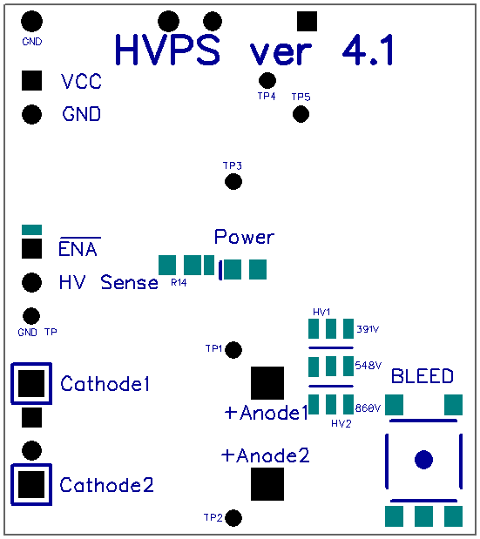

Specifications
Specification | Value | Note
Physical size (HxW) | 40x36 mm
Supply Voltage | +3.3 ~ +5.0V | single Li-Po/Li-Ion 3.7V cell
Operating Current | ~130μA | under no load
Output Voltage | 391V, 548V, 860V | jumper selectable, 2 outputs
Number of HV outputs | 2 | independent
Anode output load resistors | 4.7MΩ
Over voltage and reverse polarity protection | resettable fuse
HV Sense output | 0~2.5V | represents 0~860V, 0~548V or 0~391V, depending on jumper configuration

NOTE: TP 1 and 2 are direct Outputs before the 4.7M anode resistors

Output voltage configurations
Place a solder bridge over the pads as indicated in red for various combinations of output voltage.

# | soldering patttern | Anode1, V | Anode2, V
A | 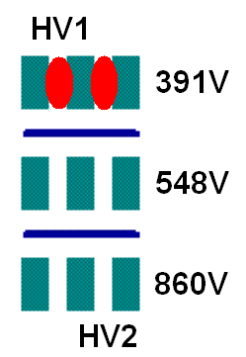 | 391 | 391
B | 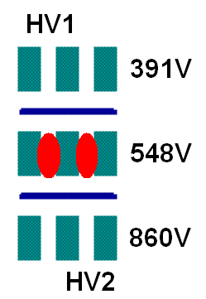 | 548 | 548
C | 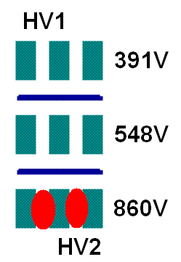 | 860 | 860
D | 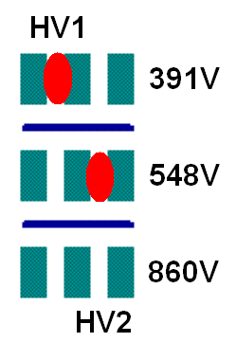 | 391 | 548
E | 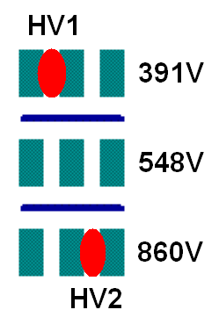 | 391 | 860
F | 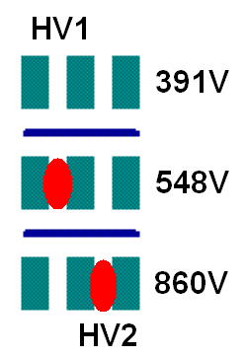 | 548 | 860

Troubleshooting tips

Symptom
No output, draws 160mA TP4 at 1.8V
Diagnosis
Check R8 for short circuit

Symptom
output ~ 650v and draw ~ 100mA TP4 above 2.5V
Diagnosis
Check R15 for short circuit

Symptom
output of ~ 50V and board drawing ~ 200mA.
Diagnosis
This means Oscillator running but there is a fault in the CW stage or on final output.

Possible causes
short circuit cap or cap breaking down at high voltage.
Check all caps for shorts. Replace C8-C12 first.
Remove discharge push button

Symptom
output of ~ 2V and the board drawing ~ 200mA.
Diagnosis
Check across zener, if this is at same potential as supply this may mean oscillator not running.
Causes
Check R8.
In two cases, have discovered one side of R8 not soldered.
Check C24 for short and if not sure of value, replace.

Symptom
Circuit drawing more than 140uA under no load and erratic.
Diagnosis
One or more caps in CW section are leaky. Or R8 leaky.

Solution
Isolate CW in stages to track down where the problem is. In one case I found more than one cap can be to blame.

Or Check R8 value. If lower than 100K could be traces of solder under the resistor, remove and re-solder.

