UOW-logo

Informatics Institute of Technology

School of Computing

Object Oriented Programming

Module : Object Oriented Programming

Date of submission : 2024.12.12

Student ID : 20231158 / W2051872

Student First Name : Thinula

Student Surname : Harischandra

Tutorial group :G23

**Test Cases**

CLI Part

|  |  |  |  |  |
| --- | --- | --- | --- | --- |
| Test No | Test Case | Self-Assesment | Test input | Expected Output |
| 1 | Display the menu | Fully implemented | Run project | Show the menu |
|  | | | | Test case status |
| Pass |
| 2 | Prompt for configuration parameters | Fully implemented | N | Prompting |
|  | | | | Test case status |
| Pass |
| 3 | Input string into a int | Fully implemented | “g” | Re prompt to that |
|  | | | | Test case status |
| Pass |
| 4 | Give option to load configuration from the json | Fully implemented | Select Y in starting manu | Configuration loading from the json |
|  | | | | Test case status |
| Pass |
| 5 | Saving configuration as a json file | Fully implemented | Give configuration parameters | Save json file |
|  | | | | Test case status |
| Pass |
| 6 | Giving start operation menu | Fully implemented | Give inputs for all parameters | Show menu |
|  | | | | Test case status |
| Pass |
| 7 | Start ticketing operations | Fully implemented | Select 1 | Start operation |
|  | | | | Test case status |
| Pass |
| 8 | Starting vendors and customers | Fully implemented | N/A | Starting vendors and customers |
|  | | | | Test case status |
| Pass |
| 9 | Stopping system | Fully implemented | Select 2 after starting system | Stopping system |
|  | | | | Test case status |
| Pass |
| 10 | End system and the application | Fully implemented | Press 3 when running | Stop the application |
|  | | | | Test case status |
| Pass |
| 11 | When ticket pool full vendor wait to add ticket | Fully implemented | N/A | Vendor wait |
|  | | | | Test case status |
| Pass |
| 12 | When there is no ticket to buy customer waits | Fully implemented | N/A | Customer waits |
|  | | | | Test case status |
| Pass |

GUI Part

|  |  |  |  |  |
| --- | --- | --- | --- | --- |
| Test No | Test Case | Self-Assesment | Test input | Expected Output |
| 1 | Open the front end application (React) | Fully implemented | Run frontend | Web app runs |
|  | | | | Test case status |
| Pass |
| 2 | Admin Login | Fully implemented | Select admin section | Open admin login |
|  | | | | Test case status |
| Pass |
| 3 | After giving password go to the admin panel | Fully implemented | Give password | Open admin section |
|  | | | | Test case status |
| Pass |
| 4 | Configuration successfull | Fully implemented | Adding values and click the button | Configuration success |
|  | | | | Test case status |
| Pass |
| 5 | Start and stop buttons start the system | Fully implemented | Click buttons | Start backend system |
|  | | | | Test case status |
| Pass |
| 6 | Show customer data table in the fe | Fully implemented | N/A | Show table |
|  | | | | Test case status |
| Pass |
| 7 | Buy a ticket from frontend | Fully implemented | Purchase ticket | Buy a ticket for that person |
|  | | | | Test case status |
| Pass |

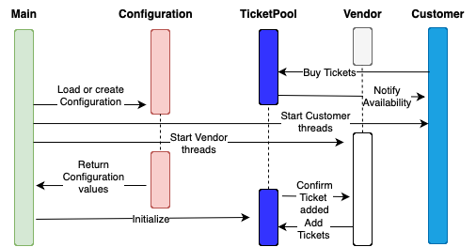Diagrams

