

THIORA EMMANUEL
BSCCS/2024/56022
BIT4138
ADVANCED CRYPTOGRAPHY
MR MICHAEL NYORO
PROJECT TITLE: SECURE FILE ENCRYPTION AND AUTHENTICATION SYSTEM
TECHNOLOGIES:
- Python
- Visual Studio code
- Cryptography library
- Github
- Open SSL

Github link
https://github.com/thiorah/cryptography.git

TABLE OF CONTENTS
WEEK 1 – Cryptography environment setup 3
Python & VS Code installation screenshots 3
Cryptography library installation 4
Open SSL Test 4
Encryption script running 5
WEEK 2 – Classical cryptography and cipher design 6
Vigenere cipher 7
Encryption and Decryption 7
User Input Validation Interface 8
Cipher Testing Results 8
WEEK 3 – Stream Ciphers and Randomness 9
LSFR Generator 9
Pseudorandom Sequence Output 10
Statistical Randomness Testing 10
RC4 Stream Cipher Simulation 11
Encryption Performance Results 11
WEEK 4 – Block cipher design and AES 12
AES Encryption Script 12
Key Generation Process 13
File Encryption Demonstration 13
Decryption Results 14
AES Performance Testing 14
WEEK 5 – RSA 16
RSA Key pair generation 16
PUBLIC KEY ENCRYPTION PROCESS 16
PRIVATE KEY DECRYPTION RESULTS 17
SECURE MESSAGE TRANSMISSION 17
RSA TESTING & VALIDATION 18
WEEK 6 – SYMMETRIC CIPHERS 19
SPN Python Program 19
S-Box Analysis 19
WEEK 7 - BLOCK CIPHER CRYPTANALYSIS 20
Differential Cryptanalysis Simulation 20
Algebraic Relationship Exploration 21
Frequency Analysis 22

WEEK 1 – Cryptography environment setup

Python & VS Code installation screenshots
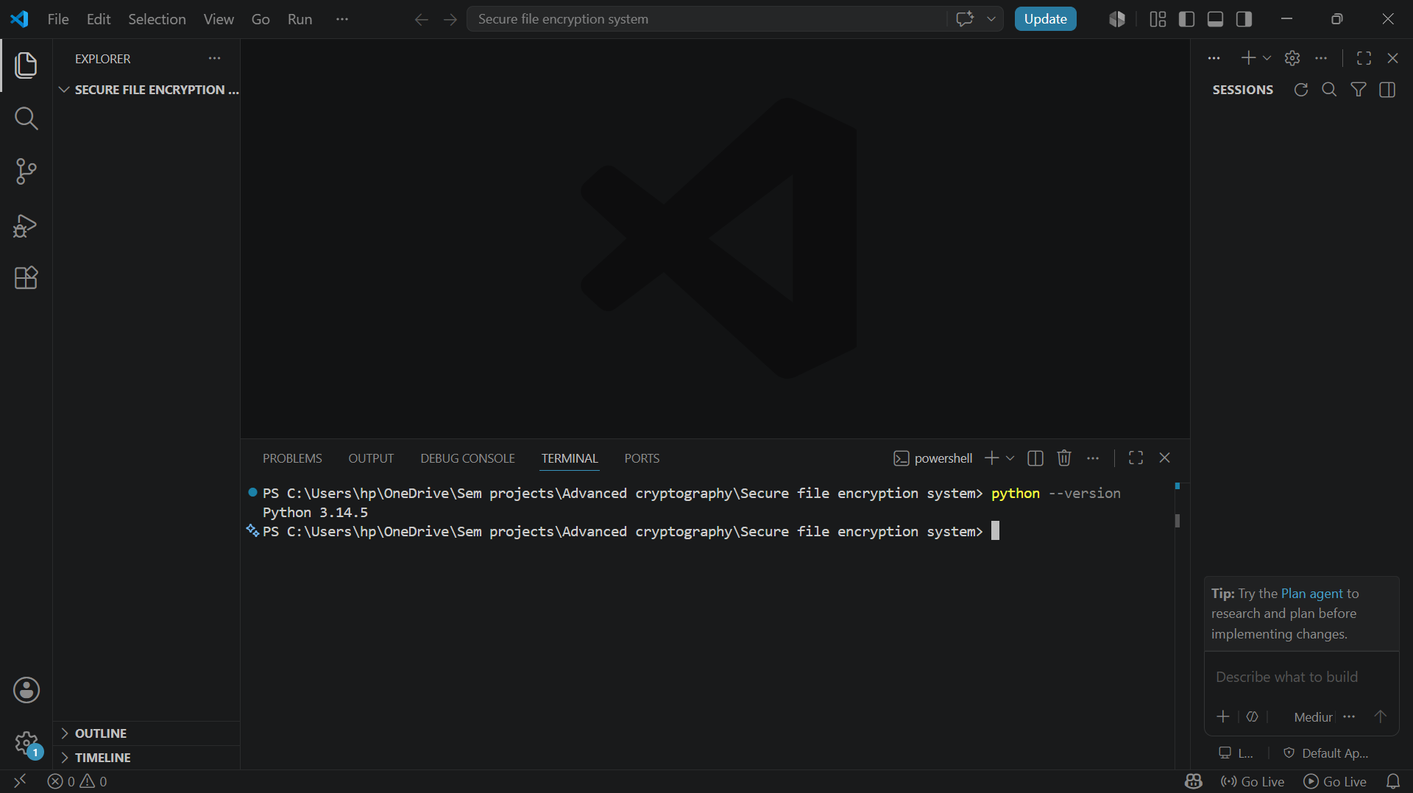
Fig 1.1 python and VS code installation

Cryptography library installation
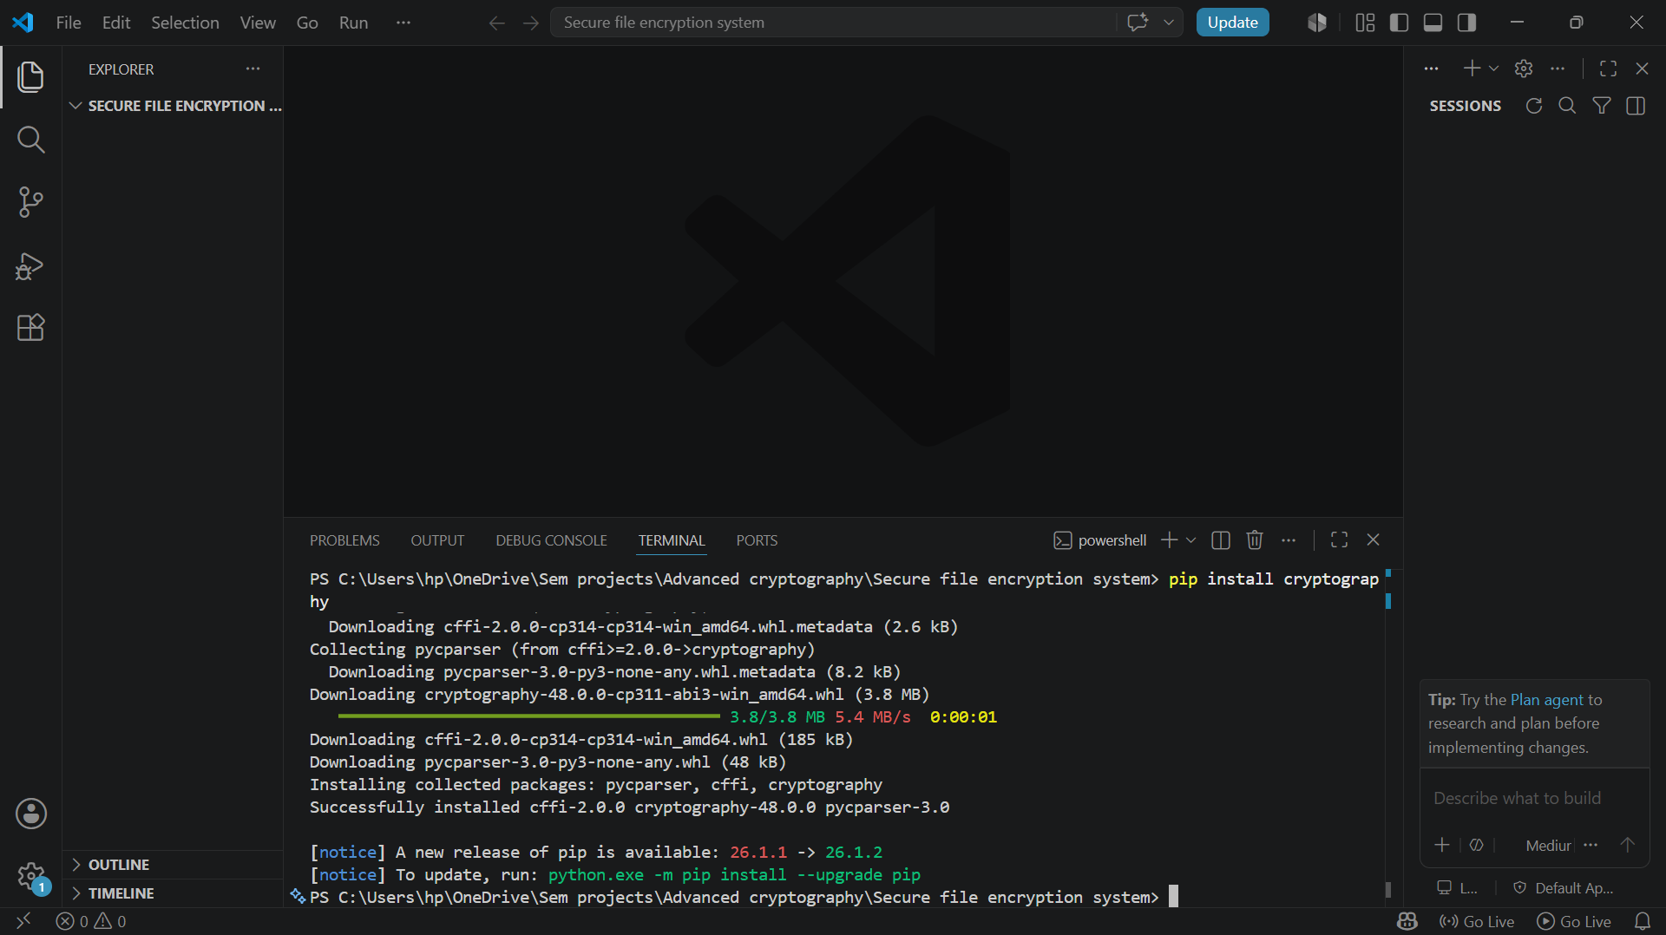
Fig 1.2 cryptography library installation

Open SSL Test

Encryption script running
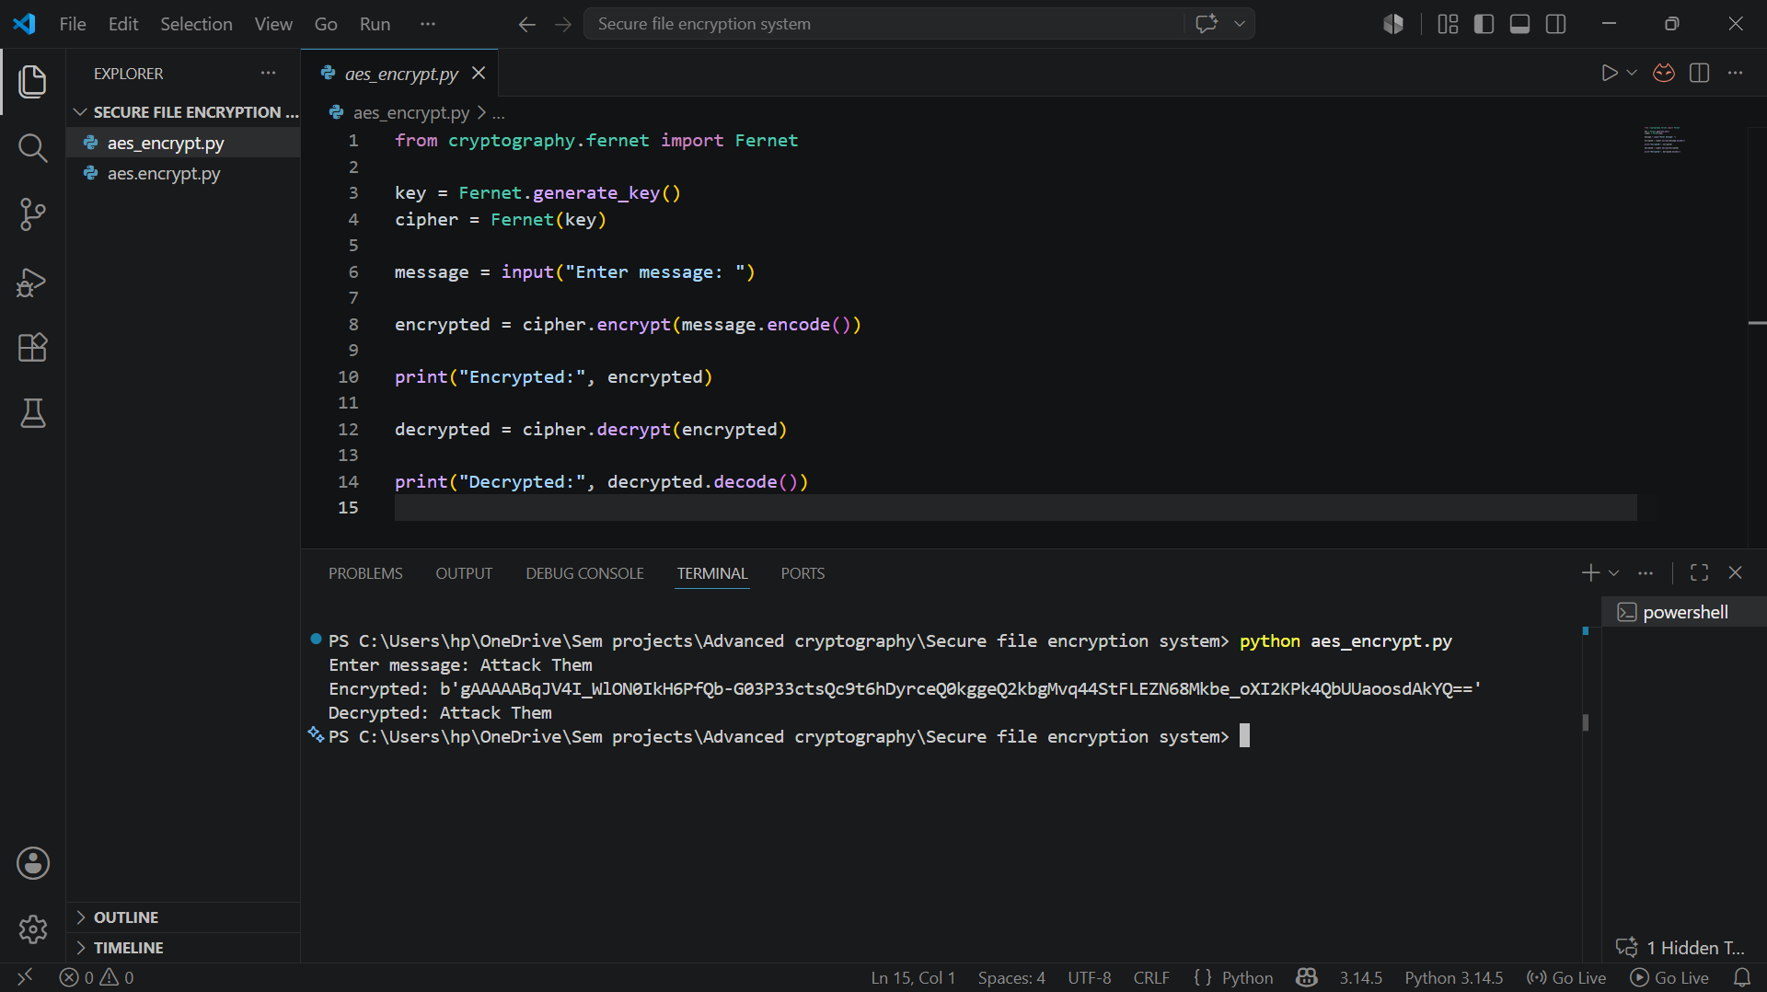
Fig 1.4 encryption script
Github initialization
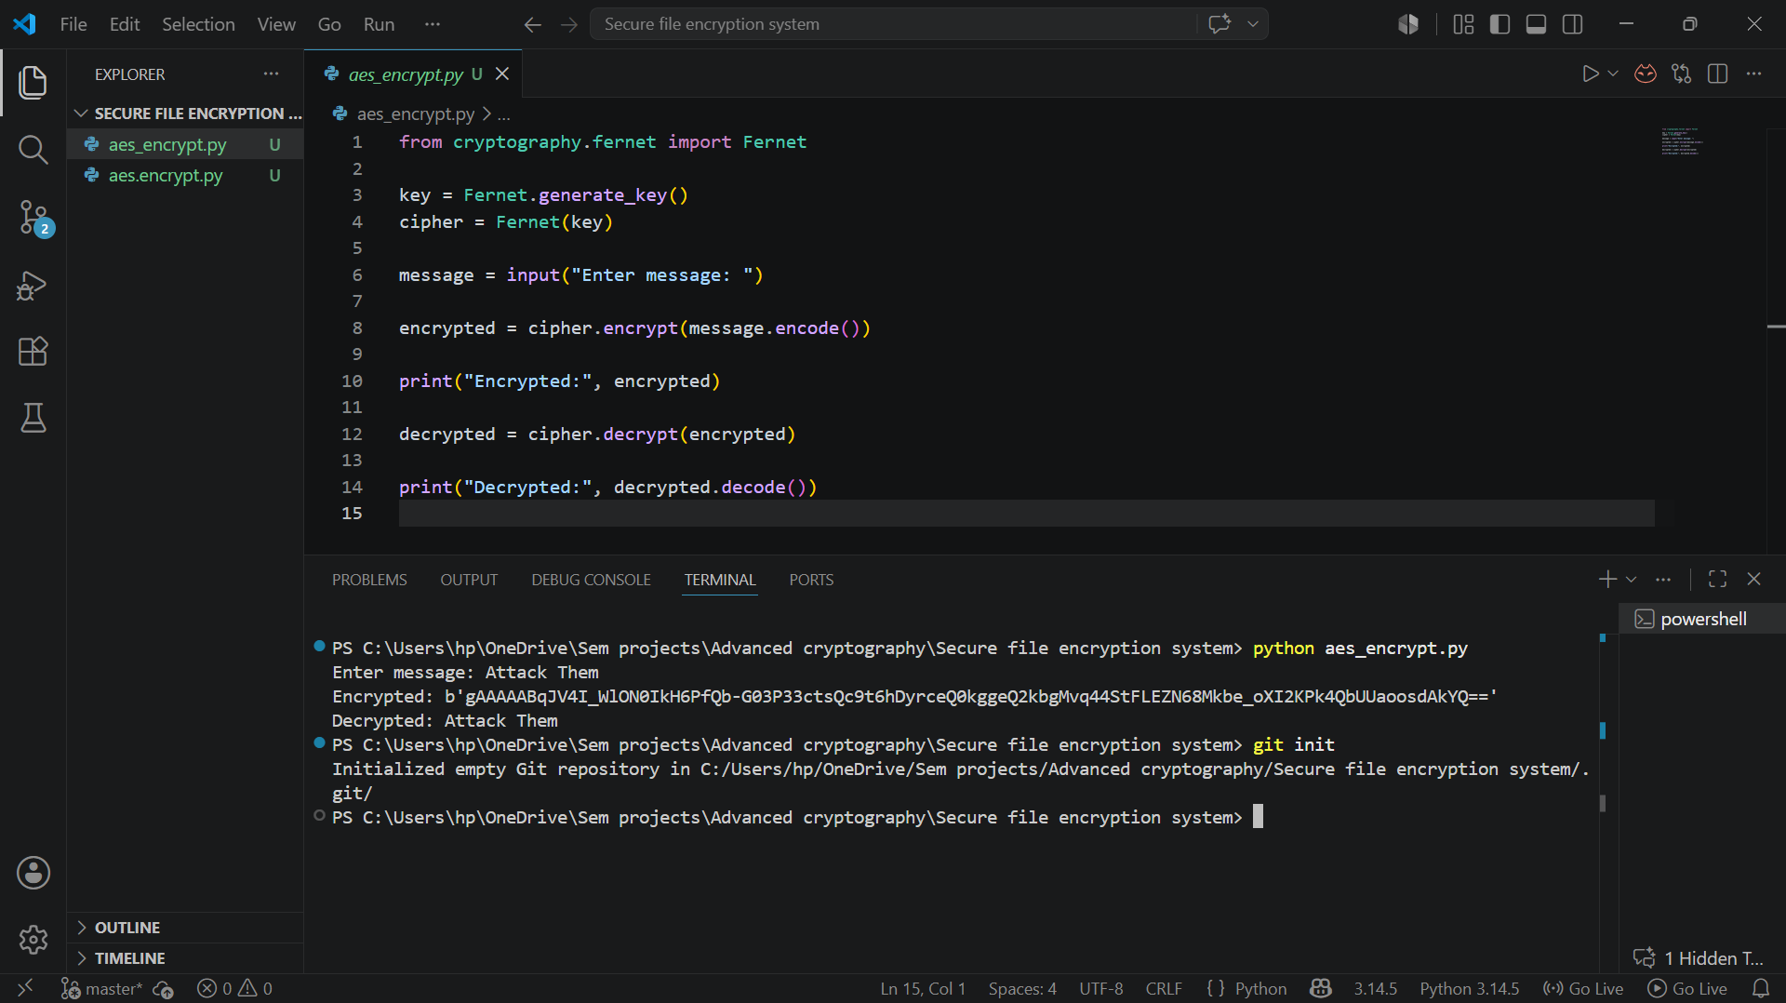
Fig 1.5 Github initialized

Reflection:
This week I configured Python, VS Code, OpenSSL, and cryptography libraries. I learned how development environments are prepared for secure cryptographic implementations and version control using GitHub.

WEEK 2 – Classical cryptography and cipher design
Ceaser Cipher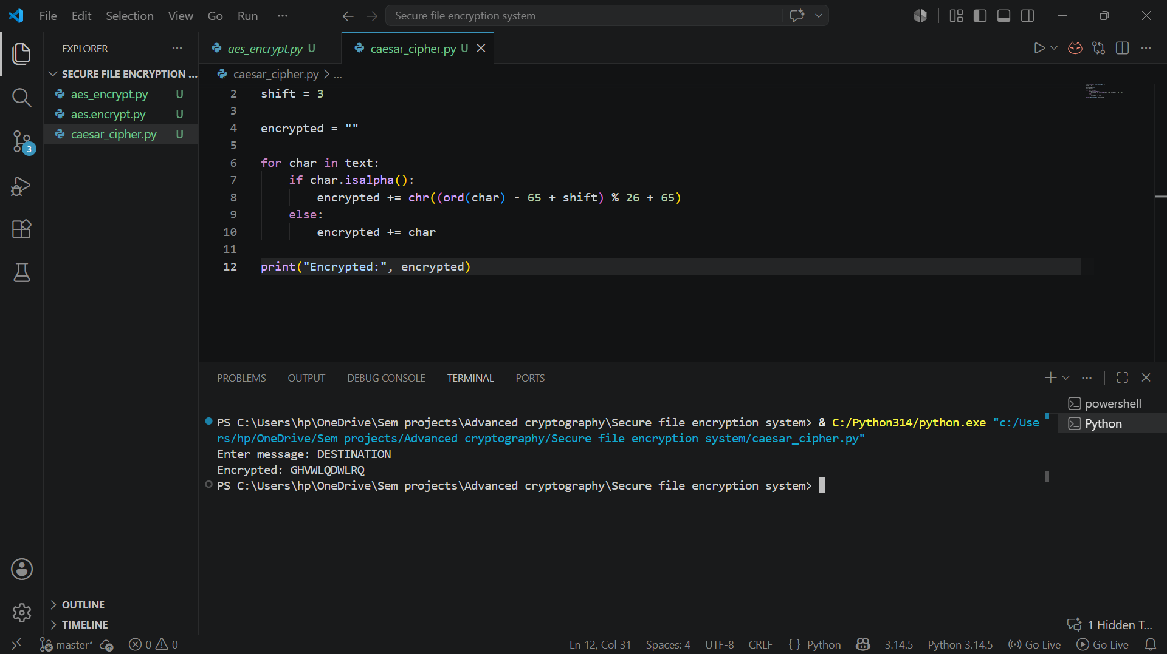
Fig 2.1 ceaser cipher

Vigenere cipher
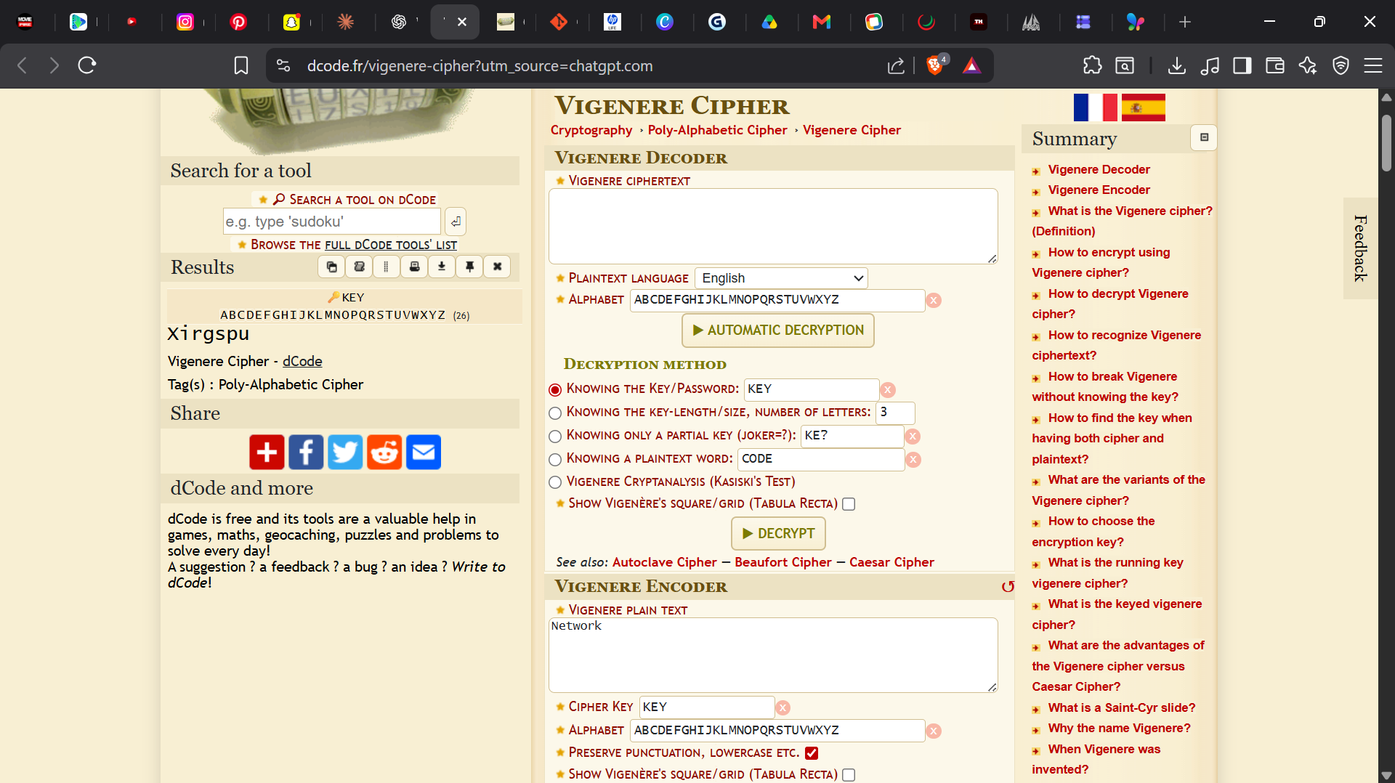

Encryption and Decryption
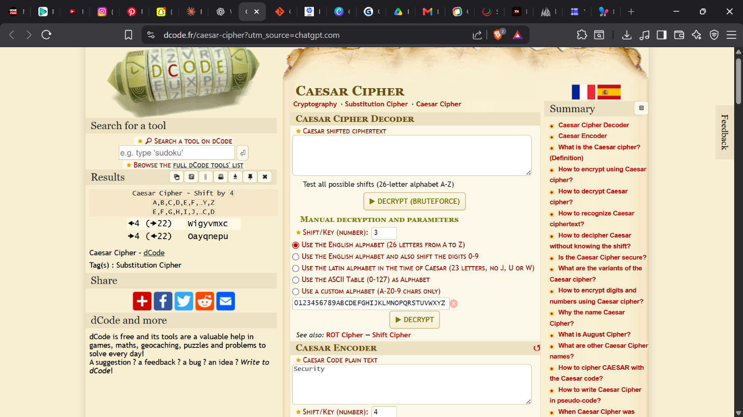
Fig 2.3 encryption and decryption

User Input Validation Interface
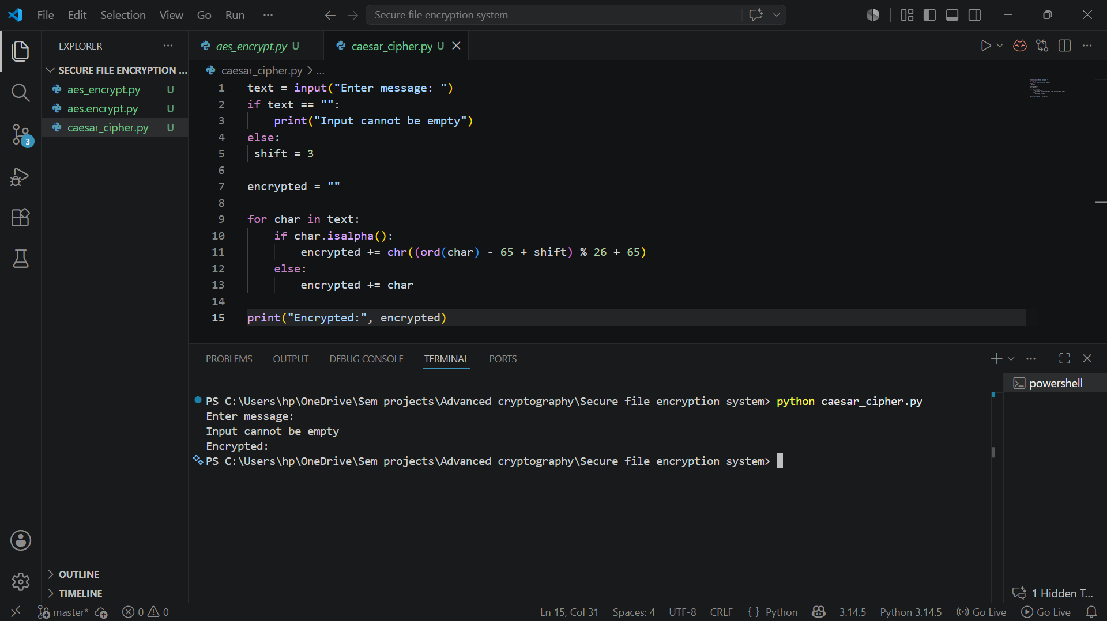
Fig 2.4 user input validation

Cipher Testing Results
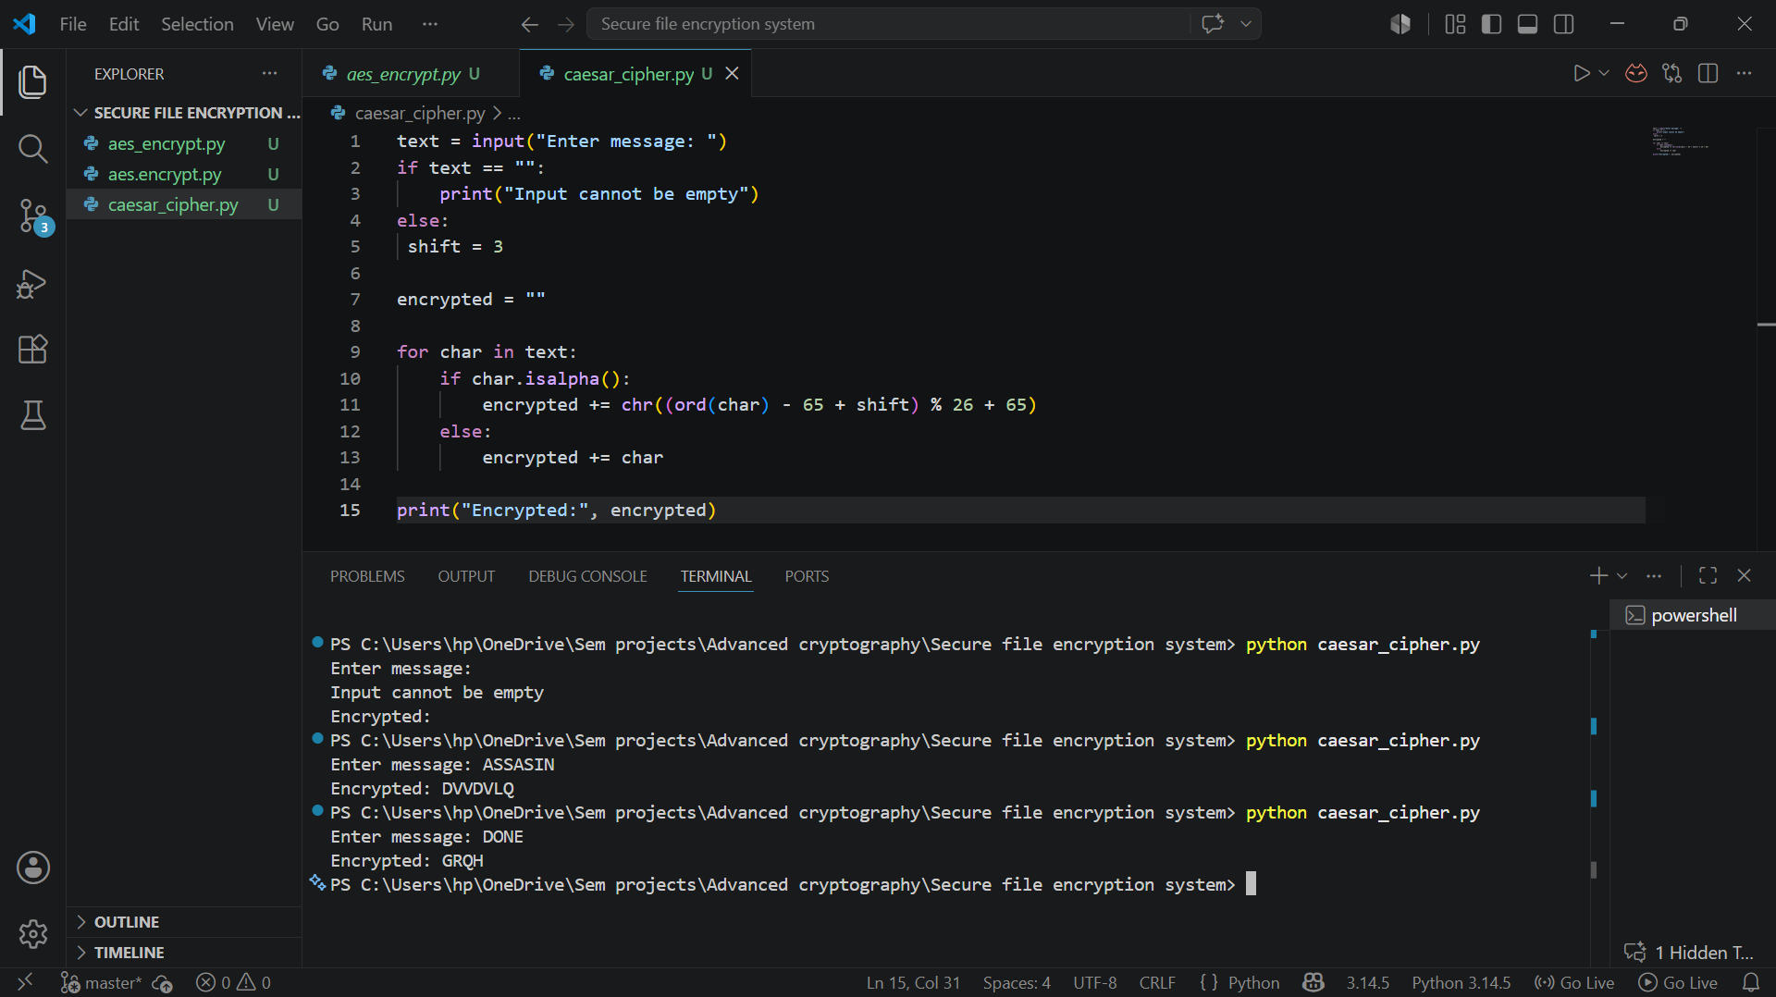
Fig 2.5 Cipher testing results of different plaintext

Reflection
This week I implemented Caesar Cipher and Vigenère Cipher encryption techniques using Python. I learned how classical encryption algorithms use keys to secure messages and understood the importance of input validation and encryption testing in cryptographic systems.

WEEK 3 – Stream Ciphers and Randomness

LSFR Generator
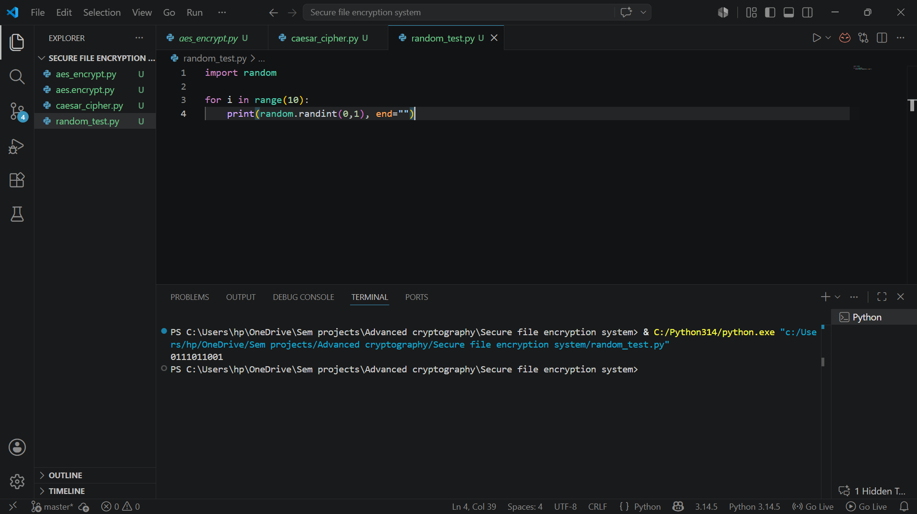
Fig 3.1 Pseudorandom binary sequence generation for stream cipher simulation.

Pseudorandom Sequence Output
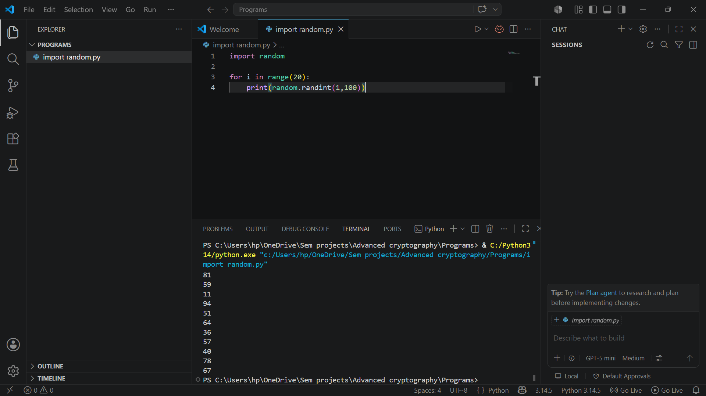
Fig 3.2 Generated pseudorandom sequences demonstrating randomness

Statistical Randomness Testing
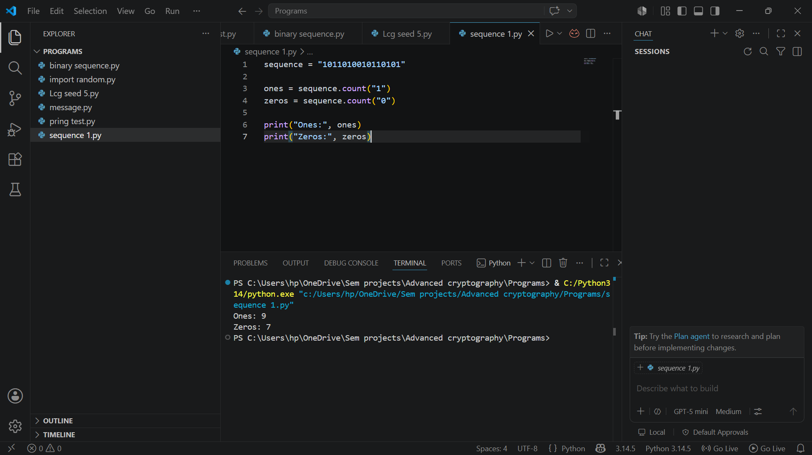
Fig 3.3 Statistical randomness analysis performed on generated binary sequences.

RC4 Stream Cipher Simulation
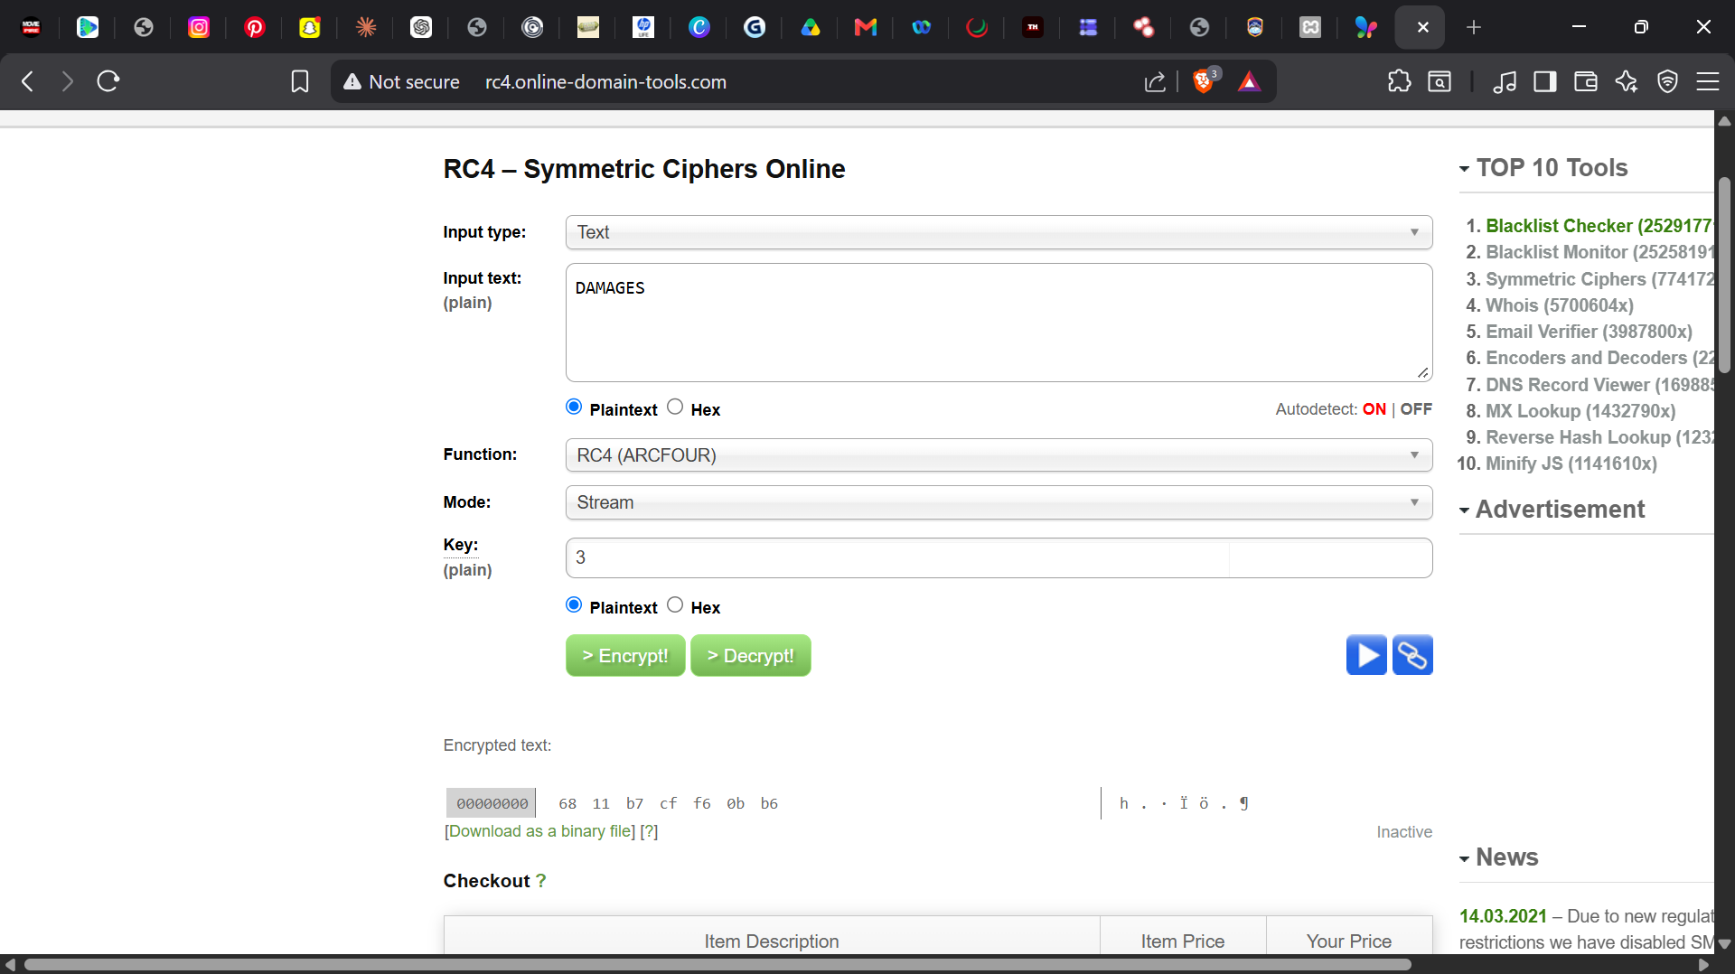
Fig 3.4 RC4 stream cipher simulation

Encryption Performance Results
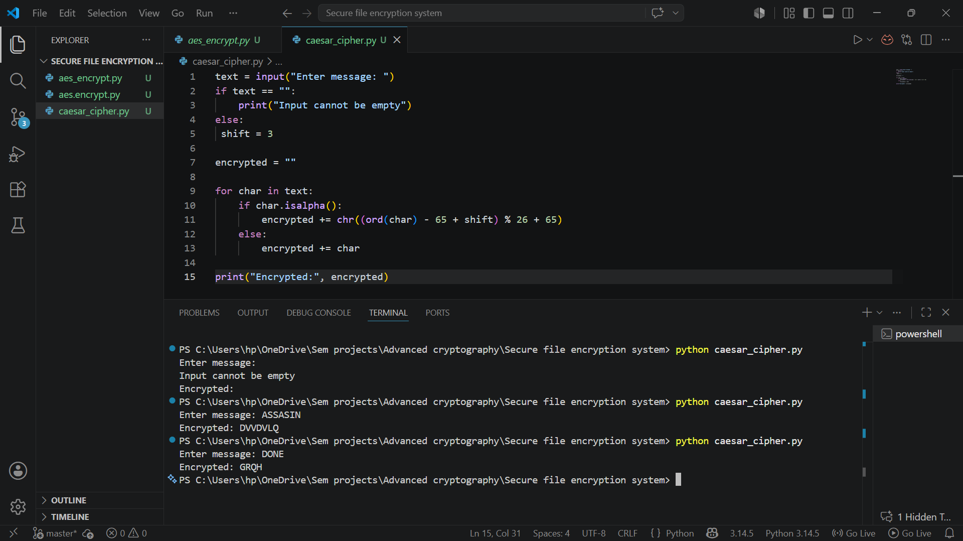

Reflection
This week I explored stream cipher concepts and pseudorandom sequence generation. I performed randomness testing on generated binary outputs and understood the importance of randomness in securing cryptographic communication systems and stream encryption workflows.

WEEK 4 – Block cipher design and AES

AES Encryption Script
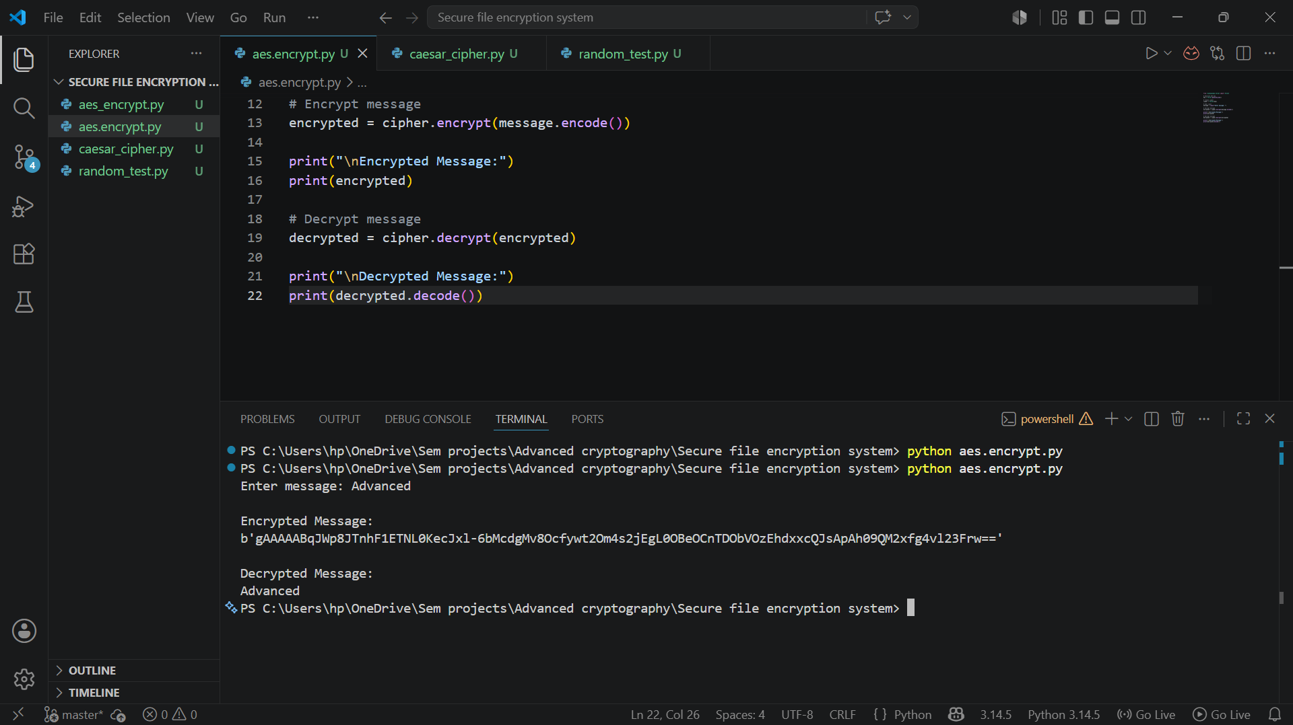
Fig 4.1 AES encryption script implementing symmetric encryption

Key Generation Process
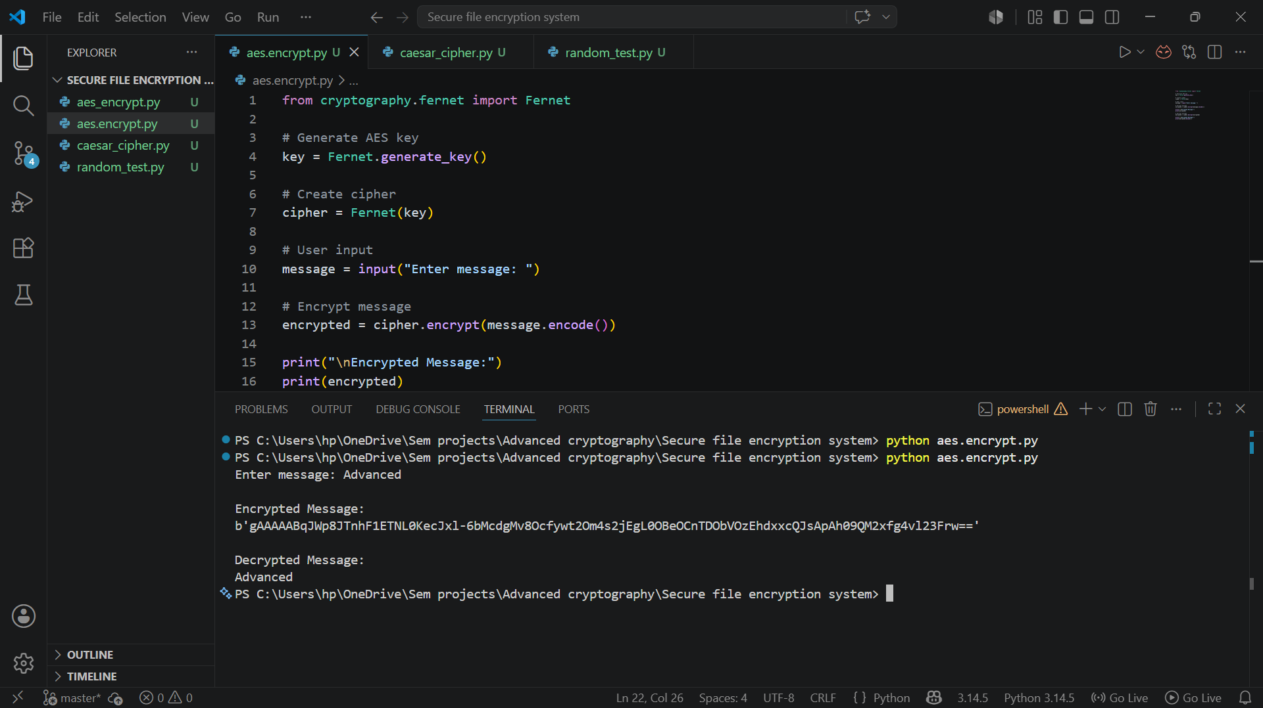

File Encryption Demonstration

Fig 4.3 Successful encryption of plaintext message using AES symmetric encryption

Decryption Results

Fig 4.4 Successful decryption restoring original plaintext message using AES.

AES Performance Testing
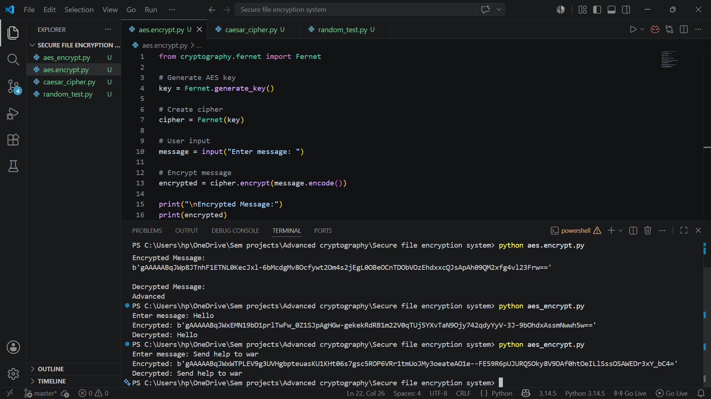
Fig 4.5 AES encryption performance testing using different plaintext inputs and message lengths.

Reflection
This week I implemented AES symmetric encryption using Python cryptography library. I successfully generated encryption keys, encrypted plaintext messages, and restored them through decryption while understanding the importance of secure key handling.

WEEK 5 – RSA

RSA Key pair generation
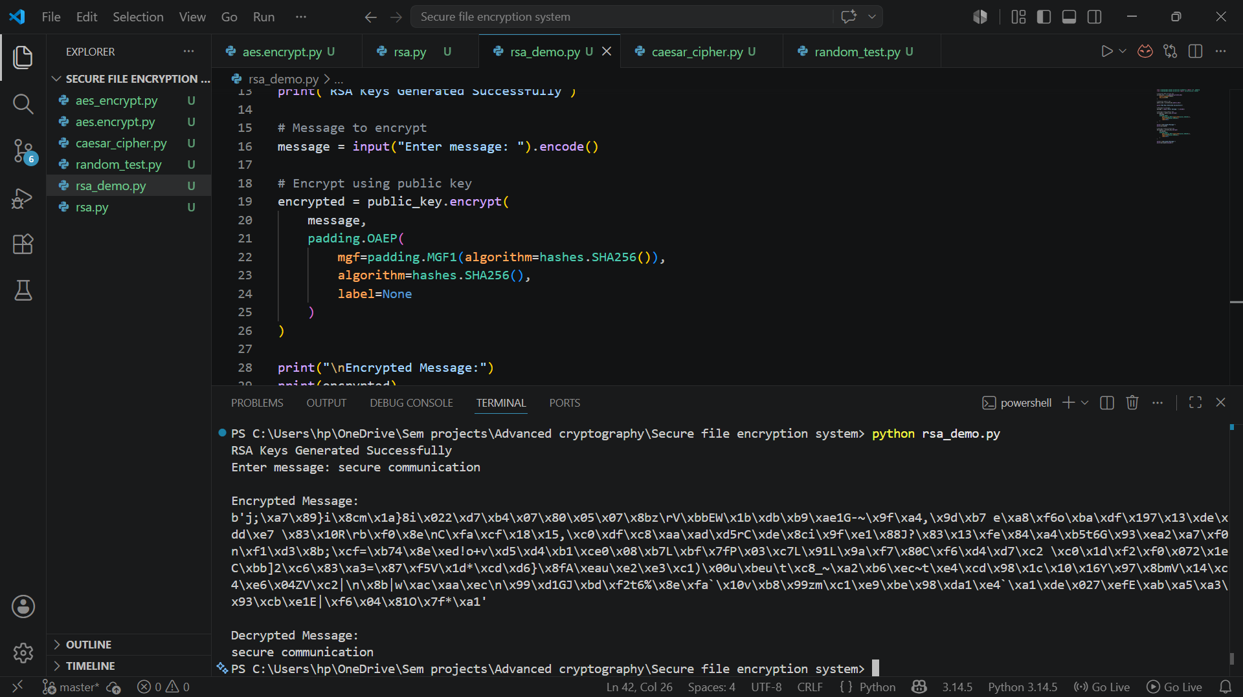
Fig 5.1 RSA public and private key pair successfully generated

PUBLIC KEY ENCRYPTION PROCESS


PRIVATE KEY DECRYPTION RESULTS

Fig 5.3 Successful private key decryption restoring original plaintext message

SECURE MESSAGE TRANSMISSION
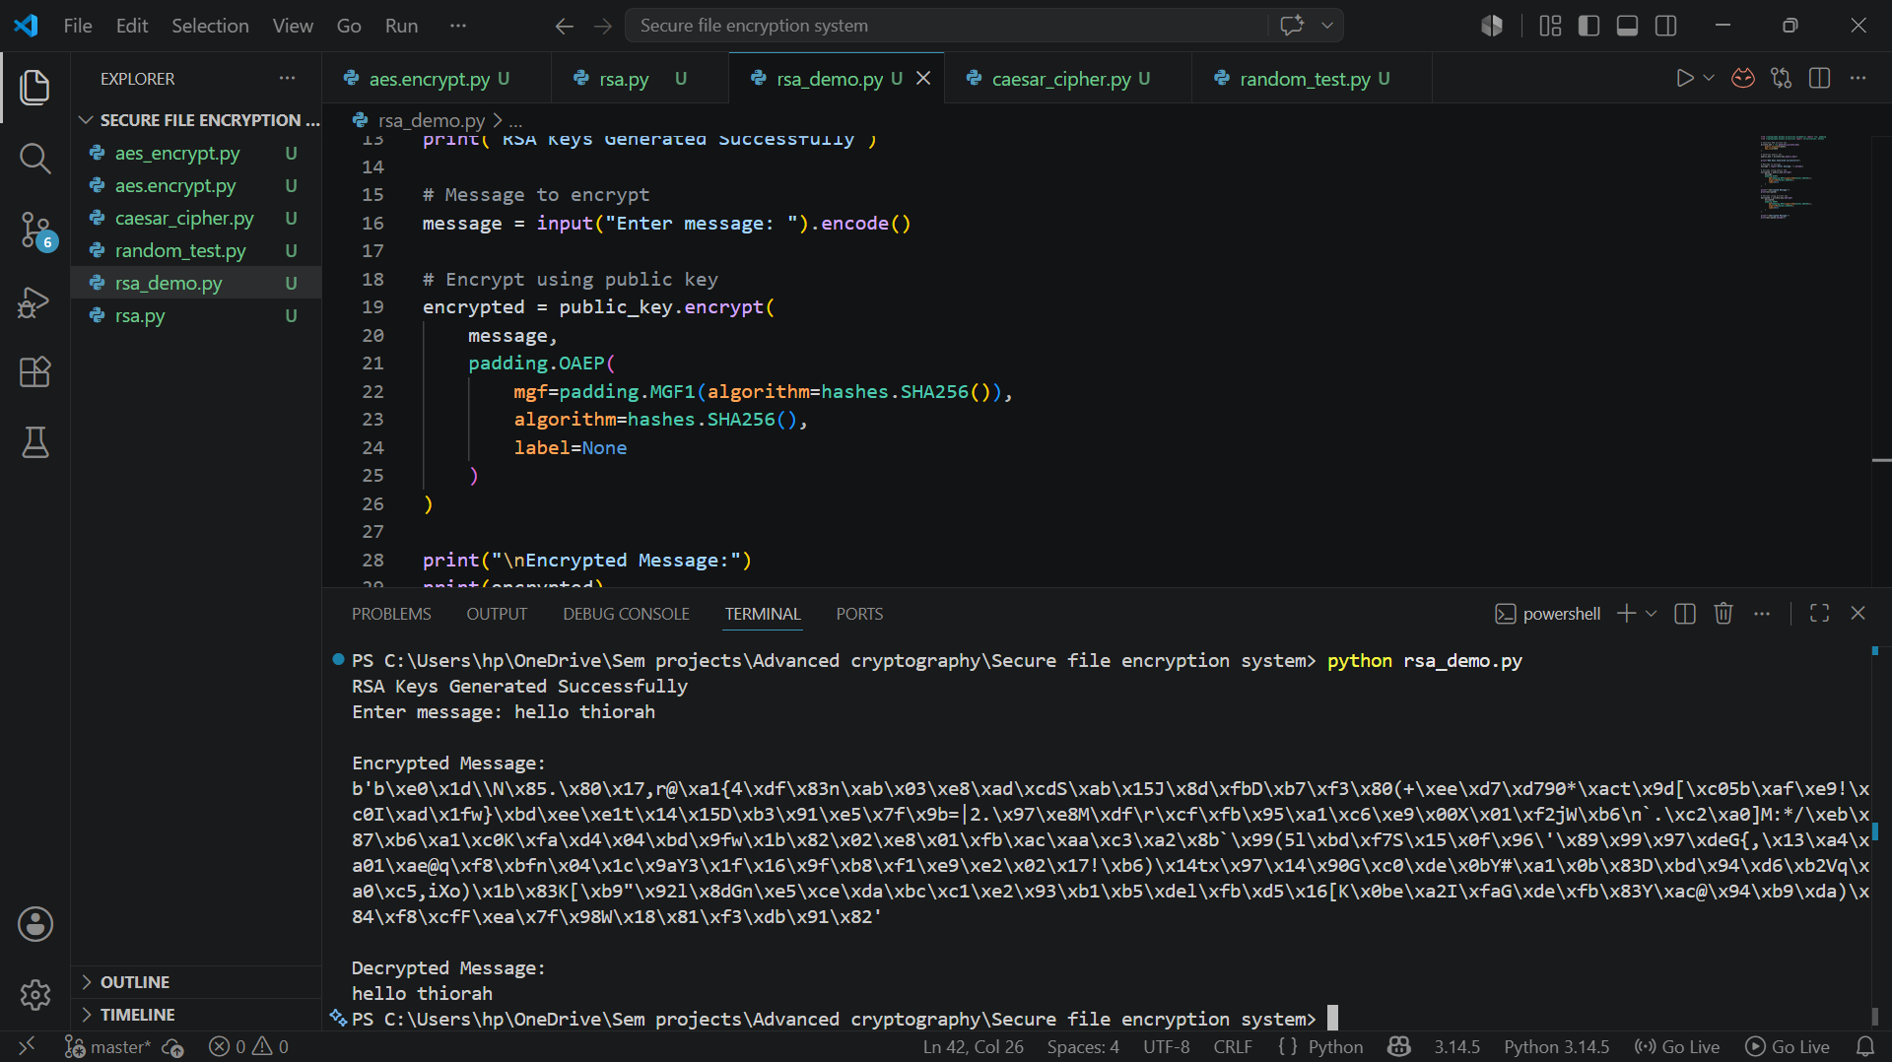
Fig 5.4 Secure message transmission workflow using RSA public and private key encryption.

RSA TESTING & VALIDATION
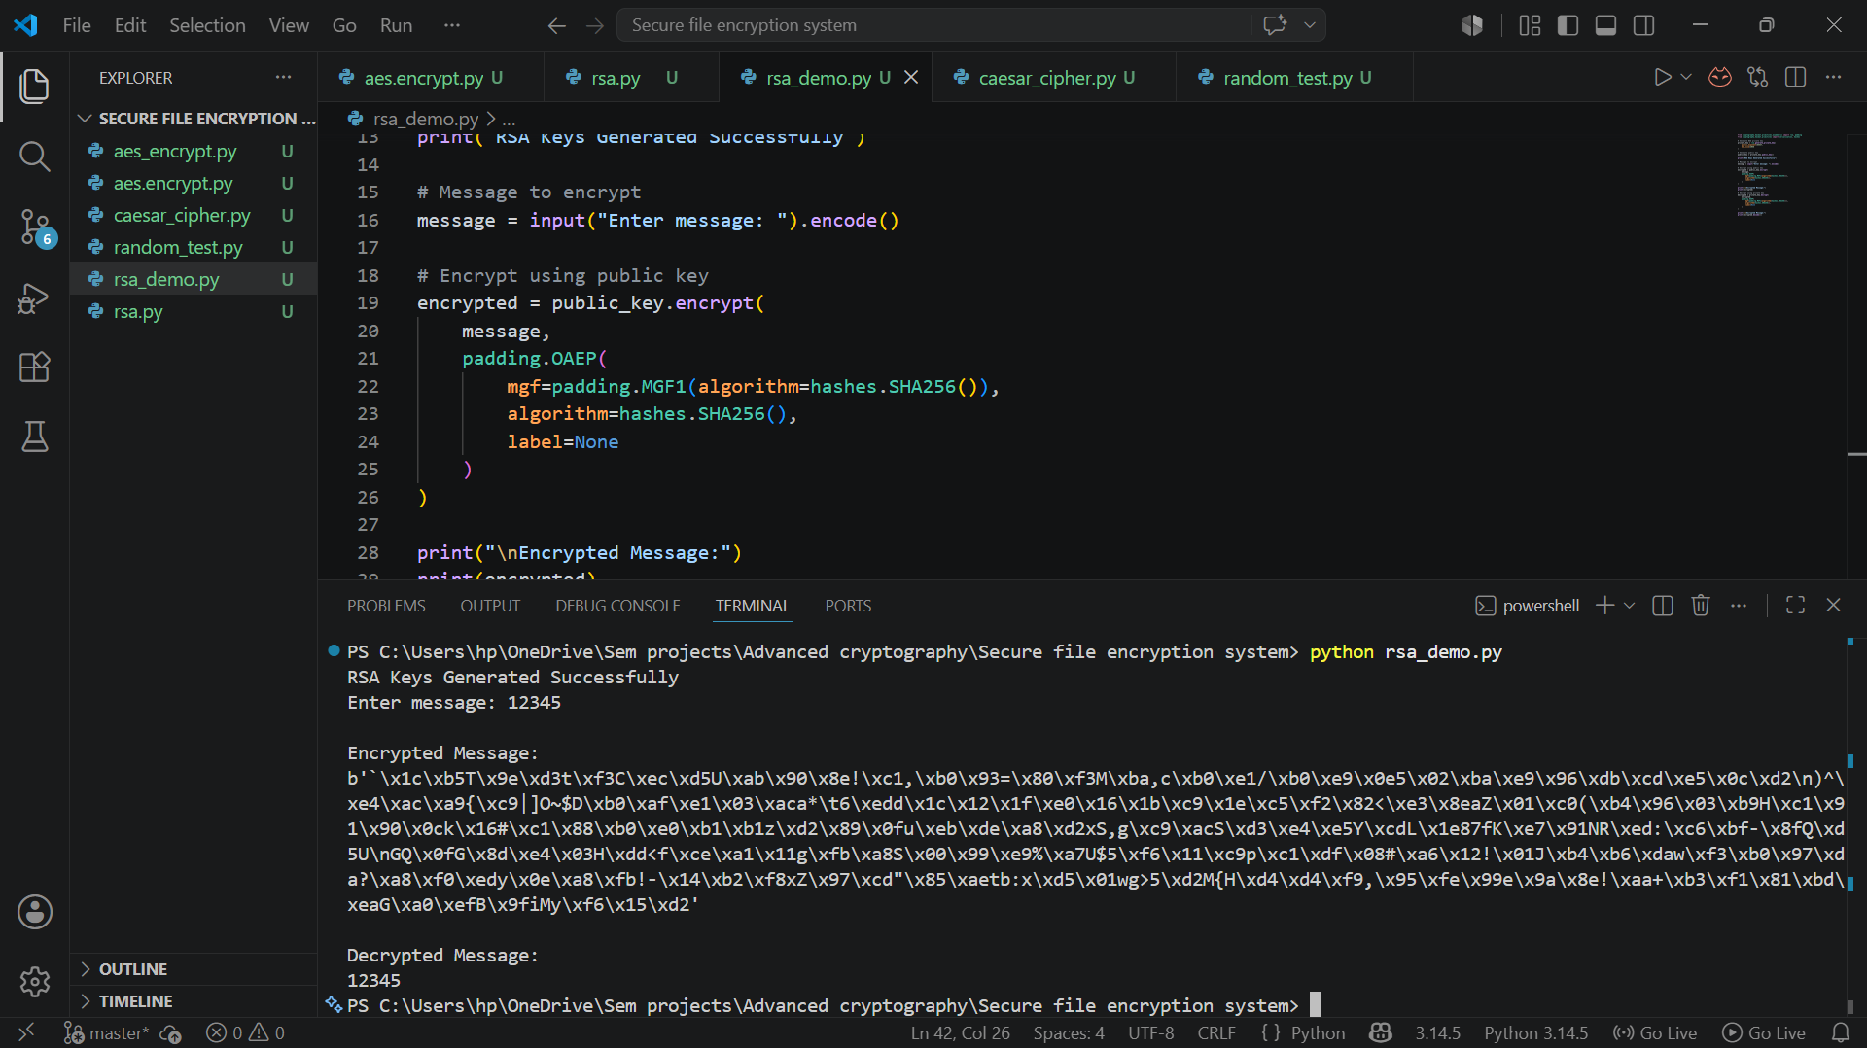
Fig 5.5 RSA encryption testing and validation using different plaintext messages

Reflection
This week I implemented RSA asymmetric encryption using public and private keys. I successfully encrypted and decrypted messages while understanding the importance of secure key management and asymmetric cryptography.

WEEK 6 – SYMMETRIC CIPHERS

SPN Python Program
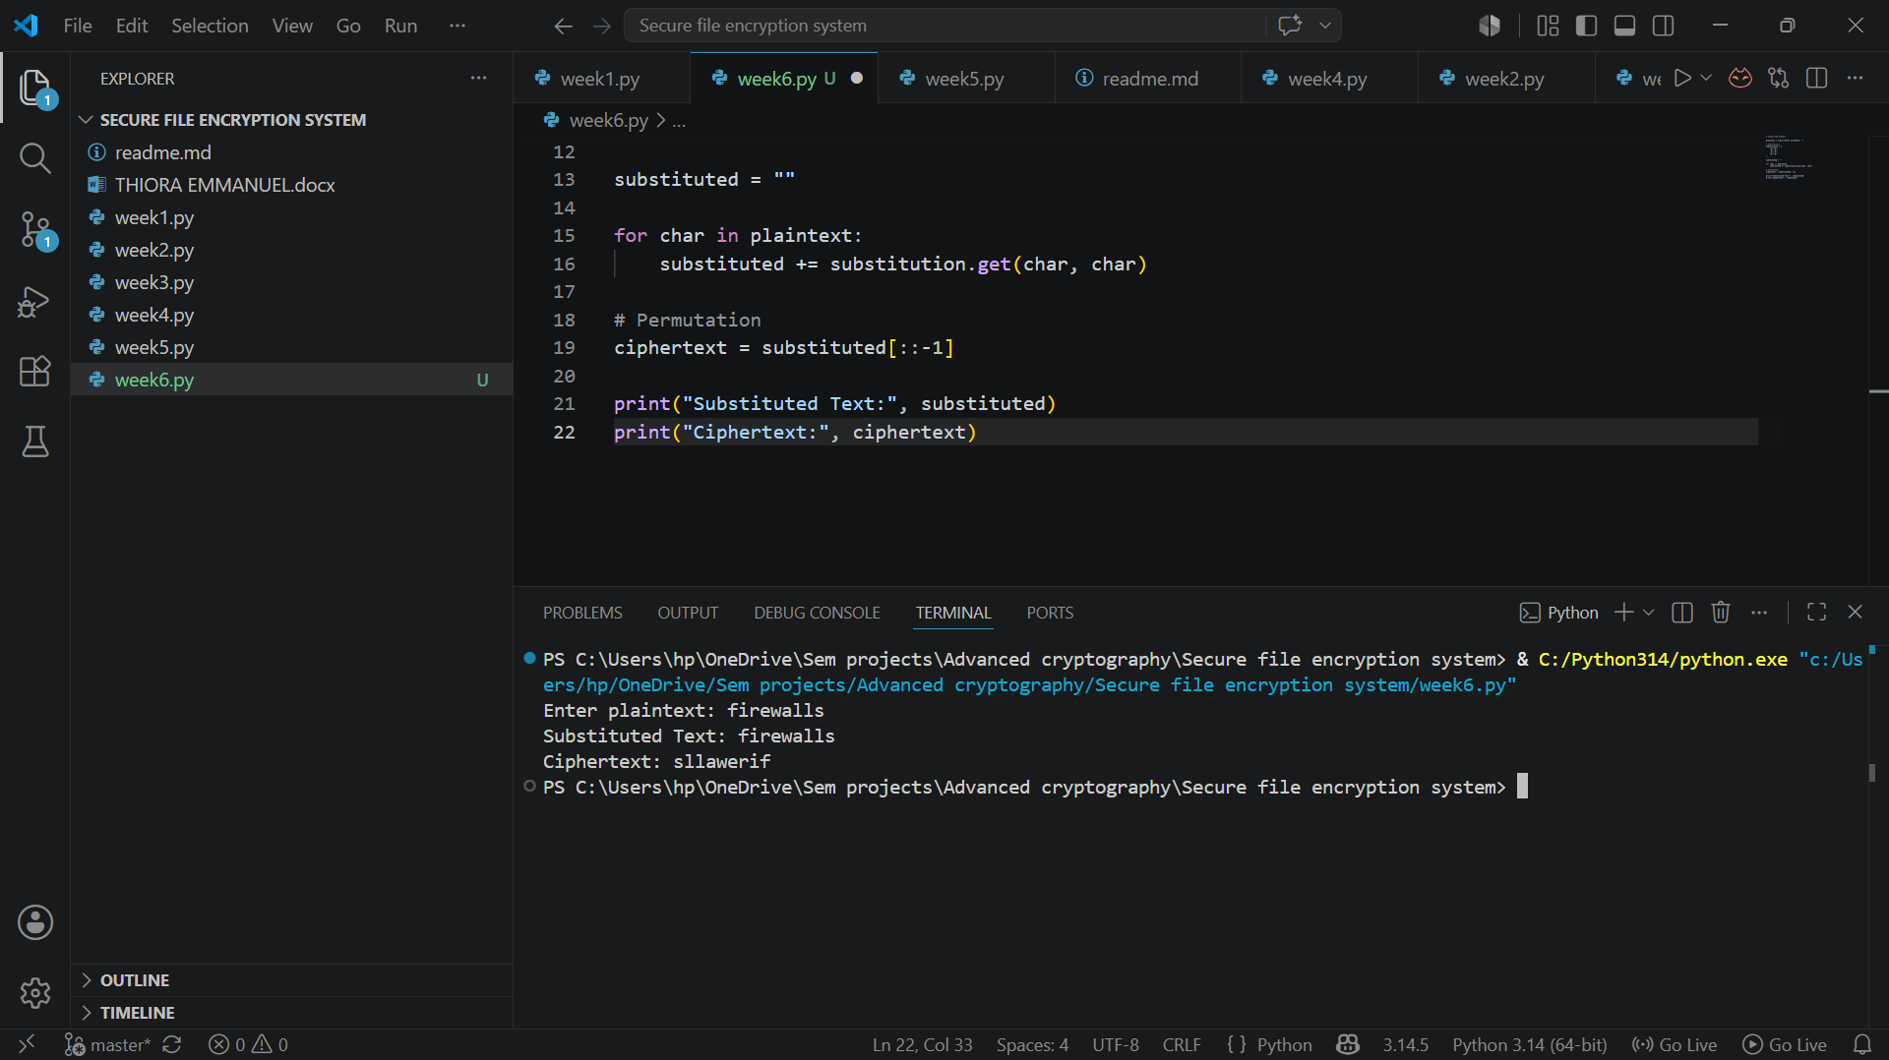

S-Box Analysis
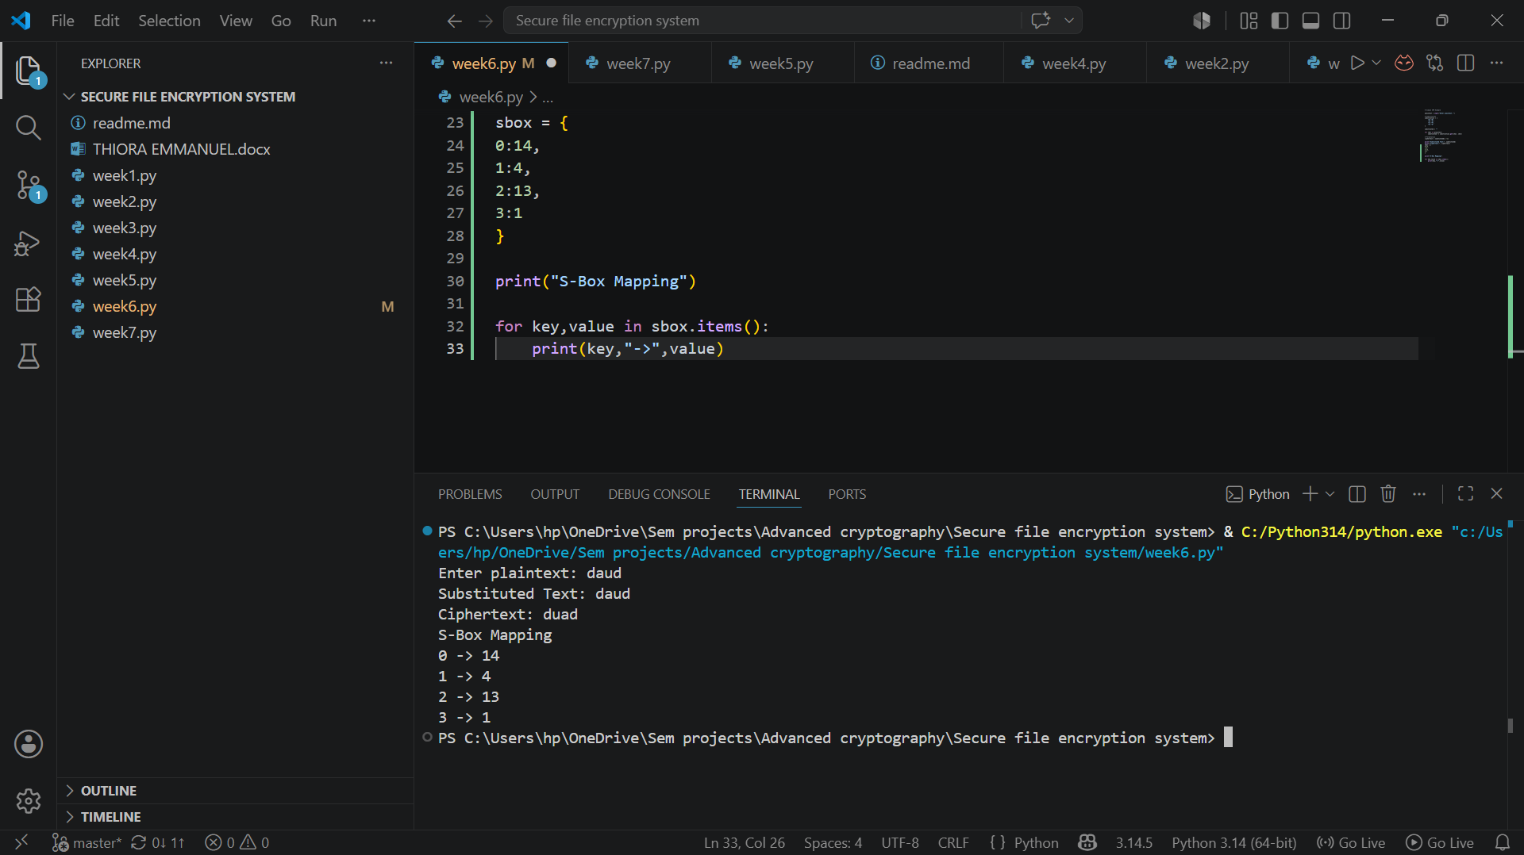

Feistel vs SPN Comparison
- Feistel splits data into two halves, while SPN uses the whole block.
- Feistel uses round functions, while SPN uses substitution and permutation.
- Feistel is easier to decrypt because it uses the same process, while SPN needs reverse operations.
- Feistel is used in DES, while SPN is used in AES.
- SPN is generally considered more secure and is widely used in modern encryption.
Both Feistel and SPN are secure encryption structures, but SPN is more common in modern systems because it provides stronger security.

Reflection
This week improved my understanding of modern block cipher design. I learned how substitution and permutation work together to provide security in encryption algorithms. The practical implementation of an SPN model helped me understand how AES uses similar concepts to achieve secure encryption.

WEEK 7 - BLOCK CIPHER CRYPTANALYSIS

Differential Cryptanalysis Simulation
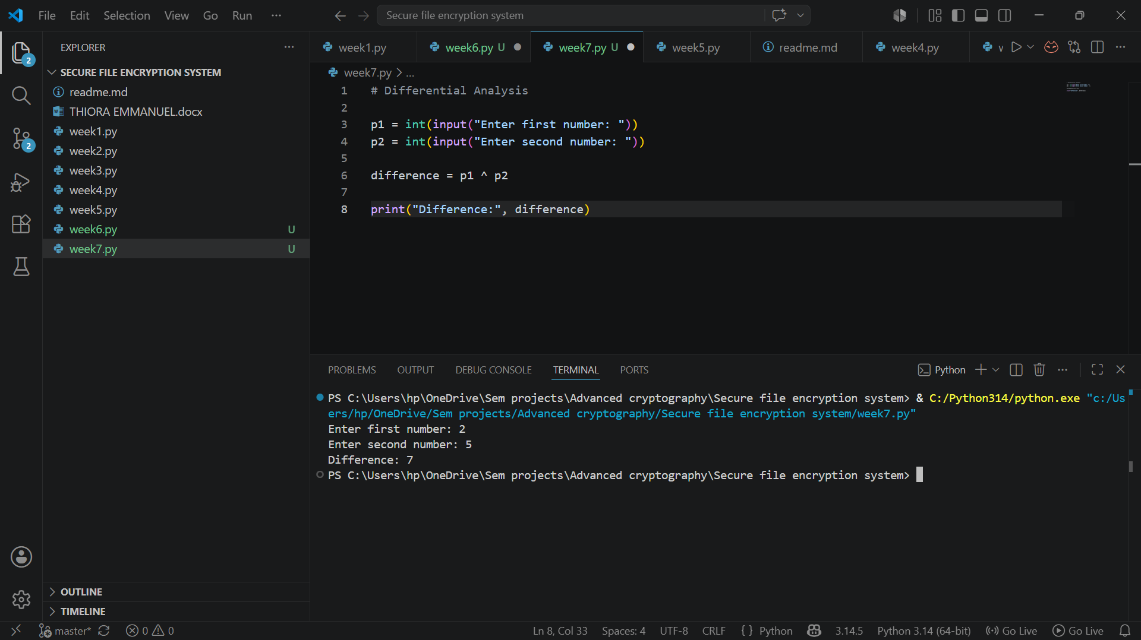

Algebraic Relationship Exploration
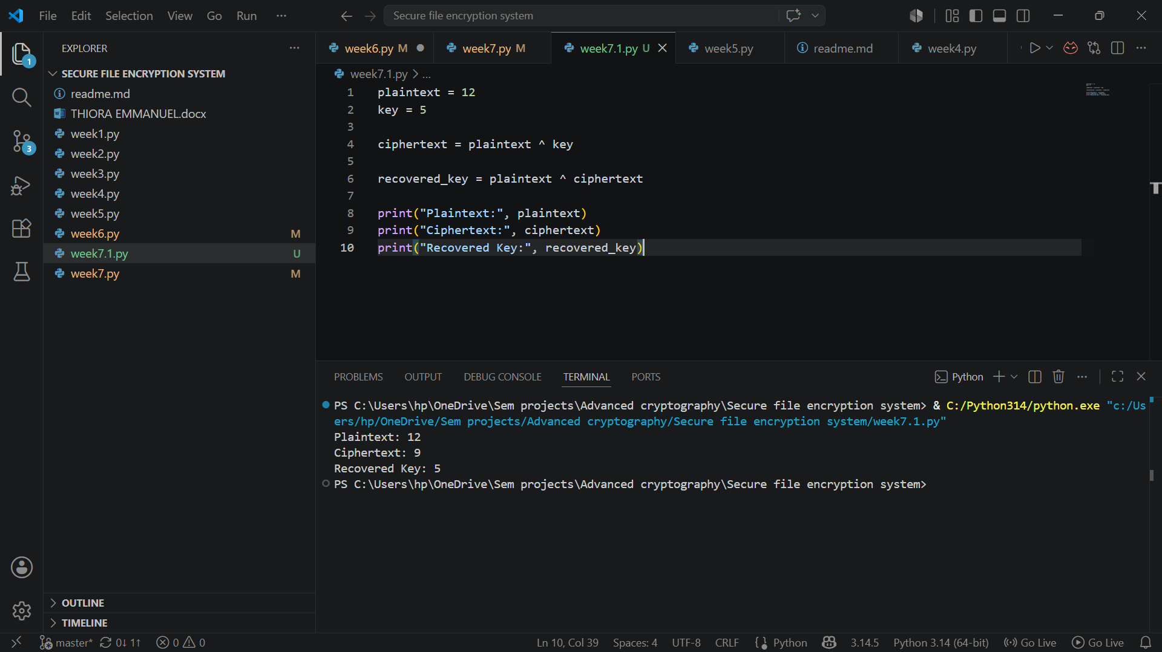

Frequency Analysis
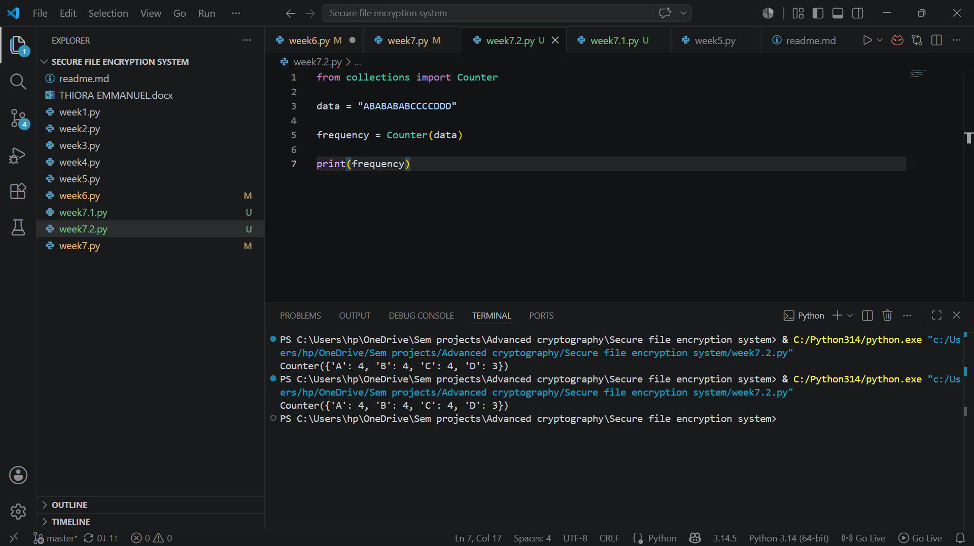

Reflection
This week I learned about cryptanalysis and how attackers analyze encryption systems. I studied differential, linear, and algebraic attacks and learned why AES remains secure. The activities improved my understanding of cryptographic security and attack prevention.

