Results

*#Pairwise Scatter plot: Pair plot*

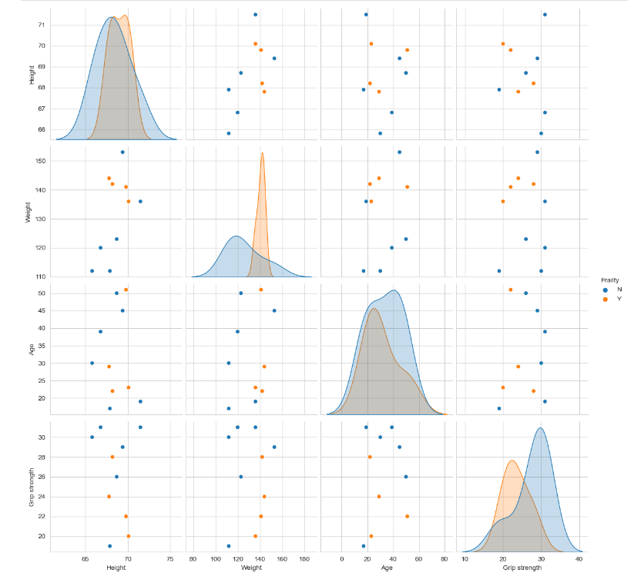

*#Observation: Here if we observe weight vs grip strength person with weight more than 135 and grip strength less than 30 are having Frailty Y*