**Results**

**1) Stacked bar chart**

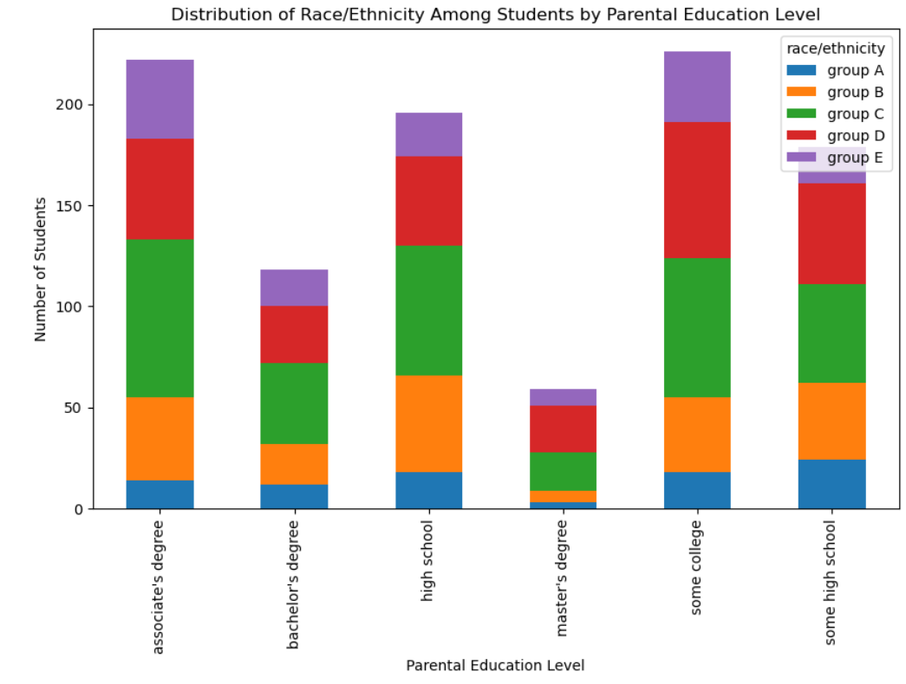

Observations:

#Students whose parental education is master’s degree is least and bachelor's degree is second least

#Group D parents has highest percentage of master’s degree compared to other groups

**2) Pie chart**

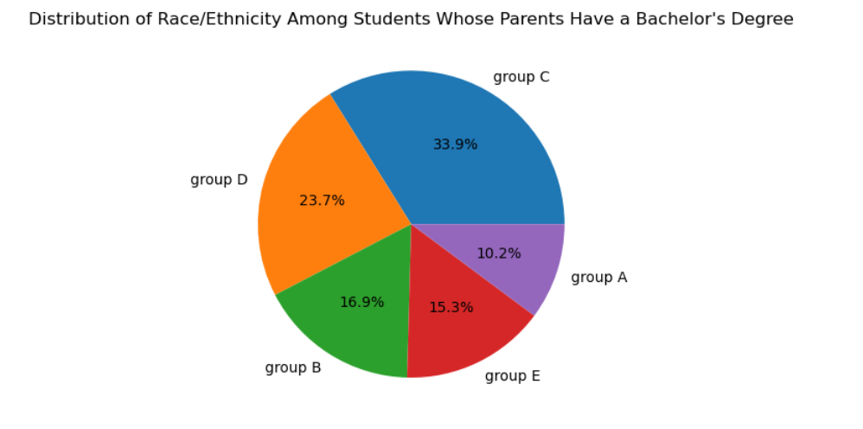

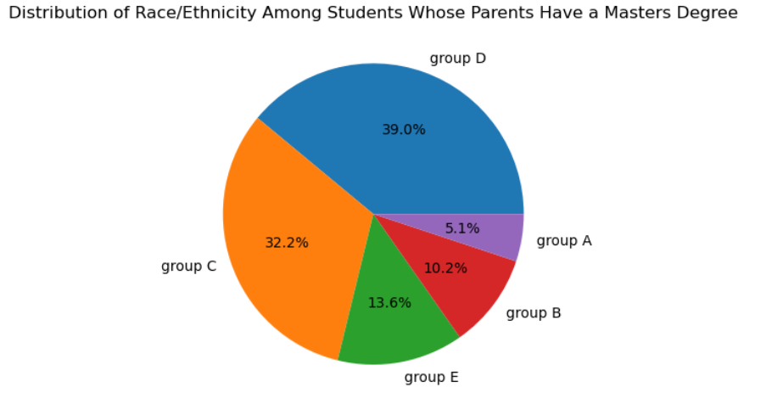

Observations

#Group D parents has highest percentage of master’s degree

# Group C parents has highest percentage of bachelor's degree

**3) Box Plot**

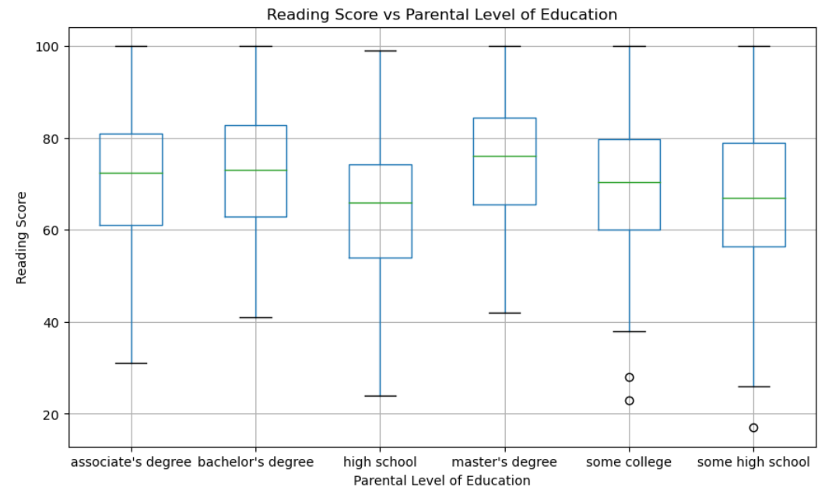

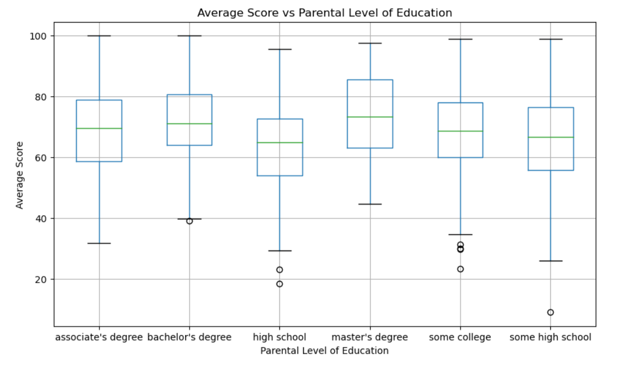

# Observation: The Reading Score of the students doesn't depend upon the Parental Level of Education

# Observation: The Average Score of the students whose Parental Level of Education is Masters is slightly higher compared to others

**4) Heat Map**

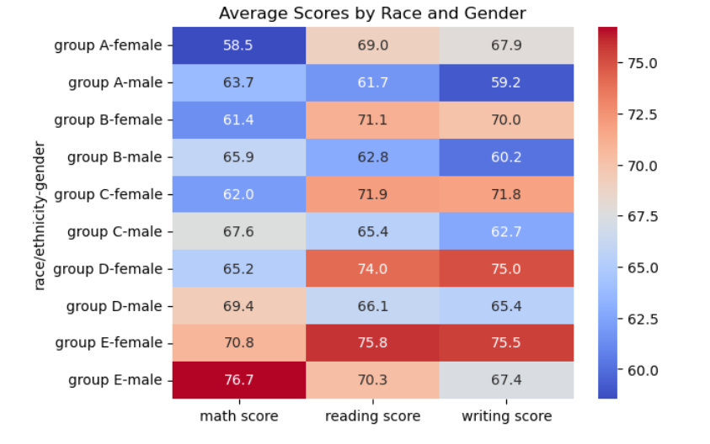

# Observation: The average Math Score is highest in Group E male and Group E female scored highest in Reading and Writing

**5) Stacked bar chart**

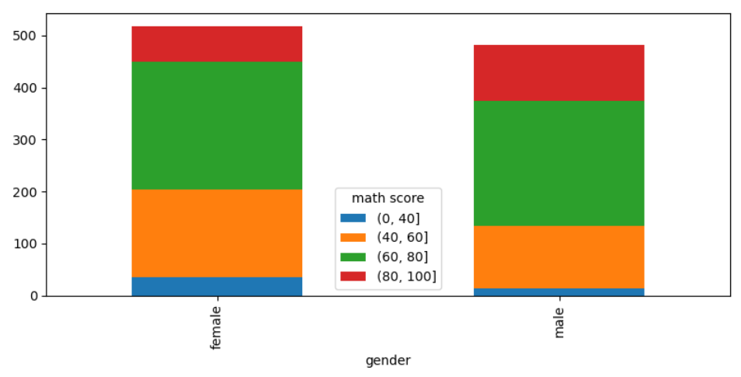

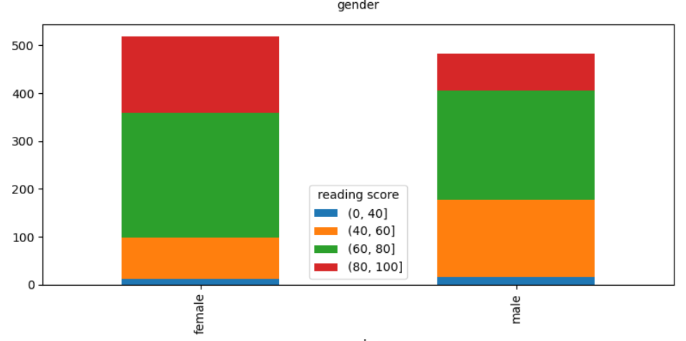

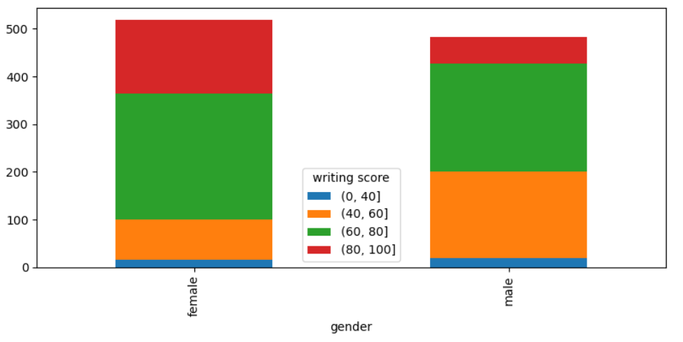

Observations: Most number of students (both male and Female) has Scored between 60-80 in Maths, Reading, Writing

***6*) Scatter plot**

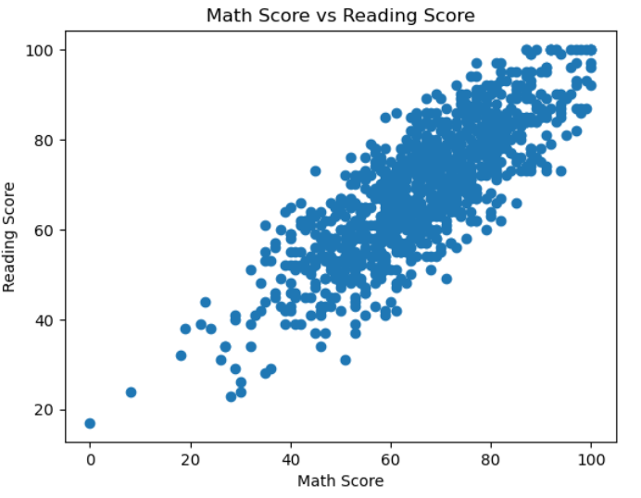

Observations: The student who scored well in maths has scored well in Reading also, the divergence of maths score and reading score is not huge

**7) Bar chart**

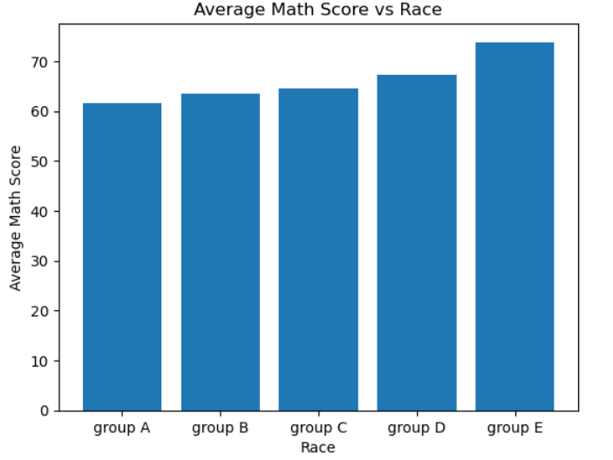

# Observation: The average Math Score of Group E students is highest among all the groups

**8) Pie Chart**

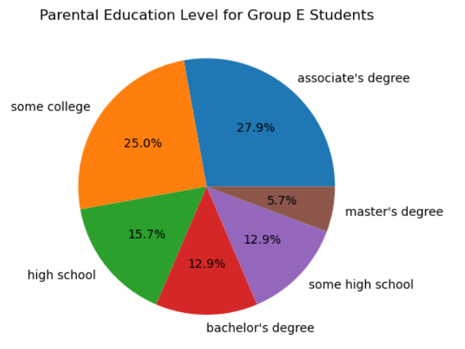

Observation:

Group E students average score is highest but only 5.7 percentage Group E parents having master’s degree