Results

1) Comparison of Glucose (Sample vs Population)

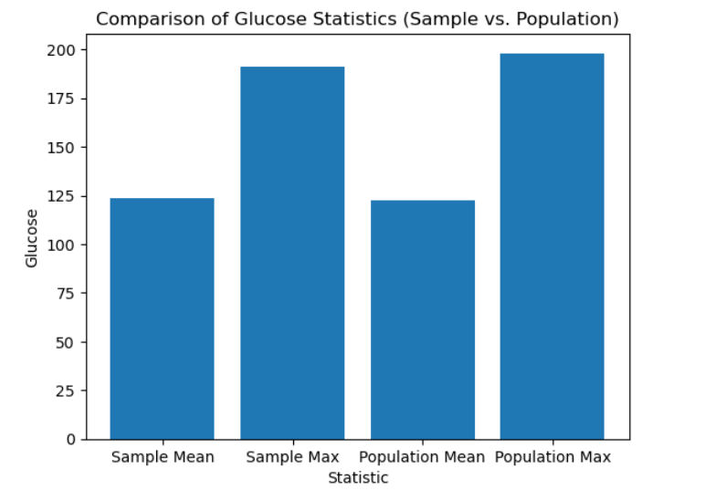

#Findings: The sample mean and population mean is almost similar and the highest glucose values of sample and population are almost equal

2) Comparison of 98th percentile of BMI (Sample vs Population)

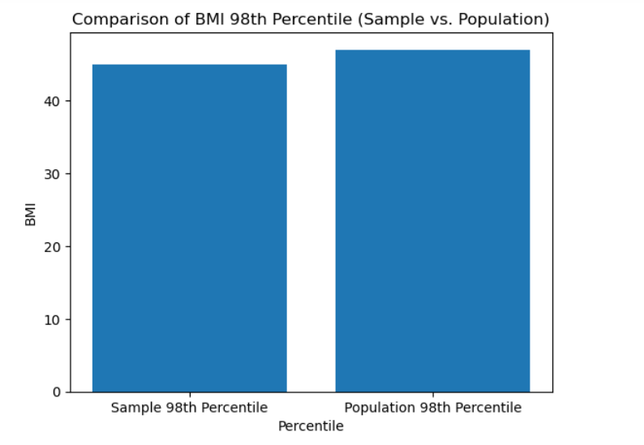

#Findings: The 98th percentile of BMI of sample and population are almost equal

3) Comparison of average mean, standard deviation and percentile (Sample vs Population)

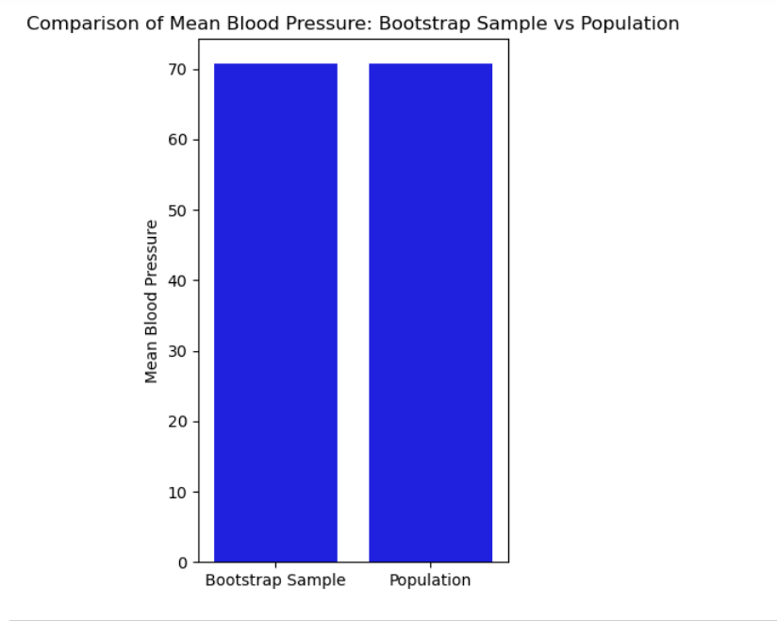

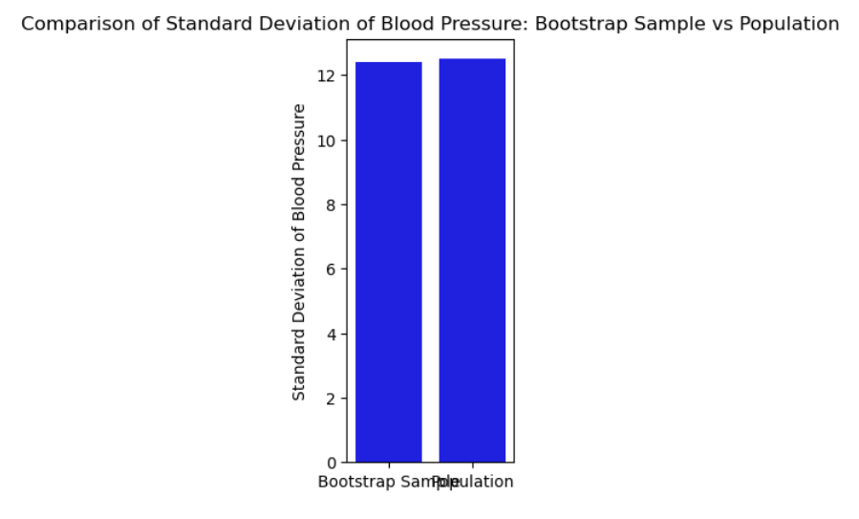

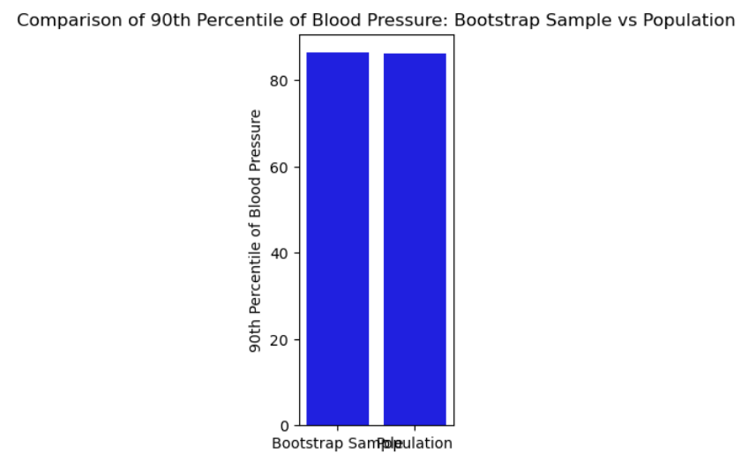

#Findings: Based on the findings from the comparison charts, we can observe that the statistics (mean, standard deviation, and percentile) calculated from the bootstrap samples are very close to the statistics calculated from the population for the Blood Pressure variable. This suggests that the bootstrap sampling is able to capture the variability in the population data and provide reliable estimates for the statistics of interest.