*# Tokenization*

*#a) Converting the text corpus into tokens.*

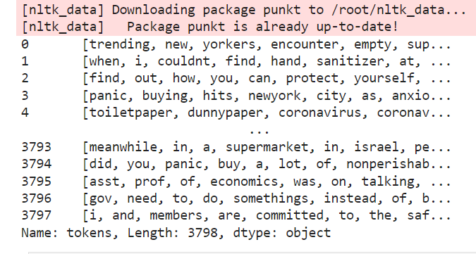

***# Stopword removal***

***#b) Performing stop word removal.***

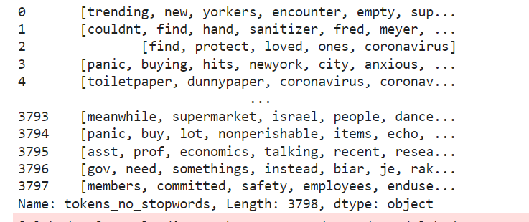

*# c) Counting word frequencies*

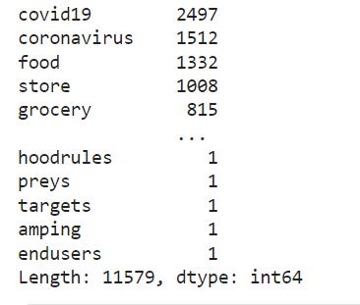

*# Create word cloud*

*#d) Creating word clouds.*

