Results

*#Pairwise Scatter plot: Pair plot*

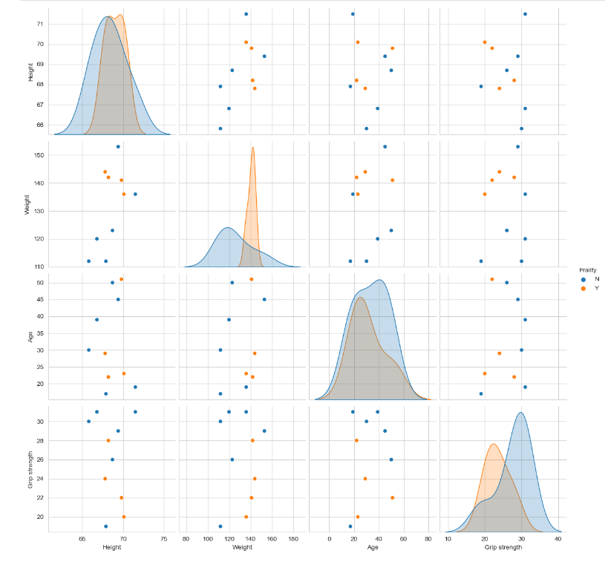

*#Observation: Here if we observe weight vs grip strength person with weight more than 135 and grip strength less than 30 are having Frailty Y*

**# Classification of Frailty based on Height**

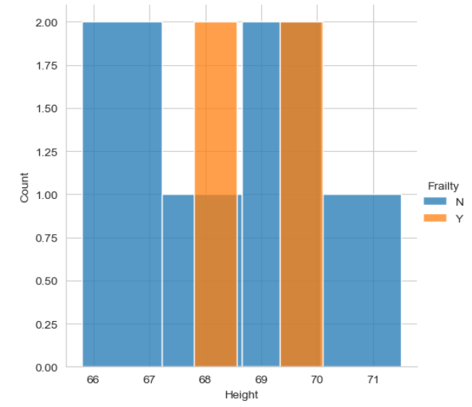

**# Classification of Frailty based on Weight**

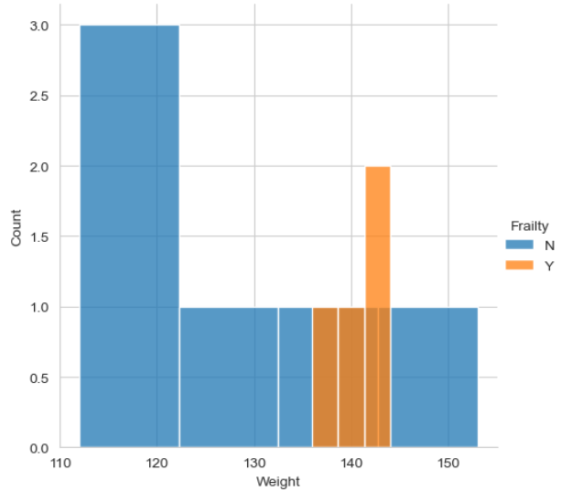

**# Classification of Frailty based on Age**

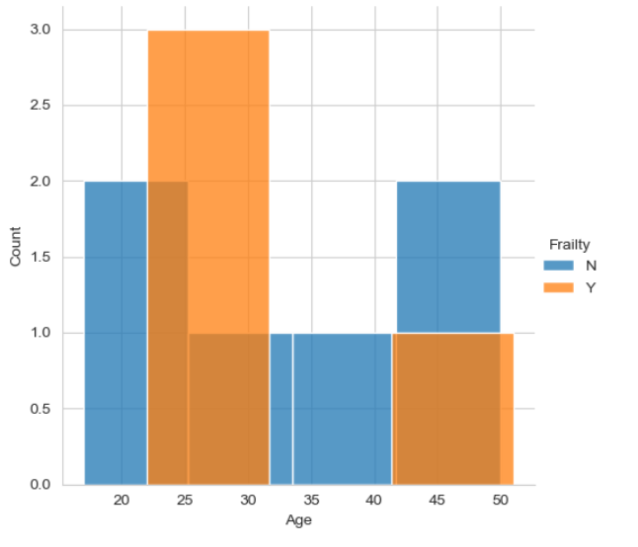

**#Scatter plot for Height vs Weight**

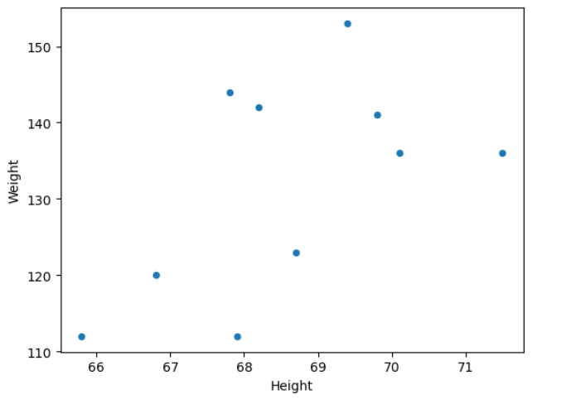

***# 2d scatter plot with legend as Frailty***

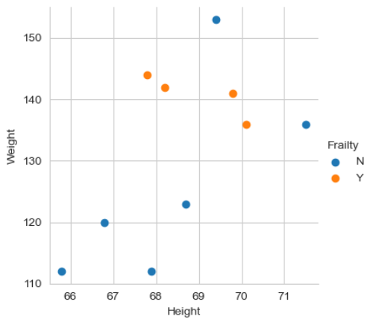

***# Observation: People whose weight is below 125 doesn’t have frailty***