2.2 Exercise - A baby bump is higher up; It's a girl!

Thip Rattanavilay, MS Data Science

Bellevue University

**Abstract**

Some people have long believed that the way someone's pregnant belly looks will determine the gender of their baby. And although the origins of this tale are unclear, some have suggested if your baby bump is higher up on your body, it means your baby will be a girl. The research article I have come across says, "high or low." There's also the belief that "carrying wide" indicates a girl, and "carrying narrow" means it's a boy (Layton, 2009) and another article from HuffPost Australia says otherwise. We will dive into this to understand their methodology to analyze their data.

**2.2 Exercise - A baby bump is higher up; It's a girl!**

Article from Health, How Stuff Works mentioned. So, if a woman is carrying both high and wide, that means it's a girl, right? It absolutely does 50 percent of the time (Layton, 2009). It turns out, the high/low method is just as accurate as pouring Drano into a cup of the woman's urine. Which is to say, not at all. Lots of people would swear by these methods, but when there's always a 50/50 chance of being right, you're going to find lots of correct predictions. While it's unclear why exactly the "old wives" believe the baby’s, gender determines the bump's position, it is perfectly clear what actually determines that position: muscles and body type. Basically, the tighter a woman's abdominal muscles (either due to age or fitness level), the higher the bump rides. An older woman or one who's had her abdominal muscles loosened by prior pregnancies will usually carry lower (Layton, 2009).

(Robin Elise Weiss, 2020)

**Facts over myths with data**

Professor Steve Robson, the vice president of the Royal Australian and New Zealand College of Obstetricians and Gynecologists, told HuffPost Australia that this isn't true. He explained that the way someone carries "has nothing to do with their [baby's] genitals and everything to do with the way the baby is lying in the uterus." The way a woman carries a baby has more to do with the size of the baby -- then the belly tends to pivot forward," Professor Robson said (Charleston, 2016).

**Methods**

First, second, and third trimester fetal ultrasound examinations were conducted between 2002 and 2012. The data was selected using the following criteria: routine examinations in uncomplicated singleton pregnancies, ethnicity, and confirmation of gestational age by a crown-rump length (CRL) measurement in the first trimester. Generalized Additive Model for Location, Scale and Shape (GAMLSS) was used to align the time frames of the longitudinal fetal measurements, corresponding with the methods of the postnatal growth curves of the WHO MGRS Group (I. Donald et al., 1970).

* One, the shape of your pregnant belly can tell you whether you're carrying a boy or a girl.
* two, your baby's heart rate can determine the sex of your baby.
* three, spicy foods can cause your baby to be born blind.
* Four, cocoa butter prevents stretch marks.
* six, you should eat for two when you're pregnant.
* seven, you cannot color your hair when you're pregnant because it will harm the baby.

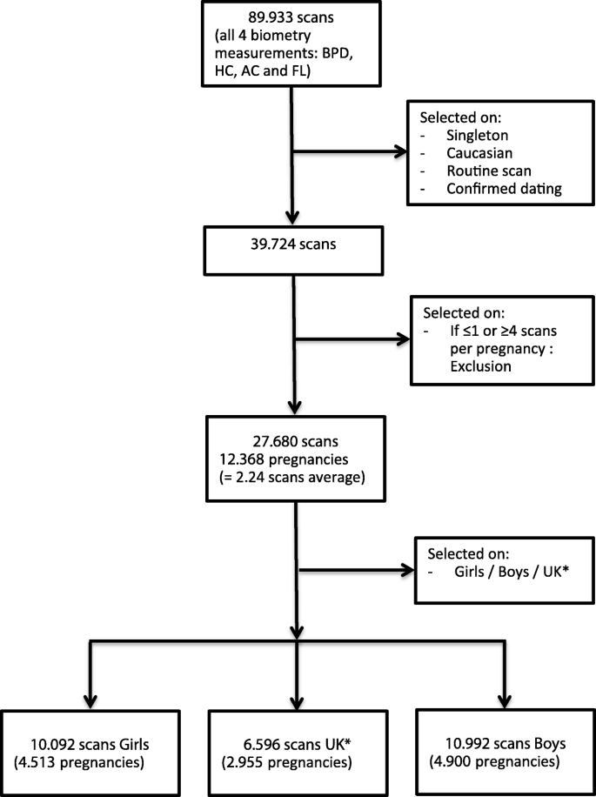

(I. Donald et al., 1970)

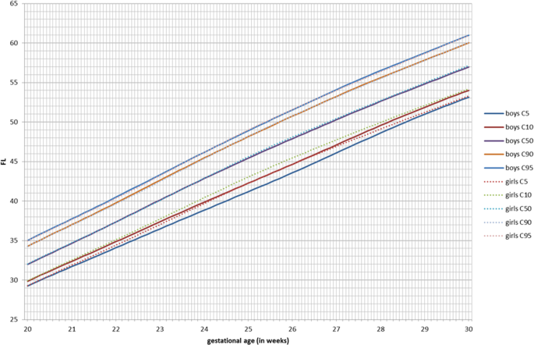

(I. Donald et al., 1970)

**Conclusion**

In my conclusion, data does provide facts and bust any myths that was shown here. The high baby bump was wrong for me. I totally thought I was having my third boy based on all the old wives tales, and my "intuition". With my third child I had a girl. Some weird people still insist it's a "boy bump", though I had the 3D ultrasound and there was definitely no boy. Much to our surprise and somewhat to our chagrin, our application of straightforward but standard scientific methods to investigate the validity of this ubiquitous pregnancy 'myth'" they put quotations around the word "myth", "resulted in its partial confirmation." Who knew? Pregnancy is still mystifying.

**Reference:** Layton, J. (2009, July 29). Can You Tell the Sex of a Baby by How the Mother Is Carrying? Retrieved September 12, 2020, from <https://health.howstuffworks.com/pregnancy-and-parenting/pregnancy/issues/carrying-boy-or-girl1.htm>

Charleston, L. (2016, July 15). How Your Body Looks During Pregnancy Has Nothing To Do With Your Baby's Gender. Retrieved September 12, 2020, from <https://www.huffingtonpost.com.au/2016/04/02/baby-pregnancy-gender_n_9588058.html>

Robin Elise Weiss, P. (2020, August 25). 5 Most Common Concerns About Your Pregnant Belly. Retrieved September 12, 2020, from <https://www.verywellfamily.com/concerns-about-your-pregnant-belly-2759765>

I. Donald, J., Campbell, S., R. Napolitano, J., JM. Lary, L., JF. Rogers, W., DJ. Bekedam, S., . . . AT. Papageorghiou, E. (1970, January 01). Sex differences in fetal growth and immediate birth outcomes in a low-risk Caucasian population. Retrieved September 12, 2020, from https://bsd.biomedcentral.com/articles/10.1186/s13293-019-0261-7

Which Pregnancy Myths Are Actually True? (n.d.). Retrieved September 12, 2020, from <https://healthcare.utah.edu/the-scope/shows.php?shows=0_qtd1io6q>