Lending Analytics Design
  - Personal Loan: data platform, data model and decision log. October 2026

1. The current design: four services, four databases
Four services, three teams, four MySQL databases. The services talk over REST and Kafka, and every cross-service join used to happen in application code. Now it happens in the data platform.
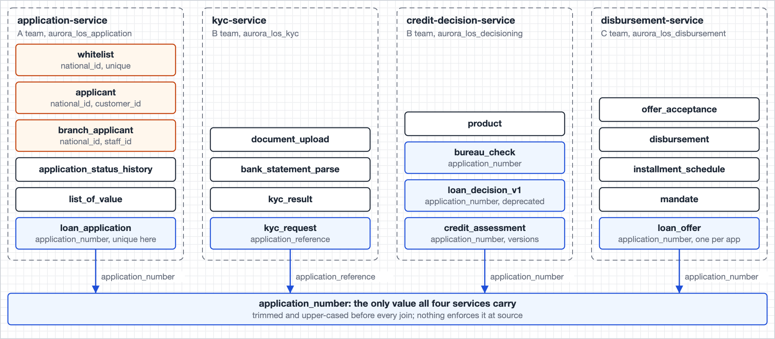
Image 1. The four source databases. The application number is the only value all four carry, under two column names, and nothing enforces it.

1.1 The four questions
Question | What it asks
Q1 | Of applications submitted in a month, what share reached FUNDED within 14 days, by channel, and why did the rest not fund? Answered in 4.1.
Q2 | For any application number, reconstruct the exact inputs the credit engine saw at decision time, even if the sources have since changed. Answered in 4.2.
Q3 | Each morning, the offers expiring in the next 24 hours that are not yet accepted, plus the offers that expired without action in the past 7 days. Answered in 4.3.
Q4 | Prove to a regulator that PII was masked before any analyst accessed the data for the funnel report in a quarter. Answered in 4.4.

2. Pipeline design

2.1 Architecture
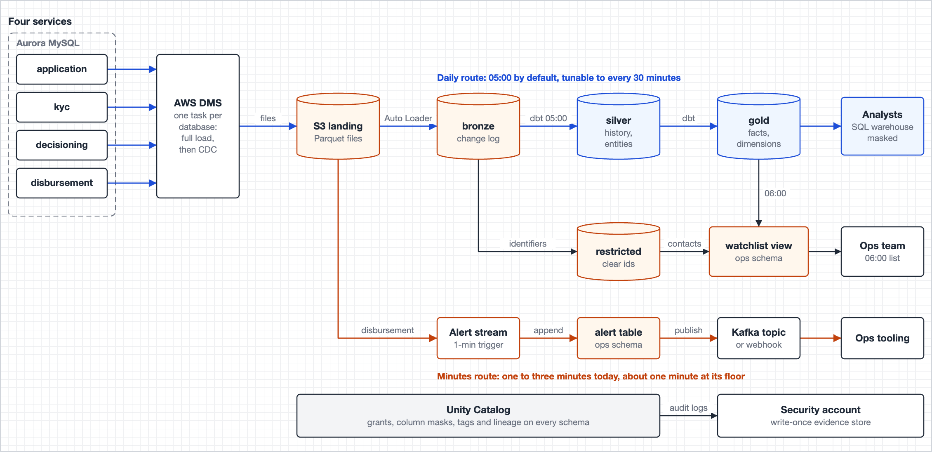
Image 2. One capture path feeds both the daily build and the alert stream, so the two cannot disagree about what happened. Clear identifiers (orange) stay in landing, Bronze and the restricted schema.
Each component below shows what I chose, why, what it costs, and the options I weighed against it, including a lower-latency route built on Debezium, Kafka and Flink. Two tests settled most rows: does any question need the extra speed, and does the option add another place where personal data has to be governed and evidenced for Q4.

2.2 Components
Component | Choice | Why | Considered, not chosen
Change capture | AWS DMS, one task per database: a full load, then ongoing replication from each cluster's writer. | In the brief's stack, listed beside Kafka; the choice here: where changes land, not DMS vs Kafka  Source commit time on every change row; the full load gives every row its first value  Managed service: no connector workers, offsets or schema registry to run  One-minute files cover the only need measured in minutes  MySQL TEXT columns arrive as plain strings, so DMS's large-object size limit cannot truncate risk_flags or the JSON blobs; a source change to MEDIUMTEXT, LONGTEXT or JSON is caught by the source contract  Cost: row-based binlog with full row images and 72-hour retention on each production writer, plus a replication user; DMS cannot read Aurora's enhanced binlog | Debezium on MSK Connect, with a schema registry  Seconds of latency; no question needs them  Connect workers, offsets and the registry to operate and patch  Full row images with PII held in Kafka topics: one more store inside the Q4 evidence  Lakeflow Connect MySQL CDC  Beta as of July 2026  Revisit at general availability; Bronze stays the same  The services' existing Kafka CDC topics  Exist (brief, section 3). Reuse: no extra binlog reader, no change on four production writers. Strongest case against DMS  Not described: tables carried; full row images; deletes; commit time; in-commit order; compaction; retention. Any one missing: no history for Silver  No first value past retention; snapshot still needed  Capture owned by three teams' connectors: every message consumed, not every change captured  Decision: DMS until owners confirm the six criteria (open question 2). Then Bronze reads the topics, S3 stays the archive, nothing downstream changes. Four approvals and one binlog reader per writer: the price of owning capture for Q1 and Q2 until then
Landing | S3, Parquet, one prefix per table, KMS-encrypted, kept to the regulatory horizon in colder storage after 30 days. | DMS's native target; no extra hop  Replay copy: Bronze rebuilds without touching the sources  Bucket policy: only DMS writes; only the catalog's ingestion and stream principals read  Cost: a second raw copy of personal data, kept to the horizon; every read is recorded as an S3 data event in the evidence store | Kafka (MSK) as the landing buffer  New topics with full row images: one more store of clear identifiers to grant, rotate and evidence for Q4. Existing topics add none; hence the fallback above  MSK: no per-read data-plane audit. S3 data events: every landing read, in the Q4 pack  Tiered storage: long retention cheap, but under the topic owner's retention setting. S3 copy: written by DMS, read-only to the platform; no platform defect or config change shortens it  Glue tables over landing, queried with Athena  Readable with IAM alone, outside Unity Catalog grants and its audit log  A second catalog to keep in step
Bronze | One Lakeflow pipeline (formerly Delta Live Tables) of Auto Loader streaming tables, continuous; append-only, with full refresh blocked. | Each file lands within a minute: alert lookups and the 06:00 acceptance check read it  Append-only, refresh blocked: a pipeline change cannot rewrite history  New columns added and changed types rescued; no row dropped  Same engine and catalog as every later layer  Cost: one pipeline running around the clock | Triggered runs every few minutes  Alert lookups up to one interval behind  More disbursement checks left to the next-morning backstop  Delta time travel as the history  Databricks advises against table history as a long-term archive  Log retention and VACUUM cut it short
Silver and Gold | One dbt Core project on a SQL warehouse: every model rebuilt from Bronze, except the written-once records, which are only appended. This is the daily route: 05:00 by default, tunable to every 30 minutes. | Daily by default: the business teams work on daily and monthly numbers; funnel cohorts close after 14 days and stage rates after 30  Tunable to every 30 minutes for intraday figures: incremental runs in the day, the full rebuild at night  A fix reaches all of history the next morning  Volume small enough to rebuild in full each day: thousands of applications a day  One place for the identifier boundary, masks and erasure  Masks and tags declared in each model file, reviewed with it  Seeds hold the versioned mappings; unit tests hold the edge cases  Cost: dbt is outside the brief's stack; it runs on the same SQL warehouse and catalog, so it adds no new engine or data store to govern | AUTO CDC SCD2 in a continuous pipeline (formerly APPLY CHANGES)  Identifier boundary and erasure split across two tools  Minute-fresh history that no question reads  Streaming Silver and Gold, one to four minutes fresh  No question needs Gold more than once a day  14-day cohorts gain nothing from minutes  Always-on compute and small files for no reader  AWS Glue jobs  Second engine and second lineage graph beside Unity Catalog  Same Spark underneath, without dbt's tests, seeds and review
Orchestration | Lakeflow Jobs: the pipeline, dbt, the stream and the governance jobs, each running as its own service principal, defined in bundles. | One scheduler for every job, in the same workspace and catalog  Every run in the audit log under its own service principal  Dependencies and the 01:00, 05:00 and 06:00 schedule in code | AWS Glue workflows (named in the brief's stack)  Second scheduler outside the workspace  Run history and lineage split across two consoles  Amazon MWAA (Airflow)  Another service to run and secure for a handful of jobs  Databricks credentials held outside the workspace
Stream | One Structured Streaming job on the disbursement change files, one-minute trigger. This is the minutes route. | One need in minutes: a failed disbursement, money moving after a decline  Reads the same landing files as Bronze: the stream and the daily build cannot disagree  Target: under five minutes end to end; about one minute at its floor  The daily build re-tests every disbursement as a backstop  Cost: one job running around the clock for one kind of alert | Amazon Managed Service for Apache Flink  Seconds of latency where ops acts in minutes  Second engine outside Unity Catalog: access, lineage and audit governed separately  New skill set and on-call surface for one alert  Spark real-time mode  Delta not supported as a source or sink: the alert table cannot be the outbox  Built for sub-second latency nobody here needs  DMS to Kafka for the stream  Second capture path for one table  One-minute files already give minutes
Alert delivery | Each alert is recorded in ops.disbursement_alert first; a second stream reads that table as an outbox and sends each alert to ops tooling: a Kafka topic or the incident tool's webhook, whichever ops confirms. | Record first: a crash or an outage never loses an alert  Deterministic alert id: a replay sends the same id, and the receiver drops the duplicate  The target can change without touching the alert table | Webhook push before recording  Endpoint down: the stream stalls, or the alert is lost with no record  Kafka as a fixed choice  Not yet confirmed that ops tooling reads Kafka  A bridge to the incident tool that someone has to build and run
Serving | A SQL warehouse over certified Gold tables; one ops view; one compliance schema. | One engine, one catalog, one audit log: Q4 evidence comes from one place  Masks fire per query for whoever runs it, through views too  BI tools connect as the viewer; no extracts of masked columns | A real-time ops store (ClickHouse, StarRocks or Postgres)  A third copy of the data with its own access control and audit  Outside the Q4 evidence  No question needs seconds  An online feature store for the credit engine (DynamoDB or Redis)  The platform sits downstream of decisions (assumption 2)  If that changes, the decision input record snapshots the served value  Contacts looked up by the ops tool in the application service  A second integration in the ops tool for one list  Contact reads leave the platform's audit log
PII protection | Direct identifiers dropped at the Silver boundary; person key from one HMAC function only the transform job can run; a mask on every sensitive column, written into each table's create statement. | No analyst-readable table ever holds a direct identifier  Masks fire per query: a row that landed a minute ago is covered like one from last year  Only the transform job can compute a person key for a given national id  CI fails a pull request that drops a mask or leaves a column untagged | Tag-driven ABAC mask policies (GA since April 2026)  A second place where masking is decided, beside the masks declared with each model  Tokenising PII in a Kafka Connect transform  Needs Kafka and Connect, which nothing else needs  HMAC key on Connect workers, outside the catalog's custody  Compliance and ops still need clear values: a vault and a decrypt path anyway  Unkeyed SHA-256, or a token vault  SHA-256 alone: a small, structured id space can be enumerated  Token vault: the mapping table is a second store of clear identifiers to guard, back up, erase and evidence, and a lookup in every build  Masked copies written by a job, one per audience  Governance surface and audit scope multiply  A policy change misses copies already written  Per-person keys, shredded on erasure  Key store indexed by person: itself a store of identifiers  Bridge delete plus vacuum already erases within seven days  Matching people on name and mobile number, or adding the ID type to the key  Name matching widens the use of personal data; the published split count shows the size of the problem first  No source column holds the ID type (open question 3)
Audit evidence | Audit logs and S3 data events delivered to a write-once bucket (Object Lock, compliance mode) in a security-owned account; daily snapshots, probe results and run lineage exported there. | The platform can add evidence but cannot change or delete it  Kept to at least 2028-08, beyond the catalog's one-year audit table  Evidence collected daily, ready before a regulator asks | system.access.audit as the evidence  365-day retention  Held by the same platform being audited  An evidence bucket in the platform's own account  Platform admins control its policy and future retention
Deployment | Declarative Automation Bundles (formerly Databricks Asset Bundles) for the pipeline, jobs and dbt; Terraform for DMS, S3, IAM and KMS. | Everything is code, deployed through review  One definition per environment: dev, test and prod  A console change shows up as drift the next morning | Terraform for the Databricks jobs and pipelines too  Job definitions kept apart from the code they run; bundles deploy both together

2.3 Near-real-time stream
- None of the questions needs Gold more than once a day.
- One thing does need minutes: a failed disbursement, because a customer is waiting for money.
- The same stream catches the most serious disagreement in the design: money moving on an application whose latest decision is DECLINED.
- One stream runs today. The pattern scales to more real-time streams as needed: each new stream reads the same landing files and writes to its own outbox table.
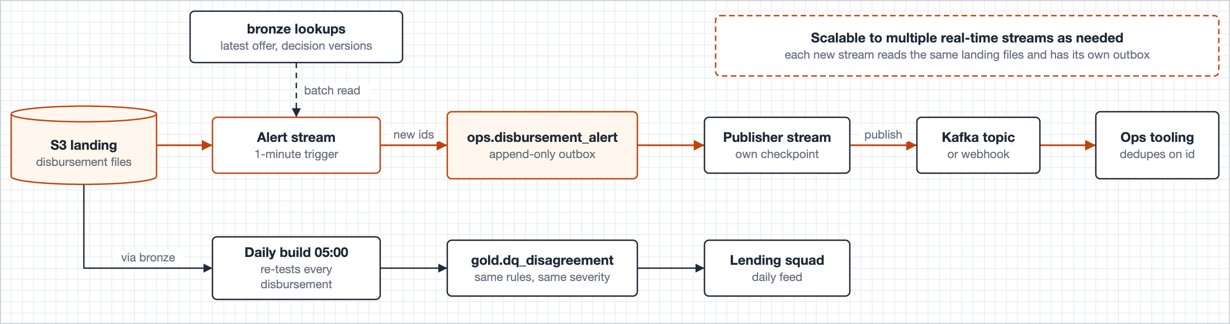
Image 3. The alert table is also the outbox: every alert is recorded before a second stream sends it on, so a crash between the two never loses an alert. Kafka is shown as the target until ops confirms what its tooling reads. The daily build re-tests every disbursement as a backstop.

How the stream works
Topic | How it works
Latency | One-minute DMS files plus a one-minute trigger: typically one to three minutes, inside the five-minute target. Shorter file and trigger intervals bring it down to about a minute
Delivery | Each alert id is built from the disbursement id, change sequence and rule, so a replay produces the same id. Alerts are recorded before they are sent and are sent at least once; the receiver drops duplicates by id. Where alerts go is for ops to confirm: a Kafka topic if their tooling reads one, otherwise a small sender that posts to the incident tool's webhook, using the alert id as the de-duplication key and retrying until it succeeds
Backstop | A decision and a disbursement can reach the platform minutes apart. The daily build re-tests every disbursement for both rules, so anything the stream misses is caught by the next morning
Health | The stream writes a heartbeat each time it checks for work, so a quiet night is not mistaken for a fault. Ten minutes without one, or a DMS latency alarm, pages the platform

2.4 Change capture
- Bronze is an append-only log: one table per source table, under its source name, holding the source columns as delivered plus the capture columns listed under Bronze.
- Nothing in Bronze is updated or deleted, and it is never vacuumed below the regulatory horizon.
- Silver turns the log into history: one row per captured version, valid from its commit time until the next version's. A delete closes the last version.
- Every as-of read in the design, from the first submission time to the decision inputs, uses the same predicate on these history tables.
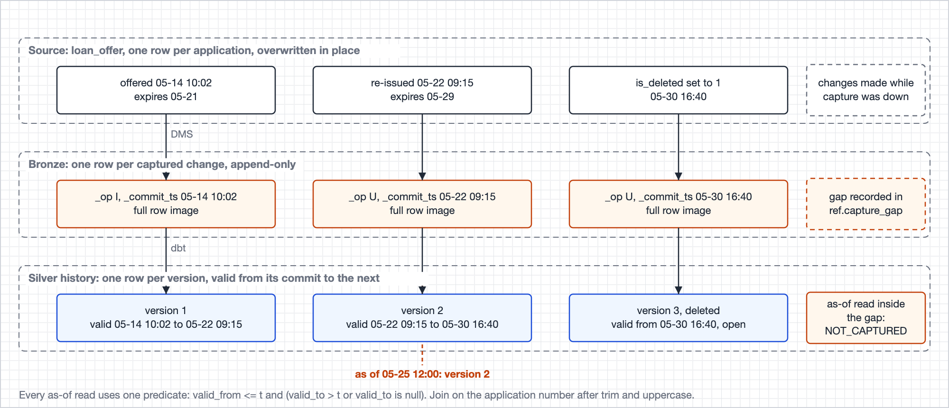
Image 4. One loan_offer row re-issued and then soft-deleted becomes three Bronze rows and three Silver versions. A read as of any instant picks one version; a read inside a capture gap says so.
Two failure modes are handled by design:
- Capture gaps. A task stopped for longer than binlog retention (72 hours) restarts from a new full load, and the changes in between are lost.
- The reload opens a gap in ref.capture_gap automatically.
- An as-of read inside a gap returns NOT_CAPTURED instead of a guess.
- A cohort whose windows overlap a gap freezes as HELD, with the gap on the row.
- The funnel starts at the first month with no gap.
- Schema change. A new source column lands in Bronze automatically and reaches Silver only when the source contract names it.
- A contracted column that disappears or changes type fails the run. By design, this is the only hard failure in the pipeline.
- An unknown enum value fails nothing: it becomes UNMAPPED, still sums, and is published as a contract violation.

3. Data model

3.1 Layers at a glance
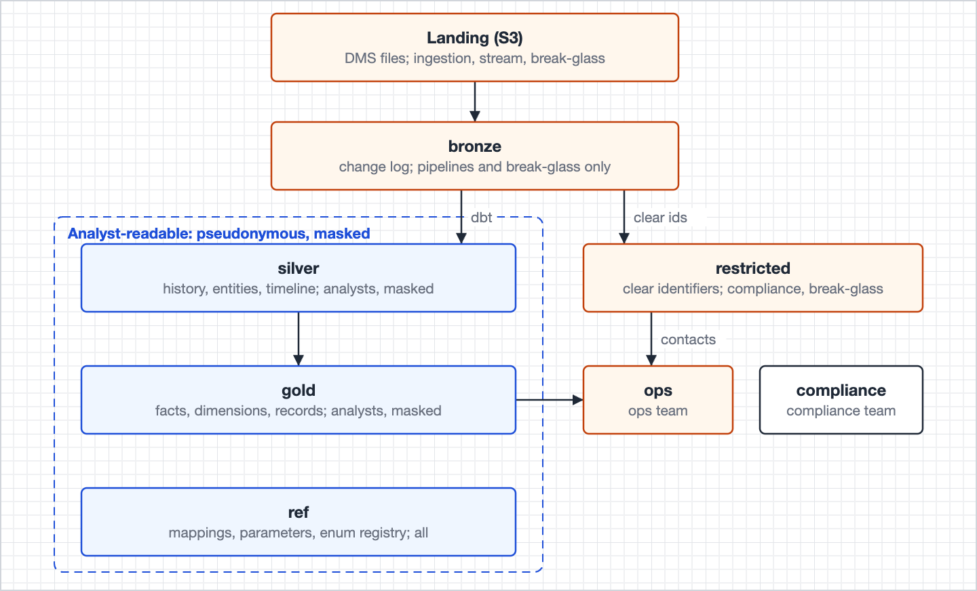
Image 5. Each layer has one job and one set of readers. Analysts read Silver, Gold and ref, all pseudonymous; clear identifiers sit only in landing, Bronze and restricted.
"Analysts" means every business reader: Product, Sales, Marketing, Risk, the Lending squad and the source teams.

What each schema holds and who reads it
Schema | Holds | Written | Read by
Landing (S3) | DMS files, clear identifiers | Continuously, by DMS | Ingestion and stream principals; break-glass
bronze | The change log, raw identifiers and blobs | Continuously | Pipelines; break-glass
silver | History per source table, conformed entities, the timeline, the person bridge | Rebuilt daily | Analysts (pseudonymous, masked); compliance
restricted | Clear identifiers per application, staff ids, erasure requests | Rebuilt daily | Compliance; break-glass; ops through one view
gold | Facts and dimensions, the metrics over them, decision records, watchlist snapshots | Daily; some tables append-only | Analysts; compliance
ops | Today's watchlist, disbursement alerts | Daily and streaming | Ops; compliance
compliance | Snapshots, probe results, lineage, the Q4 views | Daily | Compliance
ref | Enum registry, mappings, parameters, capture gaps | On merge | Analysts, ops, compliance
governance | Mask functions and the person key function | On merge | Masks apply through the tables they protect; only the transform job can run the person key function

3.2 Bronze
Nineteen tables, one per source table under its source name; the names are unique across the four databases.
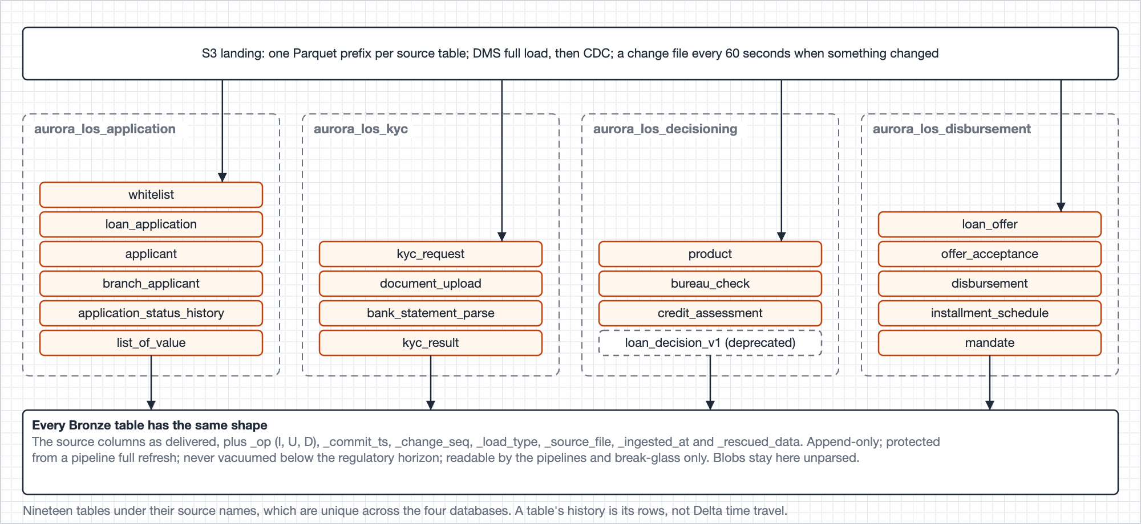
Image 6. Bronze. Landing files stream into one change-log table per source table; every table has the same shape, so one macro can build Silver from all nineteen.
Object | Grain | Write | Used for | Carries
whitelist, loan_application, applicant, branch_applicant, application_status_history, list_of_value | One row per captured change to a source row | Append-only, from the application database | Rebuilding Silver history; replay after a rule change; break-glass reads | The source columns as delivered, plus the seven capture columns below
kyc_request, document_upload, bank_statement_parse, kyc_result | Same | Append-only, from the KYC database | Same; the decision input record reads KYC as of its time | Same; document blobs stay here unparsed
product, bureau_check, credit_assessment, loan_decision_v1 | Same | Append-only, from the decisioning database | Same; loan_decision_v1 is deprecated and kept for the legacy record | Same
loan_offer, offer_acceptance, disbursement, installment_schedule, mandate | Same | Append-only, from the disbursement database | Same; the disbursement stream reads its change files first | Same

Each table carries the source columns as delivered plus:
Column | Holds
_op | I, U or D, the captured operation; full-load rows are I
_commit_ts | The source commit time, or the task start for full-load rows, so both sort on one clock
_change_seq | The DMS change sequence; breaks ties inside one commit, never a gap detector
_load_type | FULL_LOAD or CDC, from the file name
_source_file, _ingested_at | Where the row came from and when it landed
_rescued_data | A value whose type no longer matches the contract, so a type change is visible instead of silent

Append-only, protected from a pipeline full refresh, kept to the regulatory horizon, readable by the pipelines and break-glass only.

3.3 Silver
- Every source table gets a history model, silver.<table>_hist, built by one macro.
- Each row is one captured version, with valid_from, valid_to and source_deleted_at. Identifiers are replaced at the identifier boundary, and DATETIME is converted to UTC.
- The conformed entities sit on top of the history tables.
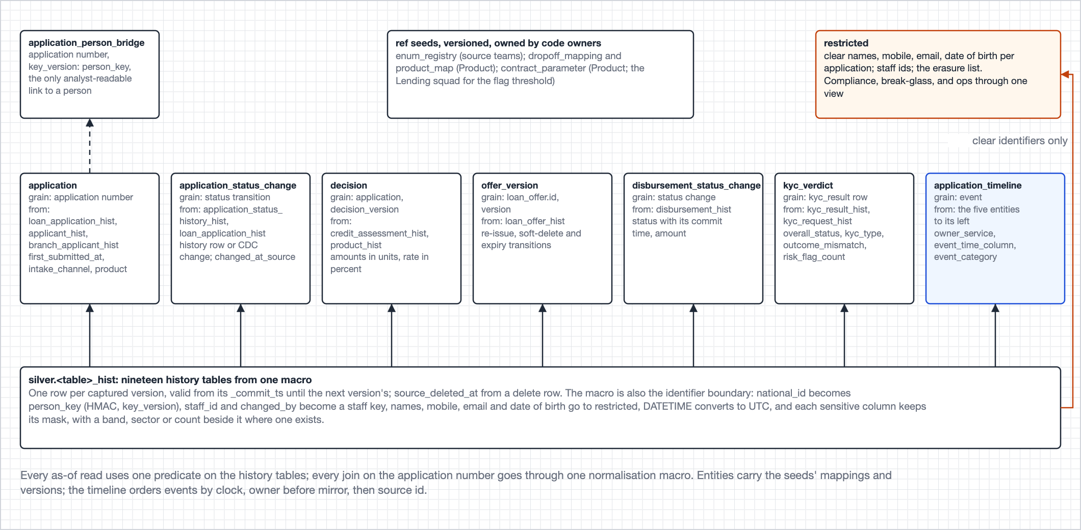
Image 7. Silver. The history tables at the bottom feed seven entities and the person bridge; the same macro writes the clear identifiers to restricted; the reference seeds supply the versioned mappings.

Silver entities and their fields
Object | Grain | Write | Used for | Carries
<table>_hist, 19 tables | One row per captured version of a source row | Rebuilt daily by one macro | Every as-of join below; the history a record is read from | The source columns as delivered, with identifiers replaced and blobs left out; valid_from, valid_to, source_deleted_at, _commit_ts, _change_seq, _load_type
application | Application number | Rebuilt daily | Spine of the funnel fact: cohort, channel, product | application_number, application_number_raw, number_quality_flag, loan_application_id, product_code, product, requested_amount, requested_tenor_months, loan_purpose, current_status, intake_channel, channel_raw, channel_source, branch_code, first_submitted_at, first_submitted_source, last_submitted_at, created_at, created_date_local, cohort_month, customer_id
application_status_change | Status transition | Rebuilt daily | Progress and exit events on the timeline; the funded timestamp | application_number, transition_seq, from_status, to_status, is_known_status, changed_at, changed_at_source, history_id, matched_cdc_row, changed_by_staff_key
decision | Application number, decision_version | Rebuilt daily | Day-14 decision, first and final decisions; spine of the decision input record | application_number, decision_version, credit_assessment_id, applicant_id, decision, decision_reason_code, decided_at, captured_at, capture_lag_seconds, product, product_id, approved_amount, approved_tenor_months, approved_interest_rate_pct, origination_fee, monthly_fee, affordability_ratio (masked), affordability_band, employer_name (masked), employer_sector, mandate_account_hash (masked), mandate_debit_day, employment_verified_at, income_verified_at, decision_channel
offer_version | loan_offer.id, version | Rebuilt daily | Offer milestones and expiry exits; spine of the watchlist | loan_offer_id, offer_version, application_number, borrower_id, offered_at, offer_expires_at, offer_expired_at, is_deleted, valid_from, valid_to, is_current, soft_deleted_at, expiry_committed_at, product, loan_product_raw, principal_amount, tenor_months, interest_rate_pct, monthly_instalment
disbursement_status_change | Status change | Rebuilt daily | The funded check, failed-disbursement exits, the funded loan fact | disbursement_id, loan_offer_id, application_number, attempt_no, disbursement_status, status_changed_at, disbursed_at, disbursed_amount, payment_reference (masked), disbursed_at_on_failure
kyc_verdict | kyc_result row | Rebuilt daily | The KYC milestone, the stuck-after-KYC count, the KYC input of a decision | kyc_result_id, kyc_request_id, application_number, customer_id, kyc_type, request_status, requested_at, completed_at, overall_status, decision_outcome (masked), outcome_mismatch, risk_flags (masked), risk_flag_count
application_timeline | Event | Rebuilt daily | The drop-off outcome: first exit after the last re-entry | application_number, event_seq, event_at, event_time_column, event_type, event_category, owner_service, is_mirrored_status, source_table, source_id, outcome_code
application_person_bridge | Application number, key_version | Rebuilt daily | The whitelist fact and any other person-level join | application_number, person_key, key_version, applicant_type, valid_from

3.4 Gold
- Gold is a star schema. Three facts sit at the centre: one row per application, one per disbursement and one per whitelist entry. Five conformed dimensions hang off them.
- Every number a reader asks for is a join and a group by over this star. There are no stored aggregate tables.
- The brief's trend and rate reporting comes from three code-owned views over the same star, so each metric is defined in one place and Product owns it through code owners.
- Beside the star, written once, sit the records of what someone was shown: the frozen cohort, the decision inputs, the morning watchlist, and the gate verdict that says whether a cohort may be published.
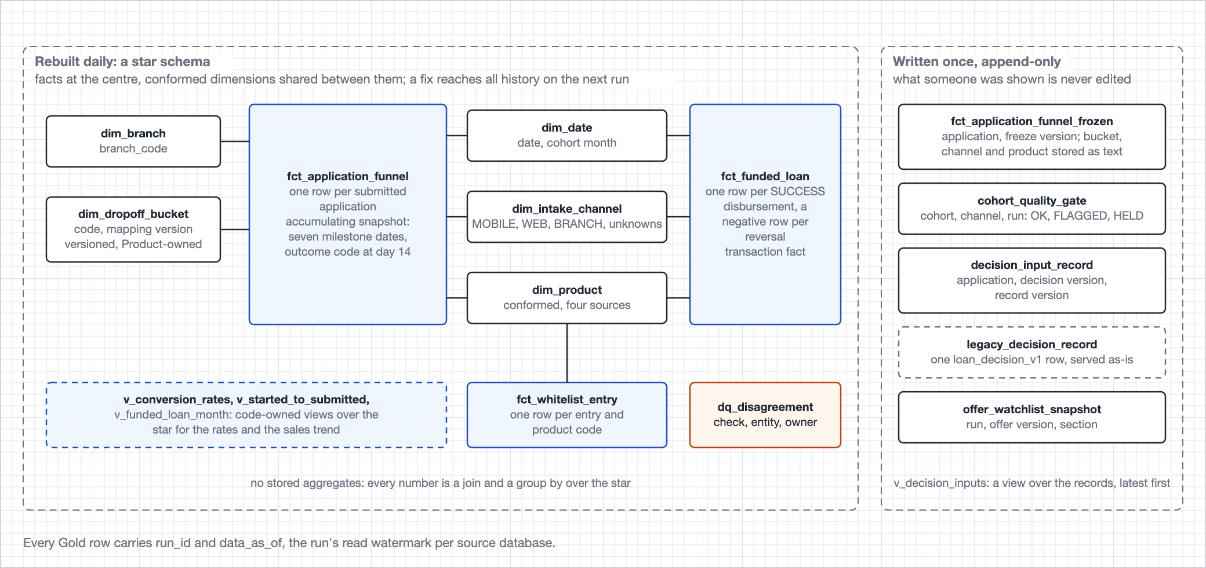
Image 8. Gold as a star. Left: the facts in the middle, the dimensions shared between them, the funnel-only dimensions on the left, and the metric views that read the star. Right: records written once and never edited.

Gold objects and their fields
Object | Grain | Write | Used for | Carries
fct_application_funnel | Submitted application | Rebuilt daily | Question 1 with its dimensions; stage rates; time to cash; Risk's approval-stage measures | application_number, cohort_month, first_submitted_at, first_submitted_source, intake_channel, branch_code, product, channel_source, assisted_acceptance, pre_approved, kyc_completed_at, first_decided_at, first_approved_at, offer_issued_at, accepted_at, funded_at, funded_at_source, outcome_code, dropoff_mapping_version, retracted_after_expiry, is_reversed, day14_decision_version, decision_reason_code, affordability_band, bureau_score_band, kyc_risk_flag_count, first_decision, redecision_count, final_decision, final_decided_at
fct_funded_loan | SUCCESS disbursement, plus a negative row per reversal | Rebuilt daily | Commercial performance: sales trend and mix | disbursement_id, loan_offer_id, application_number, row_type, reverses_disbursement_id, funded_date_local, disbursed_at, origination_month, signed_amount, product, tenor_months, interest_rate_pct, amount_mismatch, terms_mismatch, intake_channel, assisted_acceptance
fct_whitelist_entry | Whitelist entry and product code | Rebuilt daily | Whitelist to application conversion | whitelist_entry_id, product_code, person_key, first_enabled_at, enablement_month, disabled_at, first_application_number, first_applied_at, applied_within_30d, funded_within_window, is_window_open
dim_date | Bank-local date | Rebuilt daily | Cohort month; month end plus 14 and plus 30 | date_local, year, quarter, month, cohort_month, is_cohort_close_date, is_rate_maturity_date
dim_product | Product | Rebuilt daily | One product name across four services | product, display_name, product_map_version, application_product_code, decision_product_key, offer_loan_product, whitelist_product_code, min_amount, max_amount, min_tenor_months, max_tenor_months
dim_intake_channel | Intake channel | Seed | Channel breakdowns that always sum | intake_channel, channel_name, channel_rule, rule_version, target_pct
dim_branch | Branch code | Seed | Question 1 cut by branch | branch_code, branch_name, region, branch_type
dim_dropoff_bucket | Outcome code, mapping version | Seed, versioned | Turning the outcome code into the brief's bucket | outcome_code, dropoff_mapping_version, exit_event, outcome_bucket, valid_from, valid_to
v_conversion_rates | Cohort month, channel, branch, assisted acceptance, product | View | The four stage rates, 30 days after month end | cohort_month, intake_channel, branch_code, assisted_acceptance, product, applications_decided, first_decision_approvals, first_decision_approval_rate, final_approvals, final_approval_rate, rate_cutoff_at, applications_with_offer, applications_accepted, offer_acceptance_rate, applications_disbursed, disbursement_rate, still_open_pct
v_started_to_submitted | Created month, channel | View | The rate before the funnel begins | created_month, intake_channel, applications_created, applications_submitted, started_to_submitted_rate
v_funded_loan_month | Month, product, tenor, channel | View | Sales trend and mix, net of reversals | funded_month, product, tenor_months, intake_channel, funded_loan_count, funded_amount, reversal_count, reversal_amount
fct_application_funnel_frozen | Application, freeze version | Append-only | What a regulator is shown for a mature cohort | Every column of fct_application_funnel as it stood at day 14, plus outcome_bucket, channel_name, product_name, freeze_version, frozen_at, restatement_reason, dropoff_mapping_version, parameter_version, quality_status, capture_gap_interval
cohort_quality_gate | Cohort month, intake channel, run | Append-only | Whether a cohort may be published | cohort_month, intake_channel, run_id, freeze_version, frozen_funded_pct, recomputed_funded_pct, max_bucket_drift_pts, open_issue_pct, flag_threshold_pct, hold_threshold_pct, restatement_threshold_pts, quality_status, hold_reason, capture_gap_interval
decision_input_record | Application, decision version, record version | Append-only | Question 2 | application_number, decision_version, record_version, decided_at, recorded_at, kyc_verdict, kyc_type, kyc_read_at, kyc_evidence, bureau_score (masked), bureau_score_band, bureau_fetched_at, bureau_evidence, applicant_declared_income (masked), statement_declared_income (masked), declared_income_band, income_evidence, engine_employer_name (masked), engine_employer_sector, source_employer_name (masked), employer_evidence, kyc_risk_flags (masked), kyc_risk_flag_count, consent_given_at, ambiguous_input, late_arriving_input, row_hash (masked)
legacy_decision_record | loan_decision_v1 row | Append-only | Pre-cutover decisions, served as they are | legacy_id, application_number, decision, approved_amount, decided_at, evidence_level, period_label, has_newer_decision, duplicate_count
v_decision_inputs | Application number | View | Question 2: the latest record, with the other versions listed | The columns of the latest decision_input_record, plus other_record_versions, other_decision_versions, legacy_rows, is_orphan
offer_watchlist_snapshot | Run, offer version, section | Append-only | Question 3: what ops was told each morning | run_id, list_as_of, run_at, data_as_of, loan_offer_id, offer_version, application_number, section, offered_at, offer_expires_at, offer_expired_at, principal_amount, tenor_months
dq_disagreement | Check, entity | Rebuilt daily | Every published disagreement with its owner | check_code, check_owner, severity, entity_type, entity_key, application_number, cohort_month, moves_cohort_month, opened_at, cleared_at, detail

Every Gold table also carries run_id and data_as_of.
- Dimension keys are the business codes themselves: intake_channel, branch_code, product, the bank-local date, and outcome_code with its mapping version.
- A join reads the way a business user would say it, and no surrogate key needs explaining.
- The frozen fact also stores the bucket, channel and product names as text at freeze time, so a frozen row never depends on a dimension that changes later.

3.5 ops, compliance, restricted and ref

Objects and their fields
Object | What it is | Carries
ops.v_watchlist_today | The latest watchlist snapshot minus offers accepted since, with name and mobile. Ops only | section, section_order, application_number, first_name, last_name, mobile_number, product, principal_amount, tenor_months, offer_expires_at, offer_expired_at, hours_to_expiry, list_as_of, data_as_of
ops.disbursement_alert | Append-only alerts: keys, statuses and amounts, no contact details | alert_id, rule_code, severity, disbursement_id, loan_offer_id, application_number, disbursement_status, disbursed_amount, latest_decision_version, latest_decision, source_commit_ts, change_seq, detected_at
compliance.policy_snapshot | Masks, tags and grants, per day | snapshot_date, object_type, securable_full_name, column_name, principal, privilege, mask_function, tag_name, tag_value, declared_in_repo, drift_finding, captured_at
compliance.group_membership_snapshot | Who held each lending group, per day | snapshot_date, group_name, member_id, member_type, member_display, finding, captured_at
compliance.probe_result | Daily masked reads and denied attempts by a test principal in the analyst group | probe_date, probe_ts, attempt_type, securable_full_name, column_name, rows_read, clear_values_seen, output_hash, outcome, probe_label
compliance.column_inventory | Every analyst-readable column with its tag and mask, plus a scan for national-id and mobile patterns | inventory_date, schema_name, table_name, column_name, data_type, pii_class, mask_function, is_direct_identifier, pattern_match_count, finding
compliance.run_lineage | The input tables and versions behind each frozen cohort | run_id, frozen_object, cohort_month, input_table, input_table_version, run_watermark, run_started_at
compliance.break_glass_exception | Each break-glass grant with its ticket, window and approver | ticket_ref, member_id, group_name, granted_at, removed_at, reason, approved_by
compliance.audit_log_archive | Read-only view over the audit logs in the security account's store | event_time, event_date, workspace_id, service_name, action_name, user_identity, request_params, response
compliance.s3_data_event_archive | Read-only view over the S3 data events in the same store | event_time, event_name, bucket_name, object_key, principal_arn, error_code
compliance.v_q4_* | The Q4 evidence pack, one view per item | v_q4_grant_history, v_q4_access_scan, v_q4_probe_coverage, v_q4_membership, v_q4_scope, v_q4_policy_history, v_q4_absence
restricted.applicant_identity | Clear identifiers per application | application_number, person_key, key_version, applicant_type, national_id, first_name, last_name, mobile_number, email, date_of_birth, valid_from, valid_to, run_id
restricted.staff_identity | The staff id behind each staff key | staff_key, staff_ref, source_column, first_seen_at, run_id
restricted.erasure_request | Erasure requests and when they were completed | request_id, person_key, key_version, received_at, completed_at, ticket_ref
ref.enum_registry | Known values of every enumerated column, owned by each source team | source_database, source_table, column_name, code, meaning, owner_team, should_not_occur, registry_version
ref.dropoff_mapping | Outcome code to brief bucket, versioned, owned by Product | mapping_version, outcome_code, outcome_bucket, effective_from, change_reason, approved_by
ref.product_map | Each service's product form mapped to one conformed product, owned by Product | map_version, source_service, source_column, source_value, conformed_product, effective_from
ref.contract_parameter | 14-day window, maturity, thresholds, watchlist time and time zones, each with its owner | parameter_name, parameter_value, value_type, owner, parameter_version, effective_from
ref.capture_gap | Every capture gap, opened automatically when a task reloads | gap_id, source_database, gap_start, gap_end, detected_at, confirmed_at, confirmed_by

4. The four questions answered
Each answer follows the same path: what gets joined, the query, an example of what comes out, and the answer as its readers see it. Example rows and figures are illustrative.

4.1 Q1. Funnel conversion
Of applications submitted in a month, what share reached FUNDED within 14 days, by channel, and why did the rest not fund?
What gets joined
- At answer time: the funnel fact and two dimensions. dim_intake_channel joins on the channel code and dim_dropoff_bucket on the outcome code and its mapping version. The cohort month is on the fact itself.
- For a mature month, the fact is the frozen copy at its latest freeze version, with today's row beside it.
- The fact itself is built once a day from the six source tables in the picture. loan_application, credit_assessment and loan_offer join on the normalised application number; the status history joins on loan_application_id, and offer_acceptance and disbursement through loan_offer_id.
- Every join is as of commit time, against the history tables.
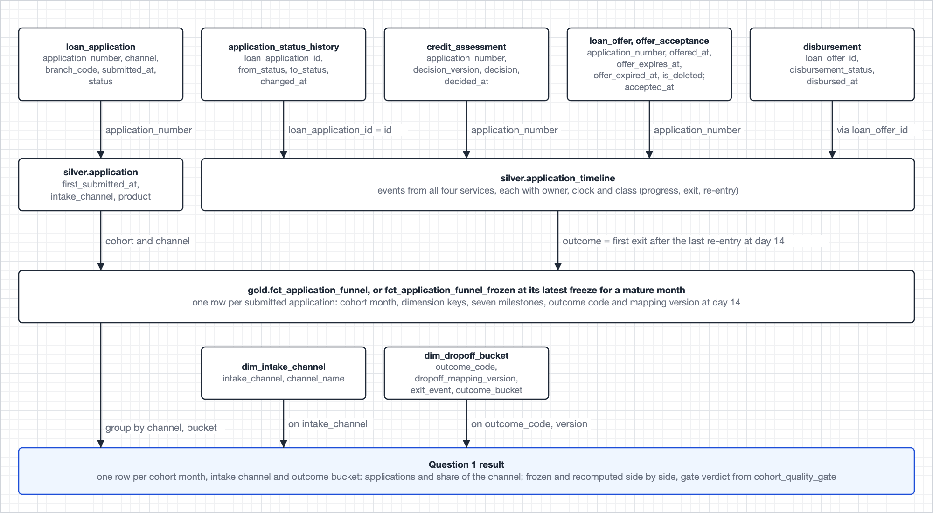
Image 9. Top: the six source tables build the funnel fact through the application entity and the timeline. Bottom: the question is a join of that fact with two dimensions, grouped by channel and bucket.
The query
-- Question 1: the May 2026 cohort at its latest freeze, by intake channel and outcome bucket
with cohort as (
select f.application_number, c.channel_name, b.outcome_bucket
from gold.fct_application_funnel_frozen f
join gold.dim_intake_channel c on c.intake_channel = f.intake_channel
join gold.dim_dropoff_bucket b on b.outcome_code = f.outcome_code
and b.dropoff_mapping_version = f.dropoff_mapping_version
where f.cohort_month = '2026-05'
and f.freeze_version = (select max(freeze_version)
from gold.fct_application_funnel_frozen
where cohort_month = '2026-05')
)
select channel_name, outcome_bucket,
count(*) as applications,
round(100.0 * count(*) / sum(count(*)) over (partition by channel_name), 1) as share_pct
from cohort
group by channel_name, outcome_bucket
order by channel_name, outcome_bucket;

-- The same query over gold.fct_application_funnel gives today's recomputed share.
-- gold.cohort_quality_gate, latest run, says whether the two may be published:
select intake_channel, quality_status, frozen_funded_pct, recomputed_funded_pct, hold_reason
from gold.cohort_quality_gate
where cohort_month = '2026-05'
qualify row_number() over (partition by intake_channel order by run_id desc) = 1;

What comes out
One row per submitted application in gold.fct_application_funnel:
application_number | cohort_month | intake_channel | first_approved_at | funded_at | outcome_code | dropoff_mapping_version
AURPL-20260513-00042 | 2026-05 | MOBILE | 2026-05-14 10:41 | 2026-05-17 14:03 | FUNDED | 3
AURPL-20260513-00043 | 2026-05 | BRANCH | null | null | CREDIT_DECLINED | 3
AURPL-20260514-00007 | 2026-05 | WEB | 2026-05-14 16:30 | null | OFFER_EXPIRED | 3

The dimensions the question joins to:
dim_intake_channel | intake_channel | channel_name | rule_version
row 1 | MOBILE | Mobile app | 2
row 2 | BRANCH | Branch, assisted | 2

dim_dropoff_bucket | outcome_code | dropoff_mapping_version | exit_event | outcome_bucket
row 1 | CREDIT_DECLINED | 3 | A DECLINED decision version or status | credit decline
row 2 | OFFER_EXPIRED | 3 | offer_expired_at, or offer_expires_at passed with no acceptance | expired

- The query groups the joined rows by channel and bucket.
- Run over the frozen copy and again over today's fact, it gives the frozen and the recomputed share side by side.
- gold.cohort_quality_gate says whether the cohort may be published.
The answer
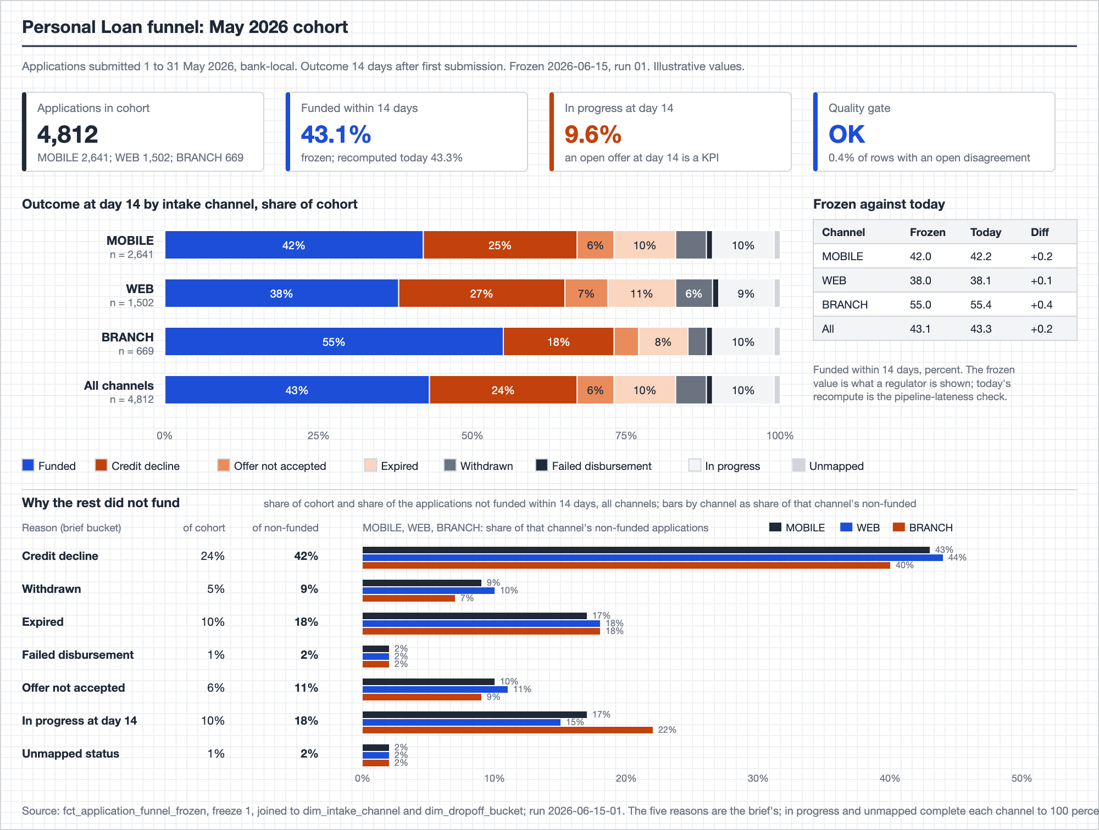
Image 10. The May 2026 cohort as Product and Sales read it. Top: cohort size and the funded share, frozen and recomputed, with the outcome mix by intake channel. Bottom: why the rest did not fund, each of the brief's five reasons as a share of the cohort and of the applications not funded, by channel. Values are illustrative.

4.2 Q2. Decision reproducibility
For any application number, reconstruct the exact inputs the credit engine saw at decision time, even if the sources have since changed.
What can be proved
- The platform proves what the sources held and what the engine copied onto its decision row.
- It cannot prove what the engine actually read unless the engine says so.
What gets joined
- The decision row is the spine.
- KYC joins through application_reference, the bureau through the application number, the applicant through the application id, and the bank statement through the KYC request.
- Each input is read as of its own timestamp from the history tables, not from the current rows.
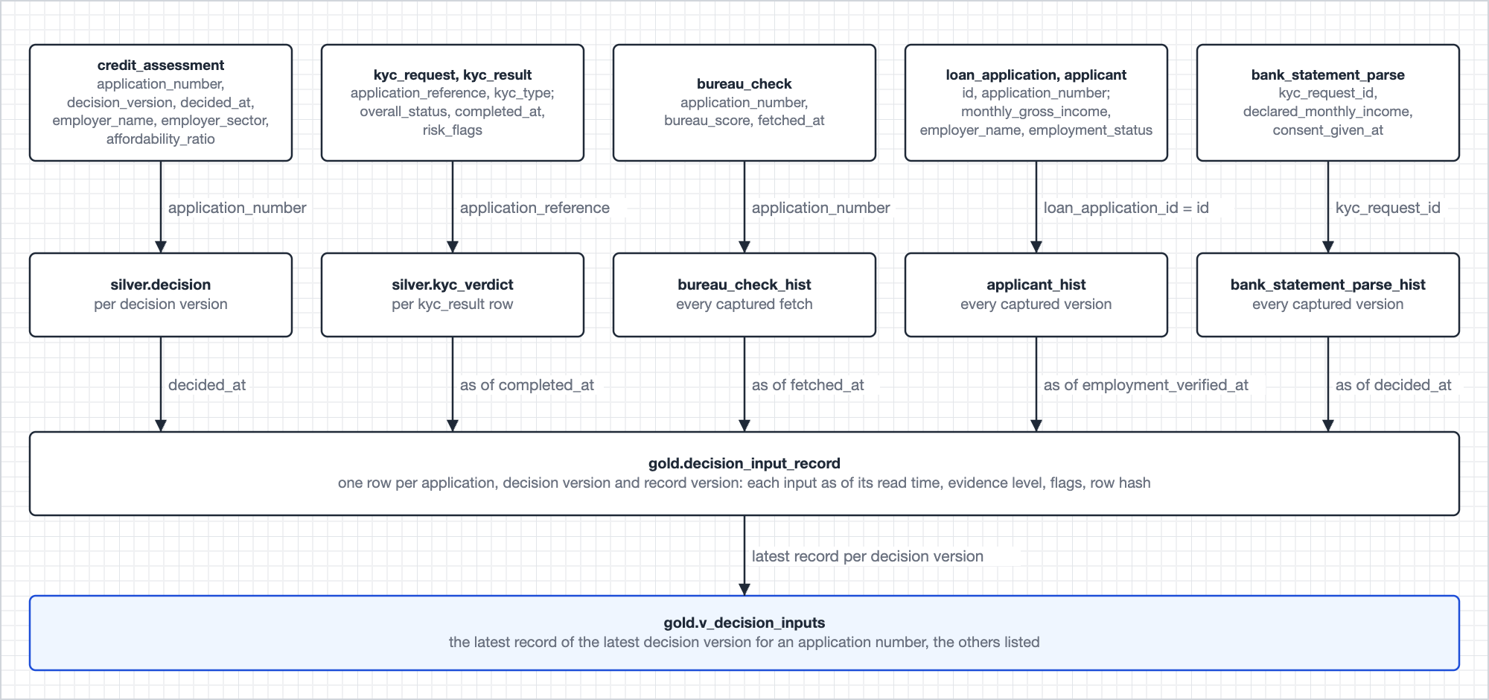
Image 11. From the decision row and its four input sources, each read as of its own time, to one immutable record per decision version.
The query
-- Question 2: the inputs the engine saw for one application, latest decision version first
select decision_version, record_version, decided_at, recorded_at,
kyc_verdict, kyc_evidence, bureau_score_band, bureau_evidence,
declared_income_band, income_evidence, engine_employer_sector, employer_evidence,
ambiguous_input, late_arriving_input, row_hash
from gold.v_decision_inputs
where application_number = upper(trim('AURPL-20260513-00042'));

What comes out
One row in gold.decision_input_record, stored clear and masked by reader group:
application_number | decision_version | record_version | kyc_verdict | bureau_score | ambiguous_input | row_hash
AURPL-20260513-00042 | 1 | 1 | PASS | 712 | bureau_score | 9f3a...c21e

- The same row also carries both declared incomes, the engine's employer copy and the applicant's employer, each with its read time and evidence level.
- Two bureau fetches fall inside the read window, so ambiguous_input names the bureau input.
- An input that reaches the platform after the record is written opens a new record version flagged late_arriving_input. The earlier version stays.
- Records are re-derived weekly. Any other hash mismatch is published as a defect, never corrected.
- Legacy loan_decision_v1 rows are served as they are, marked NOT_CAPTURED, and never merged into the version sequence.
The answer
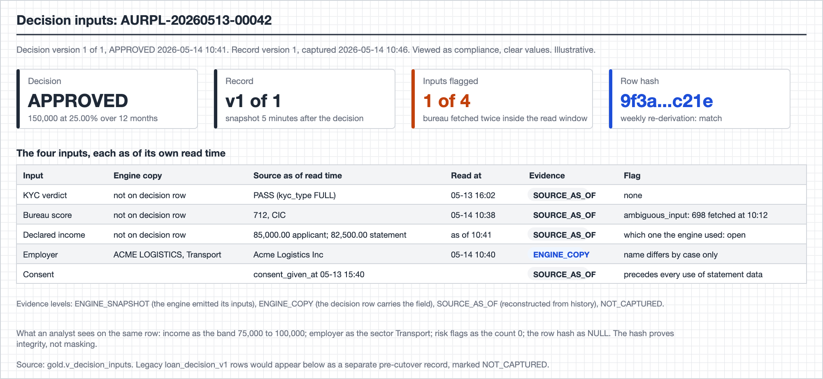
Image 12. One application's decision inputs as compliance reads them: what the engine copied, what the sources held at read time, the evidence level and the flag per input. Values are illustrative.

4.3 Q3. Offer expiry watchlist
Each morning, the offers expiring in the next 24 hours that are not yet accepted, plus the offers that expired without action in the past 7 days.
What gets joined
- The offer row is the spine. It is read by version from change history, because loan_offer is overwritten in place.
- The acceptance table is an anti-join: an offer is open only if no acceptance exists at or before data_as_of.
- The timeline supplies exits since the offer was issued.
- Names and mobiles come from the restricted schema, for ops only.
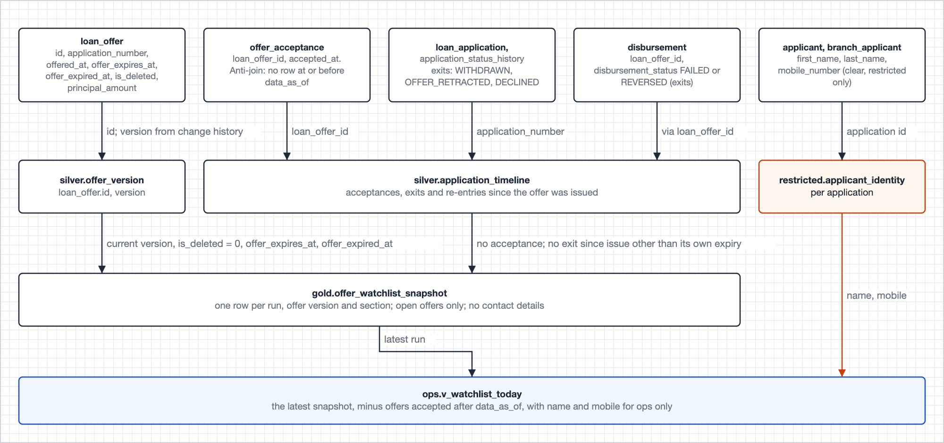
Image 13. From the offer, its acceptances, the application's exits and the applicant's contact details to the morning snapshot and the ops view.
The query
-- Question 3: this morning's list, most valuable call first
select section, application_number, first_name, mobile_number,
offer_expires_at, offer_expired_at, principal_amount, data_as_of
from ops.v_watchlist_today
order by case section when 'EXPIRY_PENDING' then 1 when 'EXPIRING' then 2 else 3 end,
offer_expires_at;

What comes out
One row per open offer and section in gold.offer_watchlist_snapshot:
run_id | data_as_of | loan_offer_id | offer_version | application_number | section | offer_expires_at
2026-10-06-01 | 2026-10-06 05:51 | 9120 | 1 | AURPL-20260927-00077 | EXPIRY_PENDING | 2026-10-05 15:30
2026-10-06-01 | 2026-10-06 05:51 | 9188 | 1 | AURPL-20260929-00118 | EXPIRING | 2026-10-06 10:10

- Both rows also carry list_as_of 2026-10-06 06:00 and a null offer_expired_at.
- The ops view adds the name and mobile from restricted, and drops any offer whose acceptance committed after data_as_of.
- The open-offer test is explicit because an accepted offer never expires in the data. Without it, every accepted offer would top the list each morning.
The answer
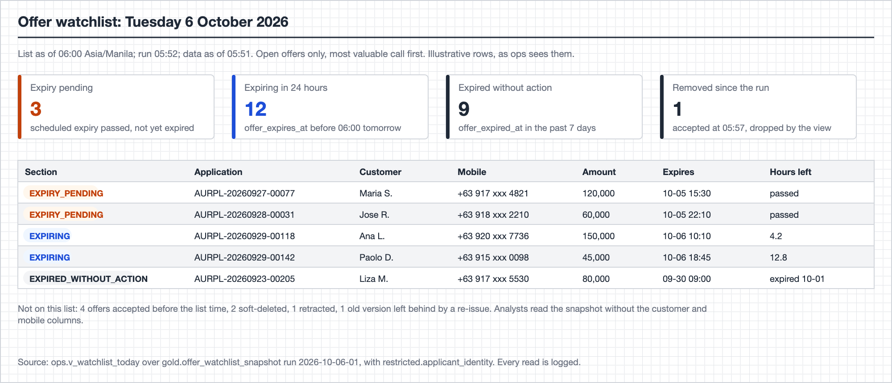
Image 14. This morning's list as ops reads it: the three sections, counts first, then the rows in call order with the contact details only ops can see. Values are illustrative.

4.4 Q4. Proof that PII was masked
Prove to a regulator that PII was masked before any analyst accessed the data for the funnel report in a quarter.
The short answer
- The fields the brief names never reach an analyst-readable table. At the Silver boundary national_id becomes person_key and mobile_number is dropped, so no table in the funnel report's lineage has either column.
- The pack then proves two more things, for every read: no analyst could reach the layers that do hold them, and every sensitive attribute an analyst did read was masked at that moment.
What gets joined
- Six evidence tables, none of them business data.
- The audit log joins to the membership snapshot on principal and day, and to the policy snapshot on table, column and day.
- It joins to the run lineage on table, which limits the scope to the quarter's frozen cohorts.
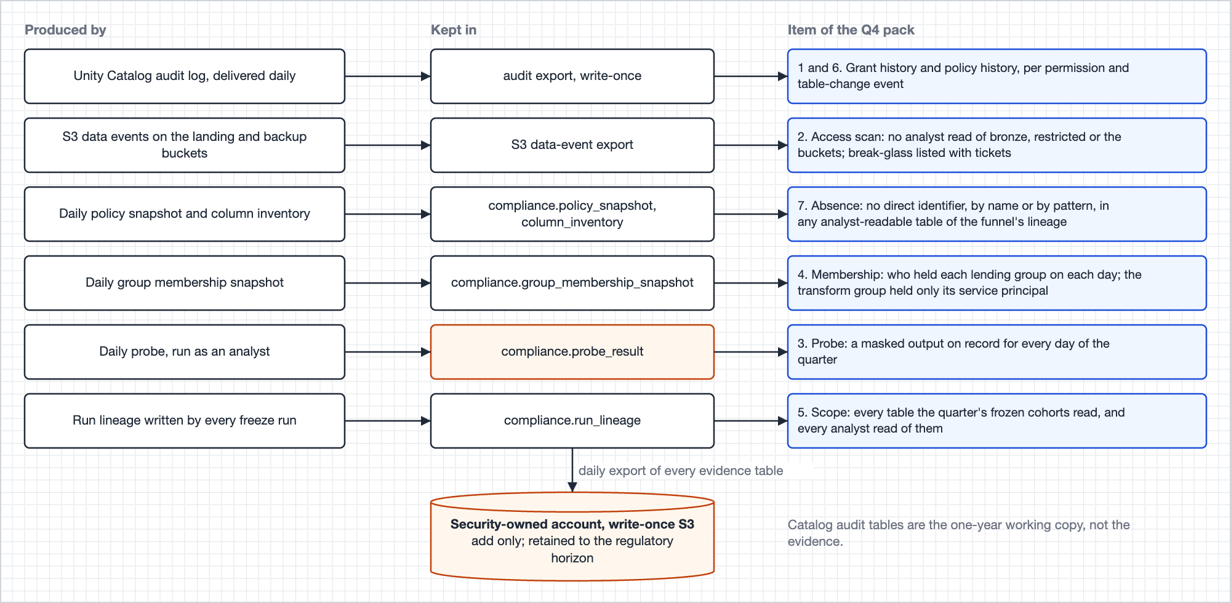
Image 15. The evidence chain: each producer feeds an evidence table, each table feeds an item of the pack, and every table is exported daily to a store the platform cannot alter.
The query
-- Question 4, item 2: reads of bronze, restricted or the landing buckets in Q1 2026.
-- Expected: no FINDING rows, and every break-glass read listed with its ticket.
select event_time, principal, object_name, ticket_ref, classification
from compliance.v_q4_access_scan
where event_date between '2026-01-01' and '2026-03-31'
and classification <> 'PIPELINE';

-- Item 7: direct identifiers in analyst-readable tables of the funnel's lineage in Q1 2026 (expected: none)
select inventory_date, table_name, column_name, status
from compliance.v_q4_absence
where inventory_date between '2026-01-01' and '2026-03-31'
and in_funnel_lineage
and status = 'FINDING';

What comes out
The seven compliance.v_q4_* views, one per item of the pack. Item 2, the access scan, is expected to return no analyst rows and to list every break-glass read with its ticket:
v_q4_access_scan | event_time | principal | object_name | ticket_ref | classification
row 1 | 2026-02-03 22:40 | sec.oncall | bronze.applicant | SEC-4471 | BREAK_GLASS_WITH_TICKET

The answer
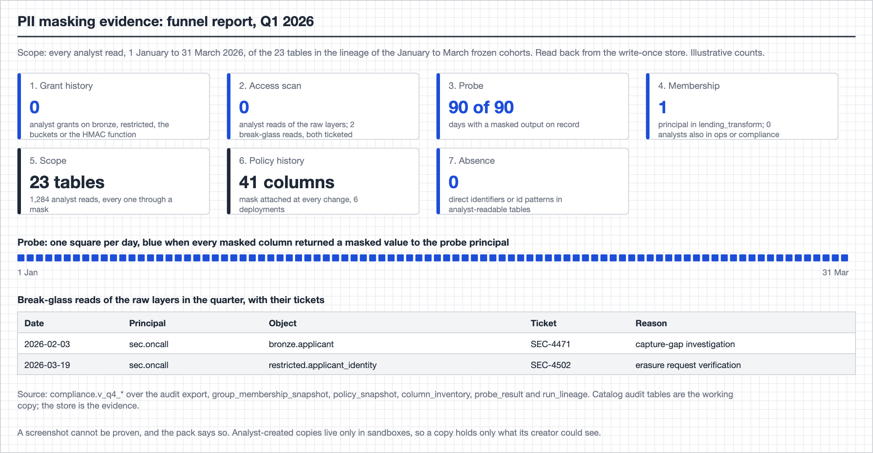
Image 16. The pack as compliance reads it: one tile per item with its count, the daily probe strip for the quarter, and the break-glass reads with their tickets. Counts are illustrative.

5. Decision log
The five decisions the brief asks for, each with the principle behind it.

5.1 Identity across the four services
- The normalised application number (trimmed, upper case) is the only key that crosses services.
- A person is identified by person_key: a keyed hash of the normalised national id, with a key version.
- Service-local UUIDs (customer_id, borrower_id, applicant_id, the id inside user_ref) are kept as attributes. Their agreement is measured, but nothing joins on them.
- Why the national id: it is the only identifier that is NOT NULL in both applicant tables and unique on the whitelist.
- Rejected: an unkeyed SHA-256, because a small, structured id space can be enumerated; a token vault, because the mapping table is a second store of clear identifiers to guard, back up, erase and evidence, and a lookup in every build.
- Risk: the key assumes national_id holds one ID scheme, and Philippine banks accept several. The platform publishes two counts: values that collapse into one key after normalisation, and applicants with the same name and mobile number under different keys. Open question 3 asks the application team which ID the field holds.
- Use: Risk counts repeat borrowers and concurrent applications with the key today, and per-borrower exposure once a servicing feed exists. See Silver.
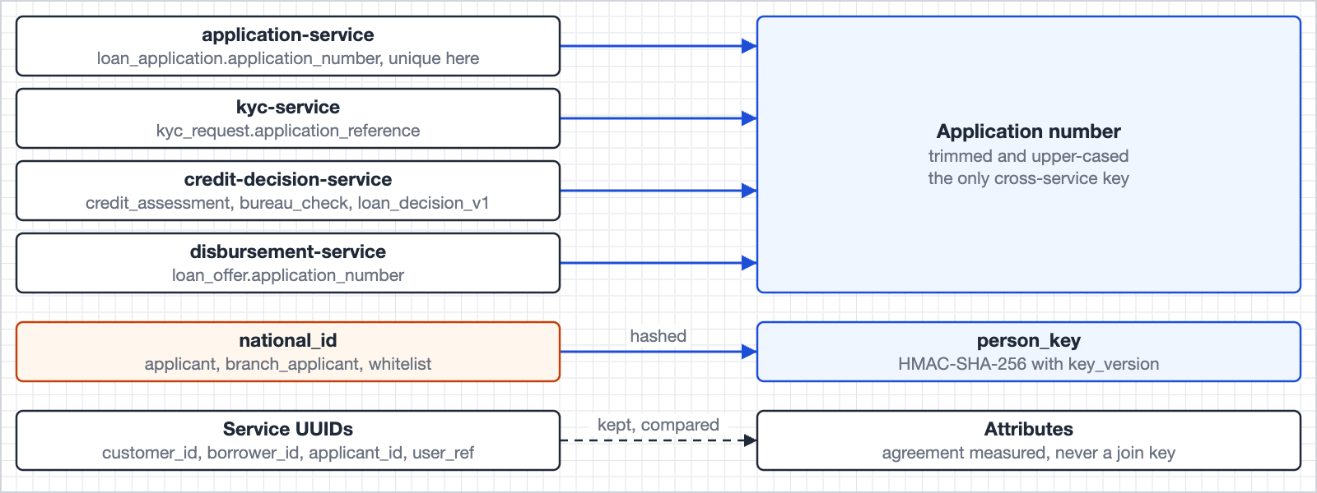
Image 19. Every service's identifiers resolve to one of two keys. Service UUIDs are kept and compared, but nothing joins on them.

5.2 Cross-service joins with no enforced foreign keys
- Every join runs as of source commit time against append-only history, records where each value came from, keeps orphans out of the denominator and publishes its match rate.
- An orphan, such as a decision row whose application number matches no application, is kept, reported to the team that wrote it, and still answered by Q2.
- All four databases are read to one common cut-off, so a row whose parent has not arrived yet is never reported as an orphan.
- Each entity declares its grain and a test checks it, so a join that multiplies rows is caught.
- One-to-many sources (several KYC results, bureau fetches, disbursement attempts) resolve by a written rule, never by whichever row comes first. See Silver.

5.3 Data-governance assumptions
- Direct identifiers never enter analyst-readable schemas.
- Sensitive attributes are masked by group.
- Every access is logged to a write-once store the platform cannot alter.
- Regulatory retention overrides erasure.
- Data residency and bureau terms are assumed to be covered by existing agreements. See Governance and PII.

5.4 A trade-off I considered and rejected: holding back rows until the sources agree
- It looks safe, but it ties every metric to the worst integration, and it changes the denominator, so the funnel stops reconciling to application counts.
- Instead, each fact has one owner, and every disagreement is published with an owner.
- A two-threshold gate acts per cohort: the Lending squad decides when a cohort is flagged, Product when it is held.

5.5 What I would confirm with a source owner before shipping
- Whether the decision service can emit an inputs snapshot keyed on application number and decision version.
- Today Q2 shows what the sources held around a decision, not what the engine read. A snapshot would lift every answer to the top evidence level.
- The decision row already copies the employer fields, so the rest is a small step.
- Runner-up: who mints customer_id, which branch applicants carry in the KYC and disbursement services but not in the application service. See Q2.
Other decisions worth knowing
Decision | Principle | See
Capture | One change-capture path for batch and stream; history is captured, never reconstructed | Change capture
Funnel start | A cohort is keyed on the first submission ever captured, so a rewrite cannot move it | Q1
Drop-off reason | The first exit after the last re-entry on one cross-service timeline, read at day 14 | Q1
Publication | A mature cohort is written once; corrections are versioned restatements with a reason | Q1
Near-real-time | One stream today, for disbursement failures, and more added the same way as needed; everything else daily | Near-real-time stream

6. Governance and PII
The brief asks for masking, role-based access and auditing. Each one below leaves evidence that feeds the Q4 pack.

6.1 The identifier boundary
Direct identifiers stop at one place: the Silver history macro.
- It replaces national_id with person_key, a keyed hash (HMAC with SHA-256) of the normalised id.
- It writes names, mobile number, email and date of birth in clear to the restricted schema. Only compliance, break-glass and, through one view, ops can read it.
- The key is a secret owned by security. Only the transform service principal can run the hashing function, so nobody else can compute the key for a chosen id.
- Every row carries key_version. Rotation re-keys from Bronze, which Silver rebuilds daily anyway.
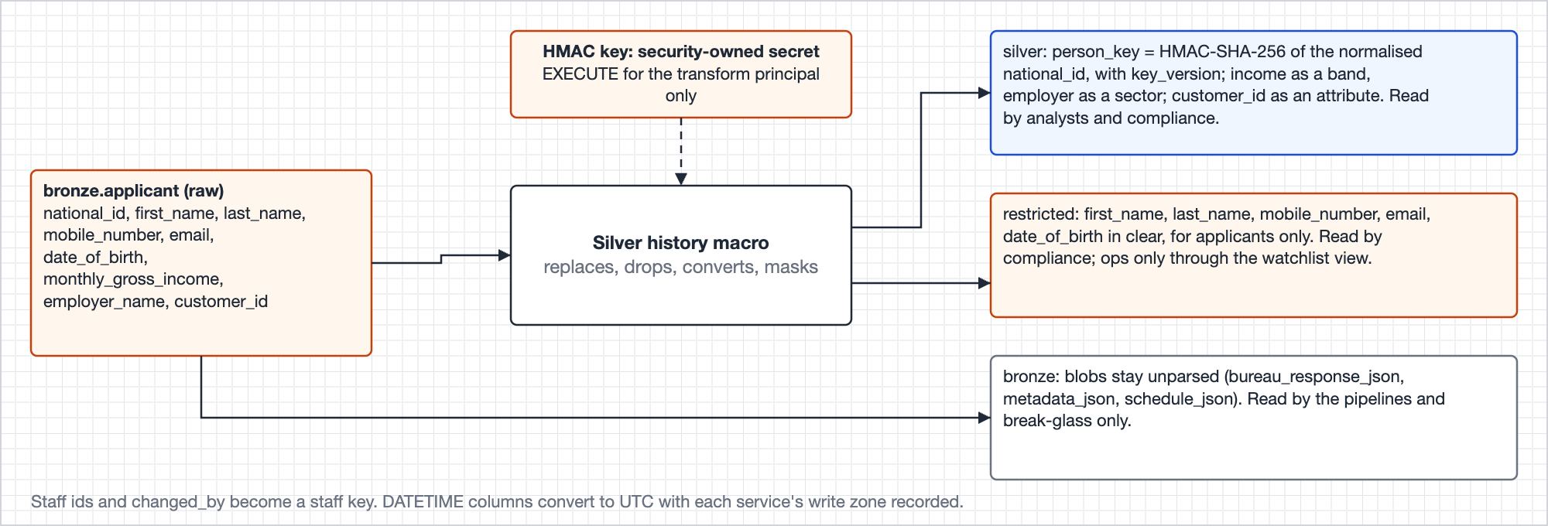
Image 17. The identifier boundary. One applicant row goes in; the pseudonymous version goes to Silver, the clear identifiers to restricted, and the unparsed blobs stay in Bronze.

6.2 Identity and joins in practice
Rule | What it means
Join key | Trim and upper-case the application number before every join. Rows that join only after normalisation are flagged; the rate is published per service
Person key | HMAC-SHA-256 of the normalised national_id (trim, upper-case, strip separators). The count of ids collapsing into one key is published
Orphans | A KYC, decision or offer row with no loan_application row: kept, out of the denominator, published to the team that wrote it. Reproducibility still answers for it
Service UUIDs | applicant_id, borrower_id and the id in user_ref are attributes. Their agreement with customer_id is one published check with no effect on joins
KYC scope | A KYC request belongs to an application through application_reference only; REFRESH is how earlier KYC is reused under it
Pre-approved | An enabled whitelist row for the person key at the first submission time whose product codes include the application's product, read from history

6.3 Access by group
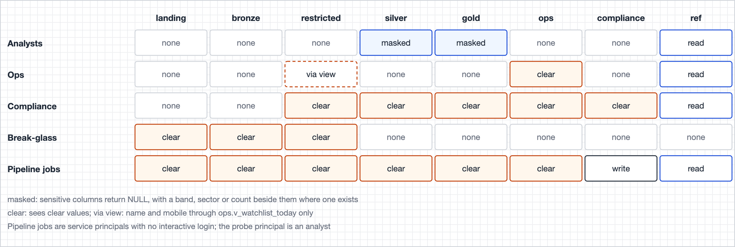
Image 18. Who reads which schema. Analysts never touch landing, Bronze or restricted; clear values reach only compliance, ops (name and mobile, through one view), break-glass and the transform job.
Group | Gets
lending_analysts | Silver, Gold and ref, masked; their own sandbox schema
lending_ops | The ops schema: today's watchlist with name and mobile, and alerts
lending_compliance | Restricted, Silver, Gold, ops and compliance, with clear values through the masks
lending_break_glass | Bronze and restricted. Membership is granted by security against a ticket and removed when the window closes
Service principals | Only their own job's reads and writes; no interactive login. The transform principal alone sits in lending_transform, the group the masks show clear values to, and a daily check confirms it
Probe principal | A member of the analyst group only

Mask policy | Columns | Clear to | Everyone else sees
clear_to_compliance | Income and deposit columns, bureau_score, affordability_ratio, marital_status, employer_name, risk_flags, s3_path, decision_outcome, signature_ref, payment_reference, the two account hashes, the decision record's row_hash; in restricted, national_id, email and date_of_birth | Compliance; the transform job | NULL; the band, sector or count beside it where one exists
clear_to_ops | first_name, last_name and mobile_number in restricted | Ops; compliance; the transform job | NULL

6.4 Columns by PII class
Columns | Class | Treatment
national_id, names, mobile_number, email, date_of_birth | Direct identifier | Person key in analytical layers; clear only in restricted
staff_id, changed_by | Direct identifier | Replaced by a staff key
document_upload.s3_path | May embed an identifier | Masked
Income, deposits, bureau_score, affordability_ratio | Sensitive | Masked; analysts see a band
employer_name | Sensitive | Masked; analysts see the sector where the source has one
risk_flags | Most sensitive present (PEP, adverse media) | Masked; analysts see a count
marital_status | Sensitive personal information | Masked; not a funnel dimension
The decision record's row_hash, a plain SHA-256 over sensitive values | Sensitive | Masked; analysts see NULL. Compliance can recompute it, and the weekly re-derivation compares it
decision_outcome, signature_ref, payment_reference | Free text or references | Masked until classified
customer_id, borrower_id, applicant_id, the id in user_ref, person_key | Pseudonymous, still personal data | Readable as attributes; only person_key links an application to a person, through the bridge
bureau_response_json, metadata_json, schedule_json | Unclassified blobs | Bronze only until parsed
disbursed_to_account, the two account hashes | Masked or hashed at source | Carried opaque; a platform mask on the hashes until the algorithm is confirmed

6.5 Masks, copies and retention
- Masks travel with the model.
- A mask does not follow data into a derived table, so every table with a classified column declares its own masks in its model file.
- CI fails a pull request that drops a mask from a tagged column or leaves a column untagged.
- A daily drift check compares tags with masks.
- No way around the catalog.
- No human holds storage credentials, and there is no Glue table or Athena query over landing.
- BI tools connect as the viewer, and masked columns cannot be extracted.
- Derived copies. Analysts create objects only in their own sandbox. A copy holds only what its creator could see, and lineage covers it.
- Retention and erasure.
- Raw data and decision records are kept to the regulatory horizon. Regulatory retention overrides erasure.
- The analytical layers honour erasure: a request removes the person's bridge and identity rows and nulls personal attributes.
- Person-level tables keep seven days of table history and are vacuumed by the erasure run, so older versions are unreadable within seven days.
- Frozen cohorts carry no person at all.

7. Assumptions and open questions
Assumptions
- The funnel starts at the first month with complete capture.
- Near-real-time means minutes. The platform sits downstream of decisions and is never in the decision path.
- Change capture stays DMS to S3, without Kafka, while three things hold:
- No consumer needs data faster than about a minute.
- The platform stays out of the decision path.
- Real-time streams stay few enough to share the one-minute landing files.
- If one stops holding: DMS writes to Kafka, or the services' own CDC topics replace DMS once they meet the six criteria in open question 2. Bronze then reads from the topics, and nothing downstream of Bronze changes.
- national_id holds one ID scheme, the same for every applicant (open question 3).
- The PII classification in Governance and PII is mine and needs confirming with the data protection officer.
- A security-owned AWS account hosts the evidence bucket. Workspaces run in a customer-managed VPC with private connectivity and bank-managed KMS keys, in a region the bank's cloud approval covers. Raw bureau responses are kept within the bureau agreement.
- The person key secret is a security-owned Unity Catalog secret read by the function. The exact binding is confirmed in the workspace before go-live.
- Threshold defaults (flag 2%, hold 5%, restatement 0.5 points, 15-minute lag margin) are starting values for their owners to set.
- Until the expiry job sets offer_expired_at, a customer can still accept an offer whose offer_expires_at has passed, so expiry-pending offers lead the morning watchlist.
Open questions for source owners, none blocking
- What OFFER_RETRACTED means operationally, and whether CONTRACT_SIGNED mirrors offer_acceptance.
- What the existing Kafka CDC topics must offer to replace DMS: (a) row-level events for all 19 tables; (b) full after-image and deletes; (c) source commit time and in-commit sequence; (d) partitioned by primary key; (e) not compacted, with retention at or above the recovery window, or tiered storage; (f) a snapshot path for first values. If all six hold, Bronze reads the topics, S3 stays the archive, and nothing downstream changes.
- For the application team: which ID scheme national_id holds, and whether the application service records the ID type.
Measured from data rather than asked: whether a soft-deleted offer is re-issued on the same row, and whether decided_at is write time or commit time.

