**Newworld**

**Game: HarvestPoint**

**Created by**

**6131017621 Thira Khunrak**

**6130169121 Nuttanon Muanphannarai**

**2110215 ProGramming Methodology Semester 1 Year 2019**

**Chulalongkorn University**

**Introduction**

HarvestPoint is the arcade bug simulation game that you will be the bugs and avoid dangerous Venus Flytrap and Insect swatter. There are four different character that have different life and velocity. Other than the obstacle we also have the power up item that would help you in the game. If you come across the obstacle, you will lose your life, if you lose all life the game will be over. In this game only use Left arrow key and right arrow key to control your character.

**Main menu**

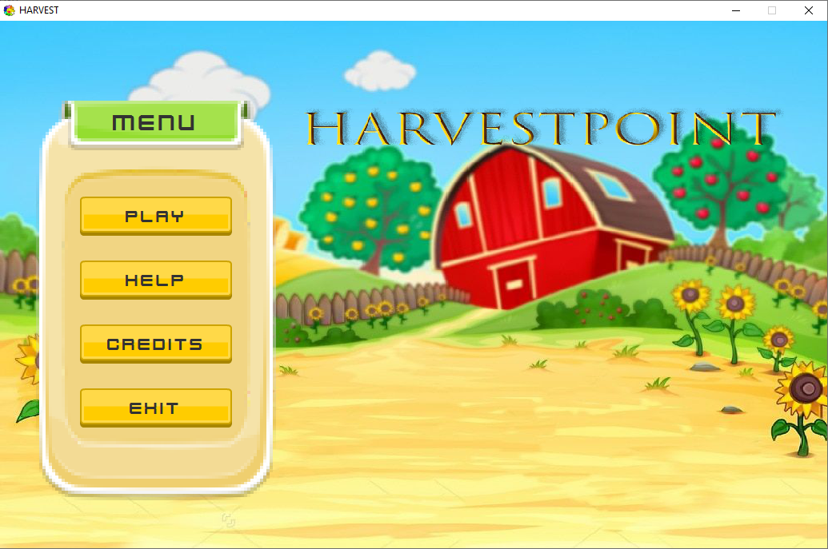

* “PLAY” button will lead you to character selection scene.
* “HELP” button will show you help subscene
* “CREDITS” button will show you credits subscene.
* “EXIT” button is for exit the game.

**Character selection scene**

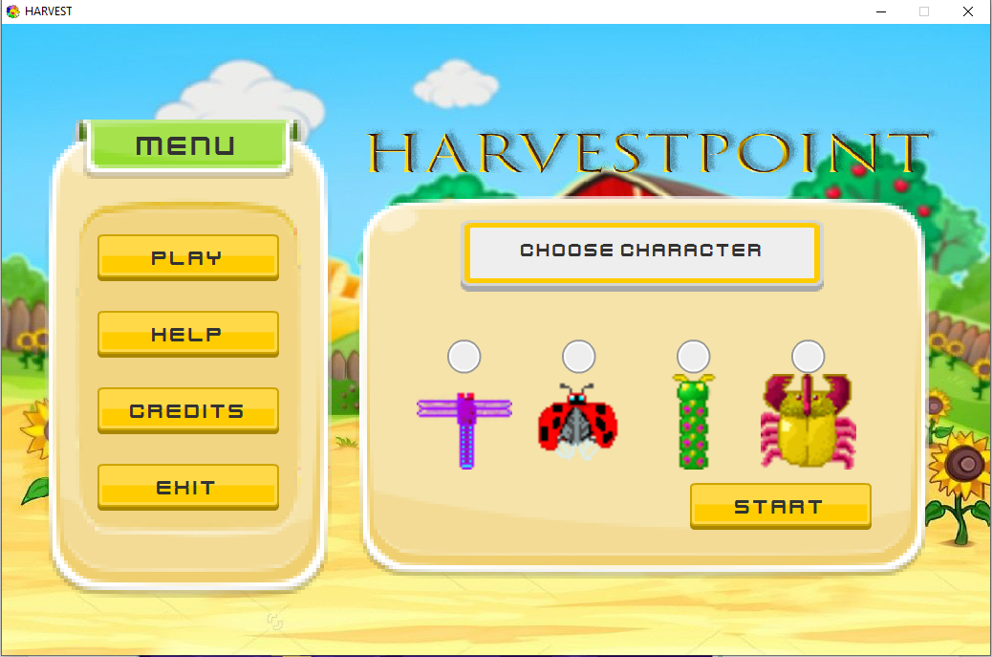

**Help subscene**

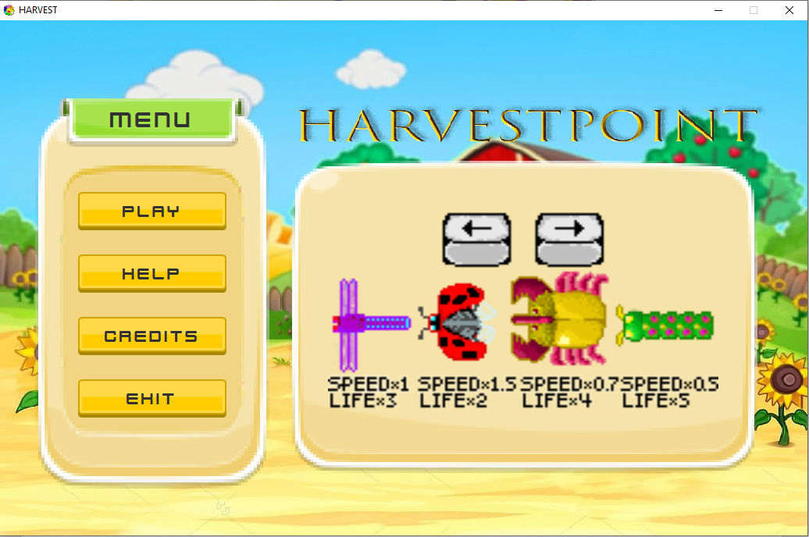

**Credits subscene**

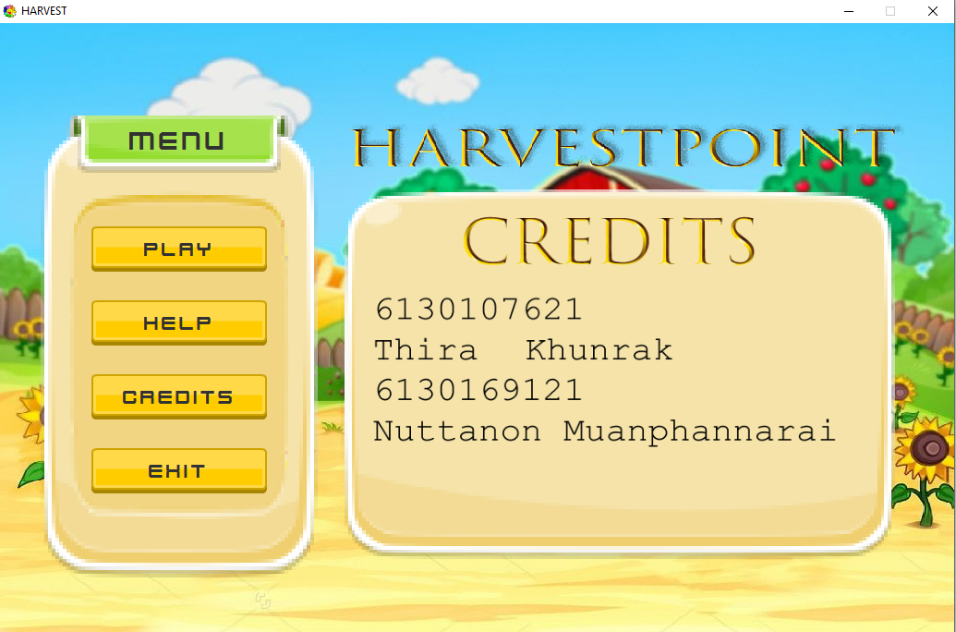

After you select the click start button to start the game

**In game scene**

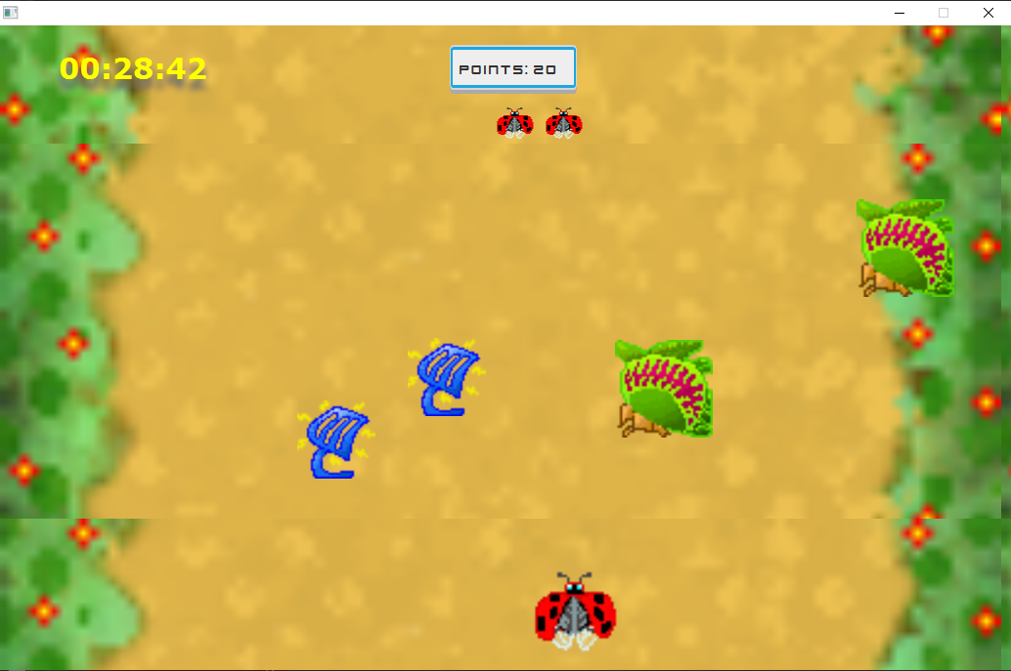

**Gameover scene**

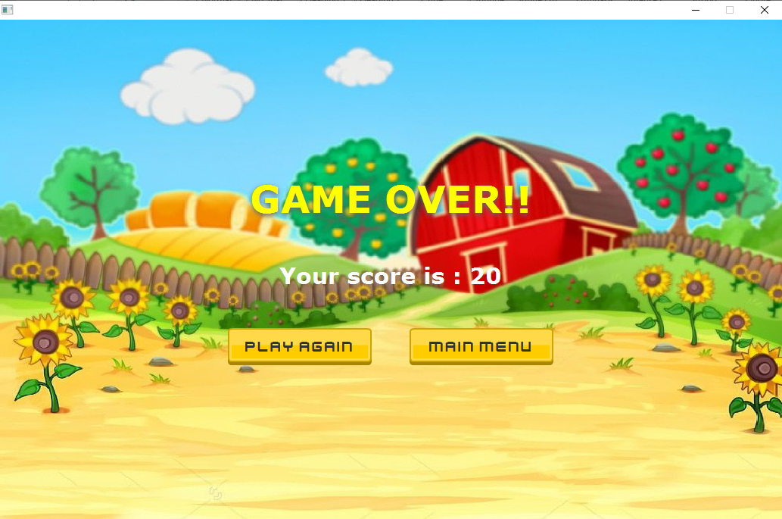

* “PLAY AGAIN” button will make you play again.
* “MAIN MENU” button will lead you back to main menu.

**Character**

|  |  |  |
| --- | --- | --- |
|  | Speed | Life |
| A close up of a device  Description automatically generatedDragonfly | 8 | 3 |
| A close up of a sign  Description automatically generatedLadybug | 10 | 2 |
| Beetle | 7 | 4 |
| Worm | 5 | 5 |

**Obstacle**

|  |  |
| --- | --- |
| Venus Flytrap | Lose 1 life |
| Insect swatter | Lose 1 life |
| Insecticide | Your character can’t move 2 seconds |

**Power up**

|  |  |
| --- | --- |
| Strawberry | Gain 1 extra life and get 10 scores |
| Murakami flower | Protect character from obstacle 1 time |

**UML**

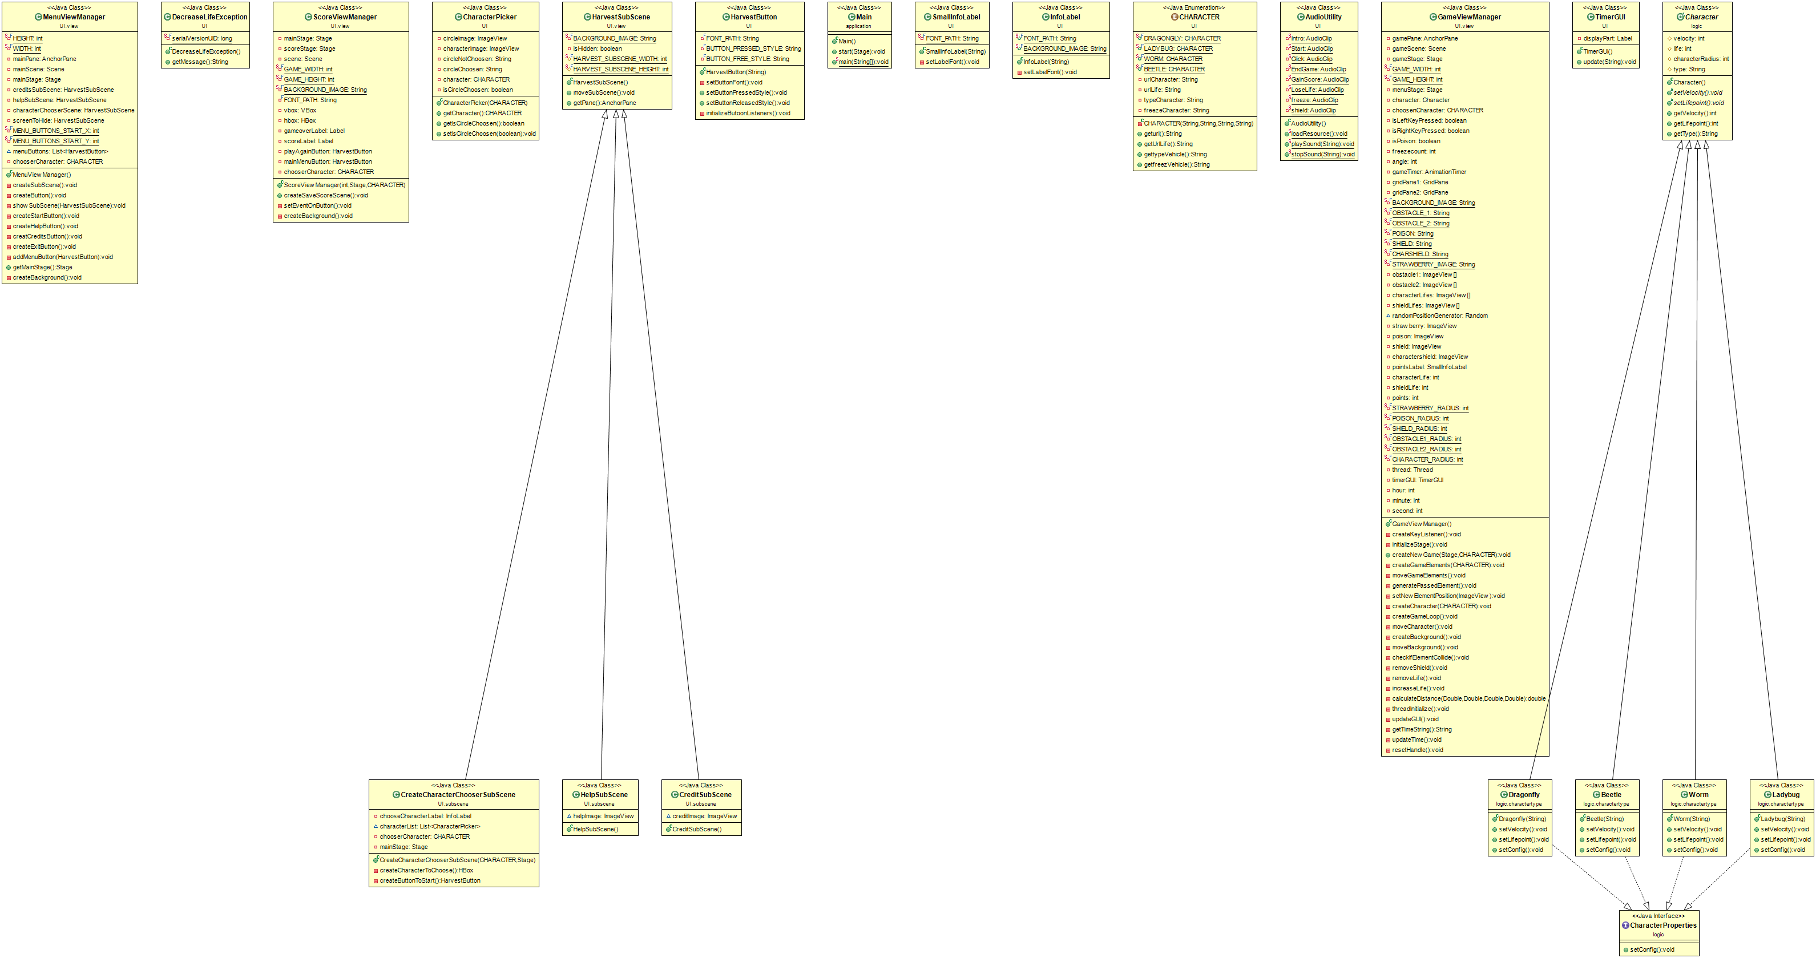

**1. Package application**

**1.1 Class:** Main extends Application

1.1.1 Method

|  |  |
| --- | --- |
| + void start(Stage primaryStage) | Initialize MenuViewManager and set it as primaryStage. |
| + void main(String[] args) | An entry point of application. |

**2. Package logic**

**2.1 Abstract Class: Character extends ImageView**

2.1.1 Field

|  |  |
| --- | --- |
| # int velocity | Velocity of the character. |
| # int life | Life of the character. |
| # int characterRadius | Radius of hit box of the character. |
| # String type | Sting type of the character. |

2.1.2 Method

|  |  |
| --- | --- |
| *+ void setVelocity()* | Setter for velocity. |
| *+ void setLife()* | Setter for life. |
| + public int getVelocity() | Getter for velocity. |
| + public int getLife() | Getter for life. |
| + public String getType() | Getter for String type. |

**2.2 Interface:** CharacterProperties

2.2.1 Method

|  |  |
| --- | --- |
| + public void setConfig() | Set configuration of character. |

**3. Package logic.charactertype**

**3.1 Class: Ladybug extends Character implements CharacterProperties**

* + 1. Constructor

|  |  |
| --- | --- |
| + Ladybug (String url) | - Initiaize setVelocity(), setLife(), setConfig().  - set url as character image.  - set type of the character to “ladybug”. |

* + 1. Method

|  |  |
| --- | --- |
| + void setVelocity() | Set character velocity to 10. |
| + void setLife() | Set character life to 2. |
| + void setConfig() | - Set image height and width to 100.  - Set position of character on x coordinate to 300 and y coordinate to 500 |

* 1. **Class:** Dragonfly extends Character implements CharacterProperties

3.2.1 Constructor

|  |  |
| --- | --- |
| + Dragonfly(String url) | - Initiaize setVelocity(), setLife(), setConfig().  - set url as character image.  - set type of the character to “dragonfly”. |

* + 1. Method

|  |  |
| --- | --- |
| + void setVelocity() | Set character velocity to 8. |
| + void setLife() | Set character life to 3. |
| + void setConfig() | - Set image height and width to 100.  - Set position of character on x coordinate to 300 and y coordinate to 500 |

**3.3** **Class:** Beetle extends Character implements CharacterProperties

3.3.1 Constructor

|  |  |
| --- | --- |
| + Beetle(String url) | - Initiaize setVelocity(), setLife(), setConfig().  - set url as character image.  - set type of the character to “beetle”. |

* + 1. Method

|  |  |
| --- | --- |
| + void setVelocity() | Set character velocity to 7. |
| + void setLife() | Set character life to 4. |
| + void setConfig() | - Set image height and width to 100.  - Set position of character on x coordinate to 300 and y coordinate to 500 |

**3.4** **Class:** Worm extends Character implements CharacterProperties

3.4.1 Constructor

|  |  |
| --- | --- |
| + Worm(String url) | - Initiaize setVelocity(), setLife(), setConfig().  - set url as character image.  - set type of the character to “worm”. |

* + 1. Method

|  |  |
| --- | --- |
| + void setVelocity() | Set character velocity to 5. |
| + void setLife() | Set character life to 5. |
| + void setConfig() | - Set image height and width to 100.  - Set position of character on x coordinate to 300 and y coordinate to 500 |

**4. Package UI**

**4.1 Class:** infoLabel extends Label

4.1.1 Field

|  |  |
| --- | --- |
| + String FONT_PATH | Sting path for font style. |
| + String BACKGROUND_IMAGE | String path for background image. |

4.1.2 Constructor

|  |  |
| --- | --- |
| + infoLabel(String text) | - Set width to 380 and set height to 30.  - Set the inset padding to 40 except top padding to 20.  - Set label text as text.  - Set wrapText to true.  - Set label font by using setLabelFont().  - Set an alignment to center.  - Initialize the background image from BACKGROUND_IMAGE and set the background. |

4.1.3 Method

|  |  |
| --- | --- |
| - void setLabelFont() | - Set label’s font to the FONT_PATH and set size to 23. But if fail to load font in FONT_PATH, use “Verdana” font instead and set size to 23. |

**4.2 Class:** SmallInfoLabel extends Label

4.2.1 Field

|  |  |
| --- | --- |
| - String FONT_PATH | String path for font style. |

4.2.2 Constructor

|  |  |
| --- | --- |
| + SmallInfoLabel(String text) | - Set Width to 130 and height to 50.  - Initialize the background image to blue_info_label. And set it as background.  - Set the inset padding to 10.  - Set font by use setLabelFont().  - Set label text from text. |

4.2.3 Method

|  |  |
| --- | --- |
| - void setLabelFont() | - Set font as the font that load from FONT_PATH and set font size to 15.If fail to load font use “Verdana” font insead. |

**4.3 Class:** AudioUtility

4.3.1 Field

|  |  |
| --- | --- |
| - Audioclip | Make audioclip field for Intro, Start, Click, EndGame, GainScore, LoseLife, freeze, shield. |

4.3.2 Method

|  |  |
| --- | --- |
| + void loadResource() | Load AudioClip of each field. |
| + void playSound(String identifier) | Play the AudioClip of the identifier.   * Only Intro and Start will play Indefinite. |
| + Void stopSound(String identifier) | Stop the AudioClip of the identifier. |

**4.4 Class:** HarvestButton extends Button

4.4.1 Field

|  |  |
| --- | --- |
| - String FONT_PATH | String path for font file. |
| - String BUTTON_PRESSED_STYLE | String path for pressed button image and background effect to transparent. |
| - String BUTTON_FREE_STYLE | String path for unpressed button image and background effect to transparent. |

4.4.2 Constructor

|  |  |
| --- | --- |
| + HarvestButton(String text) | - Set button text as text.  - Set font style by setButtonFont().  - Set width to 190 and height to 49.  - Set style as BUTTON_FREE_STYLE.  - Initialize button listener by initializeButoonListeners(). |

4.4.3 Method

|  |  |
| --- | --- |
| - void setButtonFont() | - Set font as the font that load from FONT_PATH and set font size to 23.If fail to load font use “Verdana” font instead. |
| + setButtonPressedStyle() | - Set style of button to BUTTON_PRESSED_STYLE.  - Set button height to 45.  - Change the position in Y coordinate downward by 4. |
| + setButtonReleasedStyle() | - Set style of button to BUTTON_PRESSED_STYLE.  - Set button height to 49.  - Change the position in Y coordinate upward by 4. |
| - void initializeButtonListeners() | - Set primary mouse pressed event to set button pressed style.  - Set primary mouse released event to set button released style.  - Set enter mouse event to set drop shadow effect to button.  - Set mouse exited event to remove button drop shadow effect. |

**4.5 Class:** TimerGUI extends Vbox

4.5.1 Field

|  |  |
| --- | --- |
| - Label displayPart | Label for show the time. |

4.5.2 Constructor

|  |  |
| --- | --- |
| + TimerGUI() | - Create drop shadow effect  - Set drop shadow color and property of offsetY.  - Set alignment to center.  - Set Spacing to 10.  - Set the insets padding to 10.  - Initialize displayPart.  - Set Font as “Verdana” and set bold style and seet size to 30.  - Set displayPart color and drop shadow effect.  - Add displayPart to TimerGUI as children. |

4.5.3 Method

|  |  |
| --- | --- |
| + void update(String text) | - Set displayPart text to text. |

**4.6 Class:** enum CHARACTER

4.6.1 Field

|  |  |
| --- | --- |
| - String urlCharacter | String path of select character. |
| - String urlLife | String path of select character’s life. |
| - String typeCharacter | Identify the class of character. |
| - String freezeCharacter | String path of freeze character. |

4.6.2 Constructor

|  |  |
| --- | --- |
| + CHARACTER(String urlCharacter,String urlLife,String typeCharacter,String freezeCharacter) | - Initialize character image path of each type.  - Initialize type of each character.  - Initialize character life image path of each type.  - Initialize freeze character image path of each type. |

4.6.3 Method

|  |  |
| --- | --- |
| Getter | Getter for character image path, type of each character, character life image and freeze character image path of each type. |

**4.7 Class:** CharacterPicker extends VBox

4.7.1 Field

|  |  |
| --- | --- |
| - ImageView circleImage | Image for select circle. |
| - ImageView characterImage | Image for character. |
| - String circleNotChoosen | String path of select circle that is not chosen. |
| - String circleChoosen | String path of select circle that is chosen. |
| - CHARACTER character | character for selected character. |
| - boolean isCircleChoosen | Boolean of circle is chosen or not. |

4.7.2 Constructor

|  |  |
| --- | --- |
| + CharacterPicker(CHARACTER character) | - Initialize circle image as circleNotChoosen.  - Initialize the character.  - Initialize characterImage as character image url.  - Set characterImage height and width to 100.  - Set isCircleChoosen to false.  - Set an alignment to center.  - Add circleImage and characterImage to CharacterPicker as children. |

4.7.3 Method

|  |  |
| --- | --- |
| + void setIsCircleChoosen(boolean isCircleChoosen) | - Set boolean for isCircleChoosen.  - Set circleImage to circleChoosen if isCircleChoosen is true, if false set to circleNotChoosen. |
| Getter | Getter for character and isCircleChoosen |

**4.8 Class:** DecreaseLifeException extends Exception

4.8.1 Field

|  |  |
| --- | --- |
| * long serialVersionUID | serialVersionUID = 1L |

4.8.2 Constructor

|  |  |
| --- | --- |
| - DecreaseLifeException() | super() |

4.8.3 Method

|  |  |
| --- | --- |
| + String getMessage | - Set message “Index out of range” and return it. |

**5. Package UI.subscene**

**5.1 Class:** CreateCharacterChooserSubScene extends HarvestSubScene

5.1.1 Field

|  |  |
| --- | --- |
| - InfoLabel ChooseCharacterLabel | The infolabel of choose character. |
| - List<Character> characterList | List for the character. |
| - CHARACTER chooserCharacter | The character that is choose. |
| - Stage mainStage | Stage for main stage. |

5.1.2 Constructor

|  |  |
| --- | --- |
| + CreateCharacterChooserSubScene (CHARACTER chooserCharacter, Stage mainStage,) | - Initialize chooserCharacter and mainStage.  - Initialize chooseCharacterLabel with “CHOOSE YOUR CHARACTER” text.  - Set layout of chooseCharacterLabel  - Add chooseCharacterLabel, createCharacterToChoose(), createButtonToStart() to pane as a children. |

5.1.3 Method

|  |  |
| --- | --- |
| - HBox createCharacterToChoose() | - Initialize HBox and set spacing to 20.  - Initialize the characterList. |
| - HarvestButton createButtonStart() | - Initialize Harvestbutton as start button.  - Set layout of start button.  - Set event button: when click Start game and already choose character (GameViewManger()). |

**5.2 Class**: CreditSubScene extends HarvestSubScene

5.2.1 Field

|  |  |
| --- | --- |
| imageView creditImage | Image for credit scene. |

5.2.2 Constructor

|  |  |
| --- | --- |
| + CreditSubScene() | - Initialize creditImage to the credit image URL.  - Set size and layout of the creditImage.  - Add creditImage to the pane as children. |

**5.3 Class:** HelpSubScene extends HarvestSubScene

5.3.1 Field

|  |  |
| --- | --- |
| imageView helpImage | Image for help scene. |

5.3.2 Constructor

|  |  |
| --- | --- |
| + CreditSubScene() | - Initialize helpImage to the help image URL.  - Set size and layout of the helpImage.  - Add helpImage to the pane as children. |

**6.Package UI.view**

**6.1 Class:** GameViewManager

6.1.1 Field

|  |  |
| --- | --- |
| - AnchorPane gamePane | The pane of game. |
| - Scene gameScene | The scene of game. |
| - Stage gameStage | The stage of game. |
| - int GAME_WIDTH | Make GAME_WIDTH = 1024. |
| - int GAME_HEIGHT | Make GAME_HEIGHT = 650. |
| - Stage mainStage | Stage of main stage. |
| - Character character |  |
| - CHARACTER choosenCharacter | Choosen character |
| - boolean isLeftKeyPressed | Boolean status of leftkey. |
| - boolean isRightKeyPressed | Boolean status of rightkey. |
| - boolean isFreeze | Freeze is false |
| - int freezecount | Freeze duration, equal 0 at first. |
| - int angle | angle that character rotate |
| - AnimationTimer gameTimer | Animationtimer |
| - Gridpane | Make GridPane of gridPane1, gridPane2. |
| - String | String path image of BACKGROUND_IMAGE, OBSTACLE_1, OBSTACLE_2, POISON, SHIELD, CHARSHIELD, STRAWBEERY_IMAGE. |
| - imageView[] | Image view[] of obsatcle1, obstacle2, characterLifes, shieldLifes. |
| Random randomPositionGenerator | Random position of obstacle to be spawn. |
| - imageView | ImageView of strawberry, poison, shield, charactershield. |
| - SmallInfoLabel pointsLabel | SmallInfoLAbel of score. |
| - int | number of characterLifes, shieldLife, strawberry. |
| - int | Int of radius of Object. STRAWBEERY_RADIUS = 25, POISON_RADIUS = 50, SHEILD_RADIUS = 50, OBSTACLE1_RADIUS = 40, OBSTACLE2_RADIUS = 35 , CHARACTER_RADIUS = 30. |
| - Thread thread | Thread to run |
| - TimerGui timerGUI | An instance of TimerGUI. |
| - int | Int amount of time. Hour, Minute, Second |

6.1.2 Constructor

|  |  |
| --- | --- |
| + GameViewManager() | - Initialize the stage, randomPositionGenerator, createkeyListener().  - Initialize charactershield image. |

6.1.3 Method

|  |  |
| --- | --- |
| - void createKeyListener() | - Set key pressed event   * If pressed left key set isleftKeyPressed is true, if pressed right key set isrightKeyPressed is true.   - Set key released event   * If released left key set isleftKeyPressed is false, if released right key set isrightKeyPressed is false. |
| - void initializeStage() | - Initialize gamePane, gameScene, gameStage.  - gameStage is not resizable and set gameScene as gameStage. |
| + void createNewGame(Stage menuStage, CHARACTER choosenCharacter) | - Initialize menuStage and hide it.  - Initialize choosenCharacter.  - Play sound “Start”.  - Create game loop, background, Character from choosenCharacter, game element as choosenCharacter.  - Show gameStage window.  - initialize the thread. |
| + void createGameElement(CHARACTER choosenCharacter) | - set character life and shield life.  - Initialize strawberry, poision, Shield set size and set spawn position by setNewElementPositio() and add to gamePane.  - Create score label “POINTS : 00” and set to the position.  - Initialize shieldLifes imageView[] to 5.  - initialize characterLifes imageView[] and set size and position of image and characterLifes add to gamePane.  - Initialize both of obstacles imageview[] to 9 set size and set each of its position by setNewElementPosition() then add it to gamePane. |
| - void moveGameElements() | - Make strawberry, shield, poison move downward with speed of 5.  - Make both obstacle speed equal character velocity and Speed increase when more time passed. |
| - void generatePassedElement() | Check do the element already pass the character then create it again with setNewElementPosition. |
| - void setNewElementPosition(ImageView image) | Randomly set the position of image.  (randomPositionGenerator()) |
| - void createCharacter(CHARACTER choosenCharacter) | - Create character as the type of choosenCharacter.  - Set character layout.  - Create characterShield and set size and layout, set visible to false.  -Add characterShield, character to gamepane as children. |
| - void createGameLoop() | - Create gameTimer .  - Make background move and game element move and character move.  - Check does element collide to character by calling checkIfElementCollide().  - update time and GUI. |
| - void moveCharacter() | - Make character and characterShield to move and make character rotate when move left or right. |
| - void createBackround() | - Create 2 gridpane then add BACKGROND_IMAGE to both gridpane.  - Set lay out of second gridpane next to the another one the add to the gamePane. |
| - void moveBackground() | - Move both gridpane of background the same speed of character velocity. when each one get off screen set that pane to first position. |
| - void checkIfElementCollide() | - Check collision by compare radius of character and element radius to distance between them.  - When character collide the strawberry: life increase, play sound “GainScore” and increase point.  - If character is poison: freezecount is increase to 100 then reset freezecount to zero and poison is false.  - If character collide the poison: character is poison and playSound “freeze” and set new position for poison.  - If character collide the shield: character get 1 shield life and playSound “Shield”  Create shieldlife imageView and add to gamePane Set new position for shield.  - If character collide to obstacle: if character still have shield, shield life decrease. If character has no shield decrease character life. and playSound “LoseLife”. |
| - void removeShield() throws DecreaseLifeException | - If shield = -1 throw the exception.  - Decrease ShieldLife by 1 and remove shield life in shieldLifes from gamePane. |
| - void removeLife() throws DecreaseLifeException | - If shield = -1 throw the exception.  - Decrease characterLife by 1 and remove characterLife in characterLifes from gamePane, if life less than 0 playSound “EndGame” close game and stop game timer.  - Create score view and playSound “Start”. |
| - void increaseLife() | Increase character life by 1 and add characterLife to characterLifes in gamePane. |
| - double calculateDistance(Double x1, Double x2, Double y1, Double y2) | Calculate distance between character and the element. |
| - void threadInitialize() | Initialize thread for update time and GUI. |
| - void updateGUI() | update the game timer (getTimeString()). |
| * String getTimeString() | return sting time in the format of HH:mm:ss. |
| - void updateTime() | update time. |
| - void resetHandler() | reset the timer to 00:00:00 and update GUI. |

**6.2 Class:** MenuViewManager

6.2.1 Field

|  |  |
| --- | --- |
| - int HEIGHT | Make height = 650 |
| - int WIDTH | Make width = 1024 |
| - AnchorPane mainPane | Make main pane |
| - Scene mainScene | Make main scene |
| - Stage mainStage | Make main stage |
| - HarvestSubScene | Make HarvestSubScene of creditsSubScene, helpSubScene, characterChooserScene, screenToHide. |
| - int | MENU_BUTTONS_START_X = 100, MENU_BUTTONS_START_Y = 220 |
| List<HarvestButton> menuButtons | List of Harvest button |
| - CHARACTER chooserCharacter | Character that choose |

6.2.2 Construtor

|  |  |
| --- | --- |
| + MenuViewManager() | - Initialize menuButtons, mainPane, mainStage, CreateSubScene(), createButton(), createBackground().  - Initialize mainScene with mainPane and WIDTH, HEIGHT.  - Play sound “Intro”.  - Set mainStage scene and can’t resizable.  - Set title “HARVESTPOINT” and icon. |

6.2.3 Method

|  |  |
| --- | --- |
| - void createSubScene() | - Initialize creditsSubScene, helpSubScene, characterChooserSubScene with chooserCharacter and mainStage.  - Add all of it to mainPane. |
| - void createButton() | - Initialize createStartButton(), createHelpButton(), creatCreditsButton(), createExitButton(). |
| - void showSubScene(HarvestSubScene subScene) | - Move subScene to show that choose and hide the last one.  - Play sound “Click”. |
| - void createStartButton() | - Create startButton with text “Play”. And add to mainPane by addMenuButton().  - If startButton is click show characterChooserScene. |
| - void createHelpButton() | - Create helpButton with text “HELP”. And add to mainPane by addMenuButton().  - If helpButton is click show helpSubScene. |
| - void creatCreditsButton() | - Create creditButton with text “CREDITS”. And add to mainPane by addMenuButton().  - If creditButton is click show creditsSubScene. |
| - void createExitButton() | Create exitButton with text “EXIT”. And add to mainPane by addMenuButton().  - If exitButton is click, close mainStage. |
| - void addMenuButton(HarvestButton button) | - Set button layout and add it to menuButtons.  - Add buttons to mainPane. |
| + Stage getMainStage() | Getter of mainStage. |
| - void createBackground() | - Load and set background image of mainPane. |

**6.3 Class:** ScoreViewManager

6.3.1 Field

|  |  |
| --- | --- |
| - Stage mainStage | Stage of main |
| - Stage scoreStage | Stage of score log |
| - Scene scene | Scene for score |
| - int | GAME_WIDTH = 1024, GAME_HEIGHT = 650 |
| - String BACKGROUND_IMAGE | String path for background image. |
| - String FONT_PATH | String path for font. |
| - VBox vbox |  |
| - HBox hbox |  |
| - Label gameoverLabel | Label text for gameover. |
| - Label scoreLabel | Label for score. |
| - HarvestButton playAgainButton | Button for play the game again. |
| - HarvestButton mainMenuButton | Button to get back to main menu. |
| - CHARACTER chooserCharacter | Character that choose. |

6.3.2 Constructor

|  |  |
| --- | --- |
| ScoreViewManger(int score, Stage mainStage, CHARACTER chooserCharacter) | - Initialize mainStage, chooserCharacter, Dropshadow().  - Set gameoverLabel Font “Verdana” and size 50 with text “GAME OVER!!”.  - Set gameoverLabel text color to yellow and dropshadow effect.  - Set scoreLabel Font “Verdana” and size 30 with text “Your score is [score]”.  - Load Font for both button from FONT_PATH with size 15 if fail to load font set font to “Verdana” with size 23.  - Initialize hbox set an alignment to center and spacing to 50.  - Add playAgainButton, mainMenuButton to hbox.  - Initialize hbox set an alignment to center with spacing to 50.  - Add gameoverLabel, scoreLabel, hbox to vbox.  - Initialize scoreStage and it can’t resize.  - Initialize with vbox, game width and height.  - set EventOnButton by calling setEventonButton() and create background. |

6.3.3 Method

|  |  |
| --- | --- |
| + void createSaveScoreScene() | Show score stage. |
| - void setEventOnButton() | - If click playAgainButton close scoreStage and start newGame.  - If click mainMenuButton close scoreStage and show mainStage with “Intro” sound. |
| - void createBackground() | - Load backgroundImage from BACKGROUND_IMAGE. And set as vbox background. |

**6.4 Class:** HarvestSubScene extends SubScene

6.4.1 Field

|  |  |
| --- | --- |
| - String BACKGROUND_IMAGE | String path of image |
| - boolean isHidden | Status of subscene |
| # int | HARVEST_SUBSCENE_WIDTH = 600, HARVEST_SUBSCENE_HEIGHT = 400 |

6.4.2 Construtor

|  |  |
| --- | --- |
| + HarvestSubScene() | - Create AnchorPane() with width and height as root.  - Load and set background image for anchorPane.  - Set isHidden is true.  - Set layout of subscene. |

6.4.3 Method

|  |  |
| --- | --- |
| + void moveSubScene() | -Create and set the duration of TranslateTransition to 0.3 second. If isHidden is true move subscene out. Else move subscene in to the main scene. |
| + AnchorPane getPane() | getter of Anchor pane root |