Electoral Roll PDF to Excel
Project Requirements Document

1. What This Project Should Do

1.1 Take Electoral Roll PDFs as Input
- Accept Tamil Nadu electoral roll PDF files
- These PDFs contain voter information in Tamil language
- Each PDF has multiple pages with voter details
Sample Electoral Roll PDF Page
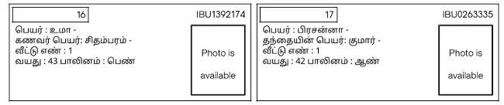

1.2 Extract the Following Information from Each Voter Entry
For Each Voter, Get:
- Serial Number (1, 2, 3, etc.)
- Voter ID Number (like IBU1392174, IBU0263335)
- Voter's Name (in Tamil)
- Age
- Gender (Male/Female)
- Father's or Husband's Name
- Complete Address
- Ward Number
- Constituency Code
- Whether Photo is Available or Not

1.3 Put All Data into Excel Files
Create Excel Sheets With These Columns:
Column | Field Name | Description
A | Serial Number | Sequential number from the PDF
B | Voter ID | Unique voter identification number
C | Name (Tamil) | Voter's name in Tamil script
D | Name (English) | English translation if possible
E | Age | Voter's age in years
F | Gender | Male (M) or Female (F)
G | Relation Type | Father or Husband
H | Relation Name | Father's or Husband's name in Tamil
I | Address | Complete residential address in Tamil
J | Ward Number | Electoral ward number (e.g., 42)
K | Constituency | Constituency code (e.g., S22)
L | Photo Available | Yes or No

1.4 Handle Multiple PDFs
- Process many PDF files at once
- Create separate Excel files for each ward
- Name files properly: Ward_42_Electoral_Roll_2026.xlsx

2. Expected Results
- Input: Tamil Electoral Roll PDF files
- Output: Organized Excel files with all voter information
- Quality: 100% accurate data extraction
- Format: Easy to search, sort, and analyze in Excel

3. Success Criteria
- All voter records extracted successfully
- Tamil text properly displayed in Excel
- No data loss or corruption
- Excel files can be opened and searched easily
- Data can be sorted and filtered
- Summary statistics are accurate

4. Important Notes
- The PDFs are in Tamil language
- Some PDFs might have scanned images instead of text
- Voter IDs follow a specific pattern (3 letters + 7 numbers)
- Each voter entry has a photo placeholder marked "Photo is available"
- The data must maintain the same order as in the PDF

