SAP SuccessFactors Employee Central Implementation with Workflow Automation Multi-Country Setup (India & UAE)

Company: Zenith Global Solutions (Simulated Project) Duration: 3 weeks
Role: SAP SuccessFactors EC Functional Consultant (Trainee / Self-Project)

- 1. Introduction

This project focuses on the implementation of SAP SuccessFactors Employee Central (EC) with key configurations including organization structure, compensation setup, business rules, workflows, and custom MDF objects.

The project also includes multi-country setup (India & UAE), basic recruitment exposure, and data migration concepts.

Project Scenario

This project simulates an end-to-end employee lifecycle for a global organization operating in India and UAE.
A business scenario was designed where:

  - A job requisition is managed for hiring in the Sales department (UAE)
  - Employee hiring is performed in Employee Central
  - Business rules are triggered for salary validation and workflow approval
  - Workflow is routed through Manager and HR roles
  - Role-Based Permissions (RBP) control access for HR, Manager, and Employee
  - Employee data is managed and validated across multi-country setup

2. System Landscape

  - Source System: SAP HCM (Legacy)
  - Target System: SAP SuccessFactors Employee Central
  - Modules Covered:
  - Employee Central (Strong)
  - Recruitment (RCM – Basic)
  - Integration & Migration (Basic)

3. Foundation Object Configuration

  - Legal Entity

    - Legal entities were created for:

    - India
    - UAE

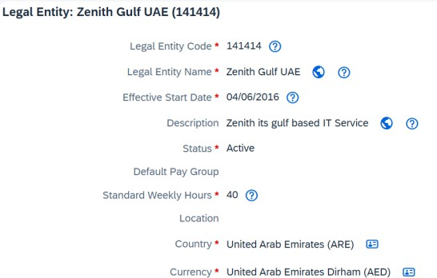
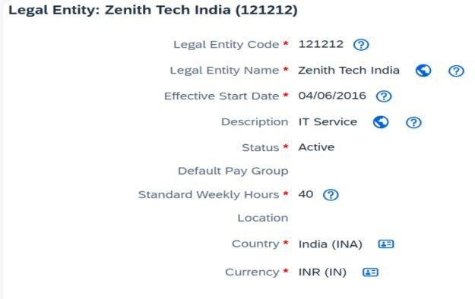
–− Image: Legal Entity Screen

Legal Entity configuration for India and UAE

Department Structure

Departments were configured to represent business units such as Sales, HR, and IT.

− – Image: Department Screen

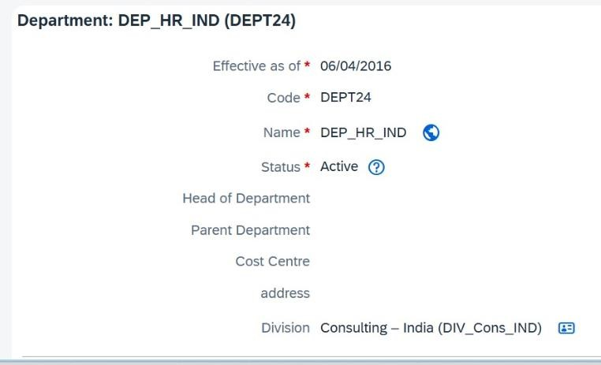
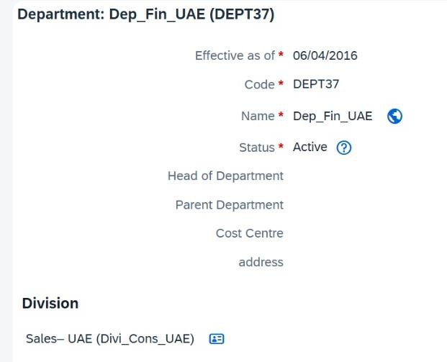

’‘vz Caption: Department structure configuration used in Job Information

Picklist Configuration

Picklists were created for standard fields. Gender Picklist

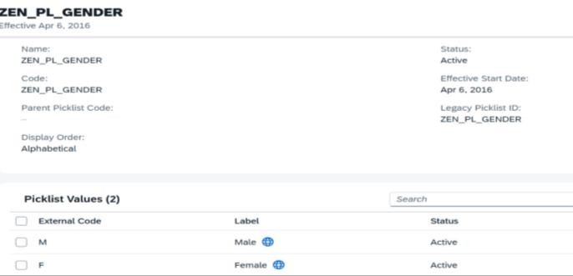

‘vz’ Caption: Picklist Configuration – Gender

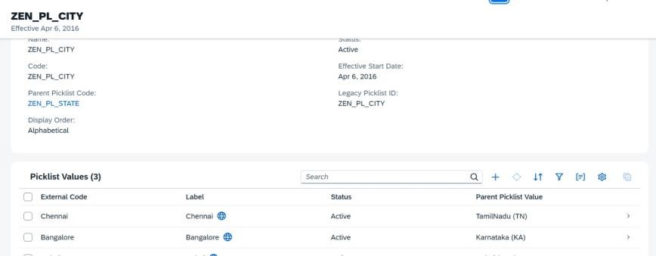
Country Picklist

- 3.4 Location

– − Image: Country Picklist (India & UAE)

v‘’z Caption: Picklist Configuration – Country (India & UAE)

Location objects were configured to represent employee work locations across India and UAE.

çˆ◆·•.。, Image: Location Screen
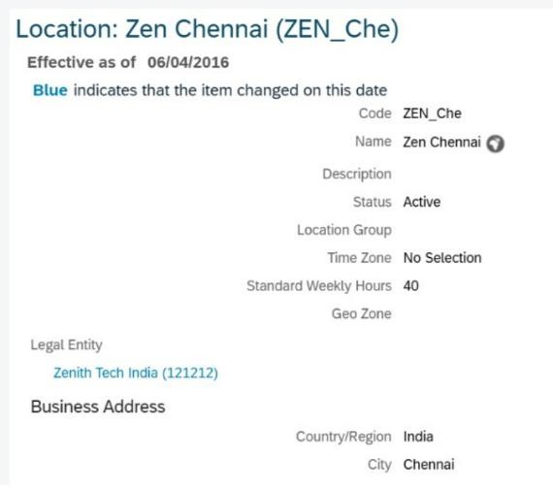
’‘zv Caption: Location configuration for multi-country setup

3.5 Job Classification

Job Classification was configured to define employee roles and designations within the organization.

ˆç,.。•·◆ Image: Job Classification Screen
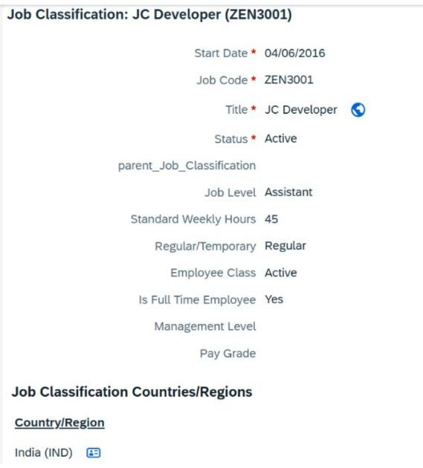
’‘zv Caption: Job Classification used for employee role mapping

3.6 Event & Event Reason Configuration

Event and Event Reason were configured to track employee lifecycle changes within the system.

Standard events such as:

  - Transfer
  - Promotion

were configured along with corresponding event reasons (Zen_Transfer, Zen_Promotion) to capture different types of employee movements.
These configurations were used in Job Information to:

  - Track employee changes
  - Maintain job history
  - Support workflow and business rule execution

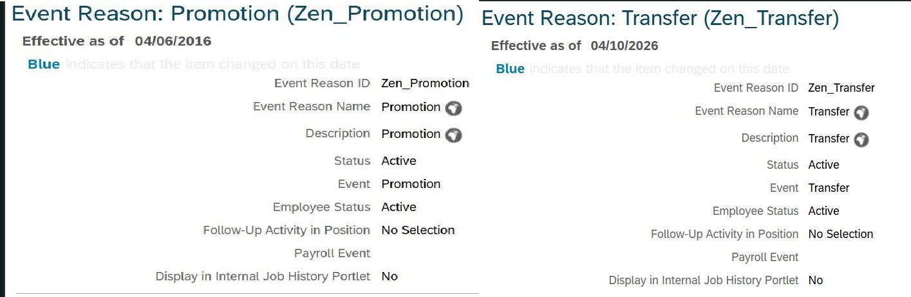
– − Image: Event Reason – Transfer Configuration C Promotion Configuration
zv‘’ Caption: Event Reason setup for employee transfer tracking C Event Reason setup for employee promotion tracking

3.7 Time Management Configuration
Time Management elements were configured to manage employee working schedules and holidays across different locations.

- Holiday Calendar- Holiday Calendar was created to define organization-specific holidays applicable for employees.

ˆç,.。•·◆ Image: Holiday Calendar Screen

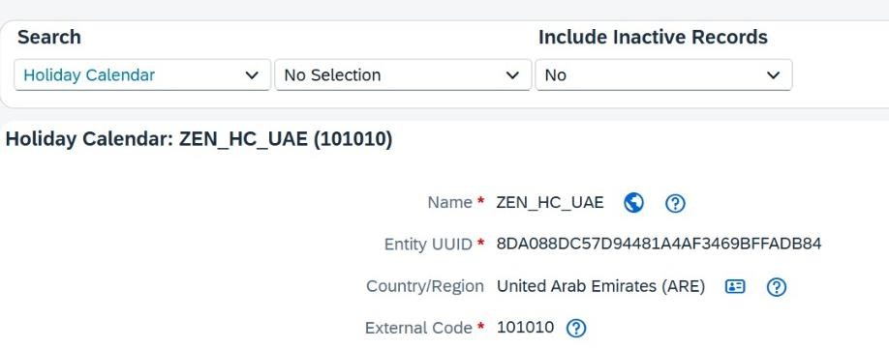

zv‘’ Caption: Holiday Calendar defining holidays for employees

Work Schedule

Work Schedule was configured to define employee working days and standard weekly hours.

ˆç,.。•·◆ Image: Work Schedule Screen
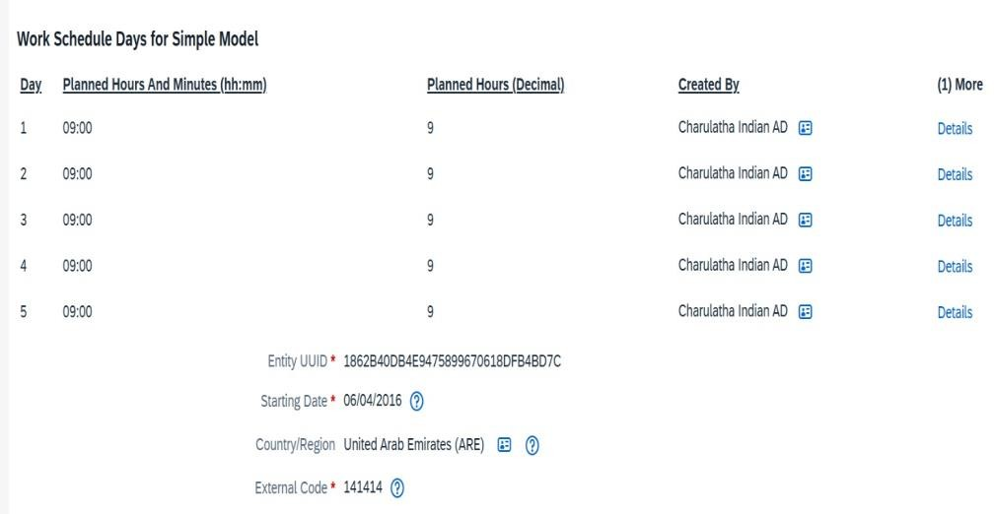

z’‘v Caption: Work Schedule defining employee working pattern and weekly hours

4. Compensation Configuration

  - Pay Component- Pay components such as Basic Pay, HRA, and Bonus were created.

– − Image: Pay Component
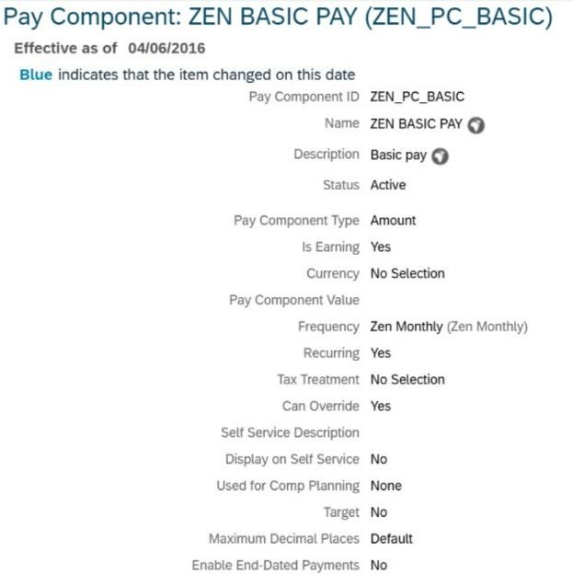

’‘vz Caption: Pay Component configuration defining salary elements

Pay Component Group

A pay component group was created to combine multiple salary components.

– − Image: Pay Component Group
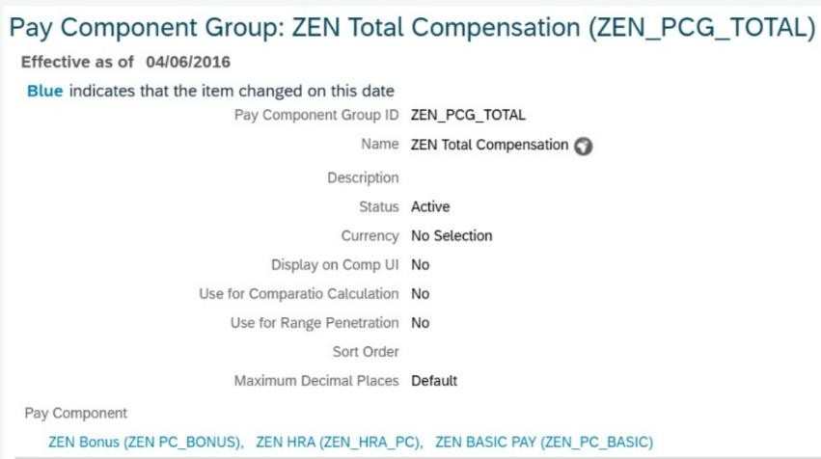

z’‘v Caption: Pay Component Group representing total compensation structure

Pay Grade

Pay grades were defined to categorize employees based on salary levels.

– − Image: Pay Grade
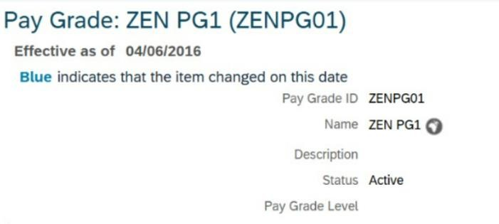

’‘vz Caption: Pay Grade configuration for employee classification

  - Pay Range: Pay ranges were configured to define minimum and maximum salary limits.
− – Image: Pay Range
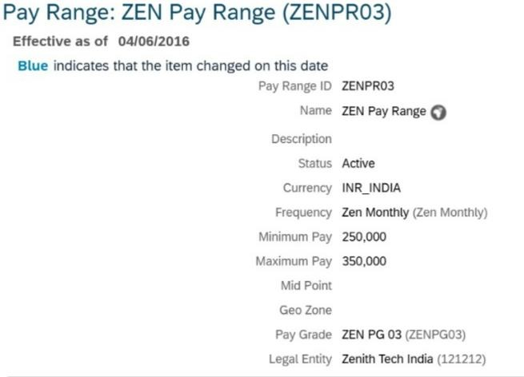

v‘z’ Caption: Pay Range configuration with defined salary bands

5. Workflow Configuration

A workflow was configured for approval process:

  - Step 1: Manager
  - Step 2: HR
  - Step 3: Director

−– Image: Workflow Screen
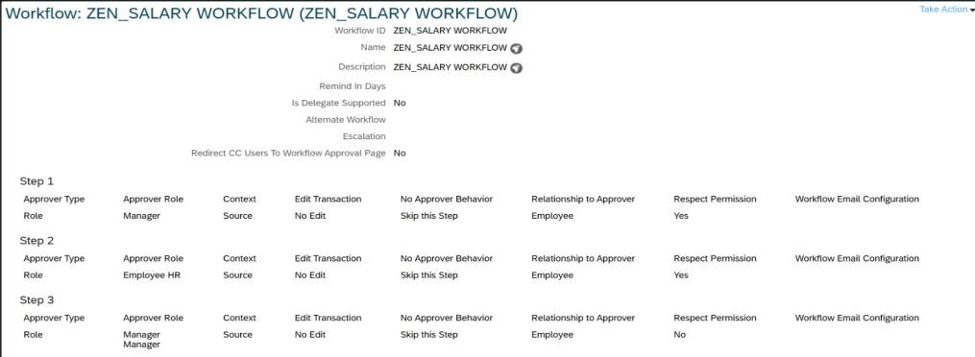

zv‘’ Caption: Workflow configuration for approval hierarchy

O 6. Business Rule Configuration

Rule 1: Department-Based Workflow Trigger

  - Condition: If Department = Sales
  - Action: Trigger Salary Approval Workflow
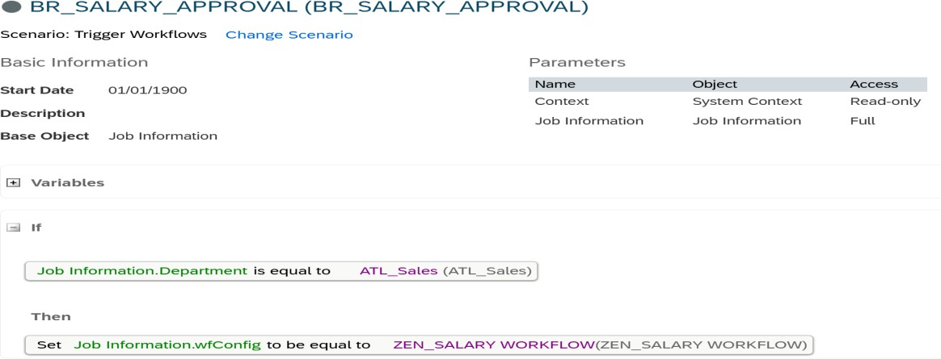
– − Image: Business Rule Screen

’‘vz Caption: Business Rule triggering workflow based on department

Rule 2: Location-Based Currency Condition: If Location = Dubai Action: Set Currency = AED
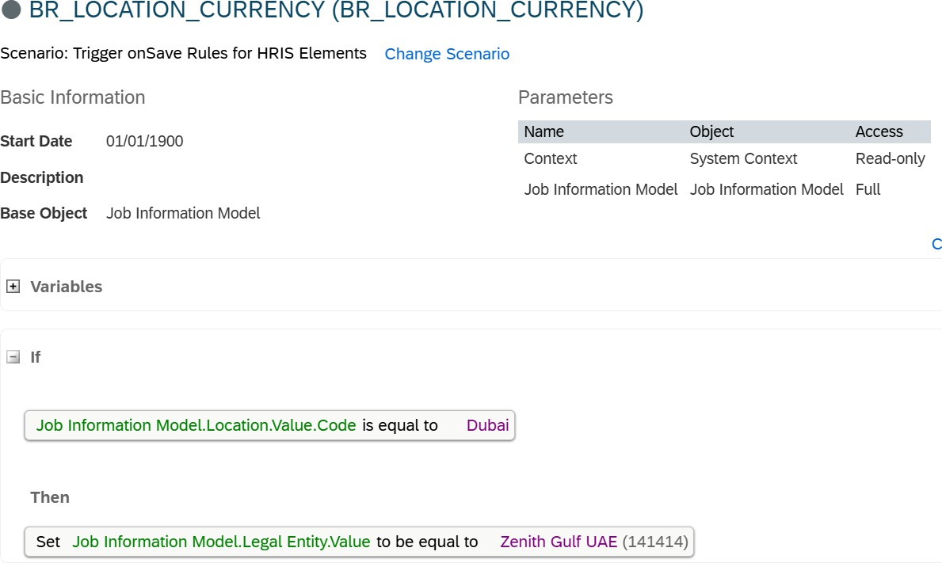

zv‘’ Caption: Business Rule for location-based currency assignment

Rule 3: Salary Increase Validation Condition: If Salary increase > 20% Action: Trigger approval workflow
– − (Optional image)

v‘’z Caption: Business Rule for salary validation and approval

O 7. Recruitment (RCM – Requisition Management)

Recruitment Management (RCM) module was explored to understand the hiring process within SAP SuccessFactors.
Recruiting settings were configured to enable recruitment features such as business rules, email communication, and agency access.
Job requisitions were accessed through the system, where details like Job Title, Requisition ID, Hiring Manager, and recruitment status were reviewed.
The system provided visibility into:

  - Job requisition management
  - Candidate tracking
  - Hiring workflow monitoring
  - Recruitment configuration settings

This helped in understanding the overall recruitment process from requisition to hiring. Recruitment process was analyzed from requisition management to candidate tracking and hiring workflow.

Recruitment (RCM) – System Screens
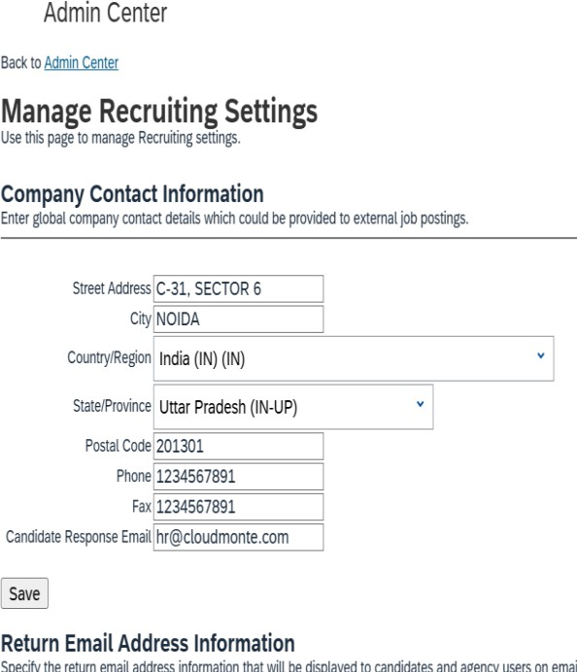
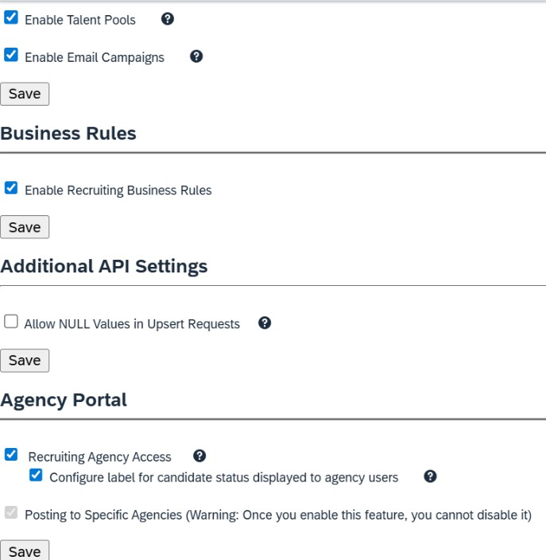
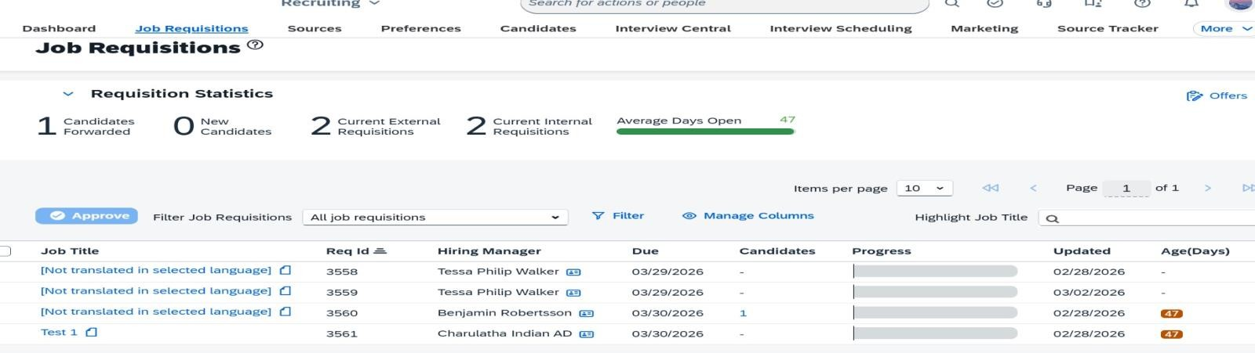

v‘z’ Recruitment module configuration and job requisition management in SAP SuccessFactors

O 8. Employee Hiring Simulation

An employee was hired in the system to validate configured business rules and workflow automation.
  - Department: Sales
  - Location: Dubai

Results:

  - Workflow was successfully triggered based on department
  - System validated configured business rules during employee creation

–− Image: Employee Hiring – Workflow Trigger
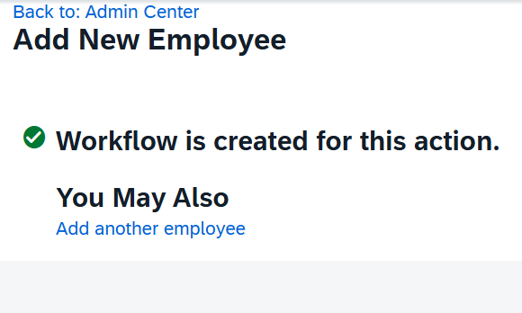
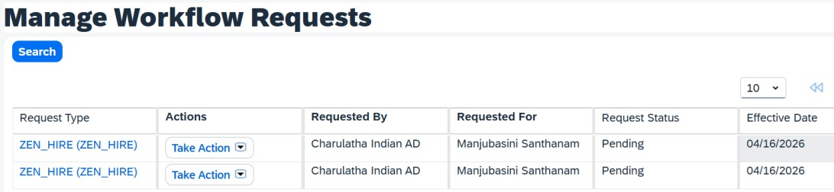

’‘vz Caption: Workflow successfully triggered during employee hiring

O Workflow Validation

The employee hiring process was tested successfully, and workflow was triggered based on configured business rules.
Due to system-level access restrictions, the approval step could not be completed. However, workflow routing and triggering were validated successfully.

O 9. Role-Based Permissions (RBP)

Role-Based Permissions (RBP) were configured to control user access within the system.An HR role (ZEN HR Role) was created and basic permissions were assigned for:
  - Viewing employee data
  - Editing job information
  - Managing employee-related transactions

Role assignment was also completed by assigning the role to users with access population set to all employees.
Additionally, the concept of different roles such as HR, Manager, and Employee was analyzed, and the permission structure for workflow approvals and role hierarchy was clearly understood.
Due to limited system access and time constraints, advanced permission configurations were not fully implemented, but the overall RBP framework and process were successfully practiced and documented.
−– Image: RBP Role Creation and Assignment Screen
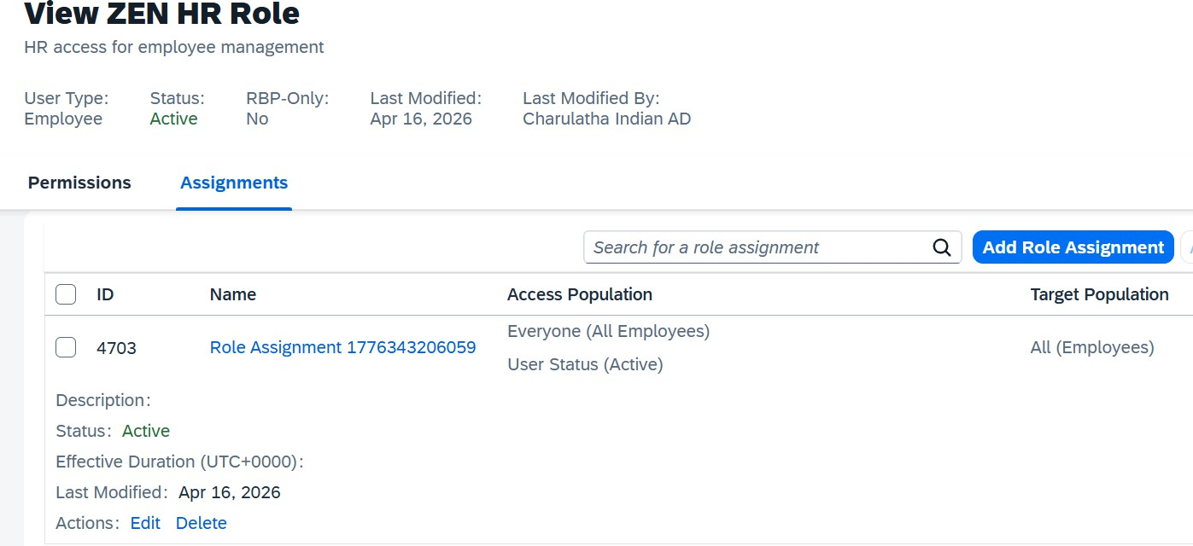
zv‘’ Caption: HR Role (ZEN HR Role) with permissions and assignment configured

O 10. Employee Data Management

Employee data structure and hiring process were studied and partially tested. Employees were planned for:
  - India (INR currency)
  - UAE (AED currency)
  - Job Information includes:
  - Department
  - Location
  - Legal Entity
  - Pay Structure
  - Instead of bulk creation, sample employee records were considered to validate:
  - Business rules
  - Workflow triggers

  - Multi-country configuration

The hiring workflow and employee lifecycle process were clearly understood.

O 11. Custom MDF Object

A custom MDF object “Visa Tracking” was created to manage employee visa details.

  - Fields configured include:
  - Employee Reference
  - Visa Number
  - Visa Type
  - Issue Date
  - Expiry Date
  - Status
This object demonstrates the ability to extend standard Employee Central functionality using MDF (Metadata Framework).
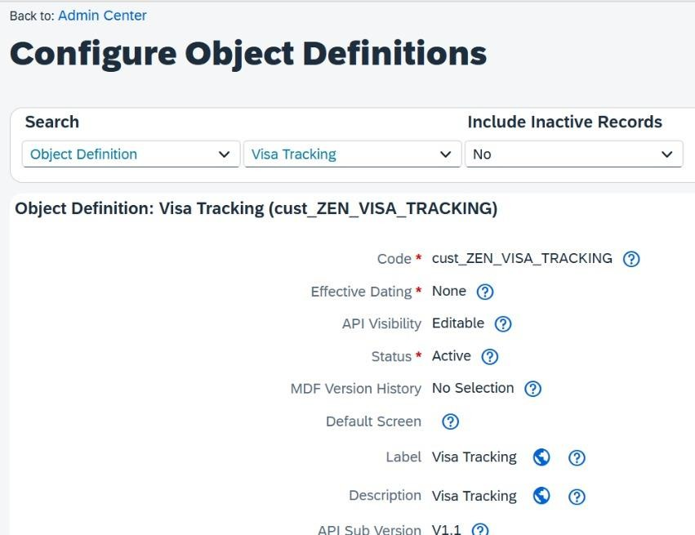
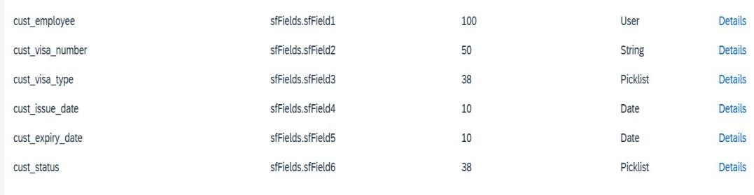

z’v‘ Caption: Custom MDF Object used for employee visa management

O 12. Data Management (Import & Export)

Basic data management activities were performed using Import and Export functionality in SAP SuccessFactors.
  - Exported employee and job-related data using the Import and Export Data tool
  - Selected relevant objects such as Job Information and Employee Details for data extraction
  - Understood configuration options like key preference, dependencies, and data selection
  - Verified export execution using Scheduled Job Manager, ensuring successful completion of data extraction
  - Downloaded employee data templates to understand the structure required for bulk data upload
  - Analyzed CSV template format for future data import activities

Due to system limitations, full data import was not executed, but the complete process and data structure were clearly understood.
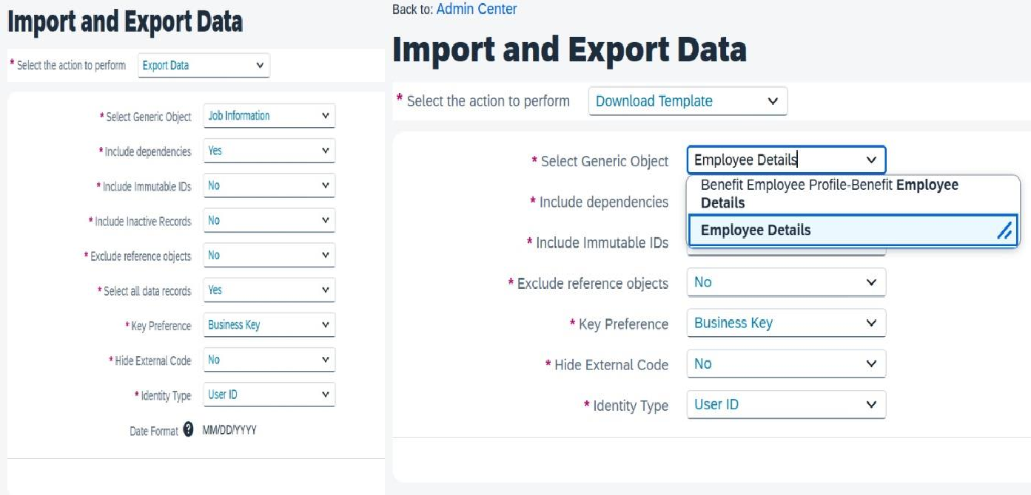

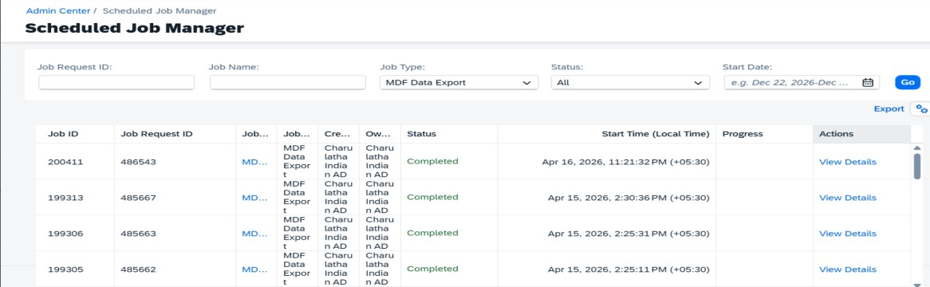

Data Export & Import Process in SAP SuccessFactors

O 13. Data Migration

Data migration approach was designed conceptually.

Steps include:

  - Extracting employee data from SAP HCM
  - Mapping legacy fields to Employee Central fields
  - Data cleansing (removal of duplicates, correcting errors)
  - Preparing upload templates

Multi-country data handling:

  - India → INR
  - UAE → AED

Due to project timeline, actual bulk upload was not executed, but the complete migration process and templates were understood.

O 14. Integration Overview

Basic understanding of integration was covered. Initial data migration planned via file-based upload Ongoing integration planned using:
  - Integration Center
  - SAP Integration Suite (CPI)
  - API-based integration concepts were explored at a foundational level.

O 15. Testing & Validation

Testing approach included:

  - Validating business rule logic
  - Verifying workflow trigger conditions
  - Checking configuration consistency

Some configurations resulted in errors during testing, which were analyzed and resolved through debugging steps.

Even though full end-to-end testing was not completed, the validation approach and troubleshooting process were clearly understood.

O 16. Conclusion (IMPORTANT)

This project demonstrates a structured and practical approach to SAP SuccessFactors Employee Central implementation with workflow automation.
Key highlights include:

  - End-to-end understanding of employee lifecycle management
  - Hands-on exposure to business rules, workflows, and RBP configuration
  - Multi-country implementation scenario (India & UAE)
  - Practical exposure to recruitment, data migration, and integration concepts

Although some configurations were partially completed due to system limitations, the overall implementation approach, system behavior, and real-time project flow were clearly understood and validated through simulation.

