Case Study: SAP SuccessFactors Employee Central Implementation
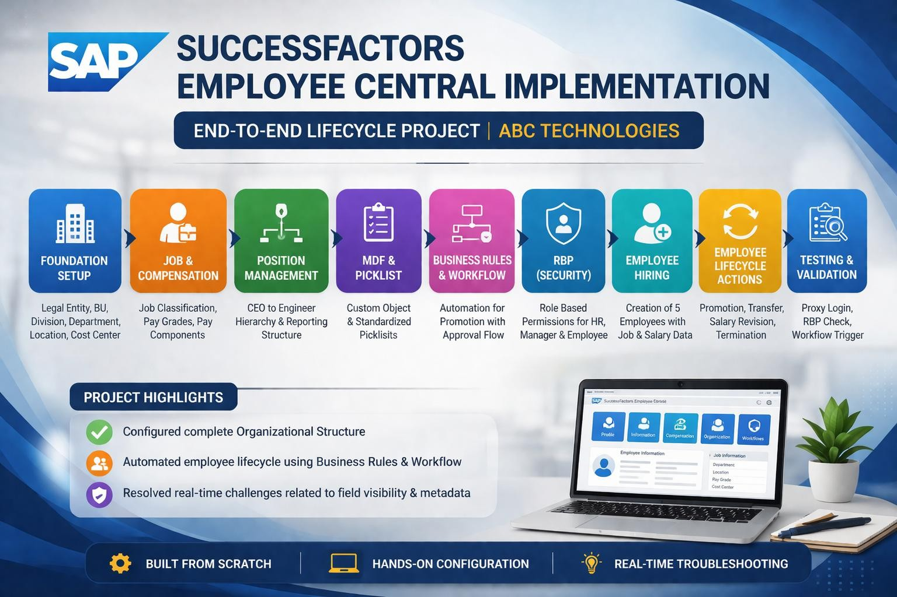
- Project Overview
This project demonstrates the end-to-end configuration of Employee Lifecycle Management
using SAP SuccessFactors for Employee Central.
The objective is to automate HR processes such as Hiring, Promotion, Transfer, Salary Revision, and Termination using:
  - Business Rules
  - Workflows
  - Dynamic Roles
  - Foundation Objects
The system ensures smooth approval of flow, data validation, and role-based access control.

Project Flow (Flow Chart)
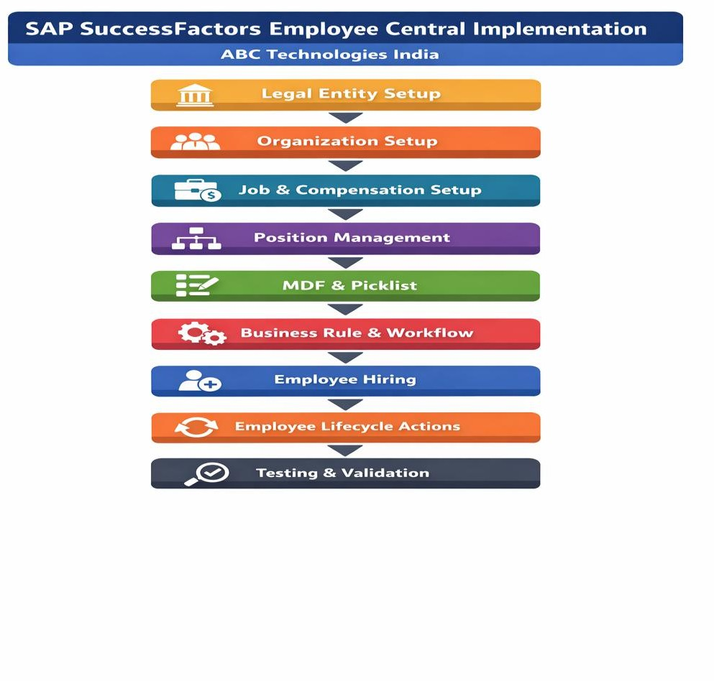
- Foundation Object Configuration
Configured the following foundation objects:
  - Legal Entity → ABC Technologies Pvt Ltd
  - Business Unit → IT Service
  - Division → Software Development
  - Department → HR, IT, Finance
  - Location → Bangalore
  - Cost Center → CC1001
  - Pay Grade → PG1, PG2, PG3

Purpose:
  - Legal Entity → Defines organization

  - Business Unit → Represents IT Service function
  - Division → Represents Software Development unit
  - Department → Defines functional teams
  - Location → Work location (Bangalore)
  - Cost Center → Financial tracking (CC1001)
  - Pay Grade → Salary structure

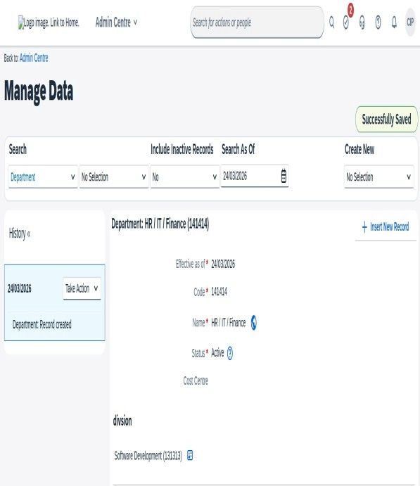
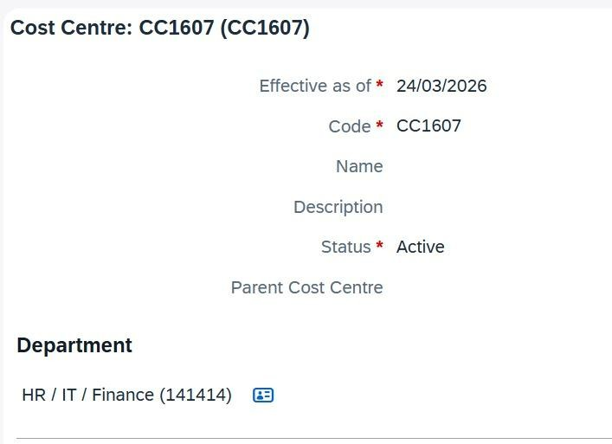
Department creation screen & Cost Centre Screen

- Job & Compensation
The job and compensation structure was configured as follows:

  - Job Classification → Software Engineer, HR Executive
  - Pay Grade → PG1, PG2
  - Pay Range → 3L–6L, 6L–10L
  - Pay Component → Basic Pay, HRA, Bonus
  - Pay Component Group → Total Salary

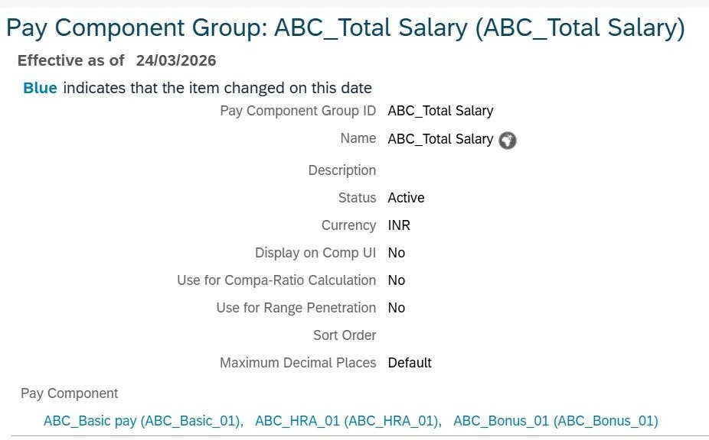

− – Purpose:
To define salary structure and job roles within the organization.

Position Management
Position hierarchy was created and configured:
  - CEO → P001
  - HR Manager → P002
  - IT Manager → P003
  - HR Executive → P004
  - Software Engineer → P005
–− Hierarchy was maintained using Position Org Chart.

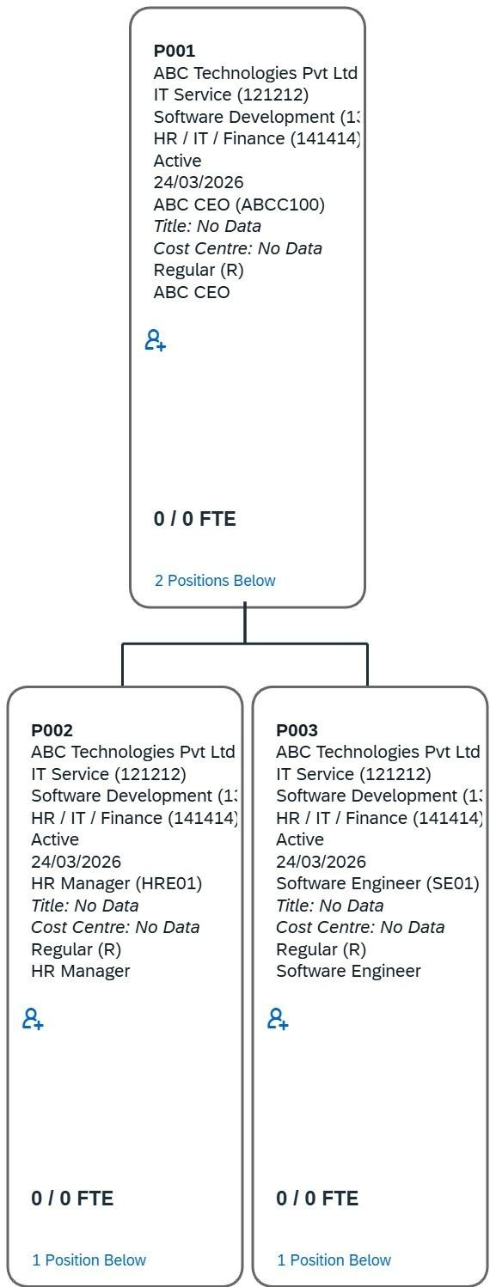
−– Purpose:
To define reporting structure and manager relationships.

MDF & Picklist
Configured:
  - MDF Object → Employee Certification
  - Picklist → Gender (Male, Female)
  - Picklist → State (Karnataka, Tamil Nadu)

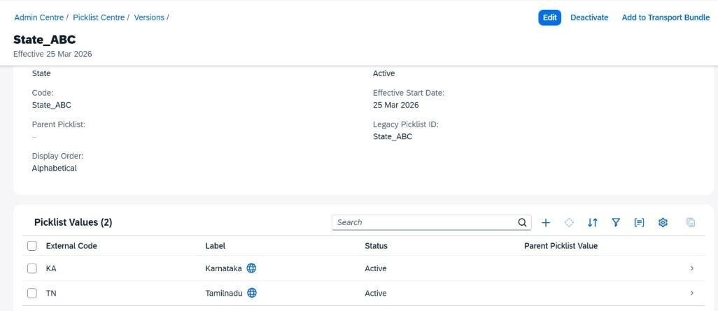
−– Purpose:
To standardize data entry and store custom employee information.

Business Rules & Workflow
Configured automation using business rules and workflow.

Business Rule:
  - Condition → Event Reason = Promotion
  - Action → Assign Workflow

Workflow:
  - Step 1 → Manager Approval
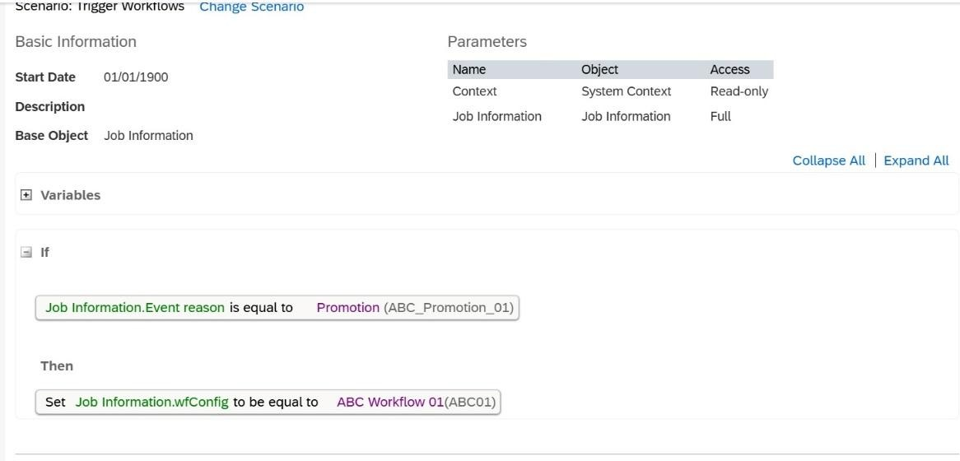
  - Step 2 → HR Approval
−– Purpose:
To automate approval process during employee promotion.

RBP (Security)
Basic Role Based Permissions concept was included:

  - HR Role → Full access
  - Manager Role → Team access
  - Employee Role → Self access
−– Purpose:
To control system access based on roles.

Employee Hiring
Planned creation of 5 employees:

Name | Role | Dept | Salary
Rajesh Kumar | HR Executive | HR | 4 LPA
Priya Sharma | Software Engineer | IT | 6 LPA
Arjun Reddy | Software Engineer | IT | 5 LPA
Sneha Iyer | HR Executive | HR | 4.5 LPA
Karthik Nair | Finance Executive | Finance | 5 LPA
−– Purpose:
To simulate real employee data for testing.

Employee Lifecycle Actions
Configured and planned:

Promotion
  - Priya Sharma → Senior Software Engineer
  - Event → Promotion
  - Workflow triggered

Transfer
  - Arjun Reddy → Bangalore → Chennai

Salary Revision
  - Rajesh Kumar → 4 LPA → 5 LPA

Termination
  - Karthik Nair → Resigned
−– Purpose:
To validate system behavior across lifecycle changes.

Data Management

Data Management:
  - Method: Used "Import Employee Data" tool to perform bulk updates.
  - Validation: Verified the imported data using "Monitor Jobs" to ensure 0% error rate.
  - Import → Employee data via CSV
  - Export → Data validation
  - Schedule Job → Background monitoring
–− Purpose:
To manage employee data efficiently.

Testing
Performed validation checks:
  - Workflow triggering
  - Approval flow (Manager → HR)

  - Role-based access validation
  - Unit Testing: Performed proxy testing for each role (Employee, Manager, HR).
  - Result: Confirmed that Business Rules triggered the 2-step workflow (Manager -> HR) correctly.

13: Challenges Faced & Troubleshooting Steps
While the implementation was successful, I encountered specific technical challenges during the testing of Employee Lifecycle Actions (Promotion/Transfer). Below is the
documentation of how I analyzed and addressed them.
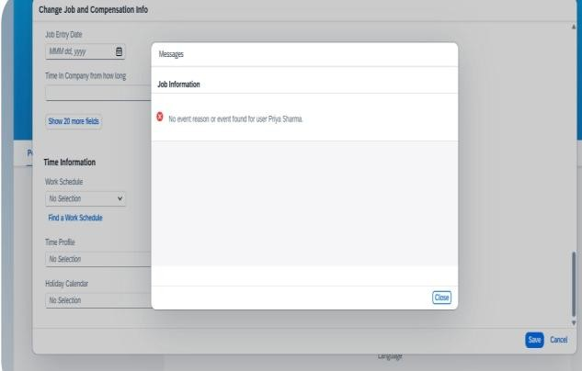
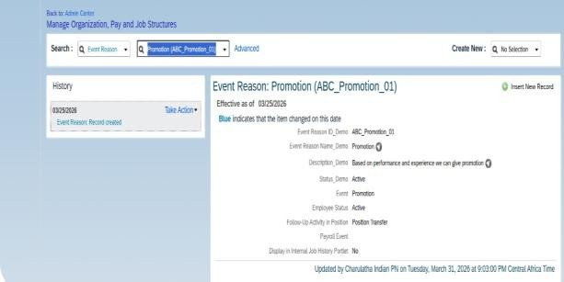
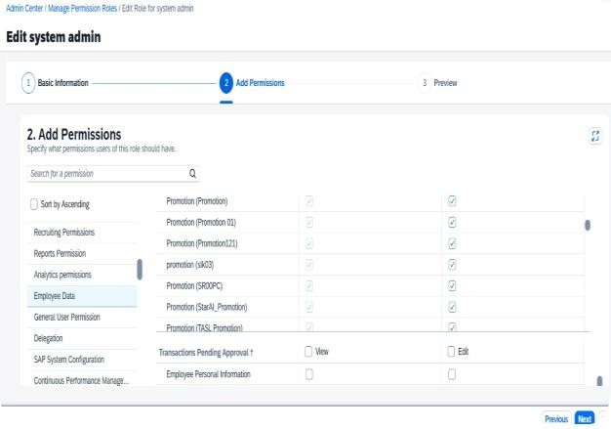
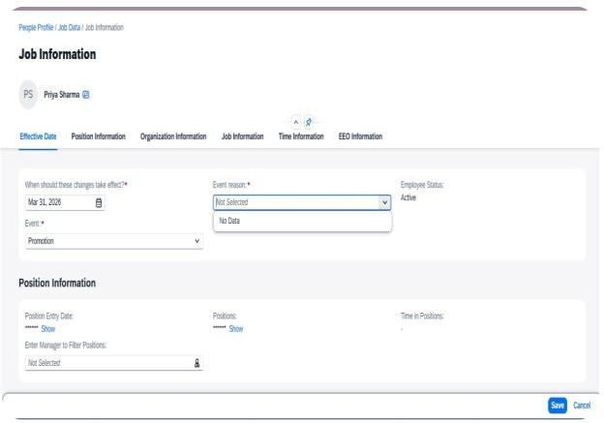

Challenge 1: Field Visibility (Event & Event Reason)
  - Issue: Initially, the 'Event' and 'Event Reason' fields were not visible in the 'Take Action' or 'History' screens.

  - Resolution: 1. Navigated to Manage Business Configuration (BCUI) > jobInfo. 2.
Audited the Visibility attribute for the event and event-reason identifiers. 3. Changed visibility from 'Hide' to 'Edit'. 4. Triggered an OData API Metadata Refresh to ensure the UI reflected the backend changes.
Challenge 2: Dropdown showing "No Data"Issue: After making the fields visible, the Event Reason dropdown failed to show the created reason (e.g., ABC_Promotion_01).

Troubleshooting Steps Performed:
  - RBP Audit: Verified if the system admin role had 'View' and 'Edit' permissions under User Permissions > Employee Data > Event Reasons.
  - Foundation Mapping: Checked Manage Organization, Pay and Job Structures to ensure the specific Event Reason was correctly mapped to the standard 'Promotion' Event.

  - Effective Date Check: Validated that the Effective Start Date of the Event Reason was earlier than or equal to the transaction date.

  - Metadata Sync: Performed a manual refresh of the Metadata cache to resolve potential indexing glitche.

Conclusion & Project Takeaway
This project was a comprehensive hands-on journey into the core of SAP SuccessFactors Employee Central. By building the system for ABC Technologies India, I gained a deep understanding of how Foundation Objects, Business Rules, and Role-Based Permissions (RBP) interconnect to manage an employee's lifecycle.

Key Learnings from the "No Data" Challenge: Although I encountered a technical hurdle where the Event Reason dropdown displayed "No Data" during testing, this phase proved to be the most valuable part of the project.
It allowed me to:
  - Master the troubleshooting workflow (BCUI Audit ⬛➜ RBP Validation ⬛➜ Metadata Sync).
  - Understand the critical impact of Effective Dating on data visibility.
  - Learn how to navigate system-level sync issues using OData API refreshes.
  - Future Outlook: My goal is to continue refining my functional knowledge and contribute to real-world implementations where I can apply this technical curiosity and problem-solving mindset.

"In SAP, as in life, the real learning begins when the system challenges you."
comprehensive hands-on journey

