WORLD FERT · SOLUTION DEVELOPMENT
Analysis and Design Document
Stakeholders, Architecture, Decisions, Data and Workflows
SOURCE-ALIGNED CANDIDATE · REVIEW
Control | Value
Document ID | WF-SAD-001
Version / Runtime | v1.0 candidate / runtime 1.0.1
Date | 23 July 2026 / 23 กรกฎาคม 2569
Source commit | 79a10a28e6a2fba9b65dc85101ff8ab6d784b91c
Source inventory SHA-256 | 12B9F964C7C90341859EDD6CDDE9B92BA35D797347F2AA64A1134E1E885FC343
Automated evidence | 2026-07-23T09-56-59-217Z · 10/10 passed · source stable
Status | Review — approval and baseline acceptance required
การใช้เอกสาร สร้างจาก Markdown และ source evidence ล่าสุดตามนโยบาย latest-document-wins; ห้ามตีความเป็น Approved, Released หรือ ISO certification จนกว่าจะมีผู้มีอำนาจลงนามและรับ baseline.

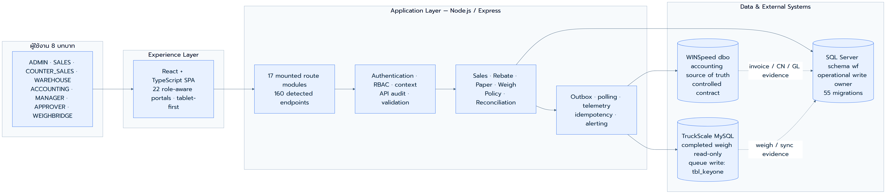
Executive visual — Analysis and Design Document

Document control
รายการ | รายละเอียด
Document ID | WF-SAD-001
Title | Analysis and Design Document
Owner | Solution Architect / Business Analyst / Data Architect
Status | Review — Candidate
Classification | Confidential — Client / Authorized Partner Use Only
Design preset | standard_business_brief · A4 · Prompt/Kanit override
Header pattern | memo_masthead
Generation rule | drift check → source merge → render → QA → human review

Revision and approval record
Version | Date | Change | Prepared by | Reviewed / approved
v1.0 candidate | 2026-07-23 | Rebuilt from source-aligned Markdown, runtime inventory, diagrams and current E2E evidence | Documentation pipeline | Pending named human approval

Executive source snapshot
Evidence area | Current verified fact | Boundary
Runtime | 1.0.1 across root/backend/frontend packages | Development source snapshot
Source | 220 files · SHA 12B9F964…FC343 · commit 79a10a28 | Dirty worktree remains visible
Application | 22 portals · 8 roles | Role-specific UAT still required
API | 17 route mounts · 160 detected endpoints | Detection is not contract approval
Data | 55 sequenced migrations through 055 | Production migration/restore gate remains
External writes | 33 detected dbo writes · 2 TruckScale writes to tbl_keyone | Explicit contract/security review required
Automated E2E | 10/10 passed · stable source · SQL Server/MySQL up | Not production hardware/manual UAT
Evidence interpretation ตัวเลขจาก static inventory และ E2E ใช้เพื่อยืนยันความสอดคล้องกับ snapshot ปัจจุบันเท่านั้น การยอมรับ UAT, external write boundary, production readiness และ ISO conformance ต้องมีหลักฐานและผู้อนุมัติแยกต่างหาก.

Standards alignment
Reference | Use in this information set | Current document
ISO/IEC/IEEE 42010:2022 | Stakeholders, concerns, viewpoints, views and decisions | Primary
ISO/IEC/IEEE 12207:2026 | Life-cycle processes, reviews and evidence flow | Development information set
ISO/IEC/IEEE 15289:2019 | Information-item content and document control | Front matter / source register
ISO/IEC 25010:2023 | Product quality characteristics and verification concerns | NFR / architecture / technical gates
ISO/IEC/IEEE 29119-3:2021 | Test documentation, cases, results and traceability | Verification and UAT linkage

Audience and reading path
Audience | Primary concern | Recommended sections
Business/process owner | stakeholders and cross-role process | Business analysis, workflow, decisions
Architect / developer | boundaries, components and constraints | SAD, C4, ADR, UML
DBA / integration owner | ownership, data and external contracts | Data design, ERD, integration decisions
Operations / audit | risk, evidence and maintainability | Architecture concerns, decision records

Table of contents
Update field in Word to refresh the table of contents
Word field เปิดเอกสารใน Microsoft Word แล้วกด Ctrl+A และ F9 เพื่อ refresh สารบัญและจำนวนหน้า.

Source-aligned diagrams
Diagram policy ภาพในส่วนนี้สร้างจาก Mermaid source ที่ version-control ได้และ render ใหม่ด้วย Prompt/Kanit policy; แหล่ง Markdown ยังคงเป็นข้อมูลอ้างอิงและภาพต้องผ่าน visual QA ก่อน release.


ภาพที่ 1 — Runtime architecture and system boundaries
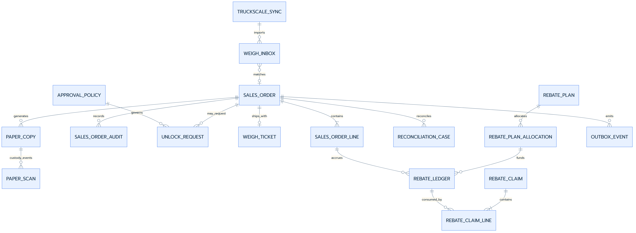
ภาพที่ 2 — Operational ERD and evidence relationships
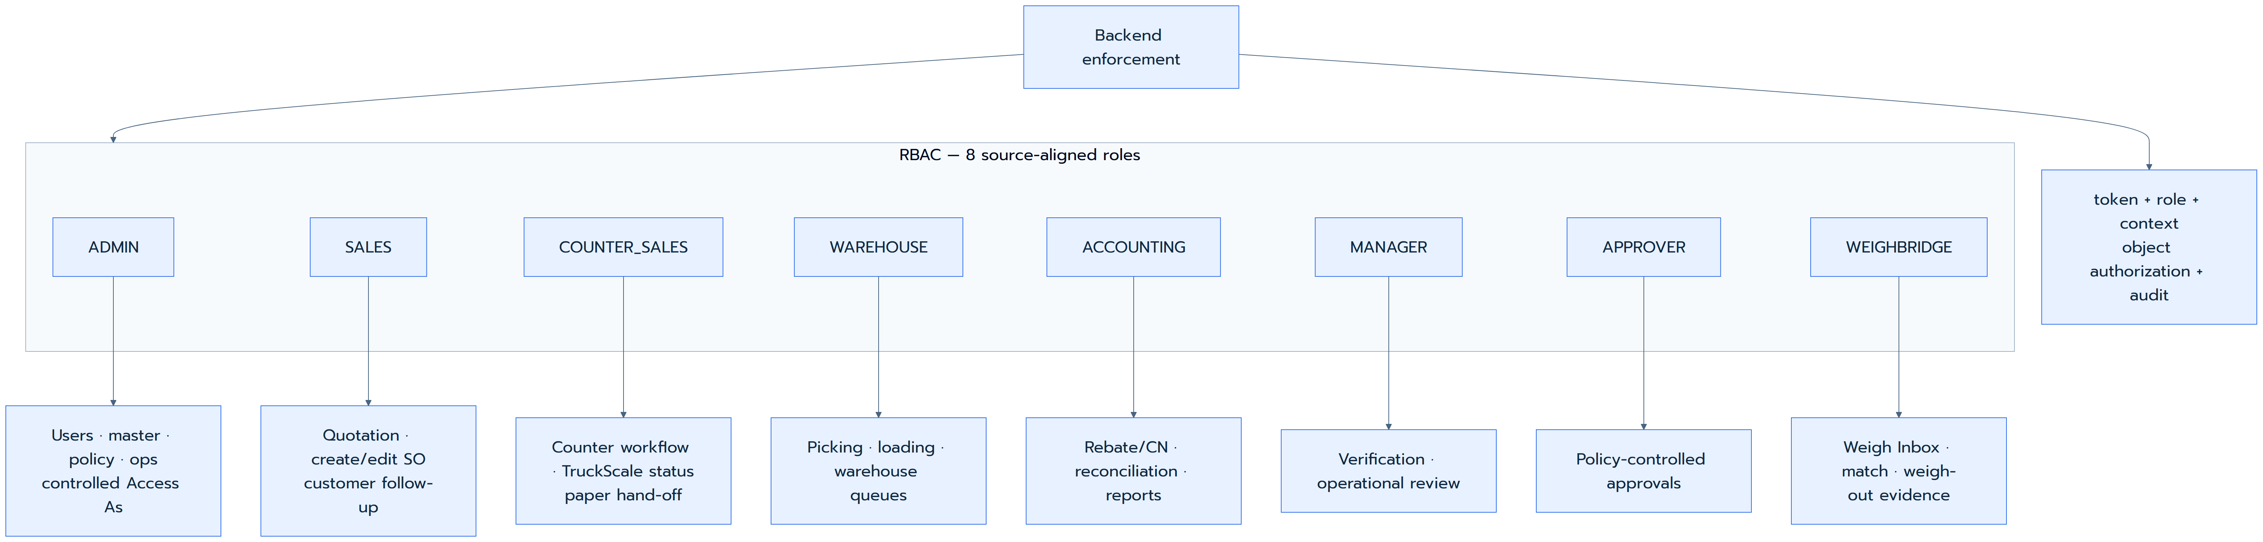
ภาพที่ 3 — Source-aligned RBAC responsibility map
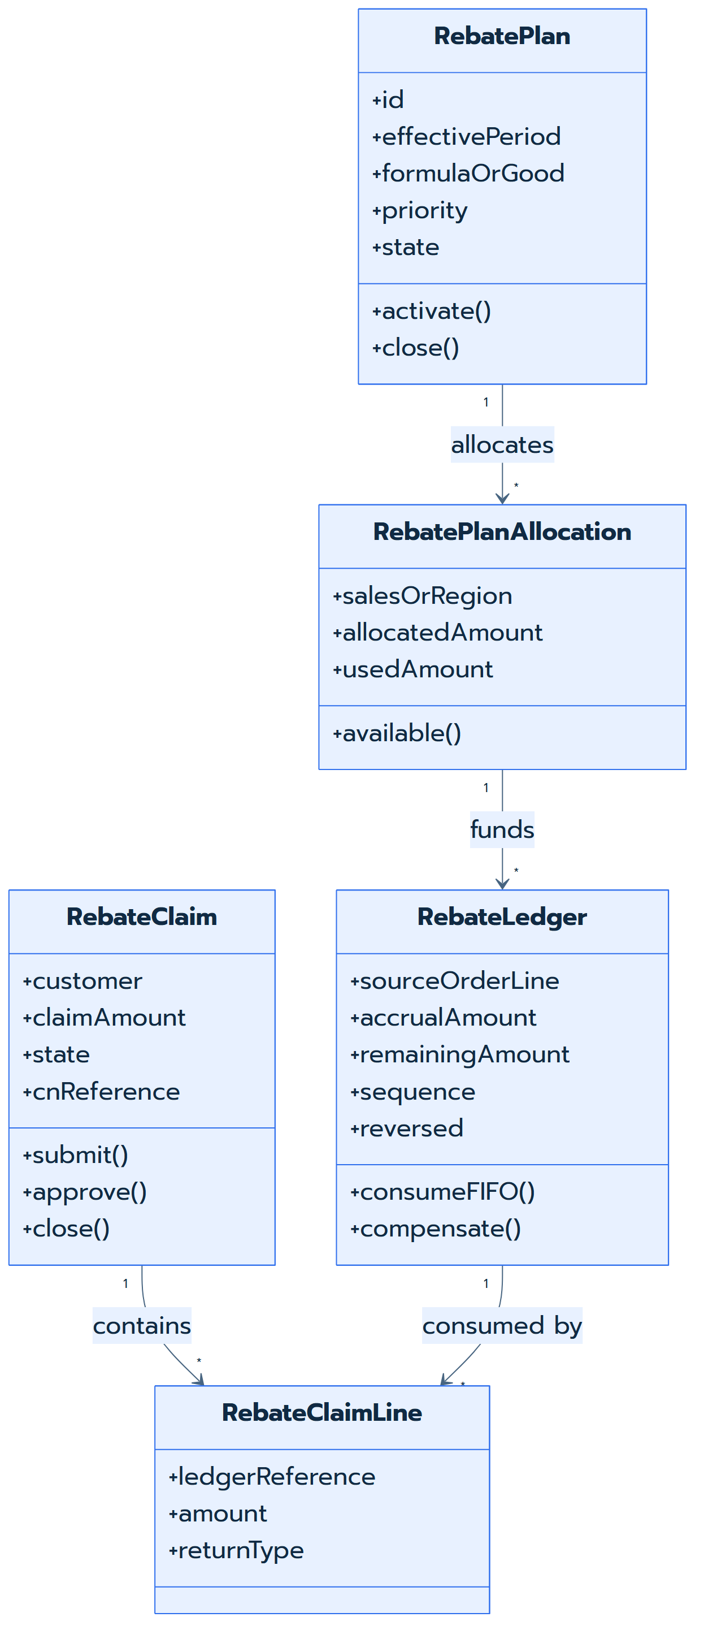
ภาพที่ 4 — Rebate domain UML
ภาพที่ 5 — Cross-role order-to-cash workflow

Business Analysis Document — Sales Execution & Rebate Platform
Authoritative source docs/enterprise/01-BUSINESS-ANALYSIS/BAD-v8.md · SHA-256 1DEB832C9B5D1B425CF369720BBAF04955E934B1F5AB2382E7473F7BEDA2DD71 · merged as Review content

Executive statement
World Fert ต้องการลดงานคีย์ซ้ำ ลดเอกสารสูญหาย ควบคุมการจ่ายสินค้าให้ตรงคำสั่งขาย และทำให้ rebate ตรวจสอบย้อนหลังได้ระดับรายการ โดยไม่กระทบการลงบัญชีเดิมของ Prosoft WINSpeed v9.0
WS-Sale-App จึงเป็น Sales Execution & Control Layer ไม่ใช่การทดแทน ERP ทั้งหมดในระยะแรก

Business context
- บริษัทผลิตและจำหน่ายปุ๋ยหลายสูตร ขายเป็นตันและรับสินค้าในโรงงาน
- คำสั่งซื้อผ่านฝ่ายขายและ Counter Sales ก่อนเข้าสู่คลัง/โรงงาน
- รถอาจรับสินค้าหลายจุด เช่น สายพาน คลัง และ bulk
- Rebate ตั้งตามสูตร พื้นที่ ระยะเวลา และราคา NET แต่การเคลมเดิมตรวจเอกสารมาก
- WINSpeed ต้องคงความเป็นเจ้าของเอกสารบัญชีและ GL

AS-IS process
Diagram source Mermaid source is retained in Markdown; the reviewed high-resolution rendering is embedded in the figure section.

Pain points ที่ยืนยันแล้ว
ID | ปัญหา | ผลกระทบ | เป้าหมาย v7
BP-01 | คีย์ order ซ้ำจากแชตไป ERP | ช้าและเกิด error | POS/tablet-first, validation, draft
BP-02 | เอกสาร 4 สีติดตามยาก/สูญหาย | audit gap | QR, paper trail, alert
BP-03 | แก้ SO หลังเริ่มจ่ายสินค้าไม่มี workflow | audit หาย | Unlock + reversible ledger
BP-04 | Rebate ตรวจทีละ invoice | งาน Accounting สูง | ledger line-level + FIFO
BP-05 | ตัด rebate แบบก้อนรวม | trace ต้นทางไม่ได้ | pool + ledger + allocation
BP-06 | ราคา NET/promotion เปลี่ยนบ่อย | execution ไม่ทัน | Price Book + Plan version
BP-07 | คลังตีความลำดับแม่/ลูก | โหลดผิด/ช้า | load sequence ต่อ line
BP-08 | ของแถมอยู่ในหมายเหตุ | ไม่เห็นงบ/สต็อก | giveaway workflow
BP-09 | ตั๋วคุมรายชุดดูยาก | ตรวจยอดยาก | drill-down balance
BP-10 | TruckScale แยกและ data quality ไม่สม่ำเสมอ | integration risk | completed-weigh read-only + controlled tbl_keyone pre-weigh contract/match policy

To-Be operating model
Diagram source Mermaid source is retained in Markdown; the reviewed high-resolution rendering is embedded in the figure section.

Business outcomes and KPI
Outcome | KPI
ลดเวลาคีย์/ตรวจ SO | median create-to-confirm time, rework rate
ลดภาระ rebate | claim-review time, % traceable automatically
ลดเอกสารสูญหาย | open/lost paper-copy count and aging
ควบคุมการจ่าย | % shipped SO with verification, weight and audit
รักษาบัญชี | reconciliation pass rate with WINSpeed
ควบคุม promotion | plan budget variance / giveaway exception
ตัดสินใจเร็ว | dashboard freshness / queue aging

Scope baseline

In scope
- Sales order, quotation-to-SO and Verification workflow
- Mother/baby load sequencing
- Rebate plan, allocation, accrual, FIFO, claim and CN evidence
- Giveaway budget/withdrawal
- Control-ticket balance and report
- Weigh-out capture, TruckScale lookup and manual fallback
- Paper Trail, QR and audit
- Dashboard, reports, RBAC, security and operations

Out of scope unless separately approved
- full factory production/MRP
- Gate Pass replacement
- TruckScale hardware/serial controller replacement
- full LINE LIFF application
- lot/expiry traceability
- changes to WINSpeed GL/accounting logic

Critical decision gates
Gate | Decision required | Owner
DG-01 | WINSpeed write boundary | Executive + IT + Accounting
DG-02 | Canonical TruckScale source | IT + Factory
DG-03 | Credit Hold: build/defer | Sales + Accounting
DG-04 | Stock source and reservation method | Warehouse + Finance
DG-05 | Approval authority thresholds | Management
DG-06 | Privacy/document retention | Management + QMR

Stakeholder Map, RACI และ Approval Authority
Authoritative source docs/enterprise/01-BUSINESS-ANALYSIS/RACI-AND-STAKEHOLDERS.md · SHA-256 52D22376C6B1D1CC28DCF1D6DAB6F872970894A137313C7FEF52F206A9395798 · merged as Review content

Roles
Role | Responsibility
SALES | สร้าง SO, rebate/claim, request unlock
COUNTER_SALES | verify SO, print/control documents
WAREHOUSE | picking/load sequence
WEIGHBRIDGE | weight/source validation/ship
APPROVER | unlock/exception/plan approval
ACCOUNTING | claim/CN/reconciliation
ADMIN | users/master/configuration
MANAGER | plan/budget/report policy
IT/DBA | infrastructure/security/backup
EXECUTIVE | scope, high-risk change, go-live

RACI
Activity | Sales | Counter | Warehouse | Weigh | Accounting | Admin/IT | Manager | Exec
Create SO | R | A/C | I | I | I | I | I | I
Verify SO | C | A/R | I | I | I | I | I | I
Confirm/exception | R | C | I | I | C | I | A | I
Pick/load | I | C | A/R | C | I | I | I | I
Weigh/ship | I | I | C | A/R | I | I | I | I
Rebate Plan | C | I | I | I | C | I | A/R | I
Claim/CN | R | I | I | I | A/R | I | C | I
Security/backup | I | I | I | I | I | A/R | C | I
Go-live | I | C | C | C | C | C | R | A
R=Responsible; A=Accountable; C=Consulted; I=Informed

Approval baseline
Scenario | Required approval
Unlock after Picking | authorized Approver
Sell above set price | named authority by policy
Sell below allowed threshold | authorized manager matrix
Price activation | Manager + Accounting review
Rebate plan activation | Manager/Approver
Overbudget giveaway | manager/delegate + reason
Manual weight override | Weighbridge + supervisory review
Direct dbo exception | IT/DBA + Accounting + delegated Executive

Solution Architecture Document
Authoritative source docs/enterprise/03-SOLUTION-ARCHITECTURE/SAD-v8.md · SHA-256 751BD422F3E4C39DC4E43A6B8572CC48D87351775A5A4617D36FE5CA2CC49777 · merged as Review content

Architecture intent
ออกแบบเพื่อให้ operational workflow เปลี่ยนเร็วโดยไม่แทรกแซง finance/GL ของ WINSpeed และสร้างหลักฐานที่ตรวจสอบได้ระดับ event/record

Logical architecture
Diagram source Mermaid source is retained in Markdown; the reviewed high-resolution rendering is embedded in the figure section.

Architecture principles
- Accounting boundary — WINSpeed owns invoice/CN/GL posting.
- Controlled write boundary — direct dbo writing is explicit exception, never implicit.
- Append-only evidence — audit, ledger and source references preserved; corrections compensate.
- Read-model isolation — heavy report/control-ticket queries use approved views/indexes/pagination.
- Integration resilience — idempotency, retry/reconciliation and manual fallback explicit.
- Least privilege — no sa/root in runtime.
- Observe before mutate — completed-weigh TruckScale records are read-only; controlled pre-weigh queue writes are limited to tbl_keyone; ambiguity is surfaced.
- Configuration over hardcode — policy/threshold/period/environment controlled.
- Operational transparency — health, version, release, failures visible.

Bounded contexts
Context | Owned data | Key responsibility
Sales Execution | SO, lines, states, verify, load sequence | lifecycle control
Rebate | plan, allocation, pool, ledger, claim | traceable promotion
Warehouse/Weighing | pick status, WeighTicket | loading/ship evidence
Paper Trail | copies, QR, scans | document custody
Integration | outbox/reconcile | safe external operations
Identity/Admin | user/role/policy | access/config
Reporting | read models/export | operational visibility

Data ownership
Data class | Owner | App authority
WINSpeed master | WINSpeed | controlled read
WINSpeed invoice/CN/GL | WINSpeed | read/reconcile
operational workflow/audit | wf | write
Rebate/claim | wf + CN evidence | write/read
Weigh source | TruckScale | completed records read-only; tbl_keyone pre-weigh queue write
Paper custody | wf | write

Integration sequence
Diagram source Mermaid source is retained in Markdown; the reviewed high-resolution rendering is embedded in the figure section.

Production topology target
- Frontend through managed static hosting/CDN or on-prem Nginx
- Backend as immutable container
- SQL Server via private network/VPN/allowlist
- TruckScale via private connectivity or managed replica
- centralized secret management
- monitoring/alerting/backup validation before Full Production

Current implementation view
View | Source-aligned fact
Runtime | frontend, backend and root packages declare version 1.0.1
Application surface | 22 portal keys, 8 roles, 17 mounted API route modules and 160 detected endpoints
Persistence | SQL Server wf operational extension, controlled WINSpeed dbo, TruckScale MySQL
Schema evolution | 55 sequenced migration files through sequence 055 with no duplicate sequence
Controlled external writes | 33 detected dbo write statements require contract review; TruckScale writes are limited to 2 statements targeting tbl_keyone
Automated evidence | E2E run 2026-07-23T09-56-59-217Z: 10/10 passed, source stable, SQL Server/MySQL health up

Architecture concerns and verification gates
- Production connectivity, scale hardware, printing, QR scanning and manual recovery remain manual/integration test gates.
- Direct WINSpeed writes are exceptions governed by ADR-003 and the approved integration contract; detection count is an inventory signal, not an approval.
- Deployment secrets, backup restore, alert delivery and network failover require environment-specific evidence before go-live.
- Architecture descriptions follow ISO/IEC/IEEE 42010:2022 concepts: stakeholder concerns, viewpoints, views, decisions and correspondence to implementation evidence.
- Life-cycle deliverables and reviews are organized against ISO/IEC/IEEE 12207:2026 and information-item control follows ISO/IEC/IEEE 15289:2019; these references do not by themselves certify the solution.

C4 Architecture Views
Authoritative source docs/enterprise/03-SOLUTION-ARCHITECTURE/C4-ARCHITECTURE.md · SHA-256 101BACF722B8A600204A0B0106779C518BF0F43692D2A1CC6013EC1EB3DA4FD7 · merged as Review content

Level 1 — System Context
Diagram source Mermaid source is retained in Markdown; the reviewed high-resolution rendering is embedded in the figure section.

Level 2 — Containers
Diagram source Mermaid source is retained in Markdown; the reviewed high-resolution rendering is embedded in the figure section.

Level 3 — Backend components
Component | Responsibility | Boundary
Auth middleware | token/RBAC/context | protected endpoints
Sales service | lifecycle, verification, audit | wf + controlled contract
Rebate service | plan/pool/ledger/FIFO/claim | wf
Weigh service | lookup/normalize/ticket persistence | TruckScale read + wf
Paper service | copies/QR/scans/custody | wf/storage
Integration service | outbox/import/reconcile/idempotency | WINSpeed + wf
Reporting service | read models/export | views/read models
Admin service | users/roles/policy/master | wf/contracts
Health/telemetry | dependency status/error metrics | runtime

Level 4 — Code constraints
- routes must not hold financial/business rules that belong in services
- every mutable workflow emits audit event through shared service
- parameterized SQL only
- cross-database calls require timeout and explicit contract
- write operations support idempotency where retry can duplicate outcome

ADR-001 — Layered Non-Invasive Integration
Authoritative source docs/enterprise/03-SOLUTION-ARCHITECTURE/ADR-001-LAYERED-NONINVASIVE.md · SHA-256 DDD206566D005742700117157341B40C9BBD1435E609CF3A693B50C0804B0C82 · merged as Review content

Context
WINSpeed is business-critical and owns historical master, finance and GL. Replacement creates unacceptable operating/accounting risk.

Decision
WS-Sale-App operates as operational extension:
- workflow/audit/rebate/paper/weigh data in wf
- WINSpeed dbo through approved read contracts
- external writes under ADR-003
- fallback remains available through WINSpeed/manual procedure

Consequences
Positive: lower replacement risk, direct data visibility where permitted, faster operational improvements.
Negative: contracts/reconciliation mandatory; legacy data quality remains visible; raw table access is not a design substitute.

Guardrails
- no schema modification to WINSpeed
- no direct GL/invoice/CN posting
- coexistence/reconciliation test at release gate

ADR-002 — Three-Database Topology and Environment Control
Authoritative source docs/enterprise/03-SOLUTION-ARCHITECTURE/ADR-002-DATABASE-TOPOLOGY.md · SHA-256 7001AB6065F504C91B5CD841061AFE7BD6FE076166576C72EDE720244B9E6A62 · merged as Review content

Context
The solution uses SQL Server WINSpeed dbo, SQL Server wf schema, and TruckScale MySQL. Evidence shows wf/dbo share SQL Server while TruckScale is logically separate.

Decision
- wf is write-owned operational schema
- dbo is legacy/external schema controlled by ADR-003
- TruckScale uses a dedicated service/pool: completed-weigh/reference tables are read-only and pre-weigh queue writes are restricted to tbl_keyone
- environment selection propagates through explicit request context
- production environment register names host, DB, runtime identity, owner, backup policy and data class for each source

Consequences
No cross-engine join is assumed at runtime. Cross-source correlation is resolved through application/service logic or an approved read model.

ADR-003 — WINSpeed Write Boundary and Financial Safety
Authoritative source docs/enterprise/03-SOLUTION-ARCHITECTURE/ADR-003-WINSPEED-WRITE-BOUNDARY.md · SHA-256 42316FD65943B863B07F10908E11050644961DB9368466FCE9D9B29EE194557A · merged as Review content

Problem
Existing implementation evidence includes direct writes to selected WINSpeed objects for SO/picking/ship/price. The target production safety model requires WINSpeed to own invoice/CN/GL and its posting/import process.

Decision

Immutable financial boundary
WS-Sale-App MUST NOT directly insert/update:
- SOInvHD, SOInvDT
- GLHD, GLDT
- other financial-posting objects not explicitly approved by WINSpeed DBA and Accounting

Approved write paths
Use case | Preferred path | Temporary fallback | Required controls
Create/Update SO 104 | WINSpeed import or approved stored procedure | legacy direct write only with signed exception | idempotency, transaction, audit, dual-run
Picking status | approved interface/SP | signed direct-update exception | audit/state validation
Ship/export state | controlled interface/import | signed direct-update exception | weigh evidence/reconcile
Price Book | approved maintenance contract | direct EMSetPrice* under policy | dual approval/effective date/audit
Invoice/CN/GL | WINSpeed UI/import/post | none | Accounting owns posting

Legacy exception exit plan
- Inventory direct writes.
- Risk-classify by object/consumer.
- Create import/SP contract.
- Dual-run/reconcile 2–4 weeks.
- Disable direct write via feature flag.
- Retain evidence.

Go-Live criterion
No production release uses undocumented direct dbo write. A temporary exception lists object, columns, role, approver, expiry, rollback and reconciliation query.

ADR-004 — TruckScale Controlled Pre-Weigh Integration and Matching Policy
Authoritative source docs/enterprise/03-SOLUTION-ARCHITECTURE/ADR-004-TRUCKSCALE-INTEGRATION.md · SHA-256 DE63608F9127325F6F68F319B607FF71857BF63443FEE36BC932F630BBDBC0DF · merged as Review content

Context
TruckScale records pre-weigh, completed weighing and product detail, but has Thai string/serial dates, mixed charsets, no enforced FK, inconsistent customer codes and imperfect truck-plate values.

Decision
- TruckScale completed-weigh and reference records are read-only; WS-Sale-App may INSERT/DELETE only tbl_keyone for the pre-weigh queue lifecycle.
- Dedicated connection/service has timeout, health and charset handling.
- Candidate match uses normalized plate as primary; movebill, document/invoice and time window corroborate.
- Candidate evidence/confidence is visible; ambiguity requires user selection.
- Selection is copied as immutable reference metadata to wf.WeighTicket.
- Production environment register declares canonical source: local, cloud replica, or managed integration DB.

Matching policy
Step | Rule
Normalize | trim spaces/punctuation; preserve raw
Filter | same normalized plate + date window
Rank | completed record > matching movebill > matching source doc > closest time
Validate | net>0, gross≥tare, capacity sanity, no duplicate ref
Resolve | ambiguous candidate selected by user + audit
Fallback | manual entry authorized + reason + later reconcile

Non-goal
WS-Sale-App does not control COM ports/hardware or alter completed TruckScale source records; the controlled tbl_keyone queue lifecycle is the only write exception.

ADR-005 — Rebate Ledger, FIFO and Compensation Model
Authoritative source docs/enterprise/03-SOLUTION-ARCHITECTURE/ADR-005-REBATE-FIFO.md · SHA-256 1C0C516C879AC8E39AFFAFDFF49B775A28794E33C45DF270E7E474454328F5C4 · merged as Review content

Decision
Rebate is represented as immutable ledger events, not one mutable aggregate balance.
- confirmed eligible SO line creates accrual using effective plan/NET snapshot
- pool is controlled aggregation, not sole source of truth
- claim consumes eligible accrual FIFO
- unlock/reversal creates compensating event/flag, never deletion
- claim approval links actual WINSpeed CN evidence
- price-difference return and sales rebate are distinct types

Benefits
Every claimed amount can trace to SO line, plan, price and date. This supports audit and prevents unexplained remaining-pool behavior.

Data Design, Ownership and Canonical Model
Authoritative source docs/enterprise/04-DATA-INTEGRATION/DATA-DESIGN.md · SHA-256 02C1218BA62552576952B01A7ECDC7BA24741919B6174907C6620059213AF243 · merged as Review content

Data ownership
Domain | Primary owner | Write mode | Retention/audit
Customer/good/account master | WINSpeed | controlled external | WINSpeed policy
SO operational workflow | wf | app owned | target 7 years
Rebate/claim | wf + CN reference | app owned / external evidence | target 7 years
Price Book | WINSpeed/source contract | controlled | versioned
Weigh source | TruckScale | tblscale/reference read-only; tbl_keyone controlled queue write | source policy + wf ref
Paper copies/scans | wf | app owned | target 7 years
User/role mapping | wf | admin controlled | access policy
Outbox/reconcile | wf | app owned | until resolved + policy

Logical entities

Sales execution
Entity | Key fields | Notes
SalesOrder | SoId, SoNo, CustomerId, Status, TruckPlate, VerifiedBy, VerifiedAt | header
SalesOrderLine | SoId, LineNo, GoodId, QtyTon, UnitPrice, LoadSequence | commercial/warehouse line
SalesOrderAudit | actor, action, before/after JSON, IP, time, correlation | append-only
UnlockRequest | SoId, reason, status, requester, approver | correction
WeighTicket | SoId, source ref, tare/gross/net, scale, time, method | ship evidence

Rebate and giveaway
Entity | Key fields | Notes
PriceBook | formula/good, month, NET, version, state | effective price
RebatePlan | dates, formula, region, return type, priority | policy
RebatePool | sales, plan, allocated/used/frozen | aggregation
RebateLedger | source line, pool, type, amount, FIFO, reversed flag | subledger
RebateClaim | customer, sales, totals, state, CN number | request
RebateClaimLine | claim/ledger, amount, return type | trace
GiveawayBudget | region/sales/item/brand/period | budget
GiveawayWithdrawal | SO/budget/item/qty/reason | issue

Controls and platform
Entity | Key fields | Notes
PaperCopy | SO, color, QR nonce, status, holder | custody
PaperScan | copy, status, actor, timestamp | append-only
AppUser | identity, role, EmpID, active | named account
ApprovalPolicy | scenario, threshold, authority, effective dates | v7 target
IntegrationOutbox | type, idempotency key, payload hash, state | v7 target
ReconciliationCase | entity/ref, expected/actual, state, owner | v7 target

Data constraints
- money uses decimal and explicit rounding; no floating point
- quantity stores canonical ton/kg plus UOM conversion
- datetime uses explicit timezone/UTC policy
- raw and normalized data both retained for matching/search
- audit JSON includes schema/version
- PII is not written to general logs/export by default

Conceptual ER
Diagram source Mermaid source is retained in Markdown; the reviewed high-resolution rendering is embedded in the figure section.

11 - Workflow and Workprocess Diagrams
Authoritative source docs/enterprise/03-SOLUTION-ARCHITECTURE/WORKFLOW-DIAGRAMS.md · SHA-256 F9BC621DB5847A2EE61E616F963946B183B3C7C74E796EECA4AD14C8DAE16054 · merged as Review content

This document contains structured data in Mermaid.js (https://mermaid.js.org/) format.

How to use with Draw.io
- Open draw.io (https://app.diagrams.net/).
- From the top menu, select Arrange > Insert > Advanced > Mermaid....
- Copy the Mermaid code blocks below (excluding the mermaid backticks) and paste them into the text box.
- Click Insert to generate the flowchart instantly.

1. End-to-End Sales Order Flow
Diagram source Mermaid source is retained in Markdown; the reviewed high-resolution rendering is embedded in the figure section.

2. Quotation Conversion Process
Diagram source Mermaid source is retained in Markdown; the reviewed high-resolution rendering is embedded in the figure section.

3. Giveaway Approval Flow
Diagram source Mermaid source is retained in Markdown; the reviewed high-resolution rendering is embedded in the figure section.

Source and evidence register
Type | Path | SHA-256 | Disposition
Markdown | docs/enterprise/01-BUSINESS-ANALYSIS/BAD-v8.md | 1DEB832C9B5D1B425CF369720BBAF04955E934B1F5AB2382E7473F7BEDA2DD71 | Merged into Review candidate
Markdown | docs/enterprise/01-BUSINESS-ANALYSIS/RACI-AND-STAKEHOLDERS.md | 52D22376C6B1D1CC28DCF1D6DAB6F872970894A137313C7FEF52F206A9395798 | Merged into Review candidate
Markdown | docs/enterprise/03-SOLUTION-ARCHITECTURE/SAD-v8.md | 751BD422F3E4C39DC4E43A6B8572CC48D87351775A5A4617D36FE5CA2CC49777 | Merged into Review candidate
Markdown | docs/enterprise/03-SOLUTION-ARCHITECTURE/C4-ARCHITECTURE.md | 101BACF722B8A600204A0B0106779C518BF0F43692D2A1CC6013EC1EB3DA4FD7 | Merged into Review candidate
Markdown | docs/enterprise/03-SOLUTION-ARCHITECTURE/ADR-001-LAYERED-NONINVASIVE.md | DDD206566D005742700117157341B40C9BBD1435E609CF3A693B50C0804B0C82 | Merged into Review candidate
Markdown | docs/enterprise/03-SOLUTION-ARCHITECTURE/ADR-002-DATABASE-TOPOLOGY.md | 7001AB6065F504C91B5CD841061AFE7BD6FE076166576C72EDE720244B9E6A62 | Merged into Review candidate
Markdown | docs/enterprise/03-SOLUTION-ARCHITECTURE/ADR-003-WINSPEED-WRITE-BOUNDARY.md | 42316FD65943B863B07F10908E11050644961DB9368466FCE9D9B29EE194557A | Merged into Review candidate
Markdown | docs/enterprise/03-SOLUTION-ARCHITECTURE/ADR-004-TRUCKSCALE-INTEGRATION.md | DE63608F9127325F6F68F319B607FF71857BF63443FEE36BC932F630BBDBC0DF | Merged into Review candidate
Markdown | docs/enterprise/03-SOLUTION-ARCHITECTURE/ADR-005-REBATE-FIFO.md | 1C0C516C879AC8E39AFFAFDFF49B775A28794E33C45DF270E7E474454328F5C4 | Merged into Review candidate
Markdown | docs/enterprise/04-DATA-INTEGRATION/DATA-DESIGN.md | 02C1218BA62552576952B01A7ECDC7BA24741919B6174907C6620059213AF243 | Merged into Review candidate
Markdown | docs/enterprise/03-SOLUTION-ARCHITECTURE/WORKFLOW-DIAGRAMS.md | F9BC621DB5847A2EE61E616F963946B183B3C7C74E796EECA4AD14C8DAE16054 | Merged into Review candidate
Figure | docs/enterprise/04-DIAGRAMS-PNG/candidate/domain/13-runtime-architecture.png | B08C8F0563C3A84D538E52E28C74370BCDAF05744B2F358CFB60D90319D9E8D3 | Embedded with alt text
Figure | docs/enterprise/04-DIAGRAMS-PNG/candidate/domain/15-operational-erd.png | 21C695D3CF235B7CE22C49E1ACC3E97A9142D959D95A24BE0FD71A4BEE127D01 | Embedded with alt text
Figure | docs/enterprise/04-DIAGRAMS-PNG/candidate/domain/16-rbac-source-aligned.png | A2FAF61E5FCB4E1EC0CB7DAC363119B89073677B1BE188DCD41CB9A1C0C78B4D | Embedded with alt text
Figure | docs/enterprise/04-DIAGRAMS-PNG/candidate/domain/18-rebate-domain-uml.png | 481932EABE7CE15D8A4E76F25DD2D675002514F7ED99542B6DBED19AA9C4CCAE | Embedded with alt text
Figure | docs/enterprise/04-DIAGRAMS-PNG/candidate/domain/17-order-to-cash-workflow.png | CC2288765EAE21DC86B1B927202EB2DA941677A6623579E16EC6C791555AC207 | Embedded with alt text

Approval boundary
Pending human decision Candidate นี้ยังไม่เป็น baseline. ต้อง review ความถูกต้องของ business rule, API/data contract, external write boundary, security, operations และ UAT evidence ก่อนบันทึกผู้อนุมัติ/วันที่/ข้อยกเว้น.

Approval role | Name | Decision / date | Conditions or evidence reference
Business owner / Product owner |  | Pending
Solution architect / Technical lead |  | Pending
Security / DBA / Integration owner |  | Pending
QA / UAT owner |  | Pending
Operations / Release authority |  | Pending

