**1. ROAD WAYS**

**DIVISION OF ROADWAYS ON THE BASIS OF MANAGEMENT**

1. National Highway.

Length: 132499 km (2.7%)

Maintain by NHAI under the central government.

1. State Highway.

Maintain and Construction by State Government.

1. Borders Road.

Maintain and Construction by B.R.O (Border Road Organization).

Established in 1960.

H.Q: New Delhi.

**SOME FAMOUS NATIOANL HIGHWAYS IN INDIA**

Golden Quadrilateral Project:

* This project connects four metros city. Delhi, Kolkata, Chennai, Mumbai.
* Delhi – Kolkata: NH19, Kolkata- Chennai: NH16, Chennai – Mumbai: NH48, Mumbai – Delhi: NH 48.
* Started in 2001 under Atal Bihari Vajpayee and completed in 2012.
* Length 5846 KM.

NORTH – SOUTH, EAST – WEST CORRIDOR

* Longest Highway: NH44 from Sri-Nagar to Kanyakumari.
* Length of North to South part: 4112Km
* Porbandar (Gujarat) to Silchar (Assam) NH 27.
* Length of East to West part: 3507 Km.
* North – South and East -West corridor meet at Jhansi. (UP)
* Started in 2001 under Atal Bihari Vajpayee and completed in 2018.

GT Road

* Amritsar -> Delhi -> Kolkata. (Present)
* Peshawar -> Amritsar -> Delhi -> Kolkata. (Past)
* Construct by Sher Shah Suri.

CHAR DHAM PROJECT

* Join four Dham: Yamunotri, Gangotri, Kedharnath, Badrinath.
* Purpose: To join all four Dham of India in all season.
* Time to complete: 4 years.
* Length of Project: 900 Cr.
* Cost of Project: 1119.69 Km

KARAKORAM HIGHWAY.

* Join India (Ladakh) and China.

SOME POINTS

Maharashtra and Tamil Naidu longest paved road network.

Orissa longest unpaved “Kachi” road.

Longest national highway network: UP -> Rajasthan -> Andhra Pradesh -> MP.

Jawahar Tunnel is the longest tunnel which located in the state of Jammu & Kashmir.

**2. RAILWAYS**

HISTORY OF RAILWAYS

* Railways started in India 16th April 1853.
* From Mumbai to Thane.
* Lord Dalhousie is the governor general of India at that time.

RAILWAYS IN INDIA

|  |  |
| --- | --- |
| INDAI | WORLD |
| * Present railway network: 66000 Km. * World fourth largest railways network. * Asia second largest railway network. * Longest Railway route to cover in India: * Kanyakumari to Dibrugarh (Vivek Express). | * World largest: USA. * Asia Largest: China. * World longest railways route: Trans-Siberian railways. * Running from Moscow to Vladivostok.   Length 9289 Km. |

ZONES IN INDIA

* Number of Railways zone in India: 18.
* 17th Zone: Kolkata Metro Railways.
* 18th Zone: South Costal Railways. (H.Q. Visakapatnam)

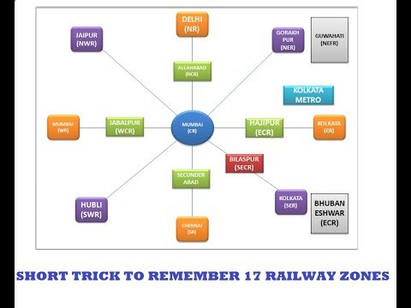

SOME IMPORTANT POINTS

Eastern Dedicated Freight Corridor of Indian Railways.

* Runs from Dankuni in West Bengal to Ludhiana (Punjab).
* Ludhiana (Punjab) 🡪 Ambla (Haryana) 🡪 Delhi 🡪 Dadari 🡪 Kanpur 🡪 Mughalsharya 🡪 Gaya 🡪 Jharkhand 🡪 Sonagar (West Bengal)
* Length of 1856 km
* The railway is one of the multiple freight corridors.

Western Dedicated Freight Corridor of Indian Railways.

* Runs from Dadri (U.P) to country largest port Jawaharlal Nehru Port Trust, near Mumbai.
* passing through Uttar Pradesh, Haryana, Rajasthan, Gujarat and Maharashtra
* Length: 1504 Km.

SOME OTHERS POINT.

Konkan Railways:

* join the Roha (Mumbai) to Mangalore (Karnataka).
* Length 760 km.

Maitree Express: India and Bangladesh.

Indian Railways included in UNESCO (H.Q. Paris) Heritage

Nilgiri Railways, Darjeeling Railways, Kalka Shimla Railways.

Rail Bandhu a newsletter in every Rajdhani, Shatabdi and AC Duronto.

Manipur is the least developed state in terms of Rail Network.

Coal is the maximum volume of good transported by the railways.

Largest railways route in term of route kilometer: Northern Railways.

Smallest railways route in term of route kilometer: N.E.R.F Railways.

Manufacturing Unit with their respective location.

* Chittranjan Locomotive work: West Bengal.
* Integeral Coach Factory: TamilNadu.
* Wheel and Axle Plant: Karnataka.
* Rail Coach Factory: Punjab.

Guages

Board:

Meter:

Narrow

**3.WATERWAYS**

**PORT IN INDIA**

In India 13 big ports and more than 200 ports.

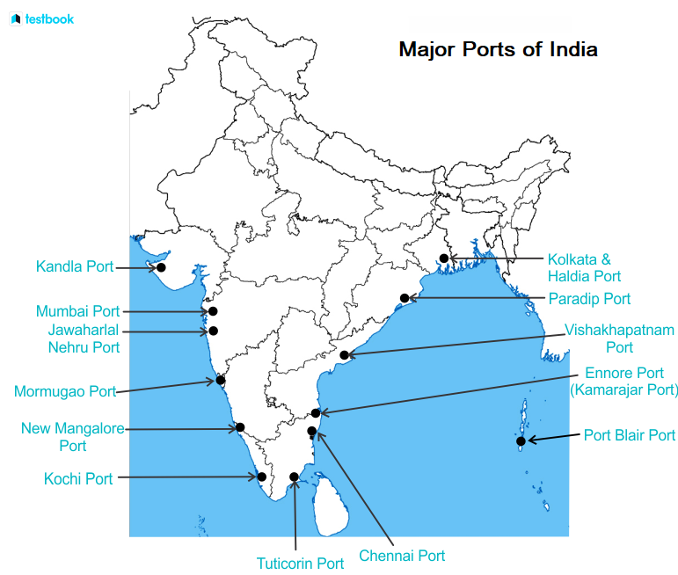

* Pandit Jawaharlal Lal Nehru port is also called Nhava Sheva.
* Pt. Jawaharlal Nehru port is largest man made port in India.
* Mumbai: Country largest natural port.
* Kandla Is the tidal port.

**NATIONAL WATERWAYS IN INDIA**

Waterways are maintained by IWAI: Indian Waterways Authority of India.

H.Q of IWAI: Noida

R.H.Q of IWAI: Patna, Kolkata, Guwahati, Kochi.

No of water ways in India: 111.

SIX IMPORTANT WATERWAYS

|  |  |  |  |
| --- | --- | --- | --- |
| S.No | LOCATION | On Which River, Canal | Length |
|  |  |  |  |
|  | Prayagraj to Haldia |  | 1620 |
|  | Sadia to Dhubri | Brahmaputra River (Dhubri – Sadiya)... Read more at: https://www.adda247.com/upsc-exam/list-of-national-waterways-in-india/ | 891... Read more at: https://www.adda247.com/upsc-exam/list-of-national-waterways-in-india/ |
|  | West Coast Canal (Kottapuram – Kollam), Champakara and Udyogmandal Canals 205    Kerala... Read more at: https://www.adda247.com/upsc-exam/list-of-national-waterways-in-india/ |  |  |
|  | Talc |  |  |

National Waterway No. 4 Kakinada to Puducherry On Bakingham lake Length;: 1095 Km.

National Waterways No.5. Talchek to Paradeep : 623 Km on river Mahanadi and Brahamni Nadi.

National Waterways No.6 : 121Km.

BORDER OF INDIA

* INDIA and Nepal = 1751km
* India and China = 3488 Km.
* India and Pakistan = 3323 Km.
* China and Pakistan = No Boundary Sharing