

WiFi Gateway Manual
Rev 1.2

iobeam inc. 2004

Contents:

Requirements: Page 3

Establish communication with iobeam gateway: Page 3

Service Settings: Page 4-6

Using your WiFi card to connect to Internet: Page 6

Active Leases: Page 7

Active Tasks: Page 7

Activity Log: Page 7

Introduction:

The iobeam gateway provides many features and functions beyond a simple WiFi access point. Advanced usage reporting, content filtering, scheduled usage, internal web administration interface and segmentation along with a solid state Linux operating system which communicates with our network operating center, is combined to create a complete and flexible commercial grade hotspot venue.

The iobeam gateway has two internal Ethernet adapters and one internal WiFi adapter with a 5dBi antenna.

Each iobeam gateway comes with mounting hardware. We recommend you mount the unit indoor and central to your user location.

Eth0 connects to your switch/router; segmenting the public WiFi network from your private wired LAN.

Eth1 is used to segment additional external access points for extended reach over your property. The Eth1 connected external access points are also segmented from the private WiFi subnet and the wired internal subnet – while allowing for special routing options to accommodate such features as printing and file sharing.

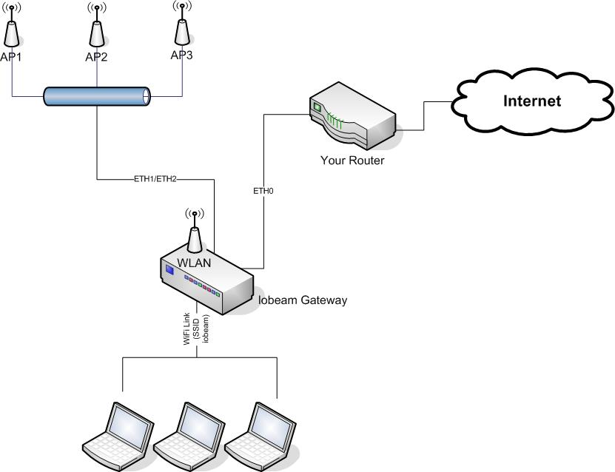
Requirements:

- Choose Static or DHCP host IP use. (iobeam recommends Static, if available).

- DHCP connection is automatic and the default unless the gateway was pre-configured to your specifications by the factory.

- DHCP is not recommended for production purposes because ports 22 and 7027 are required network address translation parameters which you will encode in your router for the iobeam gateway to provide splash page, content filtering, advanced usage reporting and remote management by iobeam. If the DHCP NAT entries change, the iobeam gateway functions will not work.

- Program your router to forward ports 22 and 7027 at the iobeam gateways’ internal IP address. Select TCP as the protocol.

- This iobeam gateway has been pre-configured with these settings:
  - Type_________________________Static
  - IP address ____________________10.120.40.189
  - Subnet Mask __________________255.255.255.0
  - Broadcast Address______________10.120.40.255
  - Gateway _____________________ 10.120.40.254
  - Primary DNS__________________172.16.1.1
  - Secondary DNS _______________ 198.6.1.125

Establish communication with iobeam gateway.

- Using a straight cat 5 RJ45 patch cable, plug the iobeam gateway into the router using the Eth0 port. Green light on left side of port indicates positive connection. Green flickering light on right side indicates traffic.

- Power iobeam gateway. Boot-up will take approximately 1 minute.

- From a Wireless PC, connect to port http://172.16.1.1:7027/gwadmin/login.jsp or:

- From a PC connected to the switch, use your browser to visit the IP address of the iobeam gateway listed above. The IP address Example: _____________________:7027/gwadmin/login.jsp

  - If this does not work, go to the command line of your pc (start, run, cmd.exe) and ping the IP address listed above (ping xxx.xxx.xxx.xxx) but not the port i.e 7027/gwadmin/login.jsp.

  - If the gateway does not respond to the ping, re-check network connectivity between PC and gateway. Connectivity to gateway must be proved before continuing with service setup.

- Login in to iobeam gateway. The login is admin and the default password is iobeam. Change the admin password first. Click “Service Settings” link on left to change password. Write password here ________________.

- You must cold boot (recycle) the iobeam gateway for any settings changes to take effect. We mention this now but wait until after all setting changes are complete.

- After you have changed the password, look through the settings. Before changing anything else, it is recommended you snapshot the page to an Adobe .pdf file and email to support@iobeam.com or print it out and fax to 404 806 8157.

- Now we will go through the items on the “Service Settings page”

Service Settings
Changing any of these settings will force all current and active users of this service to re-authenticate.

- Reset configuration: Restores all settings to their factory defaults.

- Reboot Gateway: Click on this button to remotely reboot gateway. We have found it is best to cold boot (unplug and re-plug power cord), which is our preferred method here at iobeam.

- Change password: iobeam recommends using letter/number substitutions for at least an eight-character password.

- Gateway configuration: Do not change these without documentation to iobeam.

  - Venue ID: DO NOT CHANGE. This value is preset by iobeam for proper communication and authentication with iobeam portal.

  - Radio Identifier: This value is presented to users, and may be changed to suit the venue. This is commonly referred to as the SSID and the default is iobeam.

  - Radio channel: 1, 4, 8, 11 are optimal for 802.11. Other channels may be used to avoid interference, if present. For example, use 2,3,5,6,7,9, or 10.

  - The default radio channel for this Gateway is 4.

  - Radio WEP key: Generally not applicable for public host venues. If set, the key must be distributed to authorized users. For 40-bit encryption, use a 5-character key. For stronger encryption, use a 13-character key. For Example: ab38a129uz4nB would be a strong encryption key.

Access Control: Start Access and Stop Access define the schedule when wireless service is available. Setting Enable Access to "NO" will disallow wireless access regardless of the schedule and can be done “on-the-fly” if necessary.

  - Set the iobeam gateway to the time your business opens and closes, using a 24-hour clock. Example 0700 to 1930. This setup will make the iobeam gateway automatically turn on at 7am and turn off at 7:30pm. All times must be in Eastern Time Zone.

  - During blocked periods, users who attempt to access the Internet will receive this splash page politely denying them access: http://www.iobeam.com/noservice.htm

This Access Control setup will turn on access 24 hours a day.
- Enable Access Yes No
- Start Access 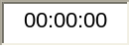 Stop Access 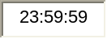

Content Filtering: iobeam filters objectionable content using a block-list database residing on the iobeam portal. Currently, iobeam block-lists over forty thousand pornographic web sites and twenty thousand URL’s. Our block-lists are updated weekly.

- Enable Content Filtering On Off

- WLAN Network Settings:

  - Private Address 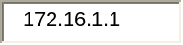
  - Private Subnet 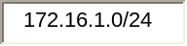
  - Private Netmask 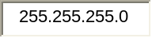
  - Private Broadcast 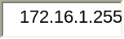
  - DHCP Lease Duration 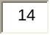 Hours
  - DHCP Address Range 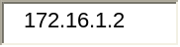 to 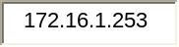

- ETH 1 Network Settings: If you do not have access points attached to this interface (i.e. a private WiFi iobeam subnet), leave these settings blank.

The ETH1 adapter enables you to connect extra WiFi Access Points to the iobeam gateway, enabling you to add coverage for roaming over a wide area. ETH1 segmentation enables you to support private WiFi networks with the same control features the public users have on WLAN (i.e. content filtering, usage reporting, scheduled use, etc).

To use multiple access points connect a cat5 cable to eth1 and then to a switch/hub. Run your extra AP’s off that hub. NEMA-4 rated external Access Points, equipment and installation is available from iobeam.

Below are ETH1 example settings. Notice ETH1 MUST be a different subnet than WLAN (i.e. 172.16.2.x vs. 172.16.1.x).

- Private Address 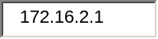
- Private Subnet 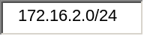
- Private Netmask 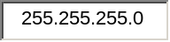
- Private Broadcast 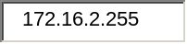
- DHCP Address Range 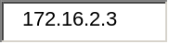 to 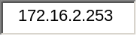
- DHCP Lease Duration 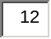 Hours

- DNS Servers:

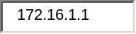 Leave this number as is.
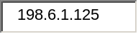 This number should be the primary DNS server of your ISP.

- Public Network Settings: Use the drop down button and change the connection to “STATIC”. Insert the rest of the data for your static connection. Enter the IP Address, netmask, broadcast address and default gateway. If DHCP leave the address, netmask, broadcast and gateway blank.

- Public Type
- Public Address 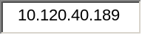
- Public Netmask
  - Public Broadcast Address 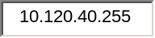
  - Default Gateway Address 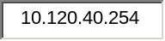

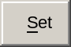

- For DHCP: You DHCP server will assign a DHCP address to the iobeam gateway when it boots and requests an IP address. To determine what that address is, go to the DHCP Server’s DHCP table and look for the “iobeam” hostname.

- To access it, use your web browser to hit http://x.x.x.x:7027/gwadmin/login.jsp , where x.x.x.x is the DHCP-issued IP address.
- Or: http://172.16.1.1:7027/gwadmin/login.jsp

- After completing entries, hit the “Set” button and power cycle the iobeam gateway.

13. Connecting to the iobeam network:

Plug your WiFi card into your laptop or use your Centrino enabled device. Set the device for DHCP. The WiFi adapter will pick up an issued DHCP IP address from the gateway and appropriate gateway and DNS addresses.

  - Use ipconfig /all from the command line to view these settings.

  - Ping the iobeam gateway.

  - In most all cases, (and this depends on the PC) the iobeam network will be instantly available. If not, navigate your mouse to the bottom right near the clock to the networking icon. Right click on this icon to view available WiFi networks and chose iobeam. Click the button that allows a non-secure connection. If there was an X over the networking icon, it should go away.

  - Surf the Internet. Each user who is assigned a new DHCP lease will first see the associated splash page to your venue that we programmed here at iobeam. As the lease expires every twelve hours (or for whatever cycle you set), the splash page will not come up again until a new lease is issued.

- After installation, login into the iobeam gateway (http://172.16.1.1:7027/gwadmin/login.jsp) and view the following user reports tools.

- Active Leases: This is an example of what the Active leases table will look like. Two hundred and fifty connections are possible but you must remember that bandwidth is ultimately limited to the speed of the Internet connection you’ve subscribed to from your ISP.

Listing of internal WLAN adapter users

MAC Address IP Address Client State
00:06:25:18:84:dd 172.16.1.2 2:Member, Restricted
00:06:25:18:84:dd 172.16.1.2 3:Member, Unrestricted
00:0d:2d:80:1c:da 172.16.1.3 3:Member, Restricted

172.16.1.3 (restricted) did not become authorized to continue.

Listing of ETH1 WLAN users

MAC Address | IP Address | Client State
00:0d:88:64:42:c5 | 172.16.2.13 | 2:Member, Unrestricted
00:0c:f1:19:92:76 | 172.16.2.16 | 2:Member, Unrestricted
00:02:2d:80:1c:dc | 172.16.2.18 | 2:Member, Unrestricted
00:90:4b:2d:4c:97 | 172.16.2.25 | 2:Member, Unrestricted
00:0d:93:7f:75:da | 172.16.2.17 | 2:Member, Unrestricted
00:05:3c:07:b2:87 | 172.16.2.23 | 2:Member, Unrestricted
00:90:96:b7:4f:4b | 172.16.2.24 | 2:Member, Unrestricted

Restricted users only have access to the iobeam Portal. Unrestricted users have access to all services (Web, FTP, Webmail, IM, etc).

- Active Tasks: This is a list of the leases and the date/time they are set to expire. By default, every lease expires within 6 hours of being created.

Date/Time MACAddress IPAddress Client State

02:27:52 08/18/2004 00:06:25:18:84:dd 172.16.1.2 2:Member, Unrestricted

- Activity Log: These log entries show all activity on the iobeam gateway since it was powered-up. This list is erased every time power is lost to the gateway.

11/22/2004 13:46:55 63774 00:0b:7d:06:0e:f6 /172.16.2.182 ClientState(Member, Restricted, 3) 11/22/2004 19:46:54
11/22/2004 13:46:56 63774 00:0b:7d:06:0e:f6 /172.16.2.182 ClientState(Member, Unrestricted, 2) 11/22/2004 19:46:56
11/22/2004 18:44:49 63775 00:09:5b:22:21:95 /172.16.2.187 ClientState(Member, Restricted, 3) 11/23/2004 00:44:48
11/22/2004 18:45:02 63775 00:09:5b:22:21:95 /172.16.2.187 ClientState(Member, Unrestricted, 2) 11/22/2004 23:59:59

Notice Restricted (3) and Unrestricted (2) use. The user logs into the iobeam network as a restricted user until authenticated by the portal, thus becoming a member (2). One indication that the user became authenticated is the presentation of the venue host Splash Page before the user moves on to the Internet at large. Also notice that the time authentication occurs (i.e. the user allows the splash page to run) within one to five seconds.

- Roll-up reports

Roll-up reports provide a month-to-month usage track of users per day. These reports are emailed to a contact address each month or on request. To receive these reports by email, send a request to support@iobeam.com. Please provide iobeam with the appropriate email address and date to receive these reports.

This is an example roll-up report:

Iobeam roll-up monthly site report
THE DATE TOTAL USERS
---------- ----------
07/28/2004 1
07/31/2004 1
08/02/2004 1
08/03/2004 1
08/06/2004 1
08/19/2004 2
08/20/2004 3
08/21/2004 2
08/22/2004 3
08/23/2004 3
08/24/2004 9
08/25/2004 13
08/26/2004 9
08/27/2004 2
08/28/2004 1
08/29/2004 5
08/30/2004 5
08/31/2004 4
09/01/2004 9
09/05/2004 4
09/06/2004 4
09/07/2004 6
09/08/2004 9
09/09/2004 6
09/10/2004 2
09/11/2004 4
09/12/2004 5
09/13/2004 10
09/14/2004 6
09/15/2004 8
09/16/2004 8
09/17/2004 7
09/18/2004 2
09/19/2004 7
09/20/2004 7
09/21/2004 19
09/22/2004 10
09/23/2004 12
09/24/2004 5
09/25/2004 8
09/26/2004 8
09/27/2004 10
09/28/2004 16
09/29/2004 22
09/30/2004 17
10/01/2004 12
10/02/2004 8
10/03/2004 8
10/04/2004 12
10/05/2004 16
10/06/2004 12
10/07/2004 12
10/08/2004 8
10/09/2004 2
10/10/2004 7
10/11/2004 13
10/12/2004 20
10/13/2004 19
10/14/2004 11
10/15/2004 9
10/16/2004 10
10/17/2004 4
10/18/2004 14
10/19/2004 24
10/20/2004 28
10/21/2004 25
10/22/2004 14
10/23/2004 7
10/24/2004 7
10/25/2004 8
10/26/2004 11
10/27/2004 16
10/28/2004 30
10/29/2004 16
10/30/2004 5
10/31/2004 6
11/01/2004 11
11/02/2004 14
11/03/2004 19
11/04/2004 11
11/05/2004 15
11/06/2004 8
11/08/2004 11
11/09/2004 20
11/10/2004 31
11/11/2004 3

END REPORT

Copyright iobeam inc. 2004

