Free Computer Labs Course Booklet
Guide for Free Computer Labs classes.

Preface
Free Computer Labs (FCL) computer classes have one main purpose: to help empower people with their technology. Many people feel frustrated with their technology, in particular their computers. However, many of these frustrations can be averted with knowledge and the right tools. To these ends, FCL helps people diagnose and repair older computers—while teaching the basics of how computers work—and helps people install and start using free/libre software, the only kind of software that keeps its users in control of their computing. We hope that you enjoy the class, and we hope that you feel empowered to share your knowledge... and the software!

A note about this booklet
We want to empower our students to be able to share their knowledge with others, as well as contribute to the class itself after participating in FCL computer classes. This is why we have chosen to license the booklet under the GNU Free Document License (see the last page of the booklet for details). Please find all the materials used to make the document at the following site: [DEVIN TODO: Move to libretools.com site and put link and password to folder here – Just this folder!] Feel free to download the document's source files, share the document, edit, improve, and even redistribute this document as you see fit. There is no need to share your edits with us, but doing so would help the community improve its methods. Thank you and enjoy!

First concepts
Computer
Informatics is the discipline that includes the study and application of using computers to process information. Information technology is often also called computer science. Computers process information when they do things for what goes. This can come from a keyboard, mouse, button, game controller, etc.
The act of inputting this information is also known as entering data. For computers running data processing instructions. A series of instructions for a computer to do something specific is called program.
Computing can separate everything into two groups one that deals only with the programs and another that deals with the devices themselves.
Many people call everything that deals with programs software; and everything that deals with devices hardware.
Computers
The most common type of computer today is the personal computer or PC. And from these, there are usually two different types. The less portable desktop for use in a home or office, and the more portable computer that is often called laptop, notebook or netbook. Desktop PCs typically come as a box or tower computer that is used in conjunction with a screen, keyboard, and other accessories provided separately (peripherals). Laptops have all the internal parts of a desktop (screen, keyboard, etc) but comes as one complete piece that is more compact. There is also other kind of personal computers called tablets or handled devices that includes modern cell phones, all of which have computer capabilities. For example, they can be used to access email, the internet, and run software programs like a regular computer.
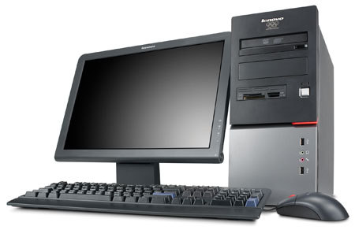
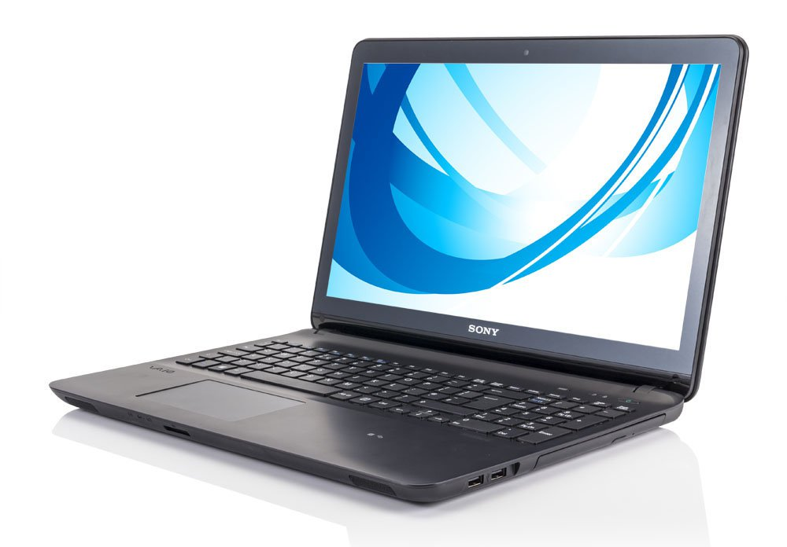
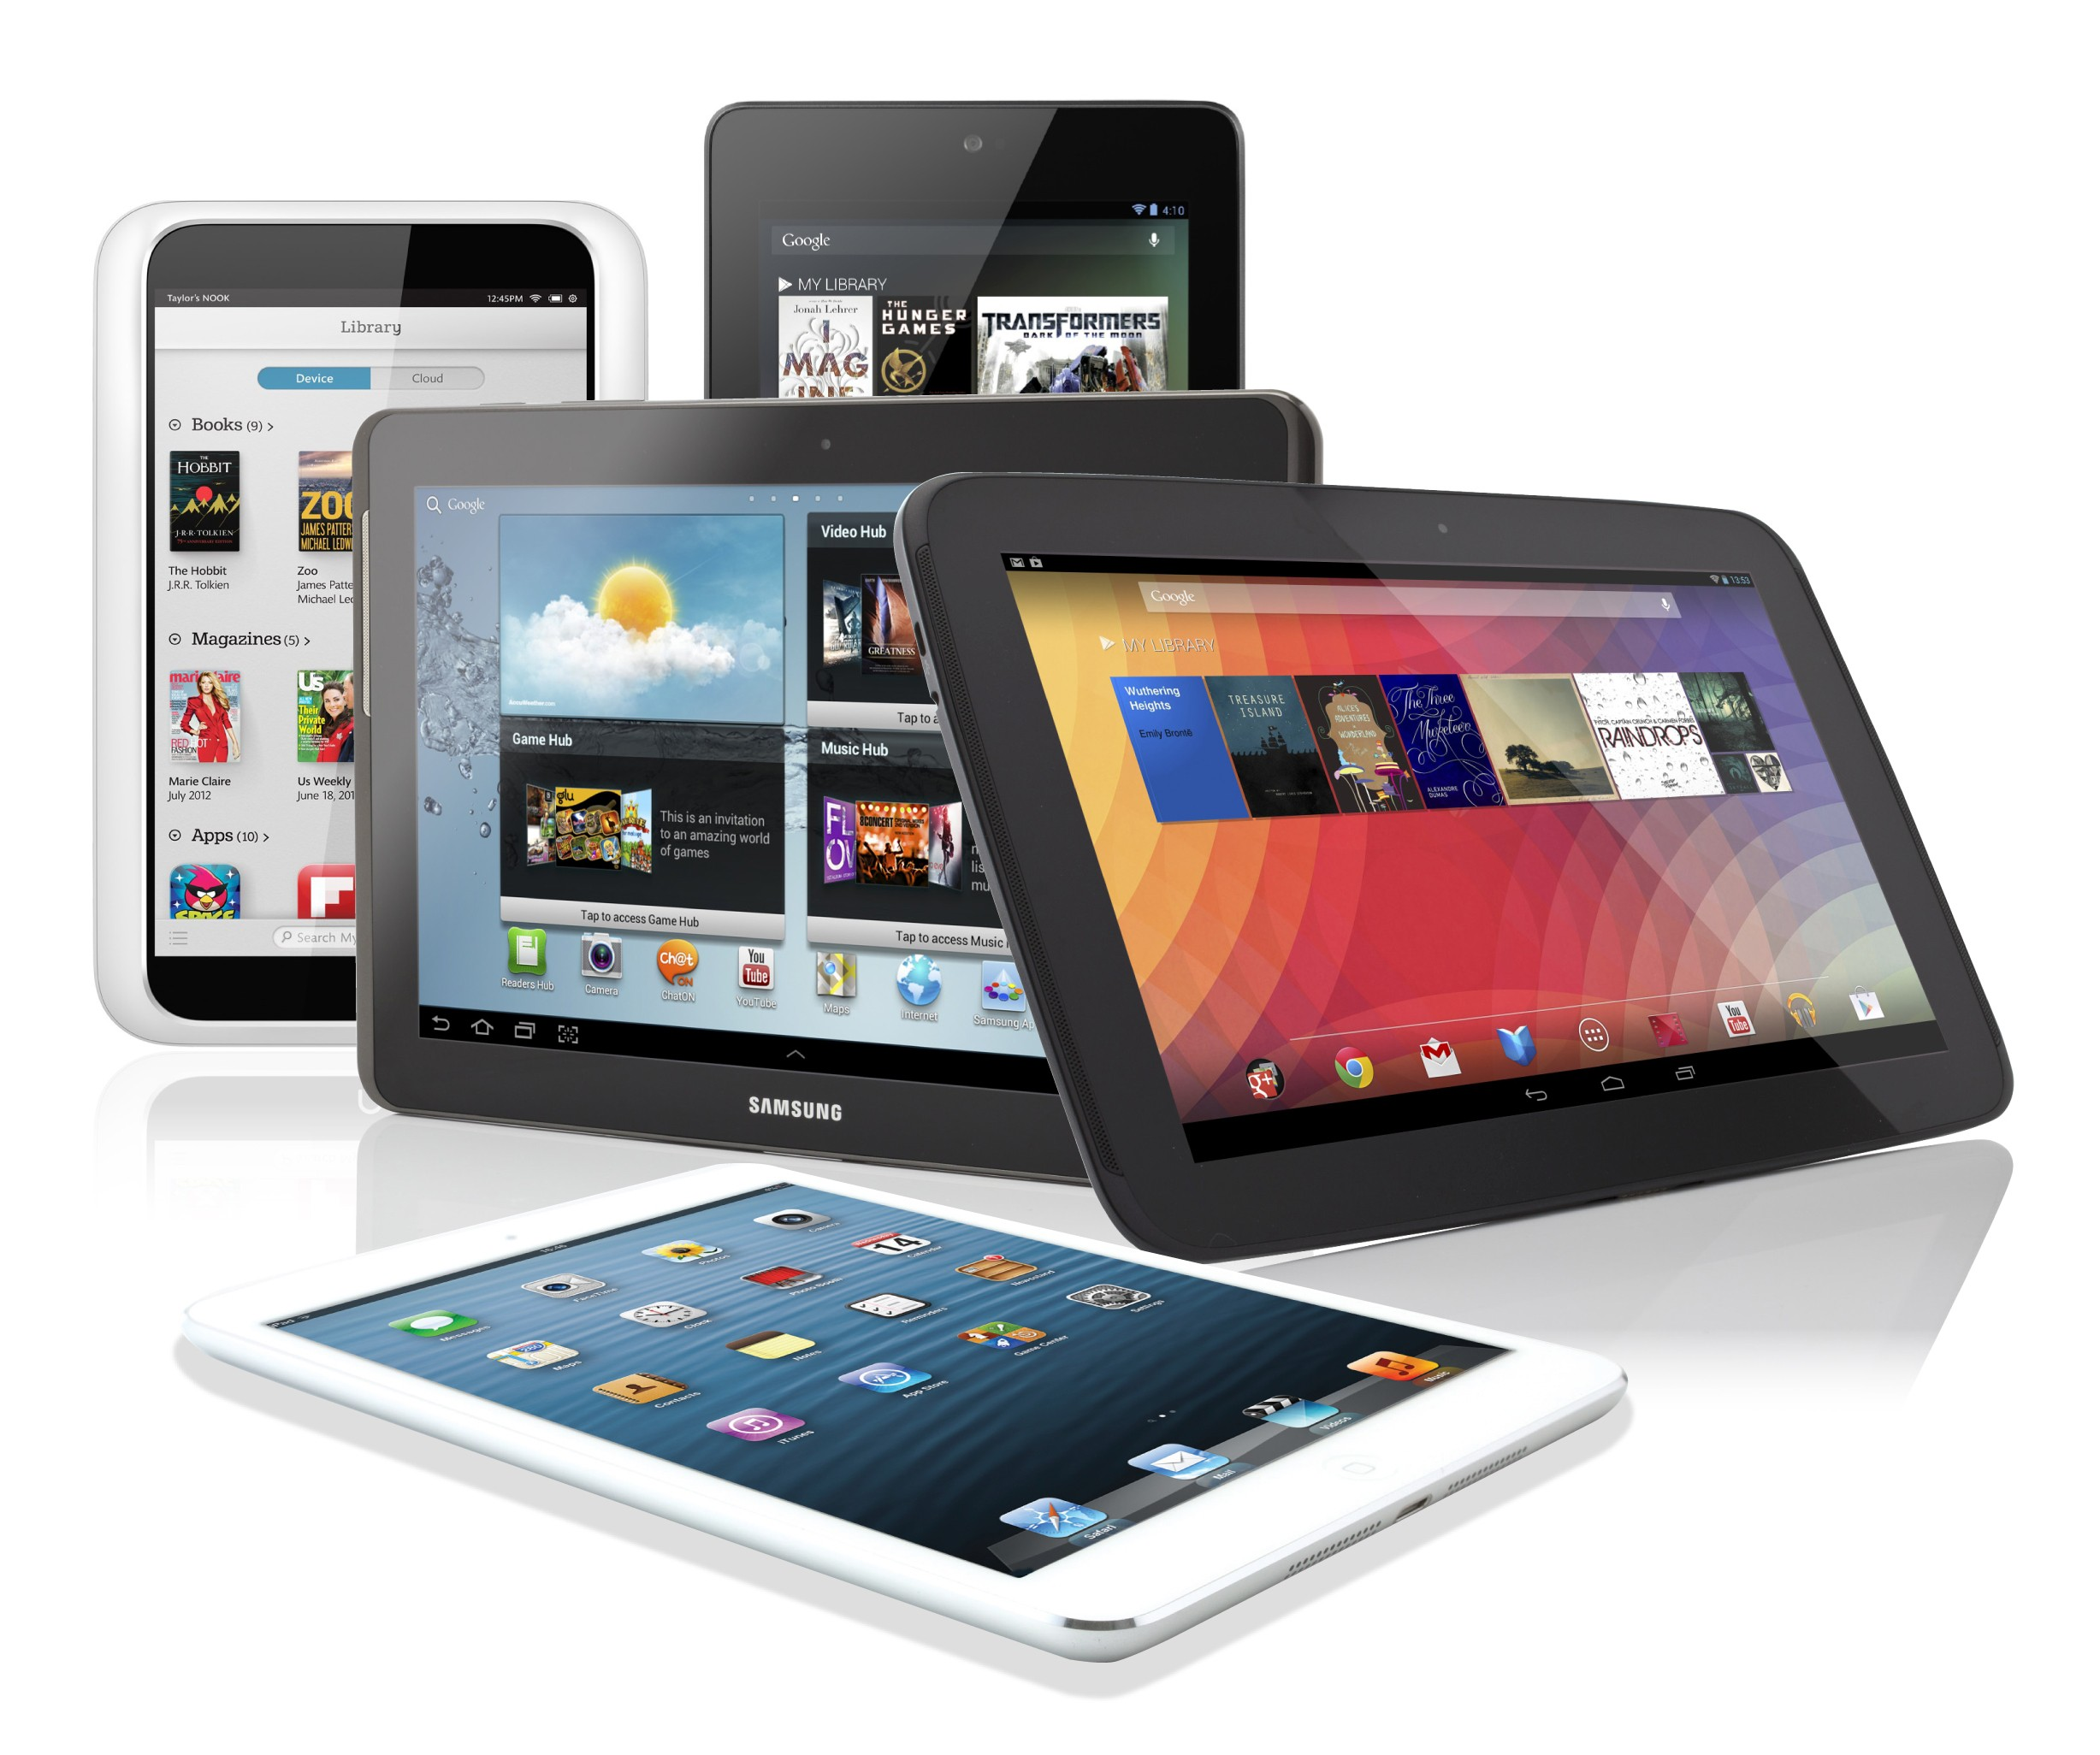
Figure 1: The most common types of personal computers today. Desktops, laptops, phones and tablets

Desktop computers are easier to disassemble, handle, and understand. In this course, we will deal first with desktop computers and their corresponding components for laptops afterwards.
The CPU
The CPU is the central processing unit. It works by interpreting and processing the program instructions. It is like the brain and the heart of computers. There must be a coordination between the different things a computer have to do, specially when working at very high speed. To do so, the CPU pulses and send signals at a rate called frequency and is usually measured in megahertz,a million beats per second, and gigahertz, which is billion beats per second.
Memory
Memory is what retain the information when the computer is on in a similar manner as our awareness or mind does. These are the elements in which computers write and/or read information. This information can be both instructions and data. There are read-only memories and read and write iones. The latter is the family of RAM (Random Access Memory). All contents of RAM are erased when we turn off the computer. The amount of information that fits within the memory is measured in megabytes, whose meaning will be explained later. Memory has time cycles in which information remains stored. These time cycles are also measured in megahertz. There are other types of memory such as ROM or EPROM that are read-only or limited write. Another type of commonly used memory is flash, where you can write and read data many times. Unlike other types of RAM memory, flash memory is not erased when are turned off or disconnected from the equipment where they were.
The part that reads or writes to memory is the same CPU. The CPU can only write or read to memory according to specified cycles of time. The most common types of RAM in computers today are the DDRAM that have replaced an older version
named SDRAM, which is now less common but still manufactured. SDRAMs differ externally of DDRAMs by having two slits on their bottom part instead a single one..
There are two different types of SDRAM, which work at different speeds. They are the PC100 and PC133. PCs more than 18 years old may have an even older type of memory called SRAM.
Connectors and slots
The parts within computers are connected via interfaces. Industry standards specify the physical dimensions and electrical characteristics of each kind of interface. These standards differ on the number, position and function of the various channels (metallic strips or traces) the connectors have. Electrical signals travel over the channels in compliance with communications standards known as protocols. The most common type of connector is PCI (Peripheral Component Interconnect). Usually computers have female slots where the different parts or pieces are connected by plugs. The parts that are connected to computers are often referred to as cards when they are internal and peripherals when they are external.
The sound card
Sound cards are the components that generate sound according in response to signals given by the CPU. Usually they have three audio jacks that are identified by color and a MIDI interface used to connect musical instruments and other devices.
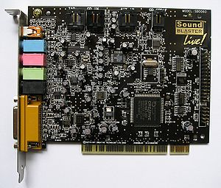Figure 2 Sound card Sound Blaster

The video card
The video card, also called the GPU, is responsible for producing a video image from data sent from memory by the CPU. The connector and signal from the video card to your monitor typically follows one of a few standards: SVGA, S-video and DVI, which is the most widespread today. Newer computers may use a fourth standard known as DisplayPort. Video cards include their own RAM chips, but of a different type from the regular system RAM, as will be explained later. Other distinguishing features of a GPU are special types of connectors and cooling technologies such as radiators, fans, cooling tubes that carry liquids, etc. The capabilities, complexity, cost, and power consumption of GPUs varies by model and manufacturer.
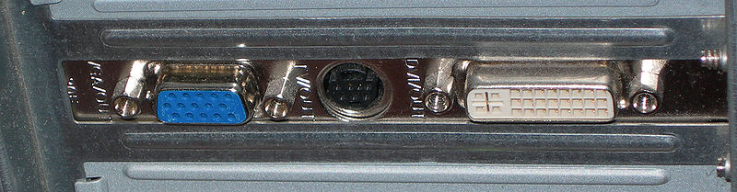Figure 3: View SVGA connectors, S-Video and DVI
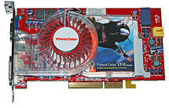Figure 4: ATI video card

Motherboard
The motherboard is like the backbone of a desktop computer . Itsupports all the cards and connectors, the power supply and the CPU. The motherboard is not only a physical structure, but also coordinates and monitors the functioning of the various parts of the computer using electrical signals. It decides when the computer will turn on and off, which speed the CPU and memory will run at, and the relative priority of the various disks and storage systems. The motherboard is controlled by a small but powerful program called the BIOS. The BIOS is stored in flash memory or an internal EPROM on the motherboard that is never erased.
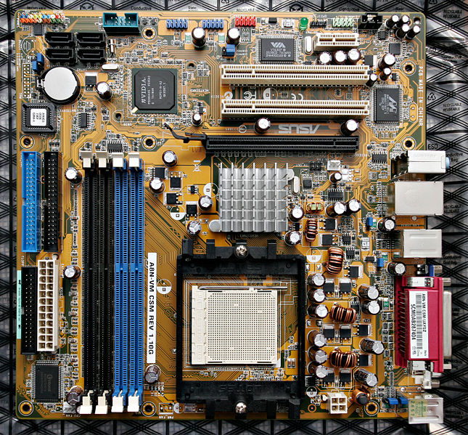Figure 5: The motherboard

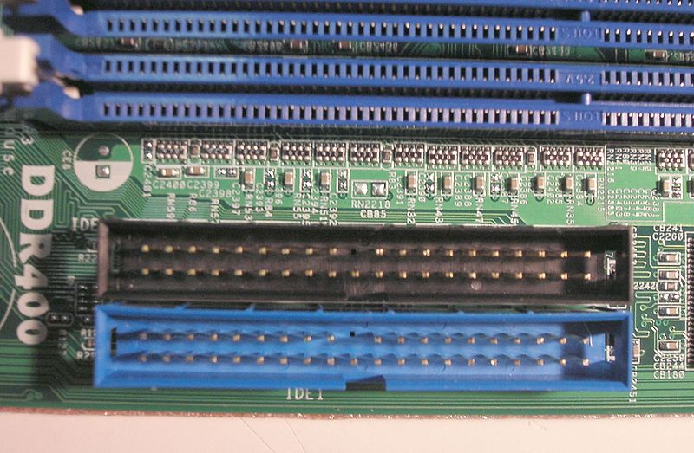Figure 6: Connectors for memory and disk on the mother board

Storage units
Storage units are devices that computers use to store information permanently analogous to the parts of our brains that store long term memories. The storage units are similar in function to the RAM memory chips described above, but are usually much slower, store much more data, and retain this data after the computer turns off and on again. The most common types of storage are magnetic disks. These may be hard drives or also floppy disks in older systems.
Floppy disks are small, flat, round sheets of magnetic material wrapped in plastic envelopes. To read and write data to them, you must insert them into a device in the computer called a floppy disk drive. PCs today usually do not include floppy disk drives, but it continues to be possible to add them. Floppy disks have limited capacity and are considered obsolete.
Hard drives are read and written much faster and have more capacity than floppy disks. They have a number of stacked, rigid disks within that are very delicate discs and cannot be removed. Their capacity is measured in hundreds of gigabytes, typically holding hundreds of times as much data as RAM. Hard drives have an interface on the back, which serves to connect them to the PC, a feed inlet and a connector or manual configuration called a jumper. The types of interfaces include IDE, SATA and SCSI. The SATA connection standard is noticeably faster and more efficient than IDE. Currently there are two versions, SATA 1 and SATA 2, which differ in their rates of transfer data specifications. SCSI hard drives are large capacity storage interfaces more frequently used in servers in corporate environments than in PCs.
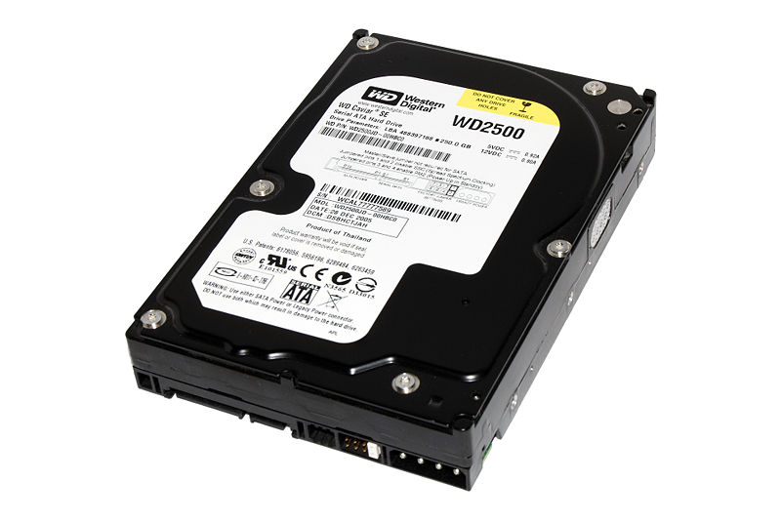Figure 7: Hard disk with SATA connector to the left side,and input jumper power supply at its right end
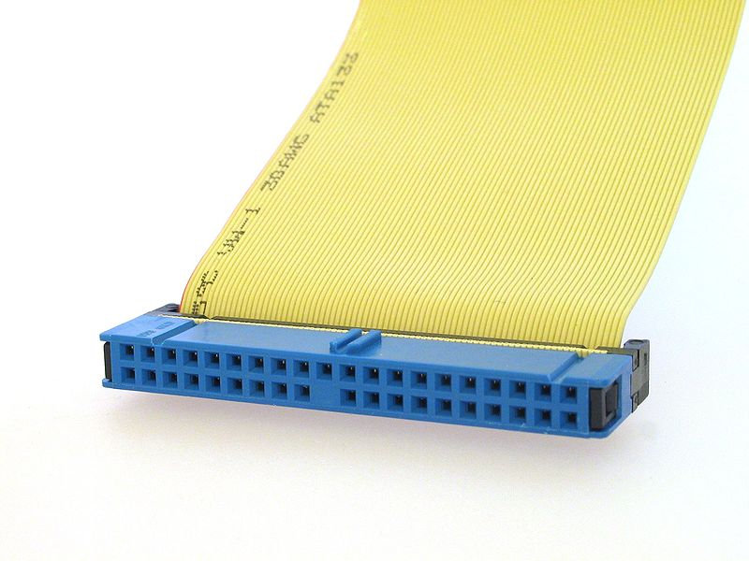Figure 8: IDE connector
Other very common storage devices are optical drives. These units include both read and read/rewrite optical discs. Optical disks can be of three types: CD, DVD or Blue Ray. Like floppy disks, these discs can be inserted and removed from a drive and carried easily from computer to computer. DVDs have a capacity seven times greater than CDs and are also faster. Both DVDs and CDs can be read only, read/write once or read with multiple write. The devices that read the discs are called the CD or DVD-ROM drive. Those that have the capability of recording are called CD recorders.
The optical storage devices have the same connectors as hard drives in the back plus an audio output that connects to a speaker inside the computer for listening music to CDs. Usually motherboards have two connectors for hard drives and optical disks. Each connector can receive two drives. A primary and a secondary. The position of the jumper determines whether a storage unit is primary or secondary.
The power supply
Computers need electricity in order to run. The power supply is a transformer that sends electric current to the various elements of the PC. It has many connector points and other smaller connectors that feed electricity to drives. The voltage going to the motherboard is about 5 volts and the disk drives is 18 volts.
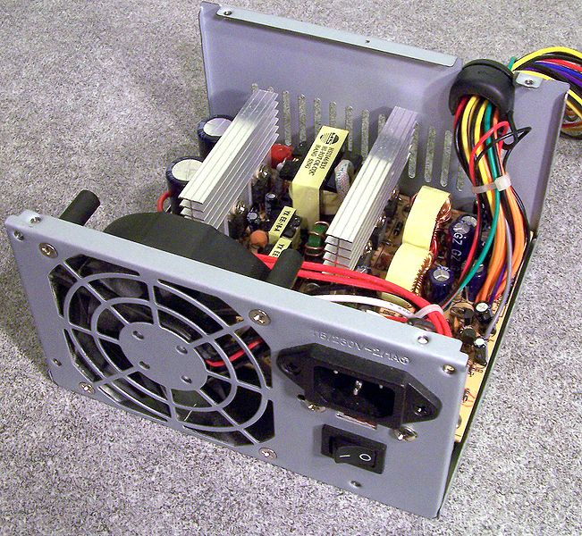Figure 9: An open power supply

Today most of the power supplies meet the Energy Star standard, which identifies products that use energy efficiently ( energy is only used when the computer is running) we distinguish two types of sources. AT and ATX (most common).

The cooling system.
The cooling system is the system that ventilates the computer and each of the system components.
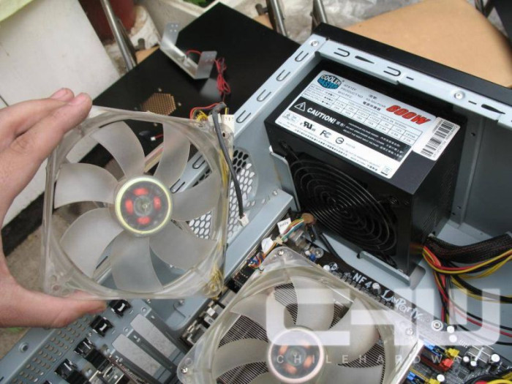Figure 10: Fan cooler
A overheating system can cause loss of data or damage to the various electronic components of the computer.
Air ventilation → cool air is created through the combination of fans and heat sinks. They usually appear in the most devices that are most sensitive to overheating (i.e. microprocessors, graphics cards, and chipsets) or attached to a box as additional fans, watercooling​​ or cooling liquid → the last two are controlled through a circuit system that contains cooling liquid.
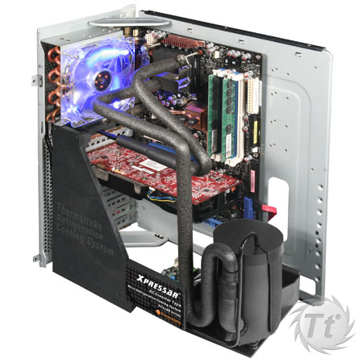Figure 11: Liquid cooling system

Hands On Repair
Learning to fix a computer is like learning to repair any other appliance. We saw above that each piece that makes up a computer has a specific purpose. With the right clues, faults can be traced back to the specific part that must be replaced or repaired. The first thing you have to do is open the computer's case and see what's on the motherboard. It is important to check that you have enough RAM, a hard drive, a graphics card and, optionally, a sound card, network card, and optical drive. Once we know everything is in place the next step is to verify that everything is connected and moving parts such as fans are free of dust, dirt and obstacles. It is a little surprising, but many times dust is the reason why computers do not work well. Dust and dirt trap heat and can even lock fans causing devices to overheat or turn off. Many people throw out computers thinking them broken, and it turns out that when someone cleans them they spring back to life. To clean the dust you can use a brush, a cloth with alcohol, or compressed air, but never water.
After completing this first reconnaissance, we can try turning on the computer. If nothing happens we will have to test the power supply. To do that, carefully unplug the power connector from the motherboard and make a bridge between the black and green wires on the connector. The connector looks like a comb. To remove it we must press little plastic locks on either side. Avoid using too much force. If making the bridge with the power unplugged makes the fan in the power supply turn that suggests the power supply is in good working order. If not, then the power supply is likely the culprit. Many power supplies have a fuse that can be changed when it blows. Others simply are ruined and need to be replaced. If we identify a faulty power supply and replace its fuse or the whole unit with a working one, then we can turn on the computer again and proceed to diagnose any potential further problems.
When we turn on a PC, the motherboard scans the entire system to check if everything is in order and whether it should continue starting the system. The technical term for this is Power On Self Test (POST). It communicates the results of these checks to us by means of sequences of beeps of different durations. The POST runs through each time the computer is turned on to make sure all the hardware is properly working before trying to load the operating system and other programs. If the computer does not pass POST, it will not boot.Here are some:
- No beeps: No power (perhaps the cable is unplugged, is broken or the power supply is damaged – the point is that there is no power to the motherboard) or it may be that the speaker that emits the beeps fails to produce a tone (which can be tested separately).
- Continuous: Error in the power supply. Even if the computer turns on, there is something wrong with the power supply box.
- Constant beeps: The motherboard is faulty, i.e. is broken, the worst that can happen to us.
- One long beep: RAM error. Typically the RAM is not fastened well to the motherboard but could be faulty.
- One long, another short: Error on the motherboard or ROM Basic. This happens a lot with old motherboards.
- One long beep and two short: Error recognizing the graphics card. The port may fail or but may also be that the graphics card is defective.
- Two long and one short: Error in synchronizing the images, most often seen in old computers. Incompatibility of the graphic card.
- Two short: Memory parity error (parity is a form of error checking). This occurs especially in old computers carrying two memory modules in two modules. This would mean that one module failed or does not have an even number of memory modules, which may be required in certain computers.
- Three short: This indicates that there is an error in the first 64K of RAM.
- Four shorts: Error in the timer or counter.
- Five short: This indicates that the processor or graphics card won't start. It usually happens from overheating.
- Six: Keyboard error: If this happens try another keyboard. If it still does not work it may the keyboard port where the keyboard plugs into the computer.
- Seven: Virtual processor mode error. Virtual mode one of the ways a CPU can use memory. It's used to support older MSDOS programs.
- Eight: Error writing to video RAM.
- Nine: Error in the checksum (error detection code) of the BIOS RAM.

We often hear beeps we do not understand but the system continues to start and operates normally. In that case it would issue the error by removing plug/ unplug parts while turn off and on the computer (trial and error).
The beep code information given here is for guidance only, not accurate, as it can vary depending on the model.
For AWARD BIOS:
- 1 Long Beep: problem of memory
- 1 Long Beep, and 2 short beeps: Error in Video card
- 1 Long Beep, and 3 short beeps: Video Error (Graphic card.)
- Continuous Beeps: Memory or video problem

For AMI BIOS:
- 1 Beep: Error in DRAM memory refresh
- 2 Beeps: Parity circuit failure
- 3 beeps: Error in first 64KB of RAM memory
- 4 Beeps: Timing system failure
- 5 Beeps: Processor
- 6 Beeps: Fault Controller Gate A20 keyboard
- 7 Beeps: Virtual mode exception
- 8 Beeps: Failure to read / write memory display
- 9 Beeps: ROM BIOS checksum error
- 10 Beeps: Error reading / writing to the CMOS when shutting down
- 11 Beeps: Cache memory error
- 1 Long Beep, 3 Short: Failure of Conventional / Extended Memory
- 1 Long Beep, 8 Short: Failure testing video
- Continuous Beep: Most surely memory or video problem
- 1 Long Beep: All tests passed, no problem.

For IBM BIOS:
- No beep or a short one: No power or loose card.
- 1 Short beeps and Normal Start: The device is OK.
- 2 Short beeps: POST Error. See screen error code.
- Continuous or short beep: No power, loose card.
- Short Repetitive beeps, or Short beep: No power, loose card.
- 1 long and one short beep: Problem on the motherboard.
- 1 long and two short beeps: Problem Video (Display Circuitry Mono / CGA).
- 1 long and three beeps: Problem EGA display circuit
- 3 long beeps: Error on the keyboard or controller
- 1 beep and black screen or garbled image: Video Circuitry failure
The BIOS
To access or enter the set up menus of the BIOS, reboot or turn on the computer and repeatedly press the "DEL" key on your keyboard. (Depending on the PC, this could instead be F2, F10, ESC, etc.) To know for sure which key to press watch the bottom of the screen when the computer starts for a message like "Press XXX to enter setup for XXX"where XXX is the key to press.
Now we see the BIOS set up screen we wished to access. Different BIOS types will have different looking BIOS but they each serve the same purpose, so once you've seen one nother will be familiar. In all cases, we move through the different options offered using the arrow keys and will select an option by pressing Enter. If you look at the bottom of the screen there will be a legend telling us how to perform the different available operations. To return to the home screen after selecting options that change to a new screen press ESC.
Then choose to save the changes to the BIOS.
Once we make the changes we require in the bios, such as changing the boot sequence, autodetect units, etc., we save these changes, i.e., burn them permanently into memory to be effective at the next boot PC. To do this, once we return to the initial BIOS screen after making changes, we can save in two ways:
1. By selecting the SAVE & EXIT SETUP (Save and exit the bios)
2. Press the F10 key
In both cases, the window will ask us to select Y (YES) to accept save changes or N (NO) to reject them, i.e. to not keep the changes we have made.
At times will specify vary the boot sequence in the BIOS for eg installing your operating system. The boot sequence is the one that will decide starting order will follow the different units of our PC, ie where the pc will go to look for information to boot the computer.
Once inside the BIOS, we're going to line Advanced BIOS Features or Advanced Setup in other BIOS and press Enter as well.
to boot from the CD
Configure
In the First Boot Device option: CD-ROM(reading unit Cds)
In option:the Second Boot Device option HDD-0(primary-master HDD)
The Third Boot Device FLOPPY(Floppy)
Then hit ESC (Escape) so we return to the initial screen of the bios, and now only subtract save the changes and restart the pc with the new settings we have selectedwell.
to boot from the hard disk
Configure
In the First Boot Device option: HDD-0(hard disk primary-master)
The Second Boot Device option: CD- ROM(reading unit CDs)
On the Third Boot Device option: FLOPPY(Floppy)
Then hit ESC (Escape) so we return to the initial screen of the bios, and now only subtract save your changes and reboot the pc with the new configuration we have chosen as well.
to boot from the floppy
Configure
In the First Boot Device option: FLOPPY(Floppy)
The Second Boot Device option: HDD-0(hard disk primary-master)
The Third Boot Device option: CD ROM(reading unit Cds)
Then hit ESC (Escape) so we return to the initial screen of the bios, and now only subtract save your changes and reboot the PC with the new settings we have selected.
Sometimes will specify Detect hard drives or readers recently installed in our pc, since the new place them on the computer may start our operating system and they do not appear. Depending on the type of BIOS this action could take place otherwise I shall report the most common and hope to guide for other situations. Denter the bios, we go to theline Standard CMOS Features .(which is usually the first column on the left), and press Enter to access all the options inside
In this section we look at the lines:
Primary IDE Master: Master Device primary channel Slave.:
IDE Primary slave device of the primary channel Master.
IDE Secondary Device master secondary channel..
IDE Secondary Slave Slave Device subchannel **
Detecting IDE hard disk
We are located on the line IDE Primary Master or at the IDE where we've set from jumpers for that purpose have these devices, so it is selected and press ENTER.
We show a new window where you will press ENTER on the online Ide HDD auto detection and at the bottom they appear the data on the drive.
For changes future units can leave already selected by default Automatic detection,so that when we place a new BIOS device will automatically find itself without having to follow this method.
Then hit ESC (Escape) so we return to the initial screen BIOS, and now only subtract save changes bios and restart the PC with recognized units.
As readers detect or CD recorders
We are located on the Secondary IDE slave line or at the Ide where we configured from the jumpers that this effect have these devices, so it is selected and press ENTER. We follow the same steps as for detecting the hard drive.
In some bios do not need to configure the auto detection. Simply a menu will appear with options for primary and secondary disks, you move to each of the options and pressing Enter on them will detect each of the devices. Then only remains to save the changes.
As we do if there are changes that do not know cancel the
Often the BIOS has anomalous behavior we do not know how to change BIOS. This usually happens when we receive a computer and someone played with the advanced BIOS options. In this case, we look at the main menu option to load the default settings, "load defaults", this will restore the factory settings and then can already make changes like doing our usual boot from the CD, etc.

The operating system (OS)
An operating system (OS) is a program or set of programs that perform basic management processes of a computer system, and allows normal performance of other operations.
Note that it is a mistake common very widespread call the complete toolset operating system, ie, the inclusion in the same term programs such as file explorer, navigator and all kinds of tools that allow interaction with the operating system, also called kernel. One of the most prominent examples of this difference is the Linux kernel, which is the core of the GNU operating system, which are called GNU. This precision error is due to the upgrading of the information held in the late 80s, when the philosophy of basic operating structure of large computers^{[2]} to be redesigned to bring it to homes and ease of use They changed the concept of multiuser computer (many users at the same time) for a single-user system (only one user at a time) easier to manage. (See AmigaOS, BeOS or MacOS as pionerosde such modernization, when the Amiga, were baptized with the nickname Video Toastersfor its capacity for video editing round robin multitasking environment with thousands of color management and intuitive interfaces for 3D design e2n.
One purpose of the operating system that manages the core intermediary is to manage localization resources and hardware access protection, a fact that relieves application programmers from having to deal with these details. They are found in most electronic appliances that use microprocessors to run. (Mobile phones, DVD players, computers, radios, etc.)
ORGANIZATION LOGIC HARD DRIVE:
A disc internally consists of the following elements:
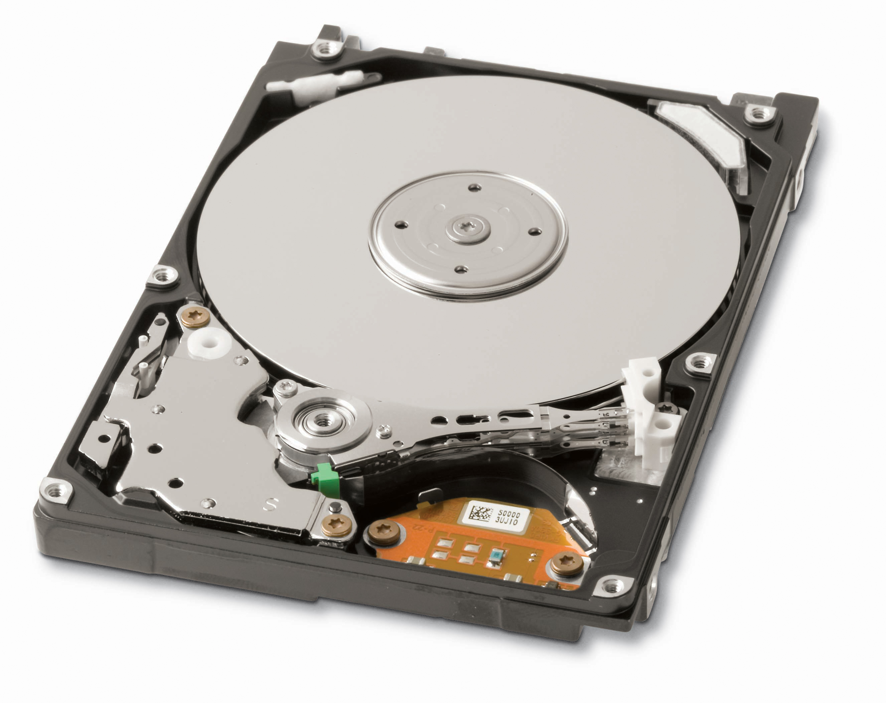

And the structure of the disk itself:
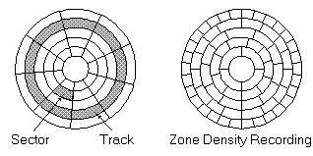

As we see in the images, an album is really a cylinder comprises several disks having two faces turn. Each face is divided into a set of tracks and each track on a set of sectors. All secores occupy 512MB; and is the minimum amount of data that a hard drive can read or writefollows.
any hard disk is organized as
MBR | DISK PARTITIONS
The first 512 MB ​​(that is, the first sector of the disk), form the MBR. Here the number of partitions that there are, what type they are and what is the active partition on the disk to give you access stored.
The disk partitions are the ways you can divide your hard disk, for example, to install it multiple operating systemsbe:...
Partitions can primary or extended
A hard disk, you can only have 4 primary partitions, of which only one is the active partition (which is being used)
A disk can have multiple extended partitions ( These are often used to add data to the system), which in turn are divided into logical partitions example.
Consider an
Suppose we want to install on a drive, two operating systems: WINDOWS XP and Ubuntu, and I leave for the WINDOWS system with a separate space for storing data. Well, then, what you could do would be:
1. See how much storage space need each system. Think, that will be the minimum space that you will give the partition holding turn the system. Typically, give as much space to store the system and all the data we want.
2. As in our case, we only want to install two operating systems, we can create only 2 primary partitions and one extended, to store data.
3. Assuming that your disk is 250GB, could split as
- 10 GB toe xtended partition
- follows:...100 GB for Linux partition that will store
- the rest for Windows XP partition that stores
A disc with two operating systems, Windows (not recommended) and Ubuntu,nternally has the following:
MBR | WINDOWS | UBUNTU | D
NOTE: Keep in mind that each operating system has its own operating system. For example, Ubuntu, when installed, automatically need 2 partitions: one where you store the data, and one for memory operations. However, the computer can make partitions to your liking, considering that this only be a logical way to organize your information on disk.

Installation: Links about Installation -

The following are some guides that are helpful for getting through the installation process for Ubuntu, a popular distribution of GNU/Linux.

All Ubuntu Guides:

https://help.ubuntu.com/12.04/installation-guide/index.html

Graphical Guides:

https://help.ubuntu.com/community/GraphicalInstall

i386:

https://help.ubuntu.com/12.04/installation-guide/en.i386/pr01.html

Troubleshooting –

There may be times when you run into problems with your operating system and your software. When this happens, there are things that you can do to solve these issues.

- Search through forums:
Usually, if you have a question, it means that others have encountered the same question before. You can often just query your favorite search engine to see what others have to say about the same problem.
- Ask on the IRC
There are many chat channels for many different topics (#ubuntustudio, [more examples HERE]). It may take a little bit of time for someone to answer, so be patient, but the people on the IRC are very knowledgeable and generous with their knowledge. You will often be able to find an answer by asking politely in an IRC channel.
- Stay connected with your local community
In Boston, for example, we have the Boston Linux and Unix Users Group. Staying connected with groups like these will make sure that you stay connected with the current trends and changes.

Copyright (C) 2016 FREE COMPUTER LABS.
Permission is solicited to copy, distribute and / or modify this document
under the terms of the GNU Free Documentation License, Version 1.3
or any later version published by the Free Software
Foundation;.With no Invariant Sections, no Front-Cover Texts, and no Back-Cover Texts
A copy of the license is included in the section Entitled "GNU
Free Documentation License".
You can read the full text of the license here: https://www.gnu.org/licenses/fdl.html

