# LBG Screening NodeJS Project

Problem Statement:

1. Write a nodejs server that listens on port 3001 and outputs a file content from any local directory
2. Write a nodejs server that serves as a RESTFUL api that takes two parameters in a GET call and produces their product.
3. Write a nodejs server that serves as a RESTFUL api that accepts a String as an input name and returns the first non-repeating character in the String
4. Write a nodejs server that serves as a RESTFUL api that accepts a file content and writes them to the disk.

Solution:

1. <http://localhost:3001> http method : get

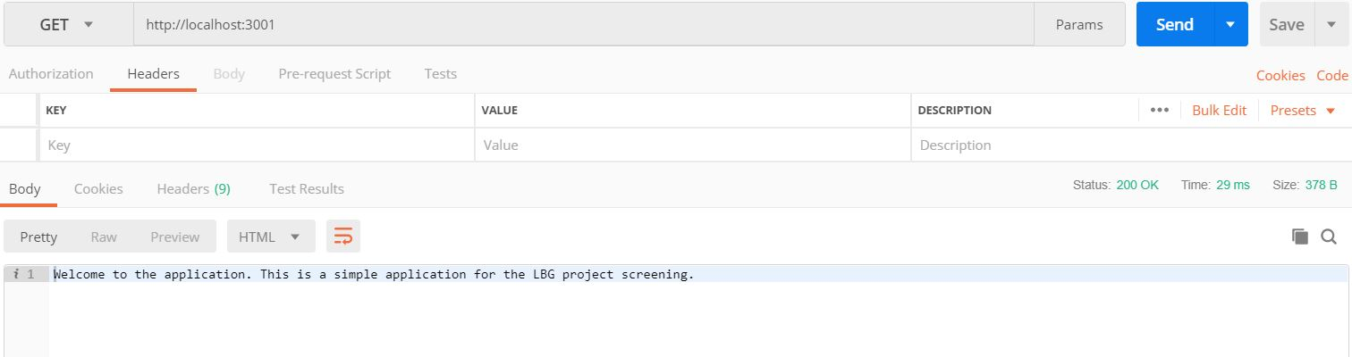

2. <http://localhost:3001/route/product/2/4> http method : get

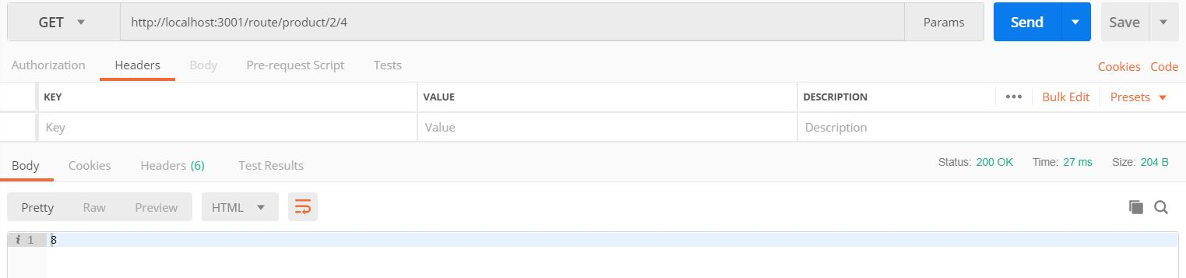

1. <http://localhost:3001/route/firstchar/harih> http method : get

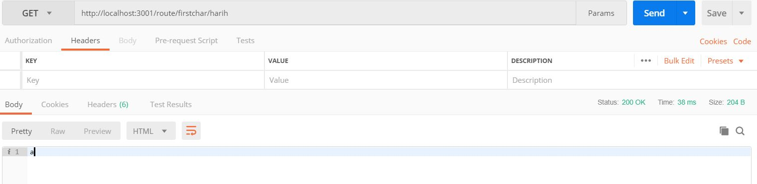

1. <http://localhost:3001/route/uploadfile>

http method : post

Key : file-to-upload

Value : any file

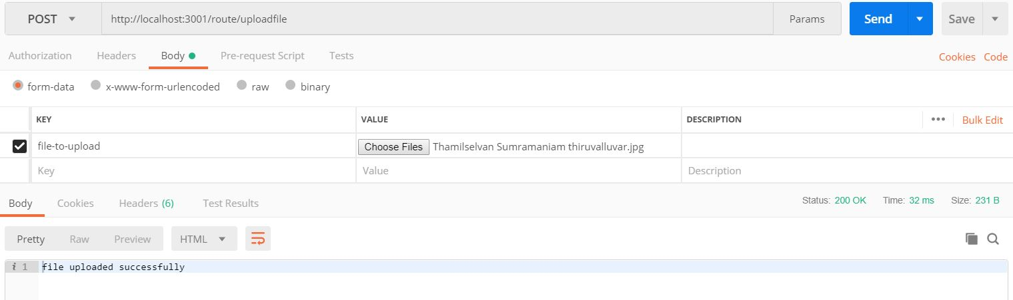

Step to start the application:

Step : 1 Download all dependencies. Command : npm install

Step : 2 Start the application. Command : npm start

Step : 3 Unit test the application. Command : npm test