# BL706 Firmware Flashing

## Firmware acquisition

**Download the firmware of BL706 USB Dongle from the following link:**

<https://github.com/thirdreality/TRy-Zigbee-3.0-USB-dongle>

Note: Choose the master branch.

## Firmware flashing

BL706 USB Dongle supports USB port to flash firmware.

#### ****Enter the serial port Bootloader****

1. **Manual mode**

**Keep pressing the Boot button and then power up the device, and release the Boot button after Dongle enters Bootloader.**

Note: Press the button and insert dongle into the PC USB port, then release button.

#### ****Using BouffaloLabDevCube flashing firmware****

1. **Unzip the download BouffaloLabDevCube-v1.8.2.zip and Firmware.zip**
2. **Double click the BLDevCube.exe.**

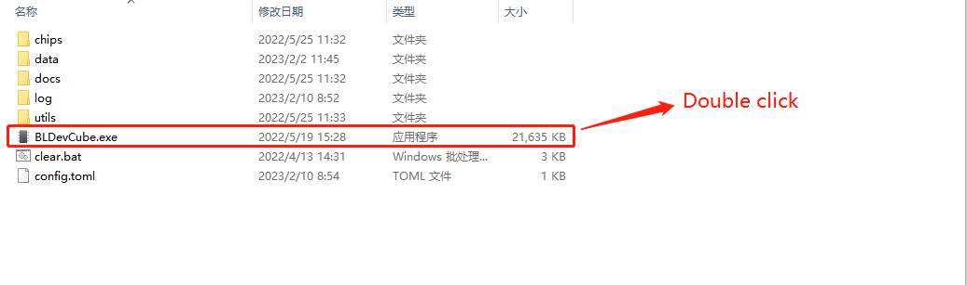

Note: Protection may pop up，clikc more information and then click Still running button.

