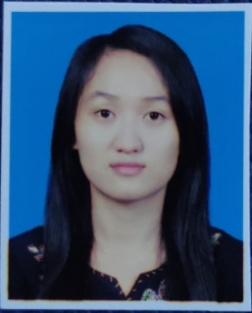

Name : Ma Thiri Nandar Nyan

NRC : 12/DAGAMA(Naing) 035277

Date Of Birth : 19/6/1998

Email : [thirinandarnyan1998@gmail.com,thirinandarnyan@ucsy.edu.mm](mailto:thirinandarnyan1998@gmail.com,thirinandarnyan@ucsy.edu.mm)

Phone : 09-794923050, 09-697334195

Address : No.1324, KyarPaDonMar Street, 41 quarter, North Dagon Township..,

Gender : Female

Material Status : Single

**EDUCATION**

* B.C.Sc (Computer Science) (2020) graduated

**PROJECT EXPERIENCE**

* Spring (small group project for Online Book Shop)
* Spring Boot (Office Asset Management group project)
* Web Design (Online Car Booking)

**PROFESSIONAL CAPABILITIES**

Proficient in using following languages, tools, applications software and operation systems:

* Programming Languages * Java
* Web-based technology * HTML,CSS,Javascript,Bootstrap,C#, Spring Framework
* Database Administration * MySQL
* Tools * Eclipse, SpringBoot, Sublime Text, XAMPP

**RESPONSIBILITIES**

* I learned spring framework for Java platform that can be used any Java application during internship and involved in spring project.
* In spring project, I wrote design template as a frontend using HTML, CSS, JavaScript, JQuery, Bootstrap.
* I wrote documentation such as Detail Design, Functional Design, Unit Testing.

**ADDITIONAL INFORMATION**

* I had certificated in Japanese Language Proficiency Test, JLPT (N5).
* I worked as a internship at ICT Star Group Myanmar (ISGM) which made web application with Spring Framework.