LIBORA API

A Mini project report

BACHELOR OF COMPUTER SCIENCE
(2024 – 2027)

Submitted by

THIRISHA.S VINITHA.V
222408439 222408442

DHANALAKSHMI.S GAYATHRI. J
222408412 222408417

Under the Guidance of
Mrs. V. THILAGAVATHY M.Sc., M.Phil.
Assistant Professor
Department of Computer Science


SOKA IKEDA COLLEGE OF ARTS AND SCIENCE FOR WOMEN,
MADHANANGKUPPAM, CHENNAI – 600 099.
Affiliated to the University of Madras, Chepauk, Chennai 600 005.

CHAPTER | TITLE | PAGE NO.
1. | INTRODUCTION
2. | PROJECT OVERVIEW
3. | PROJECT INSTRUCTIONS
4. | PROJECT ARCHITECTURE
5. | ER DIAGRAM
6. | FEATURES
7. | ROLES AND RESPONSIBILITIES
8. | USER FLOW
9. | PROJECT SETUP AND CONFIGURATION
10. | PROJECT SETUP
11. | BACKEND OVERVIEW
12. | DATABASE DEVELOPMENT
13. | LIBORA SCHEMAS & MODELS
14. | PROJECT EXECUTION
15. | OUTPUT SCREENSHOT
16. | CONCULSION

LIBORA API-A Robust Backend for Library Operations.

1. INTRODUCTION:

Libora API is a powerful backend built for modern library operations. It streamlines cataloging, circulation, and user management. Flexible and secure, it scales from small libraries to large institutions. With strong performance, it makes library systems seamless and efficient.

2.PROJECT OVERVIEW:
- Libora is a micro web-based library management system that provides secure user authentication and basic book management features.
- The application allows users to register, log in, log out, and delete their accounts. Once authenticated, users can perform CRUD (Create, Read, Update, Delete) operations on books, including adding new books, viewing the list of books, updating book details, and deleting books.
- The main goal of Libora is to demonstrate authentication flow and CRUD operations while
- backend, and database functionalities in a structured manner.

3.PROJECT INSTRUCTIONS – LIBORA:

1. Register a new user account using the registration form.
2. Log in with the registered credentials to access the dashboard.
3. After successful login, perform book management operations:
○ Add a new book.
○ View the list of available books.
○ Get book by ID
○ Update book details.
○ Delete a book.
4. Users can log out securely after completing operations.
5. Users also have the option to delete their account permanently from the system.
These instructions describe how the system should be used once it is running.

Pre-requisites:

Before running or developing Libora, ensure the following:
● Basic knowledge of:
○ JavaScript
○ Backend concepts (e.g., Node.js / Express)
○ Database fundamentals (CRUD operations)

● Software Requirements:
○ Node.js and npm installed
○ Database setup (MongoDB / MySQL)
○ Code editor (e.g., VS Code)
○ Web browser (Chrome/Firefox)

● Basic understanding of:
○ REST APIs
○ Authentication (sessions or JWT)
○ Environment variables configuration.

4.PROJECT ARCHITECTURE:

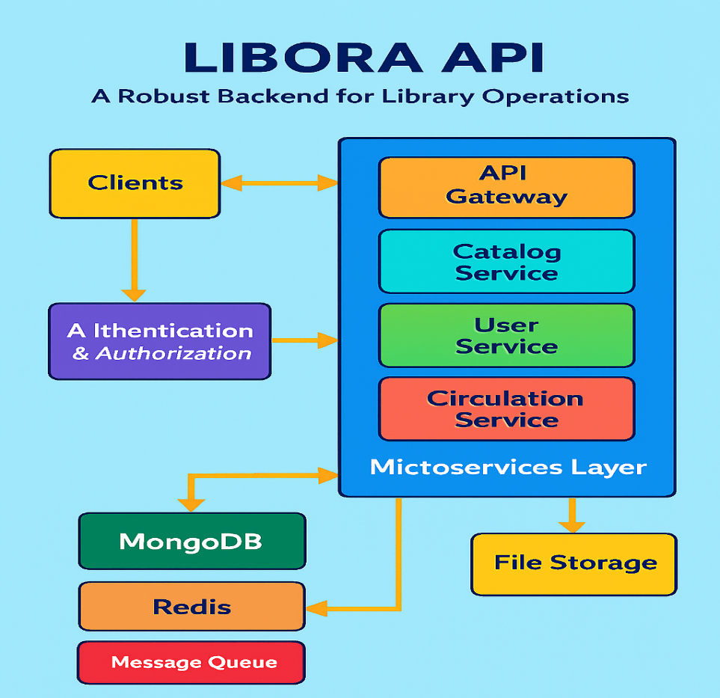

Technical Architecture
Libora follows a Layered Backend Architecture consisting of:
- API Layer (Routes)
Business Logic Layer (Controllers)
- Data Access Layer (Models / Database)
This structure ensures clean code organization, scalability, and maintainability.
1. API Layer (Routes):
The API layer handles incoming HTTP requests and defines application endpoints.
- Built using: Node.js + Express.js
- Responsible for:
  - Defining routes (e.g., /register, /login, /books)
  - Mapping routes to controllers
  - Handling HTTP methods (GET, POST, PUT, DELETE)
  - Applying middleware (authentication, validation)
Example Endpoints:
- POST → Register User
- POST → Login User
- DELETE → Delete User
- POST → Add Book
- GET → Fetch Books
- PUT → Update Book
- DELETE → Delete Book
2. Business Logic Layer (Controllers):
The controller layer contains the core application logic.
Responsibilities:
- Processing user registration and login
- Password hashing (e.g., bcrypt)
- Token generation (JWT) / session handling
- Implementing CRUD operations for books
- Validating request data
- Handling errors and sending responses
This layer acts as a bridge between routes and database.
3. Data Access Layer (Models / Database):
The data layer manages persistent storage.
- Database: MongoDB / MySQL
- Models define schema structure for:
  - Users (username, email, password)
  - Books (title, author, published_date, etc.)
Responsibilities:
- Executing database queries
- Storing and retrieving data
- Maintaining data integrity
4. Request Flow:
- Client sends HTTP request to API endpoint.
- Route receives the request and forwards it to the controller.
- Controller processes business logic.
- Controller interacts with the database via models.
- Database returns data to controller.
- Controller sends structured JSON response back to client.

5.ER DIAGRAM:

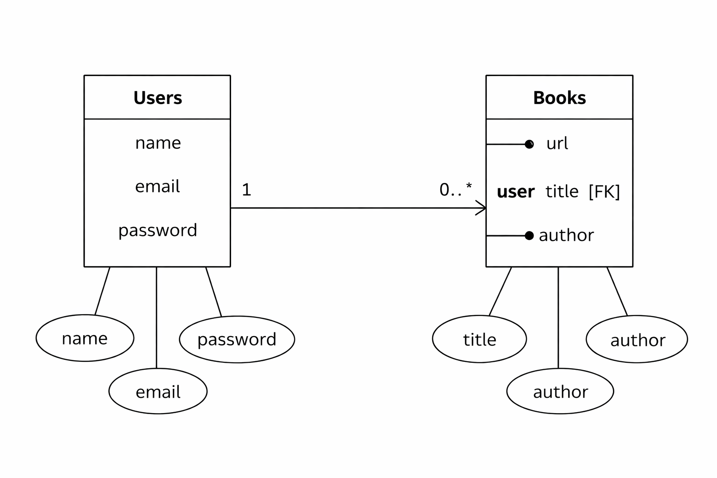6. FEATURES:

1. User Authentication
- User Registration (name, email, password)
- Secure password storage (hashed password)
- User Login with credential verification
- Token-based authentication (JWT)
- Delete User Account
- Automatic timestamps (createdAt, updatedAt)

2. Book Management (CRUD Operations)
Each book is linked to a specific user using a reference (user: ObjectId).
- Add a new book (url, title, author)
- Get all books of a specific user
- Get book by ID
- Update book details
- Delete a book
- Books are protected and accessible only to the authenticated user

3. User–Book Relationship
- One-to-Many Relationship:
  - One User → Can have multiple Books
  - Each Book → Belongs to one User (via ObjectId reference)
- Maintains data integrity using MongoDB references

4. Security & Validation
- Input validation for required fields
- Protected routes using authentication middleware
- Error handling for invalid requests
- Unauthorized access prevention

5. RESTful API Design
- Follows REST principles
- Uses standard HTTP methods:
  - POST
  - GET
  - PUT
  - DELETE
- Returns structured JSON responses

- ROLES AND RESPONSIBILITIES:

Requirement Analysis
- Understanding project requirements (authentication + book CRUD).
- Designing database schema for Users and Books.

Database Design
- Creating Mongoose schemas:
  - User Schema (name, email, password, timestamps)
  - Book Schema (url, title, author, user reference)
- Establishing ObjectId reference between Book and User.

API Development
  - Developing restful API endpoints.
  - Implementing:
    - User Registration
    - User Login
    - Delete User
    - Add Book
    - Get Books
    - Update Book
    - Delete Book
- Structuring routes and controllers properly.
Authentication & Security
- Implementing password hashing (bcrypt).
- Generating JWT tokens for authentication.
- Protecting private routes using middleware.
- Handling unauthorized access and validation errors.

Error Handling & Validation
- Validating required fields.
- Handling invalid credentials.
- Managing database errors.
- Returning structured JSON responses.

Testing & Debugging
- Testing APIs using Postman.
- Verifying CRUD operations.
- Fixing bugs and ensuring proper response status codes.

8.USER FLOW – LIBORA BACKEND
The user flow describes how a user interacts with the system APIs step-by-step.

1️. User Registration
- User sends a POST request to /api/auth/register
- System validates input fields (name, email, password)
- Password is hashed using bcrypt
- User data is stored in the database
- Success response is returned

2️. User Login
- User sends a POST request to /api/auth/login
- System verifies email and password
- If valid, a JWT token is generated
- Token is sent back in the response
- User is now authenticated

3️. Access Protected Routes
User sends requests with:
Authorization: Bearer <token>
- Middleware verifies JWT: If valid → request proceeds
4️. Book Operations (After Login)
Authenticated user can:
- Add Book → POST /api/book/add
- Get Books → GET /api/book
- Update Book → PUT /api/book/:id
- Delete Book → DELETE /api/book/:id
Each book is linked to the logged-in user.

5️. Logout
- User sends request to /api/auth/logout
- Token is stored in blacklist
- User session becomes invalid

6️. Delete user (Optional)

User sends DELETE request with userId

Account is removed from database

9.PROJECT SETUP AND CONFIGURATION:

FOLDER STRUCTURE:
MY-LIBORA-MAIN/
│
├── Config/
│ └── db.js
│
├── controller/
│ ├── authController.js
│ └── bookController.js
│
├── middlewares/
│ └── verify_token.js
│
├── models/
│ ├── blackListerToken.js
│ ├── book.model.js
│ └── user.model.js
│
├── routes/
│ ├── book.route.js
│ └── user.route.js
│
├── node_modules/
│
├──. gitignore
├── index.js
├── package. json
├── package-lock. json
└── README.md

10.PROJECT SETUP:

1. Install Dependencies
Install all required npm packages:
- npm install
2. Configure Environment Variables
Create a .env file in the root directory and add the following:
PORT=5000
MONGO_URI=your_database_connection_string
JWT_SECRET=your_secret_key
- Replace your_database_connection_string with your MongoDB/MySQL connection string.
- Replace your_secret_key with any secure random string.

3. Start the Database
- Make sure MongoDB/MySQL is installed and running on your system.
- Verify the connection string matches your database configuration.

4. Run the Server
Start the application using:
- npm start
Or (if using nodemon):
- npm run dev

6️. Access the Application
Open your browser and navigate to:
http://localhost:5000
The Libora application should now be running successfully.

11.BACKEND OVERVIEW (Libora)
- Tech Stack: Node.js + Express.js, RESTful APIs, MongoDB with Mongoose.
- Core Functions: Authentication, business logic, database operations, API responses.
- Security: JWT authentication, bcrypt password hashing, token blacklist for logout.

1️ API Development & Routing
- User Routes: Register, Login, Logout, Delete User.
- Book Routes: Add, Get, Update, Delete Book.
- Structure: Requests flow through Routes → Controllers → Business Logic → Database.
- Best Practices:
  - Modular route files for clarity.
  - Centralized error handling middleware.
  - Input validation with libraries like express-validator or Joi.

2️ Database & Authentication
- MongoDB + Mongoose: Schema modeling, indexing for efficient queries, and structured data management.
- Authentication Flow:
  - Passwords securely hashed with bcrypt.
  - JWT issued on login, verified via middleware for protected routes.
  - Blacklist collection invalidates tokens during logout.
- Enhancements:
  - Role-based access control (e.g., admin vs. user).
  - Refresh tokens for longer sessions with short-lived access tokens.

3️ Middleware & Security
- Middleware: Auth checks, role-based permissions, error handling.
- Security Tools:
  - helmet for secure HTTP headers.
  - cors for cross-origin resource sharing.
  - express-rate-limit for brute-force protection.

4️ Suggested Folder Structure
Code
libora-backend/
│── routes/ (userRoutes.js, bookRoutes.js)
│── controllers/ (userController.js, bookController.js)
│── models/ (User.js, Book.js)
│── middleware/ (authMiddleware.js, errorHandler.js)
│── utils/ (jwtUtils.js)
│── config/ (db.js)
│── app.js
│── server.js

12.DATABASE DEVELOPMENT (LIBORA)
- Database: mongodb (nosql, document-based).
- Collections: Users, Books.
- Relationship:
  - One User → Many Books.
  - Each Book → Belongs to one User (via ObjectId).
- Data Format: JSON-like documents → flexible & scalable.

MongoDB Setup (Mongoose)
- Install:
bash
npm install mongoose
- Config/db.js:
js
const mongoose = require("mongoose");
const connection = mongoose.connect(process.env.MONGO_URI);
module.exports = { connection };
- .env:
Code:
MONGO_URI=mongodb://127.0.0.1:27017/libspace

Connection in index.js
js
const { connection } = require("./Config/db");

app.listen(5000, async () => {
try {
await connection;
console.log("Connected to Database");
}
catch (err)
{
console.log("Database connection failed");
}
}
});
Server starts only after successful DB connection, ensuring stability.

13.LIBORA SCHEMAS & MODELS
- Schemas define how documents are structured in MongoDB collections. Libora uses two main collections: Users and Books, linked by a one-to-many relationships.
- One User → Many Books
- Each Book → Belongs to one User (via ObjectId reference)

User Schema (models/user.model.js)
js
const mongoose = require("mongoose");

const userSchema = new mongoose.Schema(
{
name: { type: String, required: true },
email: { type: String, required: true },
password: { type: String, required: true },
},
{ versionKey: false, timestamps: true }
);

const UserModel = mongoose.model("User", userSchema);
module.exports = UserModel;
- Stores basic user info (name, email, password).
- Includes timestamps for created/updated records.
- Passwords are later hashed before saving.

Book Schema (models/book.model.js)
js
const mongoose = require("mongoose");

const bookSchema = new mongoose.Schema({
url: { type: String, required: true },
user: { type: mongoose.Schema.Types.ObjectId, ref: "User", required: true },
title: { type: String, required: true },
author: { type: String, required: true },
});

const BookModel = mongoose.model("Book", bookSchema);
module.exports = BookModel;
- Each book stores URL, title, author.
- user field references the User collection via ObjectId.
- Ensures every book belongs to a valid user.

14. PROJECT EXECUTION (LIBORA)

1️ Install Dependencies
bash
npm install
Installs all required packages from package.json.

2️ Start the Server
bash
npm start
Or (with nodemon):
bash
npm run dev

3️ Database Connection
- On server start, connectDb() connects to MongoDB.
- If successful:
Code
Connected to Database
Our server is working at PORT :5000

4️ Test API Endpoints (via Postman)
User Routes
- POST /api/auth/register
- POST /api/auth/login
- DELETE /api/auth/delete
Book Routes
- POST /api/book/add
- GET /api/book/
- PUT /api/book/:id
- DELETE /api/book/:id
With these steps, Libora’s backend runs smoothly, connects to MongoDB, and exposes secure API endpoints for testing.

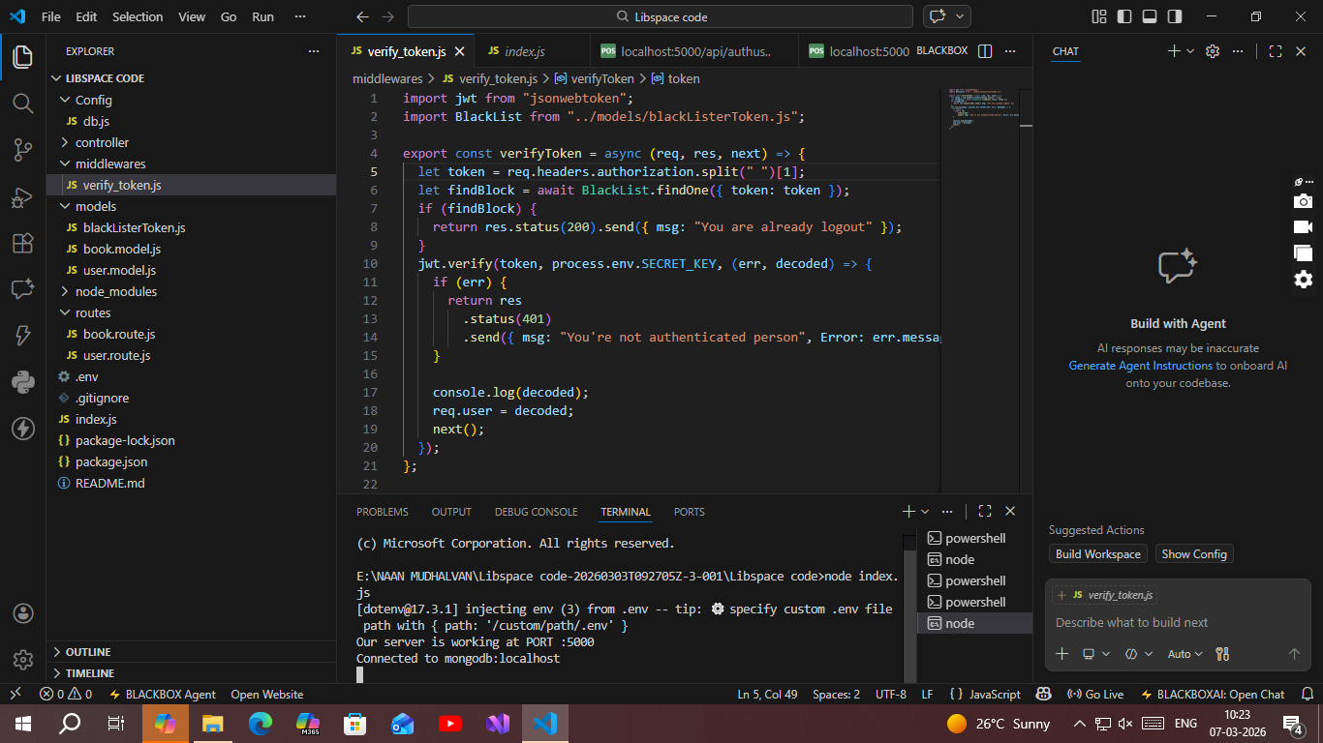
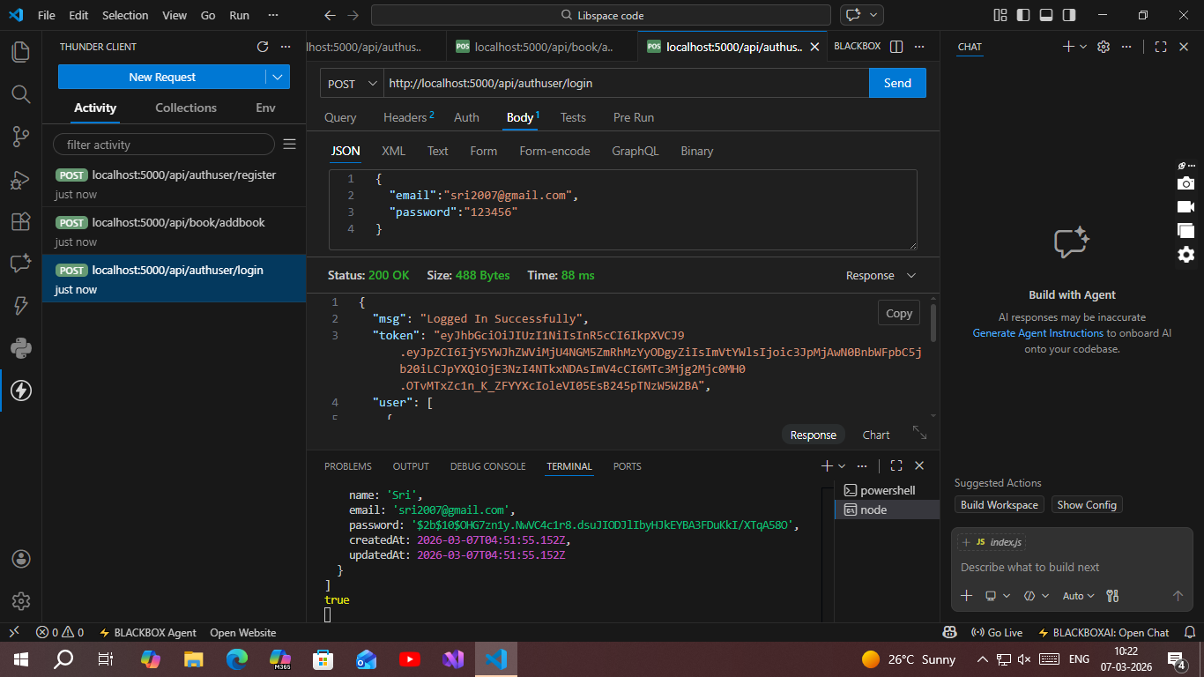
15. OUTPUT SCREENSHOT:
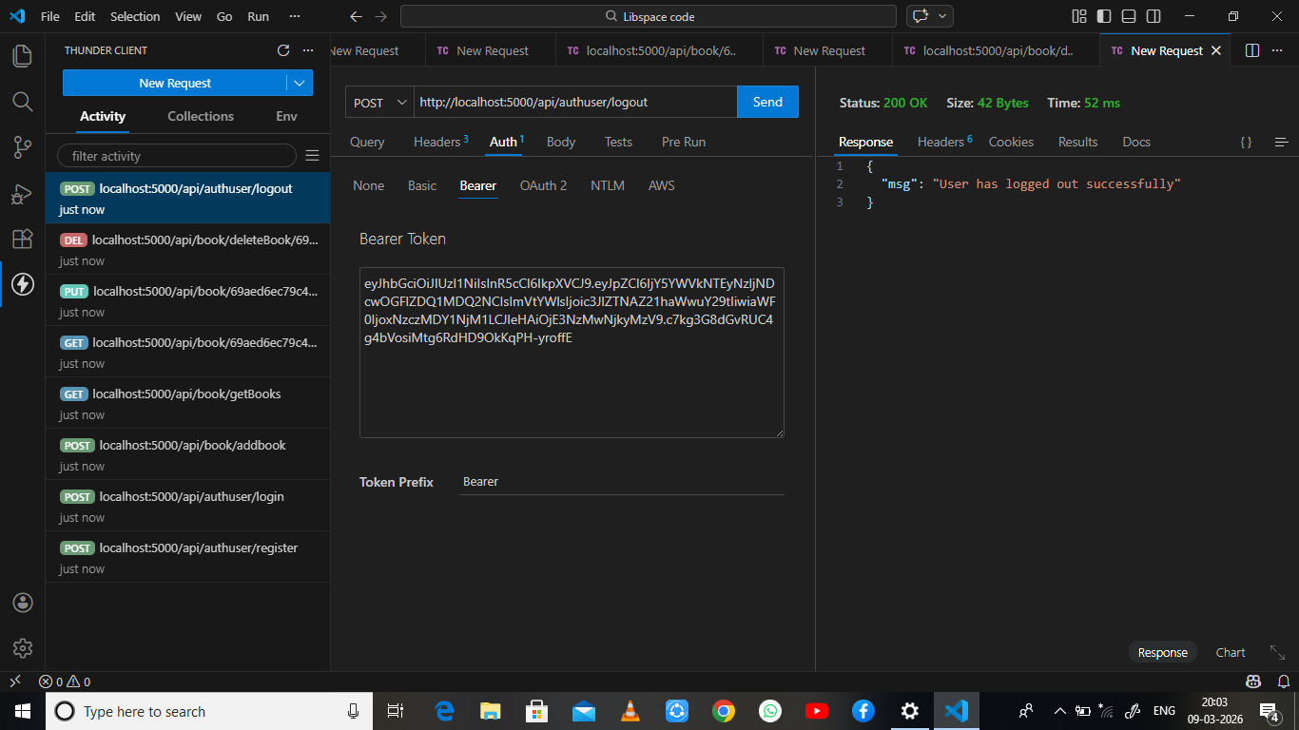
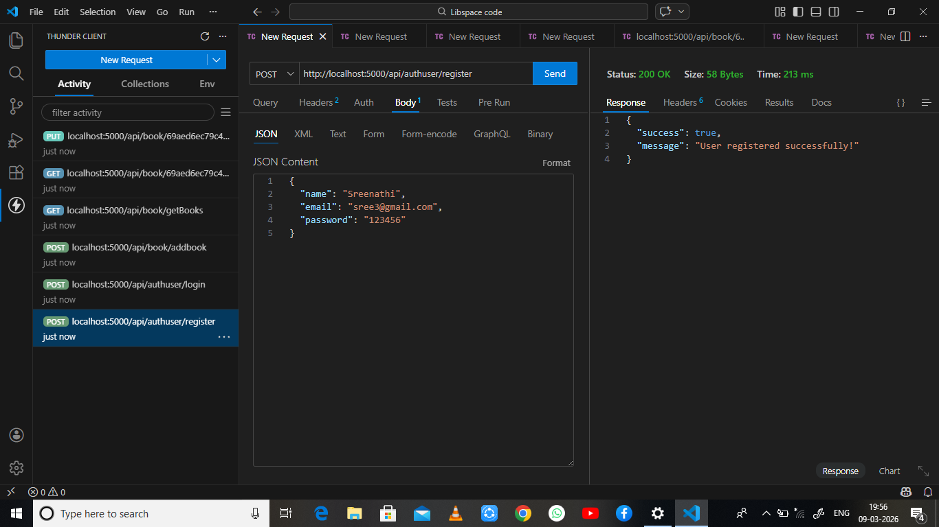

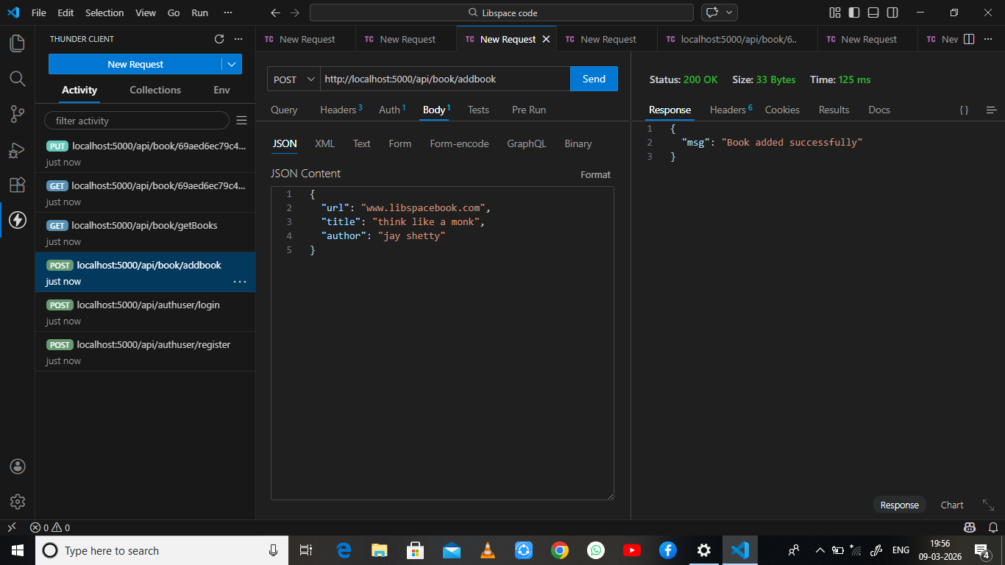

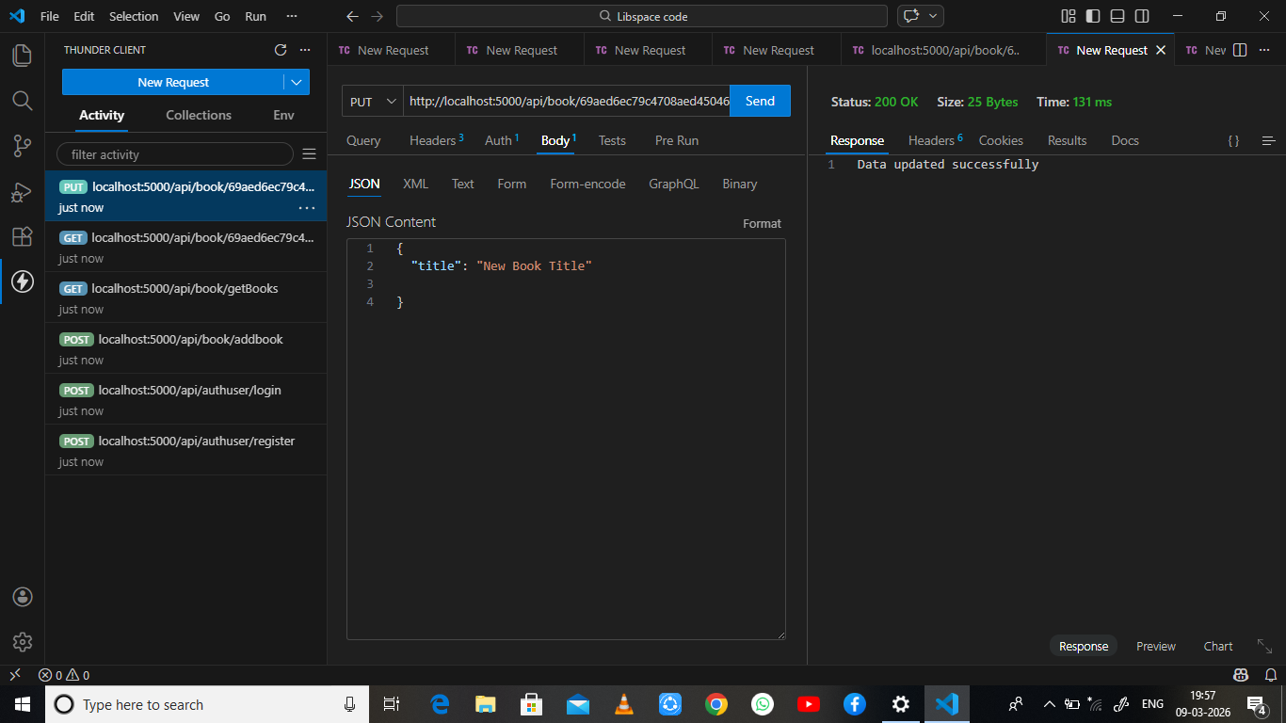

16. CONCLUSION:
Libora API’s core value lies in democratizing machine learning—making it approachable for non-experts and organizations testing ML feasibility. It is best seen as a gateway tool: excellent for experimentation and validation, but not a replacement for full-fledged frameworks when scaling to complex or production-level applications.

