**Lab Exercise - 1**

Q1.

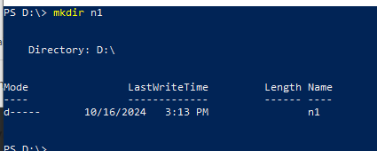

Q2.

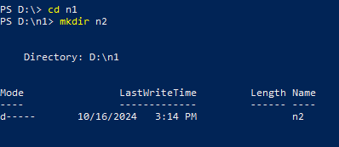

Q3.

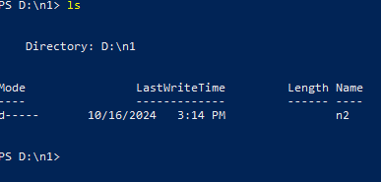

Q4.

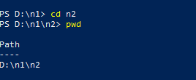

Q5.

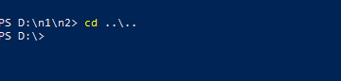

Q6.

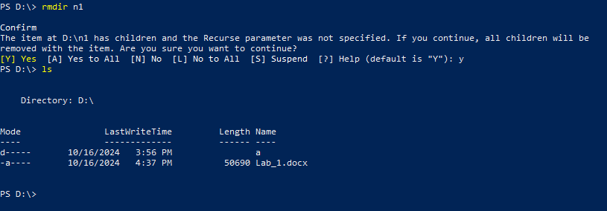

**cat:** Use to view the content inside the file

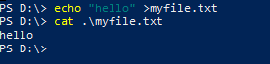

**cp:** copy the file content

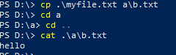

**mv:** copy the file content



