**Lab_2.1**

1. **Template and Live server**

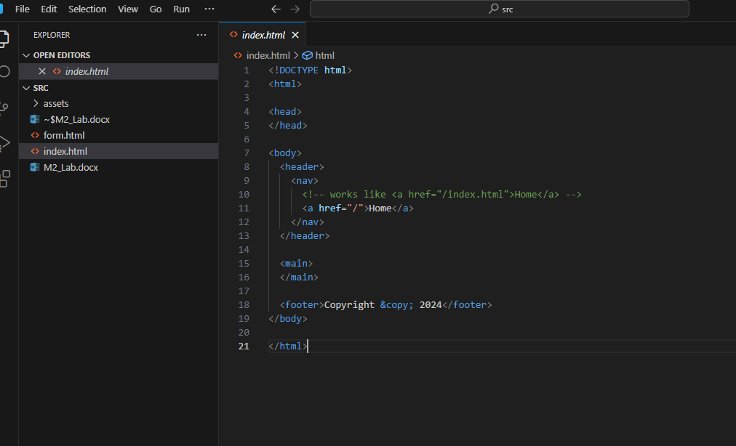

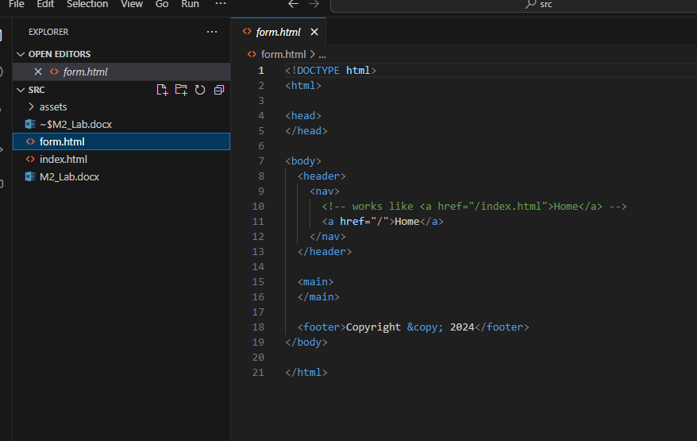

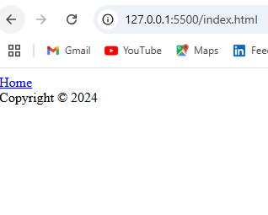

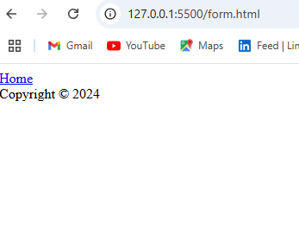

**III**

**2.**

**Observing the difference**

**When we see it the browser Block elements displays Vertically and when we type inline elements next to each other it displays horizontally.**

**3.**

**Observing the difference**

**When we see it text inside <p> tag appears as single, collapsed line. <pre> tag showing the spaces and newlines as they are in the HTML code.**

**9.**

**Observing the difference**

**When we see it in the browser h1 appears larger and it represents the page’s main topic. h2 inside <article> is smaller. It indicates the smaller heading within the content structure.**

**IV**

**5.**

**Observation**

**When we see to keep the table’s shaple each <tr> should have same number of <td> cells or empty cells should be added where needed.**

**8.**

**Observation(rowspan)**

**When we see we add rowspan=”2” to any <td> tags in the second row. It merges the 2nd and 3rd row. And the 3rd row 2 elements are adjusted when we change rowspan into each <td> tag in second row.**

**V**

**6.**

**Observing the difference(controls vs autoplay)**

**When we see if we add controls attribute video/audio will display with play/pause button, volume control and progress bar. Autoplay attribute starts play automatically when page loads.**

**VIII**

**2.**

**Observing**

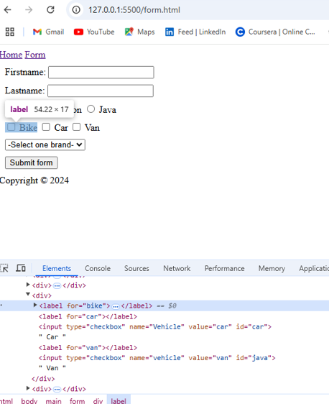

**3. margin: 20px; color: blue; font-size: 24px;**

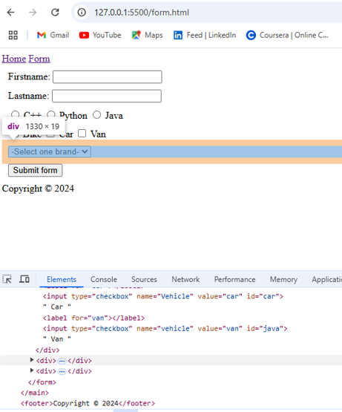

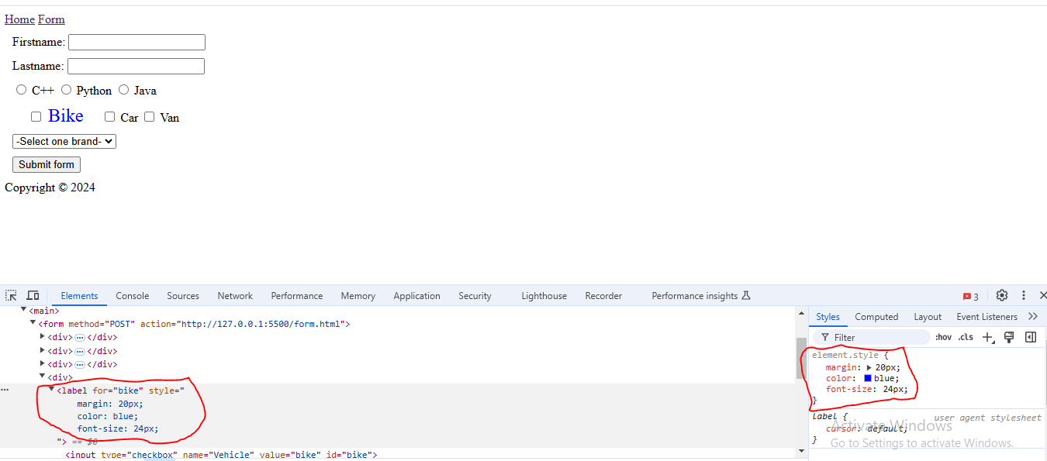

**Lab 1, part 2 - Submitting HTML forms**

**Creating dummy server**

