 | Министерство науки и высшего образования Российской Федерации  Федеральное государственное бюджетное образовательное учреждение  высшего образования  «Московский государственный технический университет  имени Н.Э. Баумана  (национальный исследовательский университет)»  (МГТУ им. Н.Э. Баумана)

ФАКУЛЬТЕТ Информатика и системы управления
КАФЕДРА «программное обеспечение эвм и информационные технологии» (иу7)
НАПРАВЛЕНИЕ ПОДГОТОВКИ 09.03.01 Информатика и вычислительная техника

Отчет
по лабораторной работе № | 4

Название: Методология разработки и верификации ускорителей вычислений на платформе Xilinx Alveo
Дисциплина: Архитектура ЭВМ

Студент |  | ИУ7-52Б |  |  |  | Короткая В. М.
 |  | (Группа) |  |  | (Подпись, дата) | (И.О. Фамилия)
Преподаватель |  |  |  |  |  | Попов А. Ю.
 |  |  |  |  | (Подпись, дата) | (И.О. Фамилия)

Москва, 2021

Цель работы
Изучение архитектуры гетерогенных вычислительных систем и технологии разработки ускорителей вычислений на базе ПЛИС фирмы Xilinx.
В ходе лабораторной работы предлагается изучить основные сведения о платформе Xilinx Alveo U200, разработать RTL (Register Transfer Language, язык регистровых передач)) описание ускорителя вычислений по индивидуальному варианту, выполнить генерацию ядра ускорителя, выполнить синтез и сборку бинарного модуля ускорителя, разработать и отладить тестирующее программное обеспечение на серверной хост-платформе, провести тесты работы ускорителя вычислений.
- Копии экранов моделирования исходного проекта VINC (транзакция чтения данных, транзакция записи результатов, инкремент данных в модуле <Название проекта>_adder.v).

- Одна транзакция чтения данных вектора на шине AXI4 MM из DDR памяти (группы сигналов m00_axi_ar* и m00_axi_r*).
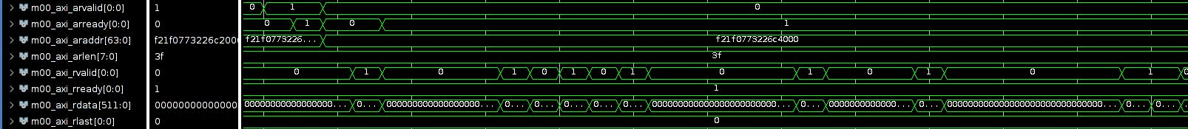
- Одна транзакция записи результата инкремента данных на шине AXI4 MM (группы сигналов m00_axi_aw*, m00_axi_w* и m00_axi_b*).
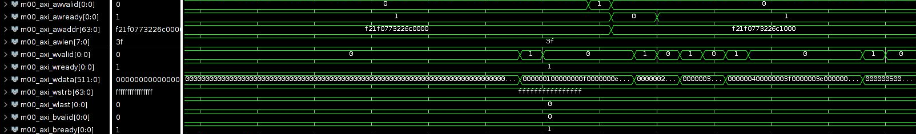
- Инкремент данных в модуле <Название проекта>_adder.v.
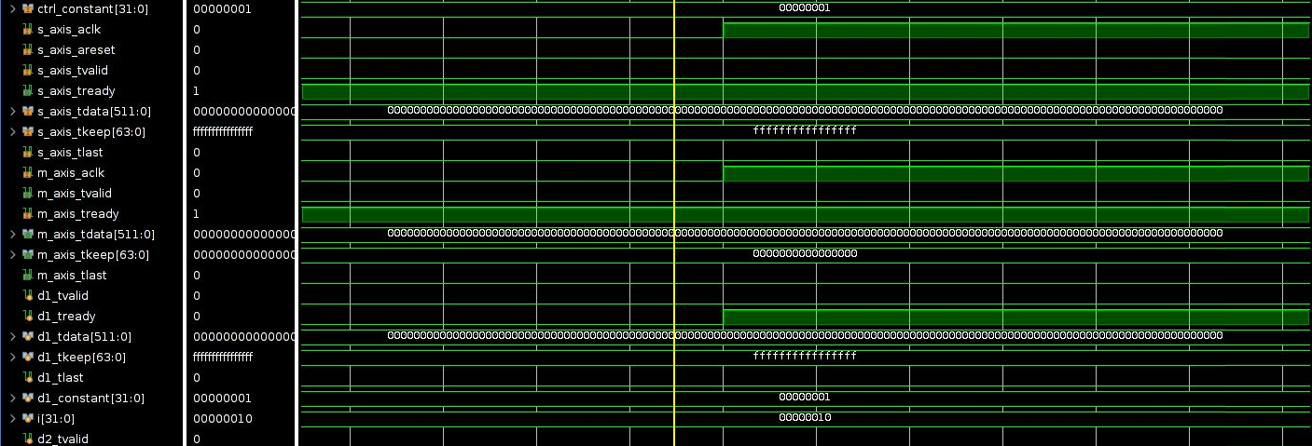
- Конфигурационный файл линковки.
[connectivity]

nk=rtl_kernel_wizard_0:1:vinc0
slr=vinc0:SLR0
sp=vinc0.m00_axi:DDR[0]

[vivado]
prop=run.impl_1.STEPS.OPT_DESIGN.ARGS.DIRECTIVE=Explore
prop=run.impl_1.STEPS.PLACE_DESIGN.ARGS.DIRECTIVE=Explore
prop=run.impl_1.STEPS.PHYS_OPT_DESIGN.IS_ENABLED=true
prop=run.impl_1.STEPS.PHYS_OPT_DESIGN.ARGS.DIRECTIVE=AggressiveExplore
prop=run.impl_1.STEPS.ROUTE_DESIGN.ARGS.DIRECTIVE=Explore
- Измененный код <Название проекта>_adder.v в соответствии с индивидуальным заданием.
R[i] = A[i]/8 + 14
- Код модифицированного модуля host_example.cpp.
// Adder function
always @(posedge s_axis_aclk) begin
for (i = 0; i < LP_NUM_LOOPS; i = i + 1) begin
d2_tdata[i*C_ADDER_BIT_WIDTH+:C_ADDER_BIT_WIDTH] <= d1_tdata[C_ADDER_BIT_WIDTH*i+:C_ADDER_BIT_WIDTH]/8 + 14;// + d1_constant;
end
end
// Check Results

for (cl_uint i = 0; i < number_of_words; i++) {
if ((h_data[i]/8 + 14) != h_axi00_ptr0_output[i]) {
printf("ERROR in rtl_kernel_wizard_0::m00_axi - array index %d (host addr 0x%03x) - input=%d (0x%x), output=%d (0x%x)\n", i, i*4, h_data[i], h_data[i], h_axi00_ptr0_output[i], h_axi00_ptr0_output[i]);
check_status = 1;
}
// printf("i=%d, input=%d, output=%d\n", i, h_axi00_ptr0_input[i], h_axi00_ptr0_output[i]);
}
- Копии экранов модулирования измененного проекта VINC (транзакция чтения данных, транзакция записи результатов, инкремент данных в модуле <Название проекта>_adder.v).

- Одна транзакция записи результата инкремента данных на шине AXI4 MM (группы сигналов m00_axi_aw*, m00_axi_w* и m00_axi_b*).
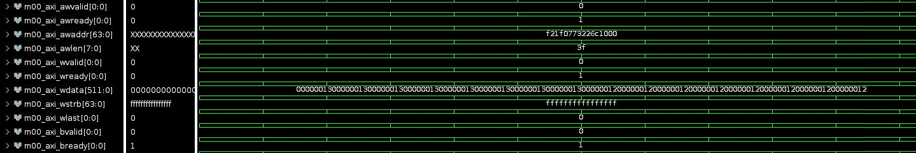
- Инкремент данных в модуле <Название проекта>_adder.v.
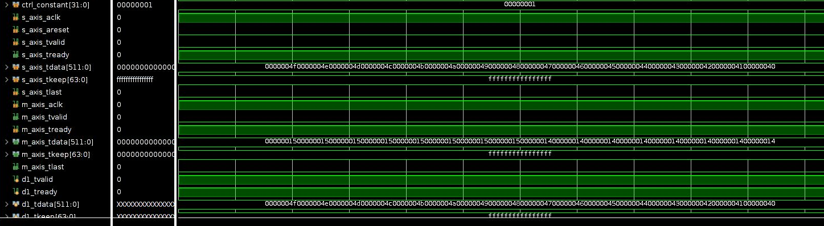
- Одна транзакция чтения данных вектора на шине AXI4 MM из DDR памяти (группы сигналов m00_axi_ar* и m00_axi_r*).
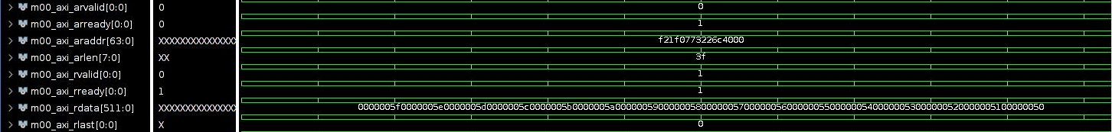

- Результаты запуска host_example.cpp (в виде листинга вывода на консоль или в виде таблицы с результатами теста).

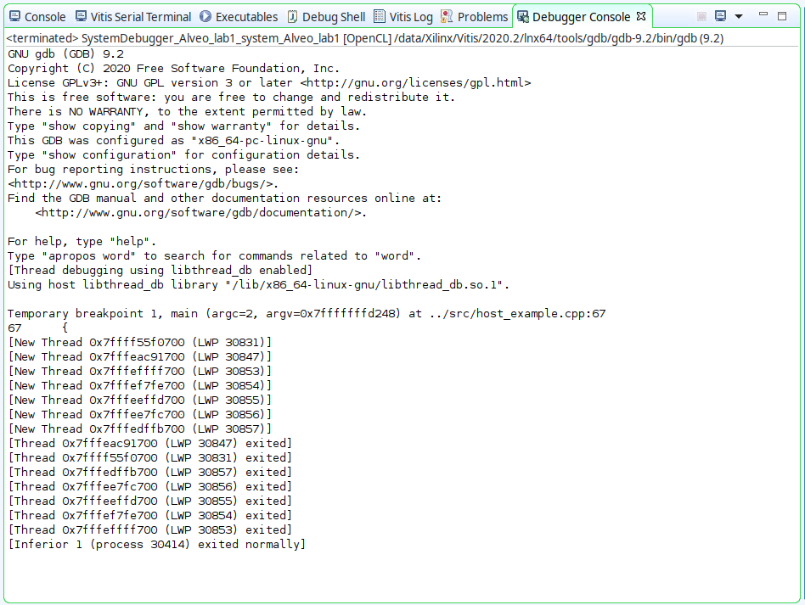
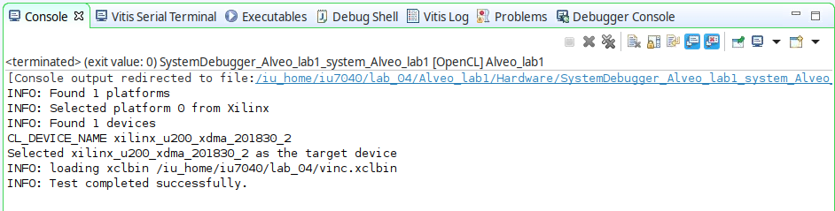
- Содержимое файлов *.xclbin.info.
==============================================================================
XRT Build Version: 2.8.743 (2020.2)
Build Date: 2020-11-16 00:19:11
Hash ID: 77d5484b5c4daa691a7f78235053fb036829b1e9
==============================================================================
xclbin Information
------------------
Generated by: v++ (2020.2) on 2020-11-18-05:13:29
Version: 2.8.743
Kernels: rtl_kernel_wizard_0
Signature:
Content: Bitstream
UUID (xclbin): 7f4ec5fa-0381-4e35-b11d-d44ff9e5804b
Sections: DEBUG_IP_LAYOUT, BITSTREAM, MEM_TOPOLOGY, IP_LAYOUT,
CONNECTIVITY, CLOCK_FREQ_TOPOLOGY, BUILD_METADATA,
EMBEDDED_METADATA, SYSTEM_METADATA,
GROUP_CONNECTIVITY, GROUP_TOPOLOGY
==============================================================================
Hardware Platform (Shell) Information
-------------------------------------
Vendor: xilinx
Board: u200
Name: xdma
Version: 201830.2
Generated Version: Vivado 2018.3 (SW Build: 2568420)
Created: Tue Jun 25 06:55:20 2019
FPGA Device: xcu200
Board Vendor: xilinx.com
Board Name: xilinx.com:au200:1.0
Board Part: xilinx.com:au200:part0:1.0
Platform VBNV: xilinx_u200_xdma_201830_2
Static UUID: c102e7af-b2b8-4381-992b-9a00cc3863eb
Feature ROM TimeStamp: 1561465320

Clocks
------
Name: DATA_CLK
Index: 0
Type: DATA
Frequency: 300 MHz

Name: KERNEL_CLK
Index: 1
Type: KERNEL
Frequency: 500 MHz

Memory Configuration
--------------------
Name: bank0
Index: 0
Type: MEM_DDR4
Base Address: 0x4000000000
Address Size: 0x400000000
Bank Used: Yes

Name: bank1
Index: 1
Type: MEM_DDR4
Base Address: 0x5000000000
Address Size: 0x400000000
Bank Used: No

Name: bank2
Index: 2
Type: MEM_DDR4
Base Address: 0x6000000000
Address Size: 0x400000000
Bank Used: No

Name: bank3
Index: 3
Type: MEM_DDR4
Base Address: 0x7000000000
Address Size: 0x400000000
Bank Used: No

Name: PLRAM[0]
Index: 4
Type: MEM_DRAM
Base Address: 0x3000000000
Address Size: 0x20000
Bank Used: No

Name: PLRAM[1]
Index: 5
Type: MEM_DRAM
Base Address: 0x3000200000
Address Size: 0x20000
Bank Used: No

Name: PLRAM[2]
Index: 6
Type: MEM_DRAM
Base Address: 0x3000400000
Address Size: 0x20000
Bank Used: No
==============================================================================
Kernel: rtl_kernel_wizard_0

Definition
----------
Signature: rtl_kernel_wizard_0 (uint scalar00, int* axi00_ptr0)

Ports
-----
Port: s_axi_control
Mode: slave
Range (bytes): 0x1000
Data Width: 32 bits
Port Type: addressable

Port: m00_axi
Mode: master
Range (bytes): 0xFFFFFFFFFFFFFFFF
Data Width: 512 bits
Port Type: addressable

--------------------------
Instance: vinc0
Base Address: 0x1c00000

Argument: scalar00
Register Offset: 0x010
Port: s_axi_control
Memory: <not applicable>

Argument: axi00_ptr0
Register Offset: 0x018
Port: m00_axi
Memory: bank0 (MEM_DDR4)
==============================================================================
Generated By
------------
Command: v++
Version: 2020.2 - 2020-11-18-05:13:29 (SW BUILD: 0)
Command Line: v++ --config /iu_home/iu7040/lab_04/Alveo_lab1.cfg --connectivity.nk rtl_kernel_wizard_0:1:vinc0 --connectivity.slr vinc0:SLR0 --connectivity.sp vinc0.m00_axi:DDR[0] --input_files /iu_home/iu7040/lab_04/Alveo_lab1_kernels/vivado_rtl_kernel/rtl_kernel_wizard_0_ex/exports/rtl_kernel_wizard_0.xo --link --optimize 0 --output /iu_home/iu7040/lab_04/vinc.xclbin --platform xilinx_u200_xdma_201830_2 --report_level 0 --target hw --vivado.prop run.impl_1.STEPS.OPT_DESIGN.ARGS.DIRECTIVE=Explore --vivado.prop run.impl_1.STEPS.PLACE_DESIGN.ARGS.DIRECTIVE=Explore --vivado.prop run.impl_1.STEPS.PHYS_OPT_DESIGN.IS_ENABLED=true --vivado.prop run.impl_1.STEPS.PHYS_OPT_DESIGN.ARGS.DIRECTIVE=AggressiveExplore --vivado.prop run.impl_1.STEPS.ROUTE_DESIGN.ARGS.DIRECTIVE=Explore
Options: --config /iu_home/iu7040/lab_04/Alveo_lab1.cfg
--connectivity.nk rtl_kernel_wizard_0:1:vinc0
--connectivity.slr vinc0:SLR0
--connectivity.sp vinc0.m00_axi:DDR[0]
--input_files /iu_home/iu7040/lab_04/Alveo_lab1_kernels/vivado_rtl_kernel/rtl_kernel_wizard_0_ex/exports/rtl_kernel_wizard_0.xo
--link
--optimize 0
--output /iu_home/iu7040/lab_04/vinc.xclbin
--platform xilinx_u200_xdma_201830_2
--report_level 0
--target hw
--vivado.prop run.impl_1.STEPS.OPT_DESIGN.ARGS.DIRECTIVE=Explore
--vivado.prop run.impl_1.STEPS.PLACE_DESIGN.ARGS.DIRECTIVE=Explore
--vivado.prop run.impl_1.STEPS.PHYS_OPT_DESIGN.IS_ENABLED=true
--vivado.prop run.impl_1.STEPS.PHYS_OPT_DESIGN.ARGS.DIRECTIVE=AggressiveExplore
--vivado.prop run.impl_1.STEPS.ROUTE_DESIGN.ARGS.DIRECTIVE=Explore
==============================================================================
User Added Key Value Pairs
--------------------------
<empty>
==============================================================================

- Содержимое файлов v++*.log
INFO: [v++ 60-1306] Additional information associated with this v++ link can be found at:
Reports: /iu_home/iu7040/_x/reports/link
Log files: /iu_home/iu7040/_x/logs/link
INFO: [v++ 60-1548] Creating build summary session with primary output /iu_home/iu7040/lab_04/vinc.xclbin.link_summary, at Sat Oct 2 21:08:59 2021
INFO: [v++ 60-1316] Initiating connection to rulecheck server, at Sat Oct 2 21:09:00 2021
INFO: [v++ 60-1315] Creating rulecheck session with output '/iu_home/iu7040/_x/reports/link/v++_link_vinc_guidance.html', at Sat Oct 2 21:09:16 2021
INFO: [v++ 60-895] Target platform: /opt/xilinx/platforms/xilinx_u200_xdma_201830_2/xilinx_u200_xdma_201830_2.xpfm
INFO: [v++ 60-1578] This platform contains Device Support Archive '/opt/xilinx/platforms/xilinx_u200_xdma_201830_2/hw/xilinx_u200_xdma_201830_2.dsa'
INFO: [v++ 74-74] Compiler Version string: 2020.2
INFO: [v++ 60-1302] Platform 'xilinx_u200_xdma_201830_2.xpfm' has been explicitly enabled for this release.
INFO: [v++ 60-629] Linking for hardware target
INFO: [v++ 60-423] Target device: xilinx_u200_xdma_201830_2
INFO: [v++ 60-1332] Run 'run_link' status: Not started
INFO: [v++ 60-1443] [21:09:58] Run run_link: Step system_link: Started
INFO: [v++ 60-1453] Command Line: system_link --xo /iu_home/iu7040/lab_04/Alveo_lab1_kernels/vivado_rtl_kernel/rtl_kernel_wizard_0_ex/exports/rtl_kernel_wizard_0.xo --config /iu_home/iu7040/_x/link/int/syslinkConfig.ini --xpfm /opt/xilinx/platforms/xilinx_u200_xdma_201830_2/xilinx_u200_xdma_201830_2.xpfm --target hw --output_dir /iu_home/iu7040/_x/link/int --temp_dir /iu_home/iu7040/_x/link/sys_link
INFO: [v++ 60-1454] Run Directory: /iu_home/iu7040/_x/link/run_link
INFO: [SYSTEM_LINK 60-1316] Initiating connection to rulecheck server, at Sat Oct 2 21:10:09 2021
INFO: [SYSTEM_LINK 82-70] Extracting xo v3 file /iu_home/iu7040/lab_04/Alveo_lab1_kernels/vivado_rtl_kernel/rtl_kernel_wizard_0_ex/exports/rtl_kernel_wizard_0.xo
INFO: [SYSTEM_LINK 82-53] Creating IP database /iu_home/iu7040/_x/link/sys_link/_sysl/.cdb/xd_ip_db.xml
INFO: [SYSTEM_LINK 82-38] [21:10:11] build_xd_ip_db started: /data/Xilinx/Vitis/2020.2/bin/build_xd_ip_db -ip_search 0 -sds-pf /iu_home/iu7040/_x/link/sys_link/xilinx_u200_xdma_201830_2.hpfm -clkid 0 -ip /iu_home/iu7040/_x/link/sys_link/iprepo/mycompany_com_kernel_rtl_kernel_wizard_0_1_0,rtl_kernel_wizard_0 -o /iu_home/iu7040/_x/link/sys_link/_sysl/.cdb/xd_ip_db.xml
INFO: [SYSTEM_LINK 82-37] [21:10:37] build_xd_ip_db finished successfully
Time (s): cpu = 00:00:27 ; elapsed = 00:00:26 . Memory (MB): peak = 1557.891 ; gain = 0.000 ; free physical = 260591 ; free virtual = 389359
INFO: [SYSTEM_LINK 82-51] Create system connectivity graph
INFO: [SYSTEM_LINK 82-102] Applying explicit connections to the system connectivity graph: /iu_home/iu7040/_x/link/sys_link/cfgraph/cfgen_cfgraph.xml
INFO: [SYSTEM_LINK 82-38] [21:10:37] cfgen started: /data/Xilinx/Vitis/2020.2/bin/cfgen -nk rtl_kernel_wizard_0:1:vinc0 -slr vinc0:SLR0 -sp vinc0.m00_axi:DDR[0] -dmclkid 0 -r /iu_home/iu7040/_x/link/sys_link/_sysl/.cdb/xd_ip_db.xml -o /iu_home/iu7040/_x/link/sys_link/cfgraph/cfgen_cfgraph.xml
INFO: [CFGEN 83-0] Kernel Specs:
INFO: [CFGEN 83-0] kernel: rtl_kernel_wizard_0, num: 1 {vinc0}
INFO: [CFGEN 83-0] Port Specs:
INFO: [CFGEN 83-0] kernel: vinc0, k_port: m00_axi, sptag: DDR[0]
INFO: [CFGEN 83-0] SLR Specs:
INFO: [CFGEN 83-0] instance: vinc0, SLR: SLR0
INFO: [CFGEN 83-2228] Creating mapping for argument vinc0.axi00_ptr0 to DDR[0] for directive vinc0.m00_axi:DDR[0]
INFO: [SYSTEM_LINK 82-37] [21:10:57] cfgen finished successfully
Time (s): cpu = 00:00:19 ; elapsed = 00:00:20 . Memory (MB): peak = 1557.891 ; gain = 0.000 ; free physical = 260536 ; free virtual = 389304
INFO: [SYSTEM_LINK 82-52] Create top-level block diagram
INFO: [SYSTEM_LINK 82-38] [21:10:57] cf2bd started: /data/Xilinx/Vitis/2020.2/bin/cf2bd --linux --trace_buffer 1024 --input_file /iu_home/iu7040/_x/link/sys_link/cfgraph/cfgen_cfgraph.xml --ip_db /iu_home/iu7040/_x/link/sys_link/_sysl/.cdb/xd_ip_db.xml --cf_name dr --working_dir /iu_home/iu7040/_x/link/sys_link/_sysl/.xsd --temp_dir /iu_home/iu7040/_x/link/sys_link --output_dir /iu_home/iu7040/_x/link/int --target_bd pfm_dynamic.bd
INFO: [CF2BD 82-31] Launching cf2xd: cf2xd -linux -trace-buffer 1024 -i /iu_home/iu7040/_x/link/sys_link/cfgraph/cfgen_cfgraph.xml -r /iu_home/iu7040/_x/link/sys_link/_sysl/.cdb/xd_ip_db.xml -o dr.xml
INFO: [CF2BD 82-28] cf2xd finished successfully
INFO: [CF2BD 82-31] Launching cf_xsd: cf_xsd -disable-address-gen -bd pfm_dynamic.bd -dn dr -dp /iu_home/iu7040/_x/link/sys_link/_sysl/.xsd
INFO: [CF2BD 82-28] cf_xsd finished successfully
INFO: [SYSTEM_LINK 82-37] [21:11:09] cf2bd finished successfully
Time (s): cpu = 00:00:10 ; elapsed = 00:00:12 . Memory (MB): peak = 1557.891 ; gain = 0.000 ; free physical = 260486 ; free virtual = 389260
INFO: [v++ 60-1441] [21:11:09] Run run_link: Step system_link: Completed
Time (s): cpu = 00:01:09 ; elapsed = 00:01:11 . Memory (MB): peak = 1585.129 ; gain = 0.000 ; free physical = 260534 ; free virtual = 389303
INFO: [v++ 60-1443] [21:11:09] Run run_link: Step cf2sw: Started
INFO: [v++ 60-1453] Command Line: cf2sw -sdsl /iu_home/iu7040/_x/link/int/sdsl.dat -rtd /iu_home/iu7040/_x/link/int/cf2sw.rtd -nofilter /iu_home/iu7040/_x/link/int/cf2sw_full.rtd -xclbin /iu_home/iu7040/_x/link/int/xclbin_orig.xml -o /iu_home/iu7040/_x/link/int/xclbin_orig.1.xml
INFO: [v++ 60-1454] Run Directory: /iu_home/iu7040/_x/link/run_link
INFO: [v++ 60-1441] [21:11:22] Run run_link: Step cf2sw: Completed
Time (s): cpu = 00:00:12 ; elapsed = 00:00:13 . Memory (MB): peak = 1585.129 ; gain = 0.000 ; free physical = 260542 ; free virtual = 389312
INFO: [v++ 60-1443] [21:11:22] Run run_link: Step rtd2_system_diagram: Started
INFO: [v++ 60-1453] Command Line: rtd2SystemDiagram
INFO: [v++ 60-1454] Run Directory: /iu_home/iu7040/_x/link/run_link
INFO: [v++ 60-1441] [21:11:29] Run run_link: Step rtd2_system_diagram: Completed
Time (s): cpu = 00:00:00.01 ; elapsed = 00:00:07 . Memory (MB): peak = 1585.129 ; gain = 0.000 ; free physical = 260176 ; free virtual = 388945
INFO: [v++ 60-1443] [21:11:29] Run run_link: Step vpl: Started
INFO: [v++ 60-1453] Command Line: vpl -t hw -f xilinx_u200_xdma_201830_2 --remote_ip_cache /iu_home/iu7040/.ipcache --output_dir /iu_home/iu7040/_x/link/int --log_dir /iu_home/iu7040/_x/logs/link --report_dir /iu_home/iu7040/_x/reports/link --config /iu_home/iu7040/_x/link/int/vplConfig.ini -k /iu_home/iu7040/_x/link/int/kernel_info.dat --webtalk_flag Vitis --temp_dir /iu_home/iu7040/_x/link --no-info --iprepo /iu_home/iu7040/_x/link/int/xo/ip_repo/mycompany_com_kernel_rtl_kernel_wizard_0_1_0 --messageDb /iu_home/iu7040/_x/link/run_link/vpl.pb /iu_home/iu7040/_x/link/int/dr.bd.tcl
INFO: [v++ 60-1454] Run Directory: /iu_home/iu7040/_x/link/run_link

****** vpl v2020.2 (64-bit)
**** SW Build (by xbuild) on 2020-11-18-05:13:29
** Copyright 1986-2020 Xilinx, Inc. All Rights Reserved.

INFO: [VPL 60-839] Read in kernel information from file '/iu_home/iu7040/_x/link/int/kernel_info.dat'.
INFO: [VPL 74-74] Compiler Version string: 2020.2
INFO: [VPL 60-423] Target device: xilinx_u200_xdma_201830_2
INFO: [VPL 60-1032] Extracting hardware platform to /iu_home/iu7040/_x/link/vivado/vpl/.local/hw_platform
WARNING: /data/Xilinx/Vitis/2020.2/tps/lnx64/jre9.0.4 does not exist.
[21:15:59] Run vpl: Step create_project: Started
Creating Vivado project.
[21:16:21] Run vpl: Step create_project: Completed
[21:16:21] Run vpl: Step create_bd: Started
[21:17:57] Run vpl: Step create_bd: RUNNING...
[21:19:38] Run vpl: Step create_bd: RUNNING...
[21:21:20] Run vpl: Step create_bd: RUNNING...
[21:23:04] Run vpl: Step create_bd: RUNNING...
[21:24:25] Run vpl: Step create_bd: Completed
[21:24:25] Run vpl: Step update_bd: Started
[21:24:28] Run vpl: Step update_bd: Completed
[21:24:28] Run vpl: Step generate_target: Started
[21:26:03] Run vpl: Step generate_target: RUNNING...
[21:27:36] Run vpl: Step generate_target: RUNNING...
[21:29:06] Run vpl: Step generate_target: RUNNING...
[21:30:50] Run vpl: Step generate_target: RUNNING...
[21:32:22] Run vpl: Step generate_target: RUNNING...
[21:34:00] Run vpl: Step generate_target: RUNNING...
[21:35:31] Run vpl: Step generate_target: RUNNING...
[21:36:39] Run vpl: Step generate_target: Completed
[21:36:39] Run vpl: Step config_hw_runs: Started
[21:36:51] Run vpl: Step config_hw_runs: Completed
[21:36:51] Run vpl: Step synth: Started
[21:38:23] Top-level synthesis in progress.
[21:38:58] Top-level synthesis in progress.
[21:39:41] Top-level synthesis in progress.
[21:40:16] Top-level synthesis in progress.
[21:40:58] Top-level synthesis in progress.
[21:41:33] Top-level synthesis in progress.
[21:42:16] Top-level synthesis in progress.
[21:42:52] Top-level synthesis in progress.
[21:43:36] Top-level synthesis in progress.
[21:44:12] Top-level synthesis in progress.
[21:44:53] Top-level synthesis in progress.
[21:45:29] Top-level synthesis in progress.
[21:46:10] Top-level synthesis in progress.
[21:46:49] Top-level synthesis in progress.
[21:47:25] Run vpl: Step synth: Completed
[21:47:25] Run vpl: Step impl: Started
[22:35:57] Finished 2nd of 6 tasks (FPGA linking synthesized kernels to platform). Elapsed time: 01h 24m 18s

[22:35:57] Starting logic optimization..
[22:41:51] Phase 1 Generate And Synthesize MIG Cores
[23:01:12] Phase 2 Generate And Synthesize Debug Cores
[23:13:17] Phase 3 Retarget
[23:15:30] Phase 4 Constant propagation
[23:16:09] Phase 5 Sweep
[23:21:14] Phase 6 BUFG optimization
[23:21:57] Phase 7 Shift Register Optimization
[23:22:42] Phase 8 Post Processing Netlist
[23:34:25] Finished 3rd of 6 tasks (FPGA logic optimization). Elapsed time: 00h 58m 28s

[23:34:25] Starting logic placement..
[23:37:55] Phase 1 Placer Initialization
[23:37:55] Phase 1.1 Placer Initialization Netlist Sorting
[23:47:43] Phase 1.2 IO Placement/ Clock Placement/ Build Placer Device
[23:54:06] Phase 1.3 Build Placer Netlist Model
[00:03:50] Phase 1.4 Constrain Clocks/Macros
[00:04:29] Phase 2 Global Placement
[00:04:29] Phase 2.1 Floorplanning
[00:07:15] Phase 2.1.1 Partition Driven Placement
[00:07:15] Phase 2.1.1.1 PBP: Partition Driven Placement
[00:08:41] Phase 2.1.1.2 PBP: Clock Region Placement
[00:12:47] Phase 2.1.1.3 PBP: Compute Congestion
[00:12:47] Phase 2.1.1.4 PBP: UpdateTiming
[00:14:09] Phase 2.1.1.5 PBP: Add part constraints
[00:14:54] Phase 2.2 Update Timing before SLR Path Opt
[00:15:31] Phase 2.3 Global Placement Core
[00:39:51] Phase 2.3.1 Physical Synthesis In Placer
[00:49:44] Phase 3 Detail Placement
[00:49:44] Phase 3.1 Commit Multi Column Macros
[00:49:44] Phase 3.2 Commit Most Macros & LUTRAMs
[00:53:36] Phase 3.3 Small Shape DP
[00:53:36] Phase 3.3.1 Small Shape Clustering
[00:54:52] Phase 3.3.2 Flow Legalize Slice Clusters
[00:55:28] Phase 3.3.3 Slice Area Swap
[00:59:23] Phase 3.4 Place Remaining
[00:59:23] Phase 3.5 Re-assign LUT pins
[01:00:42] Phase 3.6 Pipeline Register Optimization
[01:00:42] Phase 3.7 Fast Optimization
[01:03:53] Phase 4 Post Placement Optimization and Clean-Up
[01:03:53] Phase 4.1 Post Commit Optimization
[01:10:56] Phase 4.1.1 Post Placement Optimization
[01:11:36] Phase 4.1.1.1 BUFG Insertion
[01:11:36] Phase 1 Physical Synthesis Initialization
[01:13:30] Phase 4.1.1.2 BUFG Replication
[01:15:33] Phase 4.1.1.3 Replication
[01:20:04] Phase 4.2 Post Placement Cleanup
[01:20:46] Phase 4.3 Placer Reporting
[01:20:46] Phase 4.3.1 Print Estimated Congestion
[01:22:03] Phase 4.4 Final Placement Cleanup
[02:10:10] Finished 4th of 6 tasks (FPGA logic placement). Elapsed time: 02h 35m 44s

[02:10:10] Starting logic routing..
[02:14:04] Phase 1 Build RT Design
[02:22:34] Phase 2 Router Initialization
[02:22:34] Phase 2.1 Fix Topology Constraints
[02:22:34] Phase 2.2 Pre Route Cleanup
[02:23:10] Phase 2.3 Global Clock Net Routing
[02:25:48] Phase 2.4 Update Timing
[02:34:45] Phase 2.5 Update Timing for Bus Skew
[02:34:45] Phase 2.5.1 Update Timing
[02:38:36] Phase 3 Initial Routing
[02:38:36] Phase 3.1 Global Routing
[02:42:24] Phase 4 Rip-up And Reroute
[02:42:24] Phase 4.1 Global Iteration 0
[03:01:23] Phase 4.2 Global Iteration 1
[03:05:48] Phase 4.3 Global Iteration 2
[03:08:18] Phase 5 Delay and Skew Optimization
[03:08:18] Phase 5.1 Delay CleanUp
[03:08:18] Phase 5.1.1 Update Timing
[03:13:25] Phase 5.2 Clock Skew Optimization
[03:13:25] Phase 6 Post Hold Fix
[03:13:25] Phase 6.1 Hold Fix Iter
[03:14:00] Phase 6.1.1 Update Timing
[03:17:15] Phase 7 Route finalize
[03:17:51] Phase 8 Verifying routed nets
[03:18:33] Phase 9 Depositing Routes
[03:21:03] Phase 10 Route finalize
[03:21:39] Phase 11 Post Router Timing
[03:26:04] Finished 5th of 6 tasks (FPGA routing). Elapsed time: 01h 15m 54s

[03:26:04] Starting bitstream generation..
[04:46:03] Creating bitmap...
[05:22:40] Writing bitstream ./pfm_top_i_dynamic_region_my_rm_partial.bit...
[05:22:40] Finished 6th of 6 tasks (FPGA bitstream generation). Elapsed time: 01h 56m 35s
[05:25:15] Run vpl: Step impl: Completed
[05:25:26] Run vpl: FINISHED. Run Status: impl Complete!
INFO: [v++ 60-1441] [05:26:00] Run run_link: Step vpl: Completed
Time (s): cpu = 00:11:33 ; elapsed = 08:14:31 . Memory (MB): peak = 1585.129 ; gain = 0.000 ; free physical = 233798 ; free virtual = 375102
INFO: [v++ 60-1443] [05:26:00] Run run_link: Step rtdgen: Started
INFO: [v++ 60-1453] Command Line: rtdgen
INFO: [v++ 60-1454] Run Directory: /iu_home/iu7040/_x/link/run_link
INFO: [v++ 60-991] clock name 'clkwiz_kernel_clk_out1' (clock ID '0') is being mapped to clock name 'DATA_CLK' in the xclbin
INFO: [v++ 60-991] clock name 'clkwiz_kernel2_clk_out1' (clock ID '1') is being mapped to clock name 'KERNEL_CLK' in the xclbin
INFO: [v++ 60-1230] The compiler selected the following frequencies for the runtime controllable kernel clock(s) and scalable system clock(s): Kernel (DATA) clock: clkwiz_kernel_clk_out1 = 300, Kernel (KERNEL) clock: clkwiz_kernel2_clk_out1 = 500
INFO: [v++ 60-1453] Command Line: cf2sw -a /iu_home/iu7040/_x/link/int/address_map.xml -sdsl /iu_home/iu7040/_x/link/int/sdsl.dat -xclbin /iu_home/iu7040/_x/link/int/xclbin_orig.xml -rtd /iu_home/iu7040/_x/link/int/vinc.rtd -o /iu_home/iu7040/_x/link/int/vinc.xml
INFO: [v++ 60-1652] Cf2sw returned exit code: 0
INFO: [v++ 60-2311] HPISystemDiagram::writeSystemDiagramAfterRunningVivado, rtdInputFilePath: /iu_home/iu7040/_x/link/int/vinc.rtd
INFO: [v++ 60-2312] HPISystemDiagram::writeSystemDiagramAfterRunningVivado, systemDiagramOutputFilePath: /iu_home/iu7040/_x/link/int/systemDiagramModelSlrBaseAddress.json
INFO: [v++ 60-1618] Launching
INFO: [v++ 60-1441] [05:26:10] Run run_link: Step rtdgen: Completed
Time (s): cpu = 00:00:09 ; elapsed = 00:00:10 . Memory (MB): peak = 1585.129 ; gain = 0.000 ; free physical = 233593 ; free virtual = 374896
INFO: [v++ 60-1443] [05:26:10] Run run_link: Step xclbinutil: Started
INFO: [v++ 60-1453] Command Line: xclbinutil --add-section DEBUG_IP_LAYOUT:JSON:/iu_home/iu7040/_x/link/int/debug_ip_layout.rtd --add-section BITSTREAM:RAW:/iu_home/iu7040/_x/link/int/partial.bit --force --target hw --key-value SYS:dfx_enable:true --add-section :JSON:/iu_home/iu7040/_x/link/int/vinc.rtd --append-section :JSON:/iu_home/iu7040/_x/link/int/appendSection.rtd --add-section CLOCK_FREQ_TOPOLOGY:JSON:/iu_home/iu7040/_x/link/int/vinc_xml.rtd --add-section BUILD_METADATA:JSON:/iu_home/iu7040/_x/link/int/vinc_build.rtd --add-section EMBEDDED_METADATA:RAW:/iu_home/iu7040/_x/link/int/vinc.xml --add-section SYSTEM_METADATA:RAW:/iu_home/iu7040/_x/link/int/systemDiagramModelSlrBaseAddress.json --output /iu_home/iu7040/lab_04/vinc.xclbin
INFO: [v++ 60-1454] Run Directory: /iu_home/iu7040/_x/link/run_link
XRT Build Version: 2.8.743 (2020.2)
Build Date: 2020-11-16 00:19:11
Hash ID: 77d5484b5c4daa691a7f78235053fb036829b1e9
Creating a default 'in-memory' xclbin image.

Section: 'DEBUG_IP_LAYOUT'(9) was successfully added.
Size : 440 bytes
Format : JSON
File : '/iu_home/iu7040/_x/link/int/debug_ip_layout.rtd'

Section: 'BITSTREAM'(0) was successfully added.
Size : 43715742 bytes
Format : RAW
File : '/iu_home/iu7040/_x/link/int/partial.bit'

Section: 'MEM_TOPOLOGY'(6) was successfully added.
Format : JSON
File : 'mem_topology'

Section: 'IP_LAYOUT'(8) was successfully added.
Format : JSON
File : 'ip_layout'

Section: 'CONNECTIVITY'(7) was successfully added.
Format : JSON
File : 'connectivity'

Section: 'CLOCK_FREQ_TOPOLOGY'(11) was successfully added.
Size : 274 bytes
Format : JSON
File : '/iu_home/iu7040/_x/link/int/vinc_xml.rtd'

Section: 'BUILD_METADATA'(14) was successfully added.
Size : 3049 bytes
Format : JSON
File : '/iu_home/iu7040/_x/link/int/vinc_build.rtd'

Section: 'EMBEDDED_METADATA'(2) was successfully added.
Size : 2759 bytes
Format : RAW
File : '/iu_home/iu7040/_x/link/int/vinc.xml'

Section: 'SYSTEM_METADATA'(22) was successfully added.
Size : 5754 bytes
Format : RAW
File : '/iu_home/iu7040/_x/link/int/systemDiagramModelSlrBaseAddress.json'

Section: 'IP_LAYOUT'(8) was successfully appended to.
Format : JSON
File : 'ip_layout'
Successfully wrote (43738074 bytes) to the output file: /iu_home/iu7040/lab_04/vinc.xclbin
Leaving xclbinutil.
INFO: [v++ 60-1441] [05:26:12] Run run_link: Step xclbinutil: Completed
Time (s): cpu = 00:00:00.39 ; elapsed = 00:00:02 . Memory (MB): peak = 1585.129 ; gain = 0.000 ; free physical = 233482 ; free virtual = 374827
INFO: [v++ 60-1443] [05:26:12] Run run_link: Step xclbinutilinfo: Started
INFO: [v++ 60-1453] Command Line: xclbinutil --quiet --force --info /iu_home/iu7040/lab_04/vinc.xclbin.info --input /iu_home/iu7040/lab_04/vinc.xclbin
INFO: [v++ 60-1454] Run Directory: /iu_home/iu7040/_x/link/run_link
INFO: [v++ 60-1441] [05:26:14] Run run_link: Step xclbinutilinfo: Completed
Time (s): cpu = 00:00:02 ; elapsed = 00:00:02 . Memory (MB): peak = 1585.129 ; gain = 0.000 ; free physical = 233353 ; free virtual = 374699
INFO: [v++ 60-1443] [05:26:14] Run run_link: Step generate_sc_driver: Started
INFO: [v++ 60-1453] Command Line:
INFO: [v++ 60-1454] Run Directory: /iu_home/iu7040/_x/link/run_link
INFO: [v++ 60-1441] [05:26:14] Run run_link: Step generate_sc_driver: Completed
Time (s): cpu = 00:00:00.01 ; elapsed = 00:00:00.06 . Memory (MB): peak = 1585.129 ; gain = 0.000 ; free physical = 233392 ; free virtual = 374737
INFO: [v++ 60-244] Generating system estimate report...
INFO: [v++ 60-1092] Generated system estimate report: /iu_home/iu7040/_x/reports/link/system_estimate_vinc.xtxt
INFO: [v++ 60-586] Created /iu_home/iu7040/lab_04/vinc.ltx
INFO: [v++ 60-586] Created /iu_home/iu7040/lab_04/vinc.xclbin
INFO: [v++ 60-1307] Run completed. Additional information can be found in:
Guidance: /iu_home/iu7040/_x/reports/link/v++_link_vinc_guidance.html
Timing Report: /iu_home/iu7040/_x/reports/link/imp/impl_1_xilinx_u200_xdma_201830_2_bb_locked_timing_summary_routed.rpt
Vivado Log: /iu_home/iu7040/_x/logs/link/vivado.log
Steps Log File: /iu_home/iu7040/_x/logs/link/link.steps.log

INFO: [v++ 60-2343] Use the vitis_analyzer tool to visualize and navigate the relevant reports. Run the following command.
vitis_analyzer /iu_home/iu7040/lab_04/vinc.xclbin.link_summary
INFO: [v++ 60-791] Total elapsed time: 8h 17m 38s
INFO: [v++ 60-1653] Closing dispatch client.

