Modelling a Defined Benefit Pension Scheme:
Funding, Valuation and the Endgame Decision

Summary
In this project, I built a model of a closed, mature UK defined benefit (DB) pension scheme to answer a practical question that trustees actually face: should the scheme aim to buy out with an insurer, or run on and share its surplus? The model projects the pensions the scheme expects to pay for the next 70 years, values them on three different bases, and then simulates the scheme's assets and liabilities forward 5,000 times to see how the funding position might evolve.
The headline result is that buy-out looks affordable at a median of 4 years, but the timing is very uncertain. The middle half of simulations reach it anywhere between 2 and 8 years, and 14% never reach it within 20 years. Running on instead releases about £70m of surplus on average, but with a real chance of dropping back below the low-dependency funding level. This report is to show that a single funding number hides this uncertainty, and that showing the whole distribution is what makes the analysis useful.

1. Introduction
A DB pension scheme promises members a pension based on their salary and service. The scheme holds assets to pay those pensions liable to their members. The funding level is just assets divided by the value of the promises (the liabilities). Most UK DB schemes are now closed to new members and quite mature, which means they are winding down (more money is going out in pensions than coming in). The big strategic question for these schemes is the “endgame” – how to finish safely.
There are two main endgame routes:
- Buy-out: pay an insurance company to take over all the pensions. This removes all risk but is expensive.
- Run-on: keep the scheme going, stay invested, and pay the pensions yourself – potentially generating surplus to share, but keeping the risk.
I wanted to model both and compare them properly, using probabilities rather than a single best guess.

2. Scope: what I did and didn't model

In scope
- A closed scheme with no future benefit build-up (so no salary projection needed)
- Deferred members (not yet retired) and pensioners (retired) only
- A contingent spouse's pension, using an assumed proportion married
- Three valuation bases: technical provisions, low dependency, and buy-out
- Annual steps, a 70-year projection, and 5,000 simulations over 20 years

Out of scope (stated as simplifications)
- GMP equalisation and conversion (which is a major actuarial work by pension actuary)
- Member options including swapping pension for cash, transfers out, early/late retirement etc
- Ill-health-death transition benefit
- Monthly payment timing
- Taxation

3. Data
The model uses public data sources (or realistic stand-ins calibrated to them):
What | Source | Used for
Gilt yield curves (nominal & real) | Bank of England | The discount rates
Implied inflation | Nominal minus real gilts | Projecting pension increases
Scheme demographics, hedging | PPF Purple Book | Calibrating the synthetic scheme
Funding levels (sanity check) | PPF 7800 index | Checking my starting funding level
Base mortality | ONS National Life Tables | How long members live
Mortality improvements | CMI-style long-term rate | How longevity improves over time
Note on mortality: the industry-standard scheme mortality tables (CMI S3PA) are not fully open, so I used ONS national life tables as a base and scaled mortality down to 92% to reflect the fact that pension scheme members tend to be wealthier and live longer than the general population.

4. Method

4.1 Building a synthetic scheme
I generated a make-believe but realistic scheme of about 3,000 members (1,200 pensioners and 1,800 deferreds) with a fixed random seed, so anyone re-running the code gets exactly the same scheme. Ages, sexes and pension amounts follow sensible distributions. Each member's pension is split into three tranches (pre-1997, 1997–2005, post-2005) because pensions earned in different periods increase by different rules each year – this matters a lot for the valuation.

4.2 How long members live (mortality)
For each member we need the probability they are still alive in each future year. I use a standard mortality formula (Makeham’s Law) fitted to the ONS tables. Then apply yearly improvements on a cohort basis – meaning I follow each person as both their age and the calendar year advance together. (Getting this right, rather than reading across a single row of a table, is a classic exam trap.) The yearly death probability and survival probability are:
q(age, k) = q_ONS(age+k) x 0.92 x (1 - improvement)^k
tPx = product over k = 0..t-1 of ( 1 - q(age, k) )
The effect of improvements is easy to see: a 45-year-old today is expected to live longer once they reach 65 than someone who is 65 today, because they get 20 more years of medical progress. My model gives cohort life expectancy at 65 of 20.5 years (male) and 23.5 (female) for someone 65 now, rising to 22.7 and 25.6 for someone 45 now.
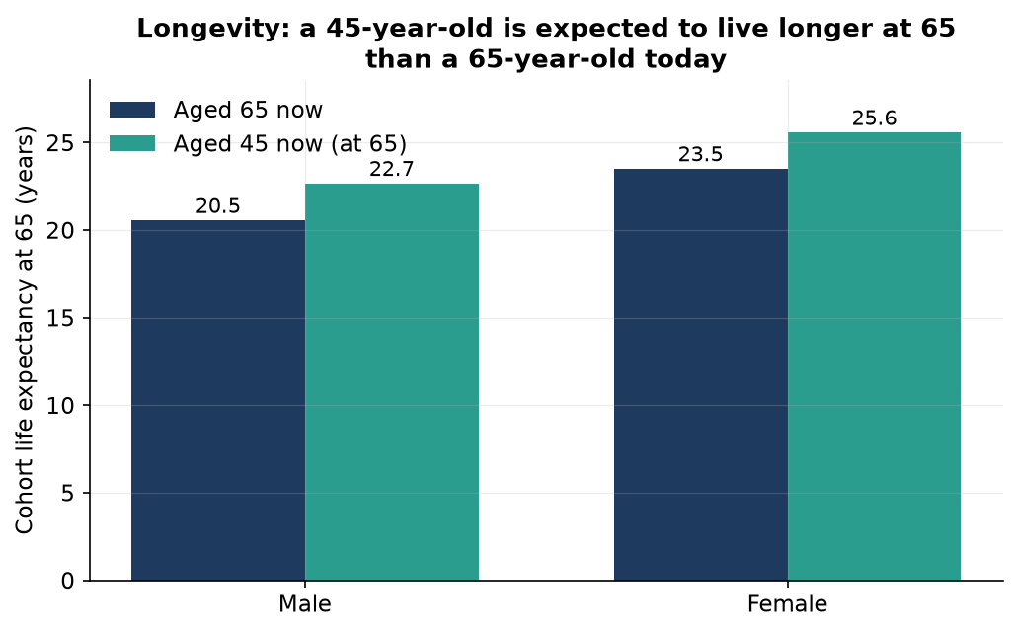

4.3 Projecting the pensions paid each year
For every member and every future year I work out the expected pension payment. A member's own pension is their starting pension, grown by the increases granted so far, multiplied by the chance they are still alive:
own_t = pension_0 x increase_factor(t) x tPx
The spouse's pension is trickier. It is only paid if the member has died, so it is conditional on death – it is not added on top of the member's own pension in the same year (that would double-count). I model it as an expected value:
spouse_t = pension_0 x 0.5 x prop_married x increase_factor(t) x (1 - tPx) x tP_spouse
A few details I was careful about: increases compound (they multiply, not add); caps apply each year separately (a 5% cap limits each year's increase, not the total); and deferred members are revalued up to age 65 once, then given increases in payment after that – not both. Adding everyone up gives the total expected outgo each year.
The shape of this is the key check. For a closed mature scheme, outgo should rise for a while as deferreds retire, peak, then run off. Mine rises to a peak of about £23m at year 19 (starting near £16m) and decays to almost nothing by the 2080s – exactly the expected hump.
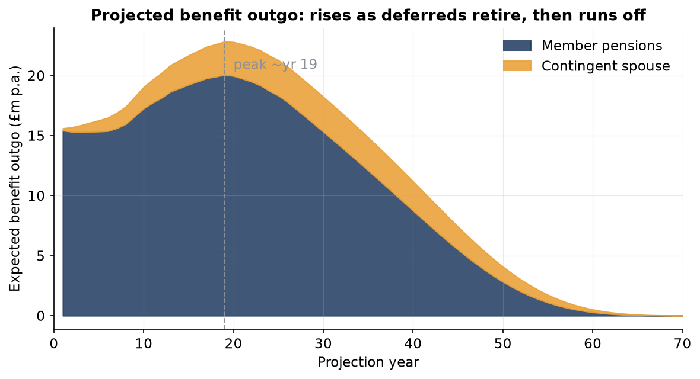

4.4 Valuing the pensions on three bases
“Valuing” the pensions means discounting all those future payments back to today. The three bases differ only in the discount rate (and, for buy-out, slightly stronger mortality). I discount each year's cashflow at t − 0.5 to approximate that pensions are actually paid monthly, not once a year:
PV = sum over t of CF_t x (1 + rate(t-0.5))^(-(t-0.5))
- Technical provisions (TP): gilts + 1.0%, falling to + 0.5% over 15 years – the statutory funding target, reflecting a scheme gradually de-risking.
- Low dependency: gilts + 0.5% flat – the 2024 Funding Code target for a mature scheme.
- Buy-out: gilts flat, stronger mortality, plus an expense loading – what an insurer would charge. This one is a proxy because insurer pricing is not public.
The results, with the modified duration (how sensitive each is to interest rates):
Basis | Value (£m) | Duration (yrs) | vs low dependency
Technical provisions | 316.5 | 14.0 | -0.7%
Low dependency | 318.7 | 13.9 | 0.0%
Buy-out (proxy) | 356.2 | 14.6 | +11.8%
With assets of £332m, the scheme is 105% funded on TP and 104% on low dependency, but only 93% on buy-out. So it is comfortably funded for running on, but not yet able to afford buy-out – which is what makes the endgame question interesting.

4.5 Simulating assets and liabilities forward
To see how the funding position might change, I simulate the future 5,000 times. Each year in each simulation I randomly move interest rates, inflation and growth-asset returns (with sensible sizes and correlations), then revalue the liabilities and update the assets. The scheme holds 25% growth assets and 75% matching assets, and hedges 80% of its interest-rate risk. Growth returns are modelled so that the median allows for the drag from volatility:
growth_return = (1 + mean) x exp( vol x Z - 0.5 x vol^2 ) - 1
One subtle but important point: the 80% hedge is set against the TP liabilities. The buy-out liabilities are longer and on a different basis, so the same hedge protects less of the buy-out position. A scheme aiming for buy-out is therefore more exposed to interest rates than the “80% hedged” label suggests – you can see this as the wider spread in the buy-out funding cone below.
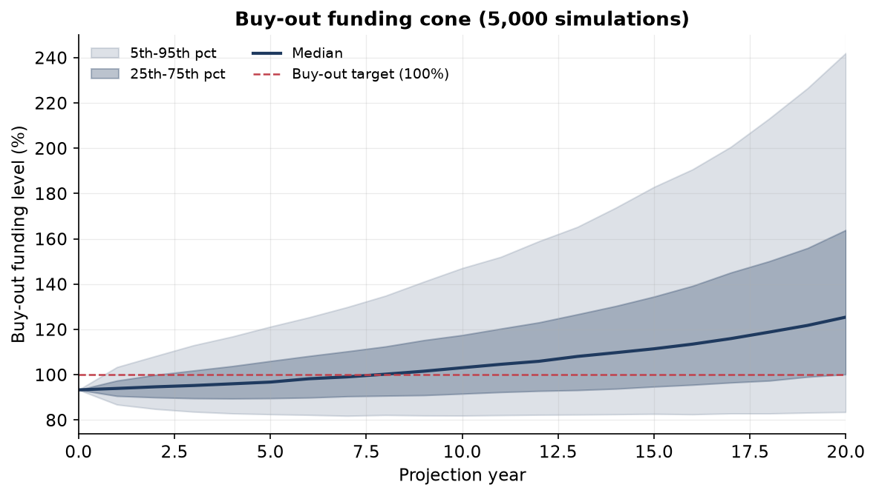
Figure 3. Buy-out funding level across 5,000 simulations. The band widens because risk compounds.

4.6 Comparing the two endgames
Route A (buy-out): for each simulation I record the first year the buy-out funding level hits 100%. Across all simulations this gives a distribution of “time to buy-out”.
Route B (run-on): the scheme releases any funding above low dependency + 5% as surplus each year, and I track how much surplus is released and how often funding falls back below the low-dependency floor.

5. Results
Route A. The median time to buy-out is 4 years, but the 25th–75th percentile range is 2–8 years. 71% of simulations can afford buy-out within 10 years, but 14% never manage it within 20. This spread is the main message: the answer is a range, not a date.
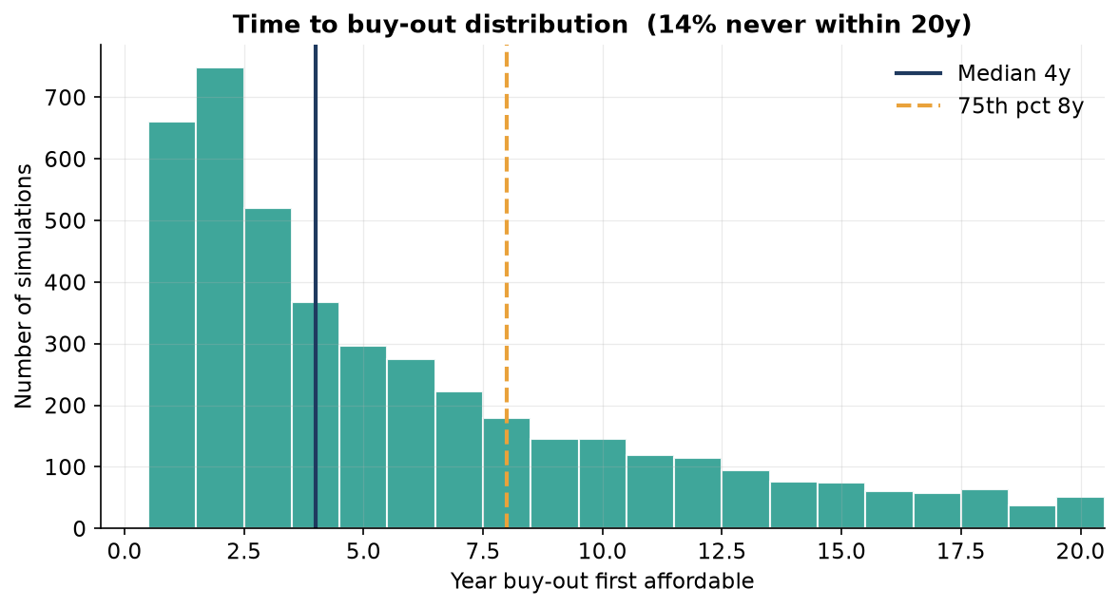
Figure 4. Distribution of the first year buy-out becomes affordable.
Route B. Running on releases about £70m of surplus on average over 20 years. But because the release rule only keeps a 5% buffer, funding dips below the low-dependency floor at some point in most simulations, and the 1-in-20 worst case leaves funding around 84%. More growth assets increase the surplus but worsen this downside – the trade-off is shown in the frontier below.
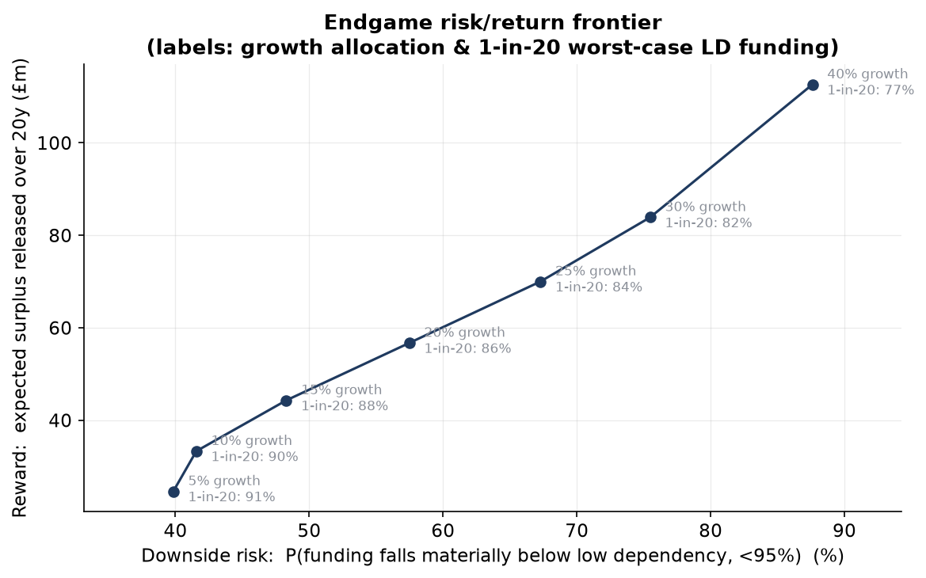
Figure 5. Risk/return frontier: expected surplus vs the chance of a material funding fall, by growth allocation.
Growth assets | Expected surplus (£m) | Chance funding < 95% LD | 1-in-20 funding
5% | 25 | 40% | 91%
15% | 44 | 48% | 88%
25% | 70 | 67% | 84%
40% | 113 | 88% | 77%
Going from 25% to 40% growth adds surplus but pushes the 1-in-20 funding down and makes a material breach much more likely. For a scheme this near its endgame, that is not a good trade.

6. Sensitivity analysis
I tested the two assumptions I was least sure about.
Mortality improvements. Changing the long-term improvement rate from 1.0% to 1.5% per year moves the TP liability from -1.2% to +1.2% around the central figure – about a 2.4% swing. Longevity is a real lever.
Buy-out loading. Sweeping the insurer loading from 0% to 6% moves the buy-out cost between 9% and 15% above low dependency. Even at 0% loading buy-out is about 8.5% dearer, which shows most of the gap comes from the gilts-flat basis and stronger mortality, not the loading itself.

7. Checking the model
Before trusting any numbers I ran five checks. An unchecked model is worse than none, because an interviewer will find the error. All five pass:
- Duration check: a small rise in the discount rate cuts the liability by (duration x rise), as it should; a full 1% move shows the expected second-order convexity.
- Improvements check: turning off mortality improvements drops the liability by ~6%, a sensible amount.
- Cashflow shape: total undiscounted pensions divided by the liability is 2.6x, inside the usual 2.5–3.5x range.
- External check: my starting funding level is in the same region as the PPF 7800 index.
- Convergence: the median time-to-buy-out settles down well before 5,000 simulations.
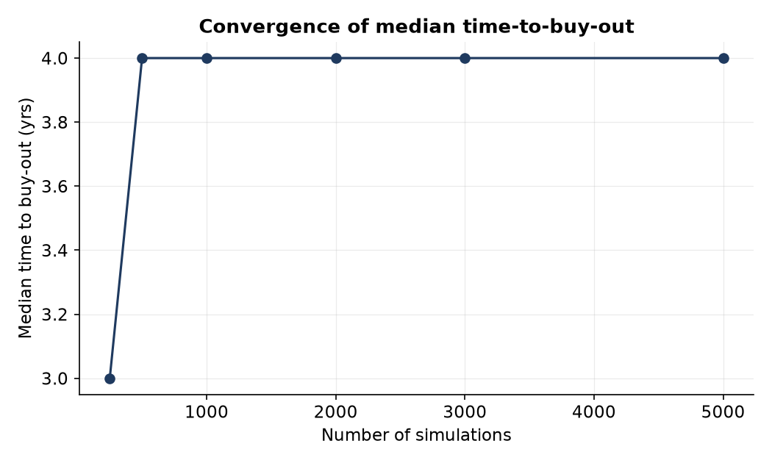
Figure 6. The median result stops moving as the number of simulations grows – enough simulations were used.

8. Limitations and further work
The model is deliberately simple, and there are things I would improve with more time:
- Buy-out pricing is a proxy – real insurer quotes could differ.
- GMP equalisation and member options are excluded; of everything I left out, these would most change the buy-out cost (and would tend to lengthen the time to buy-out).
- The economic model is a simple single-factor one – fine for this purpose, but not a full stochastic model.
- Adding a sponsor covenant (the chance the employer can still pay) would complete the funding picture.
- A trigger-based de-risking rule behaves like a feedback controller and can overshoot – an interesting extension linking to control theory.

9. What I learned
The most useful lesson was that the interesting answer is a distribution, not a point estimate. It is easy to compute one funding number; the value is in showing the range of outcomes and explaining what drives it – the growth allocation, the hedge basis, and longevity. I also learned how much the small modelling details (compounding increases, cohort mortality, revaluing deferreds once, not double-counting the spouse's pension) matter to the final answer, and why being explicit about assumptions is what makes a model trustworthy.

Appendix: assumptions
Assumption | Value | Reason
Valuation date | 31 Mar 2026 | Single base date
Discount rate – TP | Gilts +1.0% -> +0.5% | De-risking flightpath (2024 Funding Code)
Discount rate – low dependency | Gilts +0.5% flat | Low-dependency target at maturity
Buy-out loading | 3% + mortality x0.97 | Proxy; insurer pricing not public
CPI | Implied RPI less 0.7% | Post-2030 RPI reform assumed
Base mortality | ONS ELT x 0.92 | Proxy for scheme tables; lighter lives
Improvements | CMI-style 1.25% p.a. | Tested at 1.0% and 1.5%
Proportion married | 80% male / 65% female | At retirement
Growth assets | 25%, gilts +3.5%, 15% vol | Purple Book-style allocation
Hedge ratio | 80% of TP liabilities | Purple Book average
Simulations | 5,000 over 20 years | Enough for convergence

