Qs 1: Retrieve all customers who have placed an order in the last 30 days.

* **select * from orders where order_date >= curdate() - interval 30 day;**

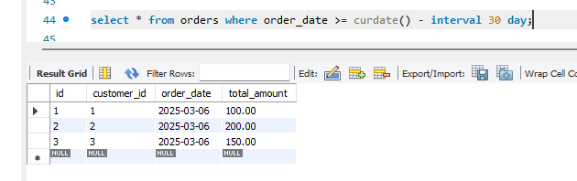

Qs 2: Get the total amount of all orders placed by each customer.

* **select customers.name, sum(orders.total_amount) as total_spent**

**from customers**

**join orders on customers.customer_id = orders.customer_id**

**group by customers.customer_id;**

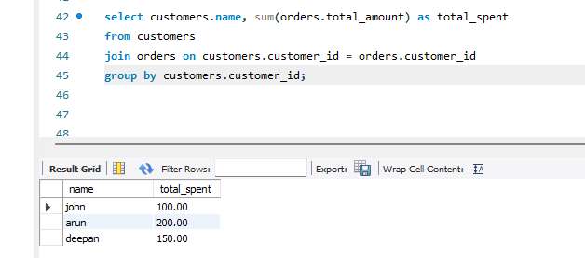

Qs 3: Update the price of Product C to 45.00.

* **update products set price = 45.00 where name = 'Product C';**

**select * from products;**

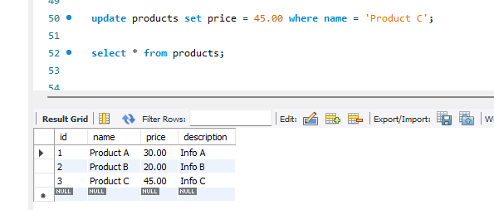

Qs 4: Add a new column discount to the products table.

* **alter table products add column discount decimal(10,2) default 0.00;**

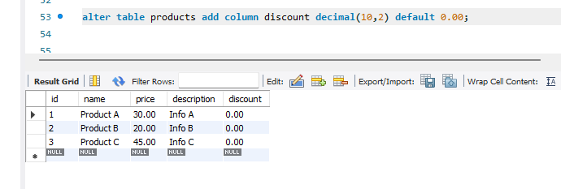

Qs 5: Retrieve the top 3 products with the highest price.

* **select * from products order by price desc limit 3;**

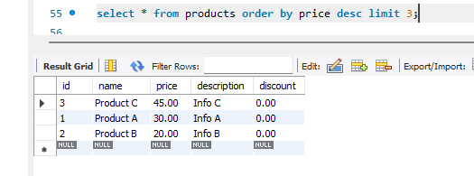

Qs 7: Get the names of customers who have ordered Product A.

* **select distinct customers.name**

**from customers**

**join orders on customers.customer_id = orders.customer_id**

**join order_items on orders.id = order_items.order_id**

**join products on order_items.product_id = products.id**

**where products.name = 'Product A';**

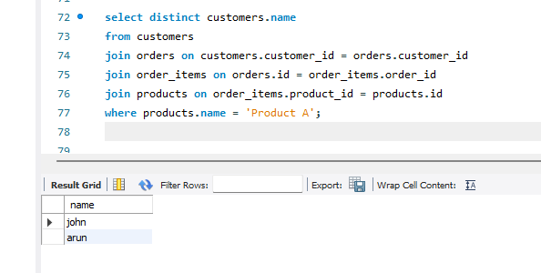

Qs 8: Join the orders and customers tables to retrieve the customer's name and order date for each order.

* **select customers.name, orders.order_date**

**from customers**

**join orders on customers.customer_id = orders.customer_id;**

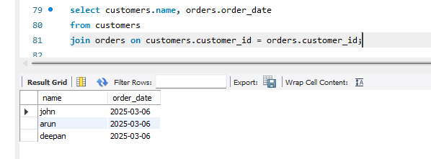

Qs 9: Retrieve the orders with a total amount greater than 150.00.

* **select * from orders where total_amount > 150.00;**

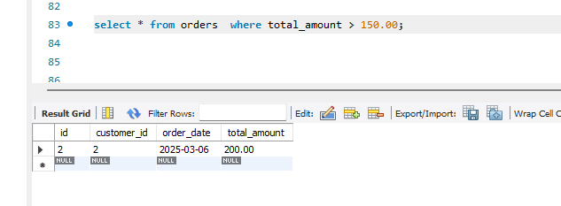

Qs 10: Normalize the database by creating a separate table for order items and updating the orders table to reference the order_items table.

* **select * from orders where total_amount > 150.00;**

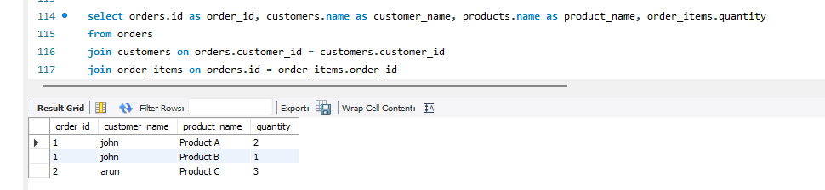

Qs 10: Retrieve the average total of all orders.

* **select avg(total_amount) as average from orders;**

