NAME: Thiru Moorthy M
REG NO:192321083
COURSE:ITA0609-MACHINE LEARNING
----------------------------------------------------------------------------------------------------

1. ML System Design for Health Analysis (Disease Prediction)
The goal is to design a machine learning system that predicts diseases such as heart disease or diabetes using patient data (age, blood pressure, glucose level, BMI, lifestyle factors, and medical history). The concept map below summarizes the end-to-end pipeline.
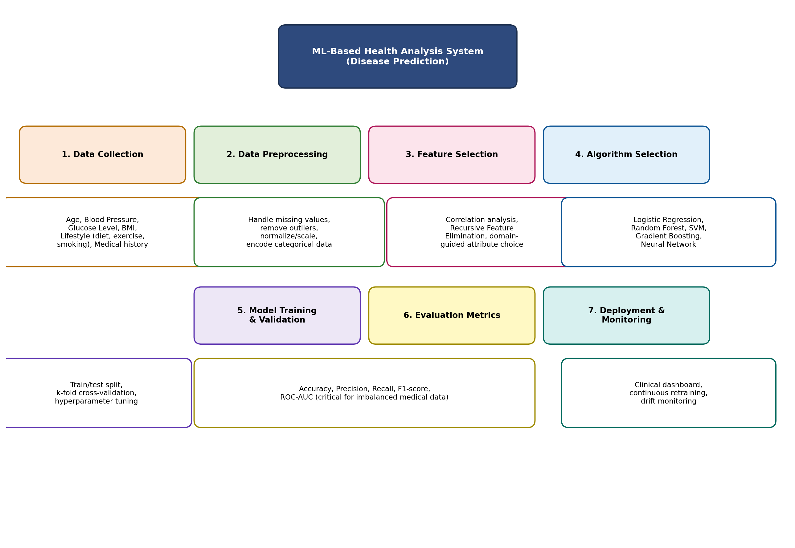
1.1 Data Preprocessing
- Handle missing values through imputation (mean/median for numeric fields such as glucose level, mode for categorical fields).
- Detect and treat outliers (e.g., implausible blood pressure readings) using IQR or z-score methods.
- Normalize/standardize numeric features (age, glucose, BP) so that features with larger ranges do not dominate distance- or gradient-based algorithms.
- Encode categorical/lifestyle attributes (smoking status, diet, exercise) using one-hot or ordinal encoding.
- Split the dataset into training, validation, and test sets, keeping class balance in mind since disease-positive cases are often a minority.
1.2 Feature Selection
- Use correlation analysis and statistical tests (chi-square, ANOVA) to identify attributes most associated with the disease outcome.
- Apply Recursive Feature Elimination (RFE) or tree-based feature importance to drop redundant or low-value features.
- Combine statistical selection with domain/clinical knowledge, since medically relevant features (e.g., glucose level for diabetes) should be retained even if statistically borderline.
1.3 Algorithm Selection and Justification
- Logistic Regression — a strong baseline; coefficients are interpretable, which matters in healthcare where clinicians need to understand why a prediction was made.
- Random Forest / Gradient Boosting (XGBoost) — handle non-linear relationships and mixed numeric/categorical data well, are robust to outliers, and provide feature-importance scores useful for clinical insight.
- Support Vector Machine (SVM) — effective on moderate-sized, high-dimensional datasets and works well when classes are not perfectly linearly separable.
- Neural Networks — considered when large volumes of patient data are available and complex, non-linear interactions between variables need to be captured; used when interpretability is less critical than raw accuracy.
- In practice, ensemble tree-based methods (Random Forest / Gradient Boosting) are usually preferred for tabular health data because they balance accuracy, robustness to missing/noisy data, and reasonable interpretability via feature importance.
1.4 Model Training and Evaluation
- Train using k-fold cross-validation to get a reliable performance estimate and reduce overfitting risk.
- Tune hyperparameters (tree depth, regularization strength, learning rate) via grid search or randomized search.
- Evaluate using accuracy, precision, recall, F1-score, and ROC-AUC — recall is especially important in healthcare since missing a true disease case (false negative) is more costly than a false alarm.
- Deploy the validated model behind a clinical decision-support interface, and monitor performance over time to detect data drift as patient population characteristics change.

2. Find-S Algorithm on Loan Approval Dataset
The Find-S algorithm searches for the most specific hypothesis that is consistent with all positive training examples, ignoring negative examples entirely.
2.1 Dataset
Example | Employment | Salary | Credit Score | Loan History | Loan Approved
1 | Employed | High | Good | Clean | Yes
2 | Employed | Medium | Good | Clean | Yes
3 | Unemployed | Low | Poor | Bad | No
4 | Employed | Medium | Excellent | Clean | Yes

2.2 Concept Map: Applying Find-S
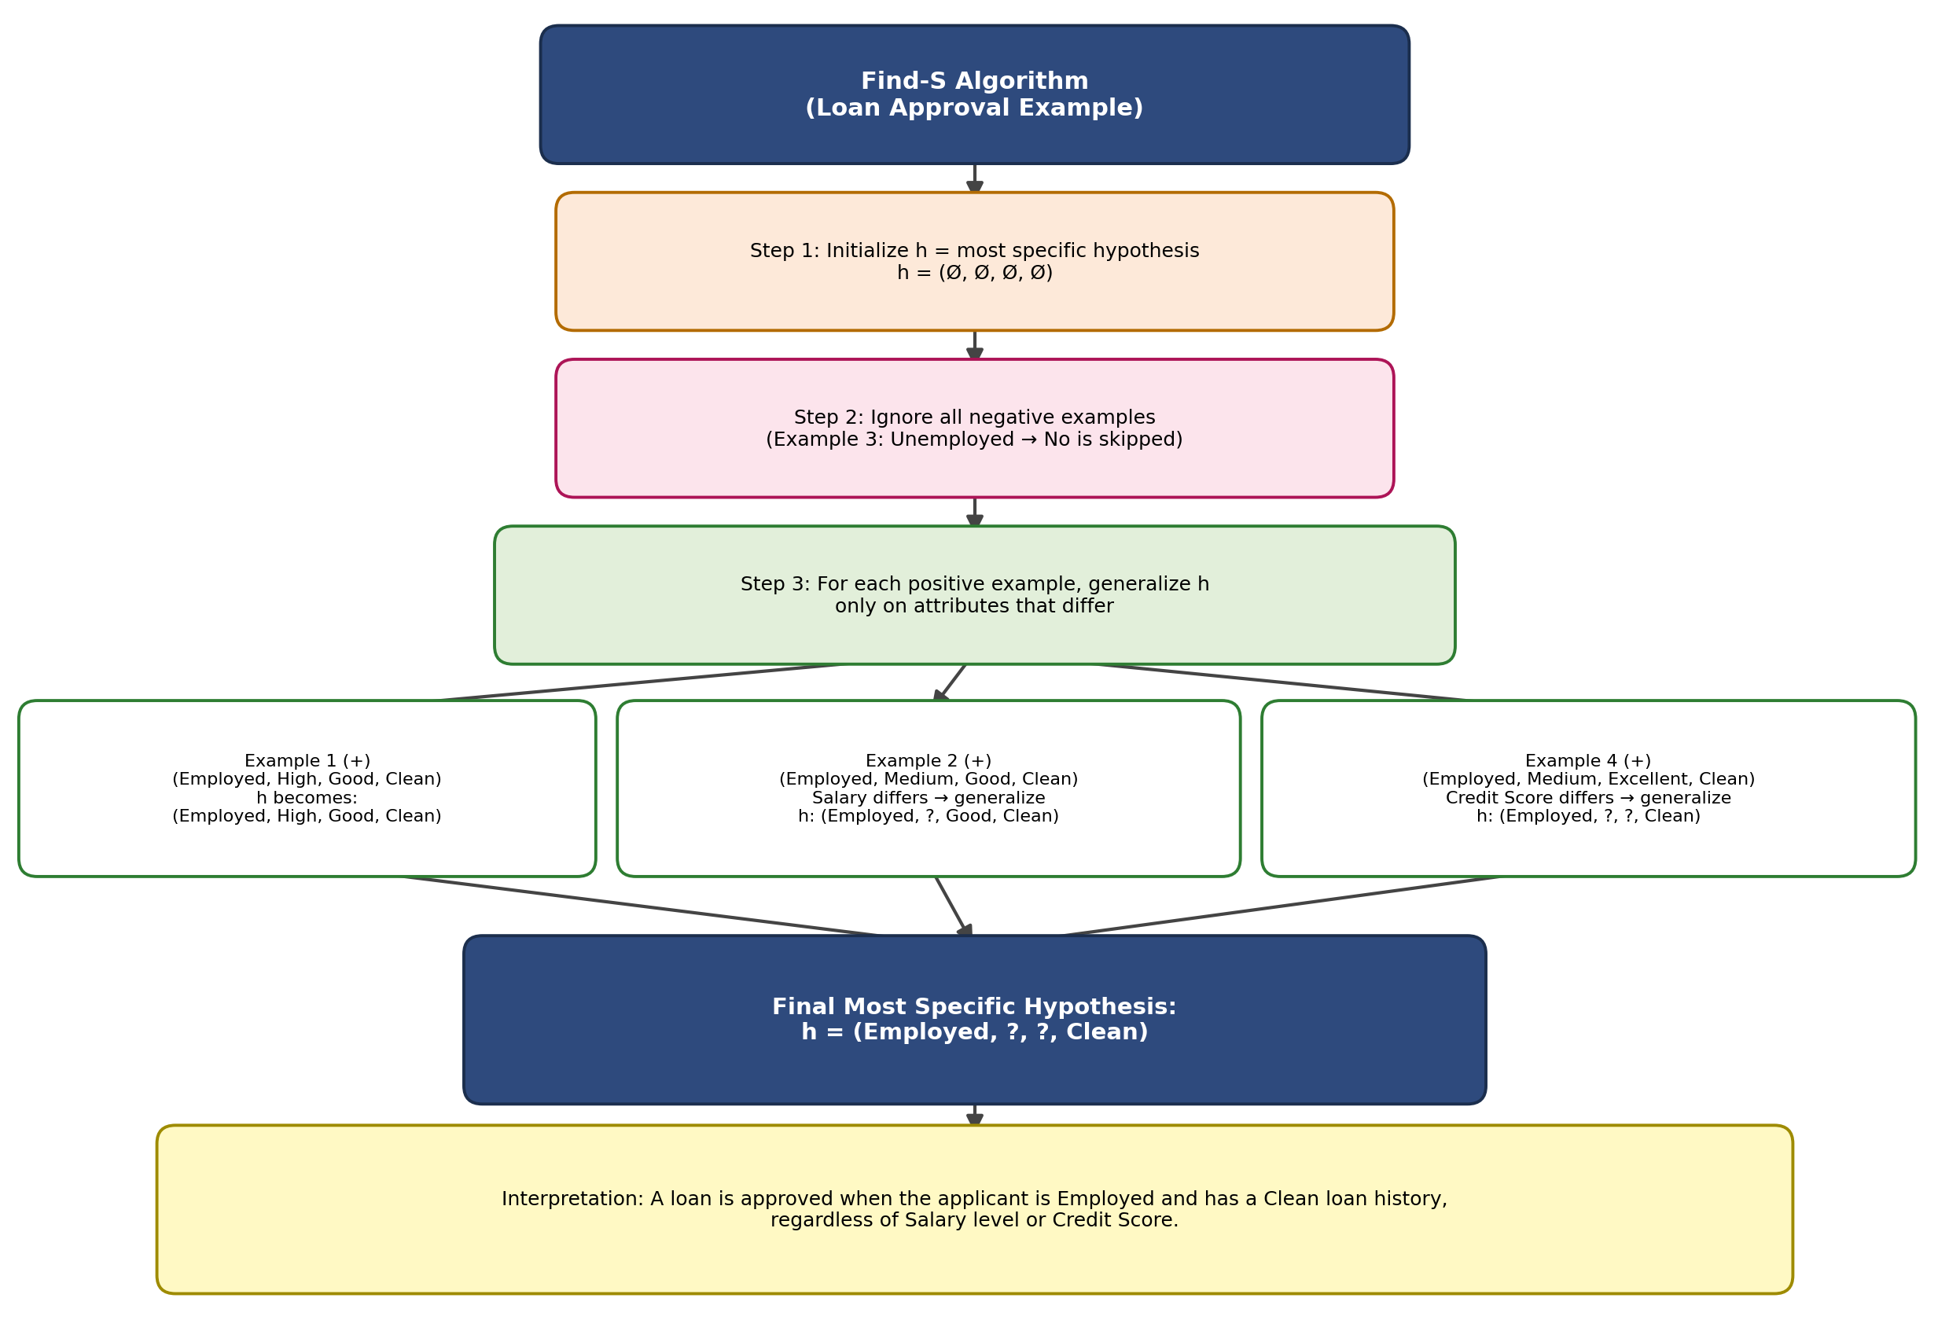
2.3 Step-by-Step Derivation
- Initialize the hypothesis to the most specific form: h = (Ø, Ø, Ø, Ø).
- Example 1 is positive (Employed, High, Good, Clean) → h becomes (Employed, High, Good, Clean).
- Example 2 is positive (Employed, Medium, Good, Clean) → Salary differs from h (High vs Medium), so Salary is generalized to '?' → h = (Employed, ?, Good, Clean).
- Example 3 is negative → it is ignored completely by Find-S.
- Example 4 is positive (Employed, Medium, Excellent, Clean) → Credit Score differs from h (Good vs Excellent), so it is generalized to '?' → h = (Employed, ?, ?, Clean).
2.4 Final Hypothesis
h = (Employed, ?, ?, Clean)
Interpretation: Based on the positive examples, a loan is approved whenever the applicant is Employed and has a Clean loan history — Salary level and Credit Score do not constrain the hypothesis, since they varied across the positive examples.

