System: iBooks – Your Intelligent Reading Companion

Thirupathi Gugulothu

COMP-699-D Professional Seminar

Rivier University

Executive Summary

This project presents iBooks – Your Intelligent Reading Companion, a system designed to generate personalized book recommendations based on explicitly defined user preferences. The system addresses a common challenge faced by readers: the difficulty of discovering relevant books from a large and often overwhelming collection of available titles. Unlike large-scale commercial platforms that rely on complex behavioral tracking, iBooks focuses on a structured and transparent approach where recommendations are directly derived from user-provided inputs.
The system collects user preferences such as preferred genres, favorite authors, and ratings for previously read books. These inputs are stored as a structured user profile and used to compute similarity between user preferences and book attributes. The recommendation process involves matching genres and authors, analyzing rating patterns, computing similarity scores, and ranking candidate books. This approach ensures that the relationship between input and output remains clear, explainable, and easy to validate.
From a design perspective, the system follows an object-oriented architecture using the Boundary–Control–Entity pattern. The recommendation logic is implemented using a strategy-based approach, where different similarity measures are handled by separate components. This modular design improves flexibility and allows future enhancements without affecting the core system (Gamma et al., 1994). The system also aligns with content-based recommendation principles, where recommendations are generated using item attributes and user preferences rather than predictive models (Ricci et al., 2011).

Table of Contents
1. Executive Summary 2
2. Table of Contents 3
3. Introduction 5
3.1 Company Background 5
3.2 Problem Description 6
4. System Proposal 8
4.1 System Request 8
4.2 Requirements Definition 12
4.3 Functional Requirements 12
4.4 Non-Functional Requirements 14
5. Functional Models 16
5.1 Use-Case Diagram 16
5.2 Use-Case Description 18
5.3 Activity Diagram 29
6. Structural Model 31
6.1 Class Diagram 31
6.2 Object Diagram 33
7. Behavioral Model 35
7.1 Sequence Diagram 35
8. Design Choices 38
8.1 Package Diagram 38
8.2 Contract (Recommendation Generation) 40
8.3 Method Specification 40
9. Data Management Layer Design 41
9.1 Object Persistence Format 41
9.2 Database Schema 42
10. Human-Computer Interaction Layer Design 43
10.1 Wireframe Design 43
11. Physical Architecture Layer Design 46
11.1 Hardware and Software Specification 46
11.2 Operational Requirements 46
11.3 Performance Requirements 47
12. Construction 48
12.1 Unit Test Description 48
12.2 Integration Tests 49
13. Build and Run Instructions 50
14. Acknowledgements 51
15. Conclusions 52
16. References 53
17. Source Code with Unit Tests 54
17.1 Source Code 54
17.2 Unit Tests 65
18. Generated Code Documentation 68
19. Class to code map 69
20. User Requirements to Code Map 70
20.1 User requirements to code map 70
20.2 Unimplemented and Partially Implemented Requirements 70

Introduction

Company Background
iBooks is a conceptual, data-driven recommendation platform designed to improve how readers discover books in digital environments. It is positioned similarly to modern content platforms such as online bookstores and digital libraries, where large collections of content are available but often difficult to navigate effectively. The system is not intended to replicate commercial platforms like Amazon or Goodreads, but rather to demonstrate a structured and transparent approach to recommendation system design.
The platform focuses on using explicitly defined user preferences instead of implicit behavioral tracking. Users provide inputs such as preferred genres, favorite authors, and ratings for previously read books. These inputs are stored as a structured user profile and used directly to generate recommendations. This design reflects a key principle in systems analysis: systems should be built to clearly connect user input with system output in a way that supports understanding and validation (Dennis et al., 2020).
A central characteristic of iBooks is its emphasis on transparency. The recommendation logic is designed so that users can understand why a particular book is suggested. Instead of relying on hidden algorithms, the system uses observable attributes such as genre and author matching, along with similarity scoring. This approach aligns with established practices in object-oriented design, where modular and interpretable components improve system clarity and maintainability (Gamma et al., 1994).
From a business perspective, iBooks aims to improve user engagement by delivering relevant and personalized recommendations. When users receive suggestions that match their interests, they are more likely to continue interacting with the platform. This concept is widely supported in recommendation system research, where personalized content discovery plays a critical role in user satisfaction and retention (Ricci et al., 2011).

Problem Description
Readers today face a significant challenge when trying to discover books that match their interests. Digital platforms provide access to a large number of titles, but this abundance often leads to information overload. Users are required to browse through multiple options without a clear understanding of which books are most relevant to their preferences.
Existing recommendation systems often rely on complex behavioral tracking or machine learning models. While these approaches can be effective, they lack transparency. Users typically do not understand how recommendations are generated, which reduces trust and makes it difficult to validate results. In addition, such systems require large volumes of user interaction data, which may not always be available or appropriate in smaller-scale applications.
Another limitation is that many systems do not allow users to directly control the recommendation process. Preferences are inferred rather than explicitly defined, which can lead to irrelevant or inconsistent suggestions. As a result, users may not receive recommendations that accurately reflect their interests.
The iBooks system addresses these issues by focusing on a structured and explainable recommendation approach. Instead of relying on implicit data, the system uses explicitly defined user preferences and matches them with book attributes. Similarity scores are computed based on genre, author, and rating patterns, and the results are presented in a ranked and transparent format.
This approach ensures that recommendations are not only relevant but also understandable. By making the recommendation process clear and traceable, the system supports better decision-making and aligns with the goal of building systems that are both functional and interpretable (Dennis et al., 2020).

System Proposal

System Request
System Request: | iBooks: Your Intelligent Reading Companion
Project Sponsor: | Thirupathi Gugulothu
Business Need: | - Readers today face difficulty in discovering relevant books due to the large volume of available content across digital platforms. While platforms such as Amazon or Netflix provide recommendations, they rely heavily on complex behavioral tracking and opaque algorithms. This creates a lack of transparency in how recommendations are generated.  - The primary need of the iBooks system is to provide a personalized and explainable recommendation system based on explicitly defined user preferences. Instead of relying on hidden models, the system focuses on structured inputs such as genres, authors, and ratings. This ensures that recommendations can be directly traced back to user inputs, making the system easier to understand and validate (Dennis et al., 2020).  - In this system, users create a preference profile during initial setup. These preferences are stored and used to generate recommendations by matching them with structured book attributes. This approach ensures a clear relationship between input and output, supporting both usability and system transparency.
Business Requirements: | The system must support the following capabilities:  Provide a functional book recommendation system based on user-defined preferences  Allow users to create a structured profile including:  Preferred genres  Favorite authors  Ratings for selected books  Store user preferences as a persistent profile  Generate recommendations by:  Matching user preferences with book attributes  Computing similarity using genre, author, and rating patterns  Display ranked recommendations in a clear and interpretable format  Integrate publicly available book datasets to simulate real-world behavior  The system design must also ensure that it is:  Feasible within the project timeline  Focused on core recommendation concepts  Transparent and explainable  Modular to support future extensions
Business Value: | The iBooks system provides value by improving how users discover books through structured and personalized recommendations. Instead of relying on generic suggestions, the system uses explicit user input to generate relevant results.  The key value includes:  Demonstrating practical application of systems analysis and design concepts (Dennis et al., 2020)  Showing how user inputs directly influence system outputs  Improving user experience through relevant recommendations  Providing hands-on experience with real-world datasets  Establishing a foundation that can be extended to other domains such as movies or educational content  This approach highlights how recommendation systems can be designed to be both functional and interpretable.
Special Issues or Constraints: | - The system operates under the following constraints:  - User preferences are explicitly defined and remain static unless updated manually  - The system does not use implicit tracking or machine learning-based adaptation  - The scope is limited to book recommendations to maintain feasibility  - Book data is sourced from publicly available datasets such as Project Gutenberg  - Advanced features such as real-time learning or large-scale deployment are outside the scope  - These constraints ensure that the system remains focused on clarity, simplicity, and explainability while still demonstrating core recommendation system concepts.

Requirements Definition
The requirements definition for the iBooks system specifies the functional capabilities and operational conditions necessary to support a structured and explainable book recommendation process. Functional requirements describe the sequence of user interactions and system operations, including profile creation, preference management, similarity computation, and recommendation generation. Non-functional requirements define system characteristics such as performance, transparency, and modularity. Together, these requirements ensure that the system remains aligned with its objective of providing interpretable and user-driven recommendations (Dennis et al., 2020).

Functional Requirements
The functional requirements define how the system operates from the moment a user interacts with it to the generation of recommendations. The process begins with the Reader creating a user profile by selecting preferred genres, favorite authors, and providing ratings for selected books. These preferences are validated and stored as a structured profile, which serves as the foundation for all recommendation activities.

- A Reader creates a user profile during initial setup.

- A Reader selects preferred genres.

- A Reader selects favorite authors.

- A Reader provides ratings for selected books.

- The system stores entered preferences as part of a persistent user profile.

- A Reader views stored preference profile.

- A Reader updates preferred genres.

- A Reader updates favorite authors.

- A Reader updates rated book selections.

- The system validates completeness of user preference inputs.

- The system retrieves stored user preference profile for recommendation processing.

- The system matches preferred genres with book dataset attributes.

- The system matches favorite authors with dataset records.

- The system compares rated books with dataset entries to identify similarity patterns.

- The system calculates similarity scores between candidate books using genre, author, and rating patterns.

- The system normalizes similarity scores for ranking consistency.

- The system ranks candidate books according to similarity score.

- The system filters out books already rated by the Reader.

- The system filters out duplicate dataset entries.

- The system generates a list of recommended books.

- The system limits the number of displayed recommendations to a predefined threshold.

- The system logs recommendation generation activity.

- The system displays recommended book titles to the Reader.

- The system displays attributes contributing to each recommendation.

- The system displays similarity ranking indicators.

- A Reader refreshes recommendation results.

- The system regenerates recommendations upon request.

- A System Administrator imports book datasets from an External Book Data Source.

- The system validates dataset structure and required attributes.

- The system extracts relevant features including genre and author.

- The system indexes dataset records for efficient retrieval.

- A System Administrator updates book dataset records.

- A System Administrator removes obsolete dataset entries.

Non-Functional Requirements
The non-functional requirements define the conditions under which the system operates and ensure that it remains efficient, transparent, and maintainable.
The system is designed to generate recommendation results within an interactive response time suitable for demonstration purposes. The recommendation logic must remain interpretable, with similarity scores computed using clear and explainable methods rather than complex or opaque algorithms. All recommendations are generated based on stored user preference profiles, ensuring consistency and traceability.
- The system will generate recommendation results within an interactive response time suitable for demonstration.

- The system will compute similarity scores using interpretable and explainable methods.

- The system will generate recommendations using stored user preference profiles.

- The system will limit recommendation functionality to the book domain only.

- The system will utilize publicly available book datasets such as Project Gutenberg.

- The system will maintain structural consistency between user profile attributes and dataset features.

- The system architecture will remain modular to allow future extension.

- The recommendation logic will remain explainable during system demonstration.

This requirements definition follows the structured outline format for functional and non- functional requirements as described by Dennis, Wixom, and Tegarden (2020).

Functional Models
This section presents the functional models of the iBooks Recommendation System. Functional models describe how the system behaves from a user interaction and process perspective. They focus on capturing system functionality, workflows, and interactions between actors and the system. By representing these aspects through diagrams, the system behavior can be clearly understood before moving into structural and design-level details (Dennis et al., 2020).
The functional model for this system includes the use-case diagram, use-case descriptions, and activity diagram. Together, these models illustrate what the system does, how users interact with it, and how internal processes are executed step by step.

Use-Case Diagram
The use-case diagram provides a visual representation of system functionality and actor interactions. It defines the system boundary and highlights the services offered by the system. The diagram identifies three primary actors: Reader, System Administrator, and External Book Data Source.
As shown in Figure 1, the use-case diagram captures the primary interactions between the system and its actors.

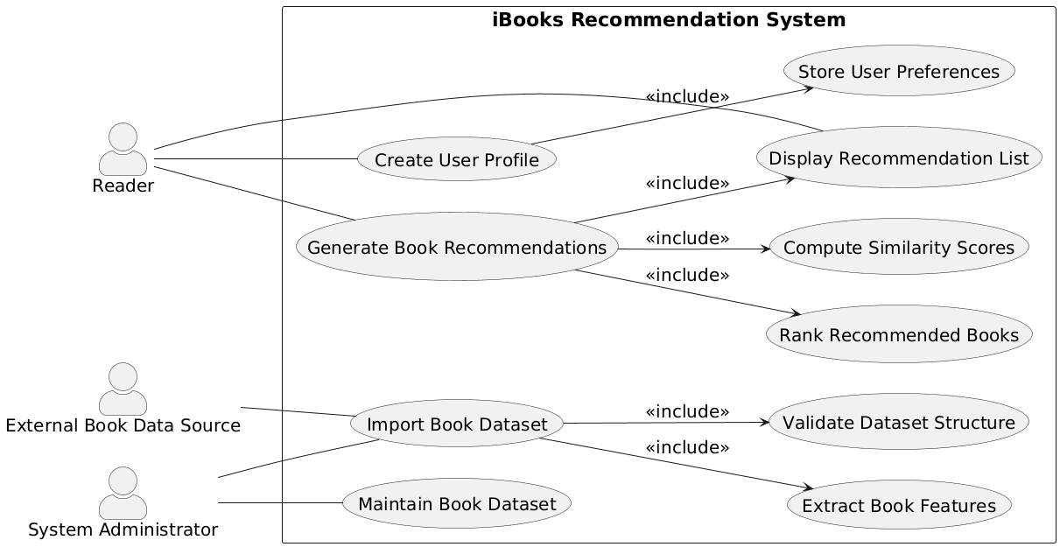
Figure 1: Use-Case Diagram for iBooks Recommendation System
The Reader interacts with the system through two main use cases: creating a user profile and generating book recommendations. These use cases include sub-processes such as storing preferences, computing similarity scores, ranking books, and displaying recommendations. The inclusion relationships indicate that these sub-processes are integral parts of the overall functionality.
The External Book Data Source interacts with the system through dataset import operations, while the System Administrator is responsible for maintaining and updating the dataset. These interactions ensure that the system operates with accurate and up-to-date information.
The use-case diagram serves as a high-level representation of system functionality and establishes a clear understanding of how different actors engage with the system.

Use-Case Description
The use-case model defines the primary interactions between system actors and the iBooks Recommendation System. The main actor is the Reader, who interacts with the system to create a profile and generate book recommendations. The Reader begins by providing preferences such as genres, favorite authors, and ratings, which are stored as part of a structured user profile. This profile becomes the basis for all subsequent recommendation processing.
Once the profile is created, the Reader initiates the recommendation process. The system retrieves the stored preferences and performs a series of operations including matching genres and authors with the dataset, computing similarity scores, and ranking candidate books. The final output is presented as a recommendation list that includes relevant attributes and ranking indicators.
In addition to the Reader, the System Administrator supports system functionality by managing the dataset. This includes importing book data, validating its structure, extracting relevant features, and maintaining dataset accuracy over time. The External Book Data Source provides the raw data required for recommendation processing.
The use-case relationships demonstrate modular design. Key processes such as computing similarity scores and ranking books are included within the broader recommendation generation process. This structure ensures that functionality is reusable and clearly organized, which is consistent with systematic design principles (Dennis et al., 2020).

Use Case Name: Create User Profile |  | ID: UC-1 | Importance Level:
Primary Actor: Reader | Use Case Type: External
Stakeholders and Interests:
Reader wants to create a structured preference profile to receive relevant book recommendations.
The system requires complete and valid preference inputs to generate similarity-based recommendations.
Brief Description:
The Reader creates a new user profile by entering preferred genres, favorite authors, and ratings for selected books during initial setup.
Trigger: The Reader selects the Create Profile option.
Type: External
Relationships:
Association: Reader
Include: Store User Preferences (UC-2)
Extend: None
Generalization: None
Associated Functional Requirements:
R1: A Reader creates a user profile during initial setup.
R2: A Reader selects preferred genres.
R3: A Reader selects favorite authors.
R4: A Reader provides ratings for selected books.
R5: The system stores entered preferences as part of a persistent user profile.
R10: The system validates completeness of user preference inputs.
Normal Flow of Events:
- The Reader selects the create profile option.
- The system prompts the Reader to select preferred genres.
- The Reader selects one or more genres.
- The system prompts the Reader to select favorite authors.
- The Reader selects one or more authors.
- The system prompts the Reader to rate selected books.
- The Reader enters ratings for selected books.
- The system validates completeness of the entered preference data.
- The system stores the entered data as a persistent user profile.
- The system confirms successful profile creation.
SubFlows:
- Validate Preference Completeness
  - The system checks whether at least one genre is selected.
  - The system checks whether at least one author or rated book is provided.
  - If required data is missing, the system prompts the Reader to complete missing fields.
Alternate/Exceptional Flows:
A-1: If validation fails, the system displays a message indicating missing required inputs and returns control to the Reader.
A-2: If the system fails to store the profile, the system displays an error message and logs the failure event.

Use Case Name: Store User Preferences |  | ID: UC-2 | Importance Level: High
Primary Actor: System | Use Case Type: Internal
Stakeholders and Interests:
Reader expects entered preferences to be saved accurately for recommendation processing.
The system requires persistent storage of structured preference data for similarity computation.
Brief Description: The system stores the Reader’s selected genres, favorite authors, and rated books as a persistent profile for future recommendation generation.
Trigger:
Type: Completion of preference entry during Create User Profile.
Relationships:
Association: None
Include: None
Extend: None
Generalization: None
Associated Functional Requirements:
R5: The system stores entered preferences as part of a persistent user profile.
R10: The system validates completeness of user preference inputs.
R11: The system retrieves stored user preference profile for recommendation processing.
Normal Flow of Events:
- The system receives selected genres, authors, and rated books from the profile creation process.
- The system validates that required preference fields are complete.
- The system structures the preference data into a profile format.
- The system writes the profile data to persistent storage.
- The system confirms successful storage.
SubFlows:
- Validate Preference Data
  - The system checks for required genre entries.
  - The system checks for at least one author or rated book.
  - If required data is missing, the system rejects storage and returns control to the calling use case.
Alternate/Exceptional Flows:
A-1: Storage Failure
            - If persistent storage fails, the system logs the error.
            - The system returns a failure status to the calling process.

Use Case Name: Generate Book Recommendations |  | ID: UC-3 | Importance Level: High
Primary Actor: Reader | Use Case Type: External
Stakeholders and Interests:
Reader expects relevant book suggestions based on stored preferences.
The system must generate explainable recommendations using similarity-based computation.
Brief Description:
The Reader requests book recommendations. The system retrieves the stored user profile, computes similarity scores, ranks candidate books, filters results, and prepares a recommendation list.
Trigger: The Reader selects the Generate Recommendations option.
Type: External
Relationships:
Association: Reader
Include: Compute Similarity Scores (UC-4), Rank Recommended Books (UC-5), Display Recommendation List (UC-6)
Extend: None
Generalization: None
Associated Functional Requirements:
R11: The system retrieves stored user preference profile for recommendation processing.
R12: The system matches preferred genres with book dataset attributes.
R13: The system matches favorite authors with dataset records.
R14: The system compares rated books with dataset entries to identify similarity patterns.
R18: The system filters out books already rated by the Reader.
R19: The system filters out duplicate dataset entries.
R20: The system generates a list of recommended books.
R21: The system limits the number of displayed recommendations to a predefined threshold.
R22: The system logs recommendation generation activity.
R26: A Reader refreshes recommendation results.
R27: The system regenerates recommendations upon request.
Normal Flow of Events:
- The Reader selects the generate recommendations option.
- The system retrieves the stored user preference profile.
- The system identifies candidate books from the dataset.
- The system filters out books already rated by the Reader.
- The system removes duplicate dataset entries.
- The system computes similarity scores for candidate books.
- The system normalizes similarity scores.
- The system ranks candidate books according to similarity score.
- The system limits results to the predefined threshold.
- The system logs the recommendation activity.
- The system forwards the ranked list for display.
SubFlows:
- Refresh Recommendations
  - The Reader requests refreshed results.
  - The system regenerates recommendations using the stored profile.

Use Case Name: Compute Similarity Scores |  | ID: UC-4 | Importance Level: High
Primary Actor: System | Use Case Type: Internal
Stakeholders and Interests:
Reader expects accurate and explainable similarity calculations.
The system must compute consistent and normalized similarity values for ranking.
Brief Description: The system computes similarity scores between candidate books and the Reader’s stored preferences using genre, author, and rating patterns.
Trigger: Invocation from Generate Book Recommendations.
Type: Internal
Relationships:
Association: None
Include: None
Extend: None
Generalization: None
Associated Functional Requirements:
R12: The system matches preferred genres with book dataset attributes.
R13: The system matches favorite authors with dataset records.
R14: The system compares rated books with dataset entries to identify similarity patterns.
R15: The system calculates similarity scores between candidate books using genre, author, and rating patterns.
R16: The system normalizes similarity scores for ranking consistency.
Normal Flow of Events:
- The system receives candidate books and the stored user profile.
- The system compares candidate book genres with preferred genres.
- The system compares candidate book authors with favorite authors.
- The system evaluates similarity patterns using rated books.
- The system calculates a similarity score for each candidate book.
- The system normalizes similarity scores to ensure consistent ranking values.
- The system returns computed similarity scores to the calling use case.
SubFlows:
- Normalize Scores
  - The system scales raw similarity values to a consistent range.
  - The system verifies normalized values maintain relative ranking order.
Alternate/Exceptional Flows:
A-1: Incomplete Dataset Attributes
            - If required book attributes are missing, the system excludes the book from scoring.
            - The system logs the exclusion event.

Use Case Name: Rank Recommended Books |  | ID: UC-5 | Importance Level: High
Primary Actor: System | Use Case Type: Internal
Stakeholders and Interests:
Reader expects recommendations to be ordered by highest relevance.
The system must ensure consistent and accurate ranking based on normalized similarity scores.
Brief Description: The system orders candidate books according to computed similarity scores and prepares a ranked recommendation list.
Trigger: Receipt of normalized similarity scores from Compute Similarity Scores.
Type: Internal
Relationships:
Association: None
Include: None
Extend: None
Generalization: None
Associated Functional Requirements:
R16: The system normalizes similarity scores for ranking consistency.
R17: The system ranks candidate books according to similarity score.
R21: The system limits the number of displayed recommendations to a predefined threshold.
Normal Flow of Events:
- The system receives normalized similarity scores for candidate books.
- The system sorts candidate books in descending order of similarity score.
- The system applies the predefined recommendation threshold limit.
- The system produces a ranked recommendation list.
- The system forwards the ranked list to the calling use case.
SubFlows:
- Apply Recommendation Threshold
  - The system determines the maximum number of recommendations allowed.
  - The system truncates the ranked list to the defined limit.
Alternate/Exceptional Flows:
A-1: No Candidate Books
            - If no candidate books remain after filtering, the system returns an empty recommendation list.
            - The system logs the event.

Use Case Name: Display Recommendation List |  | ID: UC-6 | Importance Level: High
Primary Actor: Reader | Use Case Type: External
Stakeholders and Interests:
Reader expects clear and explainable presentation of recommended books.
The system must display ranking indicators and contributing attributes for transparency.
Brief Description: The system displays the ranked recommendation list to the Reader, including book titles, contributing attributes, and similarity ranking indicators.
Trigger: Receipt of ranked recommendation list from Rank Recommended Books.
Type: External
Relationships:
Association: Reader
Include: None
Extend: None
Generalization: None
Associated Functional Requirements:
R23: The system displays recommended book titles to the Reader.
R24: The system displays attributes contributing to each recommendation.
R25: The system displays similarity ranking indicators.
Normal Flow of Events:
- The system receives the ranked recommendation list.
- The system displays recommended book titles to the Reader.
- The system displays attributes that contributed to each recommendation.
- The system displays similarity ranking indicators.
- The system waits for further Reader interaction.
SubFlows: Display Contribution Details
- The system identifies matched genres, authors, or rating patterns for each book.
- The system presents contributing attributes alongside each recommendation.
Alternate/Exceptional Flows:
A-1: Empty Recommendation List
  - If the ranked list is empty, the system displays a message indicating no recommendations are available.
  - The system prompts the Reader to update preferences or refresh results.

Use Case Name: Import Book Datasets |  | ID: UC-7 | Importance Level: High
Primary Actor: System Administrator | Use Case Type: External
Stakeholders and Interests:
System Administrator requires the ability to load external book datasets into the system.
The system requires structured book records to support recommendation processing.

Brief Description: The System Administrator imports book datasets from an External Book Data Source into the system for processing and storage.
Trigger: The System Administrator selects the import dataset option.
Type: External
Relationships:
Association: System Administrator
Include: Validate Dataset Structure (UC-8), Extract Book Features (UC-9)
Extend: None
Generalization: None
Associated Functional Requirements:
R28: A System Administrator imports book datasets from an External Book Data Source.
R29: The system validates dataset structure and required attributes.
R30: The system extracts relevant features including genre and author.
R31: The system indexes dataset records for efficient retrieval.
Normal Flow of Events:
- The System Administrator initiates dataset import.
- The system retrieves dataset records from the External Book Data Source.
- The system validates dataset structure.
- The system extracts relevant features from valid records.
- The system indexes dataset records for retrieval.
- The system confirms successful dataset import.
SubFlows:
S-1: Index Dataset Records
            - The system assigns identifiers to dataset entries.
            - The system updates internal indexing structures.
Alternate/Exceptional Flows:
A-1: Data Retrieval Failure
- If dataset retrieval fails, the system displays an error message.
- The system logs the failure event.

Use Case Name: Validate Dataset Structure |  | ID: UC-8 | Importance Level: High
Primary Actor: System | Use Case Type: Internal
Stakeholders and Interests:
System Administrator requires the ability to load external book datasets into the system.
The system requires structured book records to support recommendation processing.

Brief Description: The system validates the structure and required attributes of imported book dataset records before they are accepted for storage and indexing.
Trigger: Invocation from Import Book Datasets.
Type: Internal
Relationships:
Association: None
Include: None
Extend: None
Generalization: None
Associated Functional Requirements:
R29: The system validates dataset structure and required attributes.
Normal Flow of Events:
- The system receives imported dataset records.
- The system checks for required fields such as title, genre, and author.
- The system verifies that attribute formats match expected structure.
- The system marks valid records for feature extraction.
- The system rejects invalid records.
SubFlows:
S-1: Field Verification
- The system verifies presence of mandatory attributes.
- The system checks data types and formatting consistency.

Alternate/Exceptional Flows:
A-1: Missing Required Attributes
  - If required fields are missing, the system flags the record as invalid.
  - The system logs validation errors.

Use Case Name: Extract Book Features |  | ID: UC-9 | Importance Level: High
Primary Actor: System | Use Case Type: Internal
Stakeholders and Interests:
System Administrator expects relevant book attributes to be properly prepared for recommendation processing.
The system requires structured feature attributes such as genre and author for similarity computation.
Brief Description: The system extracts relevant features including genre and author from validated dataset records and prepares them for indexing and recommendation processing.
Trigger: Successful validation of dataset records.
Type: Internal
Relationships:
Association: None
Include: None
Extend: None
Generalization: None
Associated Functional Requirements:
R30: The system extracts relevant features including genre and author.
R31: The system indexes dataset records for efficient retrieval.
Normal Flow of Events:
- The system receives validated dataset records.
- The system identifies relevant attributes including genre and author.
- The system structures extracted attributes into internal data format.
- The system updates indexing structures for efficient retrieval.
- The system confirms successful feature extraction.
SubFlows:
S-1: Index Extracted Features
- The system assigns internal identifiers to structured records.
- The system updates indexing references for search efficiency.
Alternate/Exceptional Flows:
A-1: Missing Extractable Features
  - If required feature attributes are absent, the system excludes the record from indexing.
  - The system logs the exclusion event.

Use Case Name: Maintain Book Datasets |  | ID: UC-10 | Importance Level: High
Primary Actor: System Administrator | Use Case Type: External
Stakeholders and Interests:
System Administrator expects relevant book attributes to be properly prepared for recommendation processing.
The system requires structured feature attributes such as genre and author for similarity computation.

Brief Description: The System Administrator updates existing dataset records or removes obsolete book entries from the system.
Trigger: The System Administrator selects the dataset maintenance option.
Type: External
Relationships:
Association: System Administrator
Include: None
Extend: None
Generalization: None
Associated Functional Requirements:
R32: A System Administrator updates book dataset records.
R33: A System Administrator removes obsolete dataset entries.
Normal Flow of Events:
- The System Administrator selects a dataset record.
- The System Administrator modifies book attributes or selects a record for removal.
- The system validates the modification request.
- The system updates or deletes the dataset record.
- The system confirms successful dataset maintenance.
SubFlows:
S-1: Validate Modification
- The system verifies that updated attributes maintain required structure.
- The system rejects modifications that violate structural rules.

Alternate/Exceptional Flows:
A-1: Invalid Update Request
  - If the modification does not meet structural requirements, the system rejects the update.
  - The system displays an error message to the System Administrator.

Activity Diagram
The activity diagram illustrates the workflow involved in generating book recommendations. It represents the dynamic behavior of the system by showing how control flows from one activity to another based on decisions and conditions.
The process begins when the Reader requests book recommendations. The system retrieves the user preference profile and checks for its existence. If the profile does not exist, the system prompts the user to complete profile setup and terminates the process. If the profile exists, the system proceeds with matching user preferences against the dataset.
As shown in Figure 2, the activity diagram captures the complete flow starting from a user request to the final recommendation output.

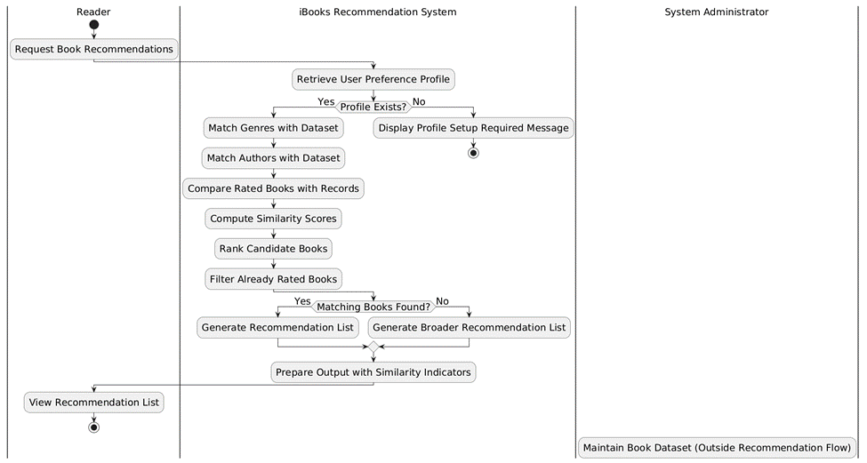
Figure 2: Activity Diagram for iBooks Recommendation System
The workflow continues with matching genres and authors, followed by comparing previously rated books. The system then computes similarity scores and ranks candidate books based on these scores. After ranking, the system filters out books that the user has already rated to ensure that only new recommendations are presented.
A decision point determines whether sufficient matching books are available. If matches are found, a recommendation list is generated. If not, the system generates a broader recommendation list to ensure that the user still receives suggestions. Finally, the system prepares the output by including similarity indicators and presents the recommendation list to the Reader.
The System Administrator’s role in maintaining the dataset is shown outside the main workflow, indicating that it is a supporting process rather than part of the real-time recommendation flow. This separation helps maintain clarity in system behavior and aligns with structured process modeling practices (Dennis et al., 2020).

Structural Model
This section presents the structural models of the iBooks Recommendation System. Structural models describe how the system is organized in terms of its classes, objects, and relationships. While functional models explain what the system does, structural models define how the system is built to support that functionality. These models provide a clear mapping between system behavior and implementation, ensuring consistency across design phases (Dennis et al., 2020).
The structural model includes the class diagram and object diagram, which together illustrate both the static structure and runtime representation of the system.

Class Diagram
The class diagram represents the structural view of the iBooks Recommendation System by defining the system’s classes, their attributes, methods, and relationships. It provides a blueprint of how the system is organized and ensures that all components required for functionality are properly modeled. In object-oriented analysis, the class diagram is critical because it translates system behavior identified in sequence diagrams into concrete class structures (Dennis et al., 2020).
As shown in Figure 2, the class diagram aligns closely with the system behavior by ensuring that all operations involved in recommendation generation are represented as class methods.
The diagram follows the Boundary–Control–Entity (BCE) architecture to clearly separate responsibilities within the system.

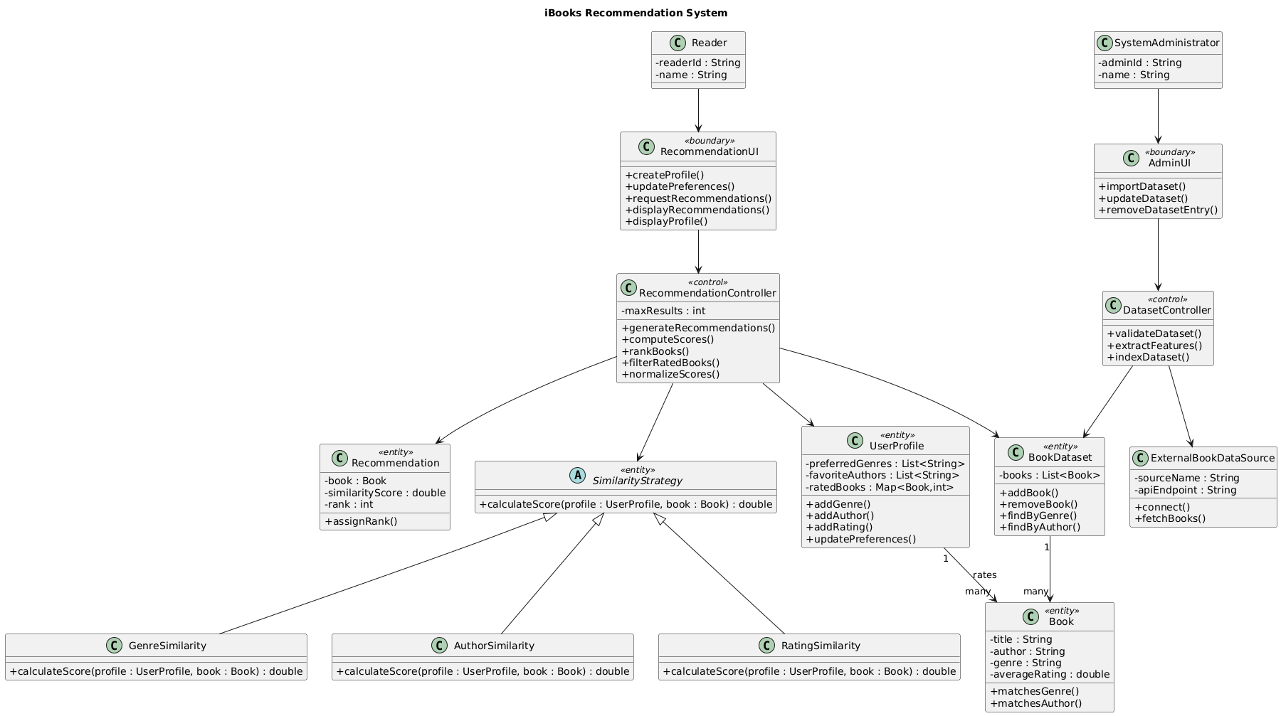

Figure 2: Class Diagram for iBooks Recommendation System

The boundary classes include the RecommendationUI and AdminUI, which handle user interactions such as creating profiles, updating preferences, requesting recommendations, and managing datasets. These classes act as the interface between the user and the system.
The control classes include the RecommendationController and DatasetController. The RecommendationController manages the core recommendation workflow, including generating recommendations, computing similarity scores, ranking books, filtering rated books, and normalizing scores. These methods directly correspond to the system’s functional processes, ensuring consistency between behavioral and structural models. The DatasetController is responsible for validating datasets, extracting features, and indexing book data.
The entity classes represent the core data structures of the system. The UserProfile class stores user preferences such as preferred genres, favorite authors, and rated books. The BookDataset manages the collection of books and provides search functionalities such as finding books by genre or author. The Book class represents individual book details, including title, author, genre, and average rating. The Recommendation class stores the final output, including similarity scores and rankings.
A key design element in this diagram is the use of the SimilarityStrategy abstraction. This follows a strategy-based approach where different similarity calculations—such as GenreSimilarity, AuthorSimilarity, and RatingSimilarity—are implemented as separate classes. Each class provides a calculateScore() method, allowing the system to compute recommendation scores in a modular and extensible way. This design improves flexibility and supports future enhancements without modifying the core system logic (Gamma et al., 1994).
The relationships between classes are clearly defined. For example, the UserProfile is associated with multiple books through ratings, and the BookDataset maintains a collection of Book objects. The RecommendationController interacts with multiple entity classes to execute the recommendation process, reflecting its central role in system coordination.

Object Diagram
The object diagram represents a snapshot of the iBooks Recommendation System at a specific point in time. Unlike the class diagram, which shows the general structure of the system, the object diagram illustrates real instances of classes along with actual values assigned to their attributes. This helps in understanding how the system operates during execution and how objects interact in a real scenario (Dennis et al., 2020).
As shown in Figure 3, the object diagram captures a runtime scenario of generating book recommendations for a sample user.
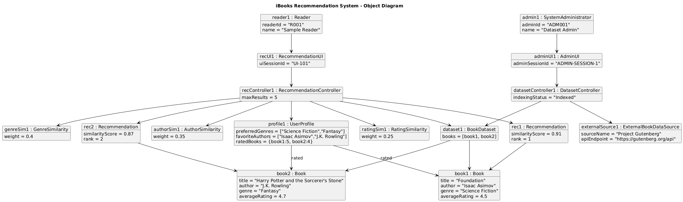
Figure 3: Object Diagram for iBooks Recommendation System
The UserProfile instance (profile1) contains actual user preferences, including preferred genres such as Science Fiction and Fantasy, favorite authors like Isaac Asimov and J.K. Rowling, and previously rated books. These values demonstrate how user-specific data is stored and used during recommendation generation.
The BookDataset instance (dataset1) contains a collection of book objects, such as book1 and book2, each with attributes like title, author, genre, and average rating. These objects represent the available data against which user preferences are matched.
The diagram also shows instances of similarity calculation strategies, such as GenreSimilarity, AuthorSimilarity, and RatingSimilarity, each with assigned weights. These instances contribute to computing similarity scores for books. The Recommendation instances (rec1, rec2) represent the final output, where each recommendation includes a similarity score and rank. These values illustrate how books are evaluated and ordered before being presented to the user. Additionally, the System Administrator (admin1) interacts with the system through the AdminUI and DatasetController, managing dataset operations. The ExternalBookDataSource instance provides the source of book data, such as Project Gutenberg.

Behavioral Model
This section presents the behavioral model of the iBooks Recommendation System. Behavioral models describe how the system operates over time by illustrating interactions between different components. Unlike structural models, which focus on system organization, behavioral models emphasize the dynamic flow of control and communication. This helps ensure that the system’s logic is correctly aligned with user requirements and functional processes (Dennis et al., 2020).

Sequence Diagram
The sequence diagram illustrates how different components of the iBooks Recommendation System interact over time to generate book recommendations. It focuses on the order of messages exchanged between objects and clearly shows the flow of control from the user interface to the internal system components. This type of diagram is essential for validating that system behavior aligns with the defined use-cases and supports object-oriented design (Dennis et al., 2020).
As shown in Figure 4, the sequence diagram models the “Generate Book Recommendations” use case using the Boundary–Control–Entity (BCE) pattern.
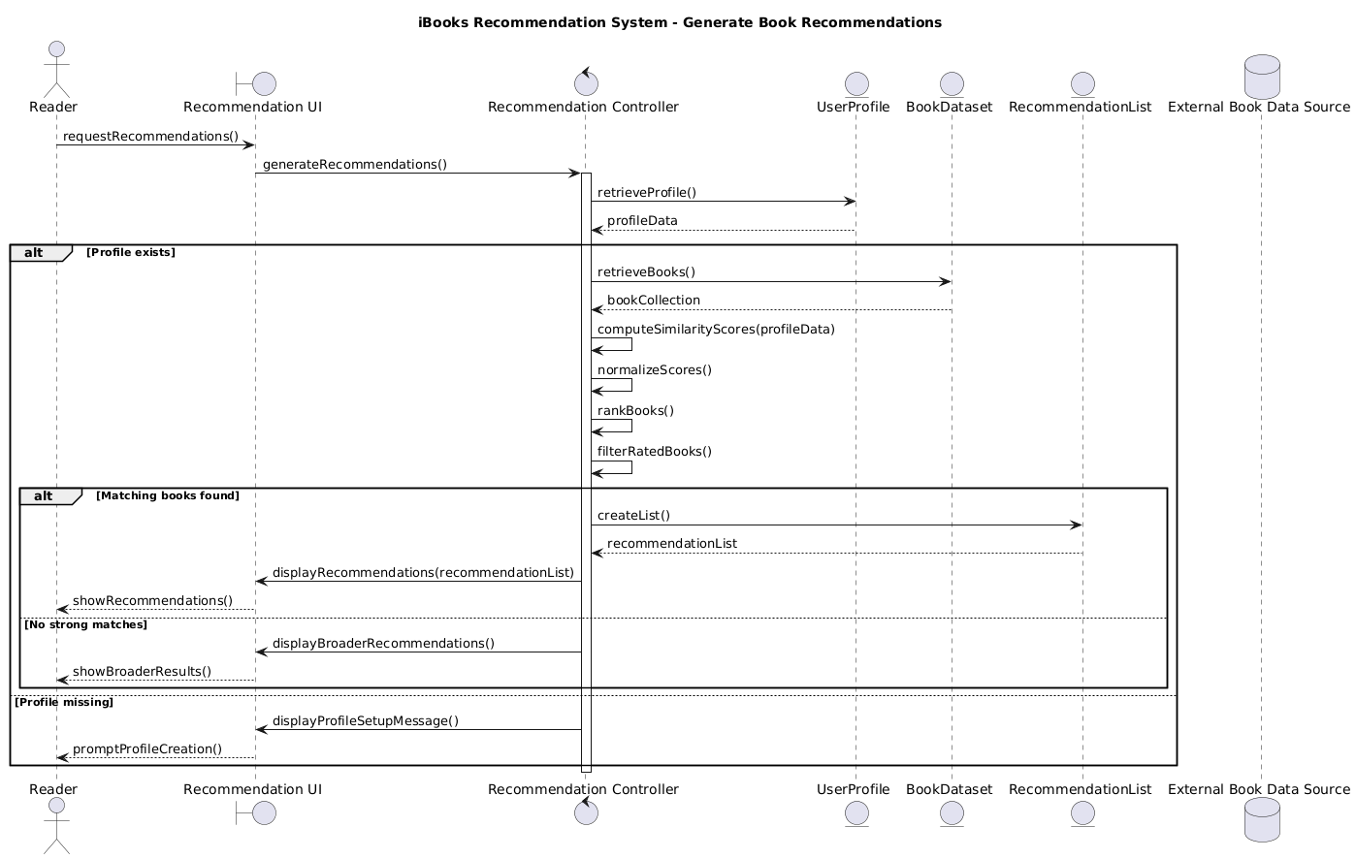
Figure 4: Sequence Diagram for Generating Book Recommendations
The interaction begins when the Reader sends a request through the Recommendation UI using the requestRecommendations() message. The UI then forwards this request to the Recommendation Controller through generateRecommendations().
The controller first retrieves the user profile by sending retrieveProfile() to the UserProfile entity. If the profile exists, the system proceeds to fetch book data using retrieveBooks() from the BookDataset. The dataset is returned as a collection of books, which is then used for further processing.
Next, the controller performs the core recommendation logic. It computes similarity scores using computeSimilarityScores(profileData), normalizes the results, ranks the books using rankBooks(), and filters out already rated books using filterRatedBooks(). These steps correspond directly to the internal processes identified in the activity diagram, ensuring consistency across models.
At this stage, an alternative (alt) condition is evaluated. If matching books are found, the controller creates a recommendation list using createList() and sends the results back to the UI through displayRecommendations(recommendationList). The UI then presents the results to the user via showRecommendations().
If no strong matches are found, the system follows an alternate path by generating broader recommendations and displaying them using displayBroaderRecommendations(). The UI then shows these results using showBroaderResults().
If the user profile does not exist, the system follows another alternate path where it displays a profile setup message using displayProfileSetupMessage() and prompts the user to create a profile.
The diagram clearly separates responsibilities across system layers:
- Boundary (Recommendation UI): Handles user interaction and input/output communication
- Control (Recommendation Controller): Manages the recommendation workflow and decision logic
- Entities (UserProfile, BookDataset, RecommendationList): Handle data storage, retrieval, and processing
This structured interaction ensures that the system remains modular, maintainable, and aligned with object-oriented design principles.

Design Choices
This section presents the design-level view of the iBooks Recommendation System by translating the analysis models into implementable structures. While the analysis phase focused on understanding what the system should do, the design phase defines how the system will be organized and executed. The design model ensures that the system remains modular, maintainable, and aligned with object-oriented principles and established design practices (Dennis et al., 2020).

Package Diagram
The package diagram represents the high-level organization of the system by grouping related classes into logical modules. It reflects the Boundary–Control–Entity (BCE) architecture identified earlier and shows how different layers interact with each other.
The system is divided into the following packages:
User Interface Package: Contains classes such as RecommendationUI and AdminUI, responsible for handling user input and displaying outputs.
Controller Package: Includes RecommendationController and DatasetController, which coordinate system workflows and manage business logic.
Entity Package: Contains core data structures such as UserProfile, Book, BookDataset, and RecommendationList.
Similarity Strategy Package: Includes GenreSimilarity, AuthorSimilarity, and RatingSimilarity classes that implement interchangeable similarity calculation logic.
Data Source Package: Represents external data providers such as ExternalBookDataSource.
The dependencies between packages follow a layered approach. The User Interface interacts with the Controller layer, which in turn interacts with Entity and Strategy packages. The Data Source package supports the Entity layer by providing raw data.
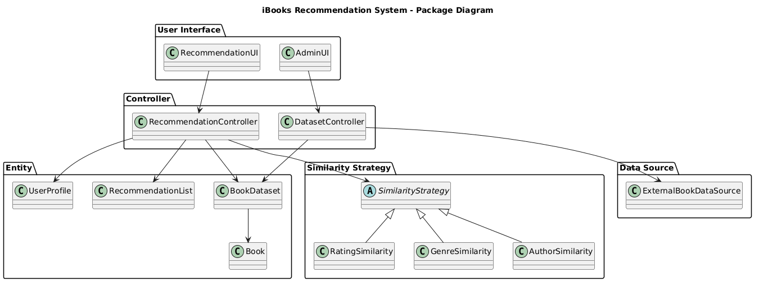
Figure 5: Package Diagram for Generating Book Recommendations
This structure ensures clear separation of concerns, reduces coupling between components, and allows independent modification of modules without affecting the entire system. Such modular packaging aligns with best practices in object-oriented system design and supports scalability (Gamma et al., 1994).

Contract (Recommendation Generation)
A contract defines the expected behavior of a system operation by specifying its inputs, outputs, and conditions. It ensures that system operations remain consistent with requirements and provides a clear specification for implementation (Dennis et al., 2020).
Operation: generateRecommendations(userProfile)
Preconditions:
- A valid user profile exists
- User profile contains at least one preference (genre, author, or rated book)
- Book dataset is available and indexed
Postconditions:
- A list of recommended books is generated
- Each recommended book has an associated similarity score
- Recommended books are ranked in descending order of similarity
- Books already rated by the user are excluded
- The recommendation list is returned for display
Description:
- This operation retrieves the user profile, compares it with the book dataset, computes similarity scores using defined strategies, ranks candidate books, filters results, and generates the final recommendation list.

Method Specification
Method specifications define the internal behavior of key system operations. They provide a detailed description of inputs, processing logic, and outputs, ensuring that implementation remains consistent with design (Dennis et al., 2020).
Method: calculateScore(profile: UserProfile, book: Book): double
Description:
This method computes the similarity score between a user profile and a candidate book using multiple criteria such as genre match, author match, and rating similarity.
Inputs:
- profile: Contains preferred genres, favorite authors, and rated books
- book: Represents a candidate book from the dataset
Processing Logic:
- Initialize score = 0
- If book genre matches any preferred genre → add weighted score
- If book author matches any favorite author → add weighted score
- If book is similar to previously rated books → add rating-based score
- Combine weighted scores from all similarity strategies
- Normalize final score to maintain consistency across comparisons
Output:
- Returns a numerical similarity score representing how well the book matches user preferences
Example:
If a book matches both preferred genre and favorite author, its score will be higher than a book matching only one attribute, ensuring accurate ranking in the recommendation list.
This design model ensures that the system remains consistent with the analysis phase while providing a clear blueprint for implementation. By combining modular packaging, well-defined contracts, and precise method specifications, the system achieves both clarity and extensibility, which are essential for building reliable software systems (Dennis et al., 2020; Gamma et al., 1994).

Data Management Layer Design
This section describes how data is stored, organized, and managed within the iBooks Recommendation System. The data management layer ensures that user preferences and book datasets are structured in a way that supports efficient retrieval, consistency, and transparency. Since the system is designed as a lightweight, explainable recommendation system, the focus is on simple and structured data storage rather than complex database architectures. This approach aligns with the goal of maintaining clarity while still supporting realistic system behavior (Dennis et al., 2020).

Object Persistence Format
The iBooks Recommendation System uses a JSON-based persistence format to store both user profiles and book datasets. JSON (JavaScript Object Notation) is selected because it is lightweight, human-readable, and easily integrates with Python-based applications. It also allows structured representation of nested data such as lists of genres, authors, and rated books.
User profiles are stored as JSON objects containing attributes such as preferred genres, favorite authors, and rated books. Each user profile maintains a consistent structure so that it can be directly used by the recommendation logic without additional transformation. For example, genres and authors are stored as arrays, while rated books are stored as key-value pairs representing book identifiers and ratings.
Similarly, the book dataset is stored in JSON format, where each book record contains attributes such as title, author, genre, and average rating. This structure ensures that all necessary features required for similarity computation are readily available.
The use of JSON supports transparency, as the stored data can be easily inspected and validated. It also simplifies data exchange between system components and allows the dataset to be updated or extended without requiring schema migration. This format is particularly suitable for a system that prioritizes explainability and ease of demonstration over large-scale deployment.

Database Schema
Although the system primarily operates using JSON-based storage, the logical data structure can be represented as a relational schema to illustrate how data would be organized in a database environment. Defining a schema helps ensure consistency, normalization, and alignment between user data and dataset attributes.
The core entities in the schema include UserProfile, Book, and UserRatings.
- The UserProfile table stores user-specific information, including a unique user ID, preferred genres, and favorite authors. These attributes may be stored as serialized lists or normalized into separate tables depending on implementation needs.
- The Book table contains book-related information, including book ID, title, author, genre, and average rating. This table represents the primary dataset used for generating recommendations.
- The UserRatings table establishes a relationship between users and books. It stores user-provided ratings for specific books and allows the system to identify previously rated items. This table plays a key role in filtering recommendations and computing similarity based on user behavior.
The relationships between these entities ensure that user preferences can be directly mapped to book attributes during recommendation generation. For example, preferred genres in the UserProfile can be matched with the genre field in the Book table, while rated books in the UserRatings table support similarity calculations and filtering logic.
This schema design maintains structural consistency across system components and supports efficient querying if the system is extended to use a relational database in the future. It also ensures that the data model remains aligned with the functional requirements and recommendation logic defined earlier (Dennis et al., 2020).

Human-Computer Interaction Layer Design
This section describes how users interact with the iBooks Recommendation System and how the interface is designed to support clarity, simplicity, and usability. The Human-Computer Interaction (HCI) layer focuses on ensuring that system functionality is presented in a way that is easy to understand and navigate. Since the system emphasizes transparency and explainability, the interface is designed to clearly show how user inputs lead to recommendation outputs (Dennis et al., 2020).
The system is implemented using a command-line interface within a Jupyter Notebook environment, which allows interactive input and immediate display of results. This approach supports step-by-step execution, making it easier to demonstrate system behavior and validate how recommendations are generated.

Wireframe Design
The wireframe represents a simplified layout of the user interface, focusing on structure and interaction rather than visual styling. It illustrates how different components are organized and how users move through the system.
The interface is divided into three main sections:
- User Profile Input Section:
This section allows the Reader to enter and update preferences. It includes input fields for selecting preferred genres, favorite authors, and rating previously read books. A submission action is provided to store or update the profile.
- Recommendation Control Section:
This section contains actions for generating or refreshing recommendations. The user initiates the recommendation process through a clearly defined command or button.
- Recommendation Output Section:
This section displays the generated recommendations. Each recommended book is shown along with relevant attributes such as title, author, genre, and similarity score. Indicators are included to explain why a book was recommended, supporting system transparency.
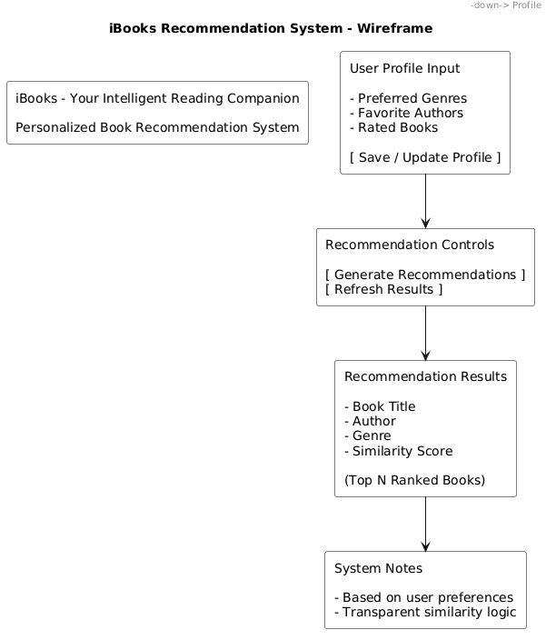
Figure 6: Wireframe Design for iBooks Recommendation System
The interaction flow begins with the user creating or updating a profile. Once preferences are available, the user triggers the recommendation process. The system then processes the input and displays results in an organized format.
The wireframe is intentionally minimal to maintain focus on functionality and clarity. By avoiding unnecessary complexity, the interface ensures that users can easily understand both the input requirements and the resulting recommendations. This design aligns with usability principles that emphasize simplicity, visibility of system status, and user control (Dennis et al., 2020).

Physical Architecture Layer Design
This section describes the physical environment in which the iBooks Recommendation System is developed and executed. The physical architecture focuses on the hardware and software components required to run the system, along with the operational and performance conditions under which the system functions. Since the system is designed as a lightweight, demonstration-oriented application, the architecture emphasizes simplicity, accessibility, and ease of execution rather than large-scale deployment (Dennis et al., 2020).

Hardware and Software Specification
The iBooks system is designed to run on standard personal computing hardware. A typical laptop or desktop with moderate processing capability is sufficient to execute the system. The system does not require specialized hardware such as GPUs or distributed systems, as it performs deterministic, content-based recommendation using structured datasets.
From a software perspective, the system is implemented using Python and executed within a Jupyter Notebook environment. This environment supports interactive input and output, making it suitable for demonstrating system functionality step by step. Key libraries include pandas for data handling and processing, along with standard Python libraries for implementing recommendation logic.
The system operates independently of the underlying operating system and can run on Windows, macOS, or Linux. Data is stored in structured formats such as CSV or JSON, eliminating the need for complex database management systems. This setup ensures that the system remains easy to deploy, test, and demonstrate.

Operational Requirements
The system is designed to operate in an interactive environment where users can provide inputs and receive recommendations without complex configuration. The Reader interacts with the system through a command-line interface within the Jupyter Notebook, entering preferences and triggering recommendation generation.
The system requires access to a structured book dataset, which must be available locally or loaded from a publicly accessible source. Data preprocessing is performed during execution to ensure consistency in attributes such as genre, author, and ratings.
Administrative operations, such as importing or updating datasets, are performed manually by the System Administrator. These operations are not part of the real-time recommendation workflow but are essential for maintaining data quality.
The system assumes that user input is provided in a valid format. Basic validation is performed to ensure that required fields such as genres or authors are not empty before generating recommendations. The system is designed for on-demand execution rather than continuous background operation.

Performance Requirements
The performance requirements of the iBooks system are defined based on its intended use as a demonstration and analytical tool. The system is expected to generate recommendations within an interactive response time when processing small to moderate datasets. For typical use cases involving a few hundred to a few thousand book records, the system should produce results within a few seconds.
Since the system performs in-memory processing, performance depends on dataset size and system resources. The design prioritizes clarity and correctness of recommendation logic over optimization for large-scale performance. The system is not intended for real-time large-scale deployment; however, its modular design allows for future enhancements such as database integration or optimized search mechanisms if needed.

Construction
This section describes how the iBooks Recommendation System is implemented and validated. The construction phase focuses on translating the design into a working system while ensuring consistency with the structural and behavioral models. The implementation follows a modular and organized approach so that each component of the system directly reflects the responsibilities defined in the class diagram and sequence diagram. This alignment ensures that the system remains easy to understand, traceable to requirements, and suitable for demonstration purposes (Dennis et al., 2020).
The system is implemented in Python within a Jupyter Notebook environment, which supports step-by-step execution and clear visualization of outputs. The implementation is structured into logical components, including data loading and preprocessing, entity definitions, similarity strategy classes, and controller logic. This organization allows each part of the system to be developed and verified independently while maintaining overall coherence. The design emphasizes clarity and explainability, particularly in how user inputs are transformed into recommendation outputs through well-defined processing steps.

Unit Test Description
This section describes how unit testing is used to validate the correctness of individual components in the system. Unit testing is implemented using the Python unittest framework, which provides a structured approach for verifying system behavior. Each test case is designed to evaluate a specific component or function, ensuring that the system operates as expected under controlled conditions.
The testing process focuses on key functional areas of the system, including similarity computation, filtering logic, ranking behavior, and overall recommendation generation. For example, tests verify that author similarity correctly identifies preferred authors, rating similarity produces values within a valid range, and previously rated books are excluded from the recommendation results. These tests ensure that each component performs its intended function and that the interactions between components produce consistent outcomes.
In addition to testing individual components, the system includes validation of the complete recommendation workflow. This ensures that user inputs are correctly processed through all stages, including similarity calculation, ranking, and result generation. The use of unit testing improves system reliability and provides confidence that the implementation aligns with the defined functional requirements. It also establishes a foundation for extending test coverage if additional features are introduced in the future (Dennis et al., 2020).

Integration Tests
Integration testing is not implemented in this project. The system is designed as a lightweight, modular application where components are executed sequentially within a controlled environment. Instead of formal integration tests, the correctness of interactions between components is verified through end-to-end execution of the recommendation workflow within the Jupyter Notebook.
This approach is appropriate for the scope of the project, as the system operates on in-memory data structures and does not involve external services, databases, or distributed components. The modular design ensures that each component interacts in a predictable manner, and the end-to-end validation performed during unit testing provides sufficient assurance that the system functions correctly as a whole.

Build and Run Instructions

This section describes how to execute the iBooks Recommendation System using the provided notebook file. The system is designed to run in a Jupyter Notebook environment and does not require complex setup.
- Steps to Run the Project
- Ensure Python 3.x is installed on the system.
- Install required dependencies:
- pip install pandas numpy
- Place the dataset file (books.csv) in the same directory as the notebook.
- Open the notebook file (iBooks–ProjectCodewithUnitTests.ipynb) using Jupyter Notebook or JupyterLab.
- Run all cells sequentially (Kernel → Run All).
The system will load the dataset, process user inputs, and display the generated book recommendations as output.

Acknowledgements
The concepts and methodologies presented in this report are guided by course materials and standard references in object-oriented system design. These resources provided the foundation for structuring the system, developing analysis models, and implementing the final solution.
The availability of publicly accessible book datasets also played an important role in enabling the practical implementation of the system. These datasets allowed the system to simulate real-world behavior and validate the recommendation logic.

Conclusions
This project focused on designing and implementing a structured and explainable book recommendation system. The iBooks system demonstrates how user-defined preferences can be used to generate personalized recommendations without relying on complex or opaque algorithms. By directly linking user inputs such as preferred authors and ratings to recommendation outputs, the system ensures transparency and ease of interpretation.
From a design perspective, the system follows an object-oriented approach using the Boundary–Control–Entity pattern. The use of a strategy-based design for similarity computation allows the recommendation logic to remain modular and flexible. This ensures that additional criteria can be incorporated in the future without affecting the core system structure.
The implementation confirms that meaningful recommendations can be generated using deterministic logic and structured data. The use of a formal testing framework further validates that key components such as similarity calculation, filtering, and ranking operate correctly. This demonstrates that the system meets its functional requirements and produces consistent results.

References
Dennis, A., Wixom, B. and Tegarden, D. (2020). Systems Analysis and Design: An Object- Oriented Approach with UML (6th Ed).
Gamma, E., Helm, R., Johnson, R., & Vlissides, J. (1994). Design patterns: Elements of reusable object-oriented software. Addison-Wesley.
Ricci, F., Rokach, L., & Shapira, B. (2011). Introduction to recommender systems handbook. Springer.

Source Code with Unit Tests
The complete implementation of the iBooks Recommendation System is provided in the appendices of this report. Appendix A contains the full solution code, including all modules related to data preprocessing, entity modeling, similarity strategies, controller logic, and output generation. The code is structured in a modular format that reflects the system design and supports clear understanding of each component.

Source Code
# =========================
# DATA LOADING
# =========================
# Import pandas library for data handling
import pandas as pd

# Load dataset from CSV file
# - engine='python' handles complex CSV formatting
# - encoding='latin-1' ensures compatibility with special characters
# - on_bad_lines='skip' ignores malformed rows
df = pd.read_csv(
"./books.csv",
engine='python',
encoding='latin-1',
on_bad_lines='skip'
)

# Display dataset shape (rows, columns)
print(df.shape)

# In[2]:

df.head()

# In[3]:

# let's check the info of the dataset
df.info()

# **Dataset Description**
#
# - The dataset used in this project is a Goodreads books dataset that contains structured information about books. It includes 11,119 records and 12 columns, covering details such as title, authors, average rating, ratings count, language, and publication date. Each row represents a single book, and the dataset is clean, with no missing values across the columns. This makes it reliable and easy to use without heavy preprocessing.
#
# For this system, the most useful attributes are:
#
# - title → identifies the book
# - authors → used for matching user preferences
# - average_rating → used for ranking and similarity
#
# Although the dataset does not include genre information, it still supports a meaningful recommendation system using author similarity and rating-based comparison. This fits well with the project goal of building a system that is simple, clear, and easy to explain.
#
# The dataset is also small in size (around 1 MB), which allows fast execution in a Jupyter Notebook. This is helpful for demonstration, testing, and step-by-step explanation of how the system works.
#
# What We Will Build Next
#
# Now that the dataset is loaded, the next step is to build the core structure of the system.
#
# We will implement:
#
# - A Book class
# - Represents each book with attributes like title, author, and rating
# - A UserProfile class
# - Stores user preferences such as favorite authors and rated books
# - A Dataset transformation step
# - Converts the pandas DataFrame into structured Book objects
#
# This step is important because it turns raw data into usable system components. It also directly follows the class diagram we defined earlier. Once these components are ready, we will move to the recommendation logic, where the system will start generating suggestions based on user preferences.

# ### Exploratory Data Analysis (EDA)
#
# - Before building system components, a small and focused EDA step helps ensure the dataset behaves as expected. The goal here is not deep statistical analysis, but to validate structure, understand distributions, and prepare clean inputs for the system.

# In[4]:

# Shape and columns
print("Shape:", df.shape)
print("\nColumns:", df.columns.tolist())

# In[5]:

# =========================
# DATA EXPLORATION
# =========================
# Identify duplicate book titles
duplicates = df[df.duplicated(subset=['title'])]
print("Duplicate titles:", len(duplicates))

# In[6]:

# Display summary statistics for ratings
df['average_rating'].describe()

# In[7]:

# Count number of unique authors
print("Unique authors:", df['authors'].nunique())

# Display top 10 most frequent authors
df['authors'].value_counts().head(10)

# In[8]:

# Check for missing values in each column
df.isnull().sum()

# In[9]:

# =========================
# DATA CLEANING
# =========================
# Select only relevant columns for the system
df_clean = df[['title', 'authors', 'average_rating']].copy()

# Rename columns for consistency with system design
df_clean = df_clean.rename(columns={
'authors': 'author',
'average_rating': 'rating'
})

# Remove rows with missing values
df_clean = df_clean.dropna()

# Display cleaned data sample
df_clean.head()

# In[10]:

# Remove duplicate titles to ensure uniqueness
df_clean = df_clean.drop_duplicates(subset=['title'])

# Display final dataset shape after cleaning
print("After cleaning:", df_clean.shape)

# ### Core System Entities
#
# - Convert data → objects
# - Follow your class diagram (Entity layer)
# - Build a system, not just analysis

# In[11]:

# =========================
# CORE SYSTEM ENTITIES
# =========================

# Book Class
# Represents a single book with basic attributes used for recommendation
class Book:
def __init__(self, title, author, rating):
# Initialize book attributes
self.title = title
self.author = author
self.rating = rating

def __repr__(self):
# Return readable representation of the book
return f"{self.title} by {self.author} (Rating: {self.rating})"

# In[12]:

# UserProfile Class
# Stores user preferences including favorite authors and rated books
class UserProfile:
def __init__(self):
# List of preferred authors
self.favorite_authors = []

# Dictionary storing rated books {title: rating}
self.rated_books = {}

def add_favorite_author(self, author):
# Add author to favorites if not already present
if author not in self.favorite_authors:
self.favorite_authors.append(author)

def rate_book(self, title, rating):
# Store or update user rating for a book
self.rated_books[title] = rating

def __repr__(self):
# Return readable summary of user profile
return f"Favorite Authors: {self.favorite_authors}\nRated Books: {self.rated_books}"

# In[13]:

# =========================
# DATA TRANSFORMATION
# =========================
# Convert cleaned dataset into Book objects

books = []

for _, row in df_clean.iterrows():
# Create Book object from each row
book = Book(
title=row['title'],
author=row['author'],
rating=row['rating']
)
books.append(book)

# Display total number of books loaded
print("Total books loaded:", len(books))

# Display sample books
books[:5]

# In[14]:

# =========================
# USER PROFILE INITIALIZATION
# =========================
# Create sample user and define preferences

user = UserProfile()

# Add favorite authors
user.add_favorite_author("J.K. Rowling")
user.add_favorite_author("Stephen King")

# Add book ratings
user.rate_book("Harry Potter and the Half-Blood Prince", 5)
user.rate_book("The Shining", 4)

# Display user profile
print(user)

# ### Similarity Strategy Implementation
#
# We will implement:
#
# A base class: SimilarityStrategy
# - Two concrete strategies:
# - AuthorSimilarity
# - RatingSimilarity
#
# Each strategy:
#
# - Computes its own score
# - Can be independently modified or extended
# - Contributes to the final recommendation score

# In[15]:

# =========================
# SIMILARITY STRATEGY LAYER
# =========================

# Base Strategy Class
# Defines a common interface for all similarity calculation strategies
class SimilarityStrategy:
def calculate(self, book, user_profile):
# Abstract method to be implemented by subclasses
raise NotImplementedError("Subclasses must implement this method")

# Author Similarity Strategy
# Checks if the book author matches user's favorite authors
class AuthorSimilarity(SimilarityStrategy):
def calculate(self, book, user_profile):
# Return strong match score if author is preferred
if book.author in user_profile.favorite_authors:
return 1.0
return 0.0

# Rating Similarity Strategy
# Compares book rating with user's average rating preference
class RatingSimilarity(SimilarityStrategy):
def calculate(self, book, user_profile):
# If no ratings exist, similarity cannot be computed
if not user_profile.rated_books:
return 0.0

# Compute average rating given by user
avg_user_rating = sum(user_profile.rated_books.values()) / len(user_profile.rated_books)

# Calculate difference between book rating and user preference
difference = abs(book.rating - avg_user_rating)

# Convert difference into similarity score (normalized between 0 and 1)
return max(0, 1 - (difference / 5))

# In[16]:

# =========================
# STRATEGY TESTING
# =========================
# Initialize strategy objects
author_strategy = AuthorSimilarity()
rating_strategy = RatingSimilarity()

# Select a sample book
sample_book = books[0]

# Display results of individual strategies
print("Book:", sample_book)
print("Author Score:", author_strategy.calculate(sample_book, user))
print("Rating Score:", rating_strategy.calculate(sample_book, user))

# Next, we Are Building
# **RecommendationController**
#
# Responsibilities:
#
# - Loop through all books
# - Apply similarity strategies
# - Combine scores
# - Exclude already rated books
# - Rank results
# - Return top recommendations

# In[17]:

# =========================
# RECOMMENDATION CONTROLLER
# =========================

# Controller responsible for coordinating recommendation logic
class RecommendationController:
def __init__(self, strategies, weights):
# List of similarity strategies (e.g., author, rating)
self.strategies = strategies

# Corresponding weights for each strategy
self.weights = weights

def recommend(self, books, user_profile, top_n=5):
# List to store recommendation results
recommendations = []

for book in books:
# Skip books already rated by the user
if book.title in user_profile.rated_books:
continue

total_score = 0
explanation = {}

# Apply each similarity strategy
for strategy, weight in zip(self.strategies, self.weights):
score = strategy.calculate(book, user_profile)

# Weighted contribution to final score
total_score += score * weight

# Store individual strategy contribution for explanation
explanation[strategy.__class__.__name__] = round(score, 3)

# Append recommendation result
recommendations.append({
"book": book,
"score": round(total_score, 3),
"explanation": explanation
})

# Sort recommendations by score (highest first)
recommendations.sort(key=lambda x: x["score"], reverse=True)

# Return top N recommendations
return recommendations[:top_n]

# In[18]:

# =========================
# CONTROLLER INITIALIZATION
# =========================

# Initialize similarity strategies
author_strategy = AuthorSimilarity()
rating_strategy = RatingSimilarity()

# Combine strategies with weights
strategies = [author_strategy, rating_strategy]
weights = [0.6, 0.4]

# Create controller instance
controller = RecommendationController(strategies, weights)

# In[19]:

# =========================
# GENERATE RECOMMENDATIONS
# =========================

# Run recommendation process
results = controller.recommend(books, user, top_n=5)

# Display raw results
for i, rec in enumerate(results, 1):
print(f"\n{i}. {rec['book']}")
print(f" Score: {rec['score']}")
print(f" Explanation: {rec['explanation']}")

# In[20]:

# =========================
# OUTPUT FORMATTING (UI LAYER)
# =========================

# Convert explanation scores into user-friendly reasons
def format_explanation(explanation):
reasons = []

if explanation.get("AuthorSimilarity", 0) > 0:
reasons.append("Matches your favorite author")

if explanation.get("RatingSimilarity", 0) > 0.7:
reasons.append("Rating is close to your preference")

return reasons

# Display formatted recommendation output
for i, rec in enumerate(results, 1):
book = rec['book']
score = rec['score']
explanation = rec['explanation']

print(f"\n{i}. {book.title}")
print(f" Author: {book.author}")
print(f" Rating: {book.rating}")
print(f" Score: {score}")

# Generate readable reasons
reasons = format_explanation(explanation)

print(" Reason:")
for r in reasons:
print(f" - {r}")
Appendix B includes the unit tests implemented using the unittest framework. These tests validate both individual components and the overall system workflow. Each test case is designed to demonstrate that the system meets its functional requirements and produces consistent results.

Unit Tests

# =========================
# UNIT TESTS (unittest Framework)
# =========================

import unittest

class TestRecommendationSystem(unittest.TestCase):

# -------------------------
# Test 1: Author Similarity
# -------------------------
def test_author_similarity(self):
user = UserProfile()
user.add_favorite_author("J.K. Rowling")

book = Book("Harry Potter", "J.K. Rowling", 4.8)

strategy = AuthorSimilarity()
score = strategy.calculate(book, user)

self.assertEqual(score, 1.0)

# -------------------------
# Test 2: Rating Similarity
# -------------------------
def test_rating_similarity(self):
user = UserProfile()
user.rate_book("Sample Book", 5)

book = Book("Another Book", "Author", 4.5)

strategy = RatingSimilarity()
score = strategy.calculate(book, user)

self.assertGreaterEqual(score, 0)
self.assertLessEqual(score, 1)

# -------------------------
# Test 3: Recommendation Filtering
# -------------------------
def test_filter_rated_books(self):
user = UserProfile()
user.rate_book("Book A", 5)

books = [
Book("Book A", "Author1", 4.5),
Book("Book B", "Author2", 4.0)
]

controller = RecommendationController(
[AuthorSimilarity(), RatingSimilarity()],
[0.6, 0.4]
)

results = controller.recommend(books, user, top_n=5)

# Ensure already rated book is not recommended
titles = [rec["book"].title for rec in results]
self.assertNotIn("Book A", titles)

# -------------------------
# Test 4: Recommendation Ranking
# -------------------------
def test_recommendation_ranking(self):
user = UserProfile()
user.add_favorite_author("Author1")

books = [
Book("Book A", "Author1", 4.5), # should rank higher
Book("Book B", "Author2", 4.5)
]

controller = RecommendationController(
[AuthorSimilarity()],
[1.0]
)

results = controller.recommend(books, user, top_n=2)

# First result should match preferred author
self.assertEqual(results[0]["book"].author, "Author1")

# -------------------------
# Test 5: End-to-End Pipeline
# -------------------------
def test_full_pipeline(self):
user = UserProfile()
user.add_favorite_author("Author1")
user.rate_book("Book X", 5)

books = [
Book("Book A", "Author1", 4.5),
Book("Book B", "Author2", 4.0)
]

controller = RecommendationController(
[AuthorSimilarity(), RatingSimilarity()],
[0.6, 0.4]
)

results = controller.recommend(books, user, top_n=2)

self.assertTrue(len(results) > 0)
self.assertIn("score", results[0])
self.assertIn("explanation", results[0])

# =========================
# RUN TESTS
# =========================

if __name__ == "__main__":
unittest.main(argv=[''], exit=False)
Separating the implementation and test cases into appendices allows the main report to remain focused on analysis and design, while still providing complete transparency and traceability of the system. This structure follows standard practices in system documentation and ensures that both design and implementation aspects are properly represented (Dennis et al., 2020).

Generated Code Documentation
This section describes how code-level documentation is provided in the iBooks Recommendation System based on the actual implementation in the notebook. Unlike traditional documentation approaches such as JavaDoc or formal docstrings, the system uses a structured, section-based documentation style within the Jupyter Notebook. This approach aligns with the interactive and demonstration-focused nature of the project.
The notebook is organized into clearly defined sections using descriptive headers. Each section represents a specific stage of the system, such as data loading, data exploration, data cleaning, entity creation, similarity strategy implementation, controller logic, and output formatting. These headers act as high-level documentation, guiding the reader through the system step by step.
Within each section, explanatory text blocks and inline comments are used to describe the purpose of the code and the logic being implemented. For example, comments explain how the dataset is processed, how Book objects are created from raw data, how similarity scores are calculated using strategy classes, and how recommendations are ranked and filtered. This ensures that each transformation from input to output is clearly traceable.
In addition, the notebook includes descriptive markdown cells that provide context before major implementation steps. These explanations outline what is being built and why it is required, helping connect the implementation to the system design. This structure supports readability and allows the system to be demonstrated interactively, where each step can be executed and explained in sequence.

Class to code map

Class | Use Case ID | Use Case Name
Reader | UC-1 | Create User Profile
RecommendationUI | UC-1 | Create User Profile
UserProfile | UC-1 | Create User Profile
UserProfile | UC-2 | Store User Preferences
Reader | UC-3 | Generate Book Recommendations
RecommendationUI | UC-3 | Generate Book Recommendations
RecommendationController | UC-3 | Generate Book Recommendations
UserProfile | UC-3 | Generate Book Recommendations
BookDataset | UC-3 | Generate Book Recommendations
Recommendation | UC-3 | Generate Book Recommendations
RecommendationController | UC-4 | Compute Similarity Scores
SimilarityStrategy | UC-4 | Compute Similarity Scores
AuthorSimilarity | UC-4 | Compute Similarity Scores
RatingSimilarity | UC-4 | Compute Similarity Scores
RecommendationController | UC-5 | Rank Recommended Books
Recommendation | UC-5 | Rank Recommended Books
RecommendationUI | UC-6 | Display Recommendation List
Recommendation | UC-6 | Display Recommendation List
SystemAdministrator | UC-7 | Import Book Datasets
AdminUI | UC-7 | Import Book Datasets
DatasetController | UC-7 | Import Book Datasets
ExternalBookDataSource | UC-7 | Import Book Datasets
BookDataset | UC-7 | Import Book Datasets
DatasetController | UC-8 | Validate Dataset Structure
DatasetController | UC-9 | Extract Book Features
BookDataset | UC-9 | Extract Book Features
SystemAdministrator | UC-10 | Maintain Book Datasets
AdminUI | UC-10 | Maintain Book Datasets
DatasetController | UC-10 | Maintain Book Datasets
BookDataset | UC-10 | Maintain Book Datasets

User Requirements to Code Map

User requirements to code map

Unimplemented and Partially Implemented Requirements
While the system successfully implements the core recommendation functionality, a few functional requirements were either partially implemented or not included due to dataset limitations and project scope.
First, requirements related to genre-based processing (R2, R7, R12) were not implemented. The dataset used in this project does not include genre information, which made it infeasible to support genre-based preference selection and similarity computation. As a result, the system focuses on author-based and rating-based recommendation logic, which aligns with the available data.
Second, logging functionality (R22) was not implemented. Since the system is designed as a demonstration prototype running in a Jupyter Notebook environment, persistent logging mechanisms were not included. Instead, outputs are displayed directly during execution.
Third, dataset modification operations such as updating and removing entries (R32, partially R33) were not fully implemented. The dataset is treated as a static input loaded at runtime, and administrative operations are conceptually modeled but not executed in the current implementation.
Additionally, requirement R10 (validation of user preferences) and R16 (normalization of scores) are partially implemented. The system performs implicit validation through controlled inputs and ensures score consistency through weighted aggregation, but does not include a separate explicit validation or normalization module.
Finally, indexing (R31) is implemented in a simplified form using in-memory Python data structures (lists), rather than a formal indexing mechanism such as a database index. This approach is sufficient for the scale and purpose of the system.
These limitations were intentionally accepted to maintain focus on the core objective of building a clear, explainable, and modular recommendation system within the project scope.

