**Question Bank(14-10-24):**

1. Duplicate questions should not allowed.
2. Edit-View Questions button alignment is need to change.
3. Question Type has been updated successfully!-Need to change to “Question type updated sucessfully!”.
4. Category has been updated successfully!-Need to change to “Category updated successfully!”.
5. In Score Settings & Question Time, Points for answer alignement need to change.
6. Select single choice option, Multiple choice, True/False -Radio button should present center with the relavant tabs.
7. Remove match the following option in question type dropdown.
8. When change to dark theme, in add/edit category background is not in dark colour.
9. When click save and update button, details gets saved but page automatically display at the bottom of the page.
10. Click edit button, without modify any details and click update buttton, it is not working.
11. In category and question type, when any option status is change to Inactive status and update it. But after that, user able to again create the option with same name.
12. Category alignment is not proper.

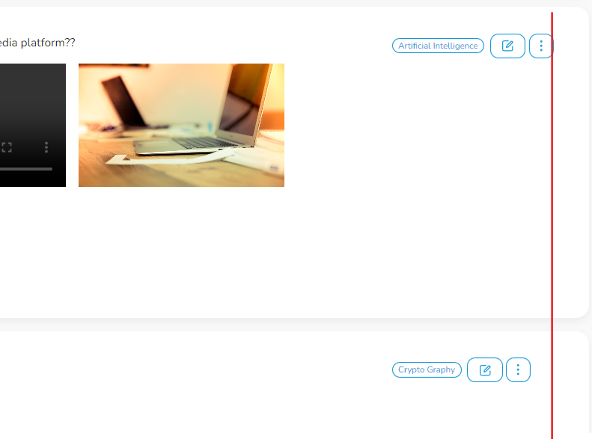

1. In 3rd and 4th page S.No is not proper.
2. Need to change active option into delete option.
3. In Questions tab, all options should display in same center alignment.
4. In Questions tab, need space between Heading and Text box.
5. In Add/Edit questions, Some heading in bold, some heading in normal. Need to fix same type.

**Suggestions:**

1. Asd