1. When upload valid files in source type field and click delete button, file is deleted but file name is not cleared from the tab-PASS
2. Tab button is not properly working in create question home page and add/edit questions page--PASS
3. Delete option in category is not working.-PASS
4. Delete option in Question type is not working.-PASS
5. After select valid category and click add button in Topic tab, select category should automatically displayed in the category selection.-PASS
6. In create question homepage, heading display wrong value. It need to show “create question”.-PASS

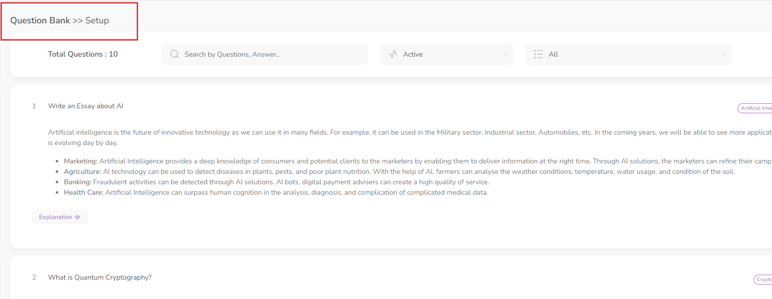

**Suggestion**:

1. When click add category or any other Add, Edit and Delete button and click ESC button pop up need to automatically close.
2. Need to fix the video upload size and image minimum and maximum quality.