**BUG LIST FOR PROJECT HUB:**

1. Login page background is not clarity.-PASS
2. Login page Login tab details text thickness need to increase-PASS
3. In Forgot Password page tab details text thickness need to increase-PASS
4. Login page and Forgot Password page-White background is not good, may be add login details transparency background-PASS
5. In forget password page, spam box message should be move to below the reset email button and it should display like “Note: If mail is not received, please check the spam folder” or any other valid message.-PASS
6. In forget password page, Back to login button alignment is not match with Forgot password text.-PASS
7. In login page, when enter the mail id, tab background display white colour. It occurs only after the select the saved user id.-Not Fixed
8. When enter un registered user id and try to login, wrong message is displayed. Error message displayed like “User not registered” or any other valid message.-Not Fixed
9. In reset password page, eye icon(Password visible icon) is not present in the confirm tab, need to add.
10. In project module, in sort by dropdown edit option is not required. Need to remove.-PASS
11. Toast message is displayed in below right side, but it need to show top center of the

page.-PASS

1. In Project, In add new page, save option is not working properly. Because when enter valid details and click save button, save message is displayed but details are not displayed in the grid. Once logout and again login then only the values are displayed.-PASS
2. In Project, In add new page, when enter details in all tab and close the tab and again click the add new button previously entered details are displayed.-FAIL
3. In Project, Click edit button for any project name, and modify valid details and click update button, modified details are not properly. Because when enter valid details and click save button, save message is displayed but details are not displayed in the grid. Once logout and again login then only the values are displayed.-PASS
4. In project, Click add new button, In email ID tab, select a email id from dropdown and click remove button, selected mail id is not removed from the tab.-PASS
5. Duplicate values are allowed in the grid.-FAIL-Page should not allow to duplicates
6. In project,click edit button for any project name, in project type tab, click support button and enter invalid data like “abcgmailcom” and click update button saved message is displayed. Again click the same edit button for same project name, entered values are erased automatically.-FAIL-Tab doesnot check the domain of the mail address
7. In project,In add/Edit project name and when move the cursor to close button, cursor is not changed to hand symbol. Where ever we want to click anything on the screen cursor should change to hand symbol.-PASS
8. In project, In search box, when enter the value of count of assignee grid doesnot display proper details.-FAIL-Search box accept only project name, created by and lead name
9. In project, in the grid why the first column name is displayed in ID?-PASS
10. In project, when try to search any name, the first colum value should display ascending order values.-FAIL
11. In Project, In Grid, All details should be in center alignment.-PASS
12. In Project, in the grid, 6th and 5th column header text need space like “Created By” and “Created On”.-PASS
13. In Project, in the grid, 2nd row bottom border is not complete. And same as in all rows.-PASS

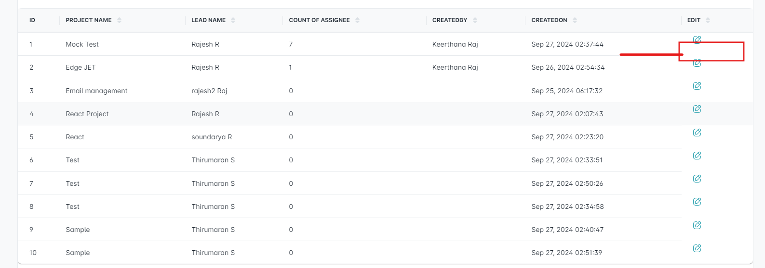

1. In Label,when try to search any name, the first colum value should display ascending order values.-FAIL
2. In label, when click delete button for any name, confirmation background is in black colour but it should be in transparency.-FAIL
3. In label, In Add/Edit status dropdown value should display “Please select”.(It is not compulsory, just a suggestion)-FAIL
4. In label, In Add new pop up heading display “Add Team” but it need to show “Add Label Name”-PASS
5. In label, In grid, Action text should present in center alignment. All details should be center alignment.-FAIL(Action column alignment is not proper).
6. In label, in the grid, 4th and 5th column header text need space like “Created By” and “Created On”.-PASS
7. When user try to click the logout button page navigates to login page. May be we can add confirmation message to logout.-FAIL

New Bugs:

1. In Project, Click Add/Edit button, In lead name dropdown, selected text size is smaller than other text.
2. In Label, when delete a lable and click yes button in confirmation there is no success message is displayed like “Label deleted successfully” or anyother valid details.
3. In Team, when select valid sort option, 1st column value details should be in ascending order.
4. In Team, Firstname and last name field allows special and numerical characters.
5. In Team, phone number tab allows alpha and special characters.
6. In Team, Enter invalid details on phone number tab the error message is displayed invalid details like this “**contact must be a `number` type, but the final value was: `NaN` (cast from the value `"szfa!#!@#"`)**.”
7. In Team, In designation tab, add and edit icon allignment is not proper and need to increase the size of the both icons.
8. In Team, In designation tab, Click add button, after enter valid details and click save button and details gets saved but after click save button pop up need to close automatically.
9. In Team, In designation tab, Click add button, heading of the pop up is invalid. It need to show add designation or any other valid message.
10. In Team, In designation tab, Click add button, after select active or inactive status pop up size is increased. But the pop up size will remain same after select any options.
11. In Team, In designation tab, Without enter any details in the tab, and click edit button pop up is opened but the pop up should not open and also valid error message should display like “Please select the designation” or any other valid message.
12. In Team, In designation tab, Enter valid details in the tab, and click edit button pop up is opened but the pop up user role name is empty but it need to show the existing values.
13. In Team,When select India in country dropdown relevant states are not displayed.(Not only for India, for many countries state options is not displayed).
14. In Team,In Project mapping field, outline is not easy to visible.
15. In Team, Click add, when enter existing mail id and enter valid details and click save button, no error message is displayed. Page should not allow duplicate value with proper error message.
16. In Team, Click add, After enter valid details in all field and select valid country and state and click save button, details gets saved and again click edit for the same user, state tab is empty.
17. In Team, search box only accept name and email address.