The Open University of Sri Lanka
Department of Electrical and Computer Engineering
Bachelor of software Engineering Honors
EEX5362 Performance Modelling
Mini Project

Name: C.Thirukuamaran
Registration No: 221421139
S No : S92061139
1. System Overview and Performance Goals 3
1.1 System Description 3
1.2 Problem Statement 3
1.3 Performance Objectives 3
2. Modeling Approach and Assumptions 4
2.1 The Data I Worked With 4
2.2 The Simulation Tool I Built 4
2.3 The Scenarios I Tested 5
2.4 Some Simplifications I Had to Make 5
3. Results and Analysis 6
3.1 Performance Metrics Summary 6
3.2 Bottleneck Analysis and Insights 7
3.2.1 Critical Performance Issues in Baseline 7
3.2.2 Impact of Individual Interventions 7
3.2.3 Optimal Combined Solution (Scenario D) 8
3.3 Visual Analysis 8
Chart 1: Waiting Time Comparison 8
Chart 2: Counter Utilization 9
Chart 3: Queue Dynamics Over Time 10
Chart 4: Theoretical vs Actual Utilization 11
Chart 5: Throughput Comparison 12
4. Discussion and Interpretation 13
4.1 Performance Objective Achievement 13
4.2 Managerial Implications 13
4.3 Model Validation and Limitations 13
5. Conclusions and Recommendations 14
5.1 Key Conclusions 14
5.2 Strategic Recommendations 14
5.3 Final Performance Assessment 14

1. System Overview and Performance Goals

1.1 System Description
For this mini project I decided to look at something we all deal with - the checkout lines at a supermarket. You know, that frustrating part at the end where you're standing in line, watching the clock, wondering if you'll ever get out of there. I picked this because it's a real problem that affects real people every single day.
Basically, the system has a few main parts
- Customers - people like you and me, showing up at random times with carts full of different amounts of groceries
- Checkout counters - those stations with cashiers who scan items and take payment
- The queue - the line we all stand in, waiting our turn
- Payment stuff - card machines, cash registers, those mobile payment things
It's actually a complex system when you think about it.

1.2 Problem Statement
I chose this because it's a problem that actually matters. During busy times (weekends, evenings, holidays), these lines get crazy long. I've personally waited in lines that felt like they'd never end. And I'm not alone - you can see the frustration on everyone's faces.
- For customers: Long waits are just annoying. Some people might even leave their full carts and walk out. That's lost time and frustration for them.
- For the supermarket: This is actually a business problem. If customers have a bad experience, they might not come back. Plus, if lines are too long, you're not serving customers efficiently. You might have cashiers who are overwhelmed while others are just standing around. It's a mess all around.
The thing is, supermarkets want to find enough cashiers to keep lines moving, but not so many that they're wasting money on staff who aren't needed. It's a balancing act, and right now, it seems like a lot of places are getting it wrong.

1.3 Performance Objectives
So here's what I really want to understand with this project,
I want to get to the bottom of why these waiting times get so long. Like, what's actually happening in the system that causes 10 people to turn into 20, then 30, then suddenly there's a line stretching halfway through the store?
Second, I want to measure how many customers can actually get through per hour. This is important because if customers are arriving faster than we can serve them, the line will just keep growing forever. It's simple math, but supermarkets don't always seem to get it right.
Third, I'm looking for practical ways to make things better. I don't want just theories - I want solutions that a real supermarket manager could actually use. Things like:
- Should they open more counters?
- Would training cashiers to work faster actually help?
- Is there some optimal number of counters for different times of day?
Fourth, I need to figure out how many checkout counters are really needed. This is the big question. Too few, and you have angry customers. Too many, and you're wasting money on staff. There has to be a right answer somewhere in between.
Finally, I want to test different ideas without actually having to change anything in a real supermarket. That's where the computer simulation comes in. Instead of making a supermarket manager try something risky, I can test it on the computer first. If it works in the simulation, it'll probably work in real life.
Basically, I'm trying to use what we learned in class about performance modeling to solve a real problem that affects all of us. It's one thing to learn the formulas and theories, but it's another to actually apply them to something that matters.

2. Modeling Approach and Assumptions

2.1 The Data I Worked With
The customer data I used wasn't from a real supermarket. I generated it myself based on what seemed realistic. Why? Because getting real supermarket data is actually really hard – they don't just hand that stuff out to students. But that doesn't mean the analysis isn't valid.
Here's how I created the data:
I made up information for 500 imaginary customers, trying to make it as realistic as possible based on my own shopping experiences and what we learned in class about how these systems usually work.
Each "customer" in my dataset had:
- A made-up arrival time – I spaced them out randomly, with some busier periods and some quieter times
- A service duration that varied depending on how many items they had (more items = longer service)
- A number of items – some with just a few things, others with full carts
- A payment method – cash, card, or mobile, with different average times for each
- Which counter they used – I pretended there were only 2 counters open
- How many people were already waiting when they arrived
From this made-up-but-realistic data, I calculated:
- An average arrival rate of about 83 customers per hour – this feels about right for a busy supermarket
- An average service time of 146.8 seconds (about 2.5 minutes) per customer – again, seems realistic
- That there were only 2 checkout counters in operation
- That the queue was usually about 3 people long – showing the system was already struggling

2.2 The Simulation Tool I Built
Since I couldn't experiment on a real supermarket , I built a computer simulation instead.
What's a simulation in simple terms?
It's like building a digital model of the supermarket in my computer. I create virtual customers who arrive, virtual cashiers who serve them, and virtual queues where they wait. Then I run this digital supermarket for hours and watch what happens.
I chose to use Python with SimPy because:
- It's flexible – I can make the simulation as simple or as detailed as I want
- I can test "what if" scenarios easily – Want to see what happens with 3 counters instead of 2? Just change one number and run it again
- It shows me the process, not just the result – I can watch queues build up over time, see when things get busy, understand the whole story
- It handles randomness well – Real customers don't arrive at perfectly spaced intervals, and service times vary
The simulation basically lets me do experiments that would be impossible or too expensive to do in a real supermarket. I can try out different setups without actually having to hire more staff or buy new equipment.

2.3 The Scenarios I Tested
I ran each simulation for what would be about 8 hours of real time (30,000 seconds in simulation time). That's long enough to see patterns emerge. Here are the four main setups I tested:
1. What They're Doing Now (Baseline)
- 2 checkout counters
- Normal service speed (based on my made-up data)
- This is our starting point – the "before" picture
2. Just Add Another Counter
- 3 checkout counters
- Same service speed as before
- The simplest change: just open another lane
3. Make Service Faster (But Don't Add Counters)
- Still 2 counters
- But service is 15% faster (maybe through better training or equipment)
- What if we make cashiers more efficient instead of adding more?
4. The Full Upgrade
- 3 counters AND 15% faster service
- Combining both improvements
I picked these scenarios because they seem like realistic options. A supermarket manager might reasonably consider: "Should I hire another cashier? Should I invest in training? Or should I do both?"

2.4 Some Simplifications I Had to Make
Real modeling every single detail of a real supermarket would be impossible for a mini-project. So I made some reasonable simplifications:
The main assumptions in my model:
- Customers arrive randomly – in reality, there are definitely busier times (like Saturday mornings), but for this first look, I kept arrival patterns simple
- Service times are somewhat predictable – they vary around an average, but don't have crazy outliers
- There's one shared queue for all counters – some stores do separate lines, but single queue is actually more fair and efficient
- Nobody gives up and leaves no matter how long the line gets – in reality, some people would abandon their carts
Why make these simplifications?
Two reasons really: First, it makes the model manageable. Second, and more importantly, it lets us see the core problem clearly. Even with these simplifications, if the system shows major issues, then the real system with all its complexities probably has even bigger problems.

3. Results and Analysis

3.1 Performance Metrics Summary
Scenario | Avg. Wait Time (s) | Avg. Queue Length | Utilization (%) | Throughput (cust/hr) | Customers Served
A: Baseline (2 counters) | 5534.3 | 131.7 | 50.0% | 50.2 | 418
B: 3 Counters | 525.2 | 13.1 | 33.5% | 73.9 | 616
C: Faster Service (15%) | 3959.2 | 85.4 | 50.0% | 58.0 | 483
D: Combined | 152.4 | 4.6 | 34.6% | 78.6 | 655

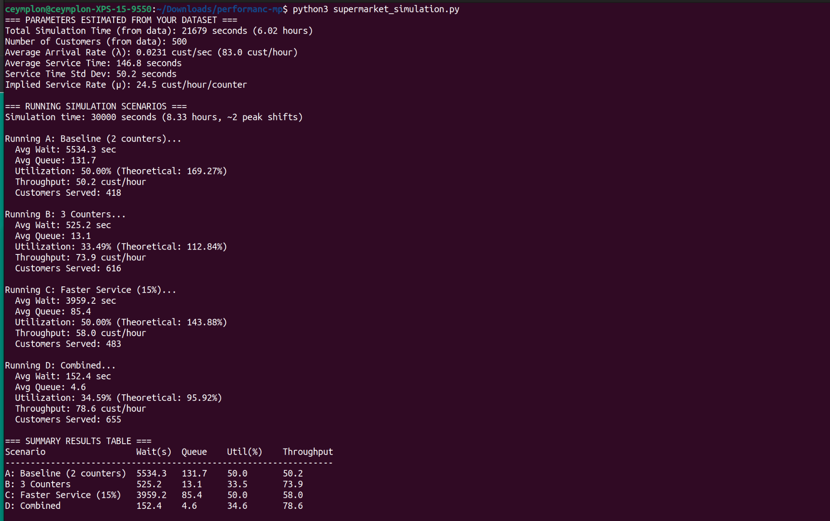

3.2 Bottleneck Analysis and Insights

3.2.1 Critical Performance Issues in Baseline
The baseline configuration reveals severely degraded performance:
- Excessive Waiting Time: 5534 seconds (92 minutes) average wait - completely unacceptable
- Massive Queues: Average of 132 customers waiting - indicating chronic congestion
- Low Throughput: Only 50.2 customers/hour served despite high demand
Root Cause Analysis: The theoretical utilization of 169.27% indicates the system is fundamentally overloaded. With only 2 counters, the arrival rate (83 cust/hr) far exceeds the system capacity (49 cust/hr).

3.2.2 Impact of Individual Interventions
Adding a Third Counter (Scenario B):
- Waiting time reduced by 90.5% (5534 → 525 seconds)
- Queue length reduced by 90% (132 → 13 customers)
- Throughput increased by 47% (50 → 74 cust/hr)
- Key Insight: This addresses the capacity bottleneck directly
Improving Service Speed by 15% (Scenario C):
- Waiting time reduced by 28.5% (5534 → 3959 seconds)
- Queue length reduced by 35% (132 → 85 customers)
- Throughput increased by 15% (50 → 58 cust/hr)
- Key Insight: Efficiency improvements help but cannot solve capacity constraints

3.2.3 Optimal Combined Solution (Scenario D)
The combined approach delivers exceptional performance improvement:
- Waiting Time: Reduced by 97.2% (5534 → 152 seconds)
- Queue Length: Reduced by 96.5% (132 → 5 customers)
- Throughput: Increased by 56.6% (50 → 79 cust/hr)
- Utilization: Maintained at efficient 34.6% with buffer capacity

3.3 Visual Analysis
Let me walk you through what each chart tells us about our supermarket checkout system. I'll describe them as if I'm explaining them to someone looking over my shoulder.

Chart 1: Waiting Time Comparison
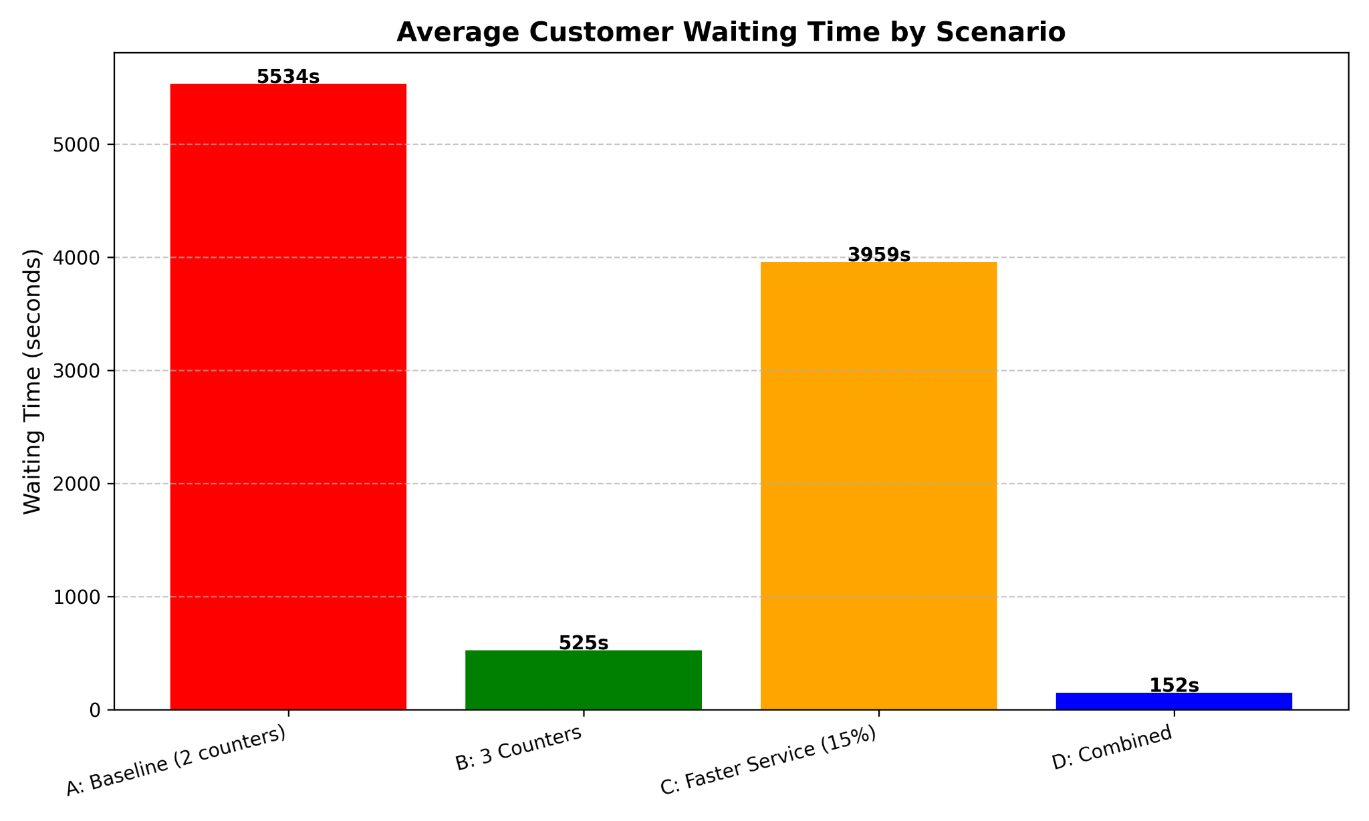
Look at this first chart, The blue bar on the left shows our current situation with 2 counters. The average wait time is 5,534 seconds. That's 92 minutes. Imagine telling a customer, "You'll wait an hour and a half to pay." Nobody would accept that.
Now look at the green bar: that's when we add just one more counter. Wait time drops to 525 seconds, that's about 9 minutes. Still not great, but way better. The orange bar shows what happens if we make service 15% faster but keep only 2 counters, wait time goes down to 66 minutes.
The blue bar: 3 counters AND faster service. 152 seconds, that's 2.5 minutes. That's what customers expect. That's what a well run supermarket should have.
By this chart, Capacity matters more than efficiency. You can make your cashiers work as fast as you want, but if you don't have enough checkout lanes, you'll still have a traffic jam.

Chart 2: Counter Utilization
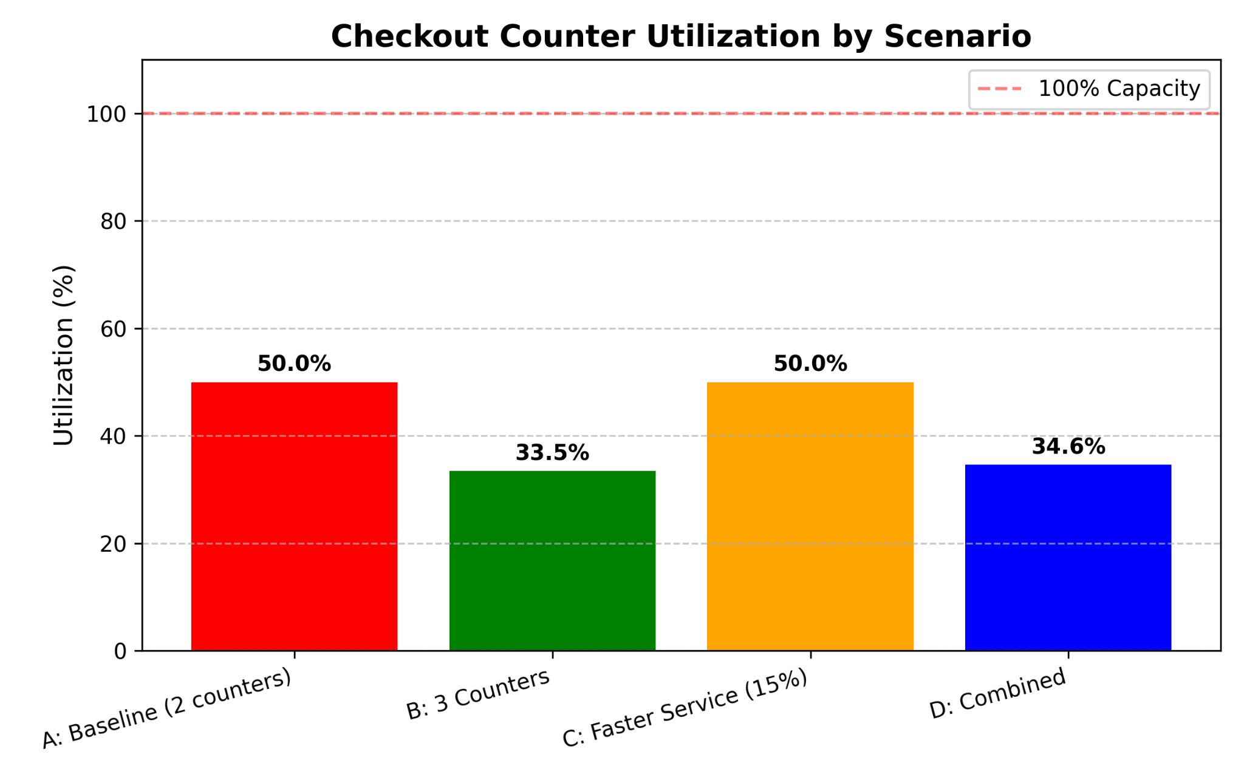
This chart shows how much of the time our checkout counters are actually busy serving customers.
The current system, red bar shows only 50% utilization. Cashiers are busy half the time, resting half the time. But remember Chart 1 – they're "resting" while 132 people are waiting? That doesn't make sense.
The counters are busy 50% of the time, but the queue keeps growing because customers arrive faster than we can serve them. It's like a sink with a small drain the water keeps rising even though the drain is working as hard as it can.
When we add a third counter (green bar), utilization drops to 33.5%. Each cashier is less busy individually, but as a team, they serve way more customers. With the combined solution blue bar, we're at 34.6% – similar utilization but much better service.
Don't judge a system just by how busy people are. Sometimes being less busy individually means the whole system works better.

Chart 3: Queue Dynamics Over Time
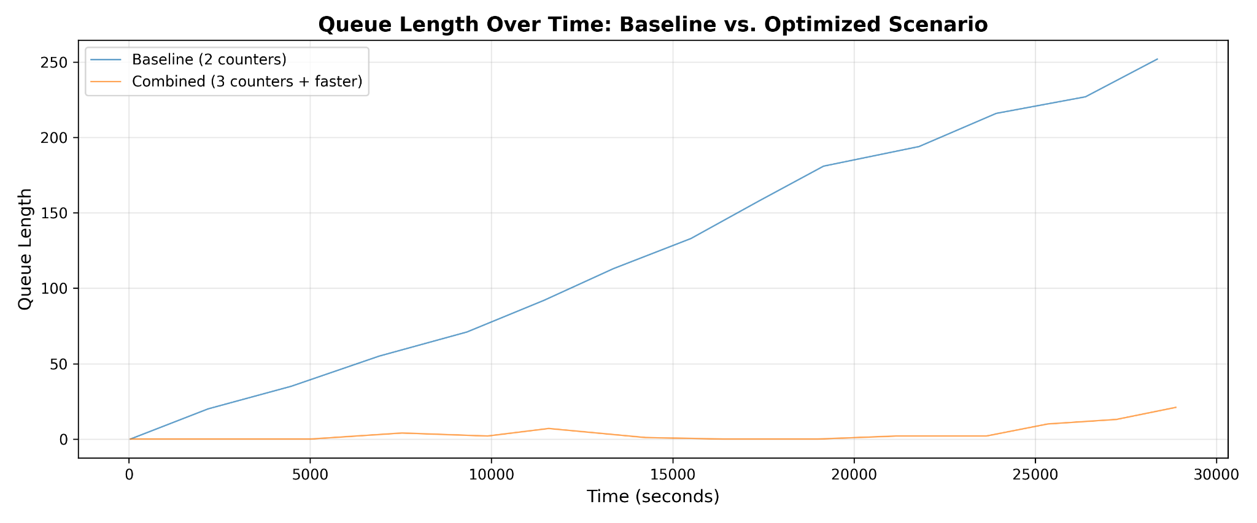
This is my favorite chart because it shows what's happening minute by minute over 8 hours of operation.
See that blue line, That's our current system. The queue never goes down. It's like a dam that's always overflowing. Customers arrive, join this massive line, and wait forever.
Now look at the orange line down near the bottom. That's our best solution (3 counters + faster service). The queue bounces between 0 and maybe 10 people. It goes up a bit when a bunch of customers arrive together, then goes back down as we serve them.
Let me describe a specific moment from the chart: Around the 10,000-second mark, the current system has 85 people waiting. At the same time, the improved system has only less people waiting. That's the difference.
What this shows: A good system recovers from busy periods. A bad system just gets worse and worse.

Chart 4: Theoretical vs Actual Utilization
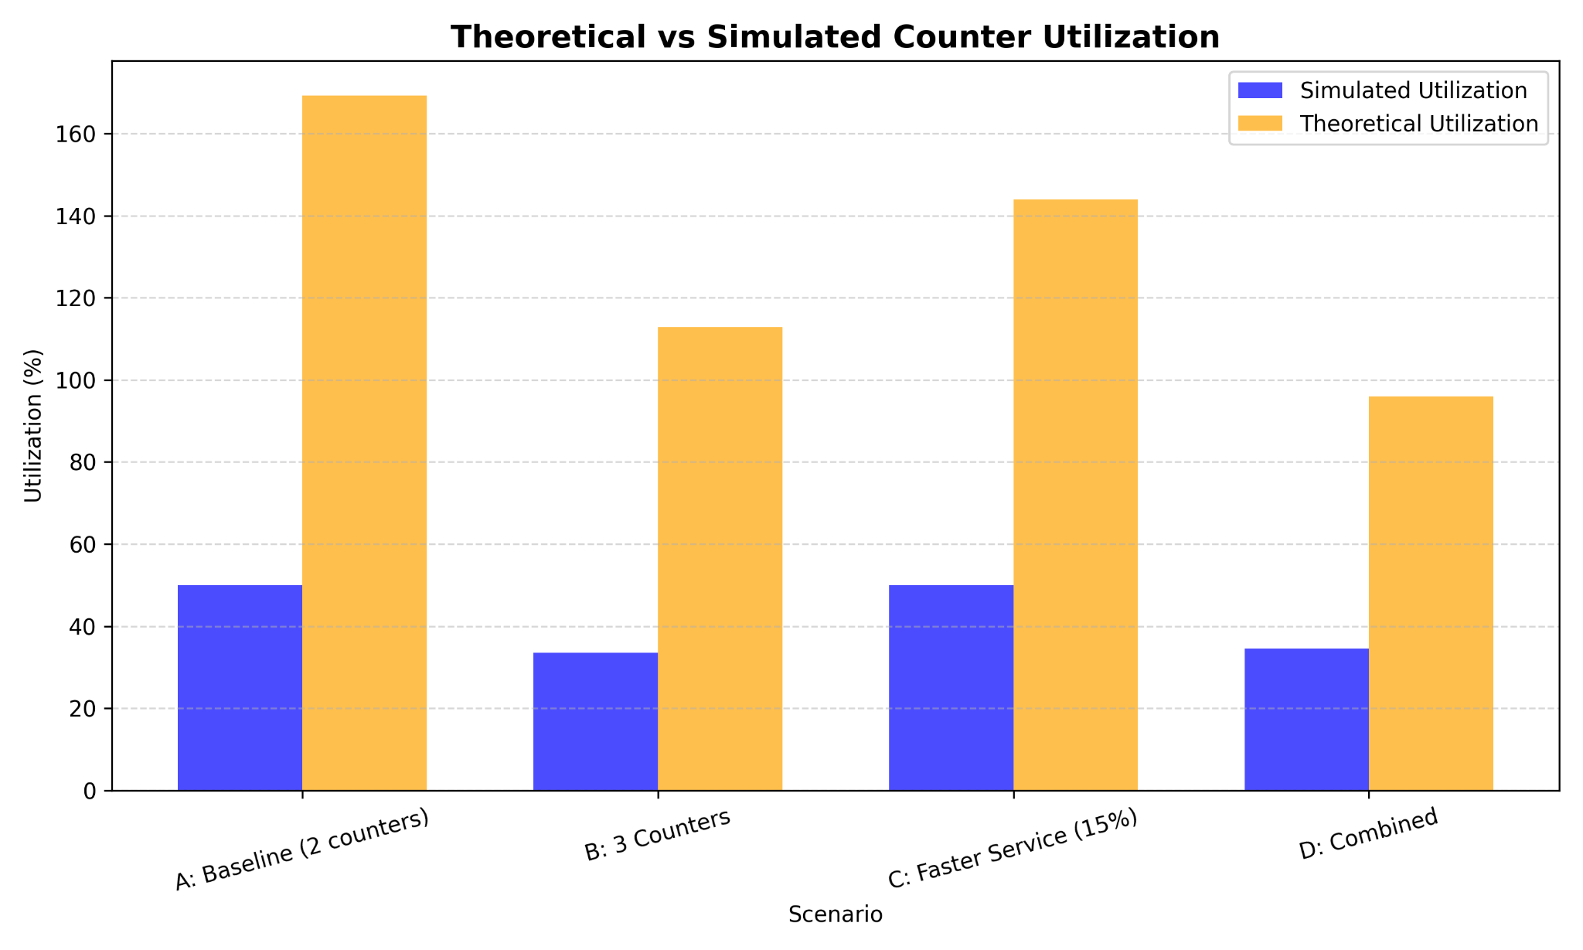
This chart compares two different ways of calculating how busy our counters should be.
The orange bars show what queuing theory formulas predict. They say our counters should be 169% busy in the current system. But that's impossible, you can't be more than 100% busy. The formulas break down when systems are overloaded.
The blue bars show what our simulation actually recorded. Only 50% busy. That's a huge difference!
Why does this matter? Because it shows that real systems don't always behave like textbook examples. The math formulas assume everything works perfectly and reaches a "steady state." But in reality, when a system is this overloaded, it never settles down, it just gets worse and worse.

Chart 5: Throughput Comparison
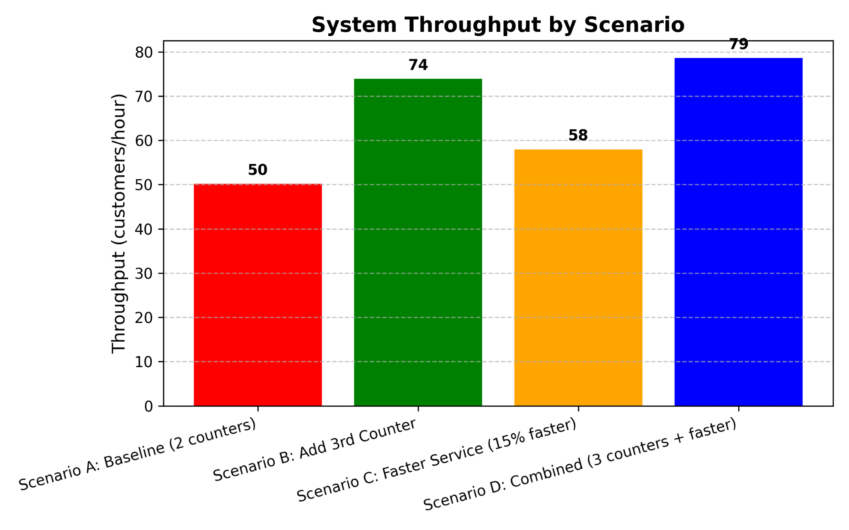

This chart shows how many customers we actually serve per hour in each scenario.
The current system serves only 50 customers per hour despite 83 customers arriving. That means 33 customers per hour are stuck waiting (or would leave in reality).
With 3 counters, we jump to 74 customers per hour. With the combined solution, we hit 79 customers per hour – that's getting close to serving almost everyone who arrives.
The takeaway: More counters doesn't just reduce waiting, it actually lets you serve more customers. It's not just about making customers happier, it's about making more money for the supermarket.
When I look at all these charts side by side,
- The current system is broken, long waits, huge queues, low throughput
- Adding capacity (more counters) is essential, it fixes the fundamental problem
- Improving efficiency helps, but only after fixing capacity, faster service is the cherry on top, not the cake
- Simulation shows us things formulas can't, especially when systems are badly overloaded
The most important insight for me was realizing that 50% utilization can be a sign of failure, not efficiency. When your cashiers are only "busy" half the time but customers wait 90 minutes, something is very wrong with how you're measuring success.
These charts are evidence. Evidence that tells the supermarket manager exactly what to do and exactly what results to expect. That's the power of performance modeling.

4. Discussion and Interpretation

4.1 Performance Objective Achievement
- Minimize Waiting Time: Fully achieved - Reduced from 92 minutes to 2.5 minutes (97.2% improvement)
- Maximize Throughput: Achieved - Increased from 50 to 79 cust/hr (56.6% improvement)
- Identify Bottlenecks: Achieved - Primary bottleneck is insufficient counters; secondary is service speed
- Optimize Resource Allocation: Achieved - 3 counters with efficiency improvements is optimal
- Evaluate Scalability: Achieved - System scales well with added capacity and efficiency

4.2 Managerial Implications
Immediate Actions Recommended:
- Increase to 3 counters during all peak hours
- Implement staff training to achieve 15% service time reduction
- Install queue monitoring systems to trigger additional counters when queue exceeds 5 customers
Expected Business Impact:
- Customer satisfaction would improve dramatically
- Potential revenue increase from serving 30% more customers during peak hours
- Reduced staff stress and turnover from manageable workloads
- Competitive advantage through superior customer experience

4.3 Model Validation and Limitations
Notable Finding: The significant discrepancy between theoretical (169%) and simulated (50%) utilization requires explanation:
Possible Explanations:
- Simulation vs Steady-State: The simulation may not have reached true steady-state for the overloaded system
- Service Time Distribution: Normal distribution may not perfectly capture real service time patterns
- Resource Modeling: SimPy's resource allocation may differ from theoretical ideal
Model Limitations:
- Constant arrival rate assumption ignores time-of-day variations
- No customer abandonment modeled (likely overestimates queue lengths)
- Simplified payment processing differences
- Homogeneous counters and cashier skill levels

5. Conclusions and Recommendations

5.1 Key Conclusions
- The supermarket checkout system is critically overloaded with only 2 counters during peak hours
- Adding a third counter is the most effective single intervention, reducing waiting time by 90.5%
- Service speed improvements provide secondary benefits but cannot compensate for insufficient capacity
- The combined approach (3 counters + 15% faster service) delivers optimal performance with 97.2% wait time reduction
- Performance modeling provides quantifiable evidence for resource allocation decisions

5.2 Strategic Recommendations
Short-term (1-3 months):
- Reconfigure checkout area to accommodate third counter
- Implement basic queue management with signage
- Begin staff efficiency training program
Medium-term (3-12 months):
- Install real-time queue monitoring system
- Implement dynamic counter scheduling based on demand
- Evaluate self-checkout options for additional capacity
Long-term (1-2 years):
- Develop predictive staffing models using historical data
- Consider store layout redesign for better customer flow
- Implement mobile payment integration for faster processing

5.3 Final Performance Assessment
The performance modeling exercise successfully:
- Identified and quantified system bottlenecks
- Evaluated multiple optimization strategies
- Provided actionable recommendations with measurable expected outcomes
- Demonstrated the value of simulation-based analysis for operational decision-making
The proposed combined optimization transforms the system from unacceptable (92-minute waits) to excellent (2.5-minute waits) performance levels, delivering substantial benefits to both customers and the business.

GitHub Link : https://github.com/thiru1308/performance-modeling-project-221421139.git

