CS 8491 - Computer Architecture

UNIT IV PARALLELISIM
Parallel processing challenges – Flynn‘s classification – SISD, MIMD, SIMD, SPMD, and Vector Architectures – Hardware multithreading – Multi-core processors and other Shared Memory Multiprocessors – Introduction to Graphics Processing Units, Clusters, Warehouse Scale Computers and other Message-Passing Multiprocessors.

4.1 Introduction
Issue packet: The set of instructions that issues together in one clock cycle; the packet may be determined statically by the compiler or dynamically by the processor. The issue packet can be thought of as a single instruction allowing several operations in certain predefined fields. (VLIW)
Very Long Instruction Word (VLIW) A style of instruction set architecture that launches many operations that are defined to be independent in a single wide instruction, typically with many separate opcode fields.
4.2 Parallel Processing challenges
The difficulty with parallelism is not the hardware; it is that too few important application programs have been rewritten to complete tasks sooner on multiprocessors. It is difficult to write software that uses multiple processors to complete one task faster, and the problem gets worse as the number of processors increases.
The first reason is that you must get better performance or better energy efficiency from a parallel processing program on a multiprocessor; otherwise, you would just use a sequential program on a uniprocessor, as sequential programming is simpler. In fact, uniprocessor design techniques such as superscalar and out-of- order execution take advantage of instruction-level parallelism.
The task must be broken into equal-sized jobs, because otherwise some units would be idle while waiting for the ones with larger jobs to finish. Another speed-up obstacle could be that the processors would spend too much time communicating with each other instead of doing their job.
Parallel Programming Challenges:
- Scheduling
- Partitioning the work into parallel pieces
- Balancing the load evenly between the workers
- Time to synchronize
- Overhead for communication
- Even small parts of a program must be parallelized if the program is to make good use of many cores.
Speed-up Challenge

Suppose you want to achieve a speed-up of 90 times faster with 100 processors. What percentage of the original computation can be sequential?
Answer:
Amdahl’s Law says:

Execution time after improvement =
Execution time affected by improvement + Execution time unaffected
Amount of improvement
We can reformulate Amdahlಬs Law in terms of speed-up versus the original execution time:

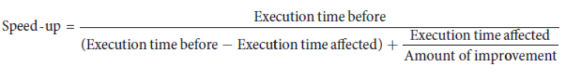
This formula is usually rewritten assuming that the execution time before is 1 for some unit of time, and the execution time affected by improvement is considered the fraction of the original execution time:

Speed- up = 1
(1 − Fraction time affected) + Fraction time affected
Amount of improvement

Substituting 90 for speed-up and 100 for amount of improvement into the formula above:
90 = 1
(1 − Fraction time affected) + Fraction time affected
100

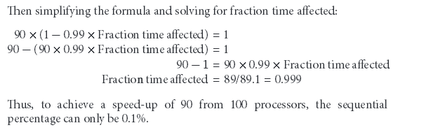

Speed-up Challenge: Bigger Problem

Suppose you want to perform two sums: one is a sum of 10 scalar variables, and one is a matrix sum of a pair of two-dimensional arrays, with dimensions 10 by 10. For now let’s assume only the matrix sum is parallelizable; we’ll see soon how to parallelize scalar sums. What speed-up do you get with 10 versus 40 processors? Next, calculate the speed-ups assuming the matrices grow to 20 by 20.
Answer:
If we assume performance is a function of the time for an addition, t, then there are 10 additions that do not benefit from parallel processors and 100 additions that do. If the time for a single processor is 110 t, the execution time for 10 processors is
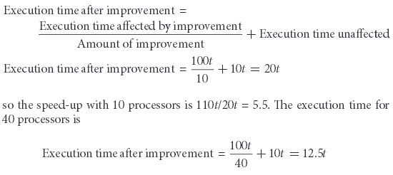
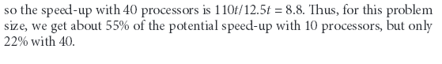
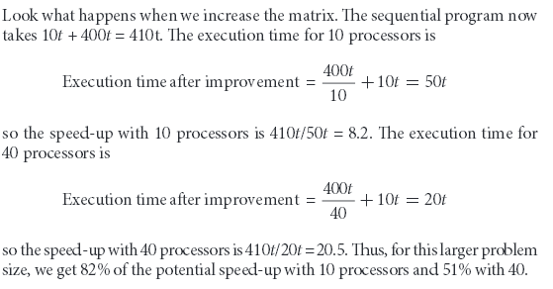

There are two types of scaling:
Strong scaling: Speed-up achieved on a multiprocessor without increasing the size of the problem.
Weak scaling: Speed-up achieved on a multiprocessor while increasing the size of the problem.
Let’s assume that the size of the problem, M, is the working set in main memory, and we have P processors. Then the memory per processor for strong scaling is approximately M/P, and for weak scaling, it is approximately M.

Speed-up Challenge: Balancing Load
To achieve the speed-up of 20.5 on the previous larger problem with 40 processors, we assumed the load was perfectly balanced. That is, each of the 40 processors had 2.5% of the work to do. Instead, show the impact on speed-up if one processor's load is higher than all the rest. Calculate at twice the load (5%) and five times the load (12.5%) for that hardest working processor. How well utilized are the rest of the processors?
Answer:
If one processor has 5% of the parallel load, then it must do 5% x 400 or 20 additions, and the other 39 will share the remaining 380. Since they are operating simultaneously, we can just calculate the execution time as a maximum
The speed-up drops from 20.5 to 410t/30t = 14. The remaining 39 processors are utilized less than half the time: while waiting 20t for hardest working processor to finish, they only compute for 380t/39 = 9.7t.
If one processor has 12.5% of the load, it must perform 50 additions. The formula is:

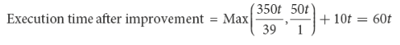

The speed-up drops even further to 410t/60t = 7. The rest of the processors are utilized less than 20% of the time (9t/50t). This example demonstrates the importance of balancing load, for just a single processor with twice the load of the others cuts speed-up by a third, and five times the load on just one processor reduces speed-up by almost a factor of three.

Two biggest challenges are insufficient parallelism and long-latency remote communication.
- The problem of inadequate application parallelism must be attacked primarily in software with new algorithms that can have better parallel performance.
- Reducing the impact of long remote latency can be attacked both by the architecture and by the programmer.
- For example, we can reduce the frequency of remote accesses with either hardware mechanisms, such as caching shared data, or software mechanisms, such as restructuring the data to make more accesses local. We can try to tolerate the latency by using multithreading or by using pre-fetch.

4.3 Flynn’s classification
Instruction stream and data stream:
The term ‘stream’ refers to a sequence or flow of either instructions or data operated on by the computer. In the complete cycle of instruction execution, a flow of instructions from main memory to the CPU is established. This flow of instructions is called instruction stream. Similarly, there is a flow of operands between processor and memory bi-directionally. This flow of operands is called data stream.
The four classifications defined by Flynn are based upon the number of concurrent instruction (or control) and data streams available in the architecture:
Flynn's taxonomy (multiprogramming context)
 | Single instruction | Multiple instruction | Single program | Multiple program
Single data | SISD | MISD
Multiple data | SIMD | MIMD | SPMD | MPMD
Visually, these four architectures are shown below where each "PU" is a central processing unit:
SISD | MISD
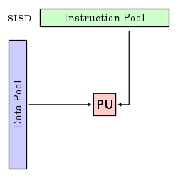 | 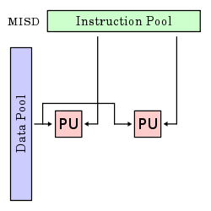
SIMD | MIMD
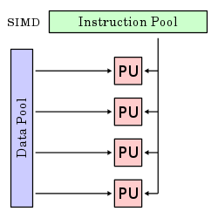 | 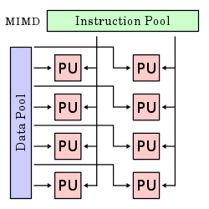

SISD(Single Instruction Single data):
A sequential computer which exploits no parallelism in either the instruction or data streams. Single control unit (CU) fetches single Instruction Stream (IS) from memory. The CU then generates appropriate control signals to direct single processing element (PE) to operate on single Data Stream (DS) i.e. one operation at a time. Examples of SISD architecture are the traditional uniprocessor machines like a PC (currently manufactured PCs have multiple processors) or old mainframes.

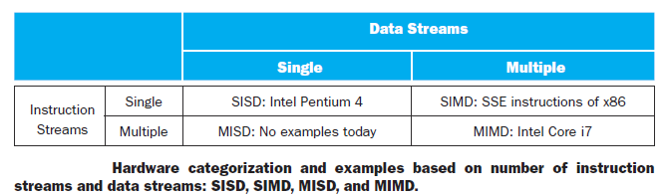
In computing, SISD (single instruction, single data) is a term referring to a computer architecture in which a single processor, a uniprocessor, executes a single instruction stream, to operate on data stored in a single memory. This corresponds to the von Neumann architecture.
SISD is one of the four main classifications as defined in Flynn's taxonomy. In this system classifications are based upon the number of concurrent instructions and data streams present in the computer architecture. According to Michael J. Flynn, SISD can have concurrent processing characteristics. Instruction fetching and pipelined execution of instructions are common examples found in most modern SISD computers.
SIMD (Single Instruction Multiple Data Stream):
A computer which exploits multiple data streams against a single instruction stream to perform operations which may be naturally parallelized. For example, an array processor or GPU (Graphics Processing Unit).
Single instruction, multiple data (SIMD), is a class of parallel computers in Flynn's taxonomy. It describes computers with multiple processing elements that perform the same operation on multiple data points simultaneously. Thus, such machines exploit data level parallelism, but not concurrency: there are simultaneous (parallel) computations, but only a single process (instruction) at a given moment. SIMD is particularly applicable to common tasks like adjusting the contrast in a digital image or adjusting the volume of digital audio. Most modern CPU designs include SIMD instructions in order to improve the performance of multimedia use.
SIMD works best when dealing with arrays in for loops. Hence, for parallelism to work in SIMD, there must be a great deal of identically structured data, which is called data-level parallelism. SIMD is at its weakest in case or switch statements, where each execution unit must perform a different operation on its data, depending on what data it has. Execution units with the wrong data must be disabled so that units with proper data may continue. If there are ‘n’ cases, in these situations SIMD processors essentially run at l/nth of peak performance.
MISD (multiple instruction, single data stream):
Multiple instructions operate on a single data stream. Uncommon architecture which is generally used for fault tolerance. Heterogeneous systems operate on the same data stream and must agree on the result. In computing, MISD (multiple instruction, single data) is a type of parallel computing architecture where many functional units perform different operations on the same data. Pipeline architectures belong to this type, though a purist might say that the data is different after processing by each stage in the pipeline. Fault-tolerant computers executing the same instructions redundantly in order to detect and mask errors, in a manner known as task replication, may be considered to belong to this type. Not many instances of this architecture exist, as MIMD and SIMD are often more appropriate for common data parallel techniques. Specifically, they allow better scaling and use of computational resources than MISD does. However, one prominent example of MISD in computing are the Space Shuttle flight control computers
MIMD (multiple instruction, multiple data stream):
Multiple autonomous processors simultaneously executing different instructions on different data. Distributed systems are generally recognized to be MIMD architectures; either exploiting a single shared memory space or a distributed memory space. A multi-core superscalar processor is an MIMD processor.
In computing, MIMD (multiple instruction, multiple data) is a technique employed to achieve parallelism. Machines using MIMD have a number of processors that function asynchronously and independently. At any time, different processors may be executing different instructions on different pieces of data. MIMD architectures may be used in a number of application areas such as computer-aided design/computer-aided manufacturing, simulation, modeling, and as communication switches. MIMD machines can be of either shared memory or distributed memory categories. These classifications are based on how MIMD processors access memory. Shared memory machines may be of the bus-based, extended, or hierarchical type. Distributed memory machines may have hypercube or mesh interconnection schemes.

Further Classifications:
SPMD:
Single Program, Multiple Data: multiple autonomous processors simultaneously executing the same program (but at independent points, rather than in the lockstep that SIMD imposes) on different data. Also referred to as 'Single Process, multiple data - SPMD is a parallel execution model and assumes multiple cooperating processes executing a program. SPMD is the most common style of parallel programming.
MPMD
Multiple Program, Multiple Data: multiple autonomous processors simultaneously operating at least 2 independent programs. Typically such systems pick one node to be the "host" ("the explicit host/node programming model") or "manager" (the "Manager/Worker" strategy), which runs one program that farms out data to all the other nodes which all run a second program. Those other nodes then return their results directly to the manager.

Vector Architectures (SIMD):
SIMD computer operateson vectors of data. The vector architectures pipelined the ALU to get good performance at lower cost. The vector architecture collects data elements from memory, put them in order into a large set of registers, operate on them sequentially in registers using pipelined execution units, and then write the results back to memory. A key feature of vector architectures is then a set of vector registers. Thus, a vector architecture might have 32 vector registers, each with 64 64-bit elements.
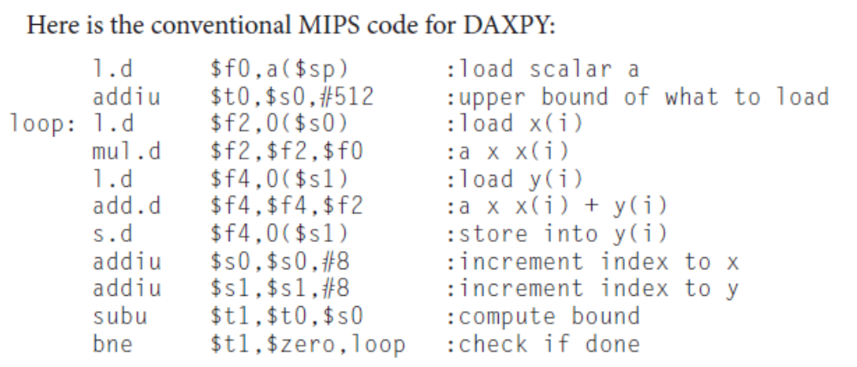
Here is the Vector MIPS code for DAXPYY:
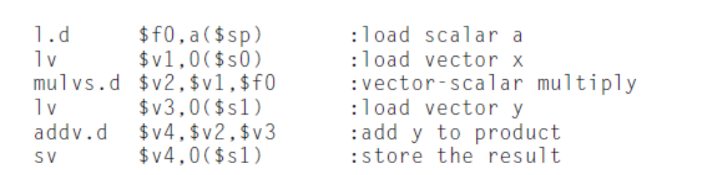
Comparing Vector to Conventional Code:
Vector instructions have several important properties compared to conventional instruction set architectures, which are called scalar architectures in this context:
- Vector operations use the same names as MIPS operations, but with the letter (V) appended. For example, addv.d adds two double-precision vectors.
- The vector instructions take as their input either a pair of vector registers (addv.d) or a vector register and a scalar register (addvs.d).
- A single vector instruction specifies a great deal of work. It is equivalent to executing an entire loop. The instruction fetch and decode bandwidth needed is dramatically reduced.
- By using a vector instruction, the compiler or programmer indicates that the computation of each result in the vector is independent of the computation of other results in the same vector, so hardware does not have to check for data hazards within a vector instruction.
- Hardware need only check for data hazards between two vector instructions once per vector operand, not once for every element within the vectors. Reduced checking can save energy as well as time.
- Vector architectures and compilers have a reputation of making it much easier than when using MIMD multiprocessors to write efficient applications when they contain data-level parallelism.
- Vector instructions that access memory have a known access pattern. If the vectors elements are all adjacent, then fetching the vector from a set of heavily interleaved memory banks works very well. Thus, the cost of the latency to main memory is seen only once for the entire vector, rather than once for each word of the vector.
- Because an entire loop is replaced by a vector instruction whose behavior is predetermined, control hazards that would normally arise from the loop branch are nonexistent.
- The savings in instruction bandwidth and hazard checking plus the efficient use of memory bandwidth give vector architectures advantages in power and energy versus scalar architectures.
Advantages of Vector code:
- Reduces dynamic instruction bandwidth.
- Frequency of pipeline stalls reduced.
- Vector elements operate in parallel, like sub-word parallelism.
Vector versus Multimedia extensions:
- Multimedia extensions typically specify a few operations while vector specifies dozens of operations.
- The number of elements in a vector operation is not in the opcode but in a separate register. This distinction means different versions of the vector architecture can be implemented with a different number of elements just by changing the contents of that register and hence retain binary compatibility.
- Unlike multimedia extensions, the data transfers need not be contiguous. Vectors support both strided accesses, where the hardware loads every nth data element in memory, and indexed accesses, where hardware finds the addresses of the items to be loaded in a vector register. Indexed accesses are also called gatherscatter,in that indexed loads gather elements from main memory into contiguous vector elements and indexed stores scatter vector elements across main memory

Structure of a vector unit containing four lanes:
Vector lanes: One or more vector functional units and a portion of the vector register file. Inspired by lanes on highways that increase traffic speed, multiple lanes execute vector operations simultaneously.
- Vector lanes increase the peak throughput of a vector unit by adding more lanes.
- Reduces the number of clocks per vector instruction.
- Both the applications and the architecture must support long vectors. Otherwise, they will execute so quickly that you’ll run out of instructions.
- Efficient way to execute data parallel processing programs.

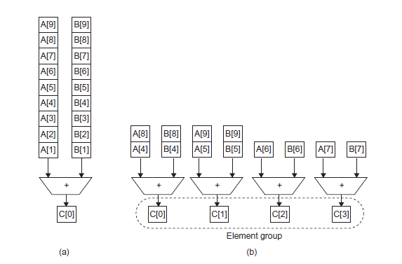
Using multiple functional units to improve the performance of a single vector add instruction, C = A + B.
The vector processor
(a) on the left has a single add pipeline and can complete one addition per cycle. The vector processor
(b) on the right has four add pipelines or lanes and can complete four additions per cycle. The elements within a single vector add instruction is interleaved across the four lanes.
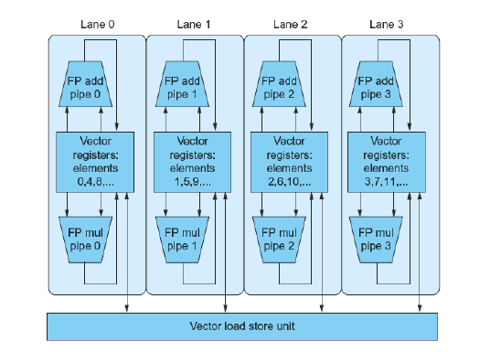
Structure of Vector unit containing four lanes

Disadvantages:
There were concerns about the larger state for vector registers increasing
- context switch time and
- the difficulty of handling page faults in vector loads and stores, and
- SIMD instructions achieved some of the benefits of vector instructions.
The vector register is divided across the lanes, with each lane holding every fourth element of each vector register.
It contains 3 functional units.
- FP add
- FP multiply
- Load- store unit.
Each of the vector arithmetic unit contains four execution pipelines ,one per lane, which acts in concert to complete a single vector instruction.

4.4 Hardware Multithreading:
Hardware multithreading:
It is defined as the process of increasing utilization of a processor by switching to another thread when one thread is stalled. It implements thread level parallelism.
Thread:
A thread is a single sequential flow of execution. It includes the program counter, the register state and the stack. It is lightweight process; thread commonly share a single address space.
- Thread may be a part of a parallel program of multiple processes, or it may be an independent program.
- Each thread has all the states necessary to allow it to execute.
- Thread level parallelism is explicitly represented by the use of multiple threads of execution that are inherently parallel.
- Multithreading allows multiple threads to share the functional units of a single processor in an overlapping fashion. To permit this sharing, the processor must duplicate the independent state of each thread.
- For example, a separate copy of the register file, a separate PC, and a page table if required.
- The memory itself can be shared through the virtual memory mechanism, which already supports multiprogramming.
- The hardware must support the ability to change to a different thread relatively quickly.
Two main approaches of hardware multithreading:
Fine-grained multithreading:
A version of hardware multithreading that implies switching between threads after every instruction, causing the execution of multiple threads to be interleaved. Interleaving is done in a round robin fashion, skipping any threads that are stalled at that time. Processor must be able to switch threads on every clock cycle.
Advantage of Fine-grained multithreading:
It can hide the throughput losses that arise from both long and short stalls, since instructions from other threads can be executed when one thread stalls.
Disadvantage of Fine-grained multithreading:
Slows down the execution of individual threads since a thread is ready to execute without stalls will be delayed by the instructions from other threads.
Coarse-grained multithreading:
A version of hardware multithreading that implies switching between threads only after significant events such as a last level cache miss. This change relieves the need to have thread switching be extremely fast and is much less likely to slow down the execution of an individual thread, since instructions from other threads will only be issued when a thread encounters a costly stall.
Advantage of Coarse-grained multithreading:
- Relieves need to have very fast thread-switching.
- Doesn’t slow down thread, since instructions from other threads issued only when the thread encounters a costly stall.
Disadvantage of Coarse-grained multithreading:
- Limited in ability to overcome throughput losses, especially from shorter stalls.
- When a stall occurs the pipeline must be emptied or frozen.
- Because of the startup overhead, this method is better for reducing penalty of high cost stalls, where pipeline refill is negligible compared to the stall time.
Simultaneous Multithreading (SMT):
A version of multithreading that lowers the cost of multithreading by utilizing the resources needed for multiple issue.
SMT is a variation on hardware multithreading that uses the resources of a multiple-issue, dynamically scheduled pipelined processor to exploit thread-level parallelism at the same time it exploits instruction- level parallelism.
Multiple instructions from independent threads can be issued without regard to the dependences among them; the resolution of the dependences can be handled by the dynamic scheduling capability. SMT is always executing instructions from multiple threads, leaving it up to the hardware to associate instruction slots and renamed registers with their proper threads.
Following figure conceptually illustrates the differences in a processors ability to exploit superscalar resources for the following processor configurations.
- A superscalar with coarse-grained multithreading
- A superscalar with fine-grained multithreading
- A superscalar with simultaneous multithreading
In the superscalar without hardware multithreading support, the use of issue slots is limited by a lack of instruction-level parallelism. In addition, a major stall, such as an instruction cache miss, can leave the entire processor idle.
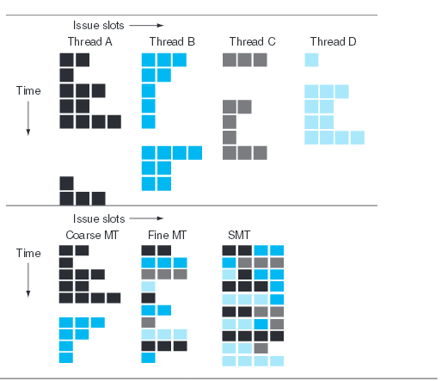

Coarse-grained multithreaded superscalar:
- The long stalls are partially hidden by switching to another thread that uses the resources of the processor.
- Although this reduces the number of completely idle clock cycles, the pipeline start-up overhead still leads to idle cycles, and limitations to ILP means all issue slots will not be used.
Fine-grained multithreaded superscalar:
- In the fine-grained case, the interleaving of threads mostly eliminates idle clock cycles.
- Because only a single thread issues instructions in a given clock cycle, however, limitations in instruction-level parallelism still lead to idle slots within some clock cycles.
Simultaneous multithreading superscalar:
- In the SMT case, thread-level parallelism and instruction-level parallelism are both exploited, with multiple threads using the issue slots in a single clock cycle.
- Ideally, the issue slot usage is limited by imbalances in the resource needs and resource availability over multiple threads.

Issue slot usage is limited by the following factors
- Resource availability over multiple threads
- Finite limitations on buffer.
- Imbalances of active threads considered.
- Ability to fetch enough instructions from multiple threads.
SMT supports multithreading by
- Large set of virtual registers that can be used to hold the register sets of independent threads.
- Register renaming provides unique register identifiers, so instructions from multiple threads can be mixed in data path without confusing sources and destinations.
- Out of order completion allows the threads to execute out of order, and get better utilization of the hardware.
Design Challenges in SMT
- Unfortunately, with a preferred thread, processor is likely to sacrifice some throughput when the preferred thread stalls.
- Larger register file needed to hold multiple contexts.
- Try not to affect clock cycle time, especially in
Instruction issue - more candidate instructions need to be considered
Instruction completion - choosing which instructions to commit may be challenging.
- Ensure that cache and TLB conflicts generated by SMT do not degrade performance.
SMT works well if:
- Number of compute intensive threads does not exceed the number of threads supported in SMT
- Threads have highly different characteristics.
SMT does not work well if:
- Threads try to utilize the same function units.
- Assignment problems (eg) dual processor systems, each processor supporting two threads simultaneously.

4.5 Multi-core Processors
Single-core processor:
It is a processor that has only one core, so it can only start one operation at a time. It can however in some situations start a new operation before the previous one is complete. Originally all processors were single core.
Design of single core processor
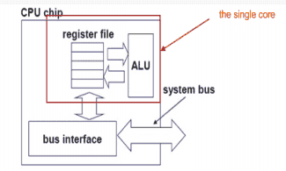

Difficulties in single-core
- Clock frequencies even higher
- Deeply pipelined circuits
- Heat problems
- Speed of light problems
- Difficult design and verification
- Large design
- Server farms need expensive
- air-conditioning
- Many new applications are multithreaded
Multi-core Processors:
- Integrated circuit(IC) chips containing more than one identical physical processor (core) in the some IC package. OS perceives each core as a discrete processor.
- Each core has its own complete set of resources, and may share the on-die cache layer
- A multi-core processor is an integrated circuit (IC) to which two or more processors has been attached for enhanced performance, reduced power consumption, and more efficient simultaneous processing of multiple tasks.
Design of a dual core processor:
A dual core allows two threads to be executed in parallel and Quad core allows 4 threads to be executed. A dual core set-up is somewhat comparable to having multiple, separate processors installed in the same computer, but because the two processors are actually plugged into the same socket, the connection between them is faster.
Following figure shows the design of Dual core-processor and the execution of thread in it.
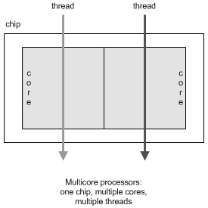

Ideally, a dual core processor is nearly twice as powerful as a single core processor. In practice, performance gains are said to be about fifty percent: a dual core processor is likely to be about one-and-a-half times as powerful as a single core processor.

Design of Quad-core processor:
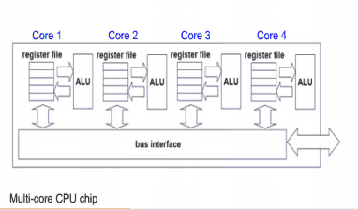

SMP (Shared Memory Multiprocessor) offers a single physical address space to be shared across all processors. Processors communicate through shared variables in memory, with all processors capable of accessing any memory location via loads and stores.
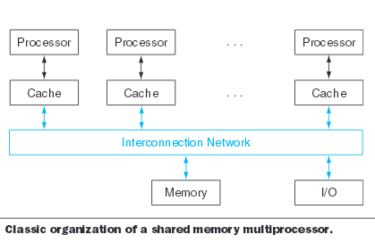
The above figure shows the classic organization of an SMP. Note that such systems can still run independent jobs in their own virtual address spaces, even if they all share a physical address space.
Single address space multiprocessors come in two styles.
Uniform memory access (UMA):
A multiprocessor in which latency to any word in main memory is about the same no matter which processor requests the access.
Non-uniform memory access (NUMA):
A type of single address space multiprocessor in which some memory accesses are much faster than others depending on which processor asks for which word, typically because main memory is divided and attached to different microprocessors or to different memory controllers on the same chip.
The programming challenges are harder for a NUMA multiprocessor than for a UMA multiprocessor, but NUMA machines can scale to larger sizes and NUMAs can have lower latency to nearby memory.
As processors operating in parallel will normally share data, they also need to coordinate when operating on shared data; otherwise, one processor could start working on data before another is finished with it. This coordination is called synchronization.
One approach uses a lock for a shared variable. Only one processor at a time can acquire the lock, and other processors interested in shared data must wait until the original processor unlocks the variable.
Advantages of multi-core architecture:
Thread level parallelism, Great energy efficient, Performance, Lower cost, Faster, Better heat dissipation, Ease of use,
Disadvantages of multi core architecture:
Adjustment to existing software required, Memory bandwidth limit the real performance.
Application benefits:
Database servers, Web servers, Compilers, Multimedia applications, scientific applications CAD/CAM, in general applications with Thread-level parallelism.

INTRODUCTION TO GRAPHICS PROCESSING UNIT (GPU)

- The original justification for adding SIMD instructions to existing architectures was that many microprocessors were connected to graphics displays in PCs and workstations, so an increasing fraction of processing time was used for graphics.
- As Moore’s Law increased the number of transistors available to microprocessors, it therefore made sense to improve graphics processing. A major driving force for improving graphics processing was the computer game industry, both on PCs and in dedicated game consoles such as the Sony PlayStation.
- The rapidly growing game market encouraged many companies to make increasing investments in developing faster graphics hardware, and this positive feedback loop led graphics processing to improve at a faster rate than general-purpose processing in mainstream microprocessors.
- Given that the graphics and game community had different goals than the microprocessor development community, it evolved its own style of processing and terminology.
- As the graphics processors increased in power, they earned the name Graphics Processing Units or GPUs to distinguish themselves from CPUs.
- For a few hundred dollars, anyone can buy a GPU today with hundreds of parallel floating-point units, which makes high-performance computing more accessible. The interest in GPU computing blossomed when this potential was combined with a programming language that made GPUs easier to program.
- Hence, many programmers of scientific and multimedia applications today are pondering whether to use GPUs or CPUs.

key characteristics as to how GPUs vary from CPUs:
- GPUs are accelerators that supplement a CPU, so they do not need be able to perform all the tasks of a CPU. This role allows them to dedicate all their resources to graphics. Its fine for GPUs to perform some tasks poorly or notat all, given that in a system with both a CPU and a GPU, the CPU can do them if needed.
- The GPU problems sizes are typically hundreds of megabytes to gigabytes, but not hundreds of gigabytes to terabytes.
These differences led to different styles of architecture:
- Perhaps the biggest difference is that GPUs do not rely on multilevel caches to overcome the long latency to memory, as do CPUs. Instead, GPUs rely on hardware multithreading to hide the latency to memory. That is, between the time of a memory request and the time that data arrives, the GPU executes hundreds or thousands of threads that are independent of that request.
- The GPU memory is thus oriented toward bandwidth rather than latency. There are even special graphics DRAM chips for GPUs that are wider and have higher bandwidth than DRAM chips for CPUs.
- In addition, GPU memories have traditionally had smaller main memories than conventional microprocessors. In 2013, GPUs typically have 4 to 6 GiB or less, while CPUs have 32 to 256 GiB. Finally, keep in mind that for general-purpose computation, you must include the time to transfer the data between CPU memory and GPU memory, since the GPU is a coprocessor.
- Given the reliance on many threads to deliver good memory bandwidth, GPUs can accommodate many parallel processors (MIMD) as well as many threads. Hence, each GPU processor is more highly multithreaded than a typical CPU, plus they have more processors.

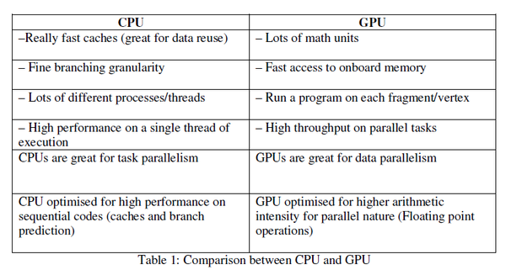

NVIDIA’s CUDA
- After tiring of trying to specify their problems using the graphics APIs and languages, developers developed C-inspired programming languages to allow them to write programs directly for the GPUs.
- An example is NVIDIA’s CUDA (Compute Unified Device Architecture), which enables the programmer to write C programs to execute on GPUs, albeit with some restrictions.
- NVIDIA decided that the unifying theme of all these forms of parallelism is the CUDA Thread. Using this lowest level of parallelism as the programming primitive, the compiler and the hardware can gang thousands of CUDA Threads together to utilize the various styles of parallelism within a GPU: multithreading, MIMD, SIMD, and instruction-level parallelism.
- These threads are blocked together and executed in groups of 32 at a time. A multithreaded processor inside a GPU executes these blocks of threads, and a GPU consists of 8 to 32 of these multithreaded processors.

Introduction to the NVIDIA GPU Architecture
- NVIDIA systems are the are representative of GPU architectures.
- Specifically, we follow the terminology of the CUDA parallel programming language and use the Fermi architecture as the example. Like vector architectures, GPUs work well only with data-level parallel problems.
- Both styles have gather-scatter data transfers, and GPU processors have even more registers than do vector processors.
- Unlike most vector architectures, GPUs also rely on hardware multithreading within a single multi-threaded SIMD processor to hide memory latency.
- A multithreaded SIMD processor is similar to a Vector Processor, but the former has many parallel functional units instead of just a few that are deeply pipelined, as does the latter.
- A GPU contains a collection of multithreaded SIMD processors; that is, a GPU is a MIMD composed of multithreaded SIMD processors.
- Below figure shows a simplified block diagram of a multithreaded SIMD processor.
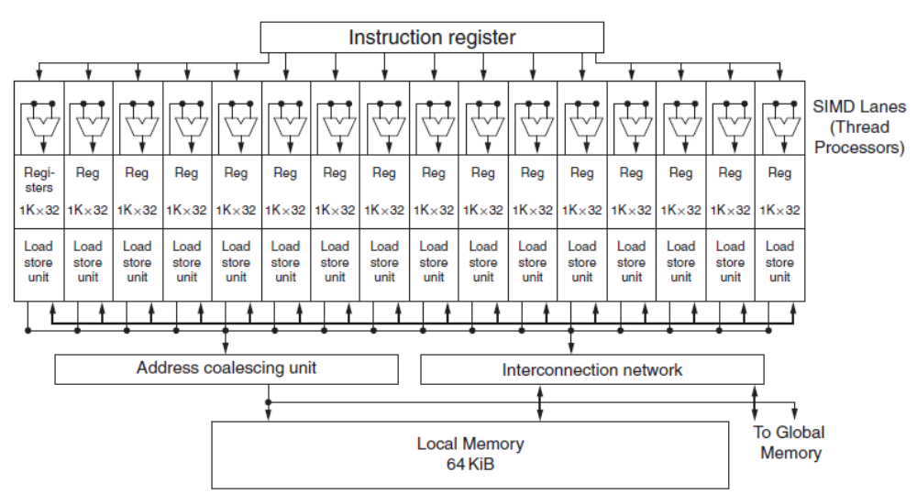
Simplified block diagram of the datapath of a multithreaded SIMD Processor.
It has 16 SIMD lanes. The SIMD Thread Scheduler has many independent SIMD threads that it chooses from to run on this processor.

- Dropping down one more level of detail, the machine object that the hardware creates, manages, schedules, and executes is a thread of SIMD instructions, which we will also call a SIMD thread. It is a traditional thread, but it contains exclusively SIMD instructions.
- These SIMD threads have their own program counters and they run on a multithreaded SIMD processor.
- The SIMD Thread Scheduler includes a controller that lets it know which threads of SIMD instructions are ready to run, and then it sends them off to a dispatch unit to be run on the multithreaded multithreaded processor (see Section 6.4), except that it is scheduling threads of SIMD instructions.
- GPU hardware has two levels of hardware schedulers:
1. The Thread Block Scheduler that assigns blocks of threads to multithreaded SIMD processors, and
2. the SIMD Thread Scheduler within a SIMD processor, which schedules when SIMD threads should run.
The SIMD instructions of these threads are 32 wide, so each thread of SIMD instructions would compute 32 of the elements of the computation. Since the thread consists of SIMD instructions, the SIMD processor must have parallel functional units to perform the operation. They are called as SIMD Lanes, and they are quite similar to the Vector Lanes.
The number of lanes per SIMD processor varies across GPU generations. With Fermi, each 32-wide thread of SIMD instructions is mapped to 16 SIMD Lanes, so each SIMD instruction in a thread of SIMD instructions takes two clock cycles to complete. Each thread of SIMD instructions is executed in lock step.
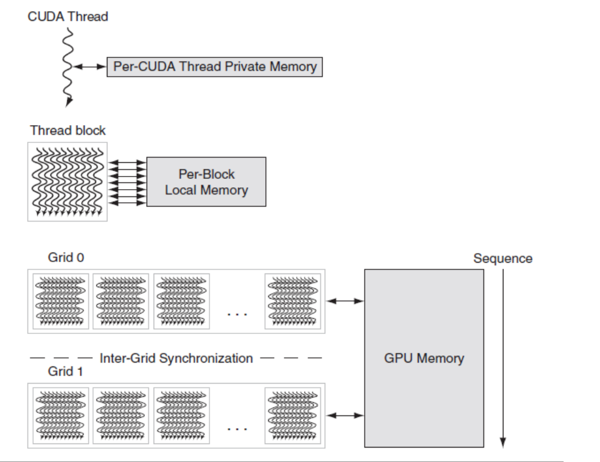
GPU Memory structures. GPU Memory is shared by the vectorized loops. All threads
of SIMD instructions within a thread block share Local Memory.

NVIDIA GPU Memory Structures
- Above figure shows the memory structures of an NVIDIA GPU.
- We call the on-chip memory that is local to each multithreaded SIMD processor Local Memory.
- It is shared by the SIMD Lanes within a multithreaded SIMD processor, but this memory is not shared between multithreaded SIMD processors.
- We call the off -chip DRAM shared by the whole GPU and all thread blocks GPU Memory.
- Rather than rely on large caches to contain the whole working sets of an application, GPUs traditionally use smaller streaming caches and rely on extensive multithreading of threads of SIMD instructions to hide the long latency to DRAM since their working sets can be hundreds of megabytes.
- Thus, they will not fit in the last level cache of a multicore microprocessor. Given the use of hardware multithreading to hide DRAM latency, the chip area used for caches in system processors is spent instead on computing resources and on the large number of registers to hold the state of the many threads of SIMD instructions

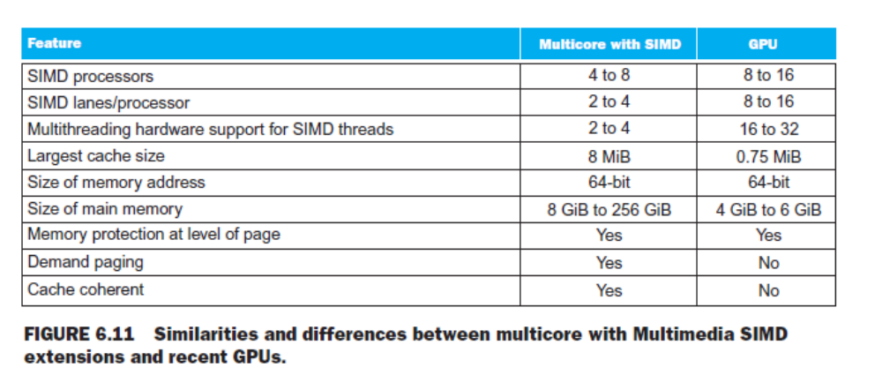
Putting GPUs into Perspective
- At a high level, multicore computers with SIMD instruction extensions do share similarities with GPUs. Above table shows the similarities and differences between them.
- Both are MIMDs whose processors use multiple SIMD lanes, although GPUs have more processors and many more lanes. Both use hardware multithreading to improve processor utilization, although GPUs have hardware support for many more threads.
- Both use caches, although GPUs use smaller streaming caches and multicore computers use large multilevel caches that try to contain whole working sets completely.
- Both use a 64-bit address space, although the physical main memory is much smaller in GPUs. While GPUs support memory protection at the page level, they do not yet support demand paging.
- SIMD processors are also similar to vector processors. The multiple SIMD processors in GPUs act as independent MIMD cores, just as many vector computers have multiple vector processors.
- This view would consider the Fermi GTX 580 as a 16-core machine with hardware support for multithreading, where each core has 16 lanes.

- The biggest difference is multithreading, which is fundamental to GPUs and missing from most vector processors.
- GPUs and CPUs do not go back in computer architecture genealogy to a common ancestor; there is no Missing Link that explains both. As a result of this uncommon heritage, GPUs have not used the terms common in the computer architecture community, which has led to confusion about what GPUs are and how they work.
- The table below (from left to right) lists the more descriptive term used in this section, the closest term from mainstream computing, the official NVIDIA GPU term in case you are interested, and then a short description of the term.

- While GPUs are moving toward mainstream computing, they can’t abandon their responsibility to continue to excel at graphics. Thus, the design of GPUs may make more sense when architects ask, given the hardware invested to do graphics well, how can we supplement it to improve the performance of a wider range of applications?

- Having covered two different styles of MIMD that have a shared address space, we next introduce parallel processors where each processor has its own private address space, which makes it much easier to build much larger systems. The Internet services that you use every day depend on these large scale systems.

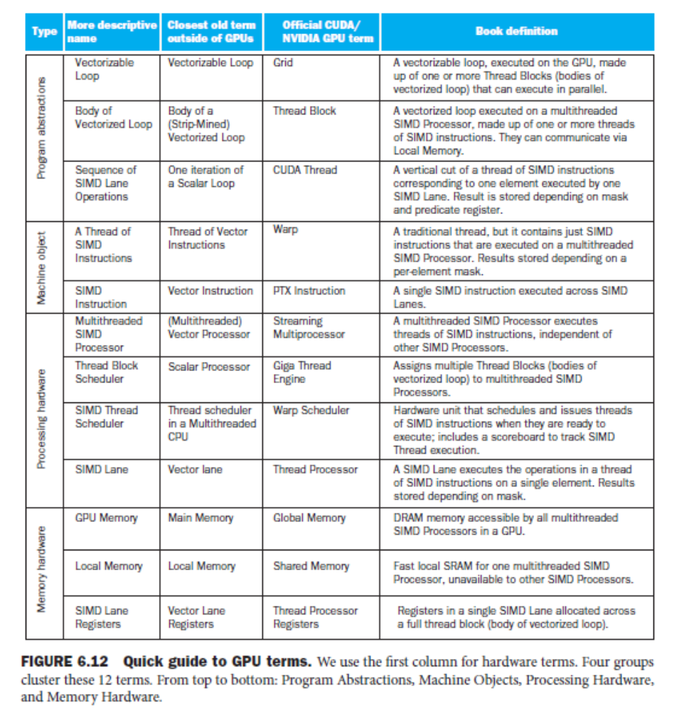

- While the GPU was introduced as having a separate memory from the CPU, both AMD and Intel have announced “fused” products that combine GPUs and CPUs to share a single memory. The challenge will be to maintain the high bandwidth memory in a fused architecture that has been a foundation of GPUs

Clusters, Warehouse Scale Computers,and Other Message-Passing Multiprocessors

Message-Passing Multiprocessors

Th e alternative approach to sharing an address space is for the processors to each have their own private physical address space.

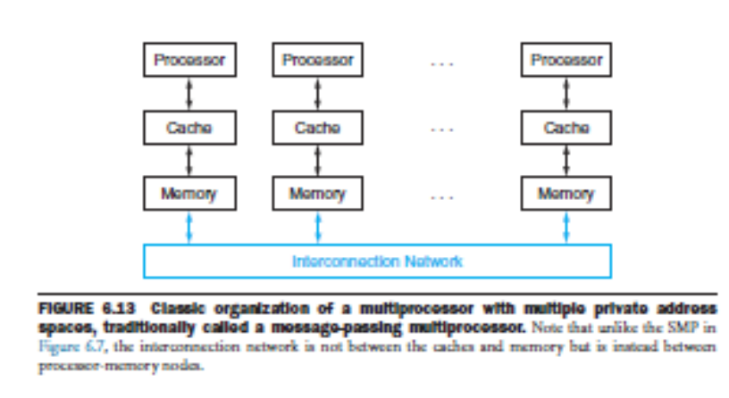
Message-Passing Multiprocessors

Th is alternative multiprocessor must communicate via explicit message passing(communicating between multiple processors by explicitly sending and receiving information), which traditionally is the name of such style of computers.

The system should have routines to send and receive messages.

coordination is built in with message passing, since one processor knows when a message is sent, and the receiving processor knows when a message arrives. If the sender needs confi rmation that the message has arrived, the receiving processor can then send an acknowledgment message back to the sender.

Th ere have been several attempts to build large-scale computers based on high-performance message-passing networks, and they do off er better absolute communication performance than clusters built using local area networks.

Computers that rely on message passing for communication rather than cache coherent shared memory are much easier for hardware designers to build .
Th ere is an advantage for programmers as well, in that communication is explicit, which means there are fewer performance surprises than with the implicit communication in cache-coherent shared memory computers.
Th e downside for programmers is that it􀲬s harder to port a sequential program to a message passing computer, since every communication must be identifi ed in advance or the program doesn􀲬t work. Cache-coherent shared memory allows the hardware to
fi gure out what data needs to be communicated, which makes porting easier.

Clusters :
clusters are collections of computers connected via I/O over standard network switches to form a message passing multiprocessor.
Th ere are diff erences of opinion as to which is the shortest path to high performance, given the pros and cons of implicit communication, but there is no confusion in the marketplace today. Multicore microprocessors use shared physical memory and nodes of a cluster communicate with each other using message passing.

Some concurrent applications run well on parallel hardware, independent of whether it off ers shared addresses or message passing. In particular, task-level parallelism and applications with little communication􀲧like Web search, mail servers, and fi le servers􀲧do not require shared addressing to run well.

As a result, clusters have become the most widespread example today of the message-passing parallel computer. Given the separate memories, each node of a cluster runs a distinct copy of the operating system. In contrast, the cores inside a microprocessor are connected using a high-speed network inside the chip, and a multichip sharedmemory system uses the memory interconnect for communication. Th e memory interconnect has higher bandwidth and lower latency, allowing much better communication performance for shared memory multiprocessors.

Th e weakness of separate memories for user memory from a parallel programming perspective turns into a strength in system dependability . Since a cluster consists of independent computers connected through a local area network, it is much easier to replace a computer without bringing down the system in a cluster than in an shared memory multiprocessor. Fundamentally, the shared address means that it is diffi cult to isolate a processor and replace it without heroic work by the operating system and in the physical design of the server. It is also easy for clusters to scale down gracefully when a server fails, thereby improving dependability. Since the cluster soft ware is a layer that runs on top of the local operating systems running on each computer, it is much easier to disconnect and replace a broken computer.

Given that clusters are constructed from whole computers and independent, scalable networks, this isolation also makes it easier to expand the system without bringing down the application that runs on top of the cluster.

Th eir lower cost, higher availability, and rapid, incremental expandability make clusters attractive to service Internet providers, despite their poorer communication performance when compared to large-scale shared memory multiprocessors. Th e search engines that hundreds of millions of us use every day depend upon this technology. Amazon, Facebook, Google, Microsoft , and others all have multiple datacenters each with clusters of tens of thousands of servers. Clearly, the use of multiple processors in Internet service companies has been hugely successful.

Warehouse-Scale Computers

Internet services, such as those described above, necessitated the construction of new buildings to house, power, and cool 100,000 servers. Although they may be classifi ed as just large clusters, their architecture and operation are more sophisticated. Th ey act as one giant computer and cost on the order of $150M for the building, the electrical and cooling infrastructure, the servers, and the networking equipment that connects and houses 50,000 to 100,000 servers. We consider them a new class of computer, called Warehouse-Scale Computers (WSC).

At this extreme scale, which requires innovation in power distribution, cooling, monitoring, and operations, the WSC is a modern descendant of the 1970s supercomputers—making Seymour Cray the godfather of today’s WSC architects. His extreme computers handled computations that could be done nowhere else, but were so expensive that only a few companies could aff ord them. Th is time the target is providing information technology for the world instead of high performance computing for scientists and engineers. Hence, WSCs surely play a more important societal role today than Cray’s supercomputers did in the past.

While they share some common goals with servers, WSCs have three major distinctions:

1. Ample, easy parallelism: A concern for a server architect is whether the applications in the targeted marketplace have enough parallelism to justify the amount of parallel hardware and whether the cost is too high for suffi cient communication hardware to exploit this parallelism. A WSC architect has no such concern. First, batch applications like MapReduce benefi t from the large number of independent data sets that need independent processing,such as billions of Web pages from a Web crawl. Second, interactive Internet service applications, also known as Soft ware as a Service (SaaS), can benefi t from millions of independent users of interactive Internet services. Reads and writes are rarely dependent in SaaS, so SaaS rarely needs to synchronize.For example, search uses a read-only index and email is normally reading and writing independent information. We call this type of easy parallelism Request-Level Parallelism, as many independent eff orts can proceed in parallel naturally with little need for communication or synchronization.

2. Operational Costs Count: Traditionally, server architects design their systems for peak performance within a cost budget and worry about energy only to make sure they don’t exceed the cooling capacity of their encl sure. Th ey usually ignored operational costs of a server, assuming that they pale in comparison to purchase costs. WSC have longer lifetimes—the building and electrical and cooling infrastructure are oft en amortized over 10 or more years—so the operational costs add up: energy, power distribution, and cooling represent more than 30% of the costs of a WSC over 10 years.

3. Scale and the Opportunities/Problems Associated with Scale: To construct a single WSC, you must purchase 100,000 servers along with the supporting infrastructure, which means volume discounts. Hence, WSCs are so massive internally that you get economy of scale even if there are not many WSCs.
Th ese economies of scale led to cloud computing, as the lower per unit costs of a WSC meant that cloud companies could rent servers at a profi table rate and still be below what it costs outsiders to do it themselves. Fault tolerance is even more important for the WSC architect than the server architect.

