

**To-Do List Application**

**Phase 5**

**COLLEGE CODE :** 9506

**COLLEGE NAME :** Einstein College of Engineering

**DEPARTMENT :** B.E COMPUTER SCIENCE

**STUDENT NM-ID :** 569499d7d464f30a31f49877e45750c8

**ROLL NUMBER :** 9506231040104

**DATE :** 10/10/2025

**Submitted By,**

**NAME :** M.THIRUMALAIKUMAR

**MOBILE NUMBER :** 9361350749

**Phase 5**

**Project Demonstration & Documentation**

**Final Demo Walkthrough**

**Objective:**

Showcase the complete working application with all features implemented in Phase 4.

**Demo Steps:**

Open the application in a browser.

* + Double-click on index.html.
  + The app will open in your **default browser** (Chrome, Firefox, Edge, etc.).

Demonstrate **adding tasks** with date, time, and priority.

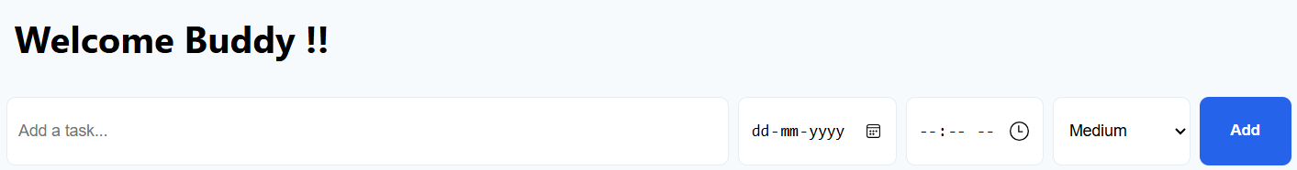

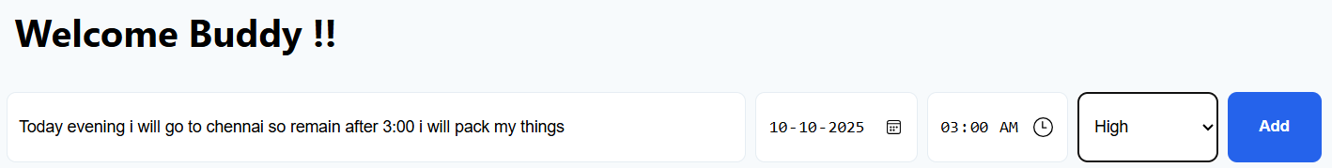

Show **editing tasks inline** using double-click.



Mark tasks as **completed**, and use **filters** (All, Active, Completed).

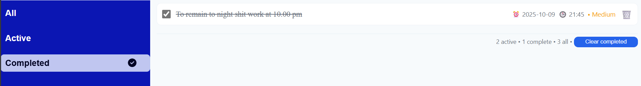

Drag & drop tasks to reorder.

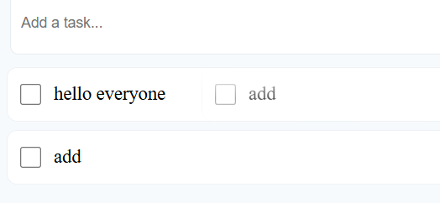

Show **search functionality** in action.

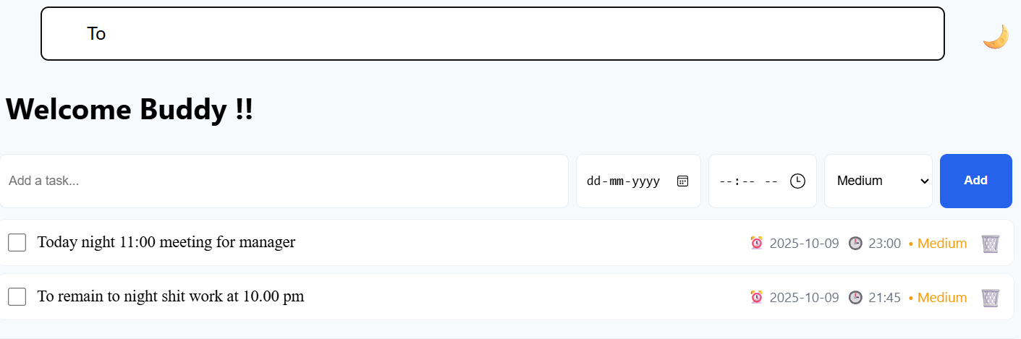

Toggle **dark mode**.

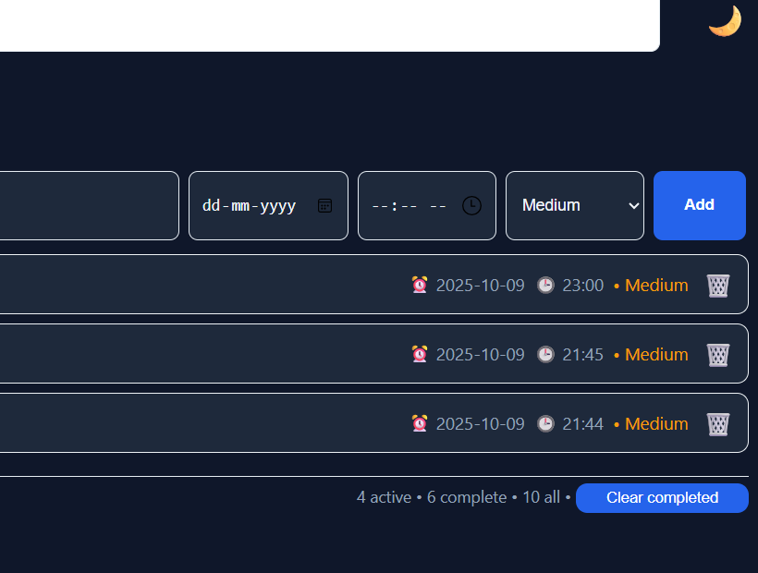

Demonstrate **reminder notifications** with sound alerts.

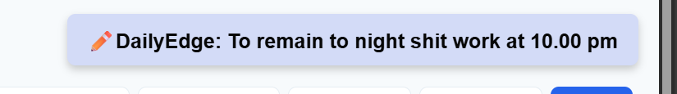

Clear completed tasks and observe count updates.

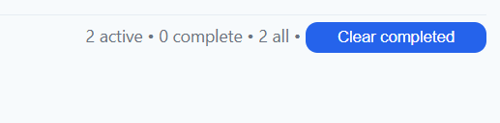

Showcase responsiveness on **desktop, tablet, and mobile**.

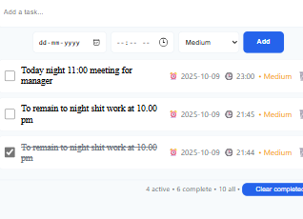

**Project Report**

**Introduction:**

The **DailyEdge To-Do List** application is designed to help users efficiently manage their daily tasks and stay organized. Unlike a simple checklist, DailyEdge offers advanced features such as task prioritization, due dates, reminders with sound alerts, inline editing, and drag-and-drop task reordering.

The primary purpose of the application is to provide a **user-friendly, interactive, and responsive platform** where users can:

* **Add, edit, and delete tasks** effortlessly.
* **Prioritize tasks** based on urgency (High, Medium, Low).
* **Set due dates and times** and receive timely reminders.
* **Search and filter tasks** for better task management.
* **Maintain task order and completion status**, even after closing the browser, through localStorage persistence.
* **Toggle between light and dark themes** for better visual comfort.

The application emphasizes **usability, accessibility, and performance**, making it suitable for both personal and professional task management. DailyEdge aims to enhance productivity while providing a smooth and engaging user experience.

* **Phase 4 Enhancements:** Additional features, UI/UX improvements, performance & security checks.
* **Implementation Details:** HTML, CSS, and JavaScript structure; localStorage usage.
* **Conclusion:** Summary of features and future scope.

**Implementation Details:**

**HTML**

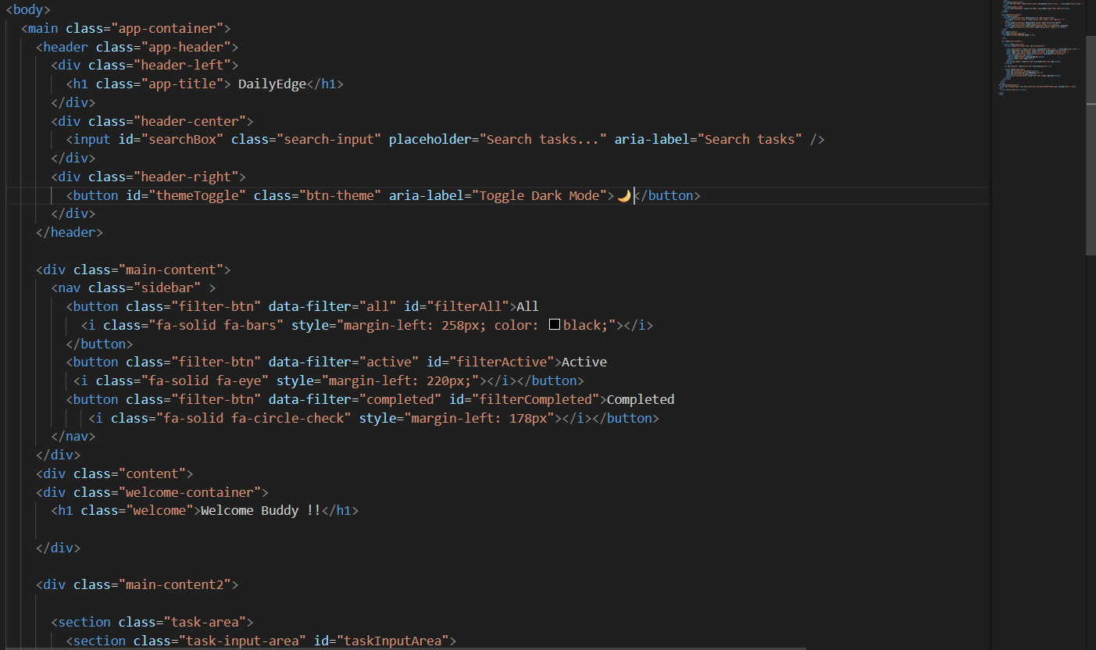

**CSS**

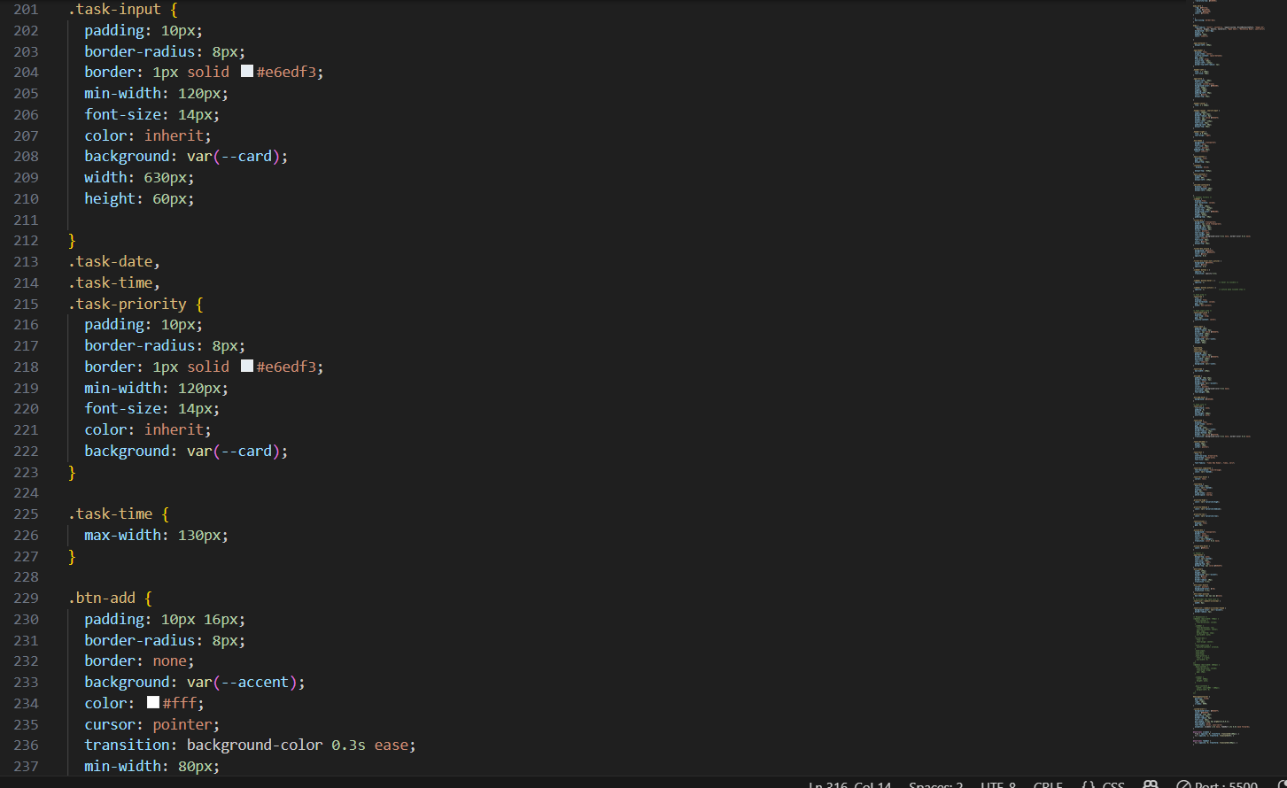

**JS**

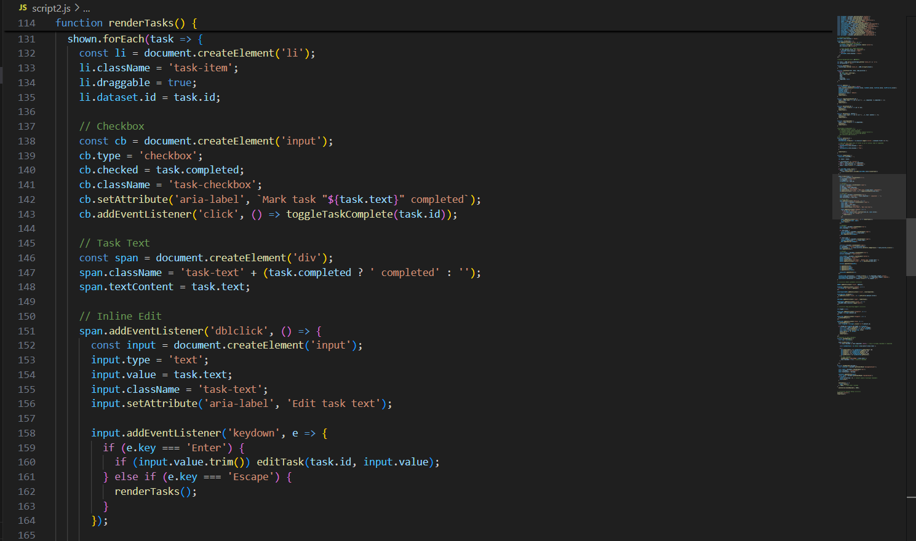

**Screenshots / API Documentation**

**Welcome Screen / Dashboard**

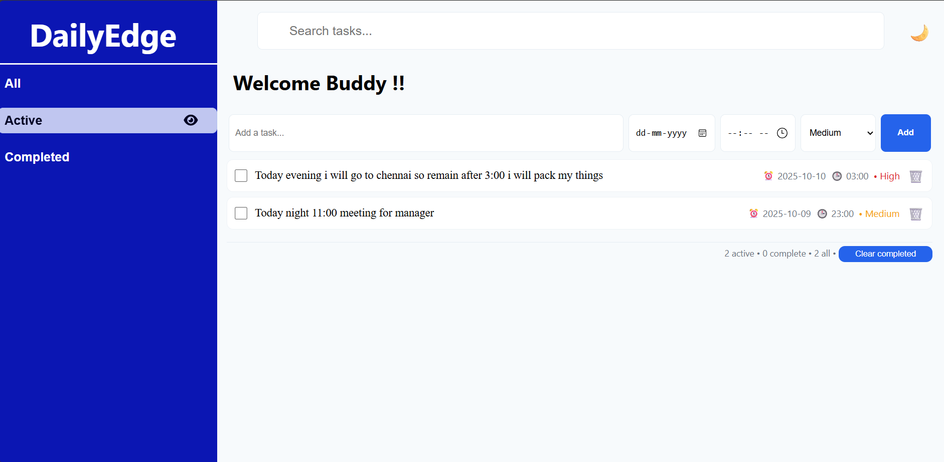

**Adding a Task**





**Task Completed & Filtered View**



**Inline Editing**



**Dark Mode View**

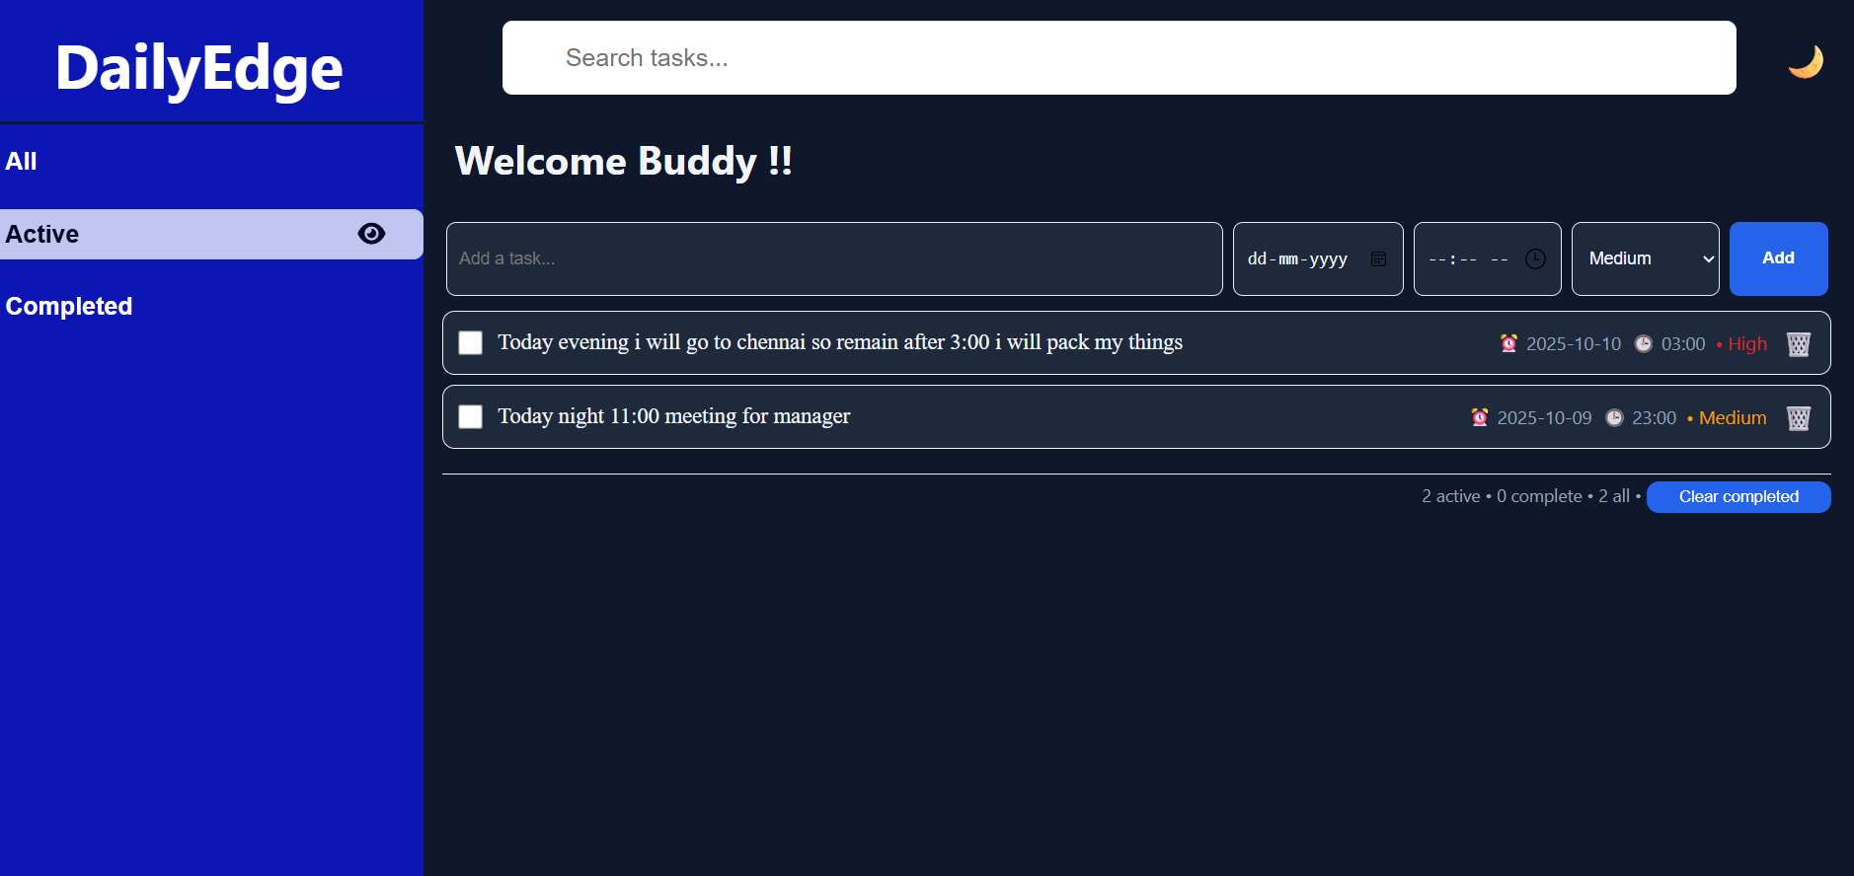

**Reminder Alert Popup**



**API Documentation:**

*If API is used in future enhancement, currently localStorage functions as “pseudo-API”*

**addTask()**

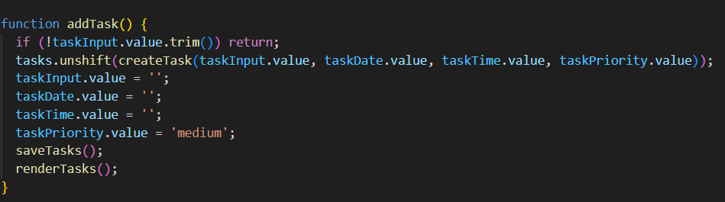

**editTask()**

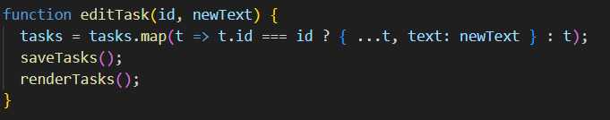

**deleteTask()**

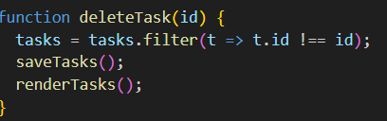

**Challenges & Solutions**

**Challenges:**

* Implementing drag & drop correctly with task reordering.
* Managing reminders for tasks with date & time.
* Maintaining localStorage persistence with live updates.
* Ensuring responsive UI for various screen sizes.

**Solutions:**

* Used dragstart, dragover, drop events for drag & drop.
* Periodic check with setInterval for reminders.
* Tasks array stored and updated in localStorage.
* Flexbox and CSS media queries for responsive design.

**GitHub README & Setup Guide**

**Case-1**

**Clone and Open Locally**

1. Clone the repository:
2. git clone <your-repo-link>
3. Navigate to the project folder.
4. Open index.html in your preferred browser (Chrome, Firefox, Edge, etc.).

**Case-2**

**Using VS Code Live Server**

1. Open the project folder in VS Code.
2. Right-click index.html → Open with Live Server.
3. The app will open in a browser with live reload support.

**Case-3**

**Deploy Online (Optional)**

1. Deploy on Netlify or Vercel for easy access.
2. Drag & drop the project folder (or connect GitHub repo) to deploy.
3. Share the live link in your README.

**Final Submission**

The final submission ensures that all project files are

organized, functional, and accessible for evaluation. This includes both the **source code repository** and the **deployed live application**.

**GitHub Repository**

**Contents:**

* **index.html** → Main HTML file for the application.
* **styles.css** → All styles including responsive layouts, dark mode, and animations.
* **script.js** → All JavaScript logic including task management, inline editing, drag & drop, reminders, search & filter, and theme toggle.
* **README.md** → Detailed project documentation, installation instructions, usage guide, screenshots, and contributor info.

**Deployment Link**

**Netlify or Vercel:**

* The project is deployed on a cloud platform for easy access
* Users can interact with the **live application** without downloading files.
* Ensures all features (adding/editing/deleting tasks, reminders, drag & drop, filters, dark mode) are fully functional.

**Expected Behavior:**

* Opening the deployed link should display the **DailyEdge Dashboard** immediately.
* All buttons, task interactions, and notifications should work exactly as in the local version.
* Responsive design ensures proper display on desktop, tablet, and mobile devices.

**Verification Before Submission**

**Check that:**

* All tasks can be added, edited, deleted, and filtered correctly.
* Drag & drop reordering is functional.
* Reminders appear with **custom notifications and sound**.
* Dark mode toggle works without affecting usability.
* LocalStorage properly saves tasks, so refreshing the page retains data.
* Search bar filters tasks accurately in real time.
* Ensures that the submission meets the project requirements and **provides a seamless user experience**.

**Submission Checklist**

* GitHub repository is complete with all project files.
* README file contains installation, usage instructions, and screenshots.
* Application deployed on **Netlify/Vercel**.
* All features tested and working correctly.
* Screenshots included in the report or README for reference.