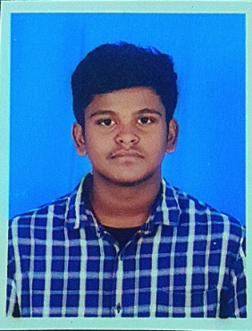

**Name: B.Thirugnanam**

**Email Id:** [**bharathbalu24@gmail.com**](mailto:bharathbalu24@gmail.com)

**Contact Number:9080004038**

**CAREER OBJECTIVE:**

**To secure a challenging position in a reputable organization to expand my learning,**

**Knowledge and skills.**

**EDUCATIONAL QUALIFICATION:**

|  |  |  |  |  |
| --- | --- | --- | --- | --- |
| **Duration/Year of Passing** | **Degree course** | **Institution** | **University/Board** | **Percentage%** |
| **2021-2024** | **B.sc computer Science** | **Swami Dayananda**  **College of Arts & Science** | **Bharathidasan University** | **75%(till)** |
| **2021** | **HSC** | **V.S Boys High Secondary School,Thiruvaur** | **State Board** | **75%** |
| **2019** | **SSLC** | **Infant Jesus Matriculation School,Thevur** | **State Board** | **62%** |

**TECHNICAL COURSES:**

**Programming in c**

**Programming in C++**

**Programming in java**

**HDML**

**CERTIFICATE COURSES:**

**Type writing (English Junior)**

**Diploma in Hardware**

**Microsoft Word, Excel**

**Working Platform:**

**Windows 7**

**Windows 8**

**Windows 10**

**HOBBIES:**

**Travelling**

**Outdoor games**

**BIO DATA:**

**Name : B.Thirugnanam**

**Father’name : T.Balasubramaniyan**

**Mother’name : B.Baby**

**Date Of Birth : 24.08.2003**

**Gender :Male**

**Address :1/23 East Street,Pallavapuram,**

**Thiruvarur 610 106**

**Nationality : Indian**

**Marital Status : Single**

**DECLARATION:**

**I here assure you that all the above details furnished about are true to my knowledge.**