**Phase 1 : Work Details**

**Step 1:**

Initially the Multimodel MRI Brain tumor BraTS20_Training Dataset is Extracted here.

# Image data descriptions

All BraTS multimodal scans are available as NIfTI files (.nii.gz) -> commonly used medical imaging format to store brain imagin data obtained using MRI and describe different MRI settings

1. ****T1****: T1-weighted, native image, sagittal or axial 2D acquisitions, with 1–6 mm slice thickness.
2. ****T1c****: T1-weighted, contrast-enhanced (Gadolinium) image, with 3D acquisition and 1 mm isotropic voxel size for most patients.
3. ****T2****: T2-weighted image, axial 2D acquisition, with 2–6 mm slice thickness.
4. ****FLAIR****: T2-weighted FLAIR image, axial, coronal, or sagittal 2D acquisitions, 2–6 mm slice thickness.

Data were acquired with different clinical protocols and various scanners from multiple (n=19) institutions.

**Step 2:** Pre processing all the imaging datasets have been segmented manually, by one to four raters, following the same annotation protocol, and their annotations were approved by experienced neuro-radiologists. Annotations comprise the GD-enhancing tumor (ET — label 4), the peritumoral edema (ED — label 2), and the necrotic and non-enhancing tumor core (NCR/NET — label 1), as described both in the BraTS20 TMI paper and in the latest BraTS summarizing paper. The provided data are distributed after their pre-processing, i.e., co-registered to the same anatomical template, interpolated to the same resolution (1 mm^3) and skull-stripped.

Pre-Processing :

1. **Show whole nifti data -> print each slice from 3d data**
2. **Show segment of tumor for each above slice**
3. **Gif representation of slices in 3D volume**
4. **Show segments of tumor using different effects**

# **Step 3:** **Cascaded 3D V-Net** — Multi-Organ Segmentation Model

# **Outline**

1. **Fine Cascaded V-Net**
2. **Loss Function**
3. **Training & Validation & Testing**
4. **Comparison with State-of-the-art Approaches**

**Fine Cascaded V-Net:**

Images, labels

Multiclass Prediction

Detected Body Parts

Final Prediction

Train 3DFCN

Dilate Fore-gnd

Train 3DFCN

**1**st Stage C1 2nd Stage C2

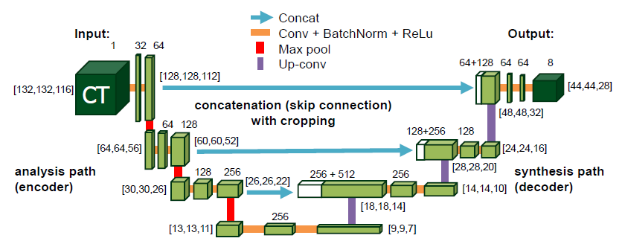

1. **stage FCNs used are [3D V-Net](http://3d u-net/" \t "https://sh-tsang.medium.com/_blank)**

# Loss Function

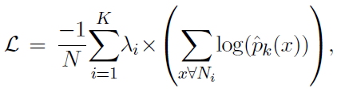

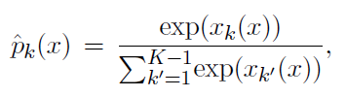

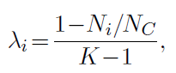

* *Ni* are the number of voxels within one class in *Ln.*
* *NC* is the number of voxels within candidate region *C1* or *C2*.
* *λi* is the value based on *Ni* and *NC*, i.e. based on the occurrence frequency of the class. And summing all *λi*equals to 1.
* Simply speaking, the loss is the **weighted voxel-wise cross-entropy loss**.

**Step 4:** Evaluate for F1score, Accuracy plot diagram, precision