ROLLNO: 240701569

EXPERIMENT 10
AIM:
To create data visualizations such as pie charts and bar graphs for an agriculture management system using JavaScript and Chart.js.

TOOLS USED:
- HTML
- CSS
- JavaScript
- Chart.js
- Visual Studio Code

PROCEDURE:
Step 1: Create HTML File
- Created an HTML file to display the charts.
- Added <canvas> elements for pie chart and bar chart.
- Included Chart.js library using CDN.

Step 2: Apply CSS Styling
- Designed a clean user interface with gradient background.
- Centered the charts using container layout.
- Styled chart boxes with padding, border-radius, and shadow.

Step 3: Add JavaScript Logic
- Defined agriculture data such as crop types and production values.
- Used Chart.js to create:
o Pie chart (distribution of crops) o Bar chart (comparison of production) Step 4: Display Charts
- Rendered charts inside canvas elements.
- Ensured proper sizing and alignment.

WORKING:
- The system takes predefined agriculture data.
- Pie chart shows percentage distribution of crops.
- Bar chart shows comparison of production values.
- Charts update dynamically using JavaScript.

OUTPUT:
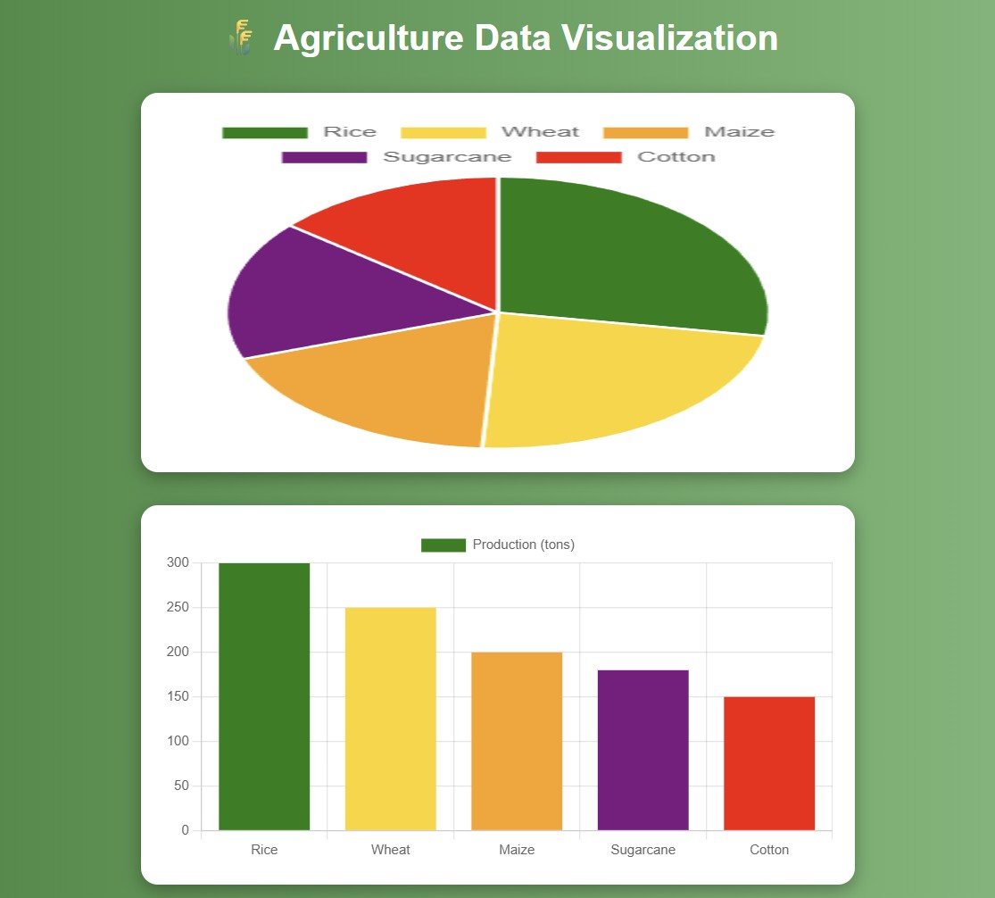
RESULT:
The experiment was successfully completed.
Data visualization for agriculture management was implemented using Chart.js, and the charts were displayed clearly with proper styling.

