AI-POWERED INTELLIGENT DOCUMENT SEARCH AND ANALYTICS USING DATA STRUCTURES AND NLP
A Project Based Learning Report Submitted in partial fulfilment of the requirements for the award of the degree

of

Bachelor of Technology
in The Department of CSE
DATA STRUCTURES AND ALGORITHMS - 3 | 25CS2103E

Submitted by
2510030004 :M.SRIHITHA
2510030007 : Y.AKSHAYA
2510030170 :T.VARSHA

Under the guidance of
DR.AFTAB YASEEN


Department of Computer Science and Engineering
Koneru Lakshmaiah Education Foundation, Aziz Nagar
Aziz Nagar – 500075
OCTOBER - 2026
Abstract
The rapid growth of digital documents has created a need for efficient and intelligent document retrieval systems. Traditional keyword-based searching becomes less effective as the number and size of documents increase. This project presents an AI-powered intelligent document search and analytics system that combines Data Structures and Algorithms with Natural Language Processing techniques.
The proposed system supports document ingestion and text extraction from multiple formats. The extracted content is preprocessed using tokenization, stopword removal and lightweight normalization. A HashMap-based inverted index is constructed to provide efficient term-to-document retrieval. Search results are ranked using TF-IDF scoring with title boosting, while edit-distance-based fuzzy matching helps handle small spelling errors. A Trie-based component is included for prefix-based search suggestions, and frequency-based extractive summarization provides concise document summaries.
The system also supports streamed document extraction and 12,000-character chunking for processing larger documents. An analytics module provides information such as the number of indexed documents, tokens, chunks, unique terms, top terms and search response time. The implementation provides a transparent demonstration of how DSA and NLP can be combined to build an intelligent document retrieval system.
The system is designed to provide users with relevant search results without requiring them to manually inspect every document. By combining term matching with TF-IDF-based relevance scoring, title boosting, and query-term coverage, the system prioritizes documents that are more closely related to the user’s search query. The fuzzy matching mechanism further improves usability by recovering relevant results when minor spelling variations are present.
The project also demonstrates the practical application of different data structures and algorithms within a single document retrieval workflow. HashMaps are used for inverted indexing, document storage, and term-frequency calculation, while the Trie supports prefix-based suggestions. Edit distance implemented using dynamic programming helps identify closely matching terms, and sorting is used to arrange retrieved documents according to their relevance scores.
In addition to search, IntelliDoc provides document-level summaries and repository analytics to improve the overall usefulness of the system. The combination of document processing, indexing, ranking, summarization, fuzzy retrieval, and analytics demonstrates how DSA and NLP techniques can be integrated into a practical Java-based application for intelligent document management.

Keywords: Intelligent Document Search, HashMap, Inverted Index, Trie, TF-IDF, Natural Language Processing, Fuzzy Search, Document Analytics.

List of Figures

FIGURE PAGE NO.
- FIGURE 2.1.1- IntelliDoc System Architecture: 6 2)FIGURE 2.5.1- IntelliDoc document processing and searchflow 7
3)FIGURE 3.2.1-IntelliDoc Search interface Showing Summarized Result 8
List of Tables Page No.

1)TABLE 3.2.1: Search Queries Used During Testing 8

2)TABLE 3.5.1:Performance Analysis Metrics 10

3)TABLE 4.1 :Observed System Test Configuration 11

Table of Contents Page No.
1. INTRODUCTION 5

2. METHODOLOGY 6

3. EXPERIMENTS AND RESULTS 8

4. RESULTS AND DISCUSSION 10

5. CONCLUSION AND FUTURE WORK 12

6. REFERENCES 13

AI-POWERED INTELLIGENT DOCUMENT SEARCH AND ANALYTICS USING DATA STRUCTURES AND NLP

Introduction
The rapid growth of digital information has resulted in a large number of documents being stored on computers and cloud-based systems. These documents may include PDF files, Word documents, text files, presentations, spreadsheets, and image-based documents. As the volume of digital documents increases, finding relevant information quickly becomes a major challenge. Traditional file searching methods generally depend on simple keyword matching or file names and may not provide effective relevance ranking, fuzzy matching, or useful document information. Users may have to manually open multiple documents to identify the information they need, which becomes inefficient when the document collection is large.
Intelligent document retrieval systems are designed to overcome these limitations by organizing document content and providing faster and more relevant search results. The IntelliDoc project is developed as an intelligent document search and analytics system that combines Data Structures and Algorithms (DSA), Natural Language Processing (NLP), and information retrieval techniques. The system allows users to add documents to a searchable repository, extract their textual content, preprocess the text, create an index, and retrieve relevant documents based on a user query. The main objective is to provide a transparent and efficient document retrieval system while demonstrating the practical application of DSA concepts.
Natural Language Processing is used to prepare document content and search queries for efficient retrieval. The system performs tokenization, stop-word removal, normalization, and basic stemming-like processing to reduce variations in words. This preprocessing allows related forms of words to be represented more consistently during indexing and searching. The system also generates important sentences from documents using an extractive summarization approach, allowing users to obtain a brief representation of the document content without manually reading the entire document.
A major component of IntelliDoc is its HashMap-based inverted index. Instead of scanning every document whenever a search is performed, the inverted index maintains a mapping between terms and the documents in which those terms occur. This provides fast average-time lookup and makes document retrieval more efficient. HashMaps are also used for storing document information and calculating term frequencies. A Trie data structure is included to support prefix-based search suggestions. These data structures demonstrate how fundamental DSA concepts can be applied to solve practical information retrieval problems.
The search engine uses TF-IDF-based ranking to determine the relevance of documents for a query. Term Frequency measures how frequently a query term occurs in a document, while Inverse Document Frequency gives greater importance to terms that occur in fewer documents. The system combines these values with a title boost and query-term coverage to produce a relevance score. This allows the most relevant documents to appear before less relevant documents rather than simply returning documents in an arbitrary order.
IntelliDoc also includes a fuzzy search mechanism based on edit distance. This allows the system to recover relevant results when a user makes a small spelling mistake in a query. For example, a query such as “machine lerning” can be matched with a document containing “machine learning”. This improves the usability of the search system because users do not always enter perfectly spelled queries. The system therefore combines exact term retrieval with fuzzy matching when necessary.
Another important feature is the handling of large documents. During document ingestion, extracted text is processed in 12,000-character chunks instead of requiring the entire document to be handled as one large text block. This supports more efficient processing of large files and allows the system to record the number of chunks created for each document. Apache Tika is used for extracting text from supported document formats. The system also calculates metadata such as file size, document type, SHA-256 hash, token count, and indexed time.
The project also provides an analytics section that displays information about the indexed document collection, including the number of documents, repository size, tokens indexed, chunks created, unique terms, and frequently occurring terms. These statistics help demonstrate how the document repository and search index are being processed internally. Image files can also be added to the repository; in the current implementation, image processing records image metadata and an OCR status message, while actual OCR-based text extraction is not yet implemented.
The overall objective of IntelliDoc is to develop a practical and understandable document retrieval system using DSA and NLP rather than relying entirely on external search platforms. The project demonstrates how inverted indexing, HashMaps, Tries, sorting, edit-distance algorithms, TF-IDF ranking, text preprocessing, summarization, and document chunking can work together to create an intelligent search application. The current system provides a foundation that can be extended in the future with OCR, semantic or vector-based search, improved ranking, multimodal document processing, and more advanced question-answering capabilities.

METHODOLOGY

2.1 System Architecture
The proposed IntelliDoc system is designed as an intelligent document search and analytics application that combines Data Structures and Algorithms (DSA), Natural Language Processing (NLP), and information retrieval techniques. The system processes documents through a sequence of stages, beginning with document upload and text extraction, followed by NLP preprocessing, indexing, query processing, relevance ranking, and result presentation.
The overall workflow of the proposed system is Document Upload → Text Extraction → NLP Preprocessing → Chunking → HashMap-Based Inverted Index → Query Processing → TF-IDF Ranking → Fuzzy Matching → Results and Summary → Analytics. The system is implemented using Java and provides a graphical user interface for adding documents, searching the indexed repository, viewing ranked results, and analyzing repository statistics.
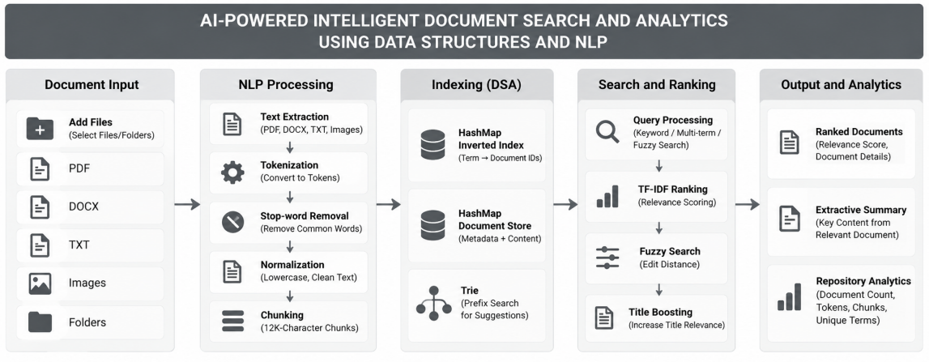
FIGURE 2.1.1: IntelliDoc System Architecture

2.2 Document Ingestion and NLP Preprocessing
The document ingestion module extracts available textual content from supported document formats using Apache Tika. The system identifies the document type and stores metadata including file name, file path, file size, SHA-256 hash, and indexing time. The extracted text is then processed using NLP techniques.
The NLP module converts text to lowercase, tokenizes the content, removes common stop words, and performs basic word normalization. The processed terms are used to generate term-frequency information for each document. Large extracted documents are divided into approximately 12,000-character chunks to support efficient processing.

2.3 DSA-Based Indexing
The main data structure used for document retrieval is a HashMap-based inverted index. The index maintains a mapping between terms and the document IDs in w hich those terms occur. This avoids scanning every document during a search and provides efficient average-time term lookup.
HashMaps are also used for document storage and term-frequency calculation. A Trie is implemented to support prefix-based search suggestions. Lists and Sets are used for query and candidate-document management, while sorting is used to arrange documents according to their relevance scores.

2.4 Search, Ranking and Fuzzy Search
When a user enters a query, it is processed using the same NLP operations used during document indexing. The inverted index retrieves documents containing one or more query terms. The retrieved documents are ranked using a TF-IDF-based scoring method.
The ranking considers term frequency, inverse document frequency, query-term coverage, and a title boost. The system also provides fuzzy matching using edit distance implemented through dynamic programming. This allows small spelling errors in a query to be handled more effectively.

2.5 Document Summarization and Analytics
The system generates an extractive summary by identifying important sentences from the document based on the frequency of normalized terms. This provides users with a short representation of the document content.
The analytics module displays information about the indexed repository, including the number of documents, repository size, tokens indexed, chunks created, unique terms, and frequently occurring terms. These statistics help evaluate the operation of the document indexing and retrieval system.
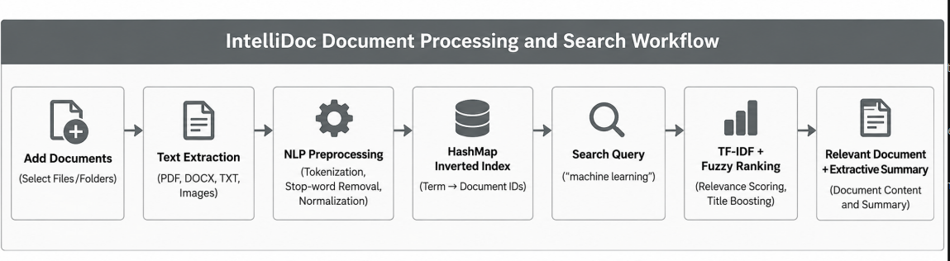
FIGURE 2.5.1: IntelliDoc document processing and searchflow

EXPERIMENTS

3.1 Experimental Setup
The IntelliDoc system was tested using a collection of technical and academic documents. The documents were added through the application interface and processed using the document ingestion and NLP pipeline. During indexing, the system extracted the available text, performed tokenization, stop-word removal, normalization, and term-frequency calculation. The processed terms were then stored in the HashMap-based inverted index.
Different search queries were used to evaluate document retrieval and ranking. The experiments tested normal keyword searching, multi-term searching, fuzzy searching, large-document processing, and image-document handling.

3.2 Search Experiments
The search functionality was evaluated using queries related to the contents of the indexed documents. The system retrieved candidate documents using the inverted index and ranked them using TF-IDF scoring, title boosting, and query-term coverage.
The following queries were used during testing:
Search Query | Purpose | Expected Result
machine learning | Keyword retrieval | Relevant machine-learning document
hash tables | DSA retrieval | Relevant DSA document
TF-IDF | NLP/IR retrieval | Relevant NLP document
precision recall | Multi-term retrieval | Relevant analytics document
machine lerning | Fuzzy search | Machine-learning document recovered
TABLE 3.2.1: Search Queries Used During Testing
The results displayed the relevance score, document type, file size, number of chunks, matched query terms, summary, and document path.
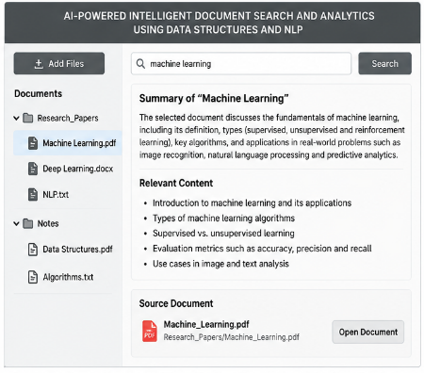
FIGURE 3.2.1: IntelliDoc Search interface Showing Summarized Result

3.3 Large Document Experiment
A large document was added to evaluate the document-processing mechanism. The extracted content was divided into approximately 12,000-character chunks instead of processing the complete document as one block.
The experiment verified that the system could extract, process, and index the content while maintaining chunk and token information. The number of chunks generated was also displayed in the search results and analytics information.

3.4 Image Document Experiment
An image document was added to evaluate the system's handling of image files. The current implementation records image metadata, including the image dimensions, and stores an OCR status message.
Actual OCR-based text extraction is not implemented in the current version. Therefore, text visible inside an image is not extracted and indexed. This experiment demonstrates the current image-processing capability and identifies OCR as a future enhancement.

E 3.5 Performance Analysis
The system records the response time for search operations and provides repository-level analytics. During testing, the analytics module displayed the number of indexed documents, repository size, tokens indexed, chunks created, unique terms, and frequently occurring terms.
One test configuration produced the following observed values:
Metric | Observed Value
Documents Indexed | 4
Tokens Indexed | 51
Chunks Created | 4
Unique Terms | 36
Index Type | HashMap Inverted Index
Ranking | TF-IDF + Title Boost + Fuzzy Fallback
Large-File Mode | Streamed Extraction + 12K-Character Chunks
TABLE 3.5.1:Performance Analysis Metrics
The experiments demonstrate that IntelliDoc can ingest documents, preprocess their content, create an indexed representation, retrieve relevant documents, rank results, and provide repository analytics. The fuzzy-search experiment additionally demonstrates the system's ability to handle small spelling errors in search queries.

RESULTS
The IntelliDoc system was successfully tested for document ingestion, indexing, keyword retrieval, relevance ranking, fuzzy search, large-document processing, and repository analytics. The experiments showed that the system can process supported documents and make their extracted content searchable through the HashMap-based inverted index.
The search engine successfully retrieved relevant documents for queries such as “machine learning,” “hash tables,” “TF-IDF,” and “precision recall.” The results displayed the document name, relevance score, document type, file size, number of chunks, matched query terms, summary, and file path.
The fuzzy-search mechanism was also tested using a query containing a small spelling error. The edit-distance-based fallback allows the system to identify closely matching indexed terms when direct retrieval does not produce candidates.
Large-document processing was evaluated using chunk-based extraction. The system processes extracted content in approximately 12,000-character chunks, allowing the number of chunks and indexed tokens to be tracked through the analytics module
In one observed test configuration, the system reported:

Metric | Result
Documents Indexed | 4
Tokens Indexed | 51
Chunks Created | 4
Unique Terms | 36
Index Type | HashMap Inverted Index
Ranking | TF-IDF + Title Boost + Fuzzy Fallback

TABLE 4.1 :Observed System Test Configuration

The analytics results demonstrate that the system can maintain useful statistics about the indexed repository. The HashMap inverted index provides the main retrieval mechanism, while the TF-IDF ranking improves the ordering of retrieved documents according to their relevance. The image-document experiment showed that the current system can process image metadata and record image dimensions. However, actual OCR is not implemented, so text contained inside an image is not currently extracted for search.
Overall, the results demonstrate that IntelliDoc provides a functional DSA- and NLP-based document retrieval system with keyword search, relevance ranking, fuzzy matching, summarization, chunk-based processing, and repository analytics.
The search experiments also showed that the system can retrieve relevant documents for different types of queries, including normal keywords, multiple terms, and small spelling errors. This demonstrates the combined use of indexing, TF-IDF ranking, and fuzzy matching in improving the search experience.The analytics and search results together show that IntelliDoc can organize document information and present useful results in a structured manner. These features provide a practical foundation for further development of the system.

The system also records document-level information such as file type, file size, number of chunks, matched query terms, summary, and file path. This gives users additional context along with the retrieved document and makes the search results easier to understand.
The use of chunk-based processing allows the system to handle extracted content in smaller sections rather than treating a large document as one continuous block. This also helps the system maintain token and chunk statistics that can be viewed through the analytics module.
Overall, the experimental results confirm that IntelliDoc combines DSA and NLP techniques into a single document retrieval workflow. The implemented features provide a foundation for future improvements such as OCR, semantic search, persistent indexing, and enhanced document analysis.

CONCLUSION and FUTURE WORK

The IntelliDoc project successfully demonstrates an intelligent document search and analytics system
using Data Structures, NLP, and information retrieval techniques. The system supports document ingestion, text preprocessing, HashMap-based inverted indexing, TF-IDF ranking, fuzzy search using edit distance, extractive summarization, and repository analytics. Testing demonstrated effective keyword retrieval, relevance ranking, spelling-error handling, and large-document processing.
In the future, IntelliDoc can be enhanced with OCR for searching text inside scanned documents and images, semantic/vector-based search for understanding related meanings, improved ranking and autocomplete, and persistent indexing for larger document repositories. The system can also be extended with multimodal document processing and intelligent question answering to provide more advanced document understanding and retrieval capabilities.
The testing and analysis of the system indicate that IntelliDoc can provide a structured approach to document retrieval. By combining document preprocessing, inverted indexing, relevance scoring, and fuzzy matching, the system reduces the effort required to locate useful information within the indexed document collection. The search results also provide additional information such as document type, file size, number of chunks, matched query terms, summary, and file path, helping users understand why a particular document was retrieved.
The project also demonstrates the practical importance of selecting appropriate data structures for information retrieval applications. The HashMap-based inverted index provides an efficient way to associate terms with documents, while term-frequency HashMaps support the calculation of relevance scores. The Trie provides a foundation for prefix-based suggestions, and the edit-distance algorithm improves the system's ability to handle minor spelling variations. Together, these components show how different DSA techniques can work together within a single application.
Another important aspect of IntelliDoc is its ability to provide repository-level analytics along with search functionality. Information such as the number of indexed documents, tokens, chunks, unique terms, and frequently occurring terms gives users a better understanding of the indexed collection. The use of streamed extraction and fixed-size chunks also provides a practical approach for processing larger documents. These features make the system more than a basic keyword search application by combining retrieval with document processing and analytics.
Overall, the project provides a foundation that can be further developed into a more advanced document intelligence system. The current implementation focuses on transparent and understandable DSA- and NLP-based retrieval, while the proposed enhancements can improve its capabilities in future versions. With the addition of OCR, semantic search, persistent indexing, improved ranking, and more advanced document processing, IntelliDoc can become a more comprehensive platform for searching, analyzing, and understanding digital documents.
The IntelliDoc project demonstrates the practical application of DSA and NLP in document retrieval. Its modular design also provides a strong foundation for future improvements.

6 . References
- Apache Software Foundation, “Apache Tika Documentation,” Apache Tika. Apache Tika Documentation
- 2) Apache Software Foundation, “Apache Tika – Project Information,” Apache Tika. Apache Tika Project Information
3) Scikit-learn Developers, “TfidfVectorizer,” scikit-learn Documentation. TfidfVectorizer Documentation
4) P. E. Black, “Edit Distance,” Dictionary of Algorithms and Data Structures, National Institute of Standards and Technology (NIST). NIST Edit Distance Reference
5) Apache Software Foundation, “Using Tika as a Library (Java API),” Apache Tika Documentation. Apache Tika Java API Documentation
6) Apache Software Foundation, “Getting Started with Apache Tika,” Apache Tika Documentation. Apache Tika Getting Started

