

Price Countdown

(Version 1.0)

Magento Extension-Price Countdown User Manual
Table of Contents

Tech Specification.............................................................................................3

General Characteristics......................................................................................3

Requirements...................................................................................................3

Configure Price Countdown.................................................................................3

General Fixes / Common Issues..........................................................................6
Tech Specification

Compatible with Magento Community Edition 1.4.x and 1.5.x

General Characteristics
1. Countdown timer for Special product price to date. Timer displays according to the

special price and to date set while adding products.

2. Displays in catalog and products page.

3. Enable/Disable the price countdown.

4. Show/Hide the timer heading and caption.

5. Can add custom title to the timer.

6. Can change color for timer, heading and caption.

7. Supports default magento terms and conditions.

Requirements

For detailed system requirements, follow magento's system requirement link given below

http://www.magentocommerce.com/system-requirements.

Configure Price Countdown

After installing product timer,

Go to Admin->System->Configuration->Apptha->Price Countdown clicking the tab, you can configure the timer module

(Refer the screenshots given below)

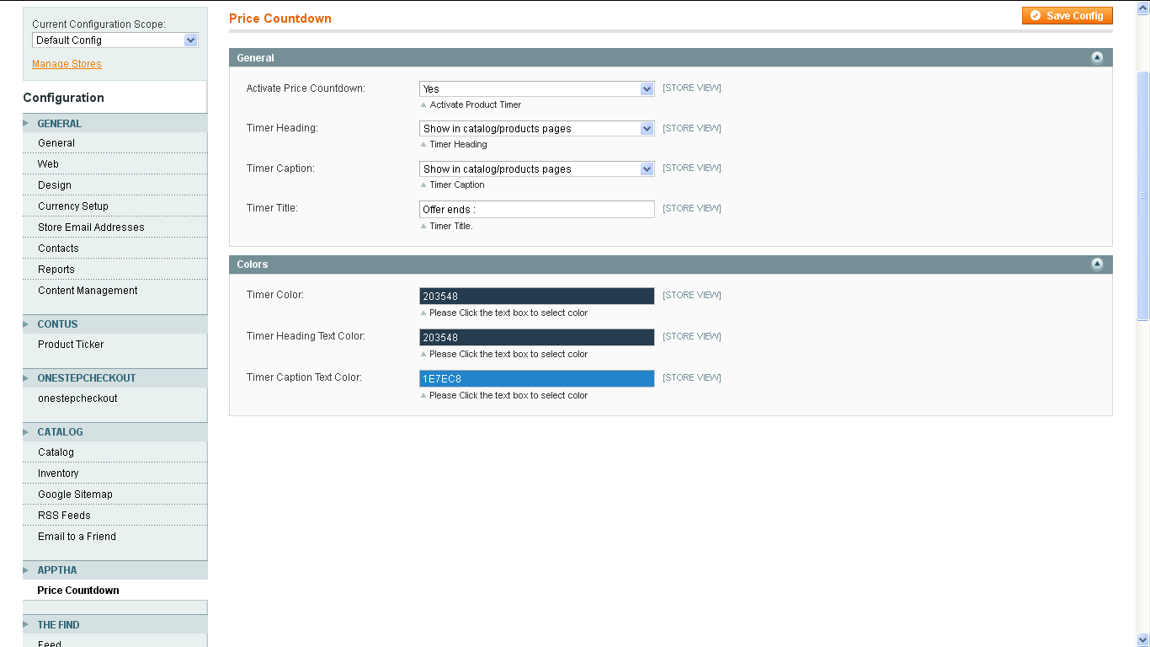

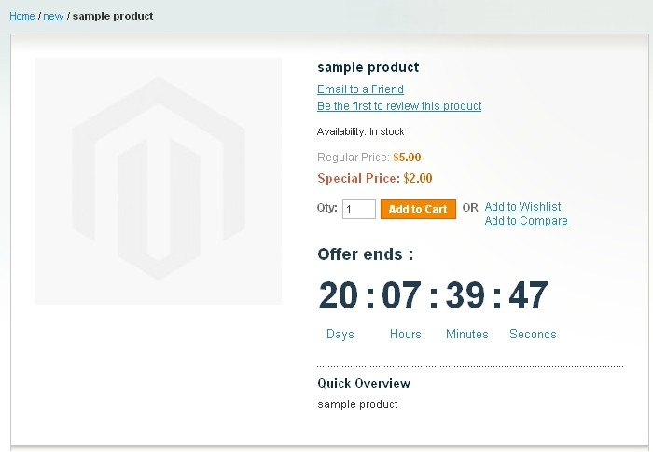
General Configuration

Activate Price Countdown:

This setting is used to activate the timer module. By selecting “Yes” – The timer process is activated.

Timer Heading:

This setting is used to show or hide the timer heading in catalog/product pages. The options are,
• Show in catalog/product pages.

• Show in catalog page.

• Show in product page.

• Hide in all pages.

Timer Caption:

Displays the caption (Days, Hours, Minutes, Seconds).This setting is used to show or hide the timer caption in catalog/product pages. The options are,
• Show in catalog/product pages.

• Show in catalog page.

• Show in product page.

• Hide in all pages.

Timer Title:

By entering a title in the timer title textbox, a title will appear at the top of the timer countdown.

Timer Color:

This setting is used to change the color of timer countdown. By clicking the textbox the color picker will be displayed and you can select the color and click save config to apply.

Timer Heading Text Color:
This setting is used to change the color of timer countdown heading. By clicking the textbox the color picker will be displayed and you can select the color and click save config to apply.

Timer Caption Text Color:

This setting is used to change the color of timer countdown caption. By clicking the textbox the color picker will be displayed and you can select the color and click save config to apply.

General Fixes: / Common Issues:

“Access Denied” in Administration Panel

If you come across “Access Denied “message when trying to access the Price Countdown page after installation, please follow the below steps:
Go to Admin->System->Permission->Roles, edit the role then save and logout. Login again in your admin panel after clearing your browser cache.

