**File Upload for Add/Update Employee**

This feature shall enable the user to add employees or update employees with file upload option.

**Version: 1.0**

**Date: 09-Nov-2020**

*All rights reserved. No part of this publication may be reproduced, transcribed, transmitted, stored in a retrieval system or translated into any language, in any form or by any means mechanical, manual, electronic, magnetic, chemical, optical, including photocopying or otherwise without the prior written permission of UPRAiZAL, Inc.*

Contents

Revision History 2

Requirement 4

Implementation Method 5

Code Modifications 6

List of required Jars & File Paths 13

Use cases (Must for Unit Test) 14

# Revision History

|  |  |  |  |
| --- | --- | --- | --- |
| Version | Author | Date | Description |
| 1.0 | HYD0176SD | 09/Nov/2020 | Initial Version |
| 1.1 | HYD0176SD | 16/Dec/2020 | Added Column level specific validations |
| 1.2 | HYD0176SD | 1/Apr/2021 | Implemented Onboarding Email schedular |
| 1.3 | HYD0176SD | 4/Apr/2021 | On Boarding Email Content changed |

**Confidentiality**

The contents of this document are considered confidential and proprietary information of UPRAiZAL, Inc. No part of this document may be reproduced, fully or in part, or divulged to any other party without prior written permission from UPRAiZAL, Inc. All logos of respective owner companies used in this presentation are recognized.

# Requirement

In employee, The file upload radio button when clicked should enable or show two checkboxes

1. Add Employees
2. Update Employee Data

**a)File Upload Add Employee(s)**

* When admin wants to add new employees in to UPRAiZAL, The standard Excel template for adding Employees will be used to add all the new employees in the system. The excel will contain multiple rows of data, wherein, each row represents one employee.
* A validation check should be made to ensure that all the mandatory fields are populated and not blank or NA in the excel. In case the mandatory fields are not populated in Excel then UPRAiZAL should throw an error message for it. ‘File Upload Unsuccessful; Mandatory Column(s) “<Field Name>”is missing data in row “<Row Number>”.

**b)File Upload Update Employee(s)**

* When Admin wants to Update any Employee(s) data in to UPRAiZAL, The excel will be populated with employee First Name , Last Name and Employee ID to identify the unique employee and the respective columns which needs to be updated in the DB will be populated with the relevant data, which will get updated in the database.
* The system will check in the backend table, if the field is blank, it will insert respective columns data for the respective employees. If the table field is already populated in the backend table then the system with overwrite that data with new data from the excel sheet.
* In case Employee does not exist in the backend table, then no data should be inserted or updated in the table. The system should throw an error message ‘Employee does not Exist’.

**C)Onboarding Mail Trigger**

**I). At roll out time of the application,**

* user should have a provision at configuration level to choose whether the onboarding mail must trigger immediately after Add Employee / Upload File or it should be triggered at specific date time.
* Based on the above configuration Onboarding mail should trigger.

**ii). After roll out completed,**

* Whenever an employee has been added through ‘Add Employee’, Onboarding mail must trigger immediately to employee mail id.
* Whenever employee details have been uploaded through upload file, Onboarding mail must trigger immediately to all the employees in the upload file.

**D) Replace Email Content in Onboarding Email**

Content:

Welcome to UPRAiZAL. We are delighted to have you a part of UPRAiZAL platform.

We want you to know that we are all excited to see you succeed and there will be plenty of opportunity for you to learn and grow in your role.

Please feel free to contact HR or your Department Head if you have any questions as you get started.

All the very best to you !

# Implementation Method

To accomplish this requirement, followed below approach.

* **UI:** Showing Check Boxes to Select File Upload Criteria (For New Employee: Insert,

For Update Employee: Update**)** Based on the check box selection, Mapping fields form will be loaded to the screen.

* **UI:** In case of New Employee, User needs to map all mandatory fields Data and click the “Upload” button.
* **UI:** In case of existing employee, User need to map mandatory fields (Only First Name, Last Name, Employee Id are mandatory) then map updated fields data,

Which are optional. And click the “Upload” button.

* **UI:** UI will Show validation error ‘s, according to the mandatory fields mapping Based on the New Employee or Existing Employee
* **UI**: Added “Onboarding Mail On Rollout” toggle at Task Configuration section, here toggle (Enable) **On** indicates email should send immediately, And toggle (Disable)**Off** indicates email should send at scheduled date and time.
* Added “Trigger Onboarding Mail On” field at Task Configuration section, for schedule employee onboarding mail trigger, if user wants to trigger employee onboard mail after  **few minutes/hours/days of the employee onboarded,** then user can disable(**off**)the toggle “Onboarding Mail On Rollout” and user can give date and time in “Trigger Onboarding Mail On” filed when onboarding mail wanted to trigger.
* **Java:** Reading Employee Details From xlsx/xls files
* **Java:** Employee Details will save/update according to the user selection
* **Java:** Added schedular to onboard mail trigger
* **Java:** Added common utility to send onboarding email.

# Code Modifications

**File Path**

"b_09_10_2020_UPRAiZAL_2.5\upraizal-web\src\main\webapp\WEB-INF\pages\employee.jsp "

**Purpose**

Employee details will be save or update with file upload (file type :xls,xlsx)

**Modifications**

Update/Insert Check box block Snippet

<span class=*"form-group label-static required"*>Select

Upload Criteria</span<div class=*"checkbox"*>

<label class=*"form-group required"*> <input id=*"inputFormUpload"* type=*"checkbox"* name=*"inputfor"* value=*"Input"*><span class=*"margin-left-5 margin-right-5"*>Insert</span></label>

<label class=*"form-group required"*> <input id=*"updateFormUpload"* type=*"checkbox"* name=*"inputfor"* value=*"Update"*>

<span class=*"margin-left-5 margin-right-5"*>Update</span></label>

<div id=*"checkBoxSelect"* class=*"text-danger"* style="display: *none*"></div>

</div>

<div>…………………{Continuous Code block goes here }…………………</div>

Sample file down load block :

<!--Employee Sample file Download fileUpload-->

<div class=*"modal-footer"*>

<span id=*"sampleUploadFormFormat"* class=*"pull-left"*><span>Download Sample File Format</span>&nbsp<i class=*"fa fa-download"*></i></span>

<button type=*"button"* id=*"saveEmployee"* class=*"btn btn-primary"*>

<fmt:message key=*"label.employee.add"* /></button>

<button type=*"button"* class=*"btn btn-primary hide"* id=*"uploadDetails"*>

<fmt:message key=*"label.employee.upload"* /></button>

<button type=*"button"* class=*"btn btn-default"* data-dismiss=*"modal"*>

<fmt:message key=*"label.employee.close"* />

</button> </div>

<div>…………………{Continuous Code block goes here }…………………</div>

**File Path**

" b_22_03_2021_UPRAiZAL_Avante _1.4_Dev\upraizal-web\src\main\webapp\WEB-INF\pages\ configuration.jsp "

**Purpose**

Added “onboarding mail trigger**”** and **“**On-Boarding Mail Schedule” fields to schedule employee onboarding mail trigger.

**Modifications**

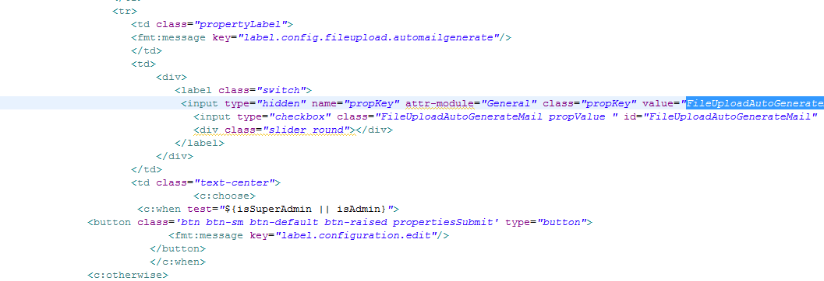

----------------------------------------------------Continution-------------------------------------------------

**File Path**

" b_22_03_2021_UPRAiZAL_Avante _1.4_Dev\upraizal-web\src\main\webapp\WEB-INF\pages\ configuration.jsp "

**Purpose**

Added “Onboarding Mail On Rollout**”** and **“**Trigger Onboarding Mail On” Retrieving logic

**Modifications**

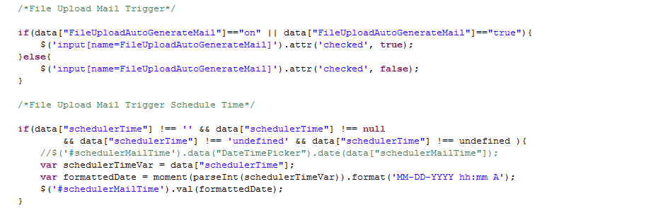

**File Path**

"b_09_10_2020_UPRAiZAL_2.5/upraizal-emp/src/main/java/com/defteam/emp/bpo/EmpBPOImpl.java”

**Purpose**

Reading Data from Xls/Xlsx:

**Modifications**

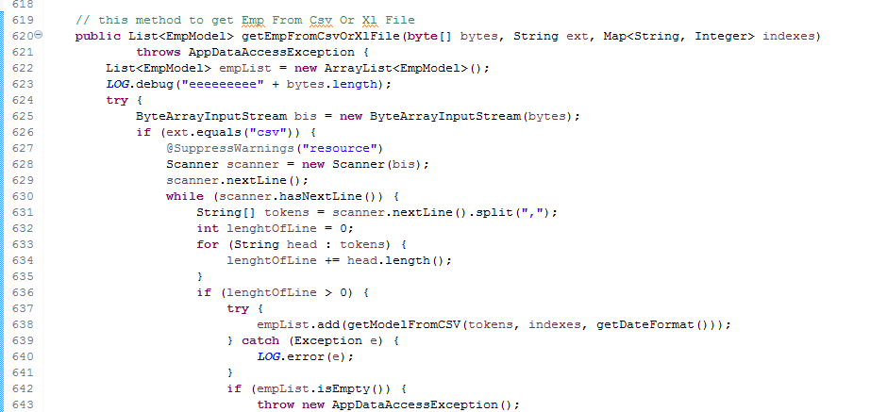

--------Continuous logic goes here---------

**File Path**

"b_09_10_2020_UPRAiZAL_2.5/upraizal-emp/src/main/java/com/defteam/emp/bpo/EmpBPOImpl.java”

**Purpose**

New Employee Save /Existing Employee Update Logic

**Modifications**

New Employee Save/update Logic:

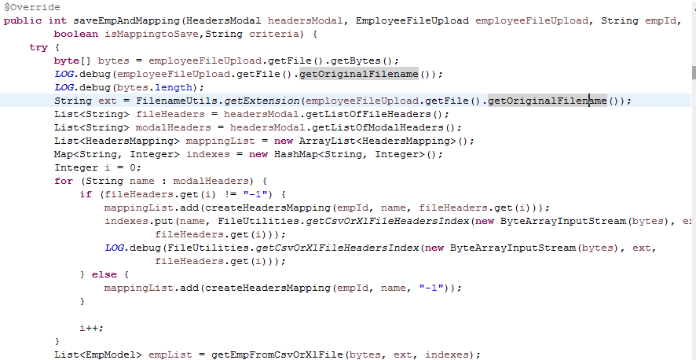

--------Continuous logic goes here---------

**File Path**

b_22_03_2021_UPRAiZAL_Avante _1.4_Dev\emp\src\main\java\com\defteam\schedule\EmployeeOnboardSchedular.java

**Purpose**

Added Scheduler to send onboarding mail.

**Modifications**

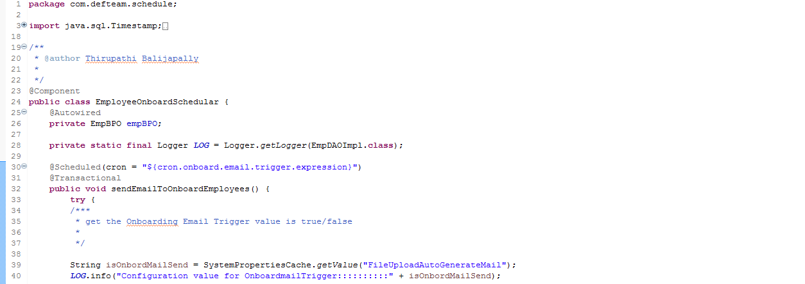

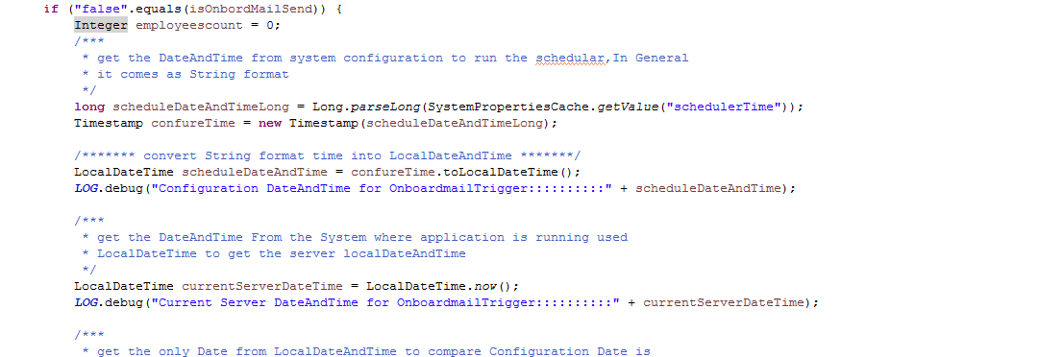

---------------------------Continuation--------------------------------

**File Path**

\b_22_03_2021_UPRAiZAL_Avante _1.4_Dev\emp\src\main\java\com\defteam\emp\dao\EmpDAOImpl.java

**Purpose**

Added utility/common method to send onboarding email.

**Modifications**

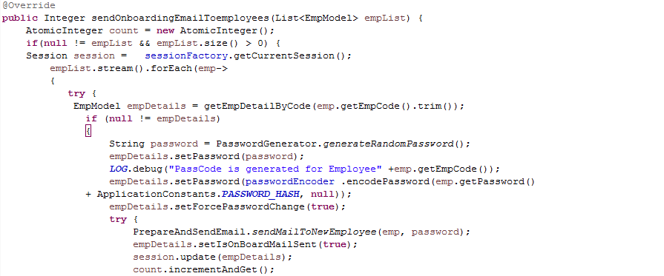

**File Path**

\b_22_03_2021_UPRAiZAL_Avante _1.4_Dev\emp\src\main\java\com\defteam\emp\dao\EmpBPOImpl.java

**Purpose**

Added new methods to get the new onboarded employees List and to check already onboard mail sent to any of the employee via scheduler.

**Modifications**

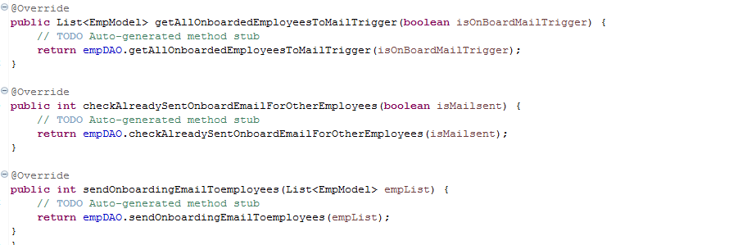

**File Path**

\b_22_03_2021_UPRAiZAL_Avante _1.4_Dev\emp\src\main\java\com\defteam\emp\dao\EmpDAOImpl.java

**Purpose**

Added data base logic to fetch new onboarded employees List and to check already onboard mail sent to any of the employee via schedular.

**Modifications**

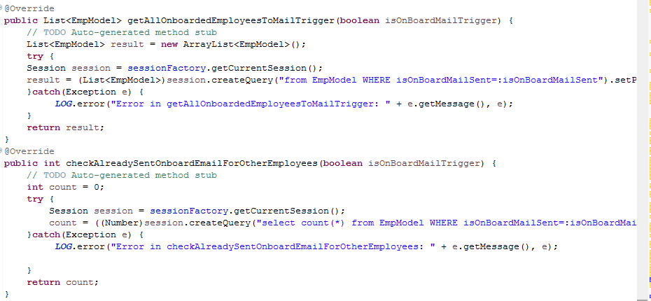

**File Path**

b_22_03_2021_UPRAiZAL_Avante _1.4_Dev\upraizal-web\src\main\resources\quartz.properties

**Purpose**

Added quartz expression to schedule the scheduler

**Modifications**



**File Path**

--\b_22_03_2021_UPRAiZAL_Avante _1.4_Dev\emp\src\main\resources\email-templates\mailToNewEmployee.ftl

**Purpose**

Onboarding email content change.

**Modifications**

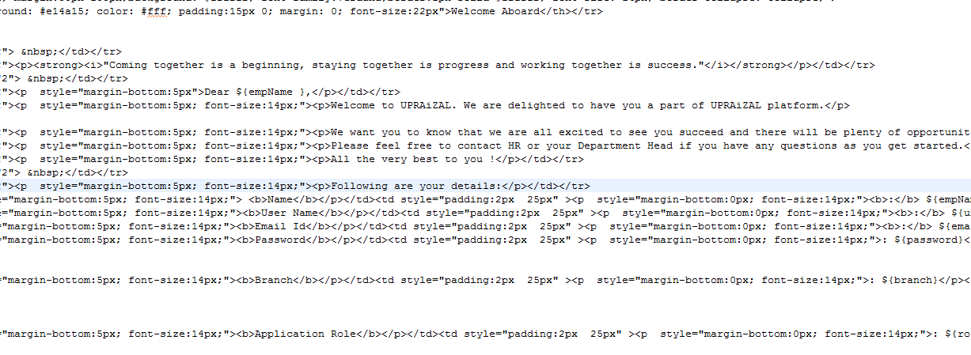

# List of required Jars & File Paths

-- b_09_10_2020_UPRAiZAL_2.5\upraizal-web\src\main\webapp\WEB-INF\pages\employee.jsp

--b_22_03_2021_UPRAiZAL_Avante _1.4_Dev\upraizal-web\src\main\webapp\WEB-INF\pages\configuration.jsp

--b_09_10_2020_UPRAiZAL_2.5\upraizal-emp \src\main\java\com\defteam\emp\controller\EmpController.java

--- b_09_10_2020_UPRAiZAL_2.5 \ upraizal-emp \ src\main\java\com\defteam\emp\service\EmpServiceImpl.java

-- b_09_10_2020_UPRAiZAL_2.5 \ upraizal-emp \ src\main\java\com\defteam\emp\bpo\EmpBPOImpl.java

-- b_09_10_2020_UPRAiZAL_2.5 \ upraizal-emp \ src\main\java\com\defteam\emp\bpo\EmpDAOImpl.java

b_22_03_2021_UPRAiZAL_Avante _1.4_Dev\emp\src\main\java\com\defteam\schedule\EmployeeOnboardSchedular.java

D:\b_22_03_2021_UPRAiZAL_Avante _1.4_Dev\emp\src\main\resources\email-templates\mailToNewEmployee.ftl

# Use cases (Must for Unit Test)

* **Add Employee File Upload –** User can perform at a time single operation either Insert or Update.
* **Employee Upload File format**: Employee upload file format should be with extension .xlsx or. xls only allowed.
* **Employee Data**: Employees upload data should not contain combination of both i.e new employee and existing employee.
* **About Insertion and Update:** There is no partial records insertion/ update into the system, once all the records pass the validation then only insertion/update happens into system.
* **Duplicate Data:** Employee’s data in the file should not contain duplicate employee Id’s and email Id’s for insertion.
* **Sample File:** User can download sample file And It can be used for further insertion and update the employee details.
* **Mandatory and Optional Fields:** Xcel File headers in Orange indicates Mandatory fields And Yellow indicates as optional.
* **Filed Level Validation**: All Mandatory fields should show error message in case if it is missing data.
* **File Update fields:** When we trying to update the fields data should be proper otherwise, we just ignore the filed to update. We will keep the existing value for the fields.
* **On Board Email Trigger**: Need to check Default value is true for the field “Onboarding Mail On Rollout”.

**On Board Email Scheduler:** Scheduler should be able to configure with different time frames. And date and time selected should be greater than current time.



File Upload Screen:

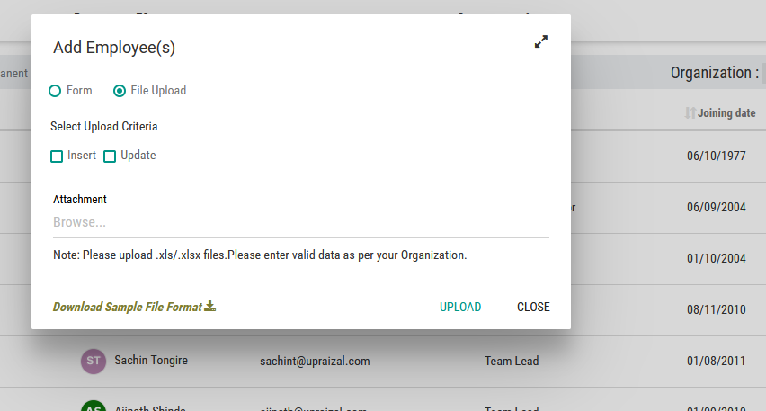

On Board Email schedule Screen Shot:

