**Employee Timeline (4 New Badges) And Badge Comments**

Added four new badges namely Team player, Awesome, Helpful, Thank you badges.

Modified the middle section to show user given badges with comments

**Version: 1.0**

**Date: 29-Oct-2020**

*All rights reserved. No part of this publication may be reproduced, transcribed, transmitted, stored in a retrieval system or translated into any language, in any form or by any means mechanical, manual, electronic, magnetic, chemical, optical, including photocopying or otherwise without the prior written permission of UPRAiZAL, Inc.*

Contents

Revision History 2

Requirement 4

Implementation Method 4

Code Modifications 5

**File Path** 9

**Purpose** 9

**Modifications** 9

**File Path** 10

**Purpose** 10

**Modifications** 10

**File Path** 11

**Purpose** 11

**Modifications** 11

List of required Jars & File Paths 12

Use cases (Must for Unit Test) 12

# Revision History

|  |  |  |  |
| --- | --- | --- | --- |
| Version | Author | Date | Description |
| 1.0 | HYD0057BI | 29/Oct/2020 | Initial Version |
| 1.0 | HYD0225SD | 29/Oct/2020 | Initial Version |
| 1.2 | HYD0176SD | 16/Dec/2020 | Initial Version |

**Confidentiality**

The contents of this document are considered confidential and proprietary information of UPRAiZAL, Inc. No part of this document may be reproduced, fully or in part, or divulged to any other party without prior written permission from UPRAiZAL, Inc. All logos of respective owner companies used in this presentation are recognized.

# Requirement

1. Configuration Page: Add 4 new badges in User and System driven Badges section which is under badges and Points tab of admin panel.
2. The default points for these badges is 10 in the Admin Panel, but it is configurable
3. Employee Timeline Page: Add Badges pop-up shall only show the 4 badges, namely Team player, Awesome, Helpful, Thank you badges.
4. These badges will be seen in all the screens where the list of badges is seen and the points will be summed up in the User Driven Points calculation.
5. Employee Timeline Page: System shall be restricted to award each badge once per day per person. Once a badge is allocated on a particular day, it cannot be awarded again till the next day, 12:01 am.
6. Employee Timeline Page: Employee drop down, shall only show the employees at same level, reporting manager and one level down (reportees).
7. Employee Timeline Page: Add Badges Popup, User will have to enter comment while awarding badge
8. NLP shall process the badge comments.

9.Need to show Employee given badges and comments in the middle section of Timeline

# Implementation Method

To accomplish this requirement, followed below approach

* **UI:** Added the newly badges (Team player, Awesome, Helpful, Thank you) in badges section under User & System Driven Badges in configuration page.
* **UI:** Showing the above 4 badges in Employee Timeline -> Add Badges Popup.
* **UI:** Disabling the badges which is already given on the same day.
* **UI:** Enabling/Disabling Comment Textbox on Enabling/Disabling the respective Badge Checkbox.
* **UI:** Once the badge(s) & comment(s) is given then sending the data to the backend.
* **UI:** Updated Employee Dropdown along with Designation using Opt Group in multiselect.
* **UI:** Based on the selected employee from dropdown, System displays badges and comments.
* **Java:** Added the newly badges (Team player, Awesome, Helpful, Thank you) in badges table
* **Java:** the employees list sorted by Application Role (same level, reporting manager, one level down)
* **Java:** Modified add badge method to add comment with badge. And restricted user to add one badge per day by same person
* **Java:** Passing Badge comments to NLP engine
* **Java:** Modified logic to display badges and its comments at middle section instead of

Task details at the middle section of the Employee Time line

# Code Modifications

**File Path**

"b_09_10_2020_UPRAiZAL_2.5\upraizal-web\src\main\webapp\resources\images\v2\badges"

**Purpose**

* Added newly badge SVG(s)

**Modifications**

SVG files added based on the id provided by backend developer:

upraizal-web\src\main\webapp\resources\images\v2\badges

14.svg

15.svg

16.svg

17.svg

**File Path**

"b_09_10_2020_UPRAiZAL_2.5\upraizal-web\src\main\webapp\WEB-INF\pages\configuration.jsp"

**Purpose**

* To show newly added 4 badges in existing User & System Driven Badges section.
* To configure points for the above 4 said badges.

**Modifications**

In getbadgesMainList function



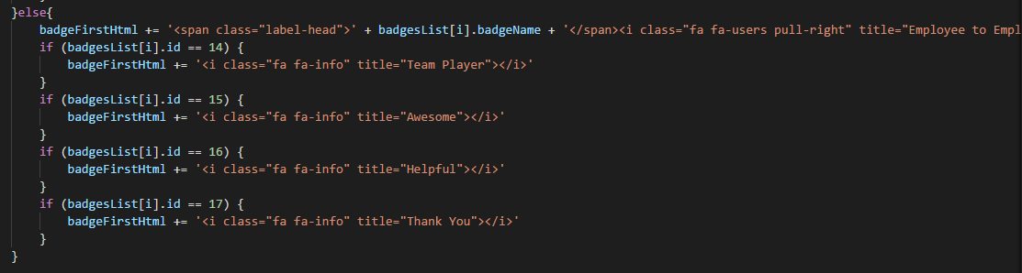

**File Path**

"b_09_10_2020_UPRAiZAL_2.5\upraizal-web\src\main\webapp\WEB-INF\pages\genericTask.jsp"

**Purpose**

* Excluded these 4 badges in Task Page - >. Add Badges Popup

**Modifications**



**File Path**

"b_09_10_2020_UPRAiZAL_2.5\upraizal-web\src\main\webapp\WEB-INF\pages\empTimelineView.jsp"

**Purpose**

* Excluded the previous Badges & showing only new 4 Employee to Employee Badge.
* Added Badge Checkbox.
* Added Comments Textbox for each Badge & disabled it by default.
* Enabling textbox on its respective checkbox true & disabling on false.
* Sending the Badge ID, along with Comments to the backend
* Updated UI with Same Day Badge Flag which is coming from Backend.
* Badge Comments are mandatory with a toast message.

**Modifications**

Adding CSS class



Add Badge Popup changes

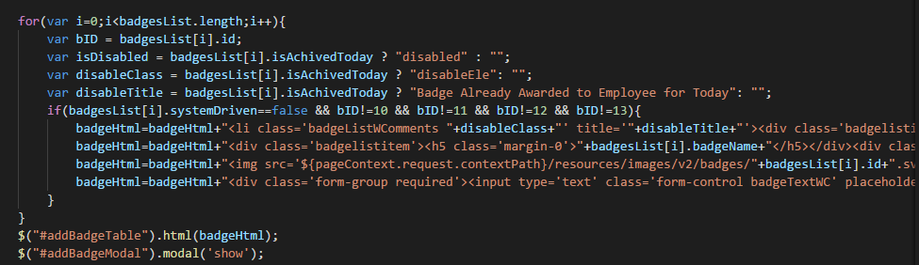

Add Badge Button

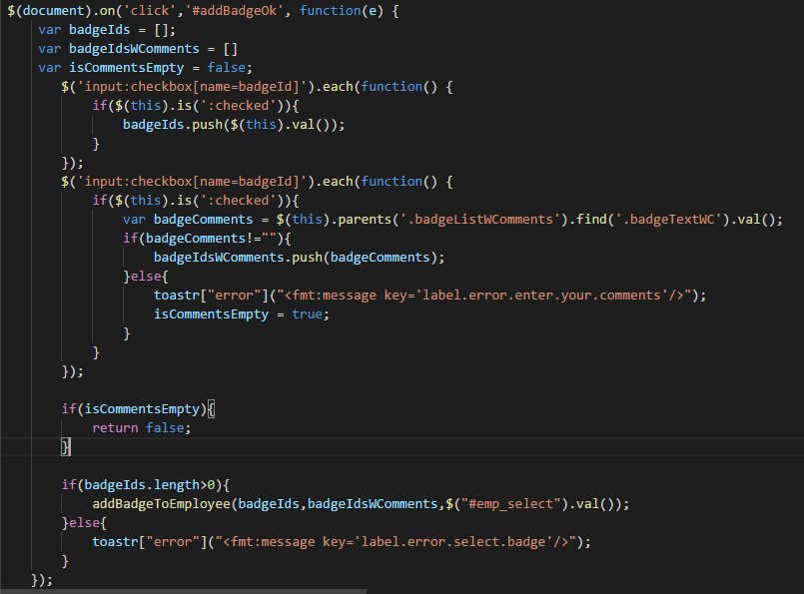

Sending data to backend

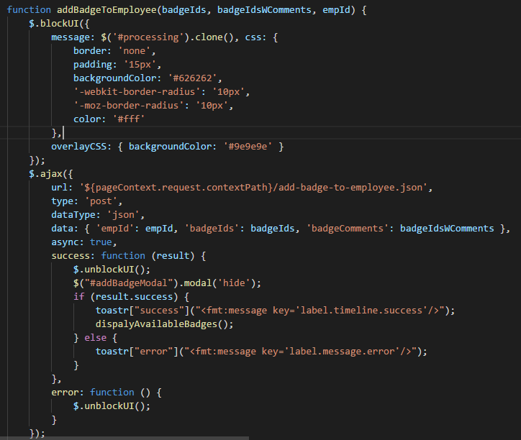

## **File Path**

“b_09_10_2020_UPRAiZAL_2.5/upraizal-dashboard/src/main/java/com/defteam/dashboard/controller/EmpTimelineViewController.java”

## **Purpose**

Created method to get the employees list sorted by Application Role (same level, reporting manager, one level down). Modified add badge method to add comment with badge. And restricted user to add one badge per day by same person.

## **Modifications**

Below method to give Employee based on logged in user role

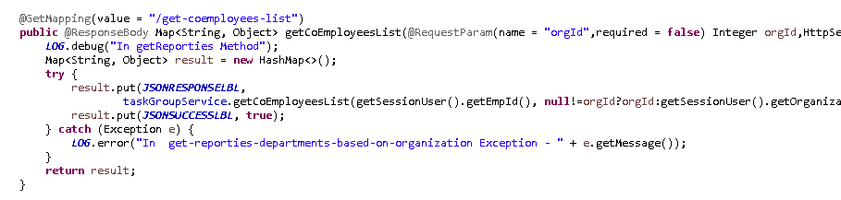

Below method modified to get comment and send to NLP engine

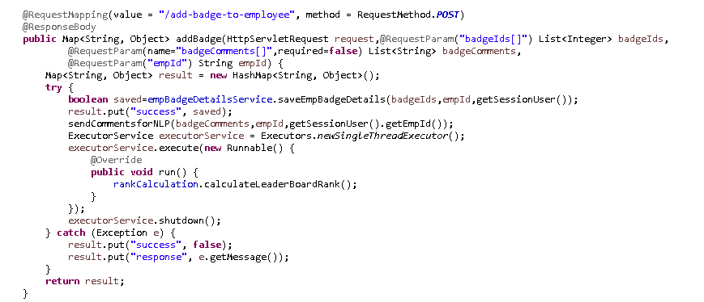

## **File Path**

“b_09_10_2020_UPRAiZAL_2.5/upraizal-task/src/main/java/com/defteam/task/bpo/TaskGroupBPOImpl.java”

## **Purpose**

Created method to process the employees list sorted by Application Role (same level, reporting manager, one level down). Modified add badge method to add comment with badge. And restricted user to add one badge per day by same person.

## **Modifications**

Method to process and return the employee list based on logged in user

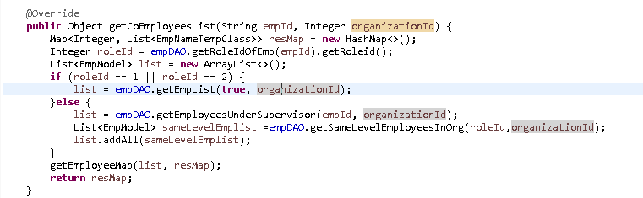

## **File Path**

“b_09_10_2020_UPRAiZAL_2.5/upraizal-task/src/main/java/com/defteam/task/bpo/TaskBPOImpl.java”

## **Purpose**

Business logic to get the Employee given badges and its comments.

## **Modifications**

Business logic to get the required data

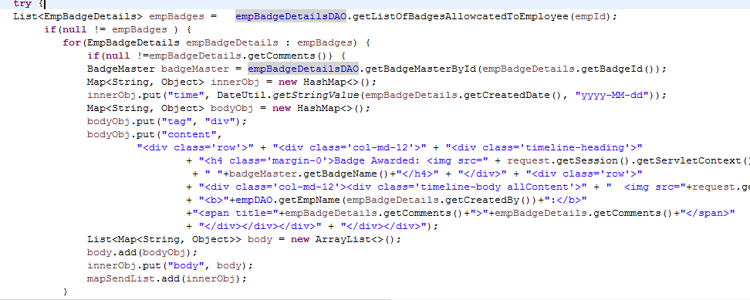

.

# List of required Jars & File Paths

-- b_09_10_2020_UPRAiZAL_2.5\upraizal-web\src\main\webapp\WEB-INF\pages\configuration.jsp

-- b_09_10_2020_UPRAiZAL_2.5\upraizal-web\src\main\webapp\resources\images\v2\badges

-- b_09_10_2020_UPRAiZAL_2.5\upraizal-web\src\main\webapp\WEB-INF\pages\genericTask.jsp

-- b_09_10_2020_UPRAiZAL_2.5\upraizal-web\src\main\webapp\WEB-INF\pages\empTimelineView.jsp

-- b_09_10_2020_UPRAiZAL_2.5/upraizal-dashboard/src/main/java/com/defteam/dashboard/controller/EmpTimelineViewController.java

-- b_09_10_2020_UPRAiZAL_2.5/upraizal-task/src/main/java/com/defteam/task/bpo/TaskGroupBPOImpl.java

-- b_09_10_2020_UPRAiZAL_2.5/upraizal-task/src/main/java/com/defteam/task/bpo/TaskBPOImpl.java

# Use cases (Must for Unit Test)

* **Configuration Page:** Should able to see 4 new badges under User & System driven section and able to configure points.
* **Employee Timeline:** Click on “Add Badge” and user should able to see 4 badges in the popup.
* The badges should get disabled if it’s given already by the same Peron on the same day.
* Enabling/Disabling Comment Textbox on Enabling/Disabling the respective Badge Checkbox.
* User should able to save badge along with comments.
* Employee Dropdown should allow to select employee and data will be displayed for the respective employee.
* Find Badge comments in NLP tone analysis page
* If any badge (i.e Employee given badges) given to selected employee, then System displays, Given badges and its comments at the middle Section.