Outlook Task Add-in

User can be able to get rated the tasks, which are created in the Microsoft outlook.

**Version: 1.0**

**Date: 02-Dec-2020**

*All rights reserved. No part of this publication may be reproduced, transcribed, transmitted, stored in a retrieval system or translated into any language, in any form or by any means mechanical, manual, electronic, magnetic, chemical, optical, including photocopying or otherwise without the prior written permission of UPRAiZAL, Inc.*

Contents

Revision History 3

Requirement 4

Implementation Method 4

Code Modifications 4

**File Path** 4

**Purpose** 4

**Modifications** 4

**File Path** 5

**Modifications** 5

**File Path** 5

**Purpose** 6

**Modifications** 6

**File Path** 7

**Purpose** 7

**Modifications** 7

**File Path** 7

**Purpose** 7

**Modifications** 7

**File Path** 8

**Purpose** 8

**Modifications** 8

**File Path** 8

**Purpose** 8

**Modifications** 9

**File Path** 9

**Purpose** 9

**Modifications** 9

**File Path** 9

**Purpose** 9

**Modifications** 9

**File Path** 10

**Purpose** 10

**Modifications** 10

List of required Jars & File Paths 10

Use cases (Must for Unit Test) 11

# Revision History

|  |  |  |  |
| --- | --- | --- | --- |
| Version | Author | Date | Description |
| 1.0 | HYD00176SD | 04/APR/2021 | Initial Version |

**Confidentiality**

The contents of this document are considered confidential and proprietary information of UPRAiZAL, Inc. No part of this document may be reproduced, fully or in part, or divulged to any other party without prior written permission from UPRAiZAL, Inc. All logos of respective owner companies used in this presentation are recognized.

# Requirement

* We need to create an Add-In to Import Tasks created as Outlook Tasks (MS Outlook) into UPRAiZAL
* Previously in older version of UPRAiZAL and MS Outlook the Add-In was created.
* Once the tasks are available in Outlook Task – they should be imported into UPRAiZAL upon click of a button or Auto import depending on the setting in Configuration.
* These tasks should be imported with their original Task ID (like another Add-In’s). Once These tasks are available in UPRAiZAL – they become UPRAiZAL task and the same UPRAiZAL, task flow will be valid for these tasks also - Self Rate, R1 rating, R2 rating.
* As soon as the task is Complete in UPRAiZAL it is status should also be updated in Outlook Task window. Only the relevant fields required by UPRAiZAL need to be picked up while importing Outlook Tasks.

# Implementation Method

1. Whenever User clicks on Outlook Tasks add-in page, it will ask for authentication for user for the first time, Next time onwards user will be authenticated automatically.
2. Once user authenticated successfully then all the tasks will be displayed, And If “Auto Import” is enabled then all unimported tasks will be imported to the system (Task manage will be displayed).
3. However, if “Auto Import” not set up, there is “Import All”,” Import” functionalities can be used to import the tasks into the system.
4. User must authenticate each time if wanted to SyncUP the tasks which are created in the outlook.

# Code Modifications

## **File Path**

"/upraizal-web/src/main/webapp/WEB-INF/tiles/page-header.jsp"

## **Purpose**

* Added code to get the pages access and Authentication for user access for MS- outlook.

## **Modifications**

* Page access for the Outlook tasks plugin.

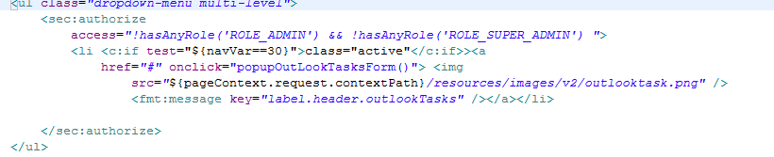

* User Authentication for Microsoft-Outlook add-in

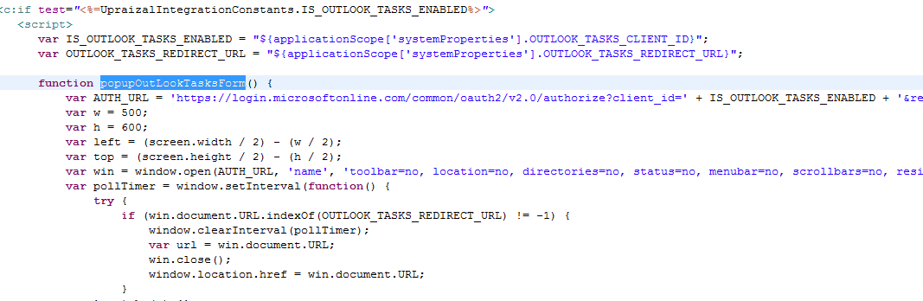

## **File Path**

/upraizal-web/src/main/webapp/WEB-INF/pages/configuration.jsp

**Purpose**

* Added configuration changes to Authenticate for user to MS- outlook access.

## **Modifications**

* Page access for the Outlook tasks plugin.

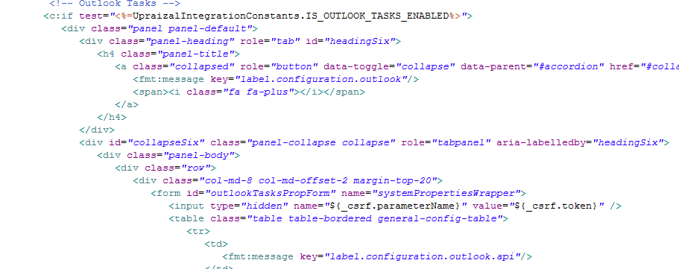

## **File Path**

"/upraizal-web/src/main/webapp/WEB-INF/pages/LoadOutlookTask.jsp"

## **Purpose**

* Added code to get the tasks for user, which are created in outlook task plugin.

## **Modifications**

* Code to get the list of tasks which are created for the user.

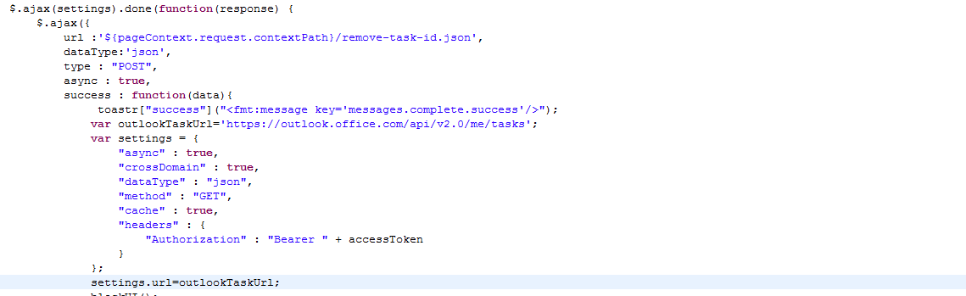

* Code to complete the task when it is completed in UPRAiZAL.

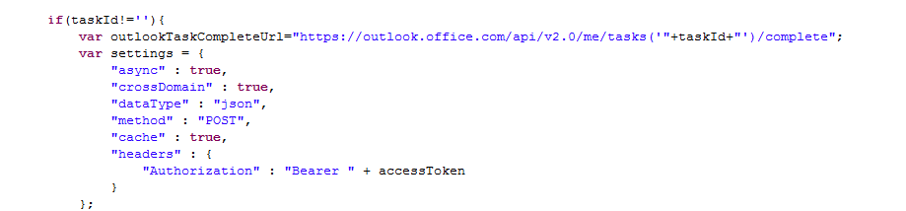

* Code to “Import” functionality implementation.

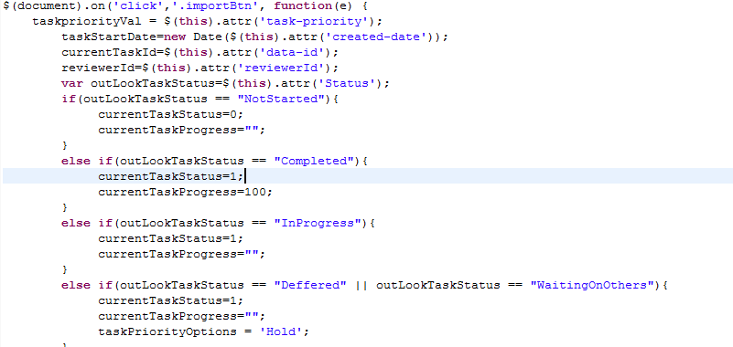

---------------------------------------------Continuation----------------------------------------------

* Code to “Import All” functionality implementation.

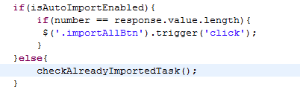

-------------------------------------------------Continuation------------------------------------------

## **File Path**

"/upraizal-integration/src/main/java/com/defteam/outlooktasks/controller/OutlookTasksController.java"

## **Purpose**

Code to perform “Auto Import “and “Import All” functionality

## **Modifications**

* Service call to save all outlook tasks into UPRAiZAL.

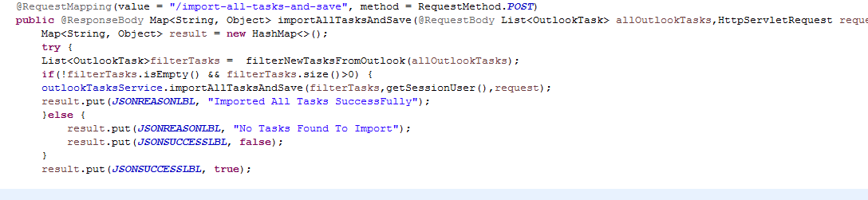

## **File Path**

“upraizal-integration/src/main/java/com/defteam/outlooktasks/service/OutlookTaskServiceImpl.java”

## **Purpose**

Service logic to save all imported tasks into UPRAiZAL system.

## **Modifications**

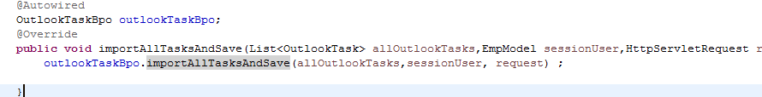

## **File Path**

“/upraizal-integration/src/main/java/com/defteam/outlooktasks/bpo/OutlookTaskBpoImpl.java”

## **Purpose**

Business logic to save all imported tasks into UPRAiZAL system.

## **Modifications**

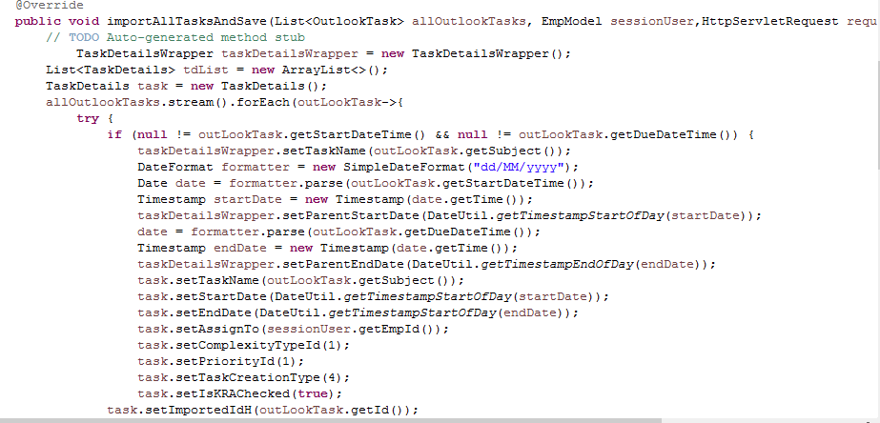

## **File Path**

“/upraizal-integration/src/main/java/com/defteam/outlooktasks/controller/OutlookTasksController.java”

## **Purpose**

Service to filter already saved/imported tasks in the UPRAiZAL system.

## **Modifications**

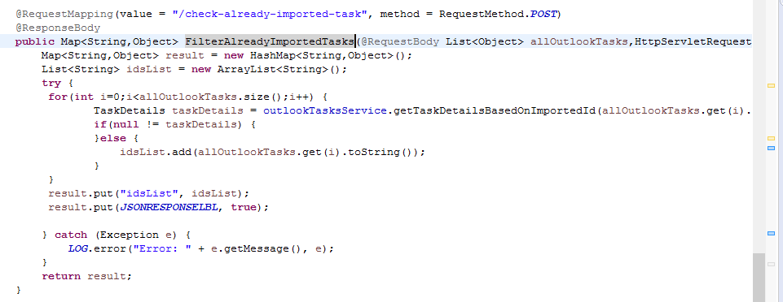

## **File Path**

“/upraizal-integration/src/main/java/com/defteam/outlooktasks/service/OutlookTaskServiceImpl.java”

## **Purpose**

Service logic to filter already saved/imported tasks in the UPRAiZAL system.

## **Modifications**

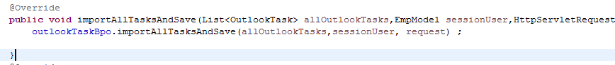

## **File Path**

“/upraizal-integration/src/main/java/com/defteam/outlooktasks/bpo/OutlookTaskBpoImpl.java”

## **Purpose**

Business logic to filter already saved/imported tasks in the UPRAiZAL system.

## **Modifications**

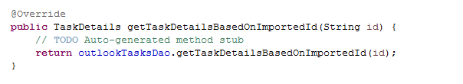

## **File Path**

“/upraizal-integration/src/main/java/com/defteam/outlooktasks/dao/OutlookTasksDaoImpl.java”

## **Purpose**

DB logic to filter already saved/imported tasks in the UPRAiZAL system.

## **Modifications**

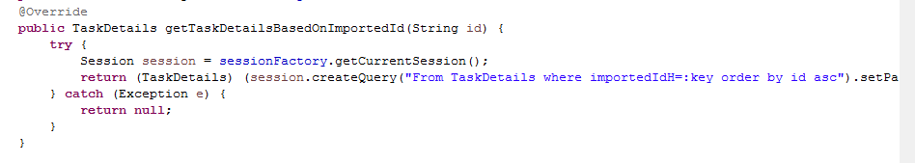

# List of required Jars & File Paths

* /upraizal-web/src/main/webapp/WEB-INF/tiles/page-header.jsp
* /upraizal-web/src/main/webapp/WEB-INF/pages/configuration.jsp
* /upraizal-integration/src/main/java/com/defteam/outlooktasks/controller/OutlookTasksController.java
* /upraizal-integration/src/main/java/com/defteam/outlooktasks/service/OutlookTaskService.java
* /upraizal-integration/src/main/java/com/defteam/outlooktasks/service/OutlookTaskServiceImpl.java
* /upraizal-integration/src/main/java/com/defteam/outlooktasks/service/OutlookTaskBpo.java
* /upraizal-integration/src/main/java/com/defteam/outlooktasks/service/OutlookTaskBpoImpl.java
* /upraizal-integration/src/main/java/com/defteam/outlooktasks/service/OutlookTaskDao.java
* /upraizal-integration/src/main/java/com/defteam/outlooktasks/service/OutlookTaskDaoImpl.java

# Use cases (Must for Unit Test)

* User Should be able configure required authentication data in Add-in’s configuration Section.
* When User first time access to the page, Popup window should open and ask for the Email id and password of the user to authenticate with Microsoft.
* User should be able to perform “import”,” import-all”, “auto-import” operations.