Prepone Task

User is allowed to start working on an assigned task before specified start date by requesting approval for prepone

**Version: 1.0**

**Date: 02-Dec-2020**

*All rights reserved. No part of this publication may be reproduced, transcribed, transmitted, stored in a retrieval system or translated into any language, in any form or by any means mechanical, manual, electronic, magnetic, chemical, optical, including photocopying or otherwise without the prior written permission of UPRAiZAL, Inc.*

Contents

Revision History 3

Requirement 4

Implementation Method 4

Code Modifications 4

**File Path** 4

**Purpose** 4

**Modifications** 5

**File Path** 6

**Purpose** 6

**Modifications** 6

**File Path** 6

**Purpose** 6

**Modifications** 6

List of required Jars & File Paths 7

Use cases (Must for Unit Test) 7

# Revision History

|  |  |  |  |
| --- | --- | --- | --- |
| Version | Author | Date | Description |
| 1.0 | HYD0070BI | 02/Feb/2020 | Initial Version |
| 1.0 |  | 02/Feb/2020 | Initial Version |

**Confidentiality**

The contents of this document are considered confidential and proprietary information of UPRAiZAL, Inc. No part of this document may be reproduced, fully or in part, or divulged to any other party without prior written permission from UPRAiZAL, Inc. All logos of respective owner companies used in this presentation are recognized.

# Requirement

This feature would be on the lines of a Self-Assign task which needs Manager approval KRA’s to strengthen are nothing but KRA values where rating of manager is lower.

In case a User has been allocated a task with a future date and the User for whatever reason wants to start working on the task: Prepone the task, he will then request his reporting Manager for approval to make the task In Progress.

This task will show tooltips on Start Date which is ‘Planned start date : ‘ and End Date which is ‘Planned end date :

# Implementation Method

1. In Task grid, showing prepone request icon for users for all tasks having start date greater than current date.
2. Once user clicks on prepone request icon, popup should come for user confirmation.
3. Upon prepone request, notification should be sent to manager to approve the request
4. Once manager approves the request, notification should be sent to user as approval intimation
5. Upon approval, status column allow user to change status of task as in progress.
6. Task start date will become the date when user change status as in progress and end date should be calculated as per the earlier difference between start and end dates.
7. Tooltips should show actual start and end dates information.

# Code Modifications

## **File Path**

"/upraizal-web/src/main/webapp/WEB-INF/pages/genericTask1.jsp"

## **Purpose**

* Added code to show icons related to prepone request and service call related to request

## **Modifications**

* Code to show prepone request icon for all tasks having start date greater than current date

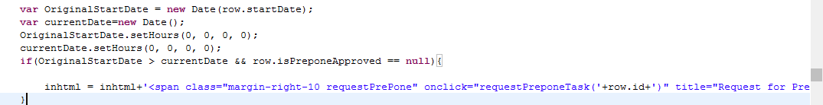

* Code to send prepone request to manager

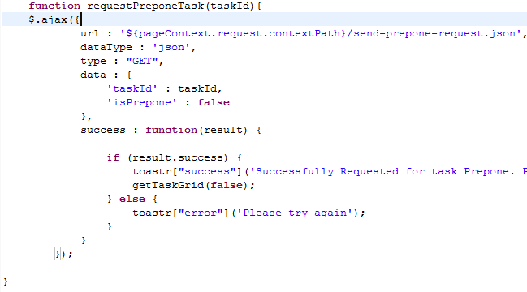

* Code to approve prepone task

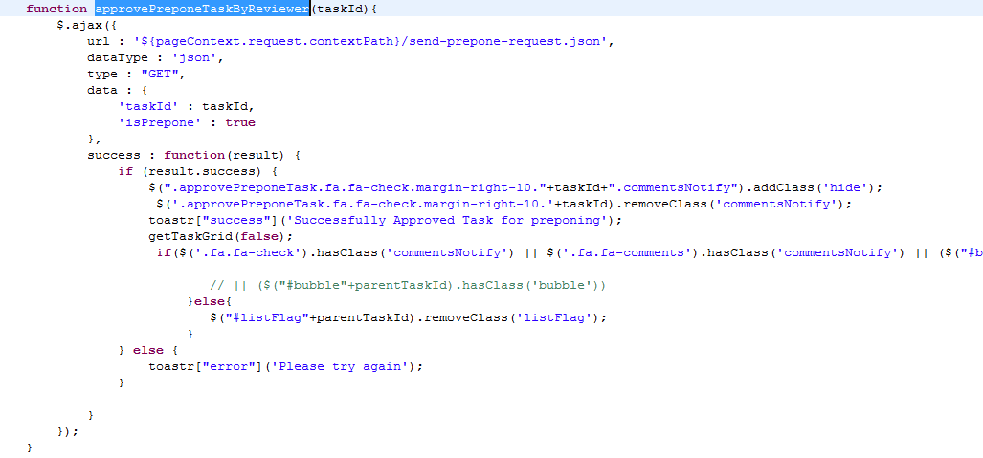

## **File Path**

"/upraizal-web/src/main/webapp/WEB-INF/pages/genericTask.jsp"

## **Purpose**

* Code to show approval icon for prepone task for manager and to show red bubble on details icon

## **Modifications**

* Code to show approval icon



* Code to show red bubble notification on parent task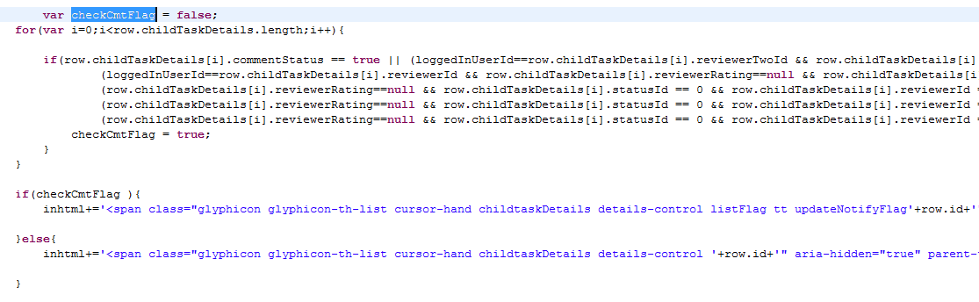

## **File Path**

"/upraizal-web/src/main/webapp/WEB-INF/tiles/footer.jsp"

## **Purpose**

* Added conditions for prepone request and approval to show notifications to manager and user

## **Modifications**

* Added conditions in following mentioned two methods with below mentioned two flags.

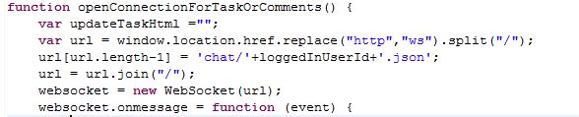

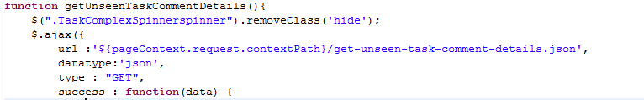

* Flags used for conditions:

1. isPreponedApproved
2. isPreponedTask

# List of required Jars & File Paths

* /upraizal-web/src/main/webapp/WEB-INF/tiles/footer.jsp
* /upraizal-web/src/main/webapp/WEB-INF/pages/genericTask.jsp
* /upraizal-web/src/main/webapp/WEB-INF/pages/genericTask1.jsp

# Use cases (Must for Unit Test)

* All tasks with start date greater than current date should show prepone icon to request
* Once user requested for prepone, Manager should get notification and task should be seen in Task notification list with legend letter ‘A’
* After manager approves request, notification should be sent to user.
* After manager approval, user can able to change task status from open to In progress
* After changing status to In progress, task start date will be changed to current date and end date will be calculated as per old start and end dates difference.
* If user didn’t get manager approval before actual start date specified, then task should have normal task behavior