Employee Removal Process

Admin can delegate the tasks which assigned to employee and go for the remove of the employee.

**Version: 1.0**

**Date: 02-Dec-2020**

*All rights reserved. No part of this publication may be reproduced, transcribed, transmitted, stored in a retrieval system or translated into any language, in any form or by any means mechanical, manual, electronic, magnetic, chemical, optical, including photocopying or otherwise without the prior written permission of UPRAiZAL, Inc.*

Contents

Revision History 3

Requirement 4

Implementation Method 4

Code Modifications 4

**File Path** 4

**Purpose** 4

**Modifications** 5

**File Path** 5

**Modifications** 5

**File Path** 6

**Purpose** 6

**Modifications** 6

**File Path** 6

**Purpose** 6

**Modifications** 6

**File Path** 6

**Purpose** 6

**Modifications** 7

**File Path** 7

**Purpose** 7

**Modifications** 7

**File Path** 7

**Purpose** 7

**Modifications** 8

List of required Jars & File Paths 9

Use cases (Must for Unit Test) 9

Screen Shots 9

# Revision History

|  |  |  |  |
| --- | --- | --- | --- |
| Version | Author | Date | Description |
| 1.0 | HYD00176SD | 17/MAY/2021 | Initial Version |

**Confidentiality**

The contents of this document are considered confidential and proprietary information of UPRAiZAL, Inc. No part of this document may be reproduced, fully or in part, or divulged to any other party without prior written permission from UPRAiZAL, Inc. All logos of respective owner companies used in this presentation are recognized.

# Requirement

* There needs to be a flow defined to remove Employees from UPRAiZAL.
* No Employee should be deleted from Application, from Active Status they should become Inactive with relevant Dates.
* There should be a Last Working Date recorded for the Employee who is Inactive now.
* Only Application Admin Can Remove Employees. Just like Only Admin can Add employees.
* When Removing an Employee, all his tasks should be shown in a separate Modal. There should be a Provision to allocate or reassign the tasks to the Employee’s R1.
* The tasks that are Allocated to R1 – should appear in the Delegate Task list of R1 and the usual process of delegation will run thereafter.

# Implementation Method

1. Whenever admin clicks on employee remove icon, then list of (open, InProgress) tasks popup window will display for delegate the tasks.
2. Admin select the check box to delegate all tasks which are assigned to the user then.

Clicks ‘delegate’ button.

1. Admin receives the success message for tasks delegation and ‘Continue’ Button will enabled.
2. Now Admin clicks ‘Continue’ button, remove popup window display and admin enter release date of employee and click remove.
3. Now employee state has change into inactive and employee moved ex-employees list.

# Code Modifications

## **File Path**

"/upraizal-task/src/main/java/com/defteam/task/controller/GenericTaskController.java"

## **Purpose**

* Added service changes to fetch the tasks related to removing employee.

## **Modifications**

* Added new parameter to fetch the tasks related to removing employee by the admin.

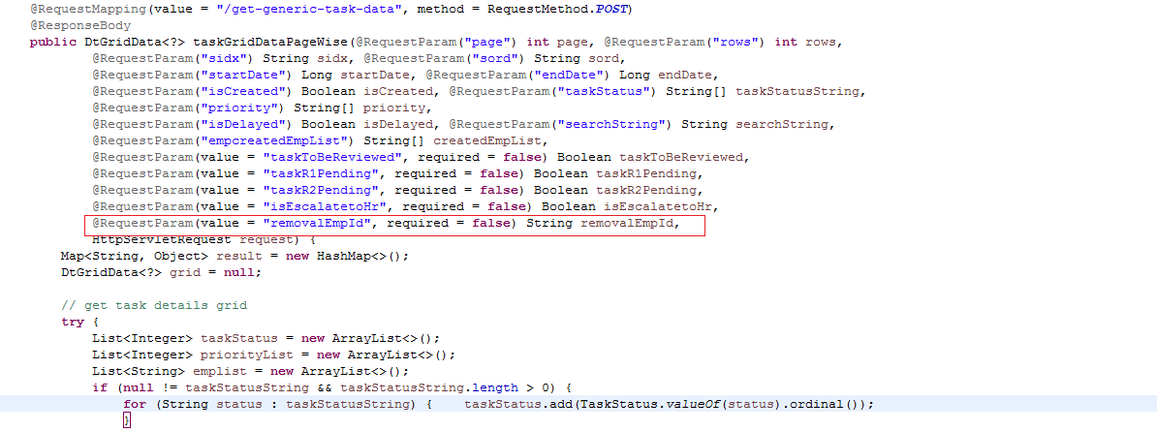

* Added new service to fetch the tasks count related to removing employee.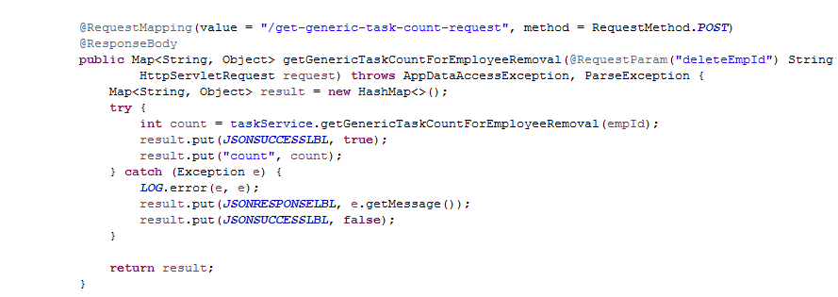

## **File Path**

“/upraizal-task/src/main/java/com/defteam/task/service/TaskServiceImpl.java”

**Purpose**

* Added service implementation logic.

## **Modifications**

* Service implementation logic

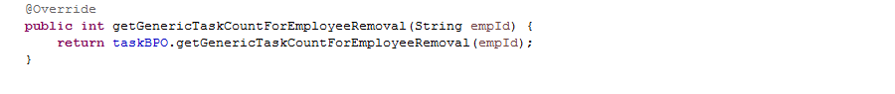

## **File Path**

" /upraizal-task/src/main/java/com/defteam/task/bpo/TaskBPOImpl.java"

## **Purpose**

* Added Business logic implementation to get the tasks count to associated employee.

## **Modifications**

* Code to get the list of tasks which are created for the user.



## **File Path**

" /upraizal-task/src/main/java/com/defteam/task/dao/TaskDAOImpl.java"

## **Purpose**

Added data base logic to get the tasks count, which are assigned to employee.

## **Modifications**

* Database query logic.

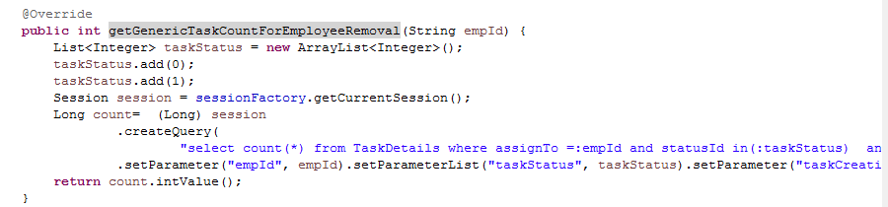

## **File Path**

“/upraizal-task/src/main/java/com/defteam/task/controller/TaskDeligationController.java”

## **Purpose**

Added new parameter to get the removal employee details to delegate the tasks.

## **Modifications**

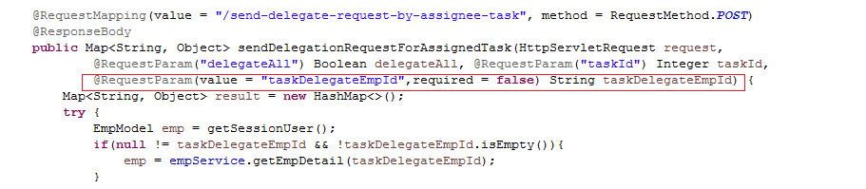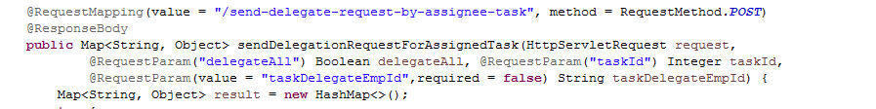

## **File Path**

“/upraizal-task/src/main/java/com/defteam/task/controller/GenericTaskController.java”

## **Purpose**

Business logic for to get the inactive employees to delegate the tasks.

## **Modifications**

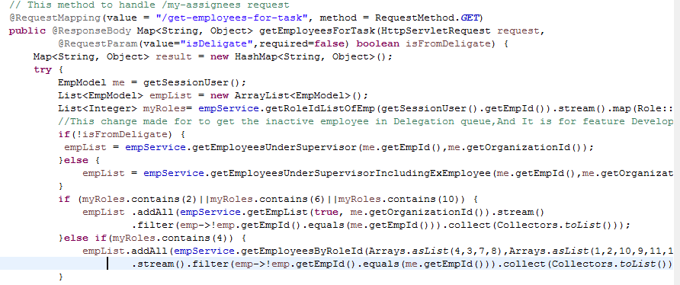

## **File Path**

“/upraizal-web/src/main/webapp/WEB-INF/pages/employees.jsp”

## **Purpose**

Added Delegate tasks model popup.

## **Modifications**

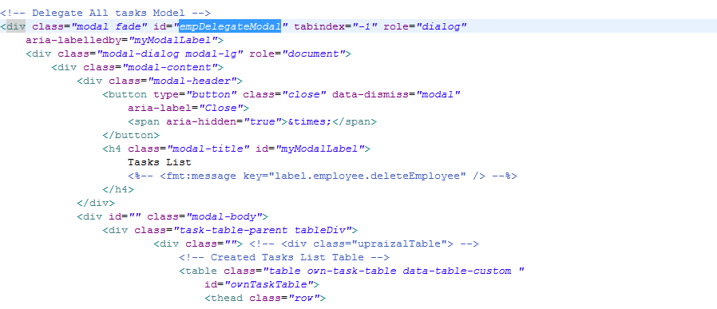

<! --------------------------------------------Continue---------------------------------------------------------------------->

Added logic to display all assigned tasks by the employee.

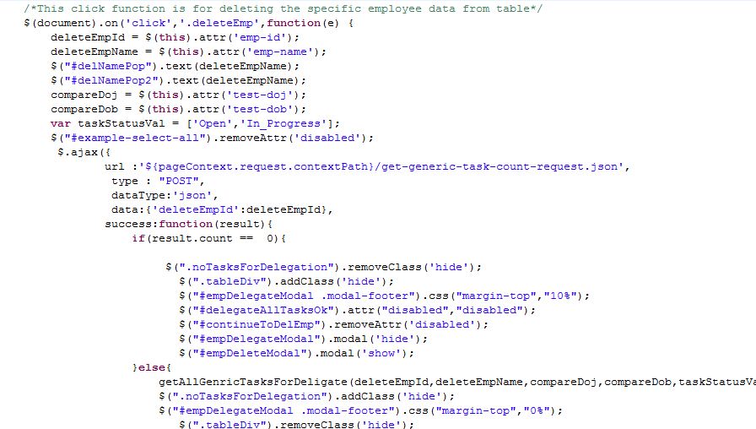

# List of required Jars & File Paths

* /upraizal-web/src/main/webapp/WEB-INF/pages/employees.jsp
* /upraizal-task/src/main/java/com/defteam/task/controller/GenericTaskController.java
* /upraizal-task/src/main/java/com/defteam/task/service/TaskService.java
* /upraizal-task/src/main/java/com/defteam/task/service/TaskServiceImpl.java
* /upraizal-task/src/main/java/com/defteam/task/bpo/TaskBPO.java
* /upraizal-task/src/main/java/com/defteam/task/bpo/TaskBPOImpl.java
* /upraizal-task/src/main/java/com/defteam/task/dao/TaskDAO.java
* /upraizal-task/src/main/java/com/defteam/task/dao/TaskDAOImpl.java
* /upraizal-task/src/main/java/com/defteam/task/controller/TaskDeligationController.java

# Use cases (Must for Unit Test)

* When user clicks delete employee button, Delegate popup window should display along with all open and InProgress tasks.
* Incase releasing employee do not have any existing tasks then directly removal employee popup window should display.
* Once employee removal happens successfully then, employee should appear in the ex-employee list.

# Screen Shots

Task Delegation popup Window screen:TT

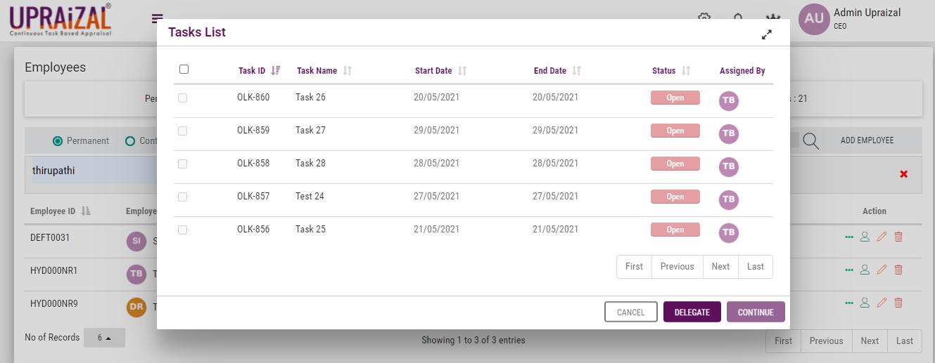

Employee Removal Modal Popup Screen:

