**System Driven Pulse Poll Changes**

System Driven Pulse Poll will be trigger’s the poll based on the system configurations.

**Version: 1.0**

**Date: 30-Jun-2020**

*All rights reserved. No part of this publication may be reproduced, transcribed, transmitted, stored in a retrieval system or translated into any language, in any form or by any means mechanical, manual, electronic, magnetic, chemical, optical, including photocopying or otherwise without the prior written permission of UPRAiZAL, Inc.*

Contents

Revision History 3

Requirement 4

Implementation Method 4

Code Modifications 4

List of required Jars & File Paths 9

Use cases (Must for Unit Test) 9

Screen Shots 10

# Revision History

|  |  |  |  |
| --- | --- | --- | --- |
| Version | Author | Date | Description |
| 1.0 | HYD0176SD | 30/Jun/2021 | Initial Version |
|  |  |  |  |

**Confidentiality**

The contents of this document are considered confidential and proprietary information of UPRAiZAL, Inc. No part of this document may be reproduced, fully or in part, or divulged to any other party without prior written permission from UPRAiZAL, Inc. All logos of respective owner companies used in this presentation are recognized.

# Requirement

1.Additionally, we want to enable a Daily Poll Option which should start and stop at a defined time within the same Date. The opportunity to answer the Poll should be available only on that date and time. It should expire at the end of the end time if unanswered.  The existing functionality of Weekly or Biweekly Polls should not be altered or affected in any way.

2.In case it is a half day then if some part of the Poll timings falls within the half day working time, then Polls should be enabled for the day.

3.There should be a configuration added to show the Total Number of Questions Unused in the Repository and on Tool Tip it should show the – ‘Total Repository Questions’

4.There should also be an option to set several questions that need to be asked in Daily Poll.

5.Admin should be able to set a time interval between the questions, like 30 mins or 1hr. The limit should be set in such a way that the Employee gets at least 1 hour to answer before the expiry of the Poll.

6.A Notification should be shown as soon as the Poll is activated. Every time a poll question is activated a Notification should be activated.

# Implementation Method

To accomplish this requirement, followed below approach.

**Java and UI:**

**UI**: Added system driven poll configurations such as time- period and question limitation and time interval for polls.

**UI:** added logic to display polls based on above configurations.

**Java:** added schedular changes to get the daily polls.

**Java**: Added counter logic to maintain no of polls populated in a day.

**Java:** Added logic to implement specific time interval for each poll.

# Code Modifications

**File Path**

/upraizal-web/src/main/webapp/WEB-INF/pages/configuration.jsp

**Purpose**

* Added ‘daily’ poll configurations for system driven polls.

**Modifications**

Added configuration for daily poll trigger period.

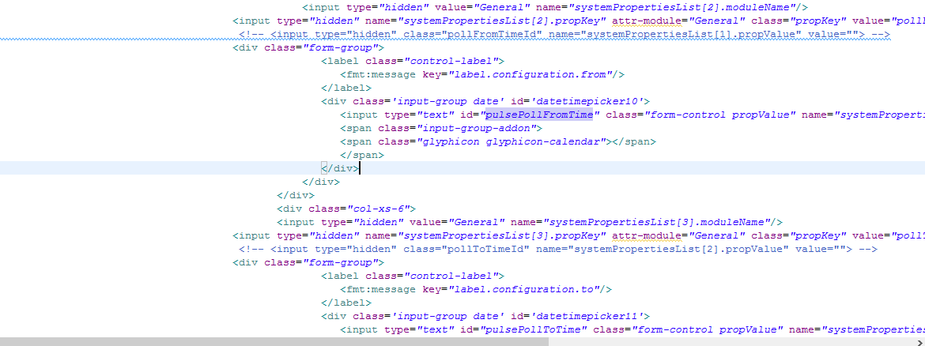

Added configuration for time interval to display polls.

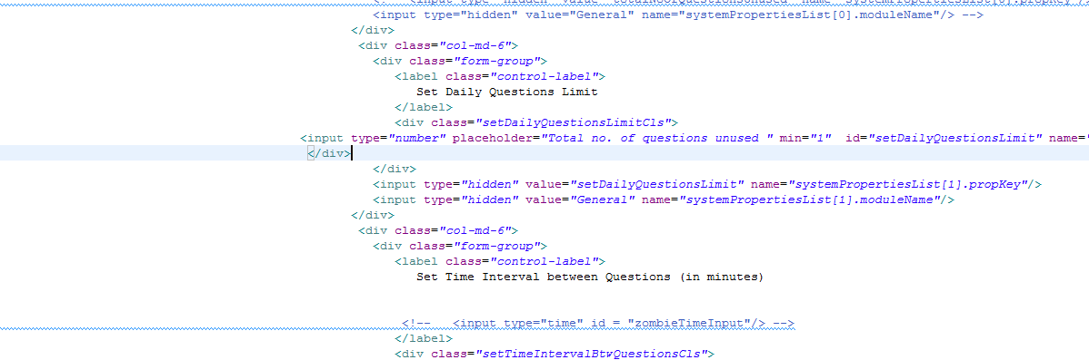

**File Path**

/upraizal-web/src/main/webapp/WEB-INF/tiles/page-header.jsp

**Purpose**

* Added logic to display polls based on the time interval.

**Modifications**

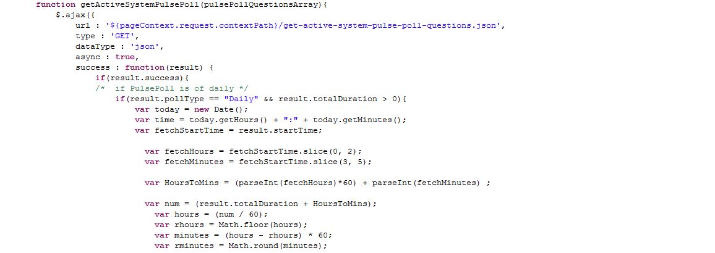

<------------------------------------------------Continuation-------------------------------------------------------->

**File Path**

/upraizal-emp/src/main/java/com/defteam/schedule/PulsePollSchedular.java

**Purpose**

* Added ‘daily’ poll trigger logic for System driven polls.

**Modifications**

Schedular changes for daily poll

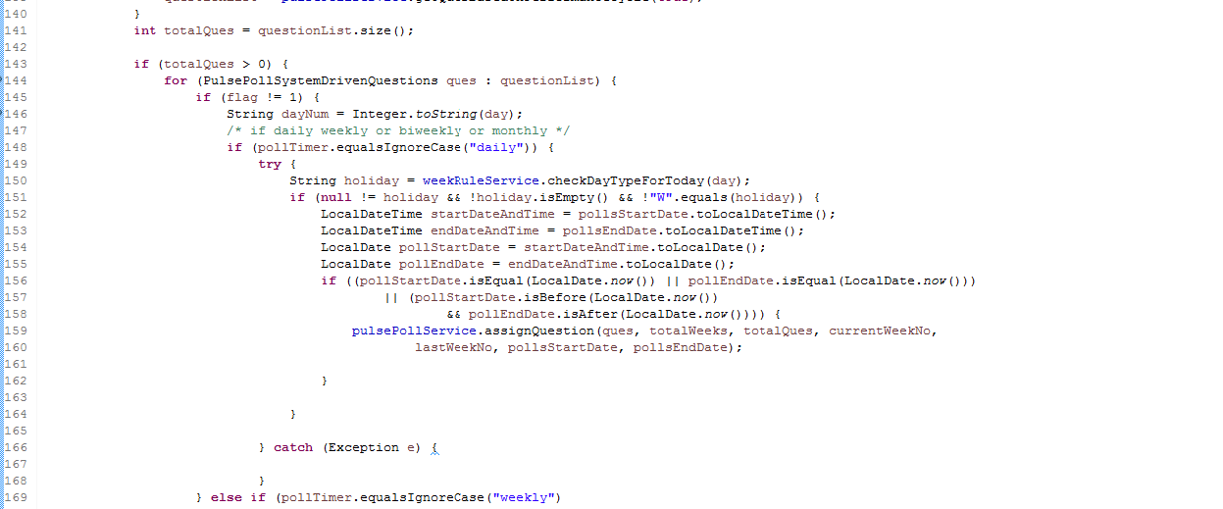

Schedular changes for maintain counter for unused questions.

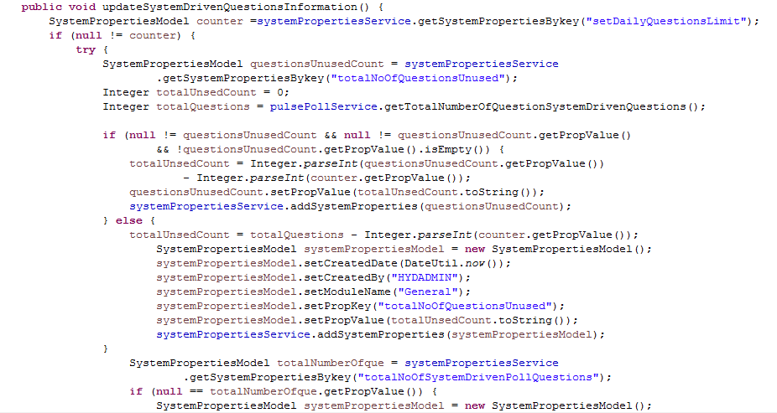

**File Path**

/upraizal-emp/src/main/java/com/defteam/emp/bpo/PulsePollBPOImpl.java

**Purpose**

* Added changes to assign questions to employees based on daily poll configuration.

**Modifications**

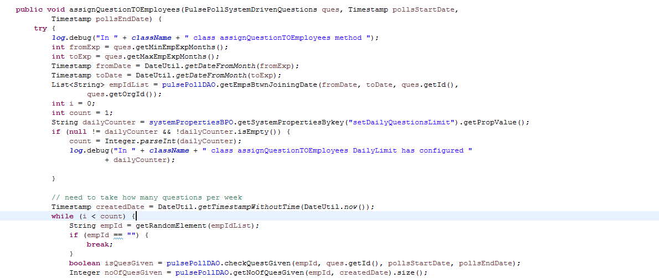

**File Path**

/upraizal-emp/src/main/java/com/defteam/emp/controller/PulsePollController.java

**Purpose**

* Added logic to get configurations for all active polls.

**Modifications**

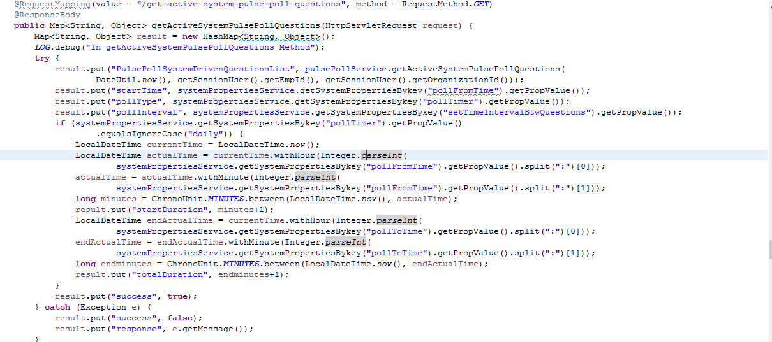

**File Path**

/upraizal-emp/src/main/java/com/defteam/emp/bpo/PulsePollBPOImpl.java

**Purpose**

* Added logic to inactivate the poll if already time interval exceeded.

**Modifications**

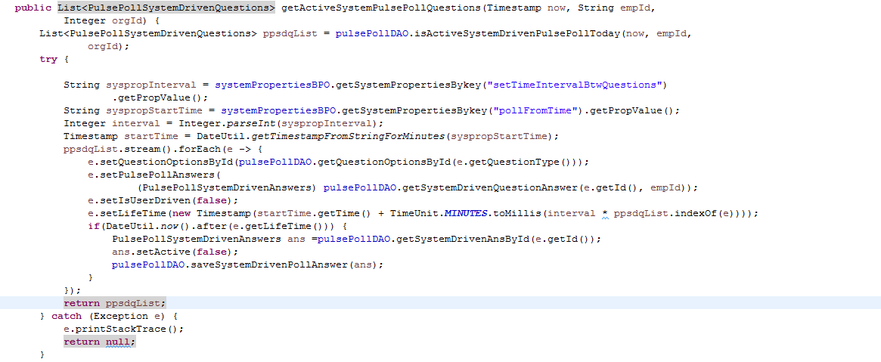

L

# List of required Jars & File Paths

b_22_03_2021_UPRAiZAL_Avante _1.6_Dev /upraizal-web/src/main/webapp/WEB-INF/pages/configuration.jsp

b_22_03_2021_UPRAiZAL_Avante _1.6_Dev\upraizal-web\src\main\webapp\WEB-INF\tiles\page-header.jsp

b_22_03_2021_UPRAiZAL_Avante_1.6_Dev/upraizal-emp/src/main/java/com/defteam/schedule/PulsePollSchedular.java.

b_22_03_2021_UPRAiZAL_Avante_1.6_Dev /upraizal-emp/src/main/java/com/defteam/emp/controller/PulsePollController.java

b_22_03_2021_UPRAiZAL_Avante_1.6_Dev /upraizal-emp/src/main/java/com/defteam/emp/bpo/PulsePollBPOImpl.java

# Use cases (Must for Unit Test)

1. user should be able to define daily polls long with weekly and bi-weekly.

2. user should be able to get the polls only between defined time-period in a day.

3.user should get the polls based on the time interval configurations within the time-period range.

4.user should be able see the unused questions count until current date in Configurations.

5.If Time interval not configured then all active polls should display sequentially.

6.once all polls submitted then should not active mode of pulls poll button.

7.if there is any active poll, until configured time-period exceeds the poll should display no matter multiple how many sessions persist.

8.Poll will become inactive and will not visible to the user after the configure time , though user has answered or not answered , and also the user will lose the points.

# Screen Shots

Configuration’s screen:

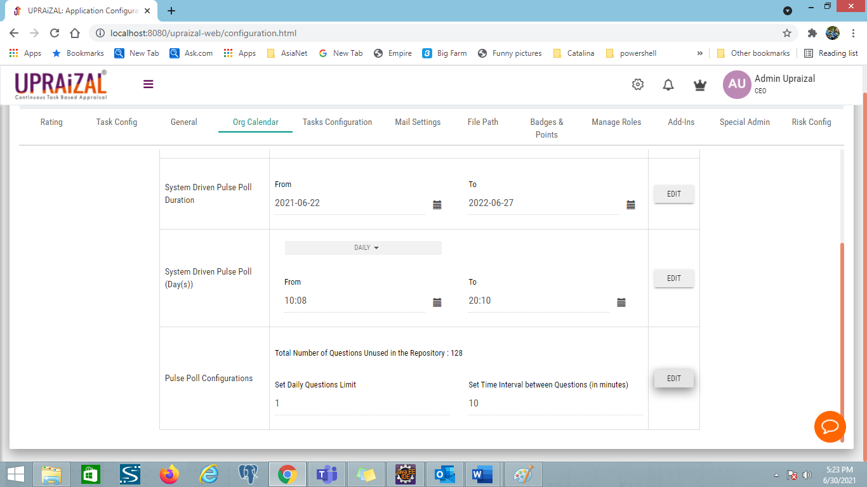

Poll popup screen

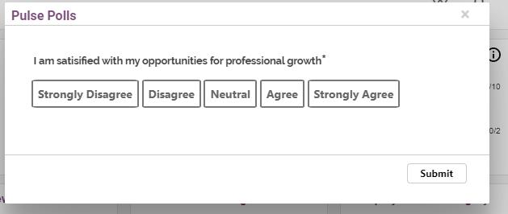

Congratulations message popup screen:

