Write the unstructured data (logs) into the mongo DB:

Ref - <https://stackoverflow.com/questions/48477651/writing-scala-spark-info-into-mongodb>

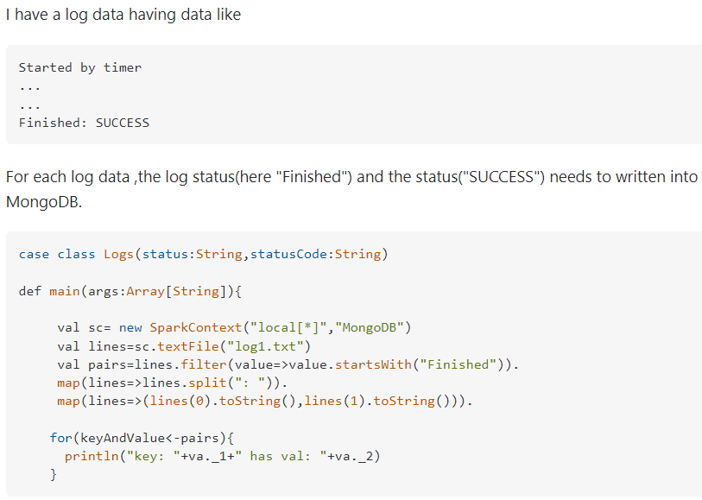

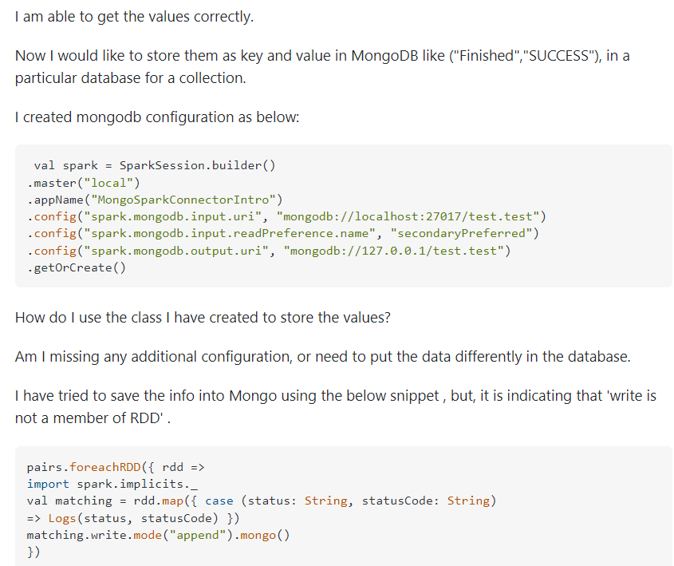

Any help will be much appreciated.

**Answer:**

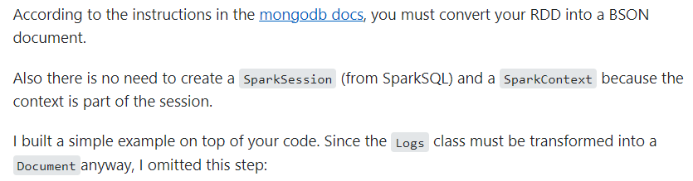

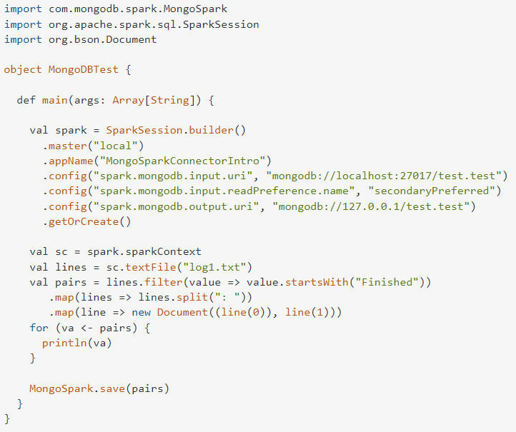

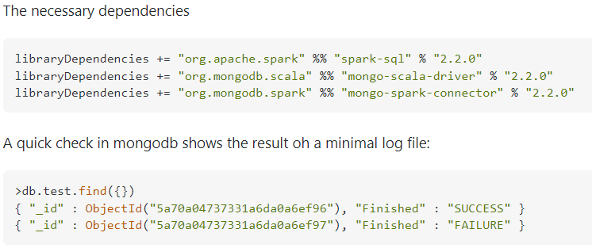

**Write to MongoDB:**

<https://www.mongodb.com/docs/spark-connector/master/scala/write-to-mongodb/>

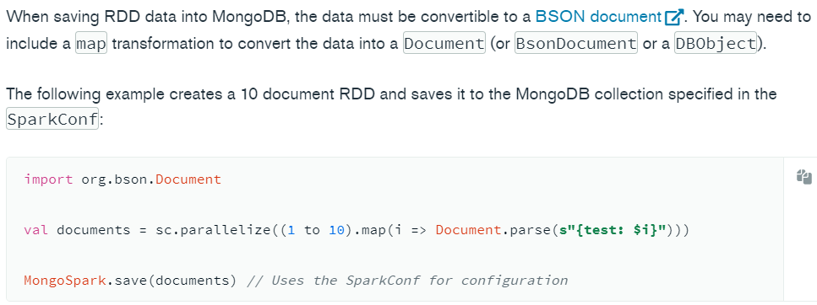

**Using WriteConfig:**





