**Print Python List Different Approach:**

**Different wats to print the python list:**

1. Pass a list as input to the print function in python
2. Use the asterisk operator in front of the list to unpack the list into the print function
3. Use sep argument to define how to separate two list elements visually

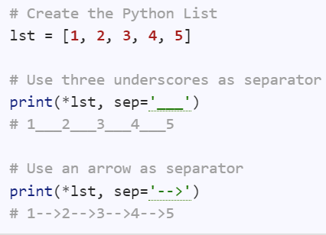

The default way to pass the list to print function

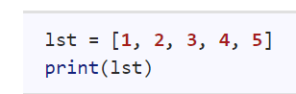



**Using For Loop:**

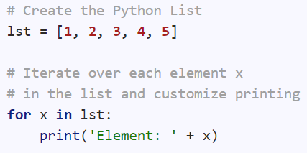

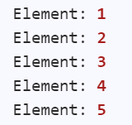

**Iterate for loop with end argument:**

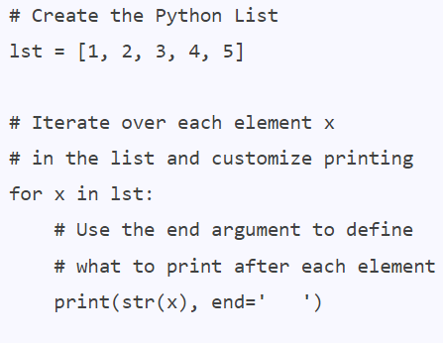



**Using Join Method:**

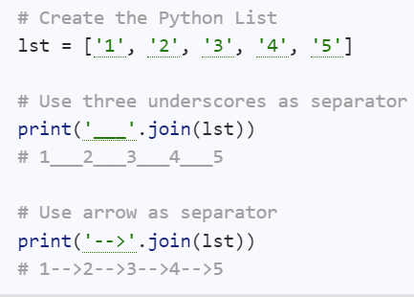

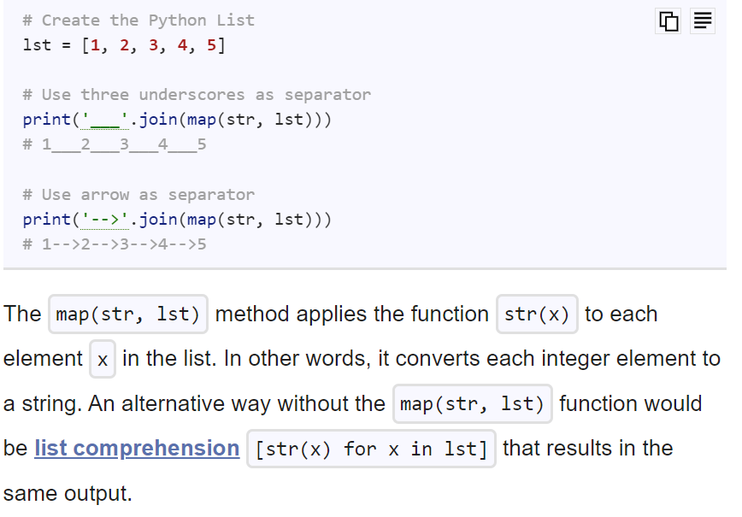

**Using * operator to unpack function:**

Ref - <https://www.tutorialspoint.com/How-does-operator-work-on-list-in-Python#:~:text=Python%20List%20also%20includes%20the,the%20specified%20number%20of%20times>.

This method is quite handy when printing data in a raw format (without any commas and brackets ). Many programmers attempt to remove commas and brackets by converging functions, thus this simple prefix asterisk can fix your problem in unpacking them.

Algorithm Steps:

Following are the Algorithm/steps to be followed to perform the desired task −

* Create a variable to store the input list and give it some random values.
* To print list elements separated by spaces without brackets [] first we convert the list to a string by passing the str and list as arguments to the map () function. It converts each element of the list to the string type and returns the resultant list of items. The join() function(join() is used to join elements of a sequence that are separated by a string separator) is used to convert the result list to a string.
* Instead of the previous method, we can use the asterisk operator (*) to print the list separated by spaces

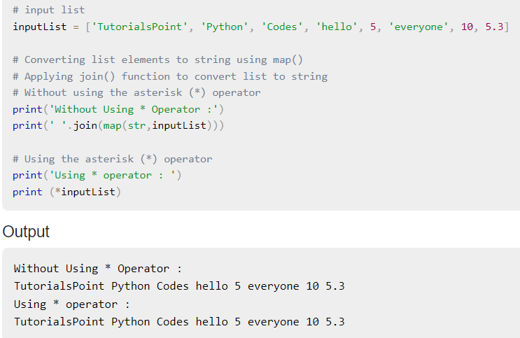s

**Repetition Operator:**

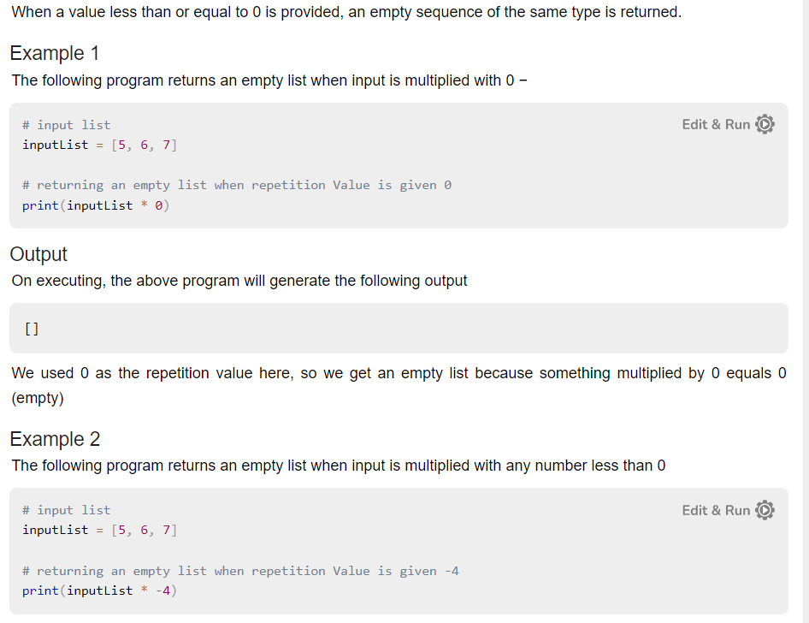

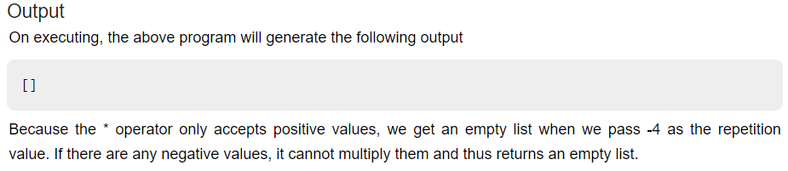

**Repetition Operator (*):**

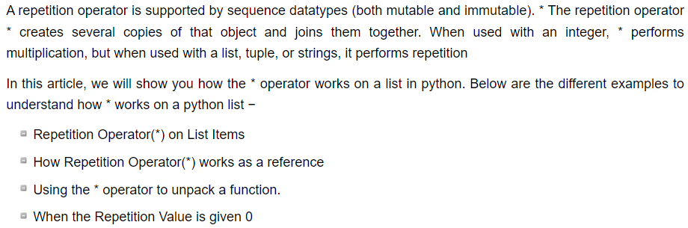

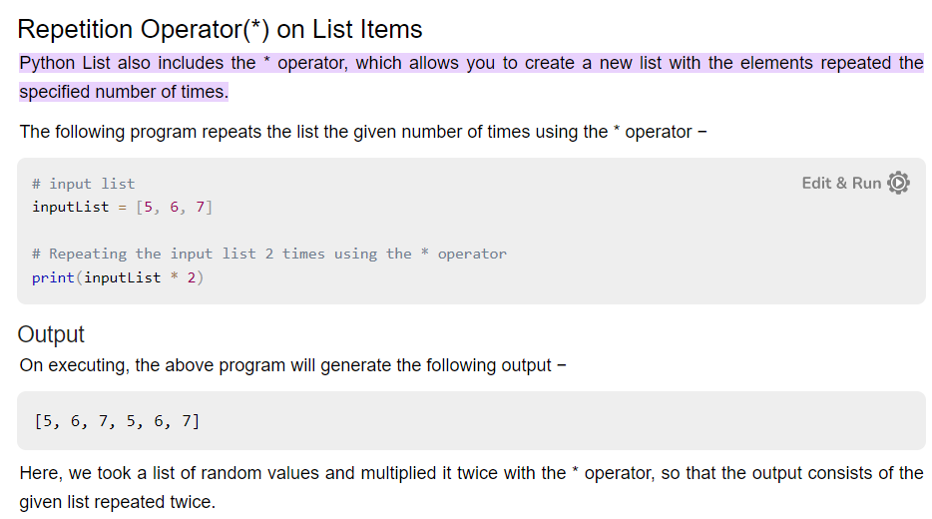

**Repetition don’t create reference if creates its own copy:**



