CO-1-AT-1

JAVA PROGRAMMING-CSA0904

NAME:-THIRUPUGAZH.S.R

REG NO:-192371016

DATE:-22/07/2026

1)Library Book Management using Classes & Encapsulation.

import java.util.Scanner;

class Book {
private int bookId;
private String title;
private String author;
private double price;
private boolean issued;

// Default Constructor
public Book() {
issued = false;
}

// Parameterized Constructor
public Book(int bookId, String title, String author, double price) {
this.bookId = bookId;
this.title = title;
this.author = author;
this.price = price;
this.issued = false;
}

// Getters
public int getBookId() {
return bookId;
}

public String getTitle() {
return title;
}

public String getAuthor() {
return author;
}

public double getPrice() {
return price;
}

public boolean isIssued() {
return issued;
}

// Setters
public void setBookId(int bookId) {
this.bookId = bookId;
}

public void setTitle(String title) {
this.title = title;
}

public void setAuthor(String author) {
this.author = author;
}

public void setPrice(double price) {
this.price = price;
}

// Issue Book
public void issueBook() {
if (!issued) {
issued = true;
System.out.println("Book Issued Successfully.");
} else {
System.out.println("Book is Already Issued.");
}
}

// Return Book
public void returnBook() {
if (issued) {
issued = false;
System.out.println("Book Returned Successfully.");
} else {
System.out.println("Book was Not Issued.");
}
}

// Display Book Details
public void displayBook() {
System.out.println("--------------------------------");
System.out.println("Book ID : " + bookId);
System.out.println("Title : " + title);
System.out.println("Author : " + author);
System.out.println("Price : " + price);
System.out.println("Status : " + (issued ? "Issued" : "Available"));
}
}

public class Main {
public static void main(String[] args) {

Scanner sc = new Scanner(System.in);

Book books[] = new Book[10];
int count = 0;
int choice;

do {
System.out.println("\n===== LIBRARY MENU =====");
System.out.println("1. Add Book");
System.out.println("2. Display Books");
System.out.println("3. Search Book");
System.out.println("4. Issue Book");
System.out.println("5. Return Book");
System.out.println("6. Exit");
System.out.print("Enter Choice: ");
choice = sc.nextInt();

switch (choice) {

case 1:
if (count < books.length) {

System.out.print("Enter Book ID: ");
int id = sc.nextInt();

sc.nextLine();

System.out.print("Enter Title: ");
String title = sc.nextLine();

System.out.print("Enter Author: ");
String author = sc.nextLine();

System.out.print("Enter Price: ");
double price = sc.nextDouble();

books[count] = new Book(id, title, author, price);
count++;

System.out.println("Book Added Successfully.");

} else {
System.out.println("Library is Full.");
}
break;

case 2:
if (count == 0) {
System.out.println("No Books Available.");
} else {
for (int i = 0; i < count; i++) {
books[i].displayBook();
}
}
break;

case 3:
System.out.print("Enter Book ID to Search: ");
int sid = sc.nextInt();
boolean found = false;

for (int i = 0; i < count; i++) {
if (books[i].getBookId() == sid) {
books[i].displayBook();
found = true;
break;
}
}

if (!found)
System.out.println("Book Not Found.");
break;

case 4:
System.out.print("Enter Book ID to Issue: ");
int iid = sc.nextInt();

found = false;

for (int i = 0; i < count; i++) {
if (books[i].getBookId() == iid) {
books[i].issueBook();
found = true;
break;
}
}

if (!found)
System.out.println("Book Not Found.");
break;

case 5:
System.out.print("Enter Book ID to Return: ");
int rid = sc.nextInt();

found = false;

for (int i = 0; i < count; i++) {
if (books[i].getBookId() == rid) {
books[i].returnBook();
found = true;
break;
}
}

if (!found)
System.out.println("Book Not Found.");
break;

case 6:
System.out.println("Thank You!");
break;

default:
System.out.println("Invalid Choice.");
}

} while (choice != 6);

sc.close();
}
}

OUTPUT:-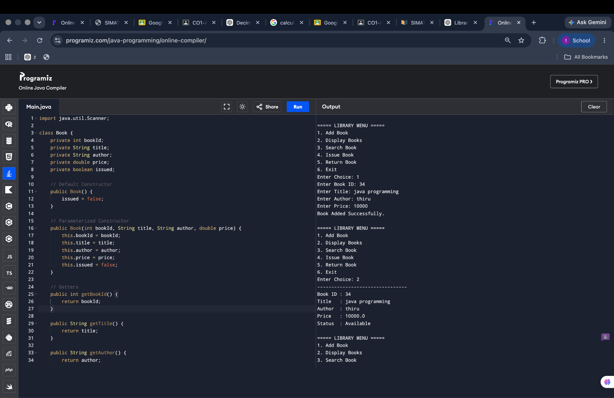

2) Payroll System (Method Overriding & Runtime Polymorphism)

class Employee {
String name;
Employee(String n) { name = n; }

void calculateSalary() {
System.out.println("Salary");
}
}

class PermanentEmployee extends Employee {
double basic;
PermanentEmployee(String n, double b) {
super(n);
basic = b;
}

void calculateSalary() {
System.out.println(name + " Salary = " + (basic + basic * 0.2));
}
}

class ContractEmployee extends Employee {
int hours;
double rate;

ContractEmployee(String n, int h, double r) {
super(n);
hours = h;
rate = r;
}

void calculateSalary() {
System.out.println(name + " Salary = " + (hours * rate));
}
}

public class Main {
public static void main(String args[]) {
Employee e;

e = new PermanentEmployee("Ravi", 30000);
e.calculateSalary();

e = new ContractEmployee("John", 100, 500);
e.calculateSalary();
}
}

OUTPUT:-

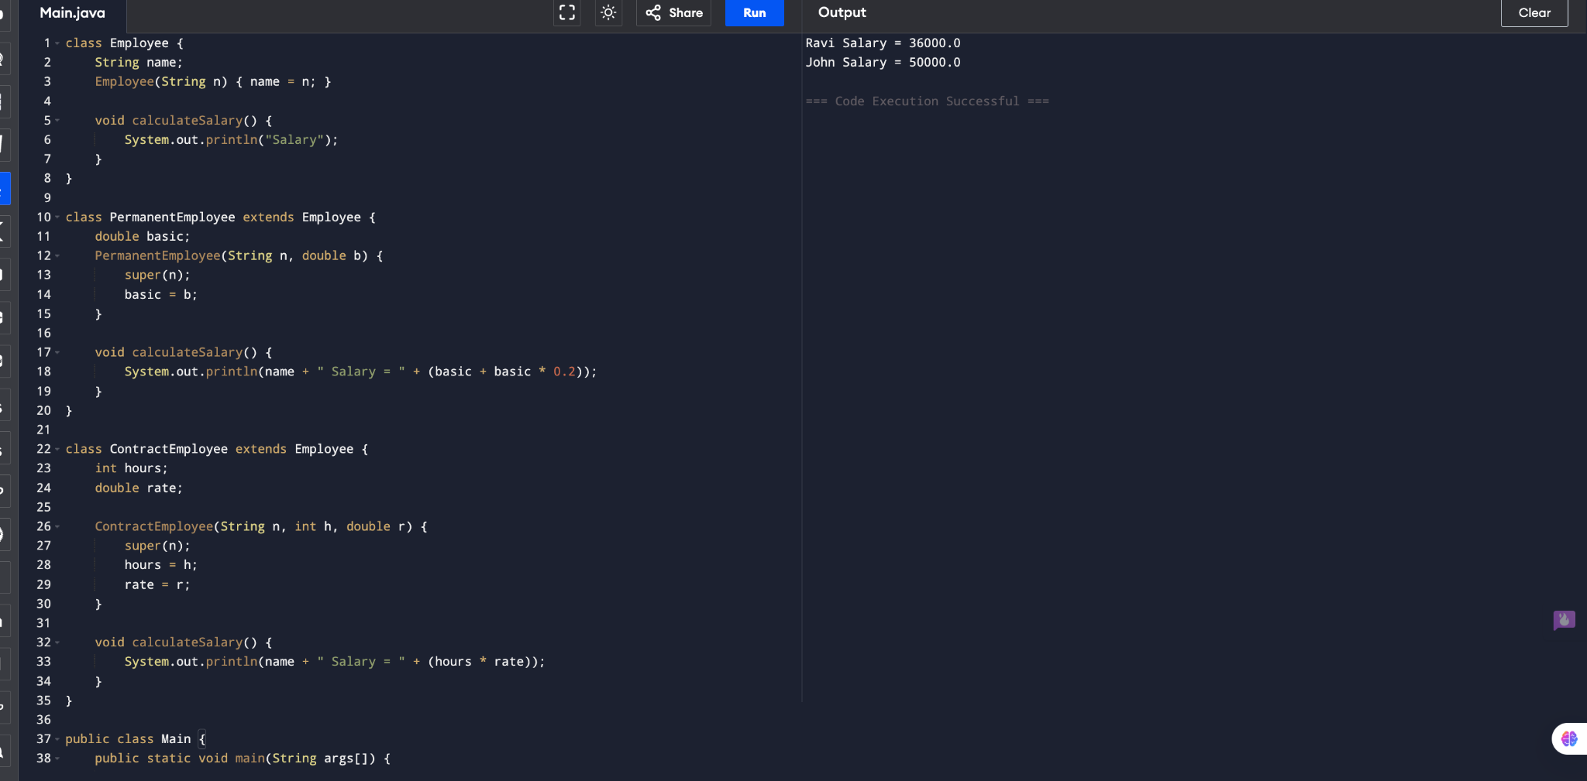

3) Vehicle Rental System (Runtime Polymorphism)

class Vehicle {
void calculateRent(int days) {}
}

class Car extends Vehicle {
void calculateRent(int days) {
System.out.println("Car Rent = " + days * 1000);
}
}

class Bike extends Vehicle {
void calculateRent(int days) {
System.out.println("Bike Rent = " + days * 500);
}
}

class Bus extends Vehicle {
void calculateRent(int days) {

System.out.println("Bus Rent = " + days * 3000);
}
}

public class Main {
public static void main(String args[]) {
Vehicle v[] = {new Car(), new Bike(), new Bus()};

for (Vehicle x : v)
x.calculateRent(3);
}
}

OUTPUT:-
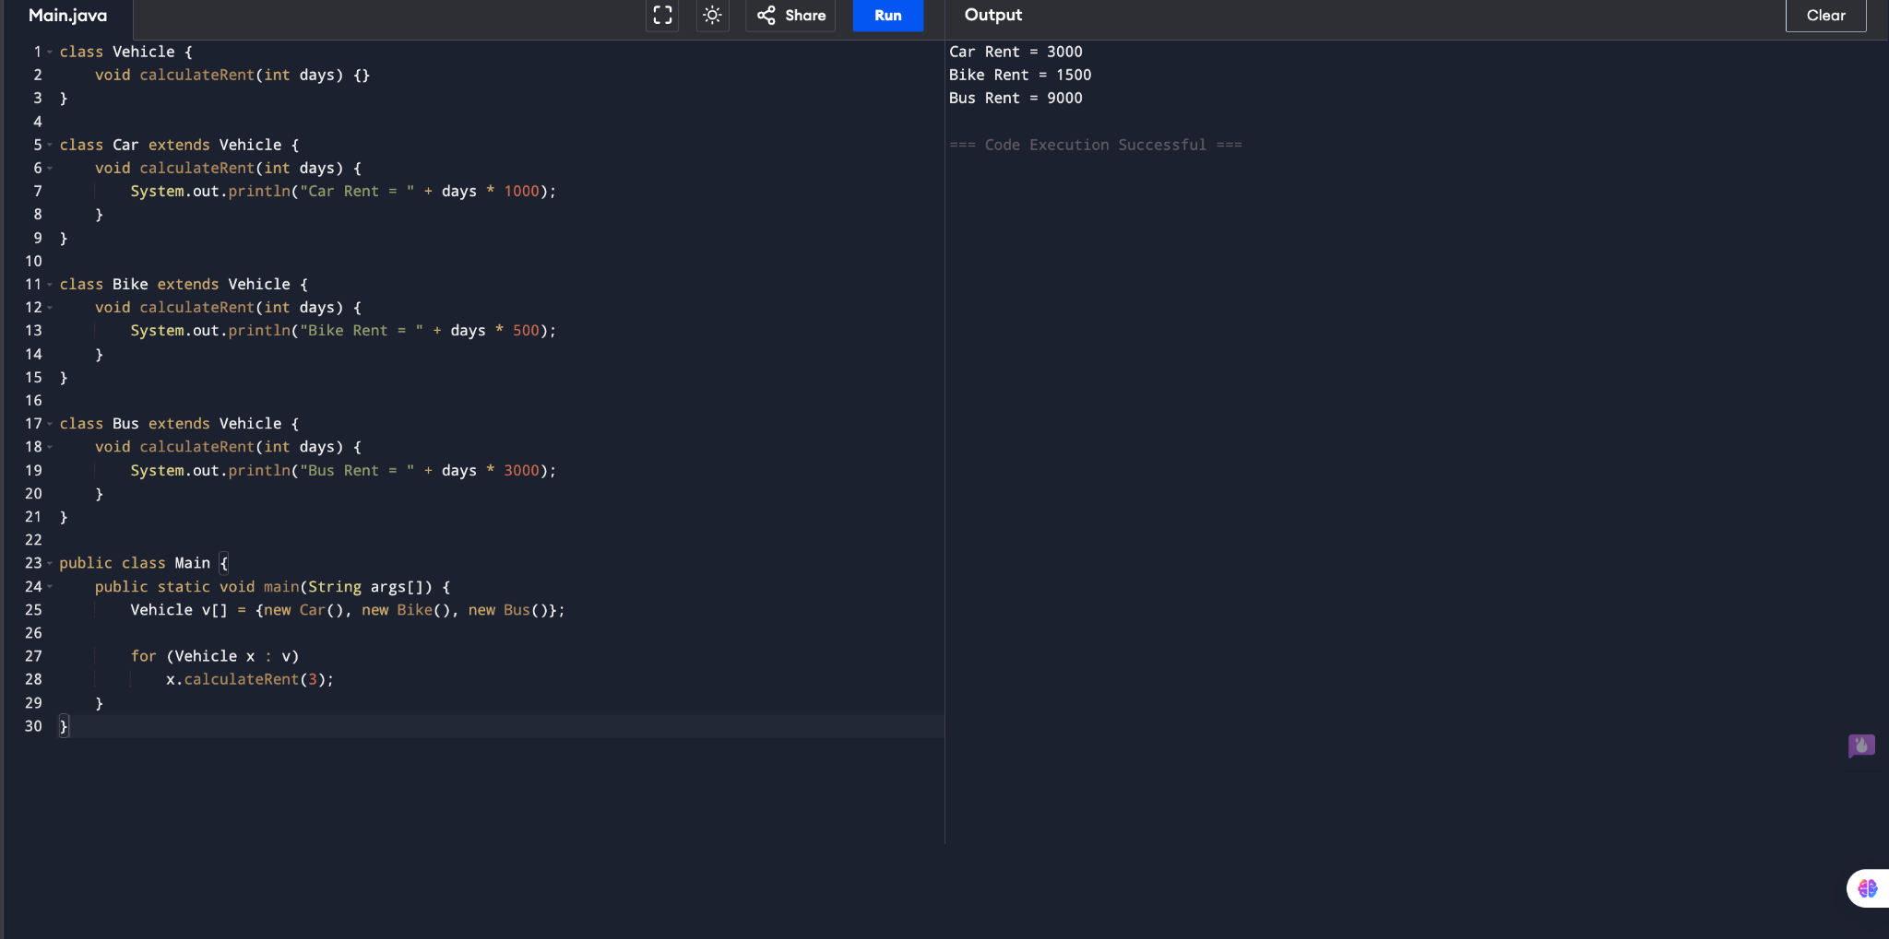

4) Bank Account System using Data Hiding

class BankAccount {
private int accNo;
private String name;
private double balance;

BankAccount(int a, String n, double b) {
accNo = a;
name = n;
balance = b;
}

void deposit(double amt) {
balance += amt;
}

void withdraw(double amt) {
if (amt <= balance)
balance -= amt;
else
System.out.println("Insufficient Balance");
}

void display() {
System.out.println("Balance = " + balance);
}
}

public class Main {
public static void main(String args[]) {
BankAccount b = new BankAccount(101, "Ram", 5000);
b.deposit(1000);
b.withdraw(2000);
b.display();
}
}

OUTPUT:-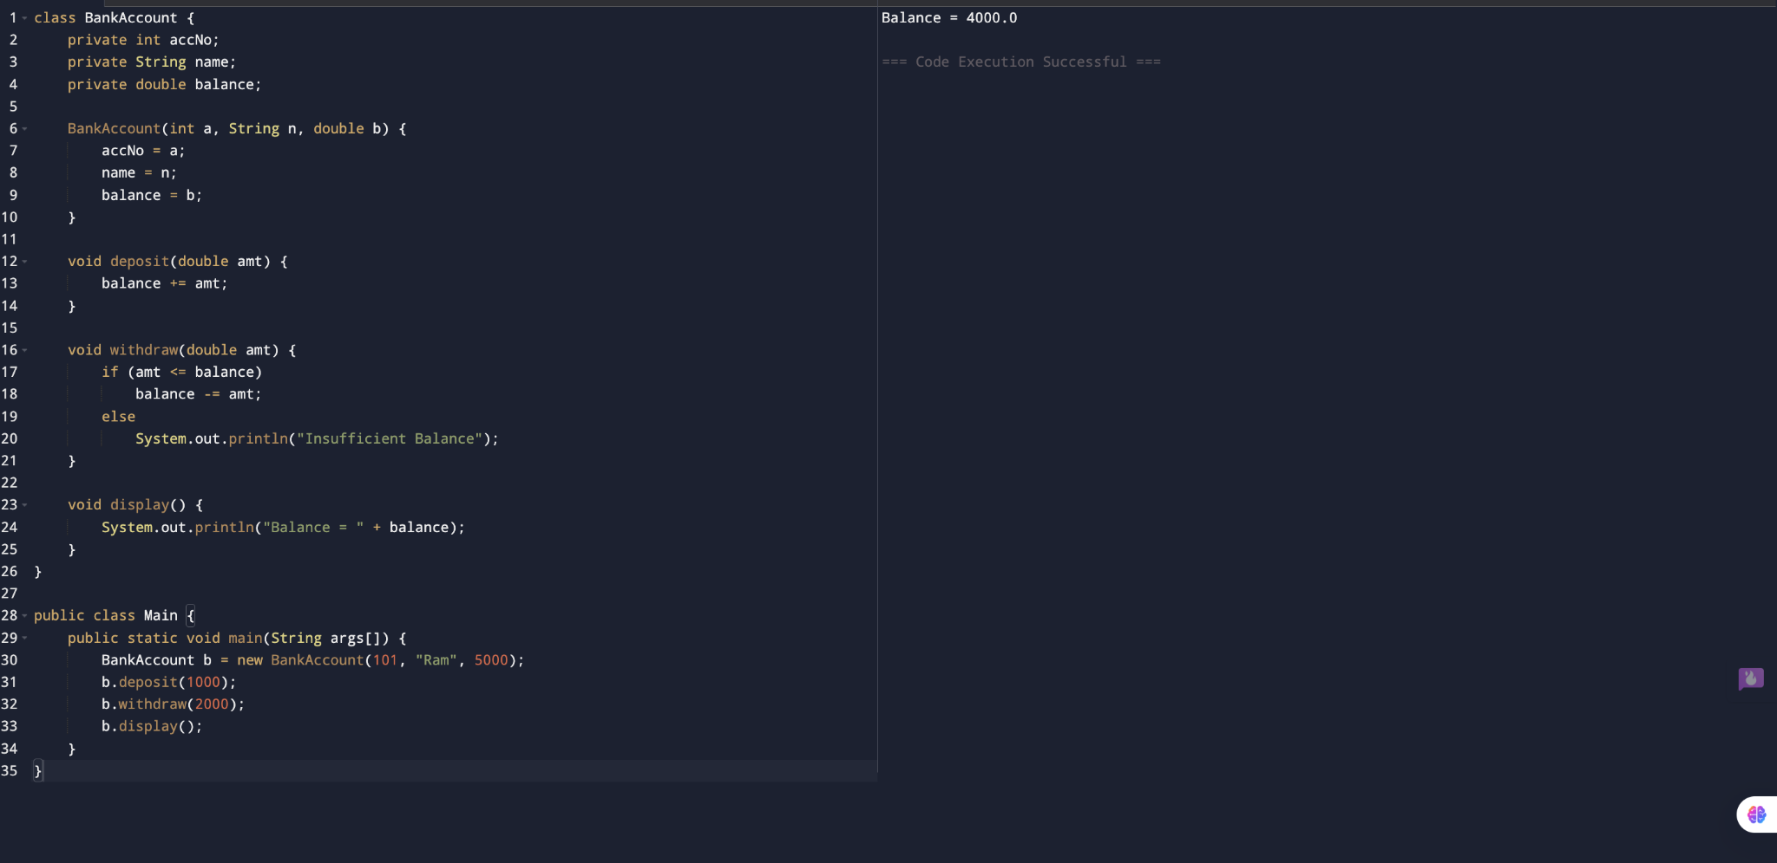

5)University Admission System using Method Overloading

class Admission {

void calculateFee() {
System.out.println("UG Fee = 50000");
}

void calculateFee(int pg) {
System.out.println("PG Fee = 80000");
}

void calculateFee(double scholarship) {
System.out.println("Scholarship Fee = " + (50000 - scholarship));
}
}

public class Main {
public static void main(String args[]) {
Admission a = new Admission();

a.calculateFee();
a.calculateFee(1);
a.calculateFee(10000.0);
}
}

OUTPUT:-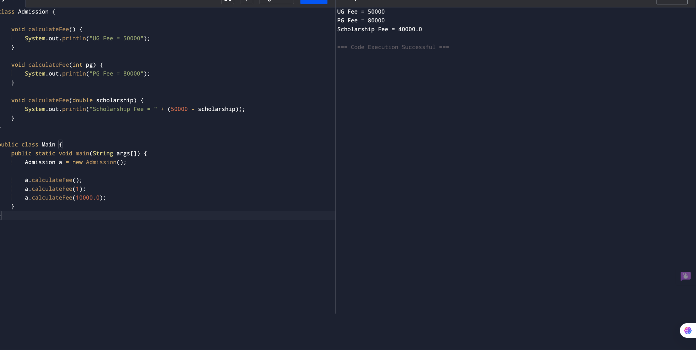

6)Shape Area Calculator using Abstract Class & Polymorphism

abstract class Shape {
abstract void area();
}

class Circle extends Shape {
void area() {
System.out.println("Circle = " + (3.14 * 5 * 5));
}
}

class Rectangle extends Shape {
void area() {
System.out.println("Rectangle = " + (5 * 4));
}
}

class Triangle extends Shape {
void area() {
System.out.println("Triangle = " + (0.5 * 5 * 4));
}
}

public class Main {
public static void main(String args[]) {
Shape s[] = {new Circle(), new Rectangle(), new Triangle()};

for (Shape x : s)
x.area();
}
}

OUTPUT:-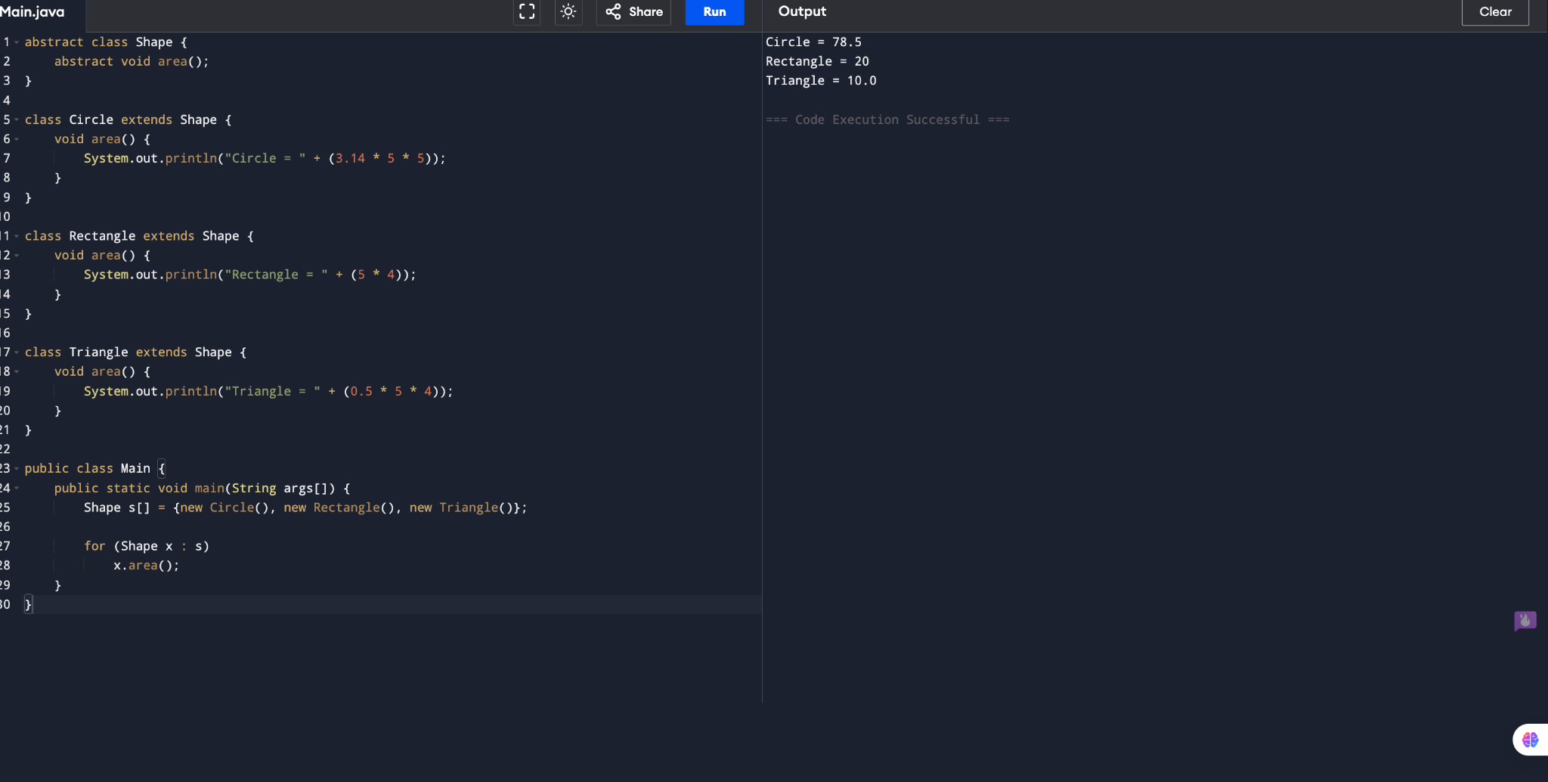

7)Hospital Management System using Interfaces

interface MedicalRecord {
void addRecord();
void displayRecord();
}

class Patient implements MedicalRecord {

public void addRecord() {
System.out.println("Patient Record Added");
}

public void displayRecord() {
System.out.println("Patient Record");
}
}

class Doctor implements MedicalRecord {

public void addRecord() {
System.out.println("Doctor Record Added");
}

public void displayRecord() {
System.out.println("Doctor Record");
}
}

public class Main {
public static void main(String args[]) {

MedicalRecord p = new Patient();
MedicalRecord d = new Doctor();

p.addRecord();
p.displayRecord();

d.addRecord();
d.displayRecord();
}
}

OUTPUT:-

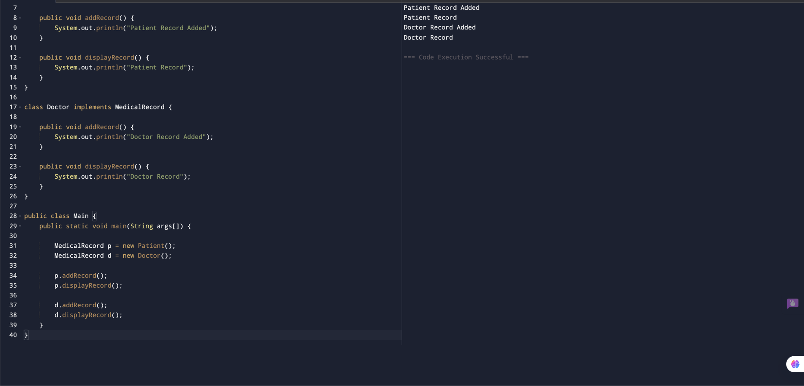

8) Online Shopping Order System using Packages

Product.java

package shopping.product;

public class Product {
public int price = 1000;
}

Order.java
package shopping.order;

public class Order {
public void bill(int qty, int price) {
System.out.println("Total = " + qty * price);
}
}

Main.java:-
import shopping.product.Product;
import shopping.order.Order;

public class Main {
public static void main(String args[]) {
Product p = new Product();
Order o = new Order();

o.bill(2, p.price);
}
}

OUTPUT:-

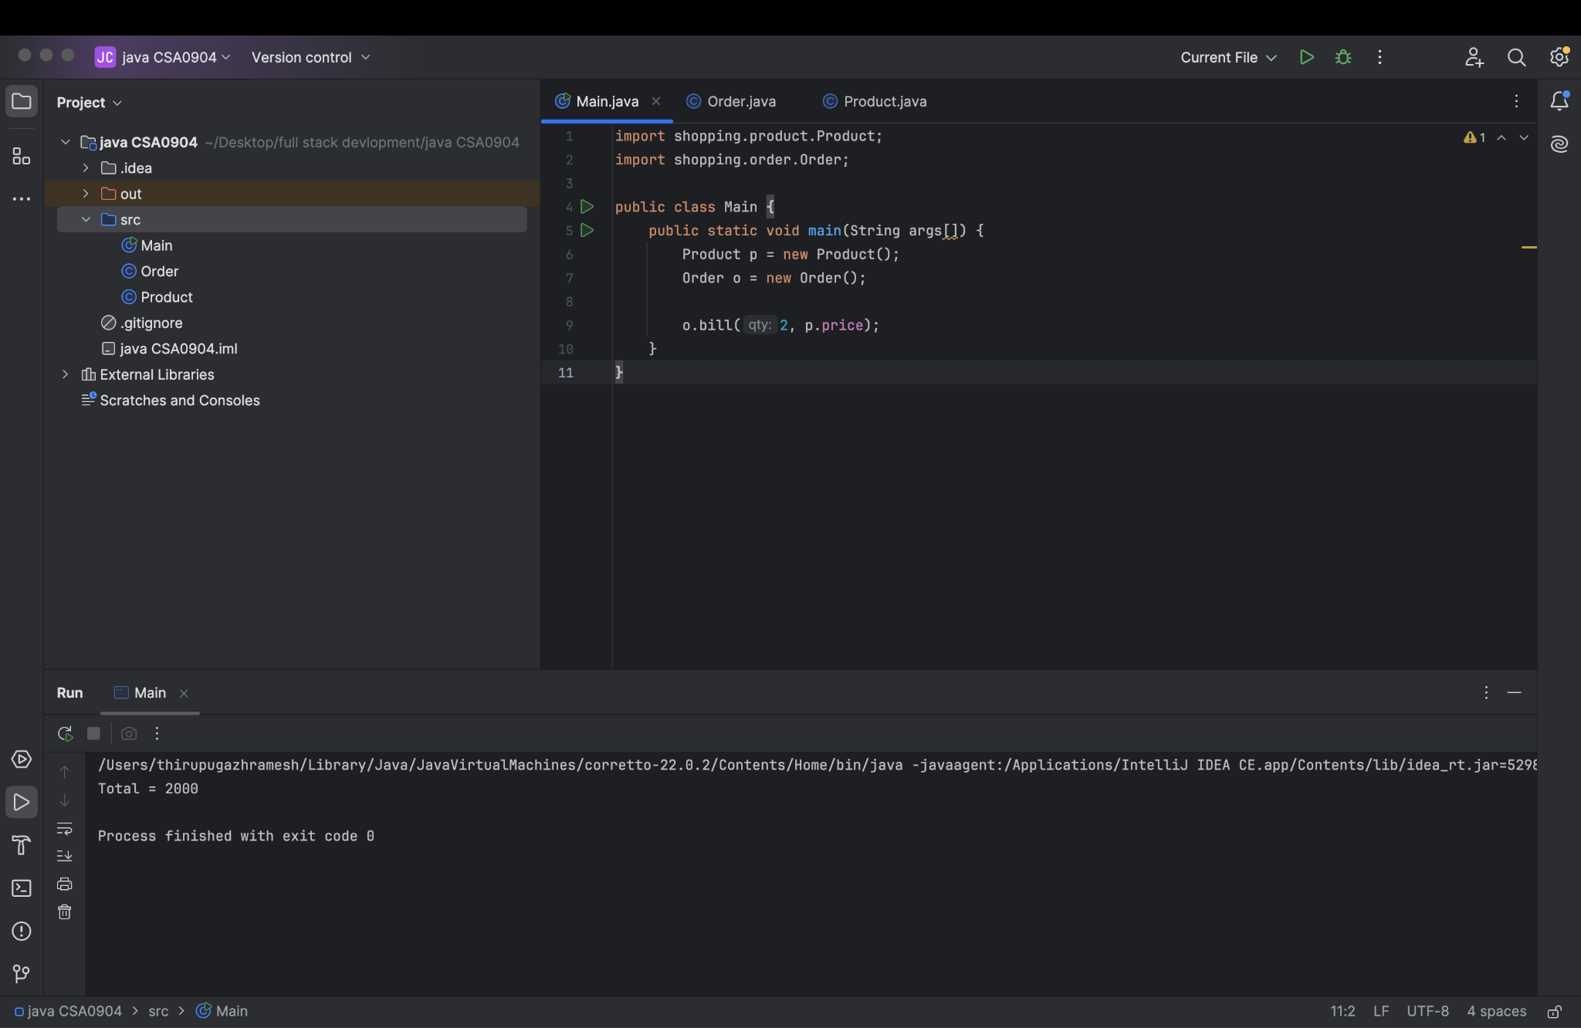

9)Student Result Analyzer using Arrays of Objects

class Student {

int roll;
String name;
int m1, m2, m3;

Student(int r, String n, int a, int b, int c) {
roll = r;
name = n;
m1 = a;
m2 = b;
m3 = c;
}

void display() {
int total = m1 + m2 + m3;
double avg = total / 3.0;

System.out.println(name);
System.out.println("Total = " + total);
System.out.println("Average = " + avg);

if (avg >= 90)
System.out.println("Grade A");
else if (avg >= 75)
System.out.println("Grade B");
else
System.out.println("Grade C");
}
}

public class Main {
public static void main(String args[]) {

Student s[] = {
new Student(1, "Ram", 90, 95, 80),
new Student(2, "Hari", 70, 75, 80)
};

int max = 0;

for (int i = 0; i < s.length; i++) {
s[i].display();

int total = s[i].m1 + s[i].m2 + s[i].m3;

if (total > max)
max = total;
}

System.out.println("Topper Marks = " + max);
}
}

OUTPUT:-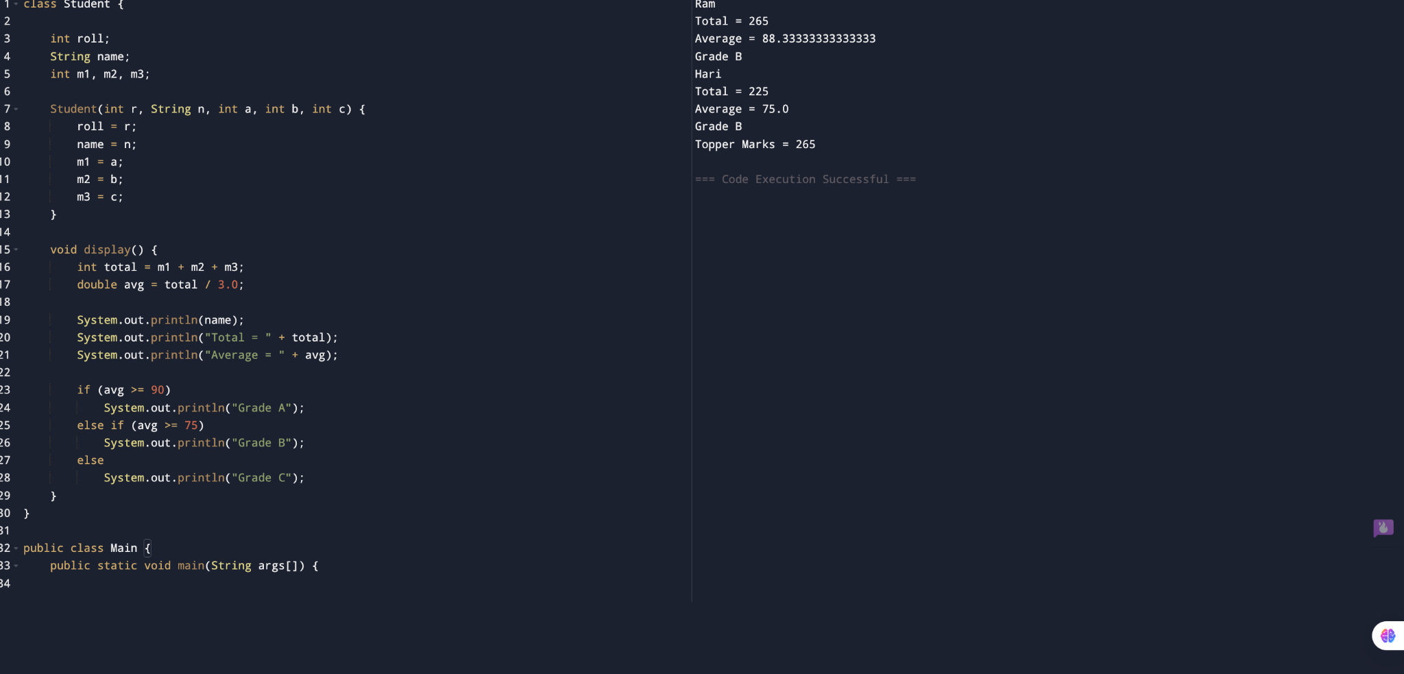

10)Smart Home Device Controller using Hierarchical Inheritance

class Device {
void on() {
System.out.println("Device ON");
}

void power() {
}
}

class Light extends Device {
void power() {
System.out.println("Power = 20W");
}
}

class Fan extends Device {
void power() {
System.out.println("Power = 75W");
}
}

class AirConditioner extends Device {
void power() {
System.out.println("Power = 1500W");
}
}

public class Main {
public static void main(String args[]) {

Device d[] = {
new Light(),
new Fan(),
new AirConditioner()
};

for (Device x : d) {
x.on();
x.power();
}
}
}

OUTPUT:-