**What is mean by Session?**

**“Session”** is the term used to refer to a user’s time browsing a web site. It’s meant to represent the time between their first arrival at a page in the site until the time they stop using the site. In practice, it’s impossible to know when the user is done with the site. In most servers there’s a timeout automatically ends a session unless another page is requested by the same user.

The first time a user connects some kind of session ID is created (how it’s done depends on the web server software and the type of authentication/login you’re using on the site).

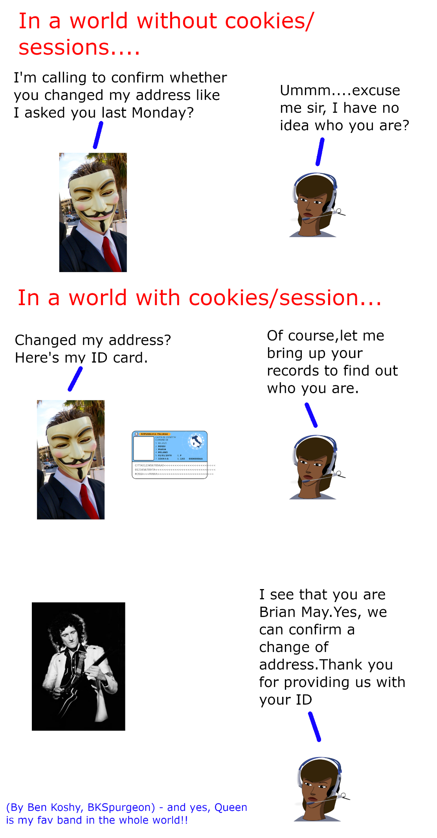

A **Browser Session** is a continuous period of user activity in the **browser,** where successive events are separated by no more than 30 minutes.

**How does a Web Session Works?**

**Websites** uses a **session ID** to respond to user interactions during a **web session**. To track **sessions,** a **web session** ID is stored in a visitor’s **browsers**. This **session ID** is passed along with any HTTP request that the visitor makes while on the site (Ex, Clicking a Link)

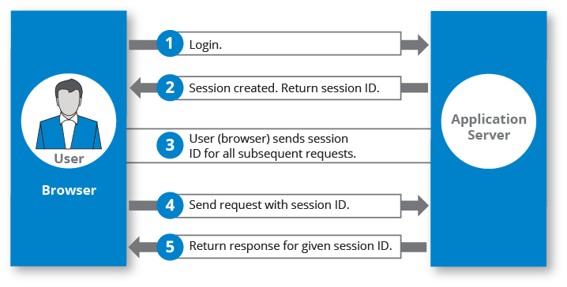

**How Long Session Will be Maintained in Web Browser?**

A **Session** also includes an expiration. A **Single Session** never lasts beyond a certain duration, at least as **far** as the web property is concerned. Depending on the site, a developer may define a web **session** as fast as **5 minutes** or as **long** as 1,440 minutes (an entire day).

By Default, a **Session** lasts until there’s 30 minutes of inactivity, but you can adjust this limit so a **Session** lasts from a few seconds to several hours. Learn more about adjusting **session** settings. When a user arrives on your site, Analytics starts counting from that moment.

**How Session is maintained in Web Application?**

**Sessions** are **maintained** automatically by a **session** cookie that is sent to the client when the **session** is first created. The **session** cookie contains the **session** ID, which identifies the client to the browser on each successive interaction.